Design Document

## Step 1:

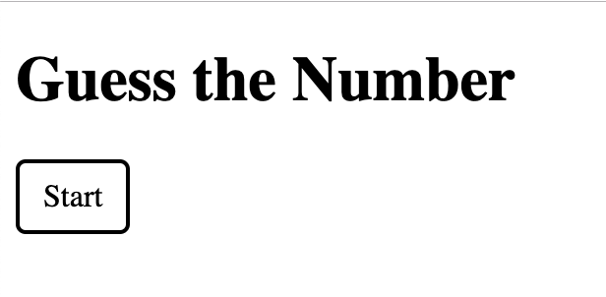

## Step 2: Click the “Start” button

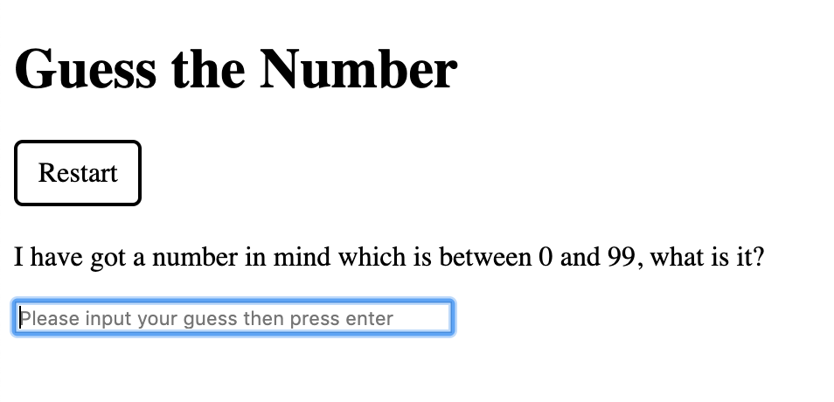

## Step 3: Make a guess The answer can be one of “COLD, COOL, WARM, HOT, or You got it in x trials!”

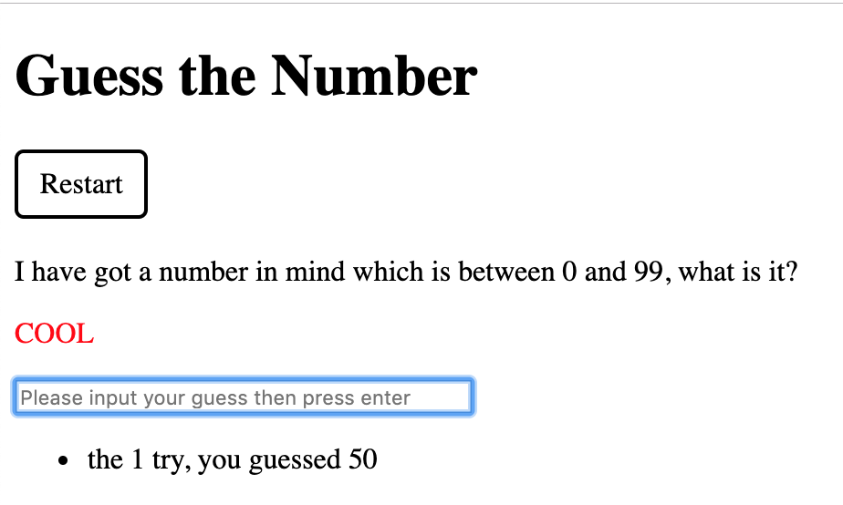

## Step 4: you hit

