**Ara Department of Computing**

**Graduate Diploma in Information and Communication Technologies**

**Bachelor of Information and Communication Technologies**

**Diploma in Information and Communications Technology**

**Diploma in Information Technology**

**BCSE101 – Software Engineering 1A**

**JavaScript Practical Test**

**Student Name: Zhong Wei**

**ID Number: 99199062**

**NOTE: For the purposes of this test you may use textbooks, your notes and any electronic files that are in your area of the network.**

This test is worth 25% of the overall mark for BCSE101

This test has 4 pages including the cover sheet

***Note that for some questions it may be necessary to write an extra method over and above the method that is asked for.***

Copy the zip file contained the test directory (and all sub-directories) from Moodle onto your local drive. Unzip all directories and files.

1. Four classes have been created in this project. Draw a class diagram in the space below showing the classes (including their attributes and methods) and relationships.

(1 mark)

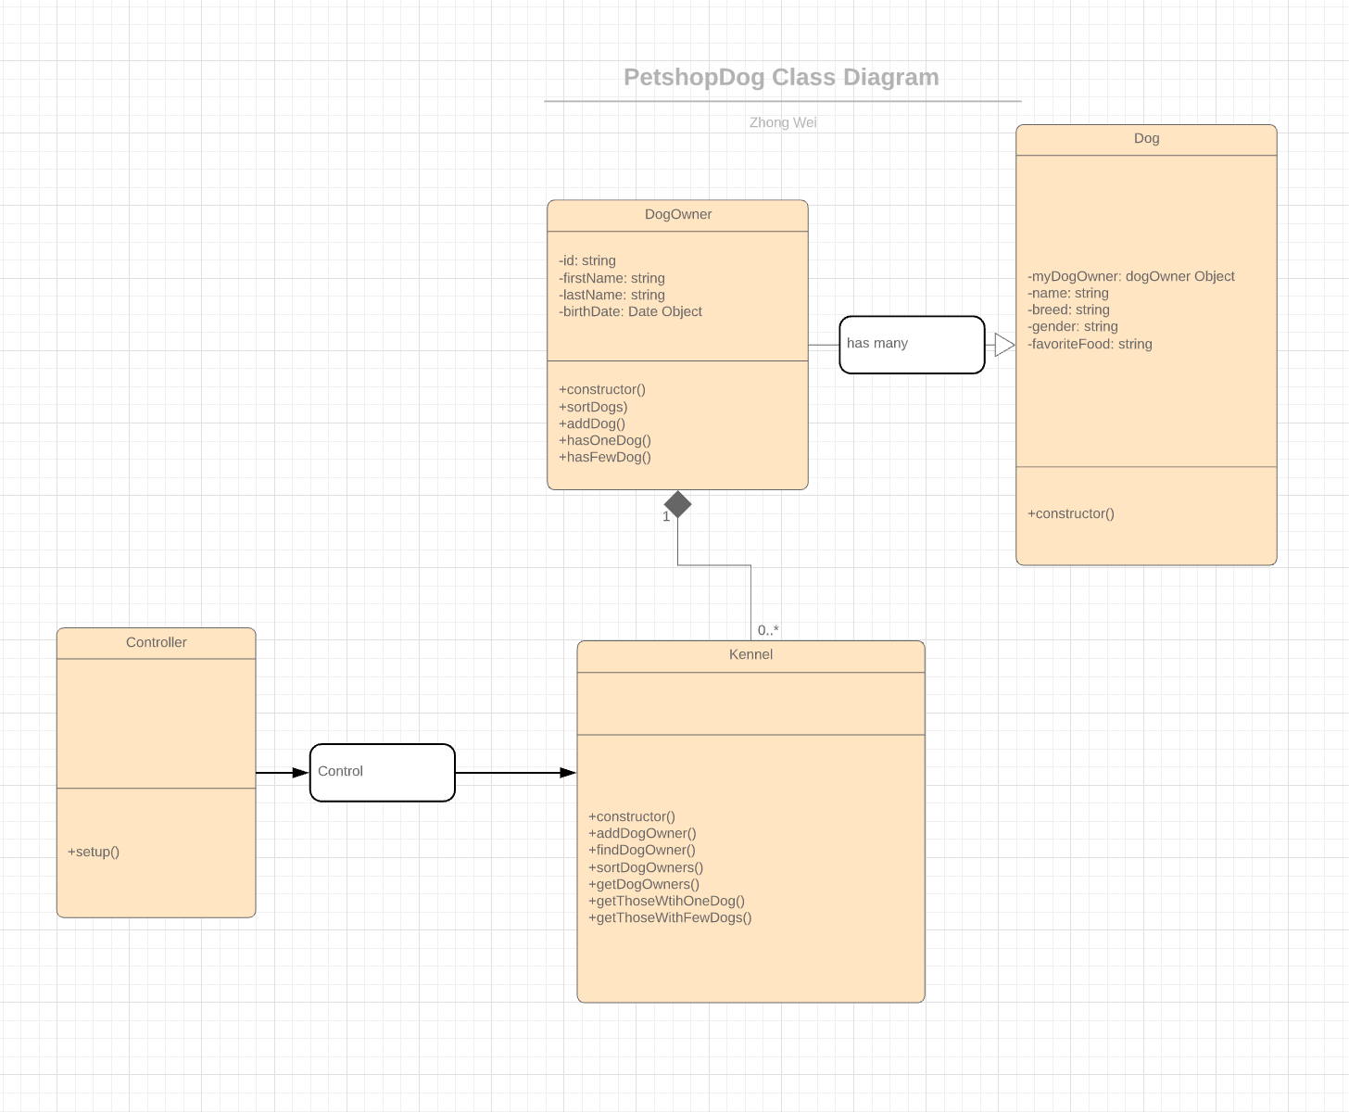

1. In the setup method of the Controller class write code that to create the following four DogOwners using the addDogOwner method that exists in the Kennel class

**ID First Name Last Name Birth Date**

BMC Brad McCaw 12/13/1982

RTH Richie Thorn 8/05/1980

DEL Dan Ellis 16/02/1984

ACR Andrew Carter 30/11/1987

***NOTE: the defect in this data is deliberate – fix it!***

(2 marks)

1. Write a getDogOwners method for Kennel class that displays only the .firstName, .lastName and .id of all the DogOwners.

***(Note that the other data for them should not be displayed).***

The required output is:

Andrew, Carter [ACR]

Brad, McCaw [BMC]

Dan, Ellis [DEL]

Richie, Thorn [RTH]

***NOTE: Punctuation and spacing and ORDER must also be as shown above.***

***Hint:***

***You WILL need to use \n and space in your methods.***

***You WILL need to call the .sortDogOwners method in Kennel.***

(3 marks)

1. Write an addDog method for DogOwner class that can be used to create a new Dog.

NB. You will need to add some code in the Dog class as well.

(4 marks)

1. In the setup method of the Controller class write code to create the following Dogs, using the addDog method that has been created previously.

***NOTE You will have to use the*** findDogOwner ***method in the Kennel class***

**DogOwner ID Name Breed Gender Favorite Food**

BMC Speedy Pomeranian N Ekanuba

RTH Victor Beagle M Chef

RTH Killer Mastiff N Purina

DEL Ruftero Poodle F Ekanuba

DEL Sausage Dachshund F Purina

ACR Random Mastiff F Cat

(5 marks)

1. Write a **Boolean** get method named hasOneDog for the DogOwner class that returns true if the number of dogs that person owns is one and false otherwise.

***(HINT: Check the value returned by the length method of allMyDogs Array.)***

(2 marks)

1. Write a getThoseWithOneDog method for the Kennel class that first lists for each DogOwner who has exactly one dog, the DogOwner’s firstName, lastName and id and then lists underneath the details of the Dog as shown below. This method must call the method created in the previous question.

The required output is:

Andrew, Carter [ACR]

Random (F) the Mastiff likes to eat Cat

Brad, McCaw [BMC]

Speedy (N) the Pomeranian likes to eat Ekanuba

***NOTE: The order shown above is the required order. Punctuation and spacing must also be as shown above.***

***Hint: You WILL need to use \t, \n and space in your method.***

(8 marks)

**HOW TO SUBMIT YOUR COMPLETED TEST**

* When you have finished the test, zip all the files in \src and send ALL files to the digital drop box on Moodle.
* You must check with one of the tutors that this has been done properly before you leave the room.
* If your work has not been loaded into digital drop box while you are in the room your test will not be marked.