Splunk Log Analysis (SOC Practice)

Overview
This report is based on analyzing Windows Security logs using Splunk.
The goal was to understand login activity, detect patterns, and learn basic SOC workflow.

Tools Used
- Splunk Enterprise
- Windows Event Logs
- (Concept) Wireshark
Key Concepts Learned
- Splunk query basics
- Log filtering using fields
- Event ID understanding:
  - 4624 → Successful login
  - 4625 → Failed login
- Log pattern analysis
- Visualization using graphs
- Basic alert creation
- SOC workflow understanding

Queries Used

1. Top Login Users
index=* sourcetype=WinEventLog:Security EventCode=4624
| stats count by Account_Name
| sort -count

2. Failed Login Detection (Brute Force)
index=* sourcetype=WinEventLog:Security EventCode=4625
| stats count by Account_Name
| where count > 5

3. Login Timeline (Visualization)
index=* sourcetype=WinEventLog:Security EventCode=4624
| timechart count

4.Event Table View
index=* sourcetype=WinEventLog:Security EventCode=4624
| table _time, Account_Name, EventCode
| sort -_time

📊 Observations
- Most login activity was from:
  - Desktop user
  - SYSTEM account (background processes)
- Login timestamps were normal
- No failed login (4625) detected
- No brute force attack found
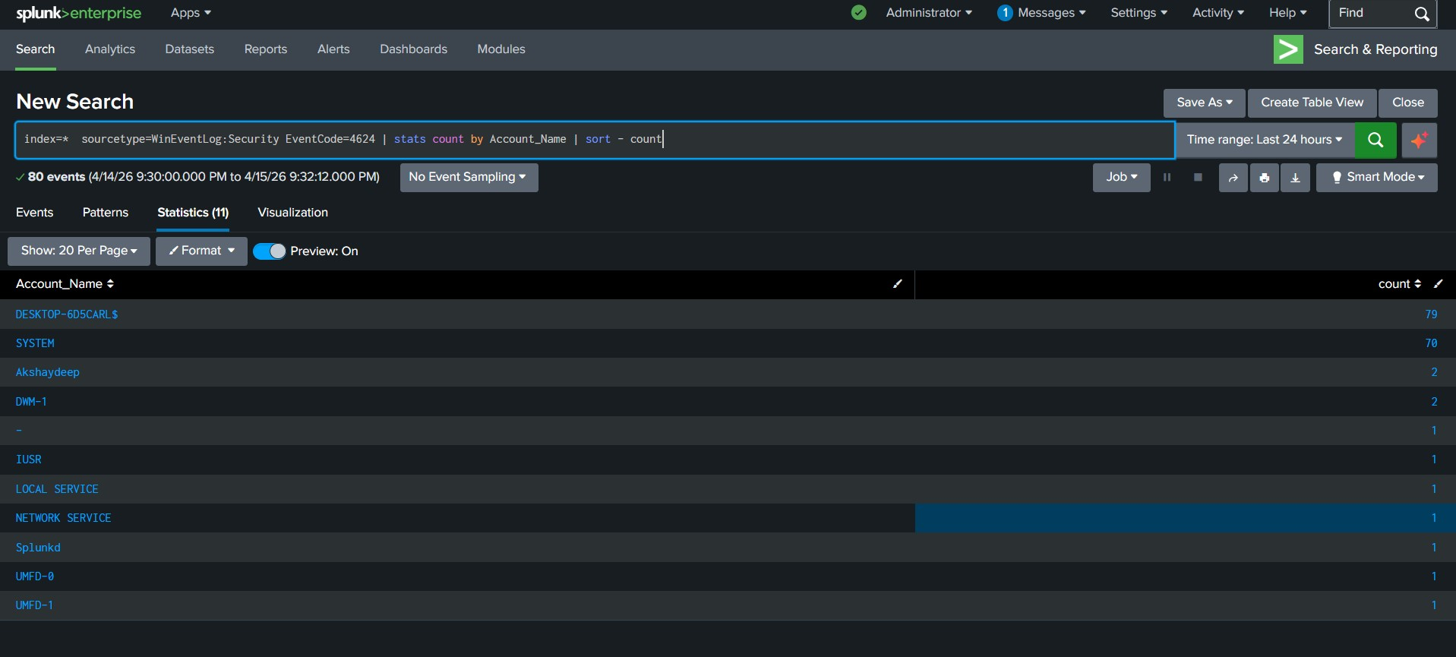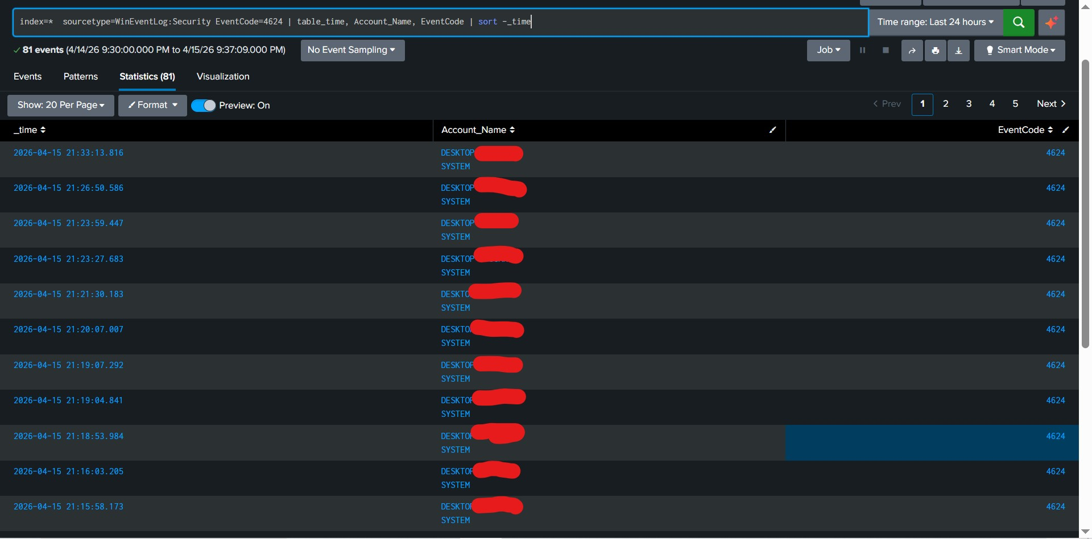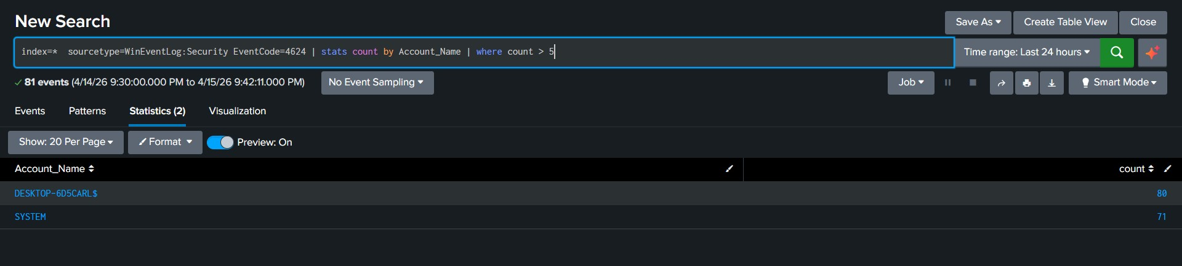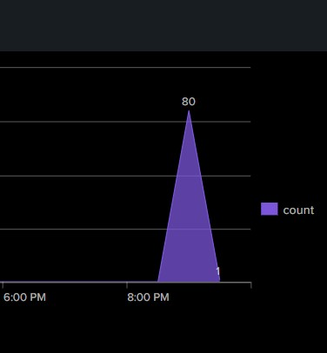
Conclusion
The system showed normal user behavior with no suspicious activity.
This practice helped in understanding how SOC analysts monitor logs and detect threats.

