**File Management in C**

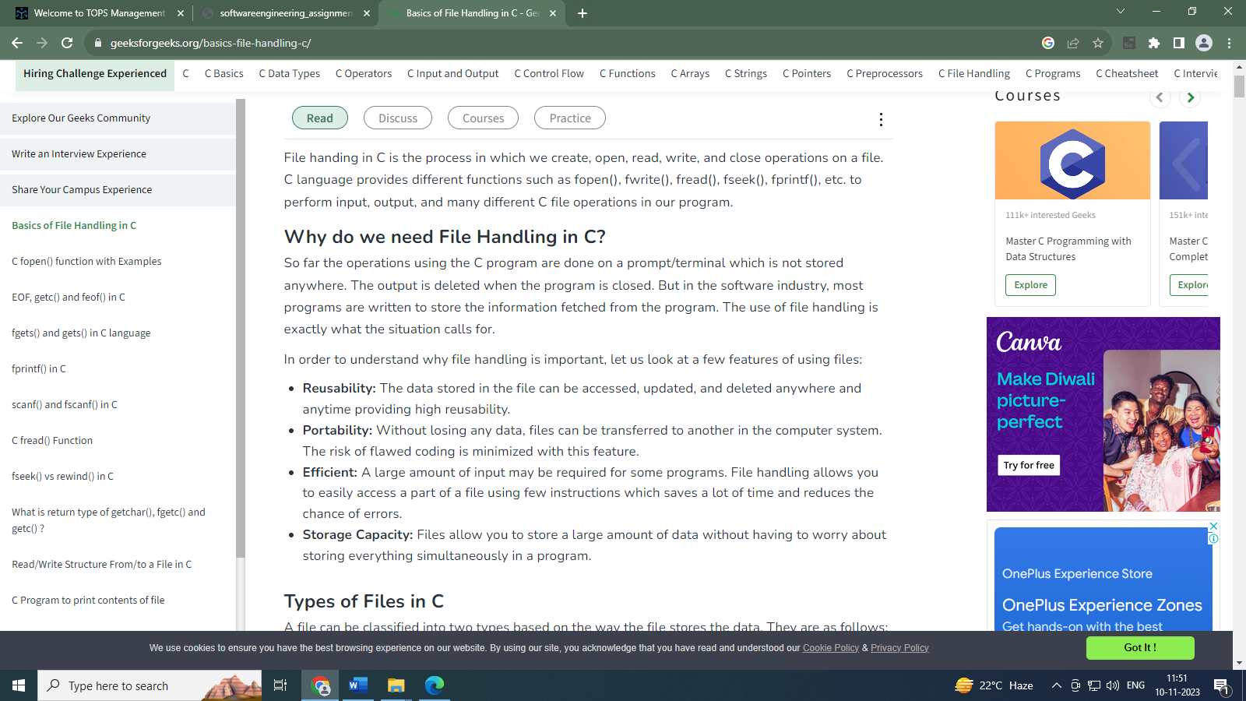

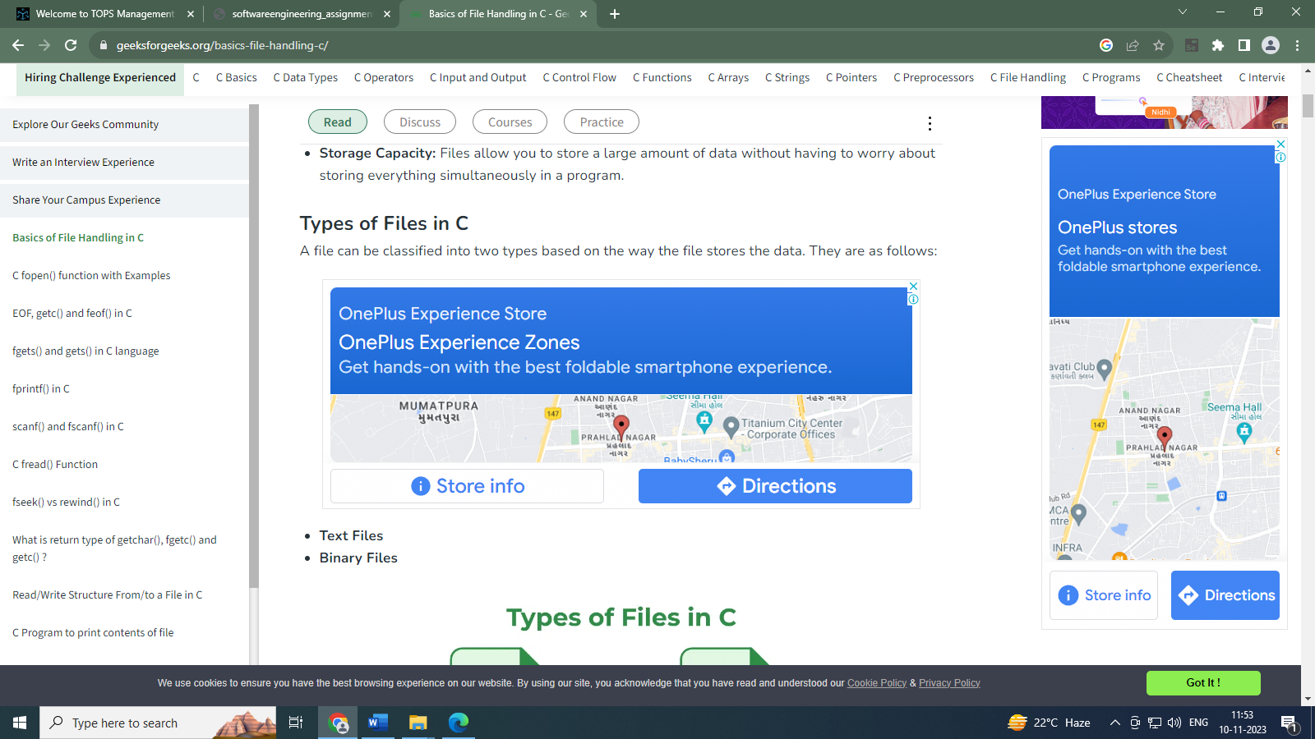

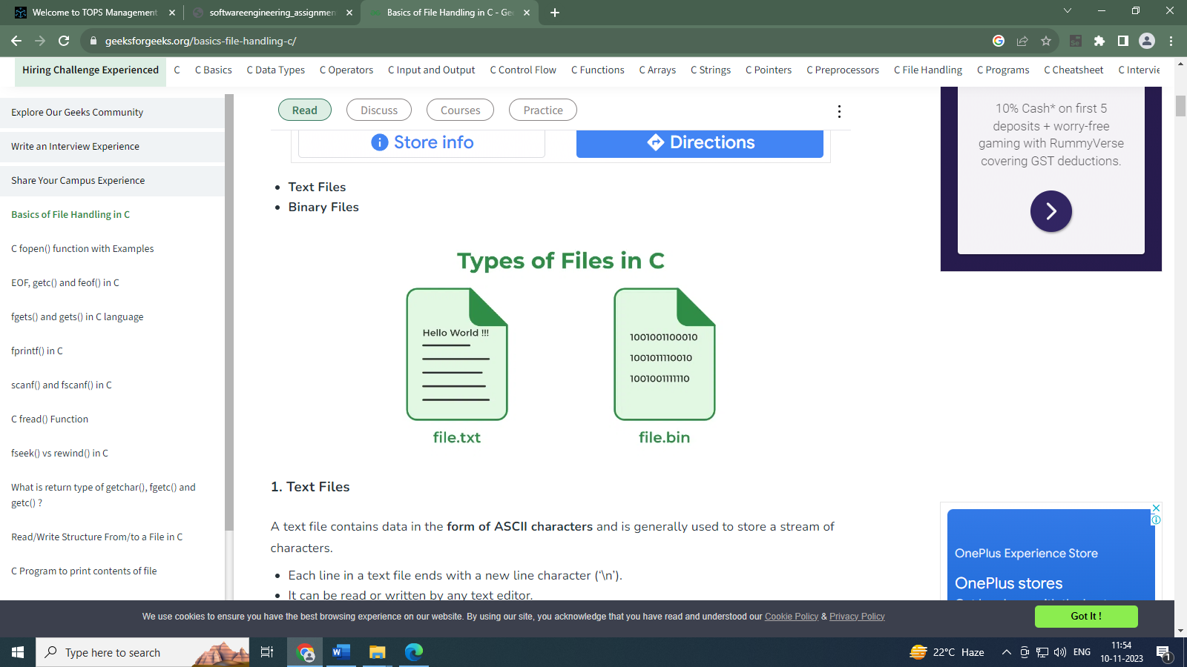

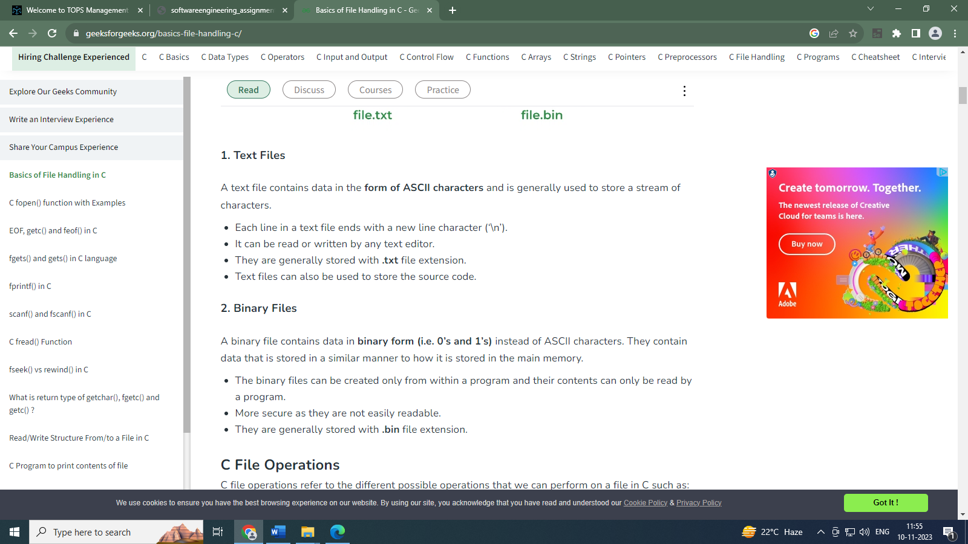

* C supports a number of functions that have the ability to perform basic file operations, which include:

1. Create a file

2. Open a file

3. Close a file

4. Read from a file

5. Write data into a file

* File operation functions in C:
* fscanf() - Reads a set of data values from a file
* getw() - Reads a integer from a file
* putw() - Writes an integer to the file
* fseek() - Sets the position to a desired point in the file
* ftell() - Gives the current position in the file
* rewind() - Sets the position to the begining of the file
* fopen() - Creates a new file for use Opens a new existing file for use
* fclose() - Closes a file which has been opened for use
* getc() - Reads a character from a file
* putc() - Writes a character to a file
* fprintf() - Writes a set of data values to a file
* **FILE POINTER:**
* FILE is a (hidden)structure that needs to be created for opening a file.
* A FILE ptr that points to this structure & is used to access the file.

**FILE *fptr;**

* **Opening a File:**

**FILE *fptr;**

**fptr = fopen("filename" , mode);**

* **Closing a File:**

**fclose(fptr);**

A file must be closed as soon as all operations on it have been completed. This would close the file associated with the file pointer.

* **FILE MODE:**

r – Opens a file in read mode and sets pointer to the first character in the file

w – Opens a file in write mode. It returns null if file could not be opened. If file exists, data are overwritten.

a – Opens a file in append mode. It returns null if file couldn’t be opened.

r+ – Opens a file for read and write mode and sets pointer to the first character in the file.

w+ – opens a file for read and write mode and sets pointer to the first character in the file.

a+ – Opens a file for read and write mode and sets pointer to the first character in the file. But it can’t modify existing contents.

FILE *p1 *p2;

p1=fopen (“Input.txt”, ”w”);

p2=fopen (“Output.txt”, ”r”);

….

…

fclose(p1);

fclose(p2);

opens two files and closes them after all operations on them are completed, once a file is closed its file pointer can be reversed on other file.

* **Opening a FILE :**

