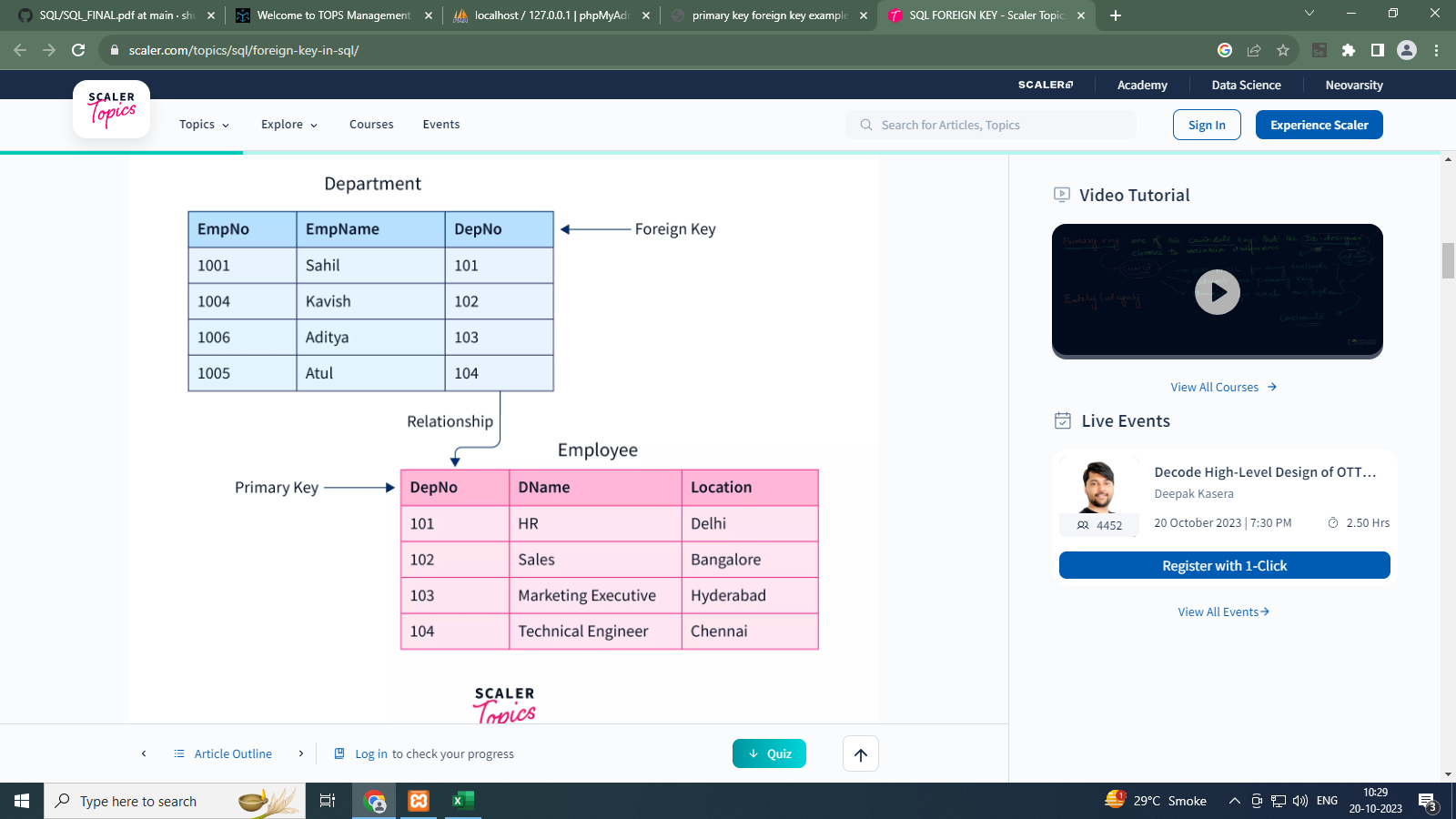

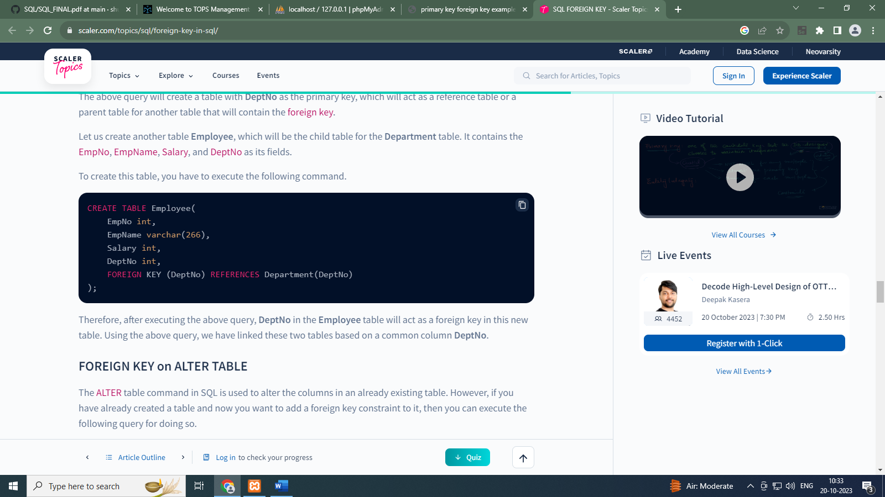

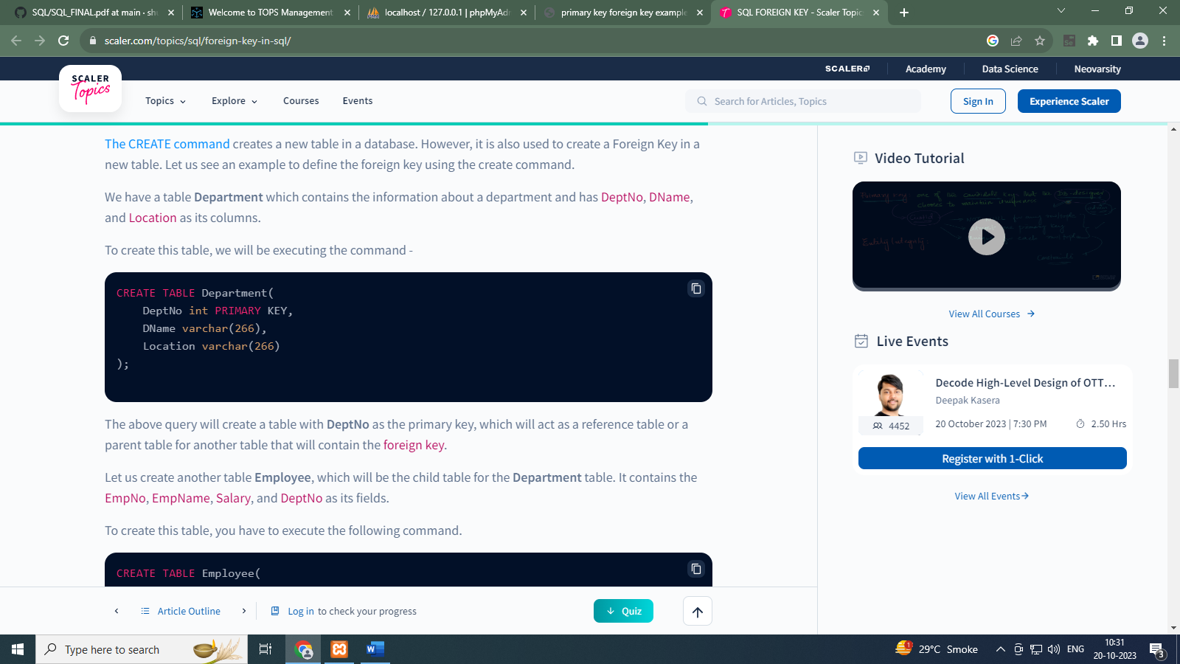

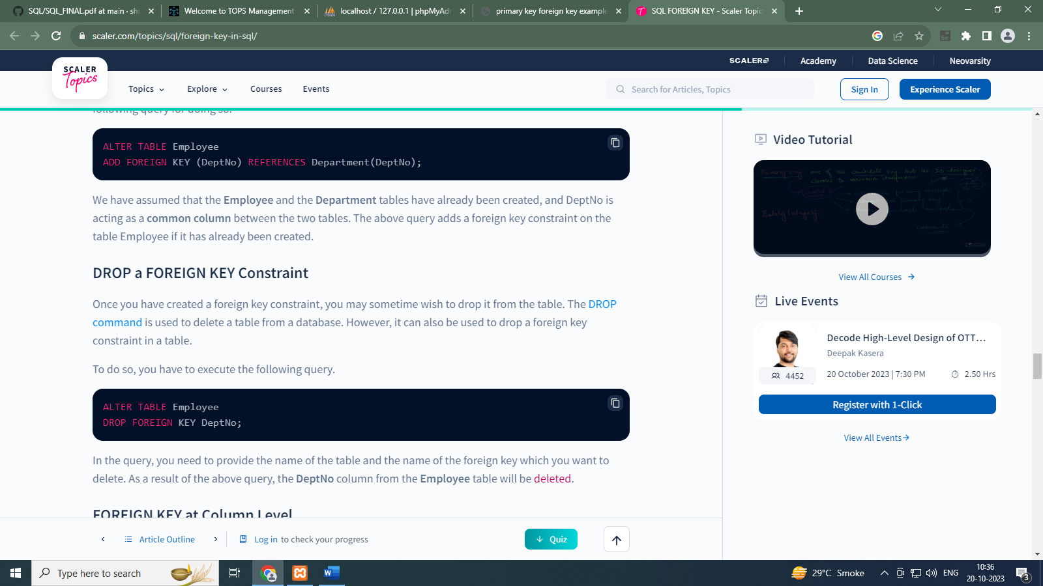



## FOREIGN KEY at Column Level

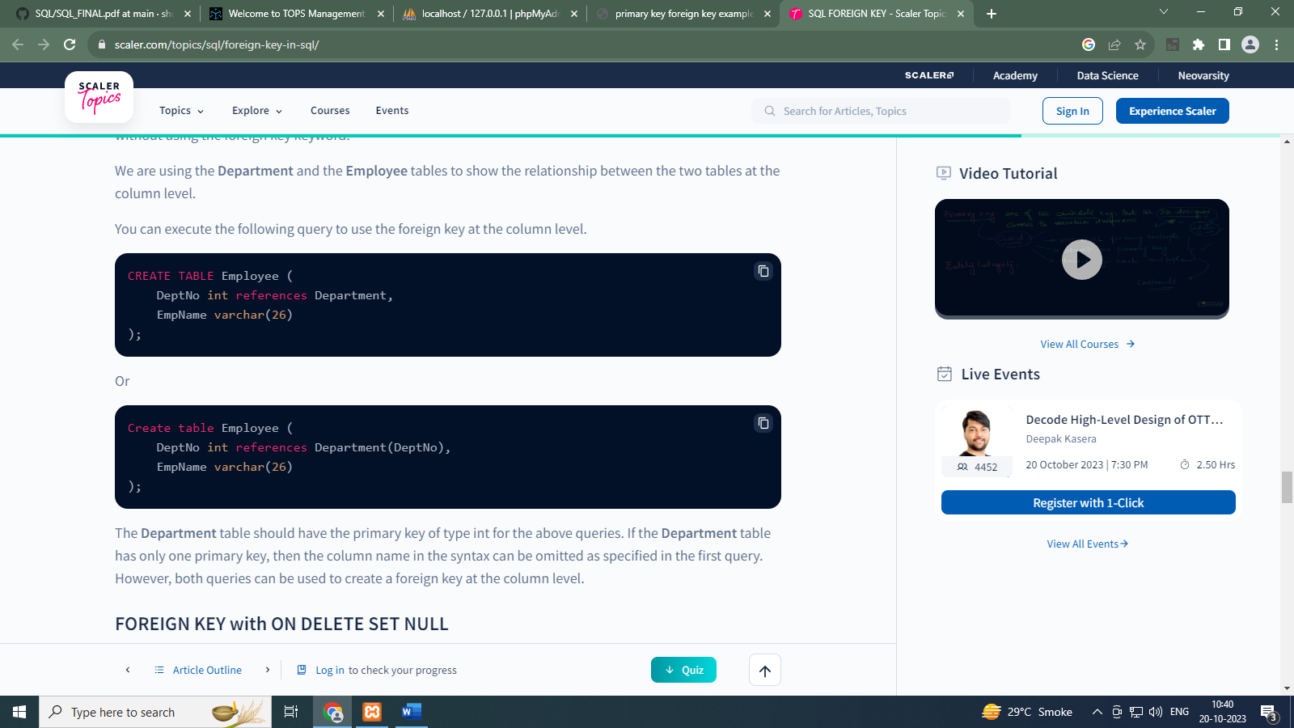

**INNER JOIN**

**SELECT** DepNo, DName, DName, EmpName **FROM** Department **INNER JOIN** Employee ON Department.Dno = Employee.DNo;

**LEFT OUTER JOIN**

**SELECT** DepNo, DName, DName, EmpName **FROM** Department **LEFT OUTER JOIN** Employee ON Department.Dno = Employee.DNo;

**RIGHT OUTER JOIN**

**SELECT** DepNo, DName, DName, EmpName **FROM** Department **RIGHT OUTER JOIN** Employee ON Department.Dno = Employee.DNo;