**Assignment-1 [Total Marks - 25]**

**M1: MLOps Foundations**

**Objective**: Understand the basics of MLOps and implement a simple CI/CD pipeline.

**Tasks**:

1. **Set Up a CI/CD Pipeline**:

• Use a CI/CD tool like GitHub Actions or GitLab CI to set up a pipeline for a sample machine learning project.

• Include stages for linting, testing, and deploying a simple machine learning model.

2. **Version Control**:

• Implement version control for your project using Git.

Here are the contributors for the git repository:

• Demonstrate branching, merging, and pull requests.

Here you can see that there are 3 branches:

1. feature/v0.1
2. main
3. origin/feature/v0.1.1

Team members are contributing to the branches as per their scope of work

For merging and pull request <Gaurav> to raise PR and ask someone to approve.

**Deliverables**:

• A report detailing the CI/CD pipeline stages.

• Screenshots or logs showing successful runs of the pipeline.

• A Git repository link with branches and merge history.

**M2: Process and Tooling**

**Objective**: Gain hands-on experience with popular MLOps tools and understand the processes they support.

**Tasks**:

1. **Experiment Tracking**:

• Use MLflow to track experiments for a machine learning project.

• Record metrics, parameters, and results of at least three different model training runs.

2. **Data Versioning**:

• Use DVC (Data Version Control) to version control a dataset used in your project.

• Show how to revert to a previous version of the dataset.

**Deliverables**:

• MLflow experiment logs with different runs and their results.

• A DVC repository showing different versions of the dataset.

**M3: Model Experimentation and Packaging**

**Objective**: Train a machine learning model, perform hyperparameter tuning, and package the model for deployment.

**Tasks**:

1. **Hyperparameter Tuning**:

• Use a library like Optuna or Scikit-learn’s GridSearchCV to perform hyperparameter tuning on a chosen model.

• Document the tuning process and the best parameters found.

2. **Model Packaging**:

• Package the best-performing model using tools like Docker and Flask.

• Create a Dockerfile and a simple Flask application to serve the model.

These are the screen shot which shows docker build. In the screen shot below docker build -t shuklagauravjn/ml-ops-group44-v-01:latest .

Leads to building of docker container.

Once the docker container is built, it’s visible in docker desktop on mac.

The screen shot below shows the docker image and possible vulnerabilities.

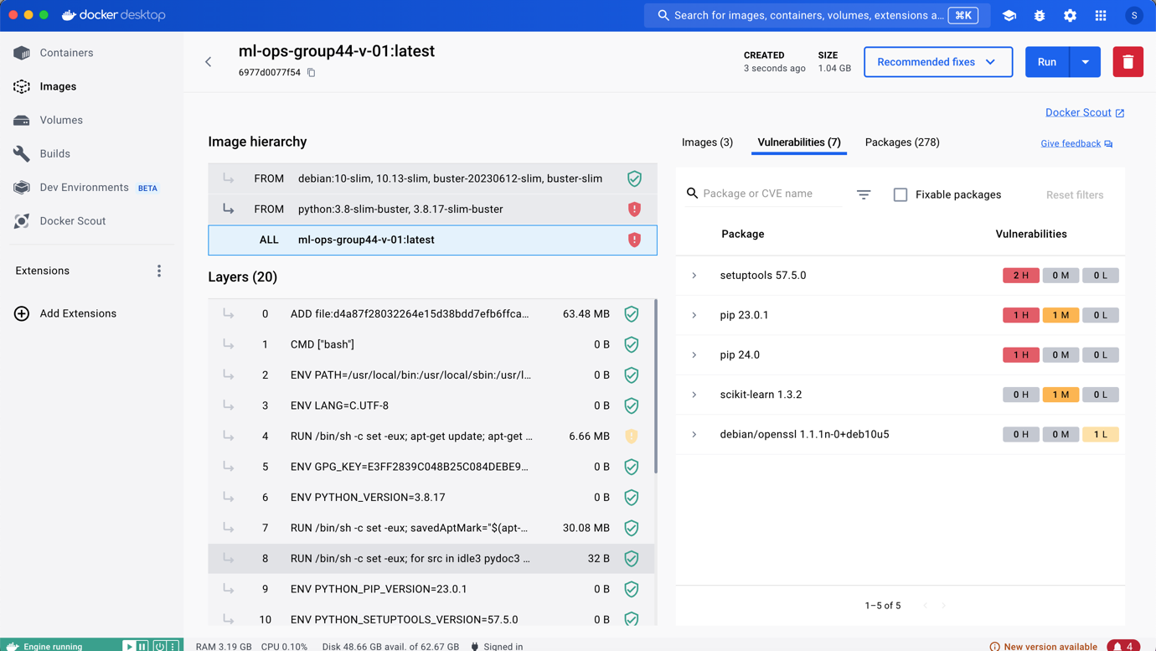

Later this docker image was pushed to docker hub using the following command:

docker login -u "shuklagauravjn" -p "XSDSDwewe#" docker.io

docker push shuklagauravjn/ml-ops-group44-v-01:latest

So it can be seen in hub.docker.com

**Deliverables**:

• A report on hyperparameter tuning results.

• A Dockerfile and Flask application code.

• Screenshots of the model running in a Docker container.

**M4: Model Deployment & Orchestration (Optional)**

**Objective**: Deploy a machine learning model and orchestrate its operations using Kubernetes.

**Tasks**:

1. **Model Deployment**:

• Deploy the Dockerized model from M3 to a cloud platform like AWS, Azure, or GCP.

• Use a platform service like AWS ECS, Azure AKS, or Google Kubernetes Engine (GKE).

2. **Orchestration**:

• Set up a Kubernetes cluster.

For local mac following things were done:

brew install minikube

minikube start

kubectl create deployment ml-ops-group44-v-01 --image=shuklagauravjn/ml-ops-group44-v-01:latest

kubectl expose deployment ml-ops-group44-v-01 --type=NodePort --port=8080

kubectl get services ml-ops-group44-v-01

minikube service ml-ops-group44-v-01

• Deploy the model using Kubernetes and create a Helm chart for managing deployments.

**Deliverables**:

• A link to the deployed model endpoint.

• Kubernetes configuration files and Helm chart.

• A report detailing the deployment and orchestration process.

**M5: Final Deliverables**

• A zip file containing:

• Code

• Data

• Model

• A one-page summary that includes:

• Description of the work completed

• Justification for the choices made

• A screen recording (maximum 5 minutes) that:

* Explains the work done
* Shows the results