**FOLLOWING REPORTS** do not have the ability to run reports branch-wise:

* Transaction report
* Discharged patients
* Expiry medicine
* Blood issue report
* TPA report
* Income group
* Expense group
* Payroll month report
* Payroll report
* Staff attendance
* User log
* Patient Login credentials
* Email/SMS log
* Inventory stock report

**Include diagnosis in the IPD and OPD reports

We will look into it and all the reports will be branch wise.

Note:: adding diagnosis in IPD and OPD reports will be chargeable and will take around 8 hours.

**DOCTORS PORTAL**

Include a field for Doctors to recommend pathology/radiology tests – this will be a drop down that will be pulled from the overall list of pathology tests/Radiology tests. (note: this is the only information that the Pathologist/Radiologist will be able to view from the Doctor).

The doctor should then be able to view the test results when reviewing the patient data after the test is complete

Referring patients detail to any other internal systems (doctor, pathology or radiology) is not supported by our system as HMS systems doesn’t work like this.

**ICD classification of diseases**. This hasn’t been implemented. See link as discussed in the last meeting below for reference:

<https://icd.who.int/browse10/2019/en>

This can be added to our system but it will be billable and it will take around 16 hours (It needs to be check if we have any API for this or we need to create a complete system) which includes type of disease in one dropdown and then name of disease on another dropdown.

**PATHOLOGIST PORTAL**

Include ability to import pathology tests. (similar to the way we are able to ‘import medicine’ under the pharmacy tab). **see snap shot from pharmacy below for reference:

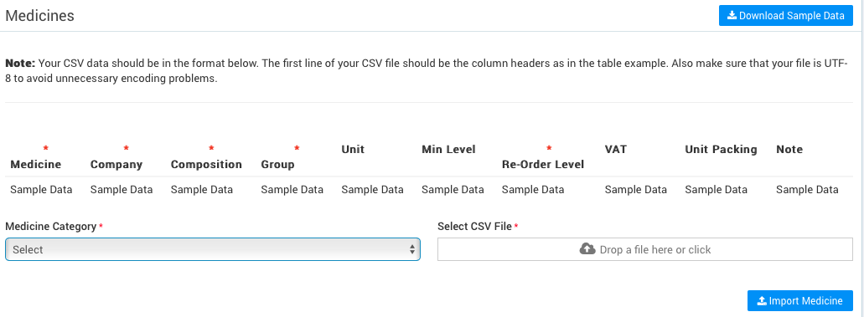

Under Pathology test report, include the following fields:

* Investigation range
* Sample request

** see excel insert below



Pathologists should be able to view list of patients recommended for tests by the Doctor (entry should be marked complete once the lab test is concluded)

As explained above referral system doesn’t work in HMS.

Pathology test results should be entered into the test report tab in the system (not just as an attachment). Therefore, make the following adjustments:

* Change Description to Test result and Description
* Include new field: Normal range(this will be pulled from the Pathology test report – see yellow highlight above)
* Include new field: Test done by

These changes can be done and CSV upload is possible but it will be billable and take around 8 hours for both.

**RADIOLOGIST PORTAL**

Include ability to import radiology tests. (similar to the way we are able to ‘import medicine’ under the pharmacy tab)

Radiologists should be able to view list of patients recommended for tests by the Doctor (entry should be marked complete once the lab test is concluded)

CSV upload is possible and it will take around 4 hours.

**PHARMACISTS PORTAL**

Pharmacists should be able to view the prescription from the Doctor for each patient, based on this, he can issue medication

Some permissions needs to be given to this role.

**NURSE:** Didn’t see any field for nurses to enter the reports in IPD and OPD

Same as the above some permissions needs to be given to this role.

**General:**

* Where can we change the landing page for the site?
* What is the difference between private and protected in the calendar?

In which section?

* Can we have the message icon show a notification when there is an unread message (similar to how the notification comes up on the TASK icon)

No as we are not working on messages.

* Provide details of the patient portal for testing

<http://myprojectdemonstration.com/development1/wehms/>

username: pat1

password: b1k0cy

* Manual prescription seems not to work well – confirm

Manual prescription is an editor where doctor can put some comments on it. Which is working fine.

* How is the patient ID assigned?

It’s auto generated starting from 1001.

* Demonstrate below:
* 

You can check it by login the patient’s portal.

* Confirm staff can be added branch-wise

Yes staff can be added branch-wise.

* Under finance – both income and expense appear not to be working well. Does not add up to the summary on the banner

It’s working fine.

* Also, the summaries on income banner appear not to be adding up – need demonstration on this

It’s working.

* Confirm the graph below can show branch-wise details?

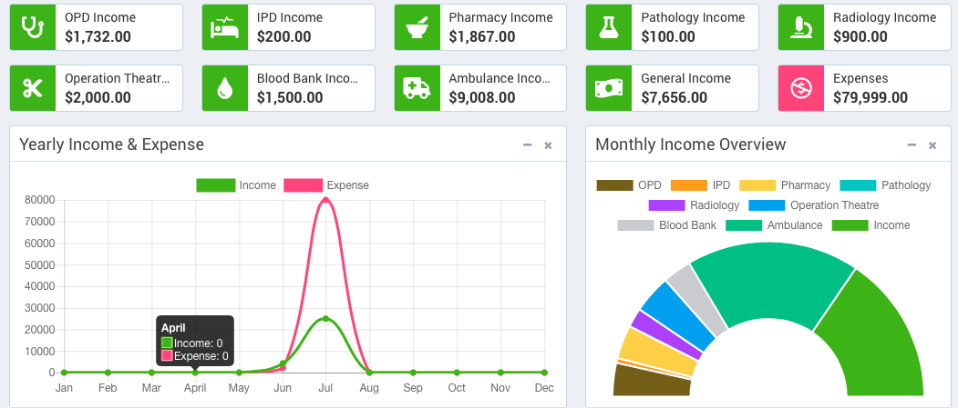

This includes combined report for all branches only.

* Confirm the snapshot below can changed?



This can be done.