Raise
PRD, User Flows, Journey Maps & Wireframes
Companion to the Raise product case study
Prepared by Himanshu Shukla
Live prototype: https://shuklahimanshu20.github.io/Raise_project/

Contents
Part A — PRD: Raise 3
1. Problem 3
2. User Persona 3
3. Success Metrics 3
4. User Stories 3
5. Acceptance Criteria 4
6. Test Cases 5
Part B — User Flows 8
Part C — User Journey Maps 10
Part D — Wireframes of Key Screens 13
Part E — Notes on Key Design Decisions 16

Conventions
[NEEDS INPUT: …] marks a gap to fill. [TARGET NEEDED] marks a metric target with no data yet. Personas and journeys are illustrative. Screens and behaviour marked “as built” were verified from the live prototype’s source.

Part A — PRD: Raise
Six sections in fixed order. Every number not taken from the build is flagged.

1. Problem
Parents of 14–19-year-olds want to talk with their teens about money, relationships, puberty, consent, online safety and pornography, but most were never taught these conversations and lack the words to begin. Talks are postponed, avoided, or happen once as a lecture after something has gone wrong. Teens learn from friends, the internet and pornography instead, and stop seeing their parent as a safe person to go to.
Product response: a five-minute, topic-specific preparation guide; the talk happens offline in the parent’s words; a two-minute reflection sets up the next talk. Research and sources are in the main case study, Section 4.

2. User Persona
Primary user: a parent aged 35–60 of a teen aged 14–19. The parent is the only user; the teen never sees the app. Launch geography: [NEEDS INPUT].
Illustrative personas (not based on research), detailed in the main case study: Sunita, 44, wordless but willing (daughter 15); Rajesh, 52, repairing after a bad attempt (son 18); Farah, 38, time-poor solo parent (son 14).

3. Success Metrics
Type | Metric | Target
North Star | Completed Conversations per month (prepared + time-gated “I’ve had it” + detailed reflection within 7 days) | [TARGET NEEDED]
Core rate | Completed Conversation Rate = CCs ÷ guides finished | [TARGET NEEDED]
Leading | Prep → Talk within 72 hours | [TARGET NEEDED]
Leading | Prep completion (start → Ready step) | [TARGET NEEDED]
Leading | Next-talk start within its window | [TARGET NEEDED]
Guardrail | Escalation miss rate (audit) | 0 — any miss is an incident
Guardrail | Repeated-stall rate; “teen got upset” reports; time in app per CC | [TARGET NEEDED]

4. User Stories
ID | Theme | Story
US1 | Onboarding | As a parent, I want to create an account and tell Raise my teen’s age band (and optionally their name), so that the guidance fits my teen.
US2 | Choose topic | As a parent, I want to pick one of six topics, so that I prepare for the talk I’ve been putting off.
US3 | Name the hard part | As a parent, I want to say what feels hardest about this talk, so that the advice tackles my actual fear.
US4 | Understand | As a parent, I want three short points on what matters for this topic, so that I feel informed without reading an article.
US5 | Start | As a parent, I want to choose one of three first sentences, so that I know exactly how to open.
US6 | Anticipate | As a parent, I want to see what my teen might say and think of my answer before seeing a calm response, so that I don’t freeze.
US7 | Avoid | As a parent, I want to know the common mistakes for this topic, so that I don’t shut the talk down.
US8 | Pocket card | As a parent, I want a one-screen summary to glance at before and during the talk, so that I have a cue, not a script.
US9 | Save for later | As a parent who isn’t ready tonight, I want to save the prep, so that I can come back to it.
US10 | Reflect | As a parent, I want to record how it went in under two minutes, so that I learn from it.
US11 | Next talk | As a parent, I want Raise to tell me what to talk about next and when, so that one talk becomes many.
US12 | Safety | As a parent whose teen disclosed something serious, I want clear next steps and the right helpline, so that I get my teen real help.
US13 | Journal | As a parent, I want a private history of our talks, so that I can see progress across topics.
Consider also (flagged for review, not assumed in scope): a second parent preparing for the same teen; a parent with two teens of different ages; a parent who wants to delete all data.

5. Acceptance Criteria
Story | Criteria (Given / When / Then)
US1 | AC1.1 Given the sign-up screen, when name, valid email, username (≥ 3 characters), password (≥ 8) and a matching confirmation are entered, then the account is created and the teen screen opens.  AC1.2 Given any invalid field, when “Create account” is tapped, then that field is outlined in red and one plain-language error is shown.  AC1.3 Given the teen screen, when no age band is chosen, then Continue is disabled. Teen name is optional.  AC1.4 Given the teen screen, the age bands shown are 14–15, 16–17 and 18–19. [Change from build: currently 11–13, 14–15, 16–18]
US2 | AC2.1 Given the topic screen, six topics are shown with a one-line description each.  AC2.2 Given no topic is selected, Continue is disabled; given one is selected, it is visibly marked.
US3 | AC3.1 Given the difficulty screen, five difficulties are shown; the parent can pick one.  AC3.2 Given a difficulty is chosen, when the guide opens, the Start step shows the tip for that difficulty labelled “Because you said: …”.
US4 | AC4.1 Given step 1 (Understand), the guide shows the parent’s real goal (with the teen’s name, or “your teen”) and three numbered points for the topic.  AC4.2 A progress bar shows step 1 of 5 and minutes left.
US5 | AC5.1 Given step 2 (Start), three openers are shown; tapping one selects it and deselects the others.  AC5.2 Given no opener is chosen by the Ready step, the pocket card uses the first opener.
US6 | AC6.1 Given step 3 (Anticipate), three teen questions are shown with responses hidden.  AC6.2 When the parent taps a question, its calm response is revealed; tapping again hides it.
US7 | AC7.1 Given step 4 (Avoid), three mistakes with a reason each are shown, plus a “listen more than you talk” note.
US8 | AC8.1 Given step 5 (Ready), the plan shows the chosen opener, one thing to remember and what to say if stuck, plus a four-item checklist.  AC8.2 Given the Go-talk screen, the pocket card shows opener, remember, avoid and if-stuck, and states that Raise does not listen, record or contact the teen.
US9 | AC9.1 When “Not yet — save for later” is tapped, Home shows the talk as pending at the Talk stage with a way back into the pocket card.
US10 | AC10.1 Given the Reflect screen, Save is disabled until one of three outcomes is chosen.  AC10.2 Any number of the eight chips can be toggled; the note is optional.  AC10.3 When saved, an entry with topic, outcome, chips, note and date is added to the journal.
US11 | AC11.1 Given outcome “Went well”, the next talk is the linked topic, “in about a week”.  AC11.2 Given “Stalled”, the next talk is the same topic, “in 3–4 days”, with a lighter approach.  AC11.3 Given “Something unexpected”, the next talk is the same topic “within 48 hours”, focused on answering questions.  AC11.4 “Prepare next talk” opens a new guide for that topic and difficulty.
US12 | AC12.1 Given a reflection note matching an escalation rule (Level 2 or 3), when saved, the insight screen shows the matching safety card first, with helpline numbers as tap-to-call links. [Not built]  AC12.2 Given a Level 3 match, no conversation script or next-talk prep is suggested for that topic until the parent dismisses the card.  AC12.3 Given a note with no match, the normal insight is shown.
US13 | AC13.1 Given the Journal, every saved talk shows topic, date, outcome, chips and note, newest first.  AC13.2 Home shows talks had and topics covered out of six.  AC13.3 Journal entries persist after the app is closed. [Not built — prototype resets on reload]

6. Test Cases
TC6, TC20 and TC23 fail on the current prototype by design — they test V1 work not yet built.
ID | Maps to | Test | Input / steps | Expected result
TC1 | AC1.1 | Sign up with valid details | Arjun / arjun@example.com / arjun.k / Passw0rd! twice | Teen screen opens
TC2 | AC1.2 | Password too short | Password “abc” | Red outline; “Passwords need at least 8 characters.”
TC3 | AC1.2 | Passwords don’t match | Two different passwords | “The two passwords don’t match.”
TC4 | AC1.2 | Invalid email | “arjun@” | “Please enter a valid email address.”
TC5 | AC1.3 | No age band | Tap Continue with none chosen | Nothing happens; button faded
TC6 | AC1.4 | Age bands match target | Open teen screen | Shows 14–15, 16–17, 18–19 (fails on current build)
TC7 | AC2.2 | Topic required | Continue with no topic | Disabled
TC8 | AC3.2 | Difficulty drives tip | Choose “I tried before and it went badly” | Start step shows “Repair first, then restart”
TC9 | AC4.1 | Name personalisation | Teen name blank | Copy reads “your teen”, never blank
TC10 | AC5.1 | Single opener selection | Tap opener 1 then 2 | Only opener 2 selected
TC11 | AC5.2 | Default opener | Skip choosing an opener | Pocket card shows opener 1
TC12 | AC6.2 | Reveal and hide | Tap a teen question twice | Response shown, then hidden
TC13 | AC8.2 | Offline promise | Open Go-talk | Text says Raise doesn’t listen, record or contact the teen
TC14 | AC9.1 | Save for later | Tap “Not yet” | Home stage = Talk; pending card shown
TC15 | AC10.1 | Outcome required | Tap Save with no outcome | Disabled
TC16 | AC10.3 | Journal entry | Save “Went well” + “We laughed” | Entry at top of Journal with chips
TC17 | AC11.1 | Next after well | Online safety → Went well | Next: Consent, “In about a week”
TC18 | AC11.2 | Next after stall + embarrassed | Money → Stalled + “Got embarrassed” | Next: Money, 3–4 days, difficulty “awkward”
TC19 | AC11.3 | Next after unexpected | Puberty → Unexpected | Next: Puberty, within 48 h, difficulty “questions”
TC20 | AC12.1 | Grooming escalation | Note: “…someone claiming to be 16…” | Safety card with 1930 / cybercrime.gov.in, 1098 (fails on current build)
TC21 | AC12.2 | Self-harm escalation | Note: “…says he wants to die…” | Crisis card; no next-talk prep shown
TC22 | AC12.3 | No false escalation | Note: “We talked in the car about crushes.” | Normal insight
TC23 | AC13.3 | Persistence | Save a talk, reload | Talk still in Journal (fails on current build)
TC24 | AC10.1 | Edge: very long note | 2,000-character note | Saves; insight layout doesn’t break [NEEDS INPUT: max length]

Part B — User Flows
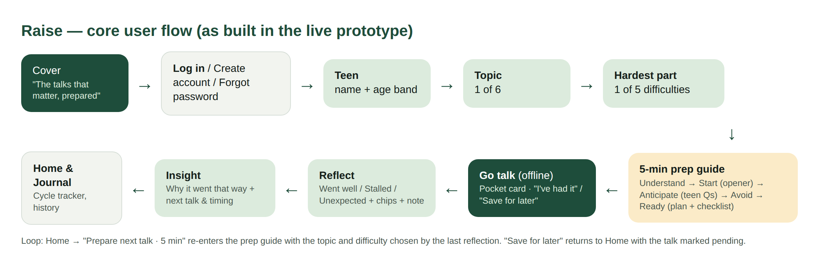
Figure B.1 — Core flow, as built in the live prototype

B.1 Onboarding and authentication
Step | Screen | Parent action | System response / branch
1 | Cover | Tap “Get started” | Opens Log in
2 | Log in | Enter username + password | Empty → error; short password → “doesn’t look right”; else Home
2a | Forgot password | Enter email | Invalid → error; valid → “check your inbox” state with resend
2b | Create account | Name, email, username, password ×2 | Field-level validation with strength meter → Teen screen
3 | Teen | Optional name; choose age band | Continue enabled once an age band is chosen

B.2 Prepare
Step | Screen | Parent action | System response / branch
4 | Topic | Pick one of six | Continue enabled
5 | Hardest part | Pick one of five difficulties | “Build my 5-minute guide” → short building state
6 | Prep 1 · Understand | Read goal + 3 points | Next: Start
7 | Prep 2 · Start | Read tip for their difficulty; choose opener | Next: Anticipate
8 | Prep 3 · Anticipate | Think, then tap to reveal calm responses | Next: Avoid
9 | Prep 4 · Avoid | Read 3 mistakes | Next: Ready
10 | Prep 5 · Ready | Review plan; tick checklist | “I’m ready — go talk”; × exits to Home at any step

B.3 Talk, reflect, next
Step | Screen | Parent action | System response / branch
11 | Go talk | Glance at pocket card; talk offline | “I’ve had the conversation” → Reflect; “Not yet” → Home (pending)
12 | Reflect | Outcome + chips + optional note | Save enabled once an outcome is chosen
12a | Escalation (V1, proposed) | Note matches a risk rule | Safety or crisis card before the insight
13 | Insight | Read why + next talk | “Prepare next talk · 5 min” → new guide; or back to Home
14 | Home / Journal | See cycle stage, counts, history | Bottom nav: Home, Topics, Journal

Part C — User Journey Maps
Illustrative journeys built on the illustrative personas and on the screens as built. Feelings are hypotheses to test in walkthroughs.

Journey 1 — Sunita: first talk about puberty with Ananya (15)
Difficulty chosen: “I don’t know how to start”
 | Trigger | Choose | Prepare | Talk | Reflect | Next
Doing | Finds a pad wrapper in the bin and realises she’s never explained anything | Opens Raise from a school WhatsApp card; picks Puberty | Reads the 3 points on the metro; picks “Nobody explained this to me, and I wish they had” | Says it on a walk to the market | Taps “Went well” + “We laughed” + “Asked something I couldn’t answer” | Gets “come back within 48 hours with what you found”
Thinking | “I should have done this two years ago.” | “Which one? All of them scare me.” | “That opener sounds like me.” | “She’s smiling. Keep it short.” | “I didn’t know about the doctor question.” | “I can actually do this again.”
Feeling | 😟 Guilty | 😐 Nervous | 🙂 Calmer | 😀 Relieved | 🙂 Proud | 😀 Confident
Pain point | No words in Hindi or English | Too many topics feel urgent | Worried about questions | Freezes on one question | — | Might forget to follow up
Opportunity | Shareable cards via schools | “Start with the easiest” hint | Anticipate step | Pocket card “if stuck” | Chip-based reflection | Reminder at chosen moment (V2)

Journey 2 — Rajesh: repairing after a bad attempt, money and relationships with Kabir (18)
Difficulty chosen: “I tried before and it went badly”
 | Trigger | Choose | Prepare | Talk | Reflect | Next
Doing | Kabir asks for money for a trading app; Rajesh remembers shouting last time | Picks Money; chooses “I tried before…” | Reads “Repair first, then restart”; picks the “money mistake at your age” opener | Opens with an apology for last time, then the story | Taps “Stalled” + “Changed the subject” | Next: Money again in 3–4 days with a lighter opener
Thinking | “If I say no, he’ll do it anyway.” | “Finally, an option that fits me.” | “Apologising to my son? Hmm.” | “He listened to the apology, then went to his room.” | “Did I fail again?” | “So a stall is normal.”
Feeling | 😠 Frustrated | 😐 Hopeful | 😕 Uneasy | 😐 Mixed | 😟 Discouraged | 🙂 Reassured
Pain point | Pride; generation gap | — | Apology feels like losing face | Son shuts down early | Reads stall as failure | Might give up
Opportunity | Money as an on-ramp topic | Difficulty-based paths | Explain why repair works | Ending early is fine (tip) | “You started. That matters.” headline | Shorter time limit next time

Journey 3 — Farah: online safety with Zaid (14) leads to an unexpected disclosure
Difficulty chosen: “They might get defensive”
 | Trigger | Choose | Prepare | Talk | Reflect | Next
Doing | Reads news about online scams targeting teens | Picks Online safety at 10 pm | Picks “if something online made you uncomfortable, you wouldn’t be in trouble” | Zaid says a friend is being messaged by someone “claiming to be 16” | Writes that in the note; taps “Something unexpected” | V1: safety card — 1930 / cybercrime.gov.in, 1098; keep evidence, don’t confront
Thinking | “Is he talking to strangers?” | “I don’t have time for a course.” | “I can promise that.” | “This is bigger than a talk.” | “What do I actually do now?” | “Okay, there’s a real next step.”
Feeling | 😟 Anxious | 😐 Tired | 🙂 Ready | 😨 Alarmed | 😟 Unsure | 🙂 Supported
Pain point | Fear from news | Late night, alone | Worry he’ll hide things | No guidance for disclosures | Prototype today only shows a normal insight | Needs a follow-up with Zaid
Opportunity | Calm framing, not fear | 5-minute promise | Safety-promise opener | Escalation rules | F10 safety card (V1) | Follow-up guide within 48 h

Part D — Wireframes of Key Screens
Captured from the live prototype (https://shuklahimanshu20.github.io/Raise_project/) at a 390 × 844 phone viewport, using sample data (parent Arjun, teen Maya). Each screen is annotated with its job and the key design choice.
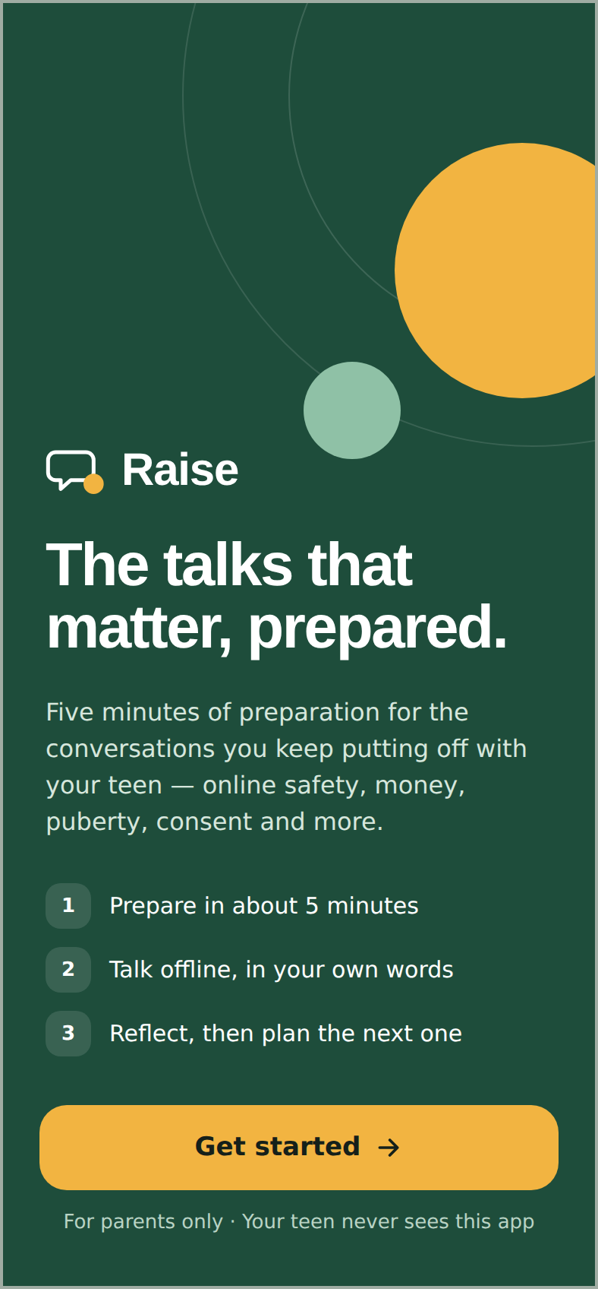 | Cover  Promise in one line; 3-step how-it-works; one gold primary action. “For parents only · Your teen never sees this app” sets trust up front. | 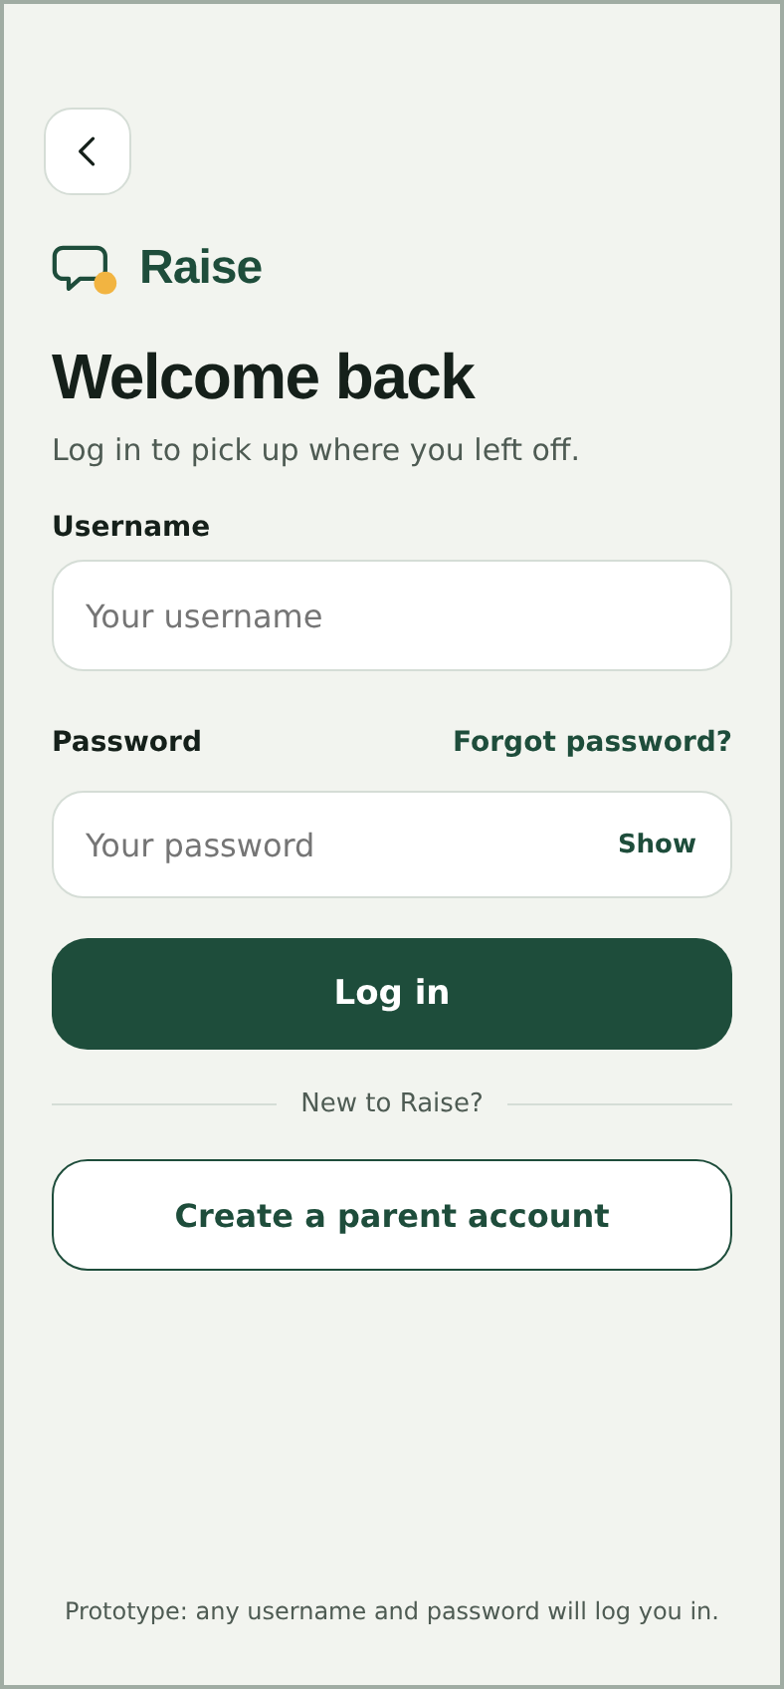 | Log in  Username + password, show/hide, inline errors, links to sign-up and forgot password. Prototype accepts any credentials.
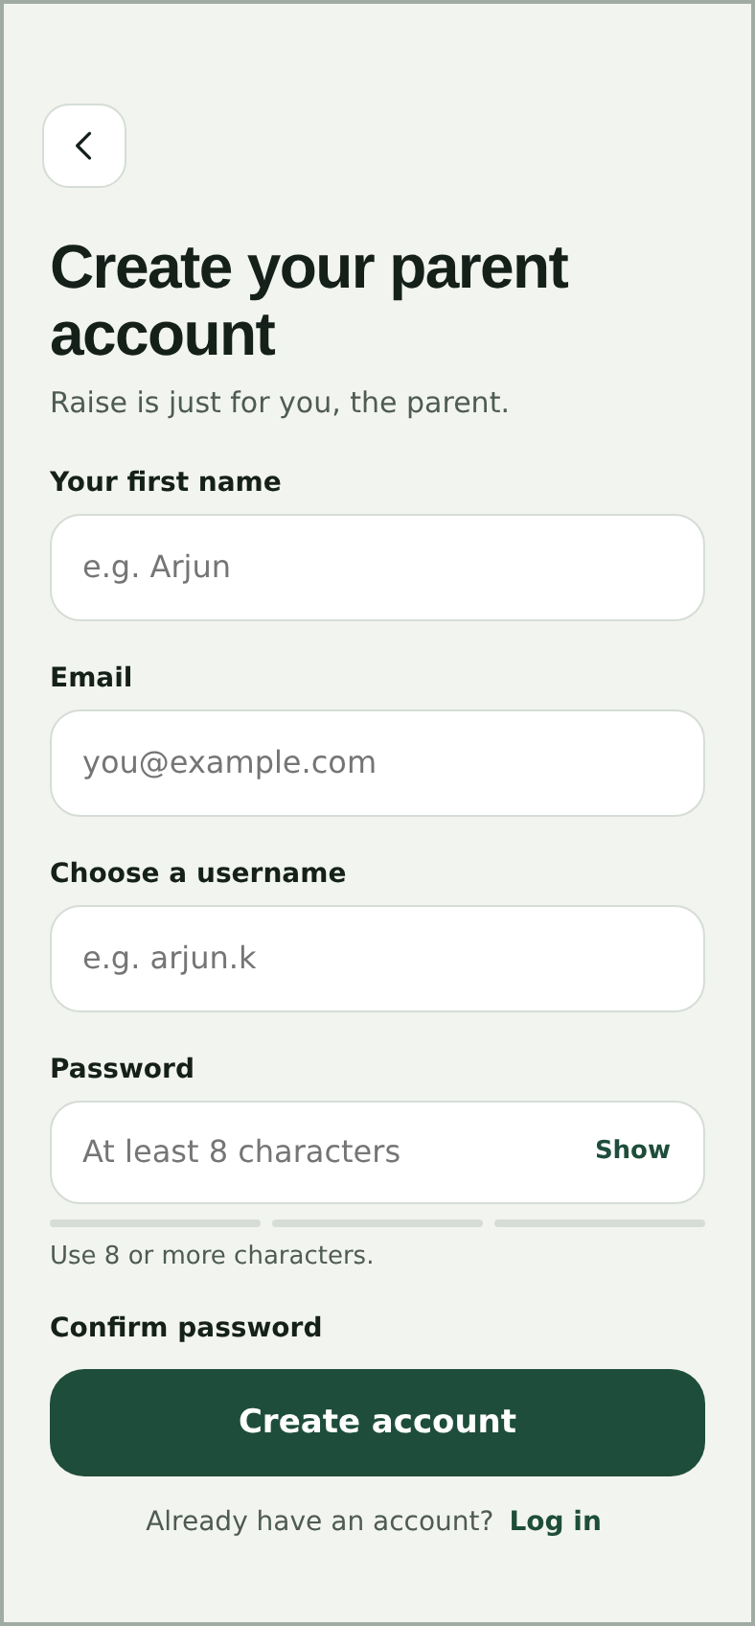 | Create account  “Raise is just for you, the parent.” Field-level validation; 3-bar password strength meter. | 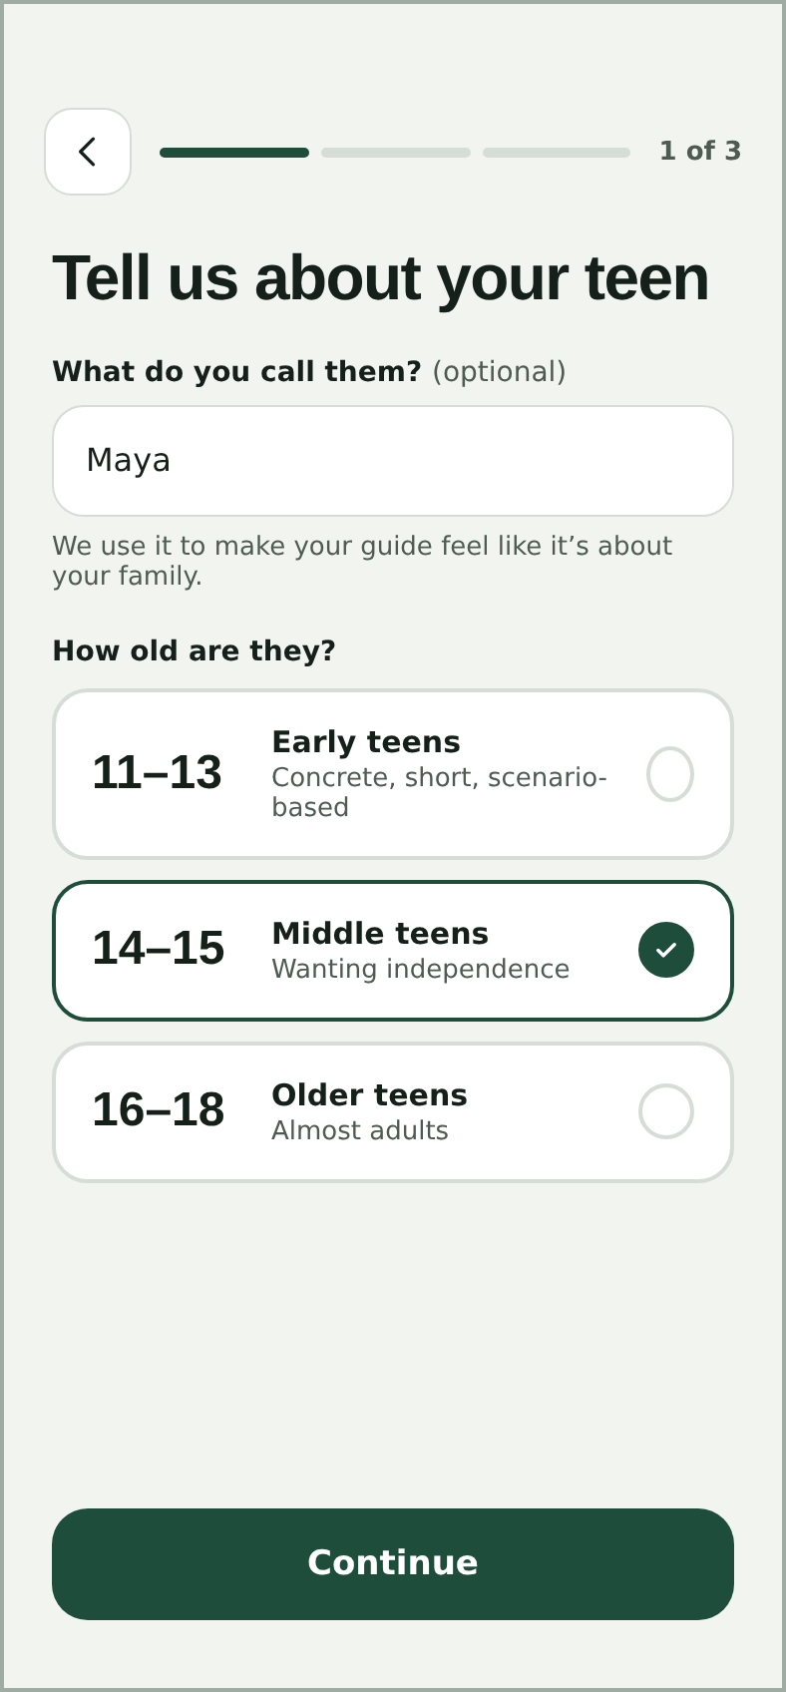 | Teen  Optional name personalises copy (“Maya”). Age band sets tone. Progress 1 of 3. Bands to change to 14–15 / 16–17 / 18–19.
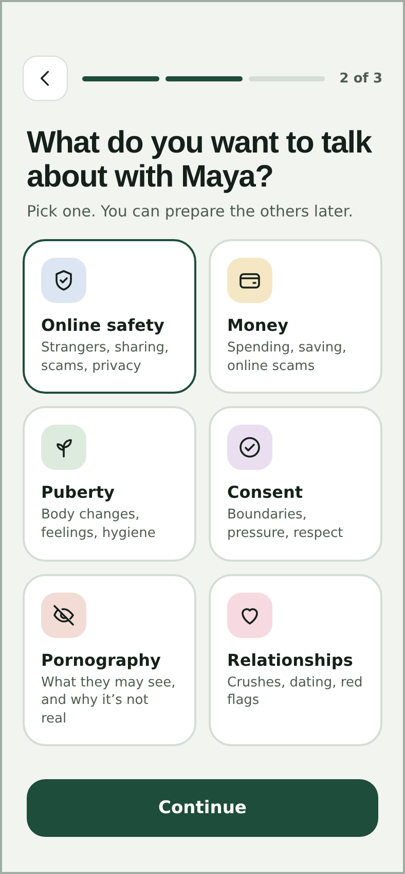 | Topic  Six tinted cards with an icon and one-line scope. “You can prepare the others later” lowers pressure to choose right. | 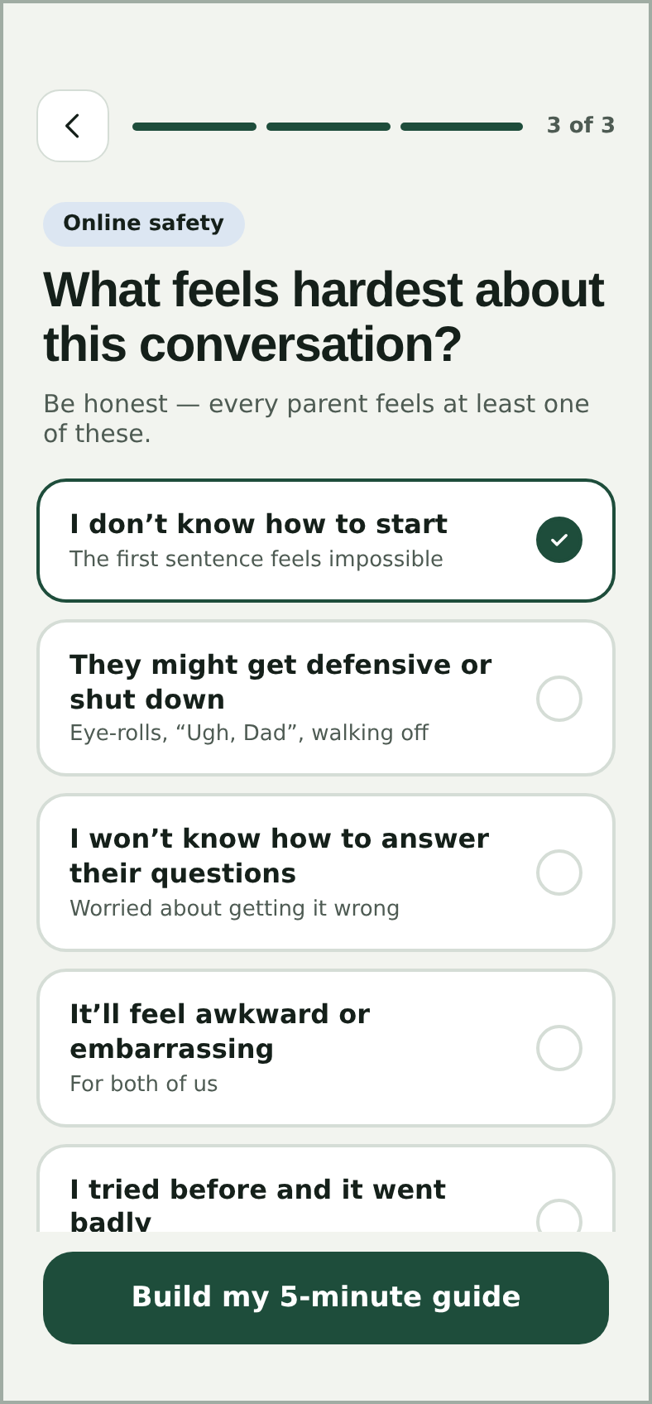 | Hardest part  “Be honest — every parent feels at least one of these.” Five options; this choice drives the Start tip.
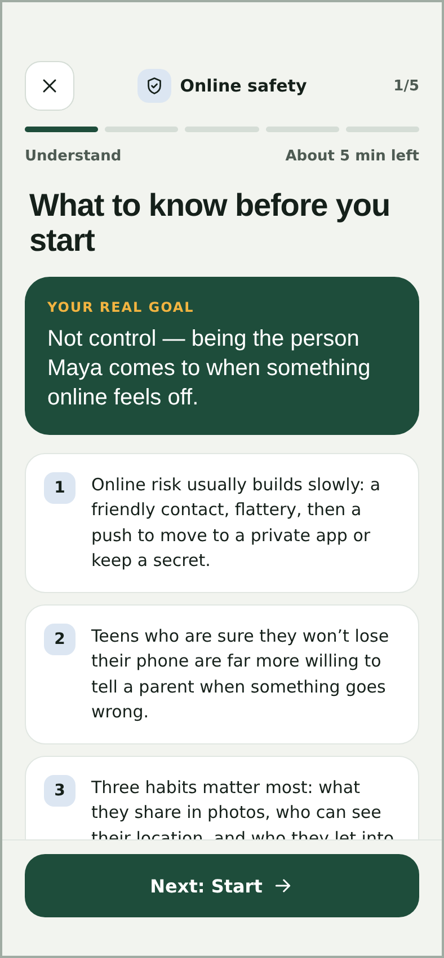 | Prep 1 · Understand  Goal reframed as trust (“the person Maya comes to”). Three numbered points. Step and minutes-left shown. | 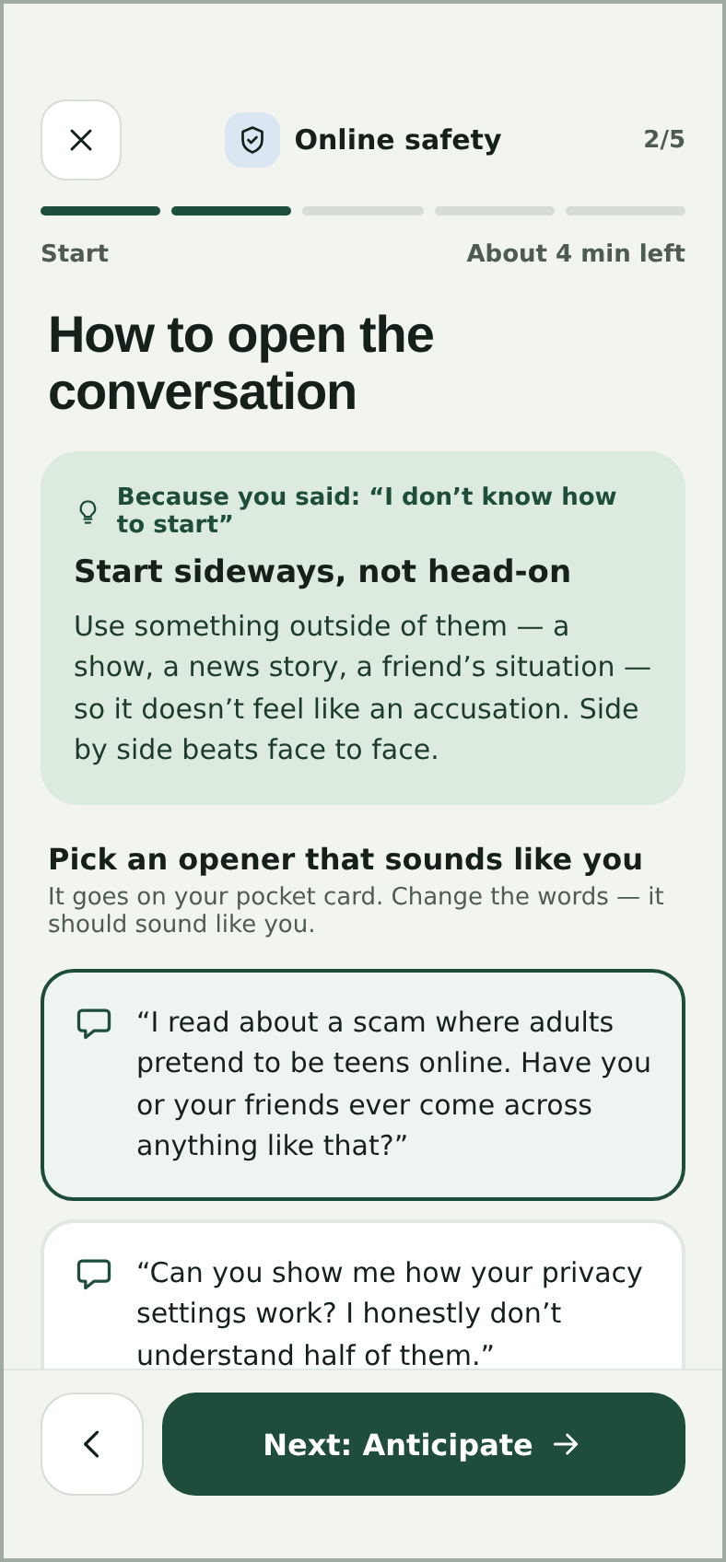 | Prep 2 · Start  “Because you said…” tip ties back to the difficulty. Three openers as selectable speech cards.
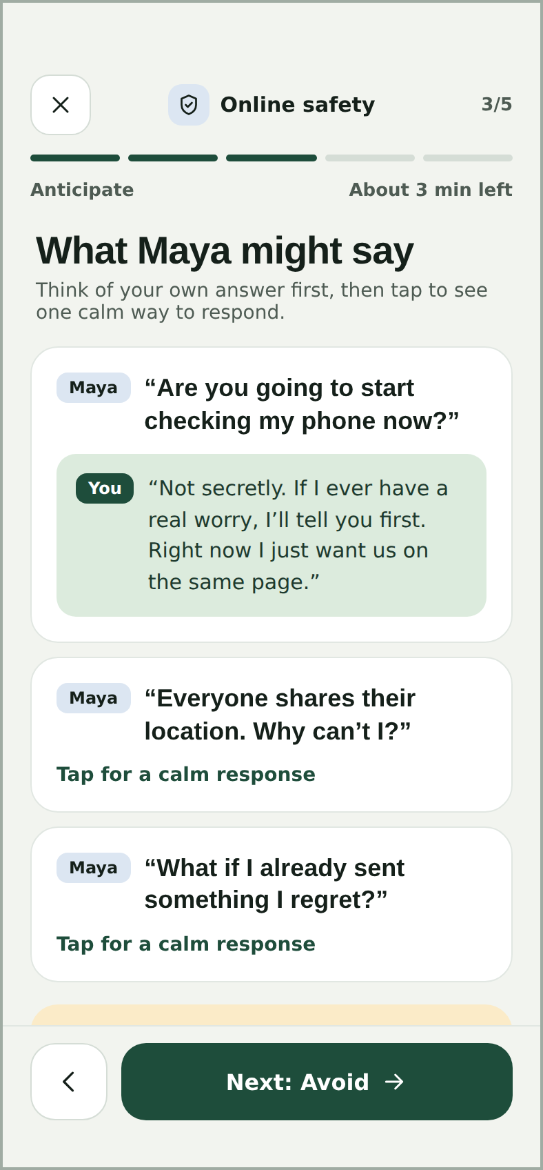 | Prep 3 · Anticipate  Teen lines in chat-style bubbles. “Think of your own answer first, then tap.” Builds the parent’s own words. | 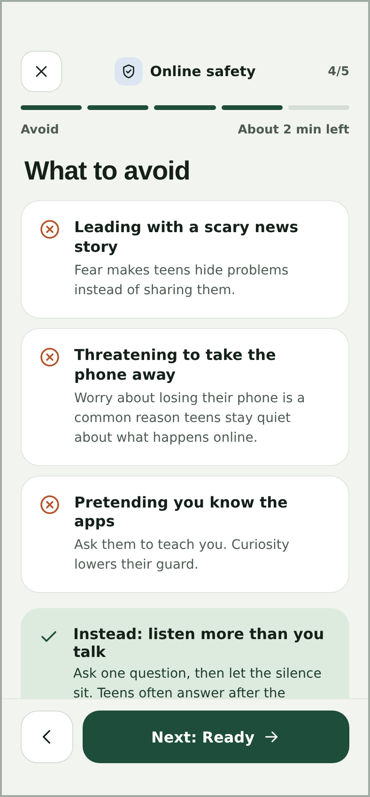 | Prep 4 · Avoid  Three mistakes with a reason each; ends on a positive “Instead: listen more than you talk”.
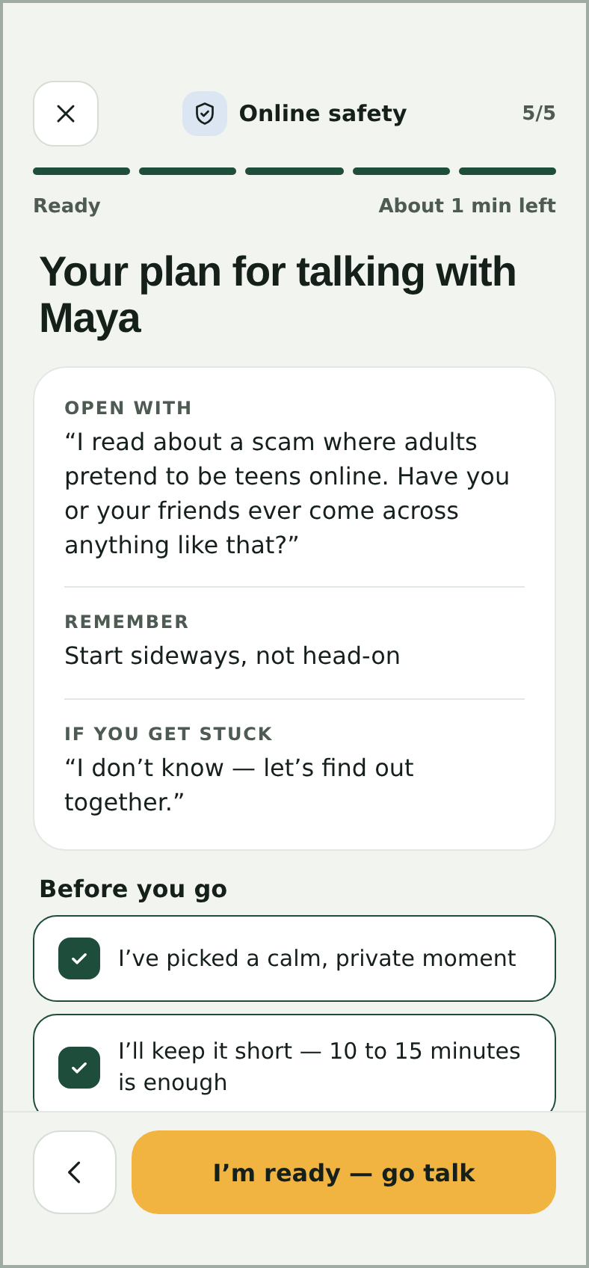 | Prep 5 · Ready  The plan in three labelled lines + a four-item checklist. Gold “I’m ready — go talk”. | 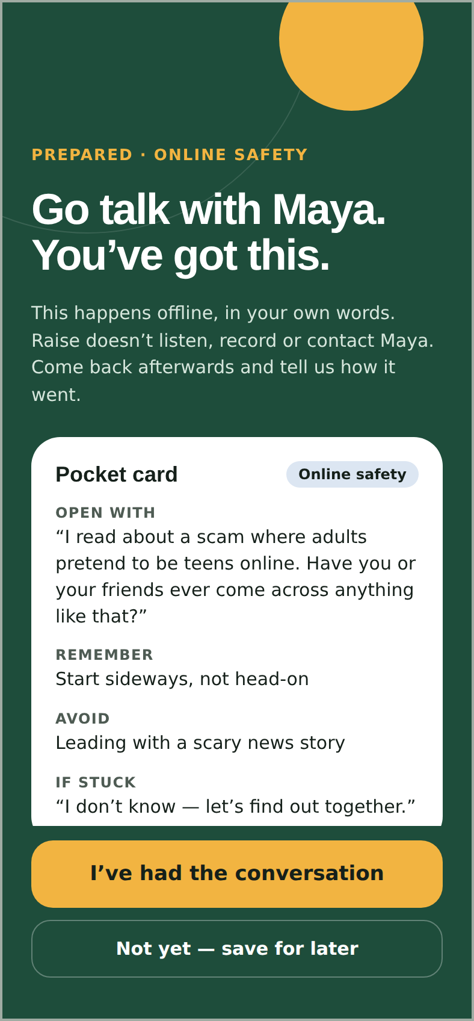 | Go talk  Dark, focused screen. Pocket card: open with, remember, avoid, if stuck. States Raise doesn’t listen, record or contact the teen.
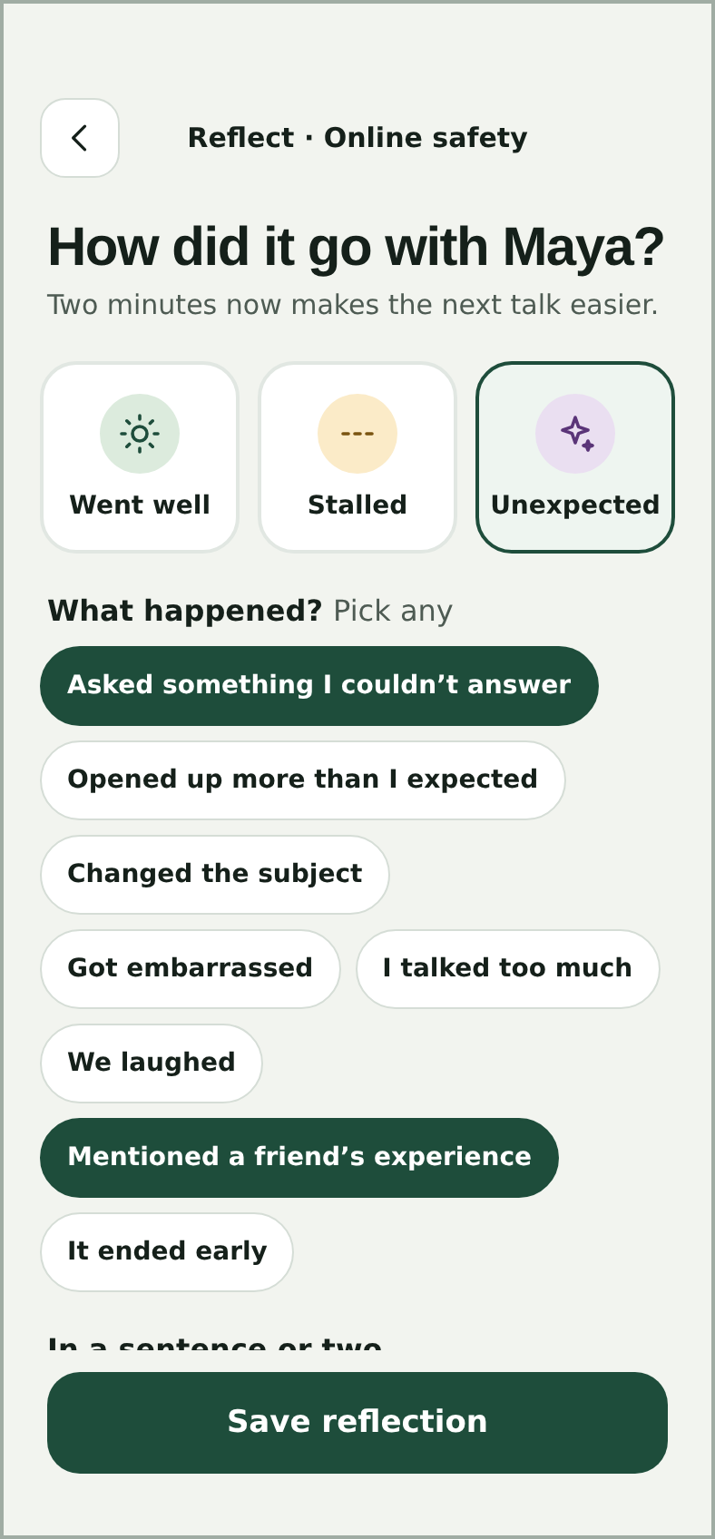 | Reflect  Three outcomes, eight chips, optional note. “Two minutes now makes the next talk easier.” | 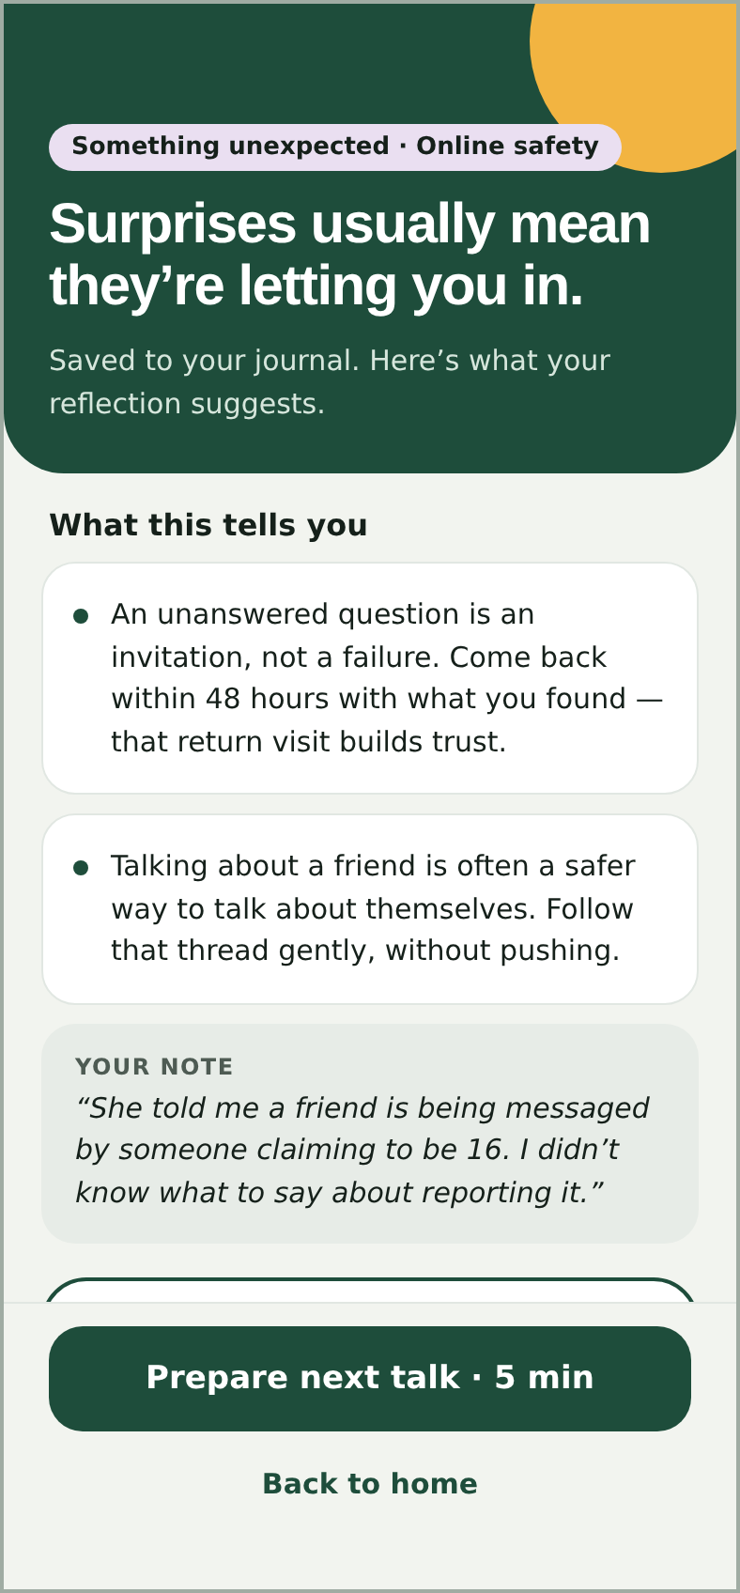 | Insight  Outcome-specific headline, up to three chip insights, the parent’s note, and the next talk with timing.
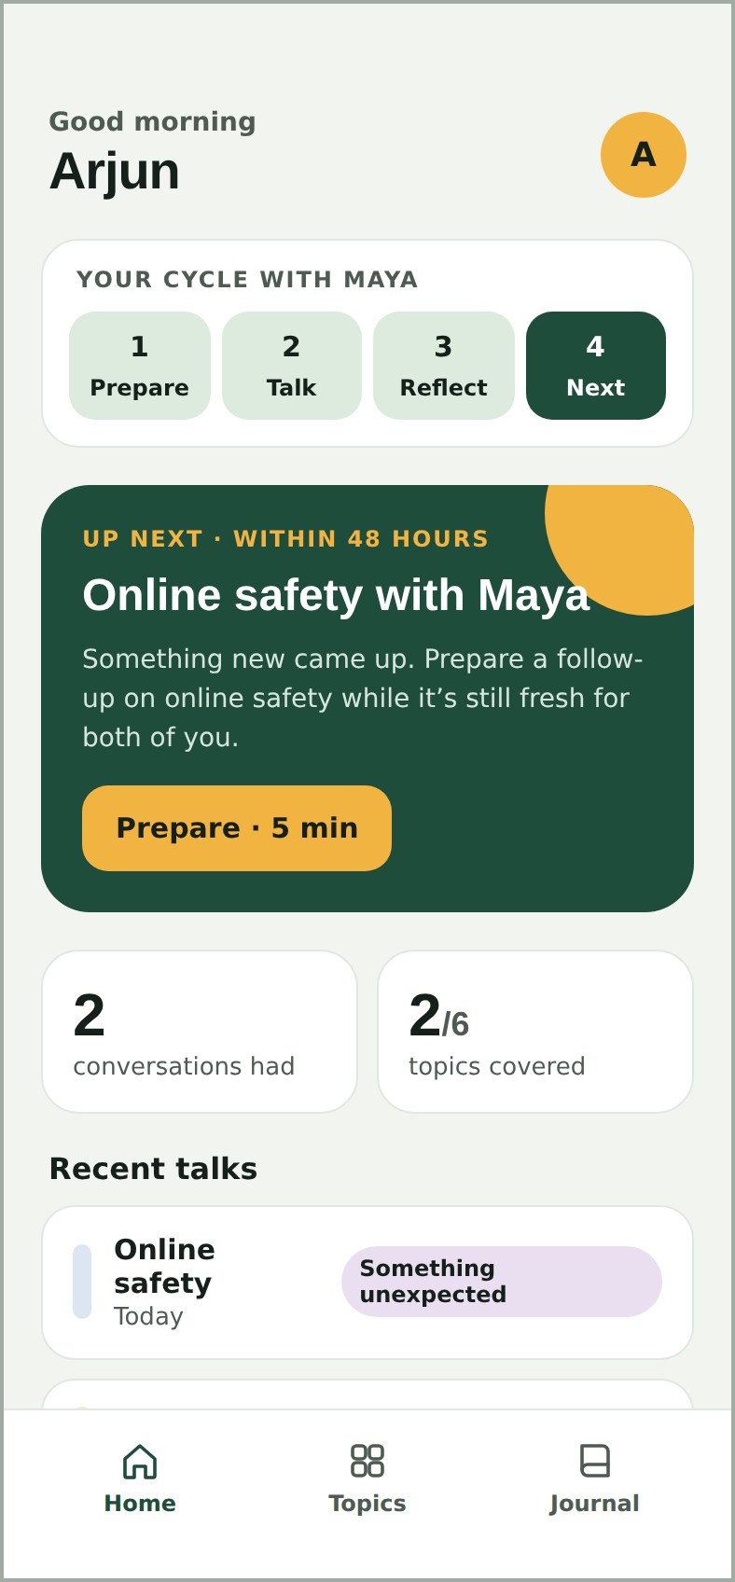 | Home  Cycle tracker (Prepare · Talk · Reflect · Next) shows where the parent is. Counts: talks had, topics covered of 6. | 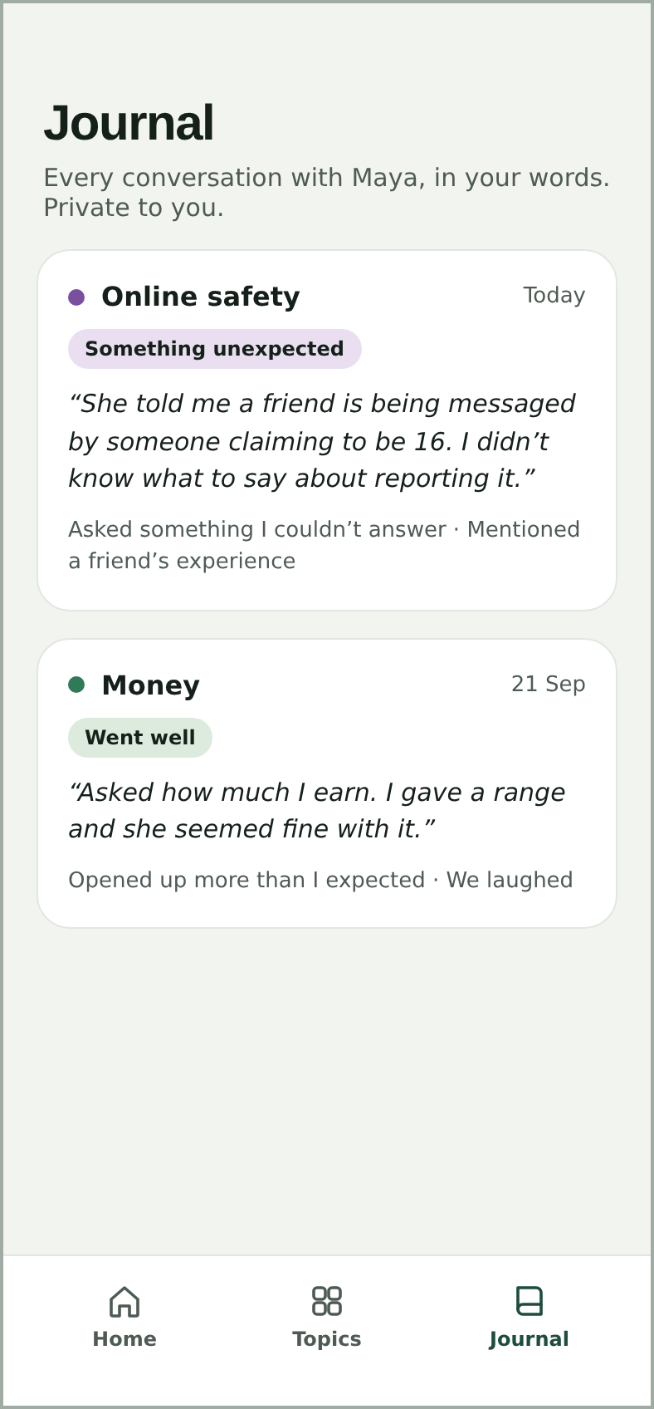 | Journal  Private history in the parent’s words: topic, date, outcome tag, quote, chips.

Part E — Notes on Key Design Decisions
Decision | Why
Parent-only, stated on the cover | Teens wouldn’t use an app their parent installed (insight I12). Saying “your teen never sees this app” up front builds the parent’s trust and rules out surveillance as a use case.
Five minutes, five steps, with minutes left | Parents said “ten minutes on the metro, not a course”. A visible countdown makes the commitment feel small and finishable.
Ask for the hardest part before the content | The fear, not the topic, is the real barrier. The Start tip is chosen by that answer and says “Because you said…” so the parent sees it was listened to.
Three openers, choose one — not one script | Choice keeps the parent’s voice. Openers are “sideways” (a show, a story, a friend) because teens read head-on talks as trouble (I2).
Think first, then tap to reveal | Hiding the calm response makes the parent rehearse their own answer, which is what they’ll actually say in the room (I3, I5).
“I don’t know — let’s find out” is taught as a good answer | Removes the biggest fear (unanswerable questions) and models honesty; teens told us it feels “real”.
Pocket card, not a teleprompter | Four short cues fit a glance. A full script would make the parent sound robotic and risk the teen feeling managed.
The talk happens off-app | No recording, no listening, no in-app chat with the teen. The app’s best session ends with the parent closing it.
Three outcomes, not a star rating | “Went well / Stalled / Something unexpected” are things parents can judge honestly; “Stalled” is framed as progress, so honesty isn’t punished.
Chips before free text | Two-minute reflections need tappable options; chips also map to specific insights and the next-talk rule. The note stays optional.
Outcome sets the cadence | A good talk waits a week, a stall comes back in 3–4 days, a surprise within 48 hours — matching how momentum and worry actually work.
No streaks, points or badges | Rewards would invite fake reflections and turn a relationship into a score — and would break the Completed Conversation metric.
Calm green, gold only for action | Deep green (#1E4D3B) reads as steady and private; gold (#F2B441) marks the one next action per screen. Topic tints help scanning without alarm colours.
Optional teen name | Personalised copy (“Maya”) helps, but the app must work without storing anything identifying about a minor.

Open design questions
- Should the escalation card interrupt before the insight, or appear as the top item on it? Proposed: interrupt for Level 3, top item for Level 2.
- Where does Hindi switching live — at sign-up, or per guide? [NEEDS INPUT: test with pilot parents]
- Should “Topics” in the bottom nav allow starting a second teen? Out of V1 scope; flagged.

