Raise
The talks that matter, prepared.
Product case study — persona, research, metrics, prioritisation, MVP, GTM and risks
Prepared by Himanshu Shukla
Live prototype: https://shuklahimanshu20.github.io/Raise_project/
Companion document: Raise_PRD_UserFlows_Wireframes.docx

How to read this document
This is the product case study for Raise, a mobile web app that helps parents prepare for the conversations they keep putting off with their teenager — money, relationships, puberty, consent, online safety and pornography — have them offline, reflect, and plan the next one.
The User Flows, PRD, Journey Maps, Wireframes and design-decision notes (point 7 of the brief) are in the companion document Raise_PRD_UserFlows_Wireframes.docx. Everything else is here.
Honesty conventions used throughout
Sourced — a published study or article, listed in the Sources appendix.
Verified from the build — read directly from the live prototype’s source code or produced by running the content engine.
Illustrative — written to show the expected shape of an answer (personas, interview answers). Not real research data; replace with your own before external use.
[NEEDS INPUT: …] and [ASSUMPTION — validate before use: …] — a gap or an estimate that you must confirm. No user numbers have been invented.

Live prototype: https://shuklahimanshu20.github.io/Raise_project/

Contents
1. User Persona 4
2. Problem Statement 6
3. Problem Framing 7
4. Market and User Research 9
5. Metric — What Counts as a Completed Conversation 16
6. Features and Prioritisation 18
7. User Flows, PRD and Wireframes 22
8. Build the MVP 23
9. Metrics and User Feedback 28
10. GTM and Habit Loop 32
11. Risks, Trade-offs and Concerns 35
Sources 38

1. User Persona

1.1 Who we are building for
Primary user: a parent aged 35–60 whose child is 14–19 years old. The age bands go together: parents in their late 30s to 50s are, in most families, the ones raising mid-to-late teenagers. Raise is used by the parent only — the teenager never sees the app.
Attribute | Definition
Parent age | 35–60
Teen age | 14–19 (middle teens 14–15, older teens 16–17, young adults 18–19)
Geography | [NEEDS INPUT: launch city / region — e.g. Delhi NCR]
Language | Hindi, English and mixed Hindi-English at home [ASSUMPTION — validate before use]
Device | Smartphone; comfortable with WhatsApp and YouTube
Core need | The words and a starting point for topics they were never taught to talk about
Out of scope | Teens using the app; parents of children under 14; crisis counselling

Gap found between brief and build
The live prototype offers teen age bands 11–13, 14–15 and 16–18. The target segment is 14–19. Recommendation: change the bands to 14–15, 16–17 and 18–19 before launch, and rewrite the 18–19 tone note as "adult to young adult". Logged in the Risks section.

1.2 Three personas
Illustrative personas — not based on user research. Names and details are invented to make the segment concrete; validate them against real interviews.
 | Sunita — the willing but wordless parent | Rajesh — the parent who tried and it went wrong | Farah — the time-poor solo parent
Profile | Mother, 44, school teacher. Daughter Ananya, 15. | Father, 52, runs a small business. Son Kabir, 18. | Single mother, 38, IT professional. Son Zaid, 14.
Main topics | Puberty, relationships, online safety | Money, relationships, consent | Online safety, pornography
Goal | Be the person her daughter comes to first | Prepare his son for adult decisions — money, dating, respect | Know her son is safe online without becoming the “phone police”
Barrier | No vocabulary — Hindi feels vulgar, English feels like a textbook | Shouted once after seeing something on his son’s phone; son went silent for a week | No co-parent to share it with; 10 minutes a day at most
What she/he says | “Tell me the first line. After that I can manage.” | “I don’t know how to start again without it being about last time.” | “I don’t need a course. I need a plan for tonight.”
What success looks like | Ananya brings a question to her unprompted | Kabir talks to him about money before a big decision | Zaid tells her when a stranger messages him

1.3 Jobs to be done
- When I realise my teen is growing up faster than I’m talking to them, I want to know exactly how to open one topic, so I can start tonight instead of “this weekend”.
- When my teen asks something I can’t answer, I want a calm response I’ve thought about beforehand, so I don’t freeze, lecture or shut it down.
- When a talk is over, I want to know whether it worked and what to do next, so one talk becomes many.

2. Problem Statement
Parents of 14–19-year-olds want to talk with their teens about money, relationships, puberty, consent, online safety and pornography, but most were never taught these conversations themselves and do not have the words to begin.
Because the first sentence feels impossible and the fear of saying the wrong thing is high, these talks are postponed, avoided, or happen once as a lecture after something has already gone wrong.
Teens then learn about these topics from friends, the internet and pornography, and stop treating their parent as a safe person to come to when something goes wrong.

The three sentences map to: who and what they want (1), the barrier and its behaviour (2), and the consequence (3). Section 3 turns this into the framing the product is built against.

3. Problem Framing

3.1 The framing sentence
[User] Parents aged 35–60 of teenagers aged 14–19 need [outcome] to have calm, honest, repeated conversations with their teen about money, relationships, puberty, consent, online safety and pornography, but currently [barrier] they lack the vocabulary and a way to start, fear their teen’s questions and reactions, and have no one showing them what to say. This causes [consequences] talks that never happen or go badly, teens who learn from peers, the internet and porn, and teens who hide problems — online risks, pressure, money mistakes — from the adults who could help. We will solve this by [our angle] giving parents a five-minute, topic-specific preparation guide (what to say first, what the teen may ask, what to avoid), sending them to talk offline in their own words, and closing the loop with a two-minute reflection that tells them what to try next.

3.2 The framing, broken down
Part | What it means for Raise | How the product responds
User | Parent 35–60, teen 14–19. The parent is the only user. | Parent-only app; teen’s name is optional.
Outcome | Not “one big talk” — an ongoing habit of short talks the teen feels safe in. | Prepare → Talk → Reflect → Next cycle on Home.
Barrier 1 — vocabulary | They don’t know the first sentence or the right words. | Three “sideways” openers per topic; pocket card.
Barrier 2 — fear of questions | “What if she asks something I can’t answer?” | “What they might say” with calm responses; “I don’t know — let’s find out” taught as a good answer.
Barrier 3 — fear of reaction | Eye-rolls, shut-down, embarrassment. | Choose the hardest part; tip tuned to it; “What to avoid”.
Consequence | Silence → teens learn elsewhere → teens hide problems. | Measure completed conversations, not app opens.
Our angle | Preparation, not monitoring. Confidence, not scripts. | No phone monitoring, no teen tracking, ever.

3.3 Why “vocabulary” is the real barrier
Research summarised in Section 4.1 points the same way: many Indian parents say these topics matter and should be taught, yet a much smaller share actually talk about them at home, and discomfort is a commonly given reason. The gap is not intent — it is the how. That is why Raise starts with the first sentence, not with information about the topic.

3.4 Topics in scope
Topic | Live in prototype | What the parent is helped to say
Money | Yes | Spending, saving, online money scams, “are we okay for money?”
Relationships | Yes | Crushes, dating rules, red flags, controlling behaviour
Puberty | Yes | Body changes, feelings, hygiene, “is it normal that…?”
Consent | Yes | Saying no, hearing no, pressure, sharing photos
Online safety | Yes | Strangers, grooming patterns, privacy, location sharing
Pornography | Yes | What they may see, why it isn’t real, without shame
Later candidates | No | Substance use, exam stress, bullying, careers [ASSUMPTION — validate demand in interviews]

4. Market and User Research

4.1 Secondary research — what published sources say
All findings below are paraphrased from published sources; full references are in the Sources appendix. Older studies are flagged so they are not read as current national figures.
Finding | Source | What it means for Raise
In a school-based study of parents, about four in five wanted sex education to be compulsory in schools, yet only around a quarter said they discussed sex-related issues with their adolescent (the paper contrasts this with a US study where nearly all did). | Pediatric Oncall journal, parents’ views study [S1] | Intent is high; at-home action is low. The gap Raise targets is the “how”.
Of 233 parents in coastal South India, 202 believed sexuality education should be given; about 60% of those gave it themselves. The rest most often said children would learn on their own, or that they felt uncomfortable. | Manipal Academy, Sex Education journal [S2] | Discomfort is a named barrier — supports the vocabulary-first angle.
In a 2015 nationwide survey, about half of Indian parents said they would be extremely uncomfortable having “the talk”, and a third of children said they could never discuss puberty and sex with parents. | ParentCircle–IMRB survey, 2015 [S3] (older data) | Discomfort runs both ways; the product must lower the teen’s guard too (sideways openers).
Among 15–19-year-olds surveyed in Bihar and Uttar Pradesh (2015–16), about 47% of boys and 6% of girls reported exposure to pornography; owning a personal mobile phone raised the odds. | Population Council, UDAYA survey, Archives of Sexual Behavior [S4] (two states, older data) | Exposure is common in the target age band, especially for boys with phones. Pornography belongs in scope.
Focus groups with parents aged 30–60 found worries about peer company, mobiles and the internet, misconceptions about sex and sexual harassment; parents were unaware of government adolescent health services. | Manipal Academy, qualitative study, coastal Karnataka [S5] | Confirms the topic list and the need to point parents to real services in escalation cards.
A Population Foundation of India review noted parents are among the most influential people in children’s lives but are often left out of sexuality education programmes. | Reported in Outlook India [S6] | Schools and NGOs reach teens, not parents — an open lane for Raise.
An Indian sex-education provider observed that urban parents increasingly support lessons on sex and safety but are often stumped when it comes to doing it themselves. | Homegrown, profile of UnTaboo [S7] | Demand exists among urban parents; they want help doing it, not just endorsement.

4.2 Competitive landscape
Alternative | What it offers | Gap Raise fills
School “good touch / bad touch” and biology classes | Basic safety and anatomy for students | Doesn’t equip the parent; stops at diagrams
Workshops (e.g. UnTaboo) | Expert-led sessions for children and parents | One-off and scheduled; not there on the evening a parent wants to talk
Parenting content sites and YouTube (e.g. ParentCircle) | Articles and videos on why to talk | Explains why, rarely the first sentence; no follow-up loop
Books and WhatsApp forwards | Free, familiar | Generic, unverified, not tailored to teen age or the parent’s hardest part
Parental-control apps (e.g. Google Family Link) | Screen time and app limits | Control, not conversation; covert use can damage trust (insight I12)
Doing nothing / “they’ll figure it out” | Avoids awkwardness | Teens learn from peers, internet and porn
Positioning: Raise is the only option here that prepares the parent for one specific conversation in five minutes, then closes the loop after it happens. [ASSUMPTION — validate before use: no direct Indian competitor does prepare → talk → reflect; run a fuller competitor scan before external use.]

4.3 Primary research — method and status
Status: interview guide ready; answers are illustrative
The question sets below are ready to use. The answers are illustrative composite responses written to show the shape of findings we expect. They are not real interview data and must be replaced with verbatim notes from real sessions before this document is shared outside the course.
Planned sample: [NEEDS INPUT: number of parents and teens interviewed, recruitment channel, dates]. Teens under 18 interviewed only with parental consent and without the parent in the room; no identifying details recorded.

4.4 Parent interview — 23 questions
# | Question | Illustrative composite answer | Topic touched
P1 | Tell me about your teen and how things are between you right now. | She’s 15 and doing well at school, but we mostly talk about homework and food. I don’t really know what’s going on in her head. | General
P2 | When did you last have a conversation with them that felt meaningful? | I honestly can’t remember. Maybe when her grandmother was in hospital. | General
P3 | Which topics feel hardest to bring up? | Anything about the body or boys. Money I can manage. That other stuff, no. | Puberty, Relationships
P4 | Did your own parents talk to you about these things? | Never. We learnt from friends. My mother only said “be careful”. | All
P5 | What stops you from starting? | I don’t have the words. In Hindi it sounds vulgar, in English it sounds like a biology textbook. | All — vocabulary
P6 | What are you afraid will happen if you start? | That she’ll be embarrassed and avoid me, or think I suspect her of something. | All
P7 | Have you tried before? What happened? | Once I saw something on his phone and I shouted. He didn’t talk to me properly for a week. | Online safety
P8 | How do you know what your teen sees or does online? | I don’t, really. Sometimes I check the phone when he’s asleep. | Online safety
P9 | Have you considered monitoring apps? | I thought about it. But if he finds out, that’s the end of trust. | Online safety
P10 | Who do you think should teach your child about sex and their body? | A doctor or the school would be better than me. But I know school only does diagrams. | Puberty, Pornography
P11 | How do you feel about pornography as a topic? | I’d rather not think about it. I hope he hasn’t seen any. | Pornography
P12 | How do you talk about money at home? | We tell her to save. We don’t discuss what we earn or loans — that’s for adults. | Money
P13 | What would you do if your teen was in a relationship? | We say “focus on studies”. But if there is someone, I’d rather know than hear it from others. | Relationships
P14 | Have you ever talked about consent or saying no? | Only “good touch, bad touch” when she was small. I don’t know how to explain more than that. | Consent
P15 | Where do you look for parenting advice on these topics? | YouTube, WhatsApp forwards, my sister. Every article says “talk openly” but never what to actually say. | All
P16 | What would genuinely useful help look like? | Give me the first line, and what to say when he asks something I can’t answer. | All
P17 | How much time could you spend preparing for one talk? | Ten minutes, maybe on the metro. Not a course. | All
P18 | When and where do your best conversations happen? | In the car. He’s relaxed and doesn’t have to look at me. | All
P19 | How would you know a talk had gone well? | If he came back later with a question. That would mean he trusts me. | All
P20 | Does the other parent share these talks? | His father avoids it completely. It all falls on me. | All
P21 | What would worry you about using an app for this? | Privacy. I don’t want my child’s private things stored somewhere, or shown to him. | All — privacy
P22 | Would you pay for this? | Maybe, if it clearly helped. I don’t want another monthly subscription. [NEEDS INPUT: real price testing] | Business
P23 | Which language would you want it in? | The mix we actually speak at home — Hindi and English together. | All — language

4.5 Teenager interview — 30 questions
# | Question | Illustrative composite answer | Topic touched
T1 | Who do you go to first when something is bothering you? | Friends, usually. Sometimes an older cousin. | General
T2 | How often do you have a real conversation with your parents? | Real? Rarely. It’s “did you eat”, “how was school”. | General
T3 | What would you never bring up with your parents? | Relationships and anything about my body. Definitely not porn. | Relationships, Puberty, Pornography
T4 | Why not? | They’d overreact or assume I’ve done something wrong. | All
T5 | How do you feel when a parent says “we need to talk”? | Dread. Like I’m in trouble. | All
T6 | What makes you shut down mid-conversation? | When it turns into a lecture, or “when I was your age…”. | All
T7 | What would make it easier to talk? | If they asked what I think first and didn’t make it a big sit-down. | All
T8 | Where would you rather have these talks? | In the car, on a walk, while doing something. Not at dinner in front of everyone. | All
T9 | How long before a talk feels too long? | About ten minutes. After that I’m just nodding. | All
T10 | Did anyone at home explain puberty to you? | Biology class and YouTube. My mum gave me pads and said “you’ll understand”. | Puberty
T11 | Where did you learn about sex? | Friends and the internet. Nobody at home. | Puberty, Pornography
T12 | Do people your age come across porn? | Most boys in my class have, some by accident through links. Nobody would tell their parents. | Pornography
T13 | If you saw something disturbing online, would you tell a parent? | No — they’d take my phone away. | Online safety
T14 | Have strangers ever contacted you online? | Random DMs happen all the time. You just block them. | Online safety
T15 | Do you think your parents check your phone? | I know mine do sometimes. So I delete chats. | Online safety
T16 | What do you think your parents worry about most? | Marks, and that I’ll “go in the wrong direction”. | General
T17 | What do you wish they understood? | That being curious doesn’t mean I’m doing something wrong. | All
T18 | Do you know how money works in your family? | No idea. I’d actually like to learn how to manage money. | Money
T19 | Have friends talked about quick-money apps or schemes? | Some friends talk about trading and betting apps. It sounds like easy money. | Money, Online safety
T20 | Would you tell a parent about a crush? | Only if they wouldn’t tease me or panic. | Relationships
T21 | What makes a relationship unhealthy? | When someone checks your phone or gets angry when you talk to other people. | Relationships
T22 | What does consent mean to you? | Saying no and it being respected. But saying no to friends is hard. | Consent
T23 | How would you feel if a parent said “I don’t know — let’s find out”? | Honestly better. At least it’s real. | All
T24 | Would it help if your parent admitted the talk felt awkward? | Yes. Then it’s less weird for both of us. | All
T25 | How would you feel if you found out your parent prepared using an app? | A bit weird… but better than them winging it and making it awkward. | All — trust
T26 | Should parents talk about porn at all? | If they can do it without shaming. Mostly I just don’t want them to freak out. | Pornography
T27 | What is one thing your parent does that helps? | When my dad tells me about his own mistakes. | All
T28 | What is one thing that hurts? | Comparing me to cousins, or “what will people say”. | All
T29 | If something serious happened — say someone was threatening you online — who would you tell? | A friend first. My parents only if I was sure they wouldn’t blame me. | Online safety, Consent
T30 | What would you want the next talk with your parent to be about? | Money and careers. Maybe relationships, if they can stay calm. | Money, Relationships

4.6 Which topics the interviews touched
Counted from the “Topic touched” column above (questions tagged “All” are excluded). Because the answers are illustrative, these counts describe the guide’s coverage, not real demand.
Topic | Parent questions | Teen questions | Coverage note
Money | 1 | 3 | Covered
Relationships | 2 | 4 | Covered
Puberty | 2 | 3 | Covered
Consent | 1 | 2 | Thin — add 2–3 questions in the real guide
Online safety | 3 | 5 | Well covered
Pornography | 2 | 4 | Covered

4.7 Mirror insights — what each side thinks of the other
What the parent thinks | What the teen thinks | Insight → product implication
“She’s too young; she hasn’t seen anything.” | “Everyone’s seen stuff already, some by accident.” | Parents are behind reality. Talk as if exposure is possible, so the teen doesn’t have to confess to join in.
“Checking his phone keeps him safe.” | “I know they check, so I delete chats.” | Surveillance teaches hiding. Raise will never offer monitoring and explicitly coaches against secret checking.
“If I don’t know the answer, I’ll lose respect.” | “‘Let’s find out’ is better — at least it’s real.” | Make not-knowing a prepared, positive move (Anticipate step).
“A proper sit-down shows it’s important.” | “A sit-down means I’m in trouble.” | Short, side-by-side talks. The checklist says 10–15 minutes.
“My child will come to me if something is wrong.” | “I’d tell a friend first. They’d take my phone.” | The most useful opener for online safety is a promise: you won’t be in trouble for telling me.
“I don’t have the right words.” | “I don’t need perfect words, just no lecture.” | The bar is lower than parents think: tone beats vocabulary. Raise sells confidence, not scripts.
“Money is an adult worry.” | “I want to learn — friends are trying trading apps.” | Money is a low-stakes first topic with real risk attached — a good on-ramp.
“I’ll talk once, properly.” | “Ten minutes, then I’m just nodding.” | Design for many short talks: the Next-talk loop and cadence.

4.8 Sharp insights (used to justify every feature)
ID | Insight | Evidence (question IDs)
I1 | Parents don’t lack intent — they lack the first sentence. | P5, P15, P16
I2 | A head-on “we need to talk” signals trouble to teens; sideways starts lower their guard. | T5, T7, T8, P18
I3 | Fear of an unanswerable question stops parents more than the topic itself — and teens respect “let’s find out”. | P16, T23
I4 | Lectures, shame and “when I was your age” end conversations; curiosity keeps them open. | T6, T17, T28
I5 | Parents freeze mid-talk. They need a cue to glance at, not a script to recite. | P6, P17
I6 | A 14-year-old and an 18-year-old need different stances — rules vs. reasoning. | P13, T30
I7 | Parents can’t tell if a talk “worked”, so they don’t try again. | P19, P2
I8 | One big talk followed by silence doesn’t build trust; many short talks do. | T9, P17
I9 | Serious disclosures come out in these talks, and parents don’t know where to turn. | T13, T29, P7
I10 | The vocabulary gap is partly a language gap: Hindi feels crude, English feels clinical. | P5, P23
I11 | Intention–action gap: “this weekend” never comes. | P2, P17
I12 | Covert phone checking teaches teens to hide — and teens describe the same behaviour as a red flag in relationships. | P8, T15, T21

5. Metric — What Counts as a Completed Conversation

5.1 Definition
Completed Conversation (CC)
A CC is counted once per prep guide when all three gates are passed:
Gate 1 — Prepared: the parent stepped through all five prep steps (Understand, Start, Anticipate, Avoid, Ready) and chose an opener.
Gate 2 — Time passed: the parent tapped “I’ve had the conversation” at least [T1] after finishing the prep. [ASSUMPTION — validate before use: T1 = 20 minutes]
Gate 3 — Reflected with detail: within 7 days, the parent saved a reflection with an outcome (Went well / Stalled / Something unexpected) and at least one “what happened” chip or a written note.

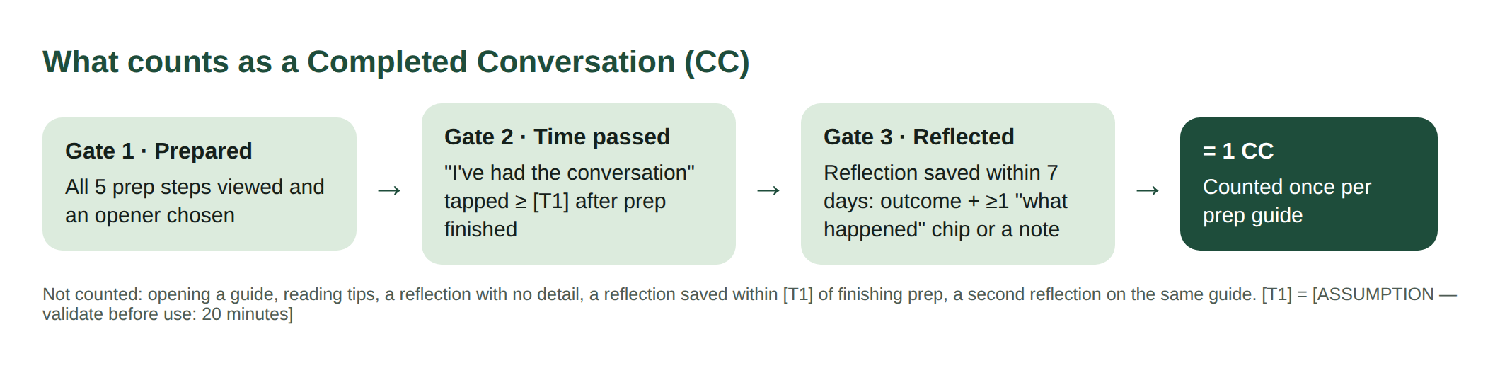
Figure 5.1 — The three gates of a Completed Conversation
Not counted: opening the app, reading a guide, a reflection with no detail, a reflection saved sooner than T1 after prep, or a second reflection on the same guide. A stalled talk does count — a parent who tried and it went badly still had the conversation, and that is the behaviour we want.
Completed Conversation Rate (CCR) = CCs ÷ prep guides finished, measured over 7 days. This is the rate the behaviour change below must move.

5.2 Why a parent who did nothing cannot inflate it
A talk happens offline, so any measure is self-reported in the end. The design goal is therefore not “impossible to lie” but “no reason to lie, and no quick way to fake it”.
Layer | How it works | What it stops
Effort gate | Must step through all five prep screens and pick an opener. | Counting a talk from just opening the app
Time gate | “I’ve had it” within T1 of finishing prep is ignored for the metric. | Tapping straight through prep → talk → reflect
Detail gate | Reflection needs an outcome plus a chip or note. | One-tap empty reflections
One per guide, capped per teen | One CC per guide; at most [ASSUMPTION — validate before use: 3] per teen per week. | Repeating a guide to pump the count
Nothing to win | No streaks, points, badges, certificates or leaderboards — by design. | The usual motive to game a metric
Faking costs the parent | The reflection decides the next guide. A fake “went well” gives worse, wrong advice next time. | Gaming gives the parent a worse product
Data-quality audit | Flag patterns: every reflection “went well” with no chips, saved in under 30 seconds, identical notes. Excluded from the audited metric, never punished. | Silent inflation of reported numbers
Ground-truth sample (V2) | Opt-in, consented, anonymous one-question check with a small sample of teens: “Did your parent talk with you about [topic] this week?” | Lets us estimate how many CCs are real
Honest limitation
Until the ground-truth sample exists, CC is a well-defended self-report, not a verified fact. We should say this whenever we quote it.

5.3 The behaviour that must change
Target behaviour
The parent says the opener out loud to their teen within 72 hours of finishing the prep guide.

Today the default is to prepare mentally and postpone (“this weekend”) — insight I11. CCR only moves if the gap between “prepared” and “started” closes. Everything after the first sentence tends to follow; everything before it is where talks die.
- Leading indicator: share of finished guides followed by “I’ve had the conversation” within 72 hours (Prep → Talk 72h).
- Supporting behaviour: the parent reflects the same day, while it is fresh — this is what turns one talk into the next.
- What we will not try to change: how long they talk, or whether it “goes well”. Pushing for good outcomes would reward parents for steering, not listening.

6. Features and Prioritisation

6.1 Feature list — each tied to an insight
ID | Feature | What it does | Insight | Status in prototype
F1 | Tailored 5-minute prep guide | Five short steps built from topic + teen age + the parent’s hardest part | I1 | Built
F2 | Sideways opener picker | Three low-pressure first sentences per topic; parent picks one | I1, I2 | Built
F3 | “What they might say” + calm responses | Likely teen pushback; parent thinks first, then taps to reveal a calm reply | I3 | Built
F4 | What to avoid | Three mistakes per topic with the reason, plus “listen more than you talk” | I4 | Built
F5 | Pocket card | One-screen cue: opener, one thing to remember, one to avoid, what to say if stuck | I5 | Built
F6 | Age-band tone | Stance changes with the teen’s age band (rules → reasoning) | I6 | Built (bands need changing to 14–19)
F7 | Two-minute reflection | Outcome + “what happened” chips + optional note | I7 | Built
F8 | Insight + next talk | Explains what happened and recommends the next topic and timing | I7, I8 | Built (rule-based)
F9 | Journal / history | Private record of every talk, topic coverage on Home | I8 | Built (no persistence yet)
F10 | Safety escalation cards | Detects risk words in notes; shows helplines and “do / don’t” steps instead of a script | I9 | Not built
F11 | Hindi + Hinglish library | Every item in the language parents actually speak at home | I10 | Not built
F12 | “Pick your moment” reminder | Parent picks when (tonight, next car ride, weekend); one reminder then | I11 | Not built

6.2 RICE prioritisation
Reach = % of active parents who would use the feature in a quarter. Impact = 3 massive, 2 high, 1 medium, 0.5 low. Confidence = how sure we are of R and I. Effort = person-weeks. Score = R × I × C ÷ E.
All inputs are team estimates [ASSUMPTION — validate before use: re-score after the first pilot]. RICE is a sorting aid, not the decision — see the overrides below.
Rank | Feature | Reach | Impact | Conf. | Effort | RICE | Release
1 | F2 Sideways opener picker | 100 | 2 | 80% | 1 | 160.0 | V1
2 | F4 What to avoid | 90 | 1 | 70% | 0.5 | 126.0 | V1
3 | F5 Pocket card | 80 | 2 | 60% | 1 | 96.0 | V1
4 | F3 “What they might say” + calm responses | 90 | 2 | 70% | 1.5 | 84.0 | V1
5 | F1 Tailored 5-minute prep guide | 100 | 3 | 80% | 3 | 80.0 | V1
6 | F7 Two-minute reflection | 70 | 2 | 70% | 1.5 | 65.3 | V1
7 | F6 Age-band tone | 100 | 1 | 60% | 1 | 60.0 | V1
8 | F8 Insight + next talk | 60 | 2 | 60% | 1.5 | 48.0 | V1
9 | F10 Safety escalation cards | 15 | 3 | 90% | 1 | 40.5 | V1
10 | F9 Journal / history | 50 | 0.5 | 80% | 1 | 20.0 | V2
11 | F12 “Pick your moment” reminder | 70 | 1 | 50% | 2 | 17.5 | V2
12 | F11 Hindi + Hinglish library | 50 | 2 | 50% | 4 | 12.5 | V2

Overrides to the RICE order
- F10 Safety escalation is V1 regardless of score. Its reach is small but the cost of missing a grooming or self-harm disclosure is unacceptable. Safety is a launch requirement, not a feature.
- F1 ranks below F2 and F4 only because it is the biggest build — but F2–F5 are parts of F1 and cannot ship without it.
- F11 Hindi scores low on RICE but is the first V2 item because insight I10 says language is part of the vocabulary barrier; the score is held down by effort, not value.

6.3 MVP scope
V1 — smallest loop that produces a real conversation | V2 — after V1 proves the loop | Cut — will not build
F1 Prep guide (6 topics, 5 difficulties)  F2 Openers  F3 Anticipate  F4 Avoid  F5 Pocket card  F6 Age tone (bands 14–15, 16–17, 18–19)  F7 Reflection  F8 Next talk (rule-based)  F10 Safety escalation  Basic account + saved last talk  Event analytics for the CC gates | F11 Hindi + Hinglish  F12 Pick-your-moment reminder (needs push → app wrapper)  F9 Full journal with search  Co-parent sharing of a plan  AI rephrasing of approved content only (see 11.4)  Ground-truth teen pulse (opt-in)  More topics (exam stress, bullying) if research supports | Teen-facing app or teen accounts  Phone monitoring, location or chat reading  Open-ended AI chat “about my teen”  Streaks, points, badges, leaderboards  Community forum (moderation risk with minors’ details)  School dashboards showing families’ data
Why V1 is small enough: one parent can go from sign-up to a reflected conversation in one evening using only V1. Everything in V1 except F10 and analytics is already working in the live prototype.

6.4 Keeping the conversation library current
Practice | How
Every item has an owner and a date | Each opener, response and tip stores topic, age band, source/rationale, reviewer, last-reviewed date and version.
Gate before publishing | Every new or edited item runs through the content engine rules (Section 8.4), then human review. Nothing ships on the engine alone.
Expert review panel | Child psychologist, adolescent doctor, online-safety specialist, plus two parent reviewers. [NEEDS INPUT: named reviewers]
Quarterly review | Each topic is re-read every quarter; online safety and money also monthly because scams change fast.
Watch real-world signals | Official cyber-crime advisories, school health curriculum changes, news of new scams or apps teens use.
Learn from reflections | “Asked something I couldn’t answer” chips and notes (topic only, no personal details) feed a gap queue for new “what they might say” items.
Retire what doesn’t work | Openers whose talks mostly “stall” after [ASSUMPTION — validate before use: 50] uses are reviewed and rewritten or retired.
Public changelog | A “What’s new in the library” note so parents can trust content is maintained.

6.5 Written boundaries and escalation rules

What Raise will always do
- Help the parent prepare and reflect; the conversation itself is always offline and in the parent’s own words.
- Tell the parent “you won’t be in trouble” style safety promises are worth making — and keeping.
- Treat a stalled talk as progress, never as failure.

What Raise will never do
- Monitor, record, listen to or contact the teen. Read the teen’s phone. Track location.
- Diagnose a medical or mental-health condition, recommend medication, or give legal advice.
- Produce sexually explicit content, or shame/fear-based scripts.
- Coach a parent on how to check a teen’s phone secretly.
- Give a conversation script for abuse, self-harm or exploitation — those need people, not prep.

Escalation ladder
Level | Trigger (examples) | What Raise does
0 — Normal | Ordinary reflection | Insight + next talk as usual
1 — Watch | Three stalls in a row with the same teen; parent notes the teen was very upset | Suggest a break from the topic, a lighter topic, or the school counsellor
2 — Risk | Stranger or adult messaging the teen, someone threatening to share private photos, bullying | Safety card: National Cyber Crime Helpline 1930 / cybercrime.gov.in; Childline 1098. Keep evidence, don’t confront the contact, reassure the teen
3 — Urgent | Self-harm, wanting to die, abuse disclosure, immediate danger | Crisis card: Tele-MANAS 14416, emergency 112, Childline 1098. No conversation script. Prep suggestions for the topic paused
Helpline numbers must be re-verified before launch and on every quarterly review. [NEEDS INPUT: owner for helpline verification]

7. User Flows, PRD and Wireframes
Delivered as a separate document: Raise_PRD_UserFlows_Wireframes.docx. It contains the six-section PRD (Problem, User Persona, Success Metrics, User Stories, Acceptance Criteria, Test Cases), the user flows, three user journey maps, wireframes of every key screen captured from the live prototype, and notes on key design decisions.

8. Build the MVP

8.1 Live app
Open Raise on your phone: https://shuklahimanshu20.github.io/Raise_project/
The prototype is a single-page web app hosted on GitHub Pages, rendered with React 18. On phones under 500px wide it fills the screen; on desktop it shows inside a phone frame. Any username and password logs in. Deep links open a screen with sample data, e.g. ?screen=home&demo=1 or ?screen=prep&step=2&demo=1.
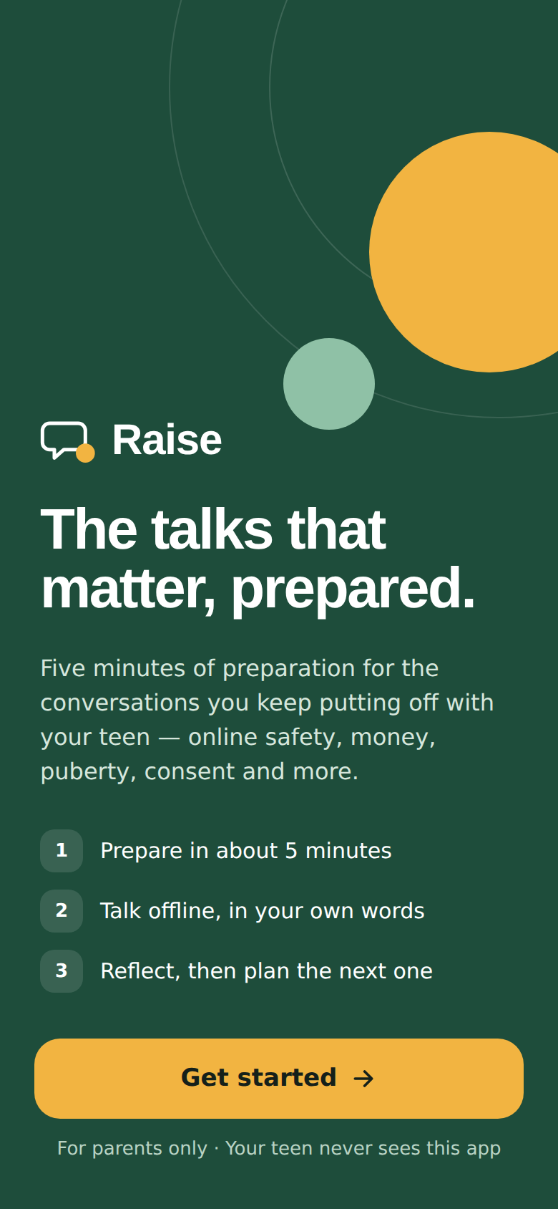  Cover | 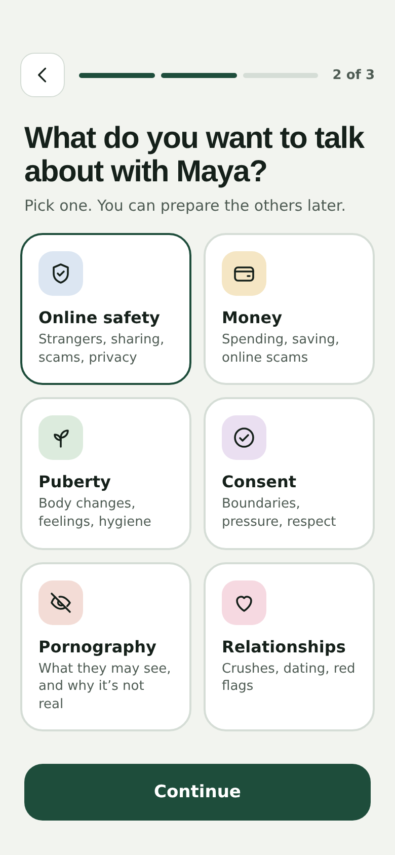  Pick a topic | 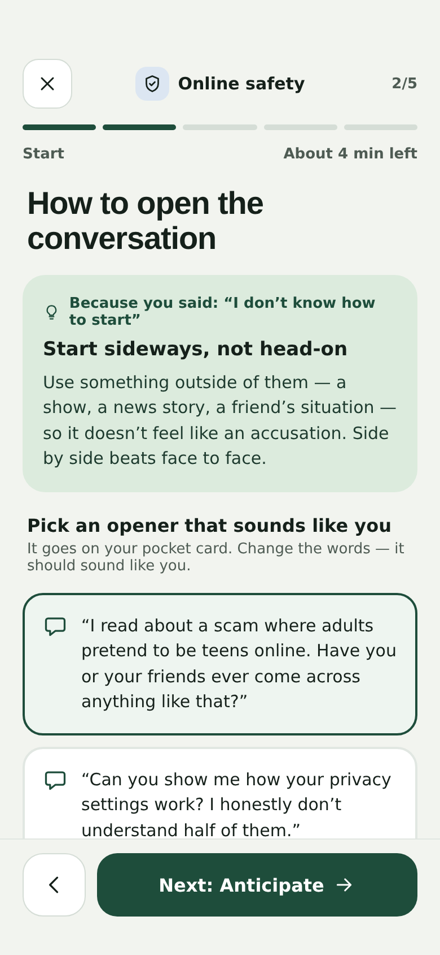  Prep · Start
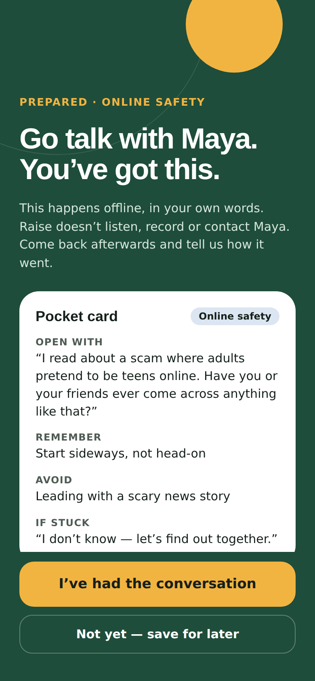  Go talk · pocket card | 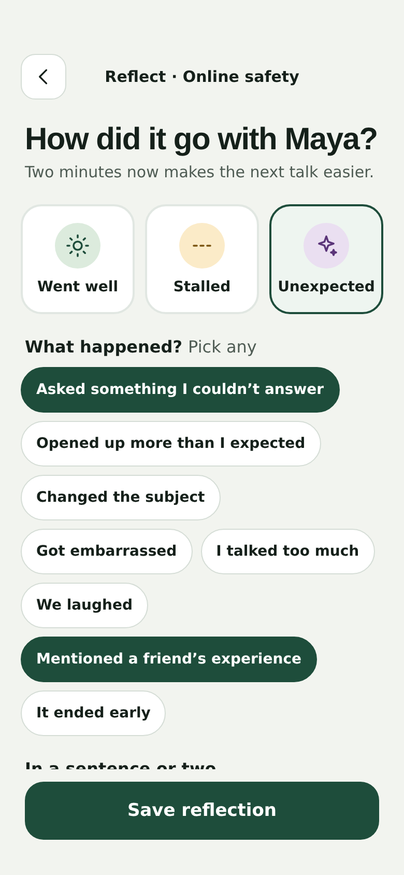  Reflect | 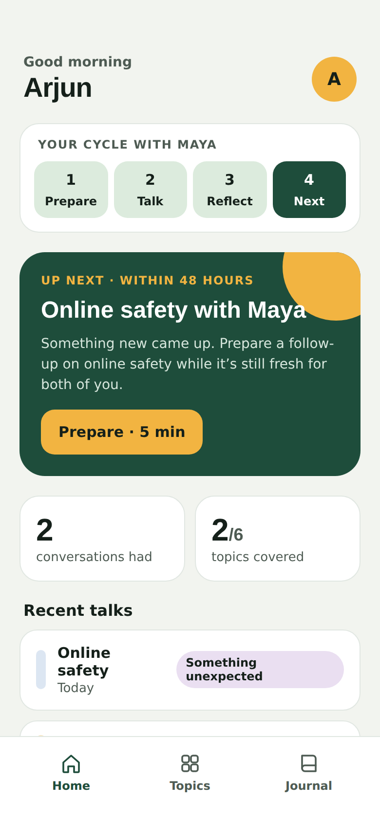  Home · the cycle
Figure 8.1 — Six of the sixteen screen states, captured from the live build at 390 × 844

8.2 What is built — verified from the source code
Area | What exists today
Screens | 14 screens in one file: cover, log in, forgot password, create account, teen age, topic, hardest part, generating, prep guide (5 steps), go talk, reflect, insight, home, journal
Content library | 6 topics × (3 talking points, 3 openers, 3 teen questions with calm responses, 3 things to avoid) = 54 publishable items, plus 5 difficulty tips, 3 age-band notes, 8 reflection chips with insights, 3 outcomes
Logic | Next-talk rule: went well → next linked topic in about a week; stalled → same topic, lighter opener, 3–4 days; unexpected → same topic within 48 hours
Validation | Sign-up checks name, email format, username ≥ 3 characters, password ≥ 8 characters with strength meter, matching passwords
Known limits (honest) | Login accepts any credentials; nothing is saved after a reload; the “Building your guide” screen is a 2.6-second pause — content is pre-written, there is no AI; no analytics; no escalation cards yet

8.3 Build log
When | Entry | Evidence
2 Oct 2026, 12:06 IST | Repository created (initial commit) | git 7891319
2 Oct 2026, 12:07 IST | Interactive mobile prototype added: full app in Main.dc.html plus seven frame files that open it mid-journey with sample data (parent Arjun, teen Maya) | git 1382036
2 Oct 2026, 12:12 IST | Web build: index.html renders the prototype with React 18.3.1; fixed card layout inside scroll areas | git fbbeb25
Case-study prep | Rendered 16 screen states in headless Chromium at 390 × 844 using the deep-link parameters; all loaded with demo data | Figures in this document and the wireframes doc
Content engine v1.0 | Ran rules over the 54 shipped items and 16 candidate items. Result: 2 shipped items flagged (both false positives), 9 candidates blocked, and 1 unsafe candidate missed (“…clearly depressed and need medication”) | Run output, Section 8.4
Content engine v1.1 | Widened the diagnosis rule (catches “are clearly depressed”, “need medication”); added logged human-review overrides for the 2 false positives instead of weakening rules. Result: 54/54 shipped pass with 2 logged overrides; 10 of 16 candidates blocked; miss fixed | Run output, Section 8.4
Gap found | The prototype’s own demo note (“…someone claiming to be 16…”) triggers escalation rule E1, but the prototype shows only a normal insight. Added F10 Safety escalation to V1 | Section 8.5
Next build | [NEEDS INPUT: next build date] Change age bands to 14–19; add persistence, real auth, analytics events, escalation cards | Backlog

8.4 Demo of the content engine
The content engine is the gate every item must pass before parents see it. V1 is deterministic and rule-based on purpose: every decision can be explained, and nothing generated by a model reaches a parent. The demo below is real output from running the engine script against the live prototype’s source file.

Rules
Rule | Blocks
R1 Shame / fear | Shaming, guilt or fear language aimed at the teen
R2 Threat | Punishment framing — e.g. taking the phone away as an opener
R3 Covert surveillance | Advice to monitor the teen secretly
R4 Explicit | Sexually explicit or graphic descriptions
R5 Medical diagnosis | Diagnosing a condition or recommending medication
R6 Unsourced statistic | Percentages or “x out of y” claims with no source
R7 Legal advice | Legal instructions instead of pointing to official channels
R8 Judgement label | Labelling the teen (“liar”, “characterless”, “stupid”)
R9 Too long | Openers over 40 words — parents won’t say them naturally

Run summary (v1.1)
Input | Scanned | Passed | Filtered out
Shipped library (from the live prototype) | 54 | 54 | 0 (2 flagged, cleared by logged human review)
Candidate items for the next update | 16 | 6 | 10

What it filtered out
Topic | Candidate text | Rule hit
Money | You are so ungrateful - do you know how hard I work for this money? | R1_SHAME_FEAR
Online safety | Install a tracking app and read their chats at night so they never find out. | R3_COVERT_SURVEILLANCE
Online safety | If I find anything bad on your phone I will take your phone for a month. | R2_THREAT
Pornography | Tell them 9 out of 10 boys watch porn by age 12 so they know it's normal. | R6_UNSOURCED_STAT
Pornography | Watching that stuff is disgusting and you should be ashamed. | R1_SHAME_FEAR
Puberty | If your teen is moody every day they are clearly depressed and need medication. | R5_MEDICAL_DIAGNOSIS
Consent | If someone touches your child, you can sue them yourself without the police. | R7_LEGAL_ADVICE
Relationships | Only a characterless girl would date at your age. | R8_JUDGEMENT_LABEL
Relationships | I know you probably think I don't understand anything about how relationships work today because times have changed so much since I was your age and there were no phones and we just met people at school or through family, but I'd still really like to hear what it's like for you and your friends. | R9_TOO_LONG
Money | Around 70% of teens have been targeted by a trading scam. | R6_UNSOURCED_STAT

What it let through
Topic | Candidate text
Money | What's one thing you'd love to buy this year, and how do you think you'd save for it?
Online safety | If anyone online ever asks you to keep a secret from me, you can tell me and you won't be in trouble.
Pornography | Some videos online show a very fake version of relationships. Can we talk about what's real?
Puberty | Your body is going to change a lot over the next few years and every question is a good question.
Consent | Can we think together about what you'd say if someone kept pushing after you said no?
Relationships | What do you think a good friend or partner does when you're having a bad day?

Lessons from the run
- Regex rules over-block on context. “Not secretly…” and “Silence teaches that money is shameful” were flagged. Fix: human-review overrides that are logged, not silent rule weakening.
- Rules under-block on phrasing. v1.0 missed “they are clearly depressed and need medication”. Fix: widened R5. Lesson: the engine is a first filter, never the only one — human review stays mandatory.

8.5 Escalation demo — reflection notes
Reflection note (sample) | Escalation | What Raise shows
She told me a friend is being messaged by someone claiming to be 16. I didn't know what to say about reporting it. | E1_GROOMING | Show 'This may need more than a conversation' card: National Cyber Crime Helpline 1930 / cybercrime.gov.in; Childline 1098. Advise: do not delete messages, do not confront the contact.
Asked how much I earn. I gave a range and she seemed fine with it. | None | Normal insight + next talk
He laughed and said he already knows all this from biology class. | None | Normal insight + next talk
She said a boy from school threatened to share her private photos if she didn't reply. | E2_SEXTORTION | Show urgent card: 1930 / cybercrime.gov.in; reassure teen they are not in trouble; preserve evidence.
He went quiet and later said sometimes he wants to die when exams come. | E3_SELF_HARM | Show crisis card: Tele-MANAS 14416; emergency 112. Pause prep-guide suggestions for this topic.
We talked in the car about crushes. Short but nice. | None | Normal insight + next talk
The first note is the prototype’s own demo content. It correctly triggers E1, which is why F10 moved into V1.

9. Metrics and User Feedback

9.1 Metric dashboard — current numbers
Current state, stated honestly
The live prototype has no analytics and no stored data, so there are no real user numbers yet. The product/content numbers below are real (counted from the build). User-metric targets are assumptions to validate in the pilot.

Product and content (real, from the build)
Measure | Current
Topics live | 6
Publishable library items | 54
Difficulty paths | 5
Prep steps / target prep time | 5 / about 5 minutes
Reflection chips | 8
Shipped items passing content engine | 54 of 54 (2 via logged review)
Escalation rules defined / built in app | 4 / 0

User metrics (to be instrumented)
Metric | Definition | Current | Pilot target
North Star: Completed Conversations / month | CCs passing all three gates | Not tracked yet | [TARGET NEEDED]
Completed Conversation Rate (CCR) | CCs ÷ guides finished, 7-day window | Not tracked yet | [TARGET NEEDED]
Prep → Talk 72h | Finished guides followed by “I’ve had it” within 72 h | Not tracked yet | [TARGET NEEDED]
Activation | New parents with a first CC within 7 days of sign-up | Not tracked yet | [TARGET NEEDED]
Prep completion | Guides started that reach the Ready step | Not tracked yet | [TARGET NEEDED]
Next-talk return | Parents who start the suggested next talk within its window | Not tracked yet | [TARGET NEEDED]

Events to add before the pilot
signup_completed · teen_profile_set (age band only) · topic_selected · difficulty_selected · prep_step_viewed (1–5) · opener_selected · prep_finished · talk_marked_done · talk_saved_for_later · reflection_saved (outcome, chip count, has_note — never the note text) · next_talk_started · escalation_card_shown · escalation_card_acknowledged.

9.2 North Star metric
North Star: Completed Conversations per month
It counts the one thing Raise exists to cause — a real, reflected parent–teen talk. It rises only when parents actually talk, not when they read more. Time in app is deliberately not a goal: the best session ends with the parent closing the app and going to find their teen.
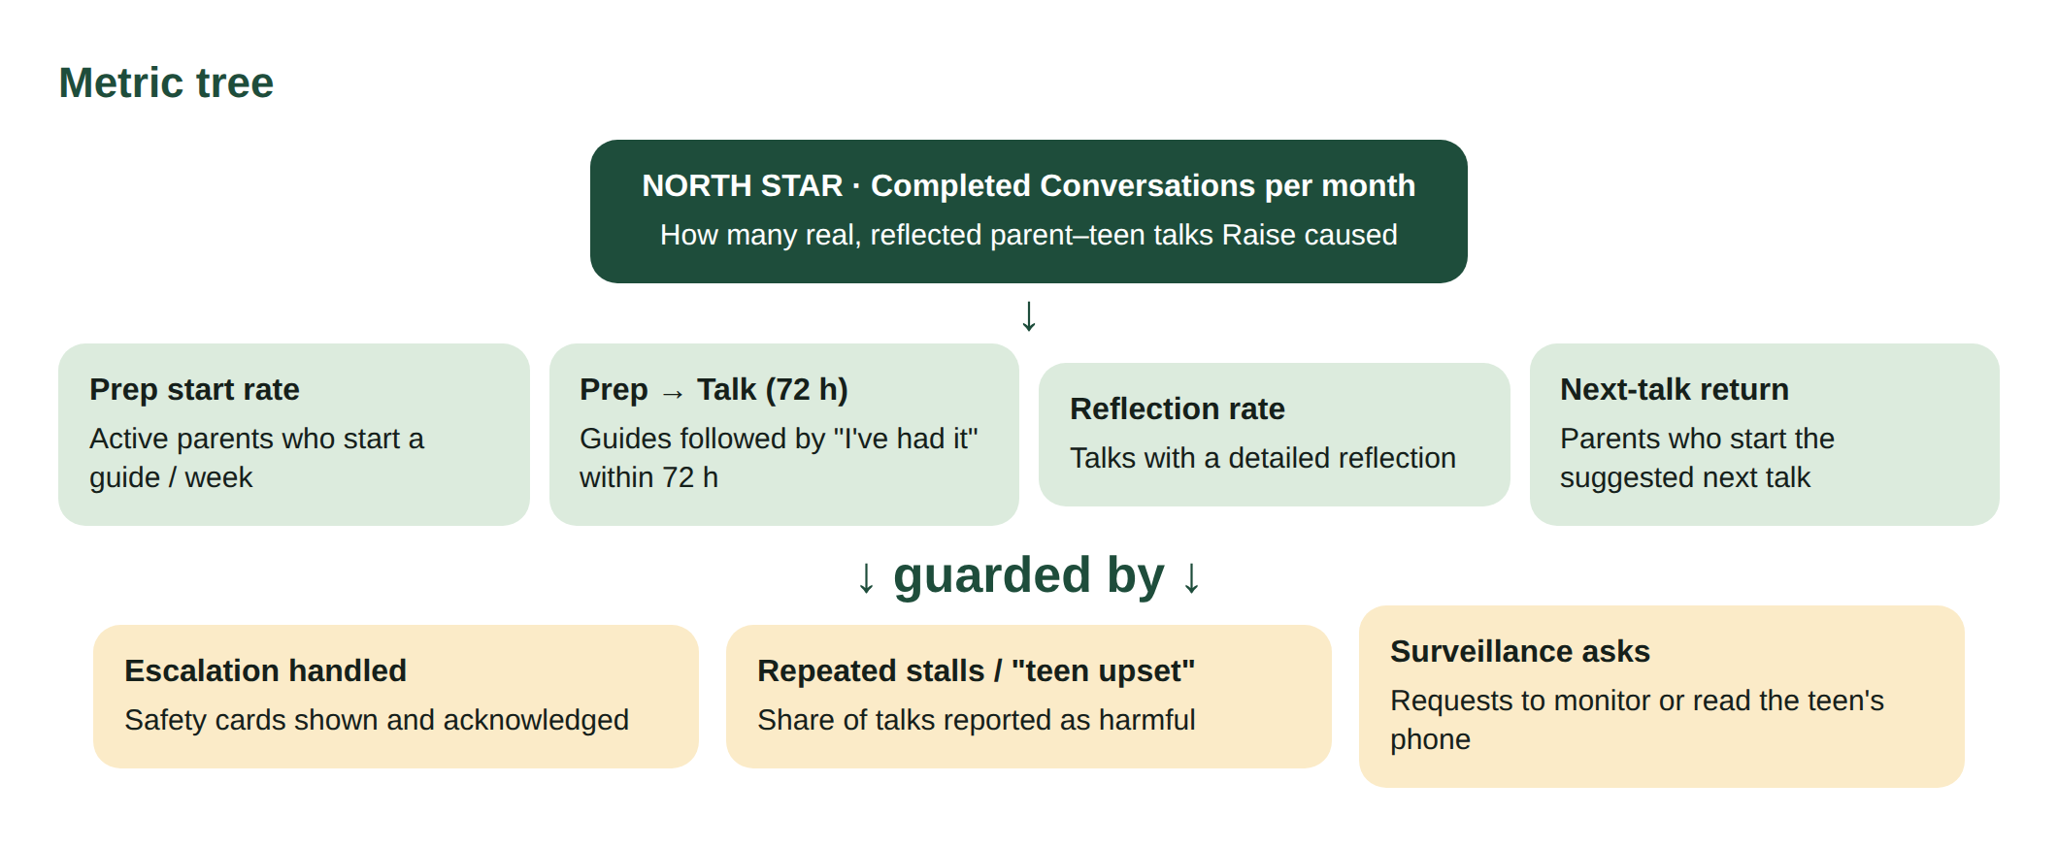
Figure 9.1 — Metric tree: North Star, leading indicators and guardrails

9.3 Leading indicators
Indicator | Why it predicts the North Star
Prep → Talk 72h | The target behaviour from Section 5.3 — the strongest predictor of CCs
Prep completion rate | A parent who reaches the pocket card has the words; drop-off shows which step is too long
Same-day reflection rate | Fresh reflections give better next-talk advice and show the loop is forming
Next-talk start within window | The habit signal: one talk becoming many
Topics covered per family | Breadth shows parents moving from easy (money) to hard (porn, consent) topics

9.4 Guardrail metrics — how we would know Raise is doing harm
We would say the product is doing harm if any of these move the wrong way. Thresholds are [ASSUMPTION — validate before use] and should be agreed before the pilot.
Guardrail | Harm it signals | Action if breached
Escalation miss rate — risk notes where no safety card was shown (from audit sample) | A child at risk and a parent left without help | Any miss = stop and fix the rule; review all notes from the period
Repeated-stall rate — 3+ stalls in a row with the same teen | Raise is pushing a family into talks that are hurting the relationship | Review that topic’s content; show “take a break” prompt earlier
“Teen got upset” reports (new chip) | Scripts landing as manipulation or pressure | Pause the opener; expert review
Monitoring requests in feedback | Parents using Raise as a control tool | Reinforce “no monitoring” copy; never build it
Time in app per CC rising | App becoming a substitute for talking | Shorten prep; cut content
Uninstall within 48 h of a stalled reflection | Raise made the parent feel worse after trying | Rewrite stall insights; follow-up message
Content complaints per 100 guides | Advice that is wrong, offensive or culturally off | Pull item; review within [NEEDS INPUT: SLA]

9.5 One planned experiment — “Pick your moment”
Element | Plan
Hypothesis | If parents choose a specific moment for the talk at the end of prep (tonight at dinner, next car ride, weekend walk), more of them will start within 72 hours — because a concrete plan closes the intention–action gap (I11).
Variant | After the Ready step: “When will you try it?” with 4 options and one reminder at that time.
Control | Current flow: “I’ve had the conversation” / “Not yet — save for later”.
Primary metric | Prep → Talk 72h
Secondary | CCR (7-day); share of reflections that are “Went well” or “Unexpected”
Guardrails | Reminder opt-out rate; “Save for later” after reminder; repeated-stall rate
Sample and duration | [NEEDS INPUT: baseline Prep → Talk rate from pilot] → sample size per arm; run at least 4 weeks to cover weekends and exam weeks
Decision rule | Ship if Prep → Talk improves by at least [TARGET NEEDED] with no guardrail worse; otherwise keep control and test a different nudge
Dependency | Reminders need push or WhatsApp — not possible on the current GitHub Pages build. Run after the app wrapper is in place

9.6 User feedback
No user feedback collected yet
[NEEDS INPUT: feedback from pilot parents]. Plan: 5 moderated walkthroughs of the live prototype (think-aloud), then a 2-week diary pilot. Capture per parent: where they hesitated, which opener they used, whether they talked, what the teen said (parent’s words), and one thing they’d change.

Parent | Topic tried | Talked? (Y/N) | Quote | Change requested
[NEEDS INPUT]
[NEEDS INPUT]
[NEEDS INPUT]

10. GTM and Habit Loop

10.1 GTM plan (one page)
Beachhead | Parents of Class 9–12 students in [NEEDS INPUT: launch city], reached through schools. Teens 14–19 map to Class 9 to first year of college.
Positioning | For parents who keep putting off the big talks, Raise is the five-minute prep before the conversation — unlike articles that tell you why, or control apps that watch your teen, Raise tells you what to say first and what to do next.
Price | Free during pilot and V1 [ASSUMPTION — validate before use]; test willingness to pay after the habit is proven.
Channel 1 — Schools | Partner with school counsellors; a QR card handed out at parent–teacher meetings: “Before the next PTM, have one talk.”
Channel 2 — WhatsApp parent groups | Forwardable single-topic cards (e.g. three money openers) that link into the matching prep guide.
Channel 3 — Trusted experts | Paediatricians, adolescent clinics and counsellors recommend Raise as homework between visits.
Channel 4 — Creators | Hindi/Hinglish parenting creators demonstrate one real opener on camera.
Channel 5 — Workplaces | Employee-wellness talks for parents aged 35–60 at companies.
Moments | New school year, board-exam season, news of online scams — each with a matching prep guide.
Phases | 1) Pilot: [NEEDS INPUT: number] parents from personal network → 2) Two partner schools → 3) City-wide via schools and creators.
Success per channel | Sign-ups, activation (first CC within 7 days), cost per activated parent.

10.2 Habit loop
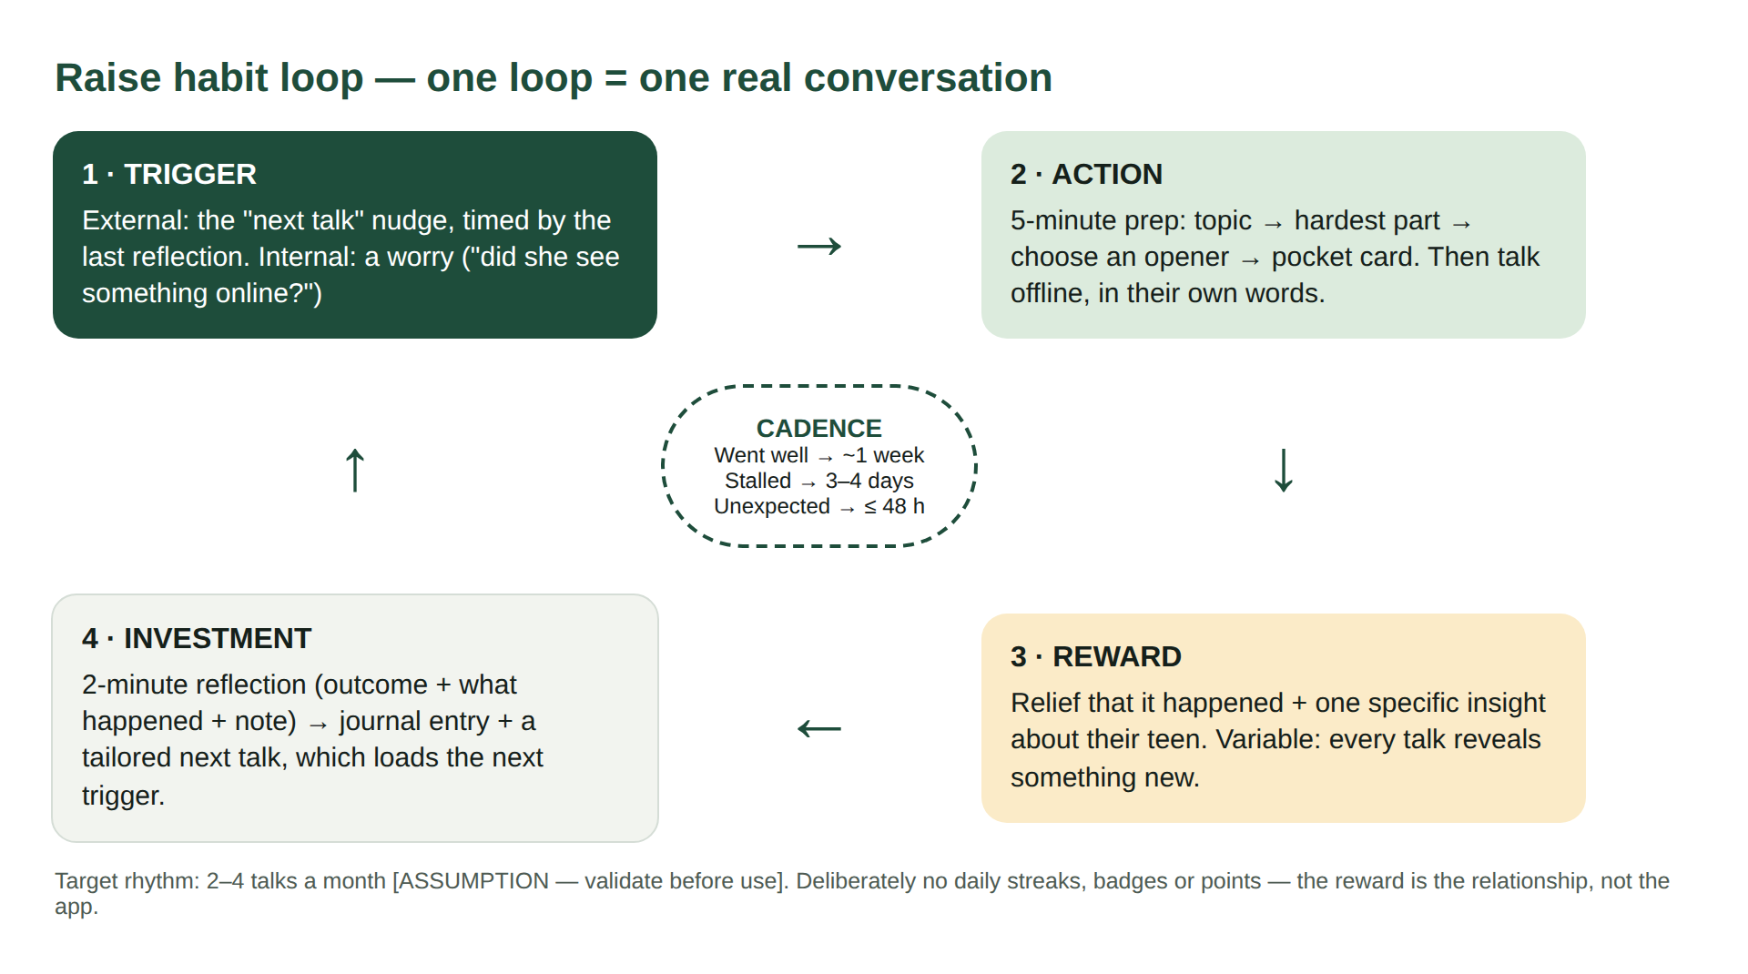
Figure 10.1 — Raise habit loop: trigger, action, reward, investment, cadence
Part | In Raise
Trigger | External: the next-talk nudge, timed by the last reflection. Internal: a worry about the teen.
Action | Five-minute prep, then the talk offline.
Reward | Relief, plus one specific insight about the teen. Variable — each talk reveals something different.
Investment | Two-minute reflection; it builds the journal and personalises the next talk.
Cadence | Set by the outcome: ~1 week after a good talk, 3–4 days after a stall, within 48 hours after a surprise. Target 2–4 talks a month [ASSUMPTION — validate before use]. No daily streaks.

10.3 The pitch — 20–30 seconds
“You know that talk you keep putting off with your teen — about their body, their phone, money or relationships? Raise gives you five minutes of preparation: the first sentence to say, what they might ask back, and what to avoid. Then you talk — offline, in your own words. Afterwards, two minutes to reflect, and Raise tells you what to try next. Your teen never sees the app. Want to try one talk this week?”
(About 75 words — roughly 25–30 seconds spoken.)

10.4 User acquisition log
No acquisition activity has been run yet; the planned activities are filled in and results are left for real data.
# | Channel | Planned activity | Reached | Sign-ups | First CC | Learning
1 | Personal network | Send pitch + link to parents of teens | [NEEDS INPUT] | [NEEDS INPUT] | [NEEDS INPUT]
2 | WhatsApp group | Post a money-openers card in one class group | [NEEDS INPUT] | [NEEDS INPUT] | [NEEDS INPUT]
3 | School counsellor | Demo to one counsellor; ask for PTM QR card | [NEEDS INPUT] | [NEEDS INPUT] | [NEEDS INPUT]
4 | Paediatrician | Leave-behind card at one adolescent clinic | [NEEDS INPUT] | [NEEDS INPUT] | [NEEDS INPUT]
5 | Creator | One creator demonstrates an opener | [NEEDS INPUT] | [NEEDS INPUT] | [NEEDS INPUT]

10.5 Churn plan
Churn point | Signal | Response
Never started | Signed up, no guide in 48 h | One message: “Start with the easiest one — money.” Deep link straight to the money guide.
Prepared, never talked | Guide finished, “save for later”, no talk in 72 h | Offer a shorter, lighter opener and “pick your moment”. Remind them a 5-minute talk counts.
Talked once, stalled, left | Stalled reflection, no return in 7 days | Stall-specific note: “A stall isn’t failure — most talks take a few tries.” Suggest a side-by-side setting.
“Done” — covered all topics | All six topics completed | New life moments: board exams, first job, first relationship, leaving home. Revisit topics at the next age band.
Privacy worry | Deletes journal or asks about data | Clear data page; one-tap delete; notes stay private; nothing about the teen beyond a first name.
Rule for all win-backs | — | At most two messages, then stop. Respecting a parent’s silence is part of the product’s values.

11. Risks, Trade-offs and Concerns

11.1 Risk table
Likelihood and impact are team judgements [ASSUMPTION — validate before use].
Risk | Likelihood | Impact | Mitigation
A disclosure of grooming, abuse or self-harm comes up and the parent gets a normal “insight” | Medium | Very high | F10 escalation cards in V1; human review of escalation rules; helplines re-verified quarterly
Harmful, wrong or outdated advice in the library | Medium | High | Content engine gate + mandatory expert review + quarterly cycle + complaint path
Sensitive notes about a minor are leaked | Low | Very high | Store as little as possible; encrypt notes; one-tap delete; no teen data beyond a first name; review against India’s Digital Personal Data Protection Act 2023 [NEEDS INPUT: legal review]
Parent recites the opener robotically; teen feels manipulated | Medium | High | “Say it your way” framing; openers ≤ 40 words (rule R9); “Teen got upset” guardrail
Parents use Raise to control rather than connect | Medium | High | No monitoring features, ever; content coaches against secret phone checks
Teen discovers the app and feels scripted | Medium | Medium | Coach honesty: “I prepared because this matters to me”
Cultural or religious objection to porn and consent topics | Medium | Medium | Parent chooses topics; respectful, non-explicit tone; Hindi copy reviewed by parents
Low retention after the first talk | High | High | Next-talk loop, outcome-based cadence, pick-your-moment experiment
Self-reported metric overstates real talks | Medium | Medium | Three gates, no rewards for faking, ground-truth sample in V2
Age-band mismatch (built 11–18 vs target 14–19) | High (exists today) | Medium | Change bands to 14–15, 16–17, 18–19 before pilot
Small team cannot sustain content review | High | Medium | Keep library small (6 topics); review panel with fixed quarterly hours

11.2 Trade-offs and rationale
We chose | Over | Because | What we gave up
Parent-only app | A shared parent–teen app | Teens would not use an app their parent installed; trust matters more than data | Any direct check that a talk happened
Curated, rule-checked library | Generative AI advice | Safety and explainability on topics involving minors | Deep personalisation
6 topics, done well | Many topics | Each topic needs expert review; quality beats breadth | Coverage of exam stress, bullying, substances
Self-report with gates | Verified outcomes | The talk is offline and private by design | A metric we can call “proven”
No streaks or points | Gamified engagement | Rewards invite faking and turn a relationship into a score | An easy retention lever
English first, Hindi in V2 | Bilingual at launch | Speed to test the loop | Some of the parents with the biggest vocabulary gap
Mobile web on GitHub Pages | Native app | Fastest way to put a working loop in parents’ hands | Push reminders — blocks the planned experiment until wrapped

11.3 One honest reflection — a decision I’m unsure about
Keeping the teen completely out of the product
I made Raise parent-only because I believe a teen would never trust an app their parent installed, and because “Your teen never sees this app” makes the promise simple. I still think that is right for V1.
But it means the one person who knows whether the talk helped — the teen — has no voice in the product. Every number I report is the parent’s account of the parent’s own effort. A parent who feels a talk “went well” after lecturing for twenty minutes will tell Raise it went well, and Raise will suggest the next topic.
I’m not sure the ground-truth teen sample in V2 is enough. The test I’d want to run: if a small, consented sample of teens disagrees with parents’ reflections more than [NEEDS INPUT: threshold] of the time, I would revisit the decision — perhaps a teen-side “one question” link the parent can choose to share, never required.
(Draft in the author’s voice — rewrite in your own words before submitting.)

11.4 Written guardrails for AI guidance and escalation
V1 contains no generative AI. These guardrails apply from the moment any model is used — for example the V2 rephrasing feature.

Scope
- AI may only select, order and lightly rephrase items from the approved library to fit the parent’s situation. It may not invent new advice on the six topics.
- Every AI output passes the same content-engine rules as human-written content before it is shown.

AI must never
- Diagnose, label or suggest medication for the teen or parent.
- Suggest secret monitoring, phone checking, tracking or reading messages.
- Produce sexually explicit material, or describe sexual acts.
- Give legal advice, or advise confronting a suspected abuser or online contact.
- Speak as, or role-play, the teen; or address the teen directly.
- State statistics without a source in the approved library.
- Promise outcomes (“this will fix it”) or confidentiality the product can’t guarantee.

AI must always
- Show “Guidance, not professional advice” on generated text.
- Stop generating and show the matching escalation card the moment a Level 2 or 3 trigger appears (Section 6.5).
- Log inputs and outputs for audit without storing the teen’s name or the parent’s free-text notes in the log.
- Fall back to the unedited library item if the output fails any rule.

Human escalation
- Every escalation card shown is reviewed weekly by the content owner to check the rule fired correctly. [NEEDS INPUT: owner]
- Any missed escalation found in audit is treated as a severity-1 incident: rule fixed, period reviewed, change logged.
- Raise never contacts authorities or the teen on the parent’s behalf; it gives the parent the right number and the next safe step.

Sources
ID | Reference | Link
S1 | Parents’ Views on Provision of Information and Education of Sex Related Issues to the Adolescents. Pediatric Oncall Journal. | https://www.pediatriconcall.com/pediatric-journal/view-article/819
S2 | Sexuality education — do our children need it? Perspective of parents from coastal South India. Manipal Academy of Higher Education (Sex Education journal). | https://researcher.manipal.edu/en/publications/sexuality-educationdo-our-children-need-it-perspective-of-parents/
S3 | How to talk to your child about sex (ParentCircle–IMRB Nationwide Survey, 2015). ParentCircle. | https://www.parentcircle.com/how-to-talk-to-child-about-sex/article
S4 | Exposure to pornographic content among Indian adolescents and young adults and its associated risks: Evidence from UDAYA survey in Bihar and Uttar Pradesh. Population Council / Archives of Sexual Behavior 52(1). | https://knowledgecommons.popcouncil.org/focus_adolescents/80
S5 | “What We Think About Them?” — perception of parents and teachers about adolescent upbringing in coastal Karnataka. Manipal Academy of Higher Education. | https://researcher.manipal.edu/en/publications/what-we-think-about-them-a-qualitative-study-addressing-perceptio/
S6 | A Father’s Anger, A Teacher’s Quiet Class: Inside India’s Slow Crawl Towards Sex Education. Outlook India. | https://www.outlookindia.com/national/a-fathers-anger-a-teachers-quiet-class-inside-indias-slow-crawl-towards-sex-education
S7 | This Start-Up Is Addressing India’s Dire Need For Proper Sex Education (UnTaboo). Homegrown. | https://homegrown.co.in/amp/story/homegrown-explore/this-start-up-is-addressing-indias-dire-need-for-proper-sex-education
S8 | Joshi, Gupta & Mukherjee (2024). A study on the perception of parents on delivery of sex education in India. Cogent Education 11(1). | https://doi.org/10.1080/2331186X.2024.2408508
Helpline numbers used in escalation rules (Childline 1098, National Cyber Crime Helpline 1930 / cybercrime.gov.in, Tele-MANAS 14416, emergency 112) must be re-verified on official government sites before launch.

