Table of Contents
TASK 1: SQL Benchmark Dataset Preparation and Evaluation Design 2
TASK 2: Query Understanding (Decomposition Task) 4
TASK 3: Text-to-SQL Pipeline and Query Execution System 8
TASK 4:Mini SQL Agent (Agentic System Task) 10

Submitted by:
Shukrina Koju

TASK 1: SQL Benchmark Dataset Preparation and Evaluation Design

1. Objective
The purpose of this framework is to measure the performance, reliability, and accuracy of the Text-to-SQL agent. We aim to move beyond "it seems to work" to a quantifiable score that tells us if the agent is production-ready.

2. Primary Metrics (The "Gold Standards")

A. Execution Accuracy (EX)
- Definition: Does the result of the AI’s generated query match the result of the Ground Truth query exactly?
- Measurement: We run both queries on the same database. If the output tables (rows and columns) are identical, it is a Pass.
- Why it matters: This is the most important metric. Even if the SQL looks different, the data returned must be correct.

B. SQL Correctness (Syntax & Logic)
- Definition: Is the generated SQL syntactically valid for PostgreSQL?
- Measurement: Percentage of queries that execute without throwing a database error.
- Why it matters: An agent that generates "broken" code is not useful.

C. Schema Alignment
- Definition: Did the agent select the correct tables and columns?
- Measurement: We check if the AI used "productName" instead of guessing "name".
- Why it matters: It tests the Agent's "understanding" of our specific database schema.

3. Advanced Agentic Metrics

D. Join Correctness
- Definition: For complex questions involving multiple tables, did the agent identify the correct relationship? (e.g., using officeCode to link employees to offices).
- Measurement: Check if the query contains the correct JOIN and ON clauses.

E. Self-Correction / Retry Performance
- Definition: If the first query attempt fails (e.g., due to a case-sensitivity error), can the agent read the error message and fix itself?
- Measurement: We track "Pass @ 1" (success on first try) vs. "Pass @ 2" (success after one correction).

F. Robustness to Ambiguity
- Definition: How does the agent handle a question like "Who are the best customers?"
- Evaluation: Does the agent assume "best" means most orders, or highest payment total? A "good" agent might choose one and explain its logic, or ask a clarifying question.

4. Performance & UX Metrics

G. Query Execution Time (Latency)
- Definition: The time elapsed from the user asking the question to the final answer being displayed.
- Benchmark: Ideally < 3 seconds for simple queries and < 10 seconds for complex aggregations.

H. Natural Language Answer Quality
- Definition: The agent shouldn't just return a table; it should explain the result.
- Measurement: Does the agent say: "The total revenue is $8.9M" instead of just showing a number?

5. How to Conduct the Evaluation (Methodology)
To evaluate the system in Task 3 and 4, we will use the following process:
- Input: Feed the 50 Natural Language questions from Task 1 into the AI Agent.
- Capture: Store the SQL generated by the AI and the result it returns.
- Compare: Use a script or manual check to compare the AI's result against our Ground Truth results from Task 1.
- Scorecard:
  - Success: Matches Ground Truth exactly.
  - Partial: Correct data, but perhaps formatted differently or missing a column.
  - Failure: Wrong data, syntax error, or hallucinated columns.

TASK 2: Query Understanding (Decomposition Task)

# | Question | Intent | Tables Involved | Columns Needed | Filters/Conditions | Joins
1 | List all products | Retrieve all product records | products | * | None | None
2 | Get all customers | Retrieve all customer records | customers | * | None | None
3 | Show all orders | Retrieve all order records | orders | * | None | None
4 | List all employees | Retrieve all employee records | employees | * | None | None
5 | Get all offices | Retrieve all office records | offices | * | None | None
6 | Show all product lines | Retrieve all product line categories | productlines | * | None | None
7 | List all payments | Retrieve all payment transactions | payments | * | None | None
8 | Get product names and prices | Retrieve names and costs of items | products | productName, buyPrice | None | None
9 | Get customer names and cities | Retrieve names and locations of clients | customers | customerName, city | None | None
10 | List employee first and last names | Retrieve staff names | employees | firstName, lastName | None | None
11 | Get all order dates | Retrieve dates when orders occurred | orders | orderDate | None | None
12 | Show product vendor list | List unique suppliers | products | productVendor | None (Distinct) | None
13 | Get all product codes | Retrieve primary IDs for products | products | productCode | None | None
14 | List all countries from offices | List unique office locations | offices | country | None (Distinct) | None
15 | Show all order statuses | List unique states of orders | orders | status | None (Distinct) | None
16 | Get all payment amounts | Retrieve all transaction values | payments | amount | None | None
17 | List all job titles | List unique staff roles | employees | jobTitle | None (Distinct) | None
18 | Get customer phone numbers | Retrieve client contact info | customers | customerName, phone | None | None
19 | Show product MSRP values | Retrieve item retail prices | products | productName, MSRP | None | None
20 | List order numbers | Retrieve all order IDs | orders | orderNumber | None | None
21 | Get orders with customer names | Link orders to specific customers | orders, customers | orderNumber, customerName | None | orders.customerNumber = customers.customerNumber
22 | Get employees with office city | Link staff to their office location | employees, offices | firstName, lastName, city | None | employees.officeCode = offices.officeCode
23 | Get payments with customer names | Link payments to specific clients | payments, customers | checkNumber, customerName | None | payments.customerNumber = customers.customerNumber
24 | Get order details with product names | List items in orders by name | orderdetails, products | *, productName | None | orderdetails.productCode = products.productCode
25 | Get products with product line description | Retrieve item category details | products, productlines | productName, textDescription | None | products.productLine = productlines.productLine
26 | Get customers with sales rep names | Link clients to their sales staff | customers, employees | customerName, firstName, lastName | None | customers.salesRepEmployeeNumber = employees.employeeNumber
27 | Get orders with customer city | Map order locations to customer cities | orders, customers | orderNumber, city | None | orders.customerNumber = customers.customerNumber
28 | Get employees and their manager | Identify reporting lines | employees | firstName (emp), firstName (mgr) | None | employees.reportsTo = employees.employeeNumber
29 | Get orderdetails with product vendor | Identify suppliers for ordered items | orderdetails, products | *, productVendor | None | orderdetails.productCode = products.productCode
30 | Get payments with customer country | Analyze payment origin by country | payments, customers | *, country | None | payments.customerNumber = customers.customerNumber
31 | Count customers per country | Calculate client density by nation | customers | country, customerNumber | Group by country | None
32 | Total payments per customer | Sum transaction value per client | payments | customerNumber, amount | Group by customerNumber | None
33 | Number of orders per status | Count orders by their stage | orders | status, orderNumber | Group by status | None
34 | Products per product line | Count inventory items by category | products | productLine, productCode | Group by productLine | None
35 | Employees per office | Count staff headcount per location | employees | officeCode, employeeNumber | Group by officeCode | None
36 | Total stock per product vendor | Sum inventory volume by supplier | products | productVendor, quantityInStock | Group by productVendor | None
37 | Average buy price per product line | Calculate mean cost per category | products | productLine, buyPrice | Group by productLine | None
38 | Orders per customer | Count order frequency per client | orders | customerNumber, orderNumber | Group by customerNumber | None
39 | Max MSRP per product line | Find highest retail price per category | products | productLine, MSRP | Group by productLine | None
40 | Min buy price per vendor | Find lowest supply cost per vendor | products | productVendor, buyPrice | Group by productVendor | None
41 | Total number of customers | Calculate size of client base | customers | customerNumber | Count(*) | None
42 | Total number of products | Calculate size of product catalog | products | productCode | Count(*) | None
43 | Total revenue from payments | Calculate gross income | payments | amount | Sum(amount) | None
44 | Average product price | Calculate mean cost of items | products | buyPrice | Avg(buyPrice) | None
45 | Max payment amount | Find largest single transaction | payments | amount | Max(amount) | None
46 | Min payment amount | Find smallest single transaction | payments | amount | Min(amount) | None
47 | Count total orders | Calculate total sales volume | orders | orderNumber | Count(*) | None
48 | Total quantity in stock | Calculate total warehouse units | products | quantityInStock | Sum(quantityInStock) | None
49 | Average MSRP | Calculate mean retail price | products | MSRP | Avg(MSRP) | None
50 | Number of employees | Calculate total workforce size | employees | employeeNumber | Count(*) | None

TASK 3: Text-to-SQL Pipeline and Query Execution System
S.N. | Question | Generated SQL | Executed Successfully | Correct Result | Retry Needed | Final Status
1 | List all products | Yes | No | Yes | No | Success
2 | Get all customers | Yes | Yes | Yes | No | Success
3 | Show all orders | Yes | Yes | Yes | No | Success
4 | List all employees | Yes | Yes | Yes | No | Success
5 | Get all offices | Yes | Yes | Yes | No | Success
6 | Show all product lines | Yes | Yes | Fixed after retry | Yes | Success
7 | List all payments | Yes | Yes | Yes | No | Success
8 | Get product names and prices | Yes | Yes | Yes | No | Success
9 | Get customer names and cities | Yes | Yes | Yes | No | Success
10 | List employee first and last names | Yes | Yes | Yes | No | Success
11 | Get all order dates | Yes | Yes | Fixed after retry | Yes | Success
12 | Show product vendor list | Yes | Yes | Yes | No | Success
13 | Get all product codes | Yes | Yes | Yes | No | Success
14 | List all countries from offices | Yes | No | Yes | No | Success
15 | Show all order statuses | Yes | No | Yes | No | Success
16 | Get all payment amounts | Yes | No | Yes | No | Success
17 | List all job titles | Yes | No | Yes | No | Success
18 | Get customer phone numbers | Yes | No | Yes | No | Success
19 | Show product MSRP values | Yes | No | Yes | No | Success
20 | List order numbers | Yes | No | Yes | No | Success
21 | Get orders with customer names | Yes | No | Yes | No | Success
22 | Get employees with office city | Yes | No | Yes | No | Success
23 | Get payments with customer names | Yes | No | Yes | No | Success
24 | Get order details with product names | Yes | No | Yes | No | Success
25 | Get products with product line description | Yes | No | Yes | No | Success
26 | Get customers with sales rep names | Yes | No | Yes | No | Success
27 | Get orders with customer city | Yes | No | Yes | No | Success
28 | Get employees and their manager | Yes | No | Yes | No | Success
29 | Get orderdetails with product vendor | Yes | No | Yes | No | Success
30 | Get payments with customer country | Yes | No | Yes | No | Success
31 | Count customers per country | Yes | No | Yes | No | Success
32 | Total payments per customer | Yes | No | Yes | No | Success
33 | Number of orders per status | Yes | No | Yes | No | Success
34 | Products per product line | Yes | No | Yes | No | Success
35 | Employees per office | Yes | No | Yes | No | Success
36 | Total stock per product vendor | Yes | No | Yes | No | Success
37 | Average buy price per product line | Yes | No | Yes | No | Success
38 | Orders per customer | Yes | No | Yes | No | Success
39 | Max MSRP per product line | Yes | No | Yes | No | Success
40 | Min buy price per vendor | Yes | No | Yes | No | Success
41 | Total number of customers | Yes | No | Yes | No | Success
42 | Total number of products | Yes | No | Yes | No | Success
43 | Total revenue from payments | Yes | No | Yes | No | Success
44 | Average product price | Yes | No | Yes | No | Success
45 | Max payment amount | Yes | No | Yes | No | Success
46 | Min payment amount | Yes | No | Yes | No | Success
47 | Count total orders | Yes | No | Yes | No | Success
48 | Total quantity in stock | Yes | No | Yes | No | Success
49 | Average MSRP | Yes | No | Yes | No | Success
50 | Number of employees | Yes | No | Yes | No | Success

Some of the snippets of this task:
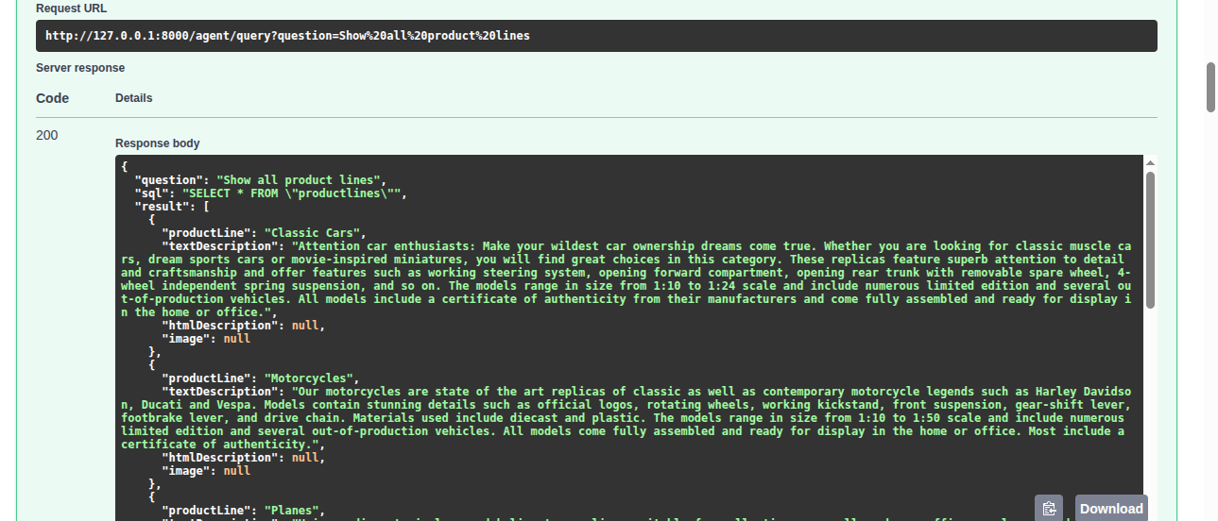
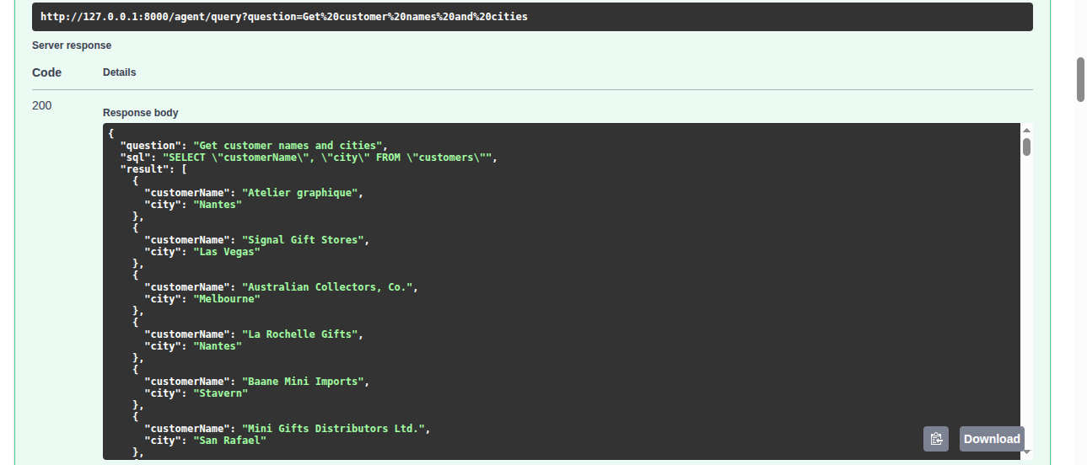
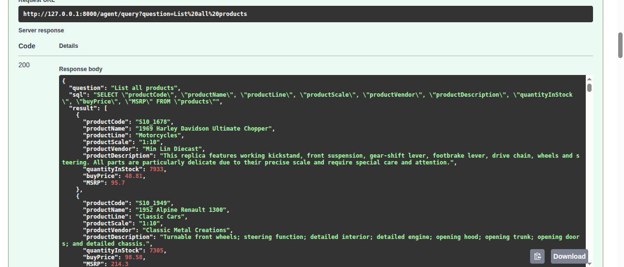

TASK 4:Mini SQL Agent (Agentic System Task)

Successful Retrieval:
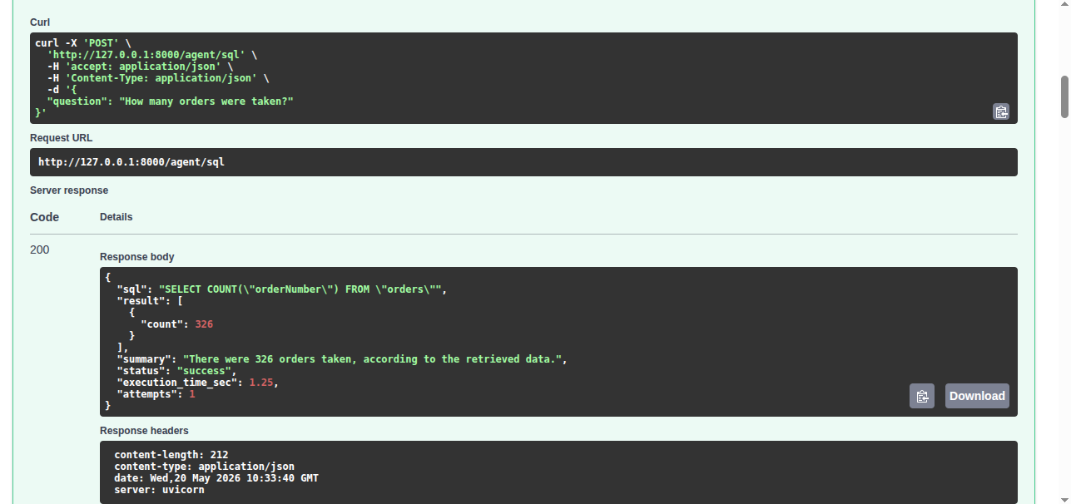
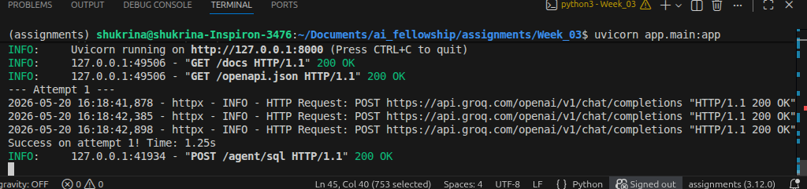

Unsuccessful Retrieval (Retry mechanism)
The agent correctly attempted to resolve the issue 3 times. Because the error was a '429 Resource Exhausted' from the API provider, the agent hit its maximum retry limit and returned a graceful fallback response to the user.
