S.N. | Natural Language Question | SQL Query | Explanation | Snippet
1 | List all products | SELECT * FROM products; | Retrieves every column and record from the products table to provide a full inventory list. | 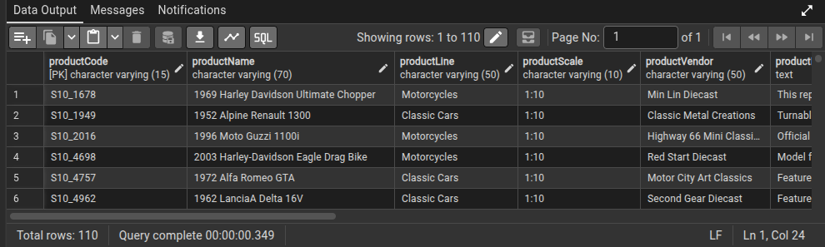
2 | Get all customers | SELECT * FROM customers; | Selects all data points for every customer registered in the customers table. | 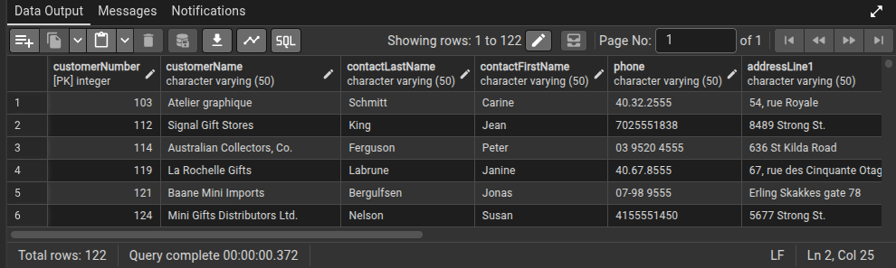
3 | Show all orders | SELECT * FROM orders; | Fetches all records from the orders table, showing order IDs, dates, and statuses. | 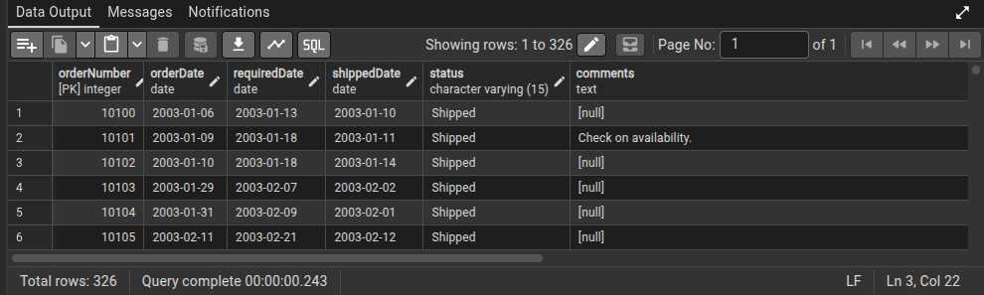
4 | List all employees | SELECT * FROM employees; | Retrieves the full profile for every staff member from the employees table. | 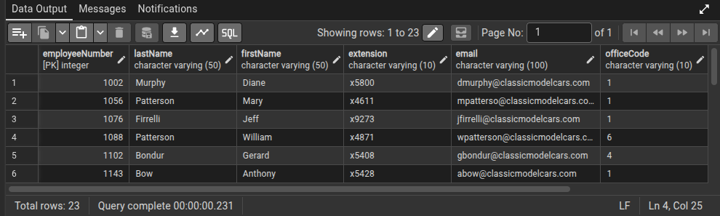
5 | Get all offices | SELECT * FROM offices; | Selects all information regarding physical office locations from the offices table. | 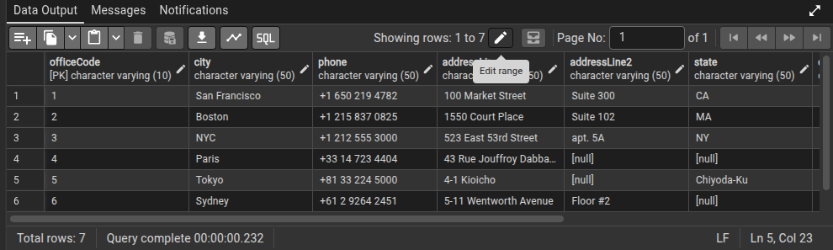
6 | Show all product lines | SELECT * FROM productlines; | Returns the categories and descriptions available in the productlines table. | 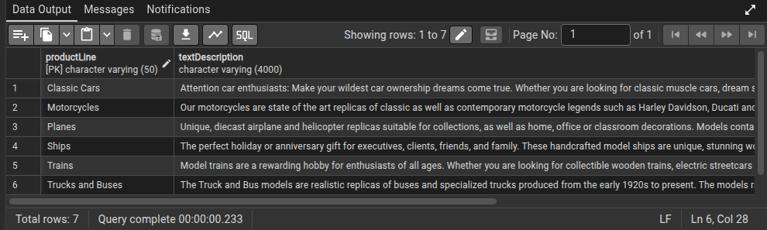
7 | List all payments | SELECT * FROM payments; | Provides a complete history of all financial transactions recorded in the payments table. | 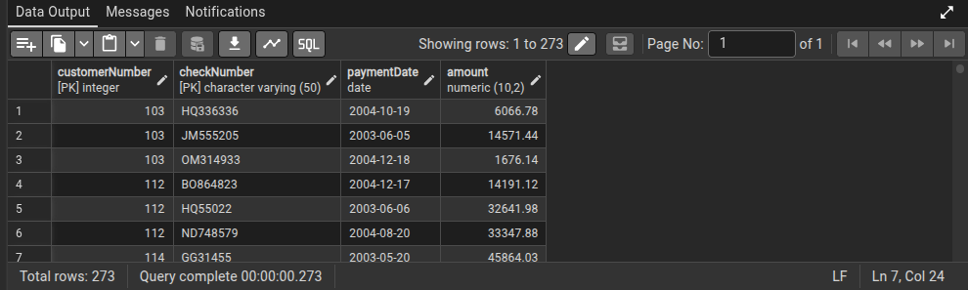
8 | Get product names and prices | SELECT "productName", "buyPrice" FROM products; | Projects specific columns (productName, buyPrice) from the products table for a price list. | 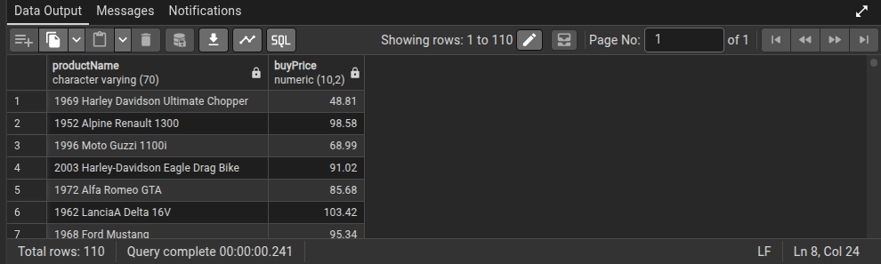
9 | Get customer names and cities | SELECT "customerName", "city" FROM customers; | Retrieves the company name and their physical city location from the customers table. | 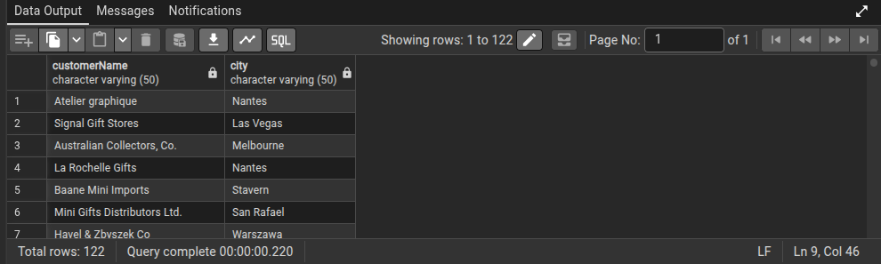
10 | List employee first and last names | SELECT "firstName", "lastName" FROM employees; | Selects only the name components of staff to create a simple directory from the employees table. | 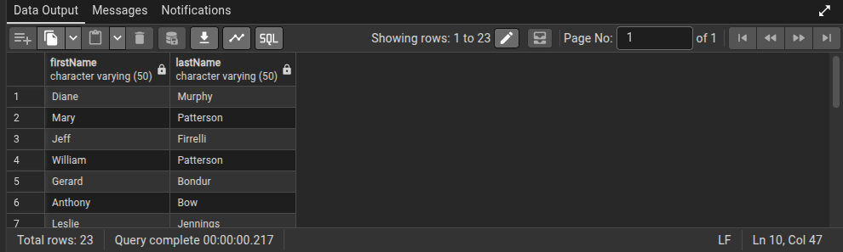
11 | Get all order dates | SELECT “orderDate” FROM orders; | Fetches the orderDate column from the orders table to analyze chronological activity. | 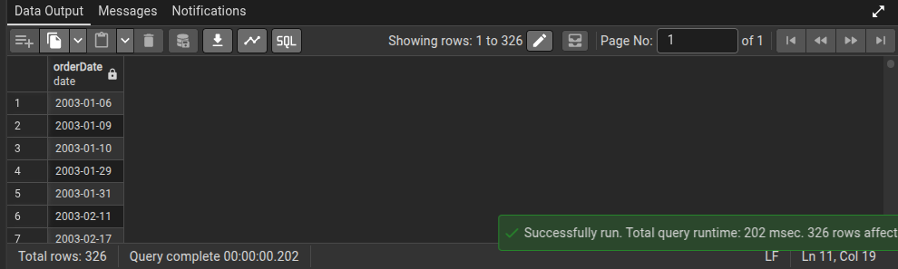
12 | Show product vendor list | SELECT DISTINCT "productVendor" FROM products; | Uses the DISTINCT keyword on the productVendor column to list unique suppliers without duplicates. | 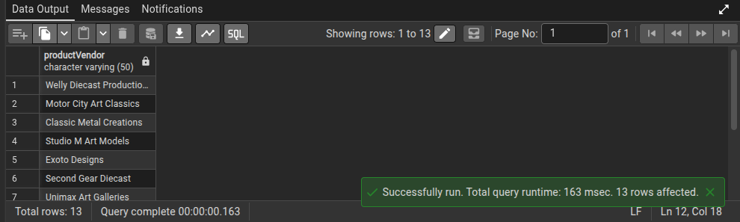
13 | Get all product codes | SELECT "productCode" FROM products; | Selects the primary key (productCode) for all items in the products table. | 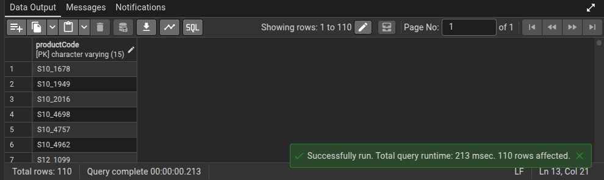
14 | List all countries from offices | SELECT DISTINCT country FROM offices; | Uses DISTINCT on the country column in the offices table to see where the company has a physical presence. | 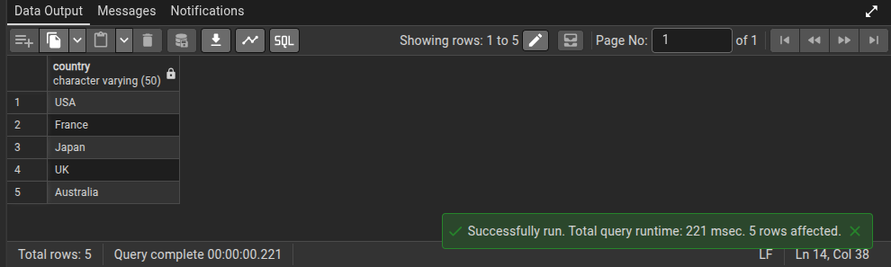
15 | Show all order statuses | SELECT DISTINCT status FROM orders; | Returns unique values (like 'Shipped', 'Pending') from the status column in the orders table. | 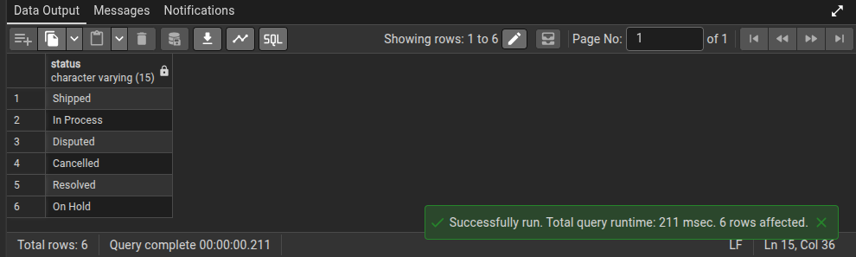
16 | Get all payment amounts | SELECT amount FROM payments; | Extracts the numerical value of every transaction from the payments table. | 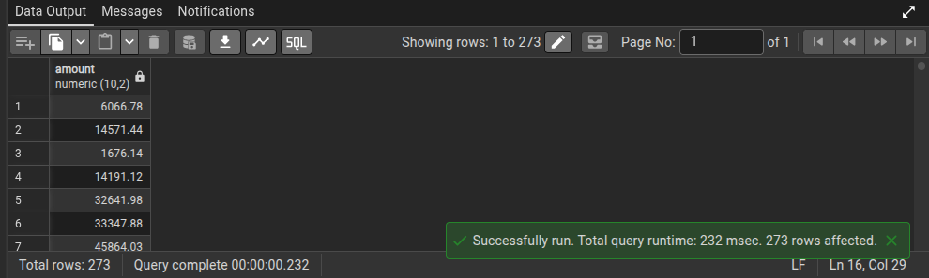
17 | List all job titles | SELECT DISTINCT "jobTitle" FROM employees; | Provides a unique list of all professional roles held by staff using DISTINCT on jobTitle. | 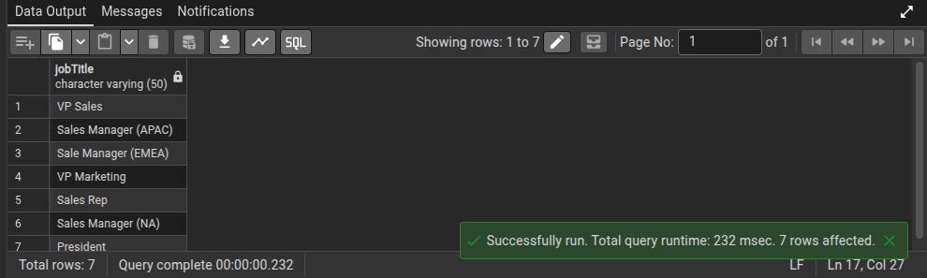
18 | Get customer phone numbers | SELECT "customerName", phone FROM customers; | Selects contact names and their corresponding phone numbers from the customers table. | 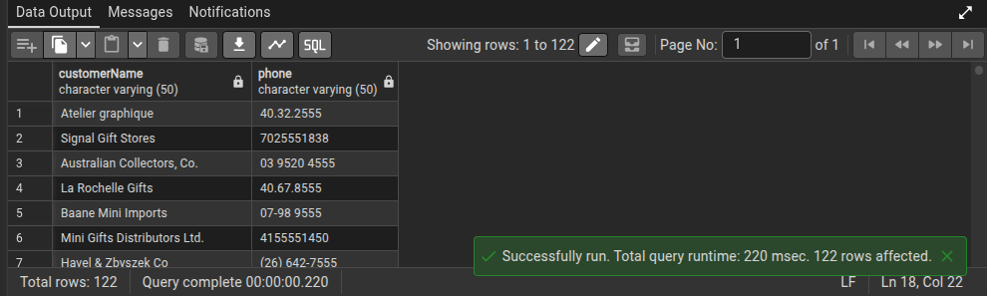
19 | Show product MSRP values | SELECT "productName", "MSRP" FROM products; | Retrieves the name and Manufacturer's Suggested Retail Price for all inventory items. | 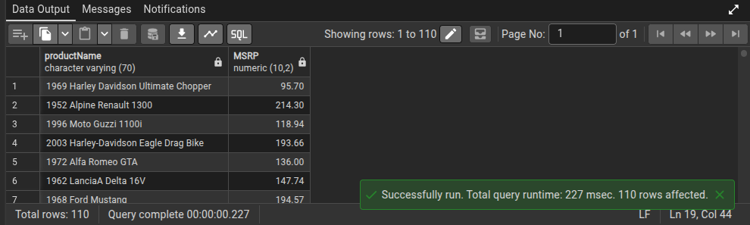
20 | List order numbers | SELECT “orderNumber” FROM orders; | Fetches the unique identification numbers for every order placed. | 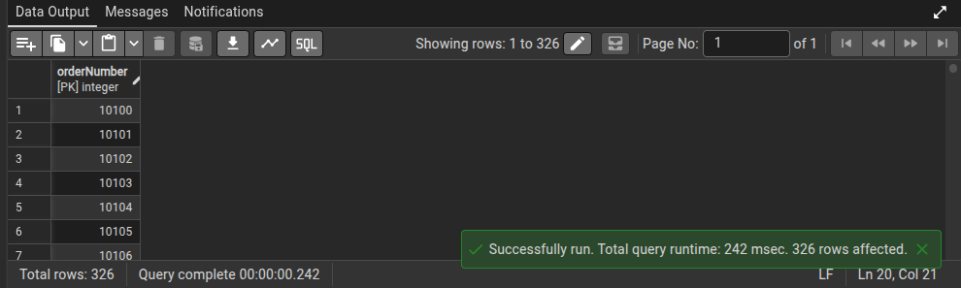
21 | Get orders with customer names | SELECT o."orderNumber", c."customerName" FROM orders o JOIN customers c ON o."customerNumber" = c."customerNumber"; | Performs an INNER JOIN between orders and customers using customerNumber to link orders to specific clients. | 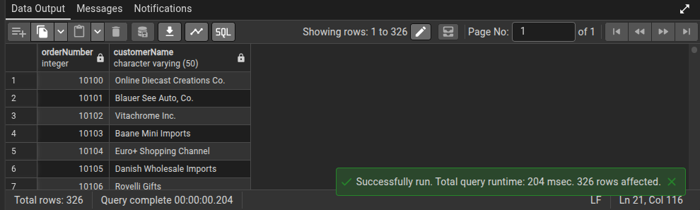
22 | Get employees with office city | SELECT e."firstName", e."lastName", o.city FROM employees e JOIN offices o ON e."officeCode" = o."officeCode"; | Joins the employees table with the offices table on officeCode to show where each employee is based. | 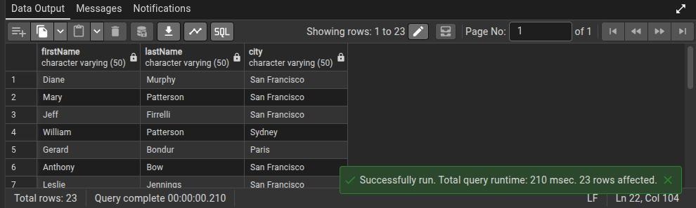
23 | Get payments with customer names | SELECT p."checkNumber", c."customerName" FROM payments p JOIN customers c ON p."customerNumber" = c."customerNumber"; | Links the payments table to customers to identify which client made each specific payment. | 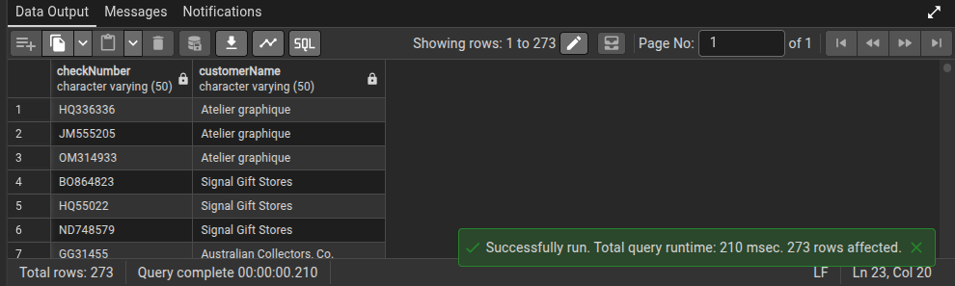
24 | Get order details with product names | SELECT od.*, p."productName" FROM orderdetails od JOIN products p ON od."productCode" = p."productCode"; | Joins orderdetails and products on productCode to show the actual name of items within specific orders. | 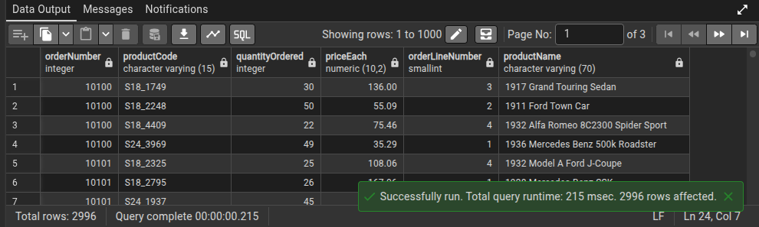
25 | Get products with product line description | SELECT p."productName", pl."textDescription" FROM products p JOIN "productlines" pl ON p."productLine" = pl."productLine"; | Joins products with productlines to provide the full text description of each product's category. | 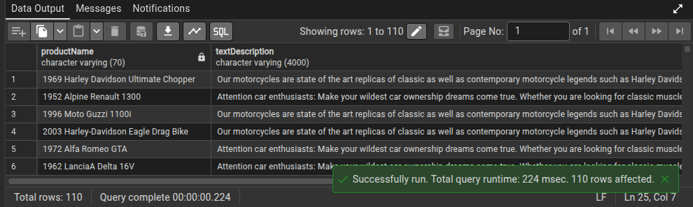
26 | Get customers with sales rep names | SELECT c."customerName", e."firstName", e."lastName" FROM customers c JOIN employees e ON c."salesRepEmployeeNumber" = e."employeeNumber"; | Links customers to the employees table to identify the specific sales representative assigned to each account. | 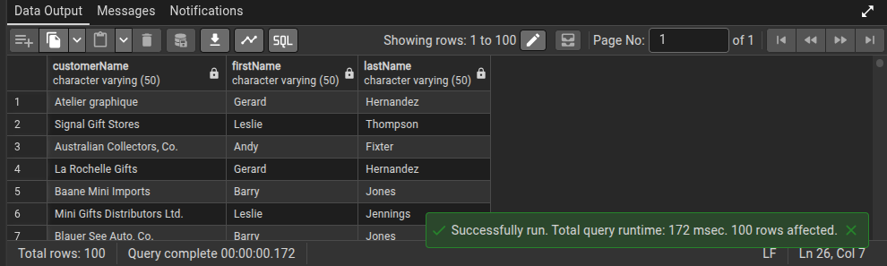
27 | Get orders with customer city | SELECT o."orderNumber", c.city FROM orders o JOIN customers c ON o."customerNumber" = c."customerNumber"; | Uses a join to retrieve the city where the customer is located for every order in the database. | 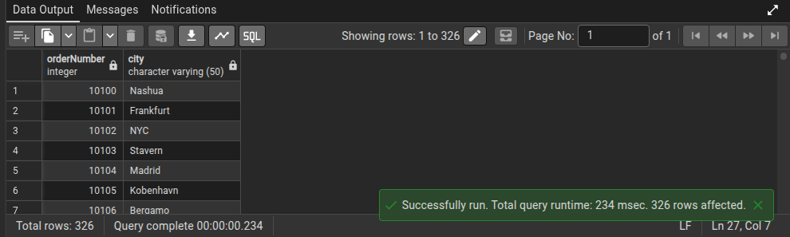
28 | Get employees and their manager | SELECT e."firstName" AS Employee, m."firstName" AS Manager FROM employees e LEFT JOIN employees m ON e."reportsTo" = m."employeeNumber"; | Uses a Self-Join on the employees table, matching reportsTo with employeeNumber to show staff/manager pairs. | 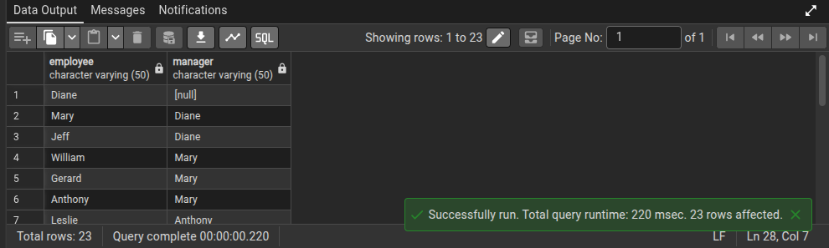
29 | Get orderdetails with product vendor | SELECT od.*, p."productVendor" FROM orderdetails od JOIN products p ON od."productCode" = p."productCode"; | Joins order line items with the products table to identify the supplier for each item sold. | 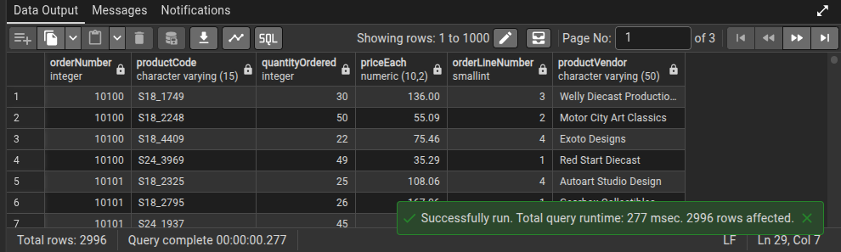
30 | Get payments with customer country | SELECT p.*, c.country FROM payments p JOIN customers c ON p."customerNumber" = c."customerNumber"; | Links payments to customers to analyze which countries are generating the most transaction records. | 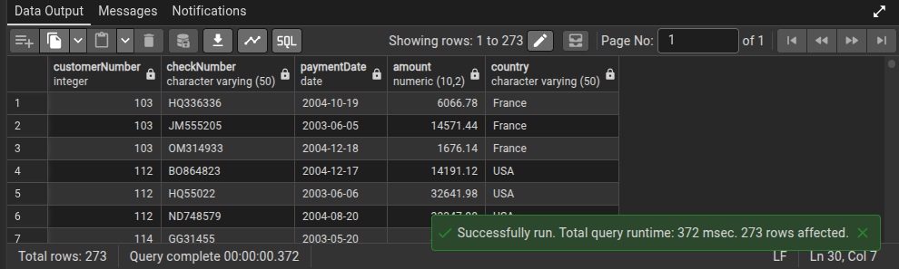
31 | Count customers per country | SELECT country, COUNT(*) FROM customers GROUP BY country; | Uses GROUP BY on the country column and COUNT(*) to find the total number of clients in each nation. | 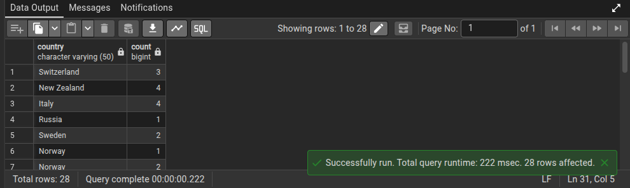
32 | Total payments per customer | SELECT "customerNumber", SUM(amount) FROM payments GROUP BY "customerNumber"; | Groups transactions by customerNumber and uses SUM(amount) to calculate the total lifetime value of each client. | 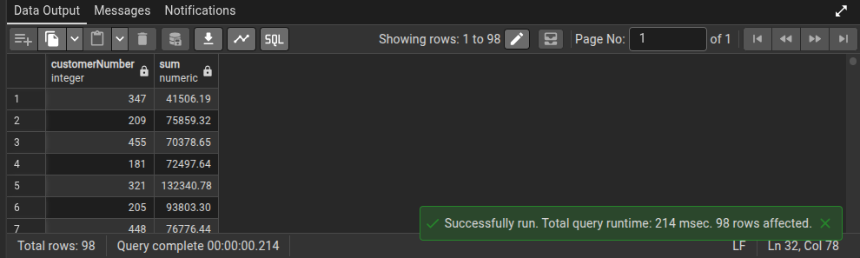
33 | Number of orders per status | SELECT status, COUNT(*) FROM orders GROUP BY status; | Uses GROUP BY status to count how many orders are currently 'Shipped', 'Cancelled', or 'In Process'. | 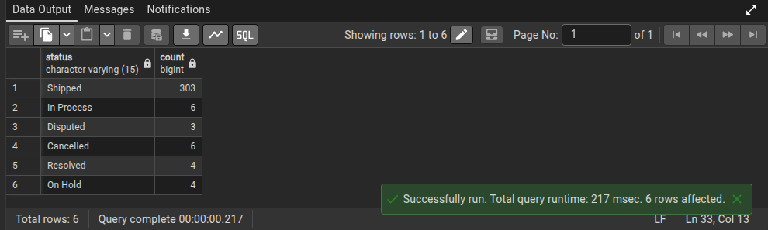
34 | Products per product line | SELECT "productLine", COUNT(*) FROM products GROUP BY "productLine"; | Groups the inventory by category and counts the number of distinct items in each line. | 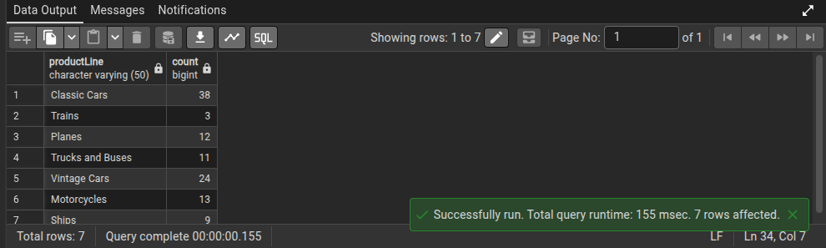
35 | Employees per office | SELECT "officeCode", COUNT(*) FROM employees GROUP BY "officeCode"; | Groups staff by their officeCode to see the headcount for each physical location. | 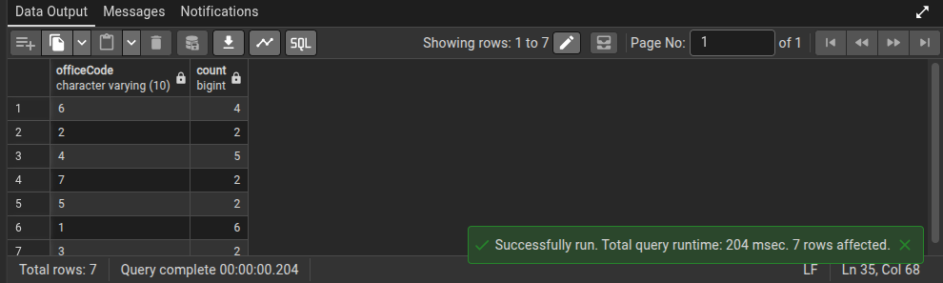
36 | Total stock per product vendor | SELECT "productVendor", SUM("quantityInStock") FROM products GROUP BY "productVendor"; | Groups by productVendor and uses SUM(quantityInStock) to see which supplier has the most volume. | 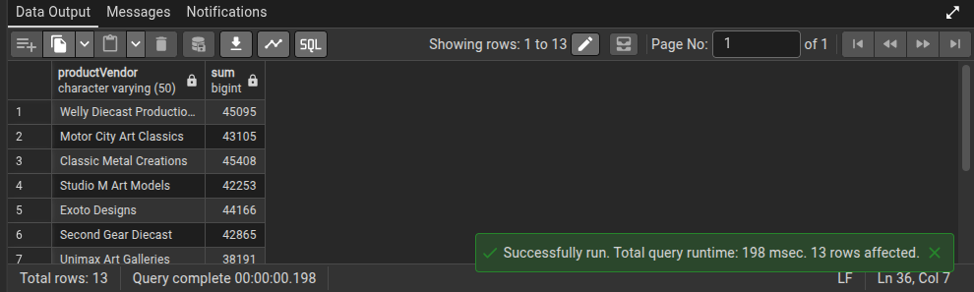
37 | Average buy price per product line | SELECT "productLine", AVG("buyPrice") FROM products GROUP BY "productLine"; | Calculates the AVG price of items grouped by their category to see which lines are most expensive to source. | 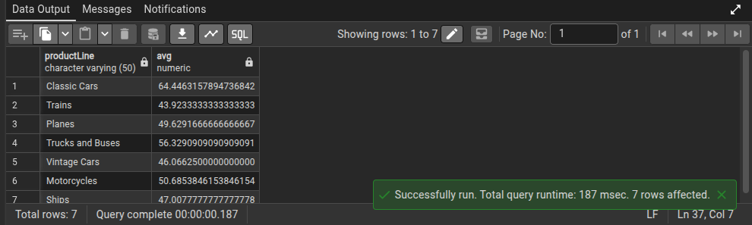
38 | Orders per customer | SELECT "customerNumber", COUNT(*) FROM orders GROUP BY "customerNumber"; | Groups by customerNumber and counts entries in the orders table to identify the most frequent buyers. | 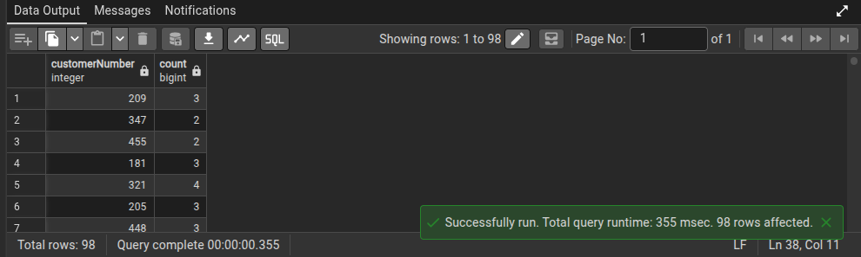
39 | Max MSRP per product line | SELECT "productLine", MAX("MSRP") FROM products GROUP BY "productLine"; | Finds the highest suggested retail price within each product category using the MAX function. | 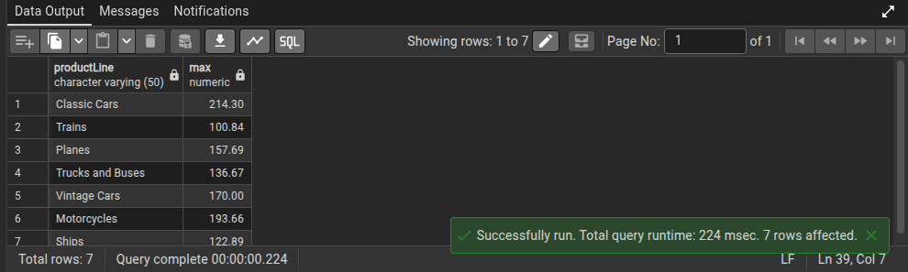
40 | Min buy price per vendor | SELECT "productVendor", MIN("buyPrice") FROM products GROUP BY "productVendor"; | Uses the MIN function grouped by vendor to find the cheapest item supplied by each vendor. | 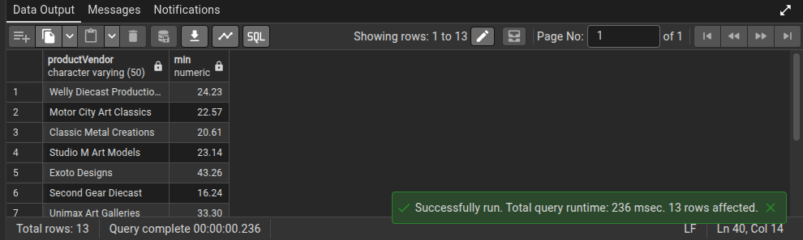
41 | Total number of customers | SELECT COUNT(*) FROM customers; | Uses the COUNT function on the entire customers table to get a grand total of the client base. | 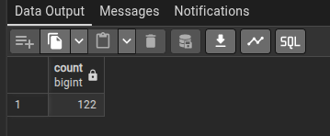
42 | Total number of products | SELECT COUNT(*) FROM products; | Performs a count of all records in the products table to find the size of the total catalog. | 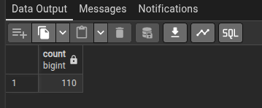
43 | Total revenue from payments | SELECT SUM(amount) FROM payments; | Applies the SUM function to the amount column in payments to calculate the company's total gross income. | 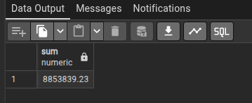
44 | Average product price | SELECT AVG("buyPrice") FROM products; | Calculates the mean value of the buyPrice column across the entire product catalog. | 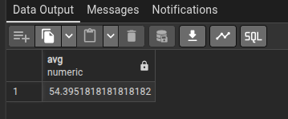
45 | Max payment amount | SELECT MAX(amount) FROM payments; | Uses the MAX function on the payments table to identify the largest single transaction ever made. | 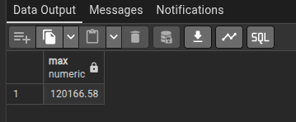
46 | Min payment amount | SELECT MIN(amount) FROM payments; | Uses the MIN function to find the smallest transaction record in the database. | 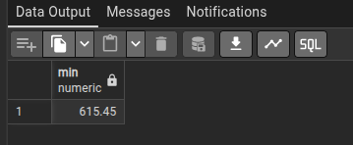
47 | Count total orders | SELECT COUNT(*) FROM orders; | Returns the total count of all rows in the orders table to measure total sales volume. | 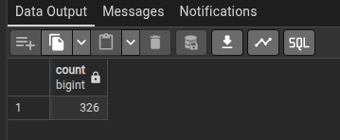
48 | Total quantity in stock | SELECT SUM("quantityInStock") FROM products; | Sums the quantityInStock column across all products to find the total units available in the warehouse. | 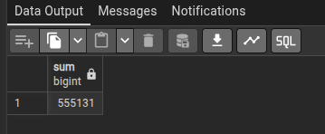
49 | Average MSRP | SELECT AVG("MSRP") FROM products; | Calculates the average Manufacturer's Suggested Retail Price across all products in the database. | 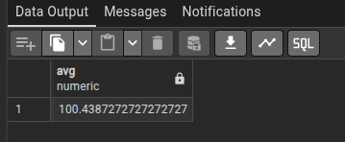
50 | Number of employees | SELECT COUNT(*) FROM employees; | Uses COUNT(*) on the employees table to determine the total size of the workforce. | 