1. Problem1

ADD school

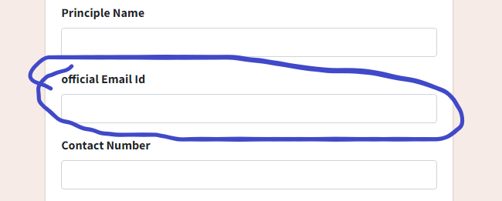

Edit School

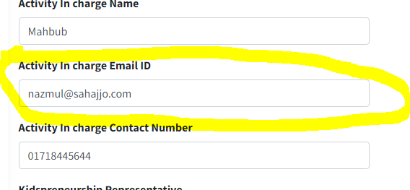

Both emails will be different or same? Please clear it. If different then we have to keep “official email id” input field at school edit.

Both should be editable. One will be school principal (official email ID) and one will be activity in charge teacher from school.

1. Problem2

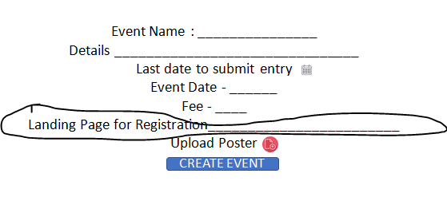

Here why use landing page please give description….

Because in student segment when students want to register… they will click on Register Now (as shown below) and it will go to the landing page specified in Landing Page for Registration during add event.

