**ASSIGN TRAINER & EDIT SCHEDULE**

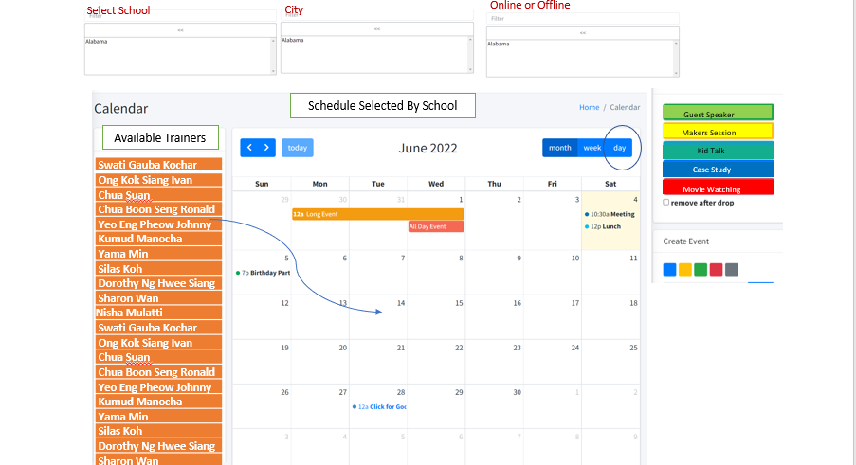

* On the top there will only be 3 sections Select school, City, Online or offline (remove topic).
* We can select school, city and mode of training (online or offline).
* Availability of trainers is dependent upon the city. So, if the mode is offline the available trainers will be the trainers from that particular city. And if the mode is online then we show all the trainers from the Country.
* For now, one trainer can have as many as 4 hours of classes in a day and 16 hours a week. So, if a trainer has been assigned his 4 hours of classes to any school, then he will not be available for other classes. So, we don’t show him in the list of available trainers.

**Use case scenario -**

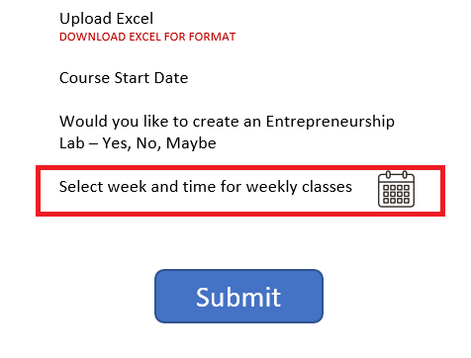

As you can see in the image above, school has a way to enter the week, date and time for classes.

Which will reflect in the “ASSIGN TRAINER & EDIT SCHEDULE” in the calendar.

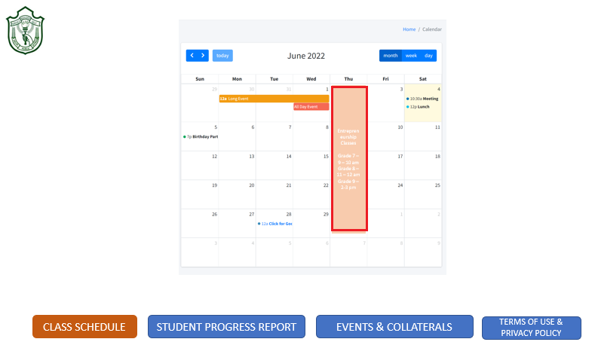

**Case –** School DPS Delhi has scheduled a session for 7th, 8th, 9th and 10th grade students on every Thursday of a week in June from 9-10 AM, 11-12 AM, 2-3PM, 3-4 PM respectively. So, when admin selects DPS Delhi online mode. All the available trainers will be listed there (note: Trainer whose time availability has been exhausted won’t be there in the list). And there in the scheduler calendar he can see the school’s schedule for sessions and by clicking on the time band on the scheduler he assigns trainers to each session. And trainers will be notified about their assigned sessions.

**Student Communication**

Student communication is just a notification sent automatically to the students when an assignment is created.   
  
Admin selects the school > Selects the grade > Uploads all the necessary files and submits the created assignment and after the submission an auto generated notification will go the student’s dashboards.

eventRender: function(event, element) {

// To append if is assessment

if(event.description != '' && typeof event.description !== "undefined")

{

element.find(".fc-title").append("<br/><b>"+event.description+"</b>");

}

},