**Cultural Safety in the workplace**

**One of the most important strategies in developing and maintaining effective workplace relationships is to establish culturally safe work practices. A culturally safe environment is one where there is no denial of a person’s identity and no challenge to who they are or what they need. When applied to Indigenous Australian individuals, community services workers and communities, it is very much about sharing knowledge and experience.**

**Culturally safe work practices require that you: 1. establish rapport 2. be sensitive to what culture means for service recipients, educators and communities 3. use interpersonal skills that acknowledge the integrity and worth of service recipients, educators and communities 4. show respect and empathy 5. be supportive and non-judgmental 6. listen rather than talk.**

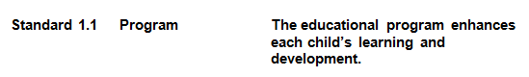**The aim of Quality Area 1 of the National Quality Standard is to ensure that the educational program and practice is stimulating and engaging, and enhances children’s learning and development. In school age care services, the program nurtures the development of life skills and complements children’s experiences, opportunities and relationships at school, at home and in the community.**

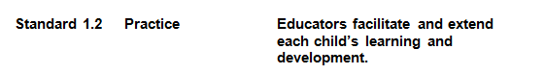

|  |  |  |
| --- | --- | --- |
| **Standard 6.1** | **Supportive relationships with families** | **Respectful relationships with families are developed and maintained and families are supported in their parenting role.** |