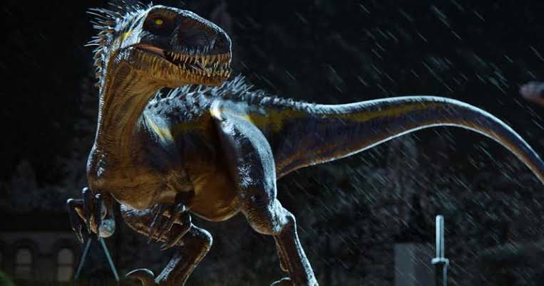

**Use your imagination to write the opening of a short story inspired by this image.**

**Requirement:**

 Begin with an introduction that you feel would be best.

 Choose and end with a conclusion.

**Note:**

Plan and choose your writing on the information provided.

Maintain proper sequence for an appropriate story telling/writing.

Choose and make paragraph(s) according to your preference(s).

Try to ignore choosing overly long sentence(s).

Choose sentence(s) that make clear statement(s).

Avoid choosing irrelevant sentence(s).

Pay attention when you choose spellings and punctuations.

**Intro**

Keith is a grumpy fellow who is always busy with his work duties. He has no interest in any sort of adventures. (Irrelevant; Details: Because we can see later on Keith went out with his children.)

Keith is a jolly fellow who took his children, Martha and Stewart out on an adventure to the forest.

Keith is a jolly fellow who took his children, Martha and Stewart, out on an adventure to the zoo. He is excited for this outdoor adventure. (Irrelevant; Details: This is not relevant because the family went to the forest for an adventure and not a zoo.)

-----------------------------------------------------------

They are going deeper into the forest. But wind kept howling in their ears. Amidst the heat, they are also feeling cold. But they are marching on forward which made them all sweaty. (Irrelevant; Details: In a family gathering, people hardly march on.)

While roaming around, they are feeling the heat of the blazing sun. They are walking by in their own pace. Gradually, they went deeper into the forest. They are exposed to an eerie silence all around the place.

They are going deeper into the forest. The silence is continuous. But birds are chirping now and then. Out of the blue, they all heard the honking of a car. (Irrelevant; Details: There cannot be a honking of a car in the middle of a forest.)

-----------------------------------------------------------

When suddenly, a friendly dinosaur approached! (Irrelevant; Details: Usually dinosaurs are unfriendly.)

When suddenly, a vicious dinosaur approached!

-----------------------------------------------------------

**Body (Paragraph)**

Keith is fascinated. He saw a dinosaur approaching them. When the dinosaur approached the children, both Martha and Stewart jump up and down excitedly. (Irrelevant; Details: No children would be excited to see a dinosaur, rather they will be frightened.)

The dinosaur is joined by a royal Bengal tiger. Both the dinosaur and the tiger roared against each other. Keith sheltered Martha and Stewart with his arms to protect his children against these wild beasts. (Irrelevant; Details: Later on we find out that this royal Bengal tiger has no relevance in the story.)

Seeing the dinosaur roar, Keith falls back, shocked. The dinosaur approached the children. Both Martha and Stewart cower in fright.

-----------------------------------------------------------

However, they are taken by surprise when the dinosaur kisses them in their forehead! With such a sweet gesture from the dinosaur, Keith feels relieved as he realizes that they are not in danger.

However, they are taken by surprise when the dinosaur starts to jump up and down too! It started to dance as well! With such a weird gesture, Keith feels a sense of wonderment. (Irrelevant; Details: Dinosaurs don’t jump up nor down, neither do they dance.)

--------------------------------------------------------

All of a sudden, they hear another loud roar. A monkey approached them, banging its arms on its chest. (Irrelevant; Details: A monkey doesn’t roar loudly but rather they chatter among its species.)

All of a sudden, they hear another loud roar. They could hear heavy thumping of a lion.

--------------------------------------------------------

Looking back, they see a tiger escaped from the shackles of its zoo’s cage. The tiger roared on and on. (Irrelevant; Details: There is no relevance of this tiger and the zoo in this story.)

Once again, Keith is worried for the safety of Martha and Stewart.

Once again, Keith is not worried for the safety of Martha and Stewart. (Irrelevant; Details: A parent will most definitely be worried for their children.)

---------------------------------------------------------

The lion directly attacked. But, the dinosaur comes to the rescue. It roars louder. It was the loudest roar that anyone has ever heard.

When the tiger roared, all hell broke loose as people screamed and ran amok. The dinosaur cowered in fright and left the children and Keith all alone. (Irrelevant; Details: The dinosaur being a large animal will surely not cower in fright against small animals.)

----------------------------------------------------------

The dinosaur then stepped forward, and ripped of the lion’s head.

The dinosaur then stepped forward, and ripped of the monkey’s head. (Irrelevant; Details: Monkey is irrelevant to the story.)

----------------------------------------------------------

Keith then heard the siren and saw police approaching them. Martha understood that the police came to rescue them, but to also harm their savior – the dinosaur.

Keith then heard the siren and saw police approaching them. He is thinking that perhaps the police will put them behind the bars. (Irrelevant; Details: There is no reason as to why the police will perhaps put them behind the bars.)

------------------------------------------------------------

She and Stewart then raised their hands and voice so that the police don’t shoot the dinosaur.

She and Stewart then raised their hands and voice so that the police could shoot the dinosaur. They hated the dinosaur. (Irrelevant; Details: Martha and Stewart were kind to the dinosaur for its behavior. They wouldn’t want the dinosaur to get hurt.)

**Conclusion (Paragraph)**

As they proceed to talk with the police and the town Sheriff, the dinosaur slowly starts to come closer. They all stopped talking and stared at the huge dinosaur in amazement. (Irrelevant; Details: We later find in the story that this is not the case. Also, previously, there wasn’t any mention of the town Sheriff before.)

As they proceed to talk with the police, the dinosaur slowly starts to step away.

-----------------------------------------------------

By the time the police learned the truth, the dinosaur was gone.

By the time the police learned the truth, they all realized that the dinosaur was an alien all along. (Irrelevant; Details: We later find in the story that this is not the case.)

-----------------------------------------------------

What followed then was an air full of gratitude and mystery as they were saved by the mysterious yet gratifying dinosaur.

What followed then was an air full of excitement and friendliness by the people who were all saved by the mysterious yet frightening dinosaur. (Irrelevant; Details: A frightening dinosaur will be unlikely to help people.)

-------------------------------------------------------

This proves that often times in stories, big beasts get charmed by little children. And that they don’t harm innocent beings.

This story indicates that often bad behavior of large wild beasts’ win over good behavior. This proves that kindness never wins. (Irrelevant; Details: This is the opposite of what the story teaches us. The story teaches us that kindness always wins.)