**Word:**

**Picture:**

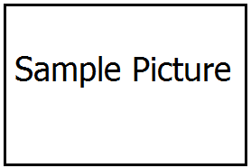

**Definition:**

**Picture Sentence:**

**Parts of speech**

**Synonym**

**Antonym**

**Category:**

**Your sentence**