TERMS

area $A^{(ϵ)}$

probability $π\left(A^{(ϵ)}\right)=ϵ$

concept $c_{r}$

by radius $r$

by radius $r^{(ϵ)}$

hypothesis $h=L(D)$

symmetric difference $h ∆ c$

FIGURE 1

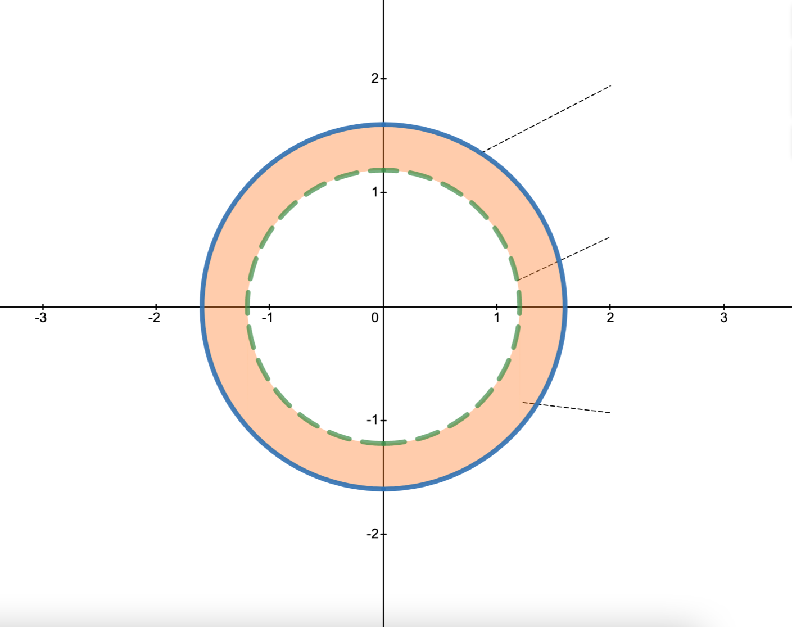

radius = $r^{(ϵ)}$

the annulus $A^{(ϵ)}$

$$π\left(A^{(ϵ)}\right)=ϵ$$

radius = $r$

-Remove all data points

FIGURE 2.1 – BAD CASE

the annulus $A^{(ϵ)}$

$$π\left(A^{(ϵ)}\right)=ϵ$$

area $A^{(ϵ)}$

radius = $r$

radius = $r^{(ϵ)}$

hypothesis $h=L(D)$

FIGURE 2.2 – GOOD CASE

the annulus $A^{(ϵ)}$

$$π\left(A^{(ϵ)}\right)=ϵ$$

hypothesis $h=L(D)$

radius = $r^{(ϵ)}$

radius = $r$

area $A^{(ϵ)}$

Change text like figure 1

FIGURE 2 – BAD CASE + GOOD CASE

FIGURE 3 – GOOD CASE SYMMETRIC DIFFERENCE

hypothesis $h=L(D)$

symmetric difference $h ∆ c$

by radius $r$

by radius $r^{(ϵ)}$

Change text like figure 1

Experiments and visualizations

//break up into 3 sections

# Overview

//Epsilon and delta have to be set and then used for all 3 sections, and should appear in all 3 sections

//Then dramatic reveal of m=m(eps,delta)

// Our c=c(r=1)

//Then introduce that in the next 3 sections, we examine L’s performance on less than enough samples, just enough samples, and more than enough samples.

//for each one, we draw a total of 10k datasets, each of size m, and run our learner on each dataset.

//we then show 6 randomly selected datasets, with c and the resulting h=L(D). In each one of these 6 graphs, we also indicate the actual error in that experiment .

//Below the 6 individual datasets, we plot the resulting error (y axis) against the experiment index (i=1,…,10k). The points are colored based on whether or not the error is less than your selected epsilon. What percentage of the points do you expect to be green?

# Insufficient samples

1. In this section, we run the experiment with half the number of samples m, we concluded to be sufficient in the previous section.
2. 6 experiments
3. 10k experiments
4. The percentage of green is represented here as the empirical 1-delta. Does this number make sense?

# Just enough samples

# Way more than enough

1. –

# Comparison / Analysis / Discussion

1. We ran 10k experiments for m=m(eps,delta)*[0.5, 0.75, 1, …]. Below, we depict 1-delta against m.
2. Based on what you’ve seen in these experiments, how tight was our calculation of m(epsilon, delta)? Can you explain the difference?
3. In this application, we demonstrated PAC learning on clean circles in R2 without errors. This is the first and simplest example of PAC learning theory.   
   In the real world, determining sample complexity is a much more complex issue, and many factors are involved.