Aaron Shultz
Dr. Silvia Preston
SE 2300 (E90) Software Construction
02/03/2026
Module 2 Assignment

Problem Statement
The unit conversion tool will allow users to choose between different categories of measurements. The tool will convert temperature, length, and time. When the user has selected their measurement type, they can then select the units they are converting from and to. Supported temperature units are Fahrenheit, Celsius, and Kelvin. Supported length units are inches, feet, yards, miles, millimeters, centimeters, meters, and kilometers. Supported time units are seconds, minutes, hours, days, and years. The user will interact with a graphical interface though python’s tkinter. Any unit value that is invalid, this includes non-numerical characters, will return an error message to the user. The measurement and unit selections will use a dropdown menu with predetermined values so the user can only select a value that is supported. The unit selections will only display options within the selected measurement type. For example, if the user selects ‘temperature’ only Fahrenheit, Celsius, and Kelvin will be available in the unit dropdown menu. The system will not need to store any external data.

System Design
Figure 1 describes the classes, objects and class components of the unit conversion tool. The tkinter interface is where the measurementType, convertFromUnit, convertFromValue, and convertToUnit are entered by the user and passed to the administerConversion object. This object of the ConversionAdministrator class uses the measurementConversionPicker method to determine which object it needs to create in order to pick and convert the right unit. If the measurementType is temperature, a convertTemperature object is created from the unitConverter class. The measurementConversionPicker method can access the convertUnit method in convertTemperature and passes along the convertFromUnit, convertFromValue, convertToUnit, and temperatureConverterList. convertUnit then calculates the convertToValue using the converterList as a conversion table. When the method is called, the convertToValue is calculated and passed back to the ConversionAdministrator which passes it to the tkinter interface.
The covertLength and convertTime objects work the exact same but pass their respective converterLists to the unitConverter class. If at any point in these objects, an error occurs, the message will be passed back to the interface as well.
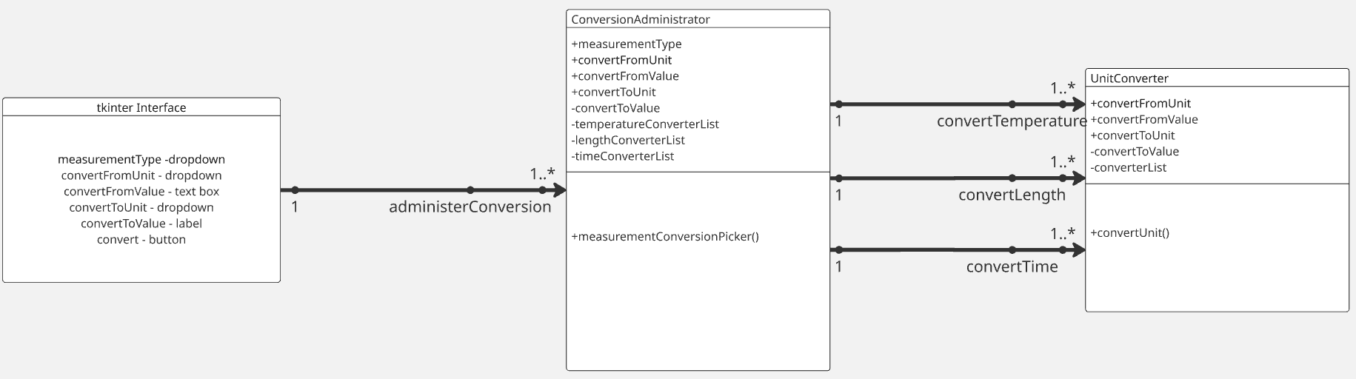
Figure 1

Pseudocode

ConversionAdministrator Class:
This class takes in the selected measurement type, unit converting from, value of the converting from unit, and the desired converted unit from the user interface. With the inputs it creates and calls the correct object to convert the value and returns the converted value to the interface.

read the measurement type from the tkinter interface
read the convert-from-unit from the tkinter interface
read the convert-from-value from the tkinter interface
read the covert-to-unit from the tkinter interface
initialize the convert-to-value
initialize the temperature converter list
initialize the length converter list
initialize the time converter list

measurementConversionPicker Method:
This method determines the measurement type selected and creates and calls the corresponding object to convert the unit and return the value to the user interface

if the measurement type equals ‘Temperature’
create an object, convertTemperature, of the unitConverter class with the convert-from-unit, convert-from-value, convert-to-unit, and temperatureConverterList variables.
call the convertTemperature object and set the response equal to the convert-to-value
if the measurement type equals ‘Length’
create an object, convertLength, of the unitConverter class with the convert-from-unit, convert-from-value, convert-to-unit, and lengthConverterList variables.
call the convertLength object and set the response equal to the convert-to-value
if the measurement type equals ‘Time’
create an object, convertTime, of the unitConverter class with the convert-from-unit, convert-from-value, convert-to-unit, and timeConverterList variables.
call the convertTime object and set the response equal to the convert-to-value

UnitConverter Class:
This class takes in the unit converting from, value of the converting from unit, the desired converted unit, and converter list and converts the value to the desired unit. Then, it returns the value to the ConversionAdministrator.
initialize the convert-from-unit
initialize the convert-from-value
initialize the covert-to-unit
initialize the covert-to-value
initialize the converter list

unitConverter Method:
This method iterates through the converter list to find the unit converting from and unit converting to base values to use in the calculation. It then calculates the converted value using the ratio from the list and returns the result to the ConversionAdministrator.

Iterate through the converter list
if the index contains the string that matches the convert-from-unit in the first index location (ex. List[i, 0] = convert-from-unit) and the index that contains the string that matches the convert-to-unit in the third index location (ex. List[i, 3] = convert-to-unit).
set the unit from value to the value in index 1 and the unit to value to the value in index 3.
Set the convert-to-value to equal multiplying the converter list to-unit-value by the convert-from-value and dividing by the converter list from-unit-value.
Return the convert-to-value

Flowchart

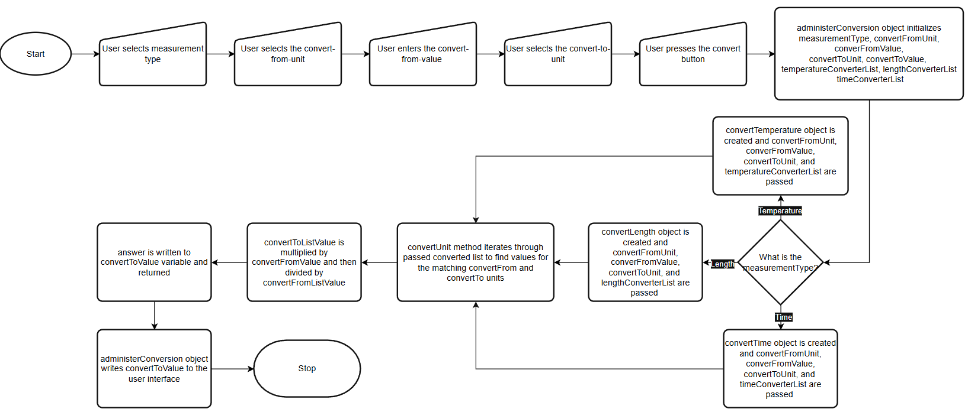
Figure 2

