Aaron Shultz
Dr. Silvia Preston
SE 2300 (E90) Software Construction
02/17/2026
Module 3 Assignment
Functional Requirements:
- The system shall allow users to select between converting temperature, length, and time measurements.
- The system shall accurately display the converted unit to the second decimal place.
- The system shall convert between Fahrenheit, Celsius, and Kelvin.
- The system shall convert between inches, feet, yards, miles, millimeters, centimeters, meters, and kilometers.
- The system shall convert between seconds, minutes, hours, days, and years.
- The system shall allow users to select which unit they are converting from based on the measurement type selected.
- The system shall allow users to select which unit they are converting to based on the measurement type selected.
- The system shall allow users to enter the unit value into a text box.
- The system shall use python tkinter as the user interface.
Non-Functional Requirements:
- The system shall notify the user if the unit value entered is invalid.
- The system shall convert the units within 1 second.
- The system shall display accurate conversions 99.99% of the time.
- The system shall contain basic instructions on how to use the system.
- The system shall contain a button that starts the conversion.
- The system shall inform the user of any known errors that may occur during use.
The high-level architecture of the system is broken into 4 parts as seen in Figure 1. The actor, or user, is the person interacting with the unit conversion tool. The interface is the human machine interaction component. This is where the actor can select and enter information about measurement type, unit they are converting, unit value, and desired converted unit. The interface is also where the system can communicate with the actor about the converted unit value and any errors that might occur. On the system side, there will be 2 major classes that are used to input the actor’s desired variables, calculate the unit conversion, and return the result. As for the data flow, most of the data starts with the user. Figure 2 shows the user selecting the measurement type, converting from unit, converting from unit value, converting to unit. The user also presses the convert button to initiate the calculation. From the button press, 2 paths are created. The first path is taken when the input data is incomplete or incorrect. This leads to an error message appearing on the interface so that the user can fix any mistakes. The second path is when all the input data is correct. Next, the python script can take in the values, calculate the converted unit, and lastly return the value to the user. Figure 3 explains essentially the same thing with the different components broken out. The interface interacts with the measurement selector component. That code determines which measurement converter should be called and calls the component and passes the values. The converted value is then passed back all the way to the interface.
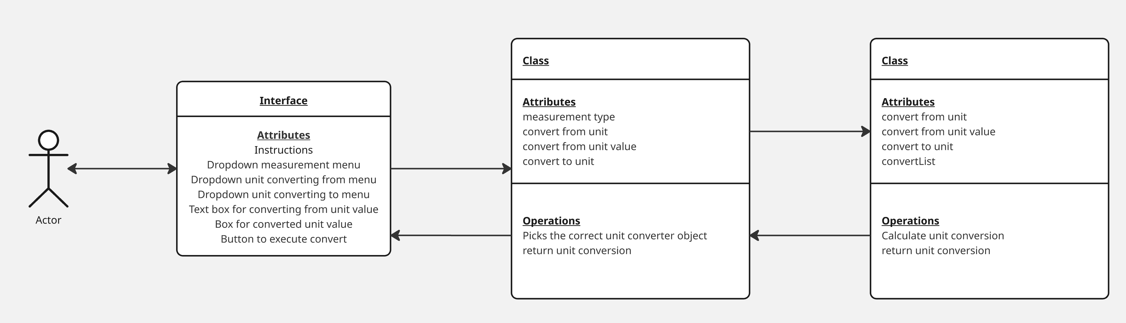
Figure 1
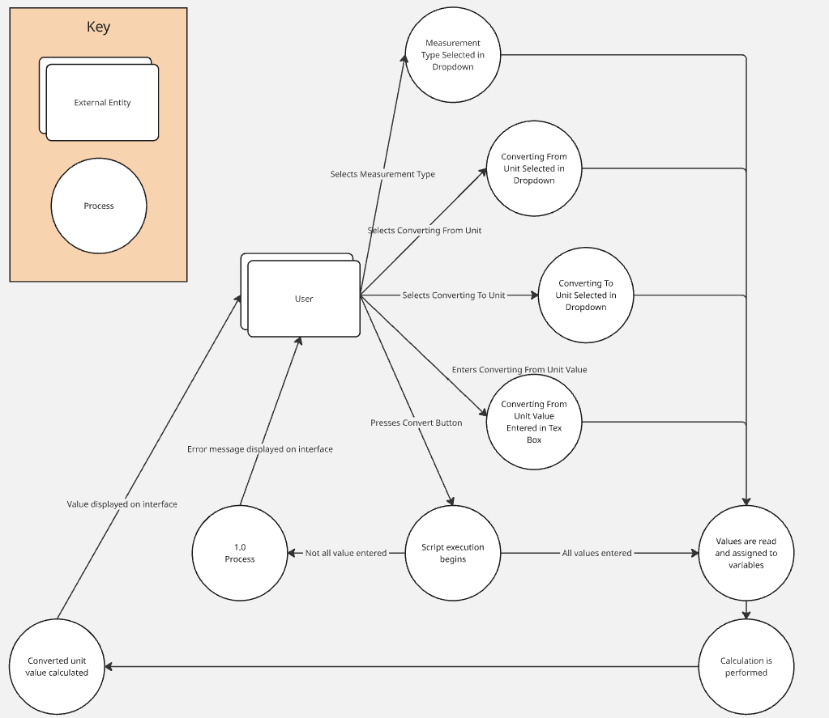
Figure 2
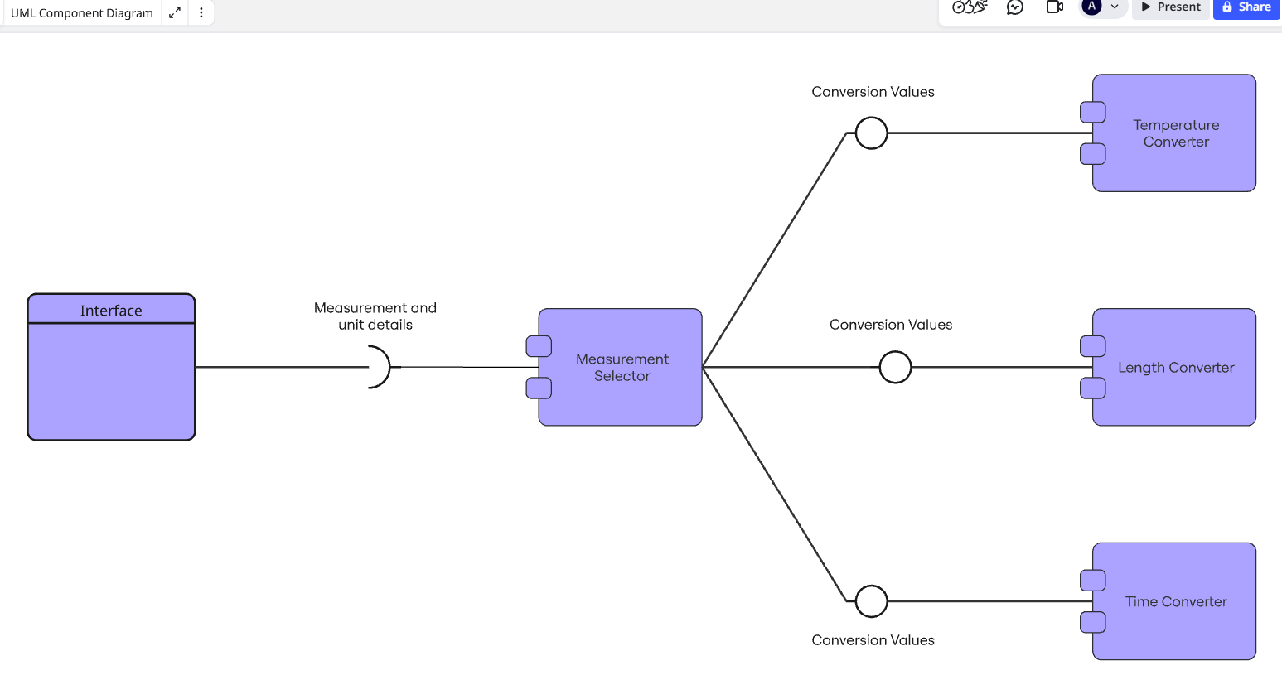
Figure 3

Testing
- Measurement Type dropdown allows the user to select “temperature”, “length”, and “time”.
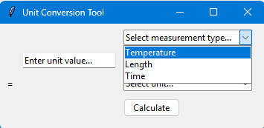
- When “temperature” is selected, the convert-from and convert-to dropdowns allow the user to select Fahrenheit, Celsius, and Kelvin.
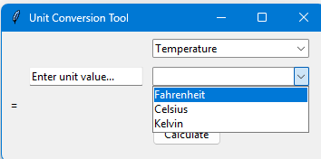
- When “length” is selected, the convert-from and convert-to dropdowns allow the user to select inches, feet, yards, miles, millimeters, centimeters, meters, and kilometers.
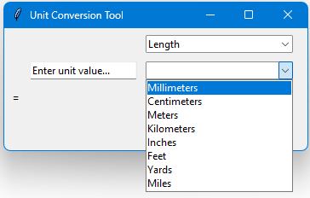
- When “time” is selected, the convert-from and convert-to dropdowns allow the user to select seconds, minutes, hours, days, and years.
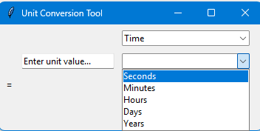
- The convert-from text box allows the user to enter in characters.
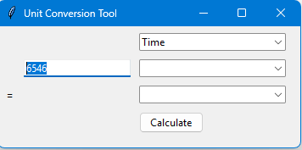
- When the convert button is pressed, the tool will display an error or a converted unit based on the expected result.
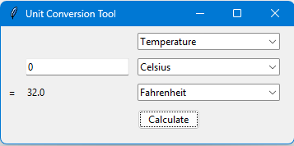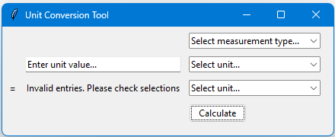
- The tool accurately converts from Fahrenheit to Celsius and rounds to 2 decimal places.
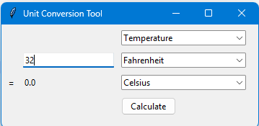
- The tool accurately converts from Fahrenheit to Kelvin and rounds to 2 decimal places.
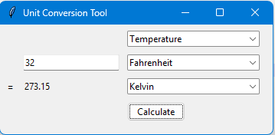
- The tool accurately converts from Celsius to Fahrenheit and rounds to 2 decimal places.
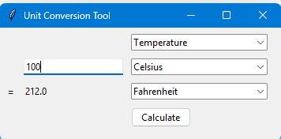
- The tool accurately converts from Celsius to Kelvin and rounds to 2 decimal places.
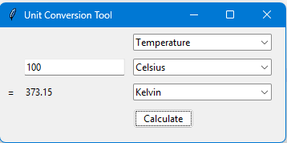
- The tool accurately converts from Kelvin to Fahrenheit and rounds to 2 decimal places.
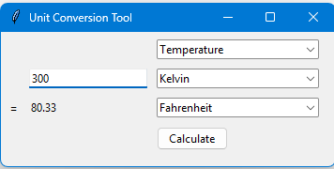
- The tool accurately converts from Kelvin to Celsius and rounds to 2 decimal places.
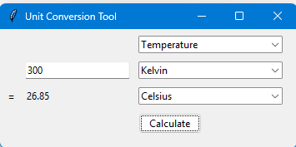
- The tool accurately converts from inches to feet and rounds to 2 decimal places.
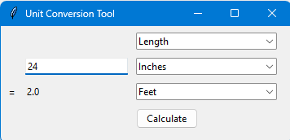
- The tool accurately converts from inches to yards and rounds to 2 decimal places.
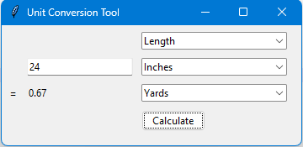
- The tool accurately converts from inches to miles and rounds to 2 decimal places.
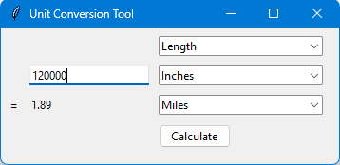
- The tool accurately converts from inches to millimeters and rounds to 2 decimal places.
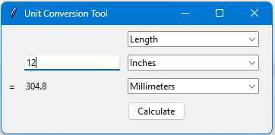
- The tool accurately converts from inches to centimeters and rounds to 2 decimal places.
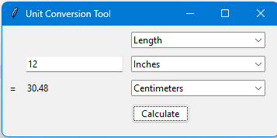
- The tool accurately converts from inches to meters and rounds to 2 decimal places.
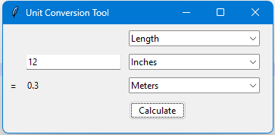
- The tool accurately converts from inches to kilometers and rounds to 2 decimal places.
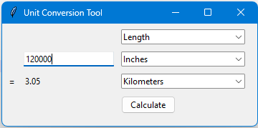
- The tool accurately converts from feet to inches and rounds to 2 decimal places.
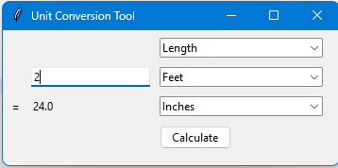
- The tool accurately converts from feet to yards and rounds to 2 decimal places.
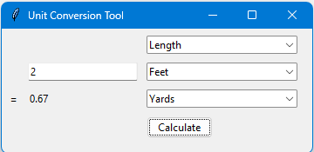
- The tool accurately converts from feet to miles and rounds to 2 decimal places.
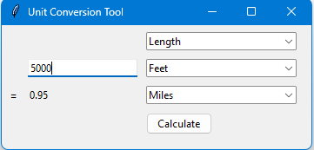
- The tool accurately converts from feet to millimeters and rounds to 2 decimal places.
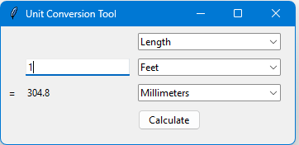
- The tool accurately converts from feet to centimeters and rounds to 2 decimal places.
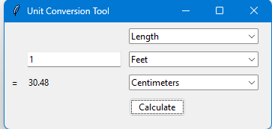
- The tool accurately converts from feet to meters and rounds to 2 decimal places.
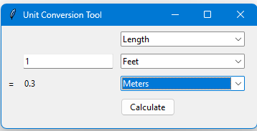
- The tool accurately converts from feet to kilometers and rounds to 2 decimal places.
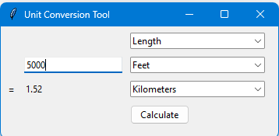
- The tool accurately converts from yards to inches and rounds to 2 decimal places.
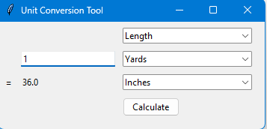
- The tool accurately converts from yards to feet and rounds to 2 decimal places.
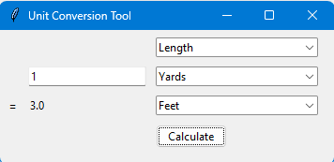
- The tool accurately converts from yards to miles and rounds to 2 decimal places.
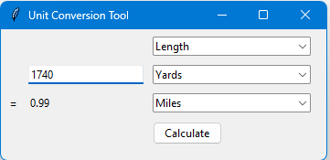
- The tool accurately converts from yards to millimeters and rounds to 2 decimal places.
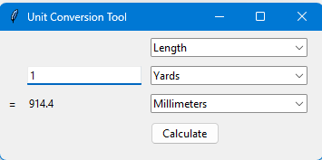
- The tool accurately converts from yards to centimeters and rounds to 2 decimal places.
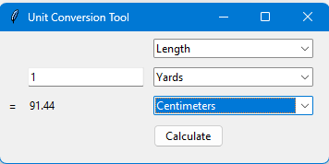
- The tool accurately converts from yards to meters and rounds to 2 decimal places.
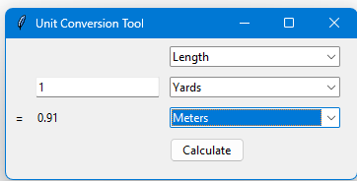
- The tool accurately converts from yards to kilometers and rounds to 2 decimal places.
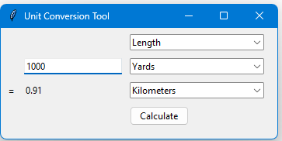
- The tool accurately converts from miles to inches and rounds to 2 decimal places.
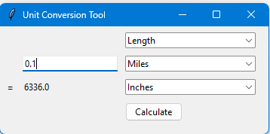
- The tool accurately converts from miles to feet and rounds to 2 decimal places.
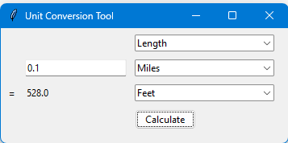
- The tool accurately converts from miles to yards and rounds to 2 decimal places.
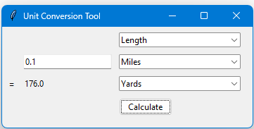
- The tool accurately converts from miles to millimeters and rounds to 2 decimal places.
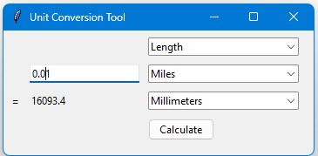
- The tool accurately converts from miles to centimeters and rounds to 2 decimal places.
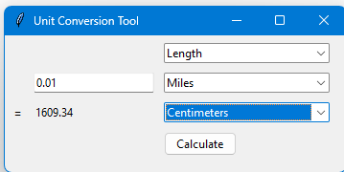
- The tool accurately converts from miles to meters and rounds to 2 decimal places.
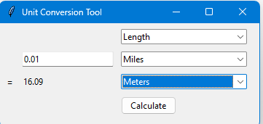
- The tool accurately converts from miles to kilometers and rounds to 2 decimal places.
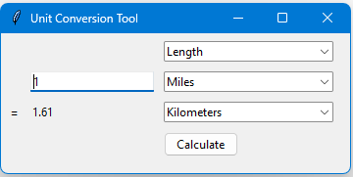
- The tool accurately converts from millimeters to inches and rounds to 2 decimal places.
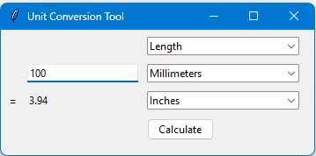
- The tool accurately converts from millimeters to feet and rounds to 2 decimal places.
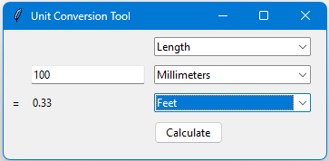
- The tool accurately converts from millimeters to yards and rounds to 2 decimal places.
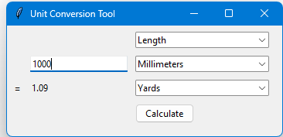
- The tool accurately converts from millimeters to miles and rounds to 2 decimal places.
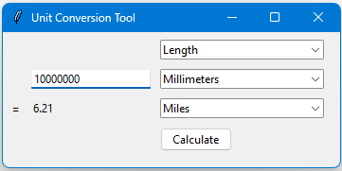
- The tool accurately converts from millimeters to centimeters and rounds to 2 decimal places.
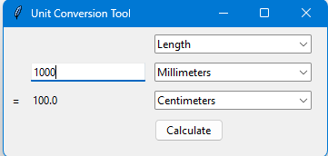
- The tool accurately converts from millimeters to meters and rounds to 2 decimal places.
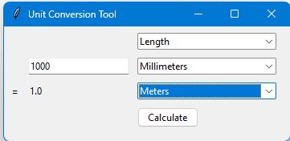
- The tool accurately converts from millimeters to kilometers and rounds to 2 decimal places.
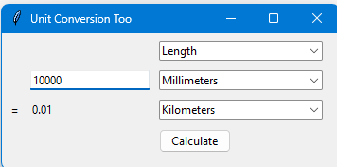
- The tool accurately converts from centimeters to inches and rounds to 2 decimal places.
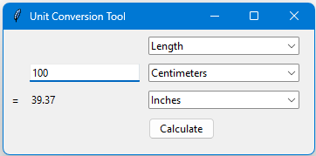
- The tool accurately converts from centimeters to feet and rounds to 2 decimal places.
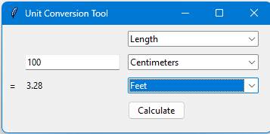
- The tool accurately converts from centimeters to yards and rounds to 2 decimal places.
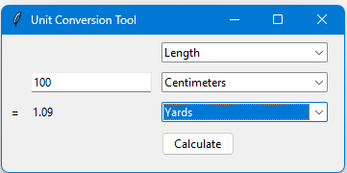
- The tool accurately converts from centimeters to miles and rounds to 2 decimal places.
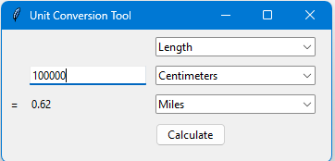
- The tool accurately converts from centimeters to millimeters and rounds to 2 decimal places.
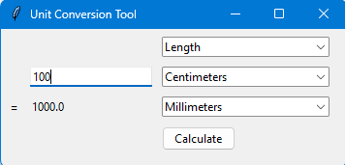
- The tool accurately converts from centimeters to meters and rounds to 2 decimal places.
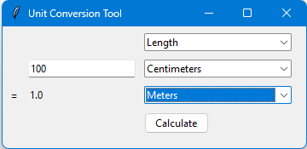
- The tool accurately converts from centimeters to kilometers and rounds to 2 decimal places.
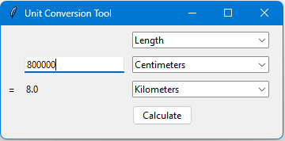
- The tool accurately converts from meters to inches and rounds to 2 decimal places.
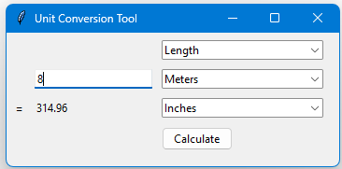
- The tool accurately converts from meters to feet and rounds to 2 decimal places.
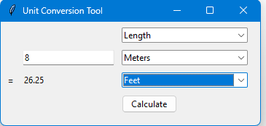
- The tool accurately converts from meters to yards and rounds to 2 decimal places.
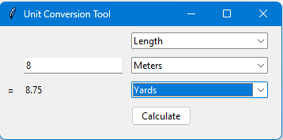
- The tool accurately converts from meters to miles and rounds to 2 decimal places.
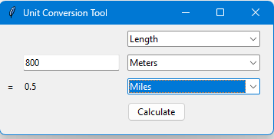
- The tool accurately converts from meters to millimeters and rounds to 2 decimal places.
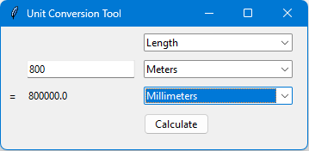
- The tool accurately converts from meters to centimeters and rounds to 2 decimal places.
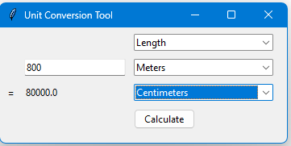
- The tool accurately converts from meters to kilometers and rounds to 2 decimal places.
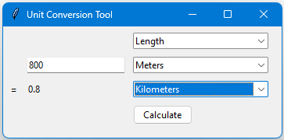
- The tool accurately converts from kilometers to inches and rounds to 2 decimal places.
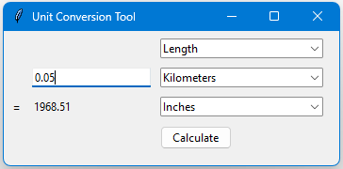
- The tool accurately converts from kilometers to feet and rounds to 2 decimal places.
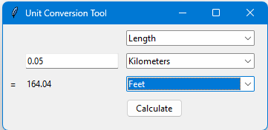
- The tool accurately converts from kilometers to yards and rounds to 2 decimal places.
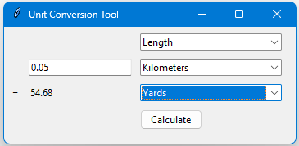
- The tool accurately converts from kilometers to miles and rounds to 2 decimal places.
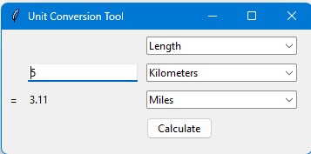
- The tool accurately converts from kilometers to millimeters and rounds to 2 decimal places.
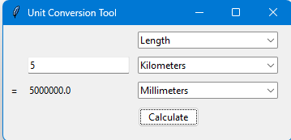
- The tool accurately converts from kilometers to centimeters and rounds to 2 decimal places.
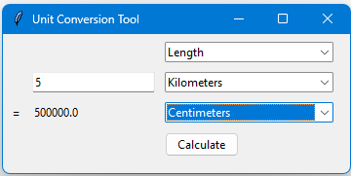
- The tool accurately converts from kilometers to meters and rounds to 2 decimal places.
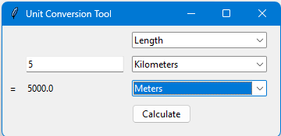
- The tool accurately converts from seconds to minutes and rounds to 2 decimal places.
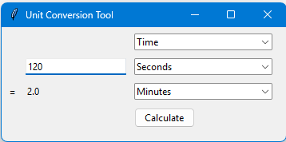
- The tool accurately converts from seconds to hours and rounds to 2 decimal places.
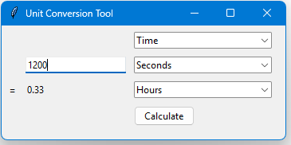
- The tool accurately converts from seconds to days and rounds to 2 decimal places.
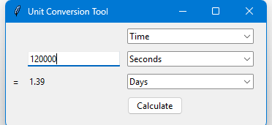
- The tool accurately converts from seconds to years and rounds to 2 decimal places.
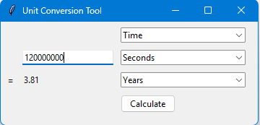
- The tool accurately converts from minutes to seconds and rounds to 2 decimal places.
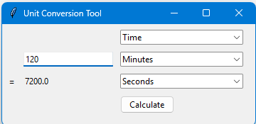
- The tool accurately converts from minutes to hours and rounds to 2 decimal places.
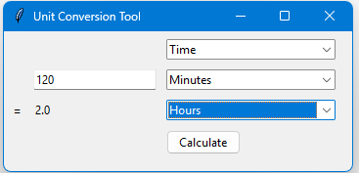
- The tool accurately converts from minutes to days and rounds to 2 decimal places.
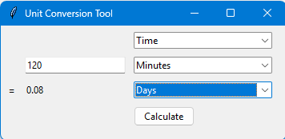
- The tool accurately converts from minutes to years and rounds to 2 decimal places.
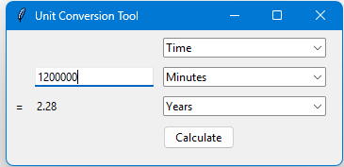
- The tool accurately converts from hours to seconds and rounds to 2 decimal places.
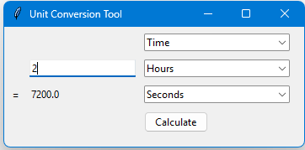
- The tool accurately converts from hours to minutes and rounds to 2 decimal places.
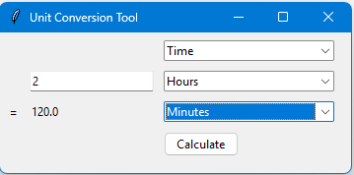
- The tool accurately converts from hours to days and rounds to 2 decimal places.
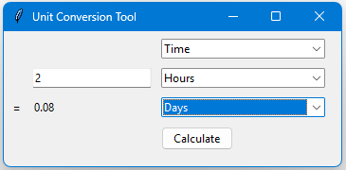
- The tool accurately converts from hours to years and rounds to 2 decimal places.
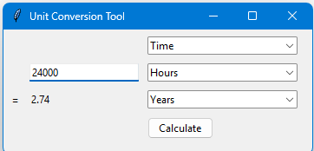
- The tool accurately converts from days to seconds and rounds to 2 decimal places.
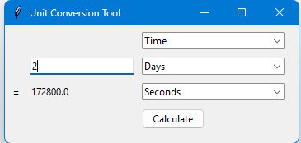
- The tool accurately converts from days to minutes and rounds to 2 decimal places.
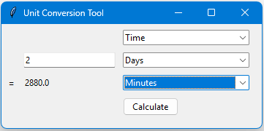
- The tool accurately converts from days to hours and rounds to 2 decimal places.
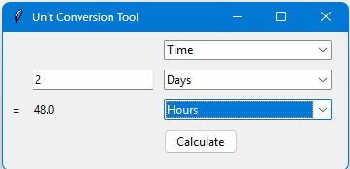
- The tool accurately converts from days to years and rounds to 2 decimal places.
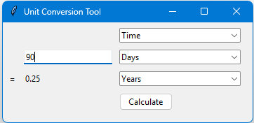
- The tool accurately converts from years to seconds and rounds to 2 decimal places.
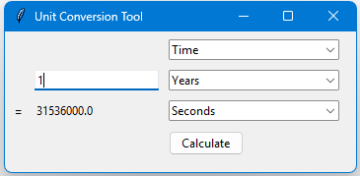
- The tool accurately converts from years to minutes and rounds to 2 decimal places.
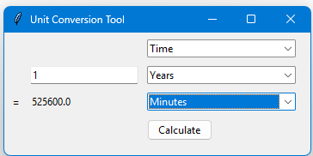
- The tool accurately converts from years to hours and rounds to 2 decimal places.
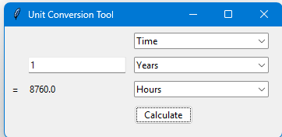
- The tool accurately converts from years to days and rounds to 2 decimal places.
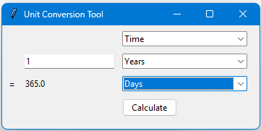
- If the convert button is pressed before the measurement type is selected, a message appears letting the user know the measurement needs to be selected.
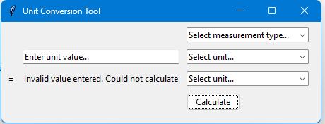
- If the convert button is pressed before the convert-from unit is selected, a message appears letting the user know the unit needs to be selected.
- If the convert button is pressed before the convert-to unit is selected, a message appears letting the user know the unit needs to be selected.
- If the convert button is pressed and the convert-from unit value is invalid (not a number), a message appears letting the user know the unit value is invalid.
- If the fromUnit and toUnit are the same, the same value is returned.
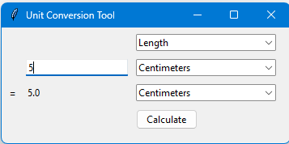
- Can convert negative numbers.
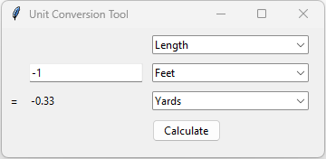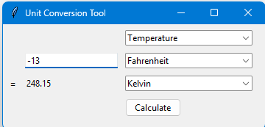
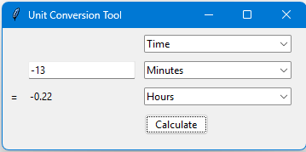
- Can convert very large numbers.
