|  |  |
| --- | --- |
| (647) 648-9178 |  |
| [ssyed067@uottawa.ca](mailto:ssyed067@uottawa.ca) |  |
| [Shumael Syed](https://www.linkedin.com/in/shumael-syed/) |  |
| [shumael.github.io](https://shumael.github.io/) |  |

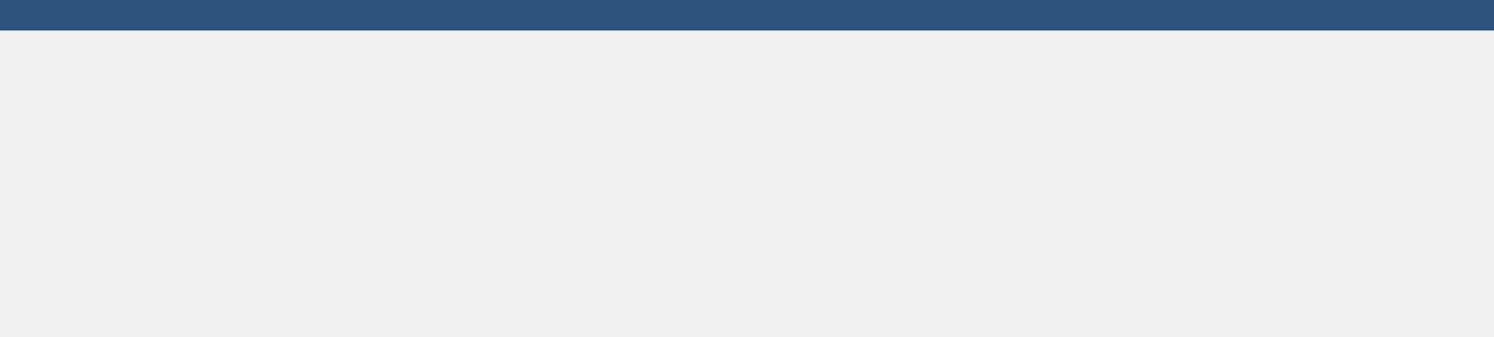

SHUMAEL SYED

Software Engineering Student

**Resume Objective**



Focused and career-oriented Software Engineering major currently attending University of Ottawa. Aiming to utilize my knowledge and passion for software and technology to contribute to the growth of the organization and progress my professional career.

**Languages & Technology**



**Technical Skills**



React

Bootstrap

Python

Java

Software Development

Web Development

UI/UX Design





JavaScript

Node.js

QA/QC

Object-Oriented Programming

Mobile Development

CSS

HTML



**EXPERIENCE**

**Infrastructure Engineer / House of Commons Canada**

*Ottawa, Canada / January 2019 – April 2019*

* Developed test cases and use cases for both PC and Mobile based applications and software.
* Interacted with clients and product line managers to receive feedback and make improvements in documentation and test cases.

**Software Test Engineer / Global Affairs Canada**

*Ottawa, Canada / May 2018 – August 2018*

* Created and modified test cases based on business requirements.
* Identified and documented test results including appropriate classification of system defect criticality and priority.
* Developed automated tests to diagnose potential bugs and irregularities within software applications.



**EDUCATION**

**BASc in Software Engineering / University of Ottawa, Ottawa, Canada**

Expected Graduation Date: December 2021

Relevant Courses Completed: Algorithms and Data Structure, Analysis and Design of User Interfaces, Computer Architecture, Introduction to Software Engineering, Operating Systems, Software Quality Assurance



**PROJECTS**



**Artificial Intelligence Connect 4**:

Implemented the famous game in Python with complete graphical user interface and functioning artificial intelligence as an opponent.

**Personal Portfolio Website:**

Developed an entire personal portfolio website from scratch using self-taught web development skills which included HTML, CSS, Bootstrap and JavaScript.

**Stock Market Analysis:**

Developed a Python script which sends text messages to indicate real-time buying and selling opportunities in the stock market.