
Intern Name: Shumaila Arif
Domain: Cyber Security

February 27, 2026
Arch-Technologies
Month 1 Report
Introduction
This report outlines the technical tasks completed during the first month of the Cyber Security internship at Arch Technologies. The primary focus was on network traffic analysis and understanding the mechanics of keystroke logging to identify potential security vulnerabilities.
Task 1: Network Traffic Sniffer
1 Objective:
The goal of this project was to build a network sniffer in Python capable of capturing and analyzing real-time network traffic. This helps in understanding how data flows across a network and how packets are structured.
1.2 Technical Implementation
- Language: Python.
- Functionality: The script captures live packets, extracting critical information such as protocol types (TCP, UDP), source/destination IP addresses, and packet sizes.
- Data Logging: All captured traffic is logged into a file for forensic analysis.
1.3 Security Insight
Through this task, I analyzed how unencrypted data can be intercepted, highlighting the importance of protocols like HTTPS and SSL/TLS in protecting data integrity.
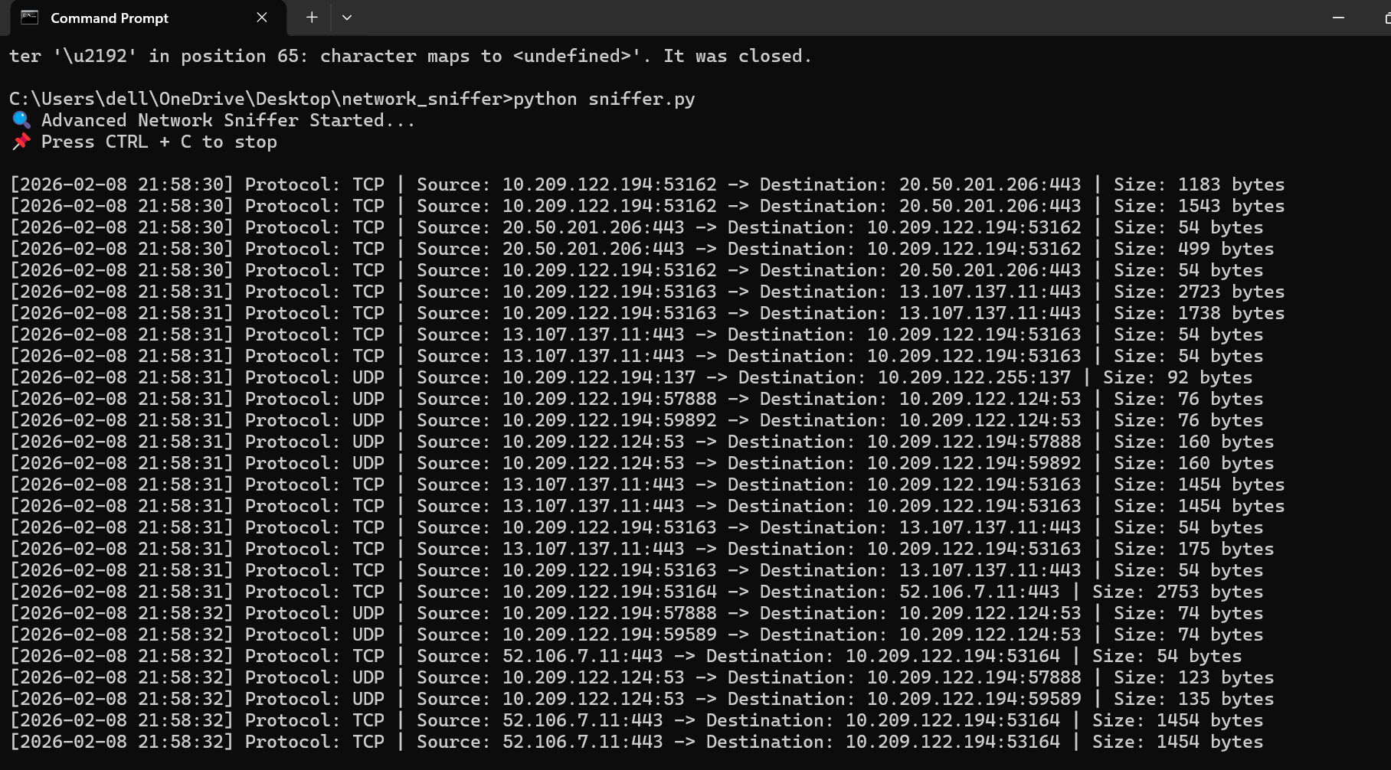
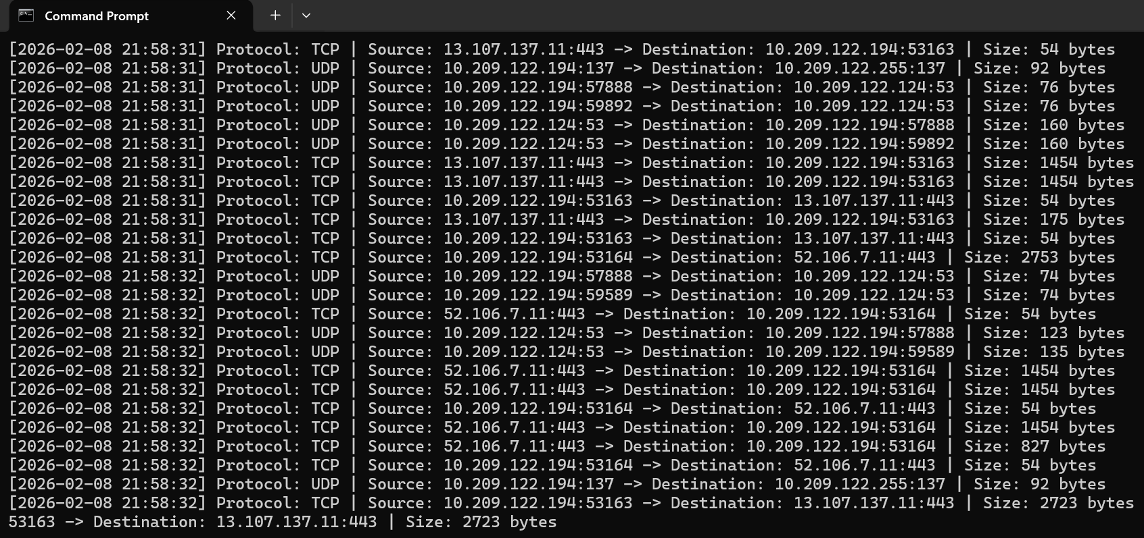
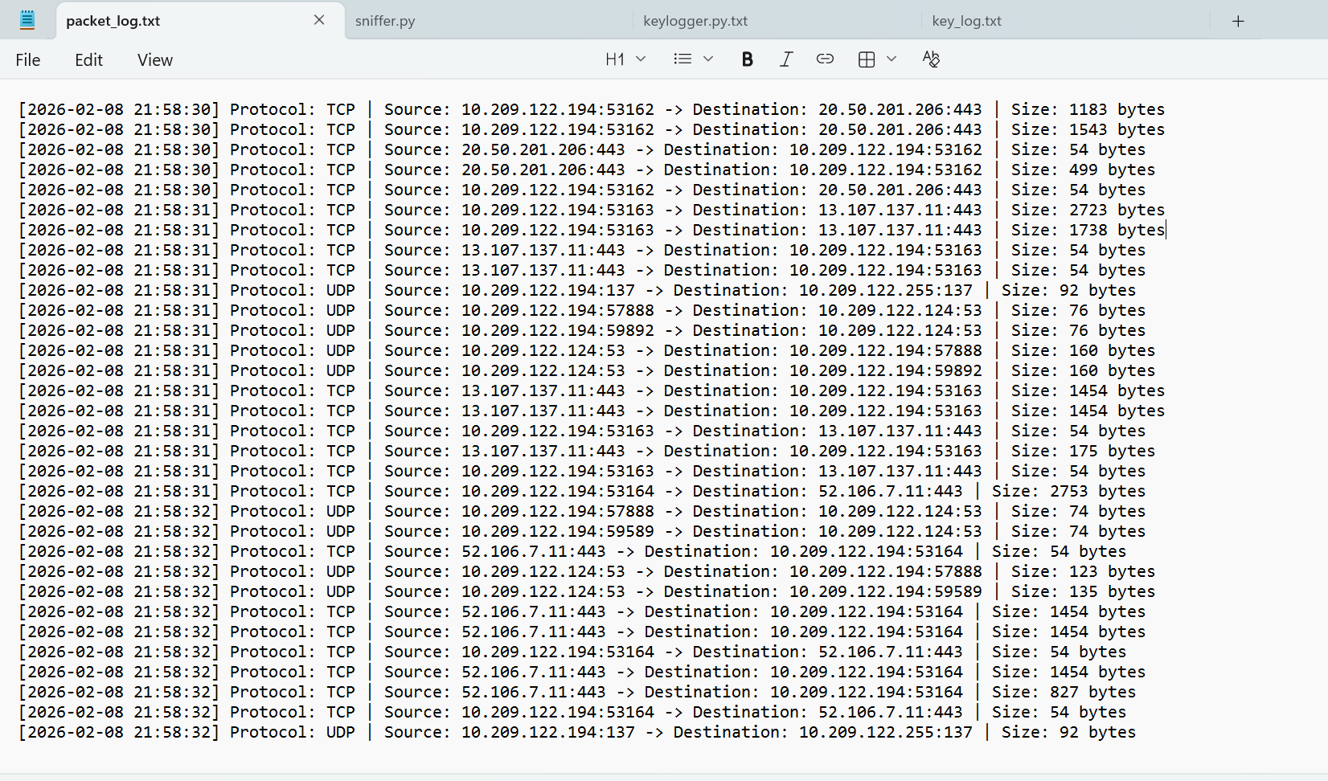

Task 2: Keylogging Simulation
2.1 Objective
This task involved simulating a basic keylogger in a controlled and safe environment to understand the mechanism of keystroke logging attacks.
2.2 Technical Implementation
- Method: Using Python scripts to capture local keystrokes.
- Storage: The captured keys are logged into a local file (key_log.txt).
- Analysis: The script handles both alphanumeric characters and special keys (e.g., Space, Enter, Shift) to provide a comprehensive log of user activity.
3.3 Risk Assessment
Keyloggers are a significant threat used in credential theft. By simulating this attack, I evaluated the risks associated with such malware and the necessity of using anti-keylogging software and multi-factor authentication (MFA).
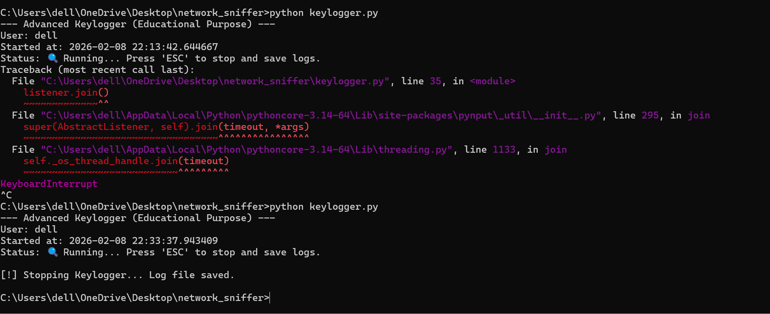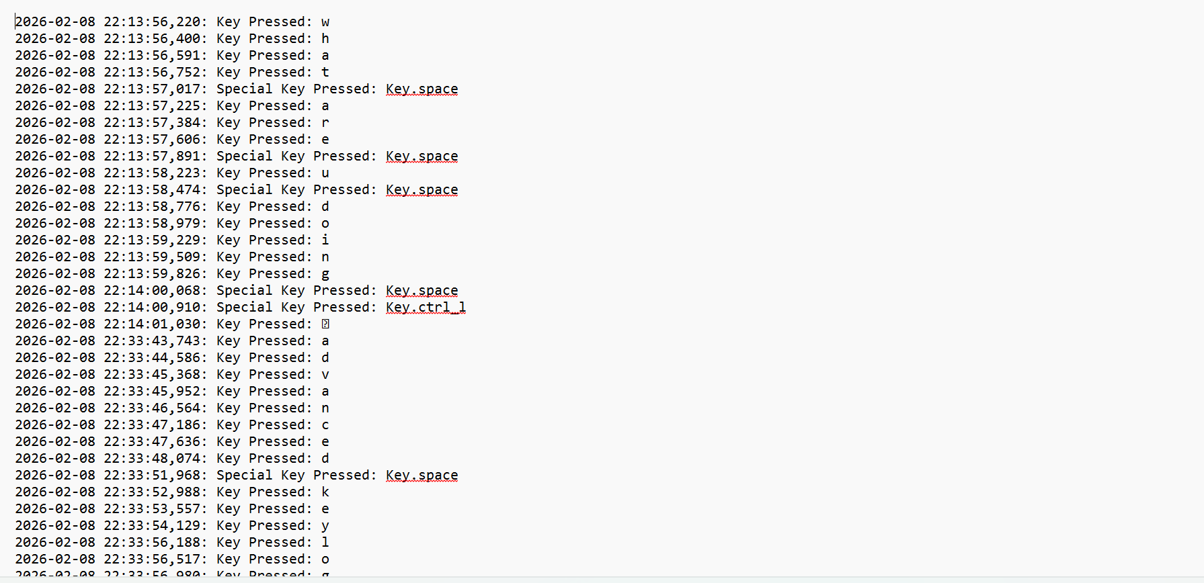
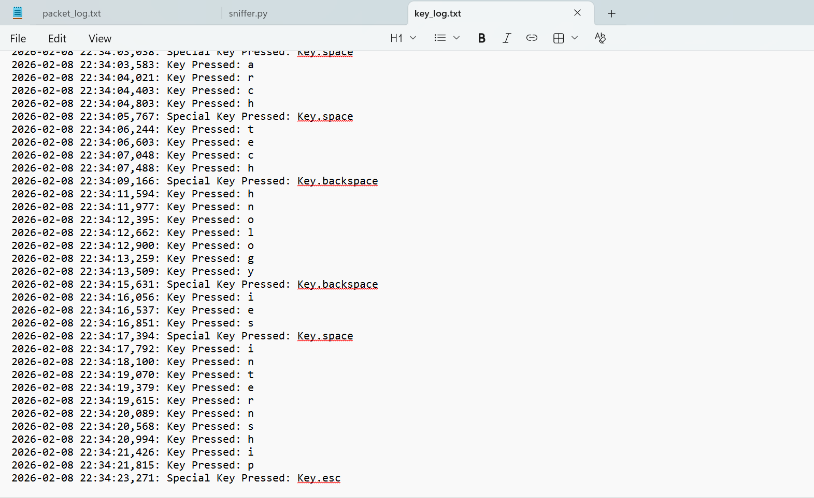

4. Conclusion
The completion of these tasks has provided a solid foundation in network monitoring and host-based security analysis. All source code and logs have been compiled according to the submission requirements.

