SIEM DEPLOYMENT, REAL-TIME LOG ANALYSIS
& THREAT HUNTING REPORT
Lab 2 Practical Documentation

Wazuh SIEM • Windows & Ubuntu VMs • Host-Only Network

Lab 2 | SIEM Deployment & Real-Time Log Analysis
Evidence basis | Provided report screenshots + screenshots shared in this chat
Evidence status | Lab 2 completed and evidenced; Lab 3 Atomic Red Team execution not evidenced in the supplied screenshots

Table of Contents
1. Lab Overview
2. System Architecture & IP Mapping
3. Lab 2 – SIEM Deployment & Real-Time Log Analysis
3.1 Wazuh Manager Services
3.2 Windows Agent Deployment
3.3 Network Connectivity
3.4 Agent Visibility in Wazuh
3.5 SSH Brute-Force / Authentication Failure Detection
3.6 Active Response – Automated IP Blocking
3.7 Lab 2 Result & Mitigation
4. Lab 3 – Threat Hunting & Malware Emulation
4.1 Threat Hunting Evidence
4.2 Atomic Red Team Evidence Status
4.3 Required Forensic/Detection Evidence
5. Deliverables Checklist
6. Conclusion

1. Lab Overview
The practical work demonstrates deployment of a Wazuh-based SIEM environment on VirtualBox, connection of a Windows endpoint through the Wazuh agent, collection of authentication events, detection of repeated SSH authentication failures, and execution of an Active Response firewall rule.
The supplied lab instructions define Lab 2 around SIEM deployment, agent-based log forwarding, SSH brute-force simulation, real-time alerting, and automated IP blocking. Lab 3 is defined around Atomic Red Team tests mapped to MITRE ATT&CK and verification of endpoint/antivirus detection.

Evidence note
This report only claims activities that are visible in the supplied screenshots. No screenshot in the available evidence proves installation or execution of Atomic Red Team tests such as T1059 or T1003. Therefore, the Lab 3 section is documented as partially evidenced rather than inventing results.

2. System Architecture & IP Mapping
The screenshots show a private 192.168.56.0/24 environment. Ubuntu is shown with 192.168.56.20/24, while the Windows VM is shown with 192.168.56.10/24. A Windows ping test successfully reaches the Wazuh manager at 192.168.56.20 with 0% packet loss.
System | Role | IP Address | Evidence
Ubuntu VM | Wazuh SIEM Manager | 192.168.56.20/24 | Ubuntu interface + Wazuh manager screenshots
Windows VM | Wazuh endpoint / target | 192.168.56.10/24 | Windows ipconfig + Wazuh agent screenshots
Network | Private VM network | 192.168.56.0/24 | Ping and interface configuration evidence
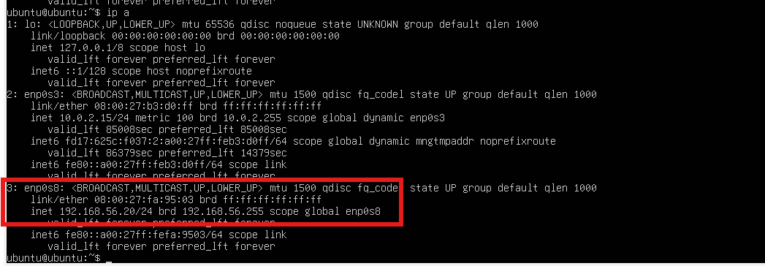
Figure 1. Ubuntu interface configuration showing 192.168.56.20/24.
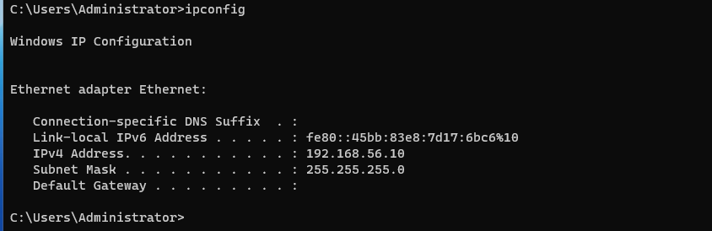
Figure 2. Windows ipconfig showing 192.168.56.10/24.
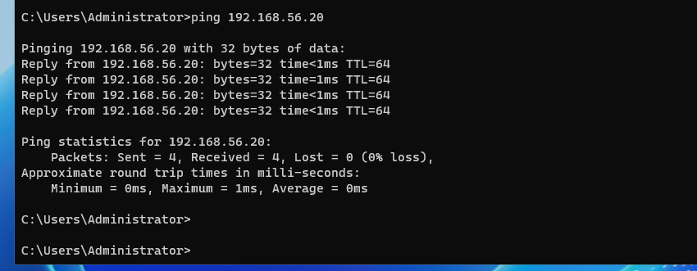
Figure 3. Windows-to-Ubuntu connectivity test: 4 packets received, 0% loss.

3. Lab 2 – SIEM Deployment & Real-Time Log Analysis
Lab 2 was completed through a Wazuh manager on Ubuntu and a Wazuh agent on Windows. The evidence shows the manager services running, the Windows agent service running, one active agent in the dashboard, authentication failures visible in Threat Hunting, and a firewall-drop Active Response event triggered by an SSH authentication failure.

3.1 Wazuh Manager Services
The Ubuntu screenshots show the Wazuh manager and Wazuh indexer services in an active/running state. The manager status output also shows the Wazuh analysis, authentication, log collector, and execution components loaded under the manager service.
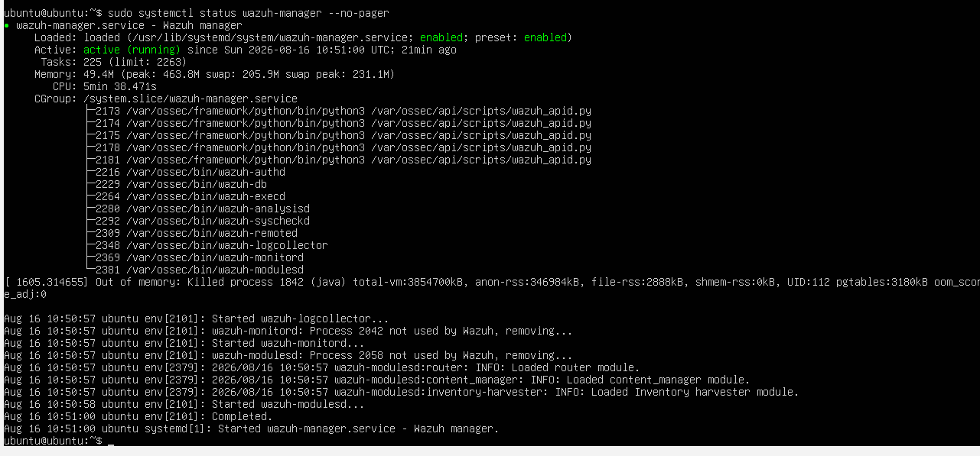
Figure 4. Wazuh manager service shown as active (running).
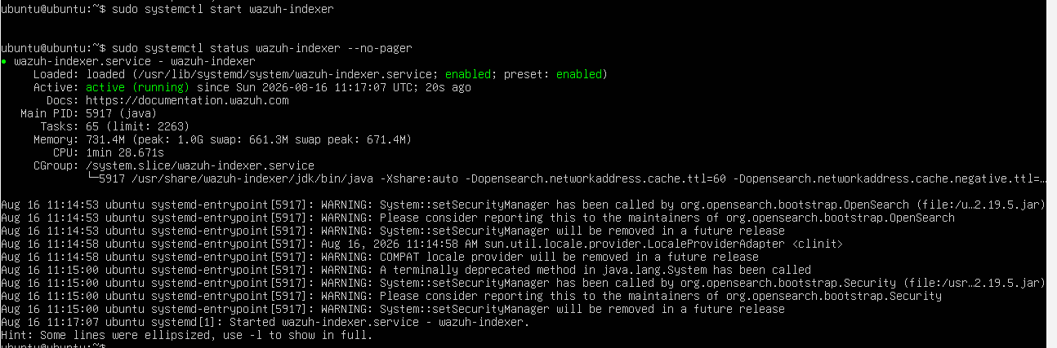
Figure 5. Wazuh indexer service shown as active (running).

3.2 Windows Agent Deployment
The Windows PowerShell evidence shows the Wazuh agent package being downloaded/configured with WAZUH_MANAGER='192.168.56.20', followed by NET START Wazuh. The command output confirms that the Wazuh service started successfully. A second screenshot verifies the service status as Running.
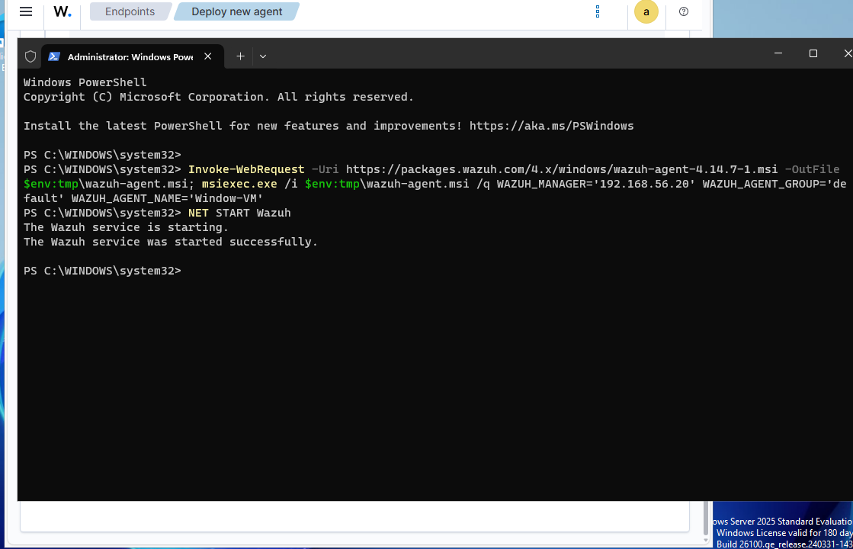
Figure 6. Windows Wazuh agent deployment and successful service start.
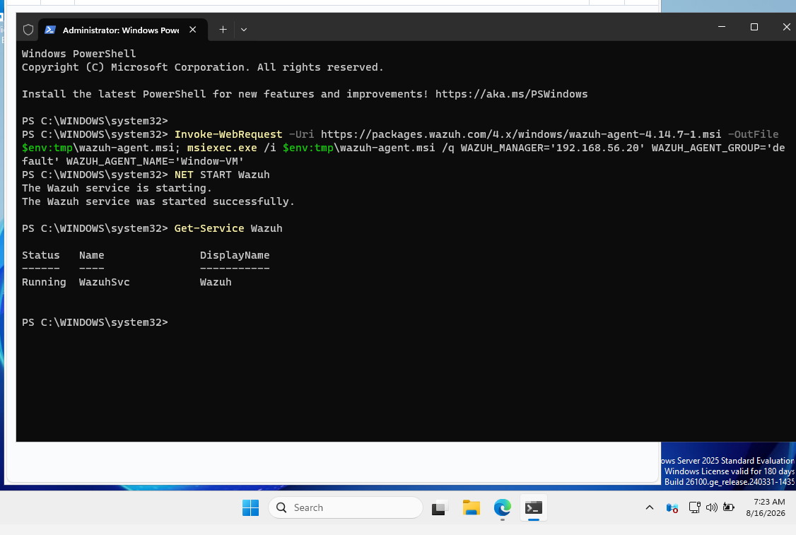
Figure 7. Windows Get-Service Wazuh output showing WazuhSvc as Running.

3.3 Network Connectivity
The Windows VM successfully pinged 192.168.56.20 four times. The result was 0% packet loss, confirming basic connectivity between the endpoint and the Wazuh manager over the private network.

Figure 8. Successful connectivity test from Windows to the Wazuh manager.

3.4 Agent Visibility in Wazuh
The Wazuh overview dashboard shows one active agent and zero disconnected agents. This provides dashboard-level evidence that the endpoint was registered/connected to the manager.
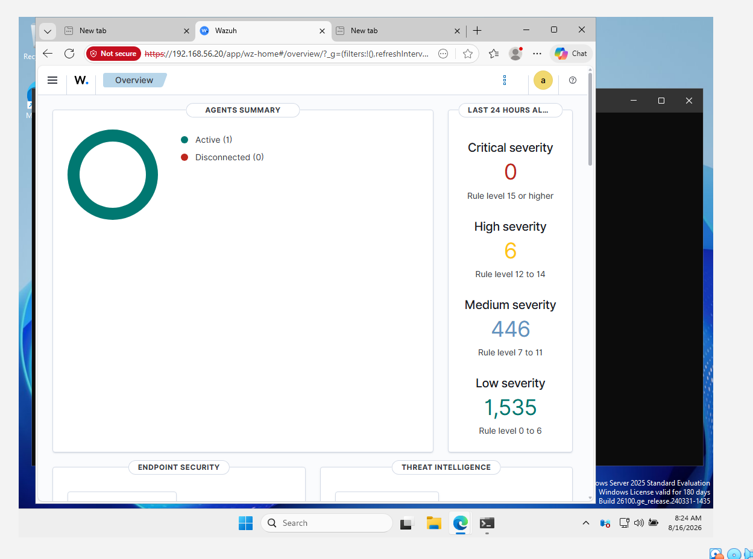
Figure 9. Wazuh overview showing Active (1) and Disconnected (0).

3.5 SSH Brute-Force / Authentication Failure Detection
The Threat Hunting dashboard was filtered for authentication_failed events. The supplied screenshot shows 6 total events, 6 authentication failures, and 0 authentication successes. The MITRE ATT&CK visualization includes Password Guessing, SSH, Account Access Removal, and Brute Force categories.
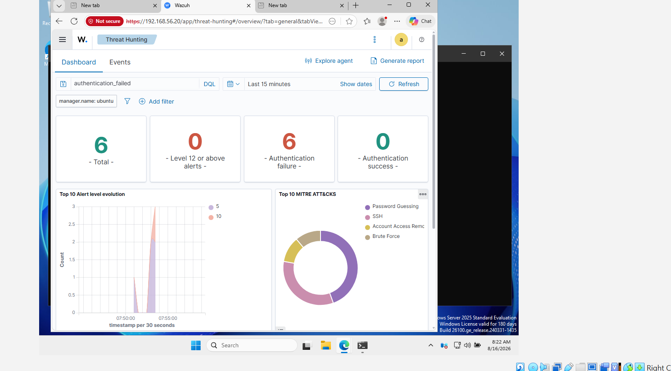
Figure 10. Threat Hunting dashboard showing 6 authentication failures and MITRE ATT&CK classifications.
The underlying Ubuntu authentication/Active Response evidence shows failed SSH authentication attempts associated with source IP 192.168.56.10. The event is passed to the configured firewall-drop response.
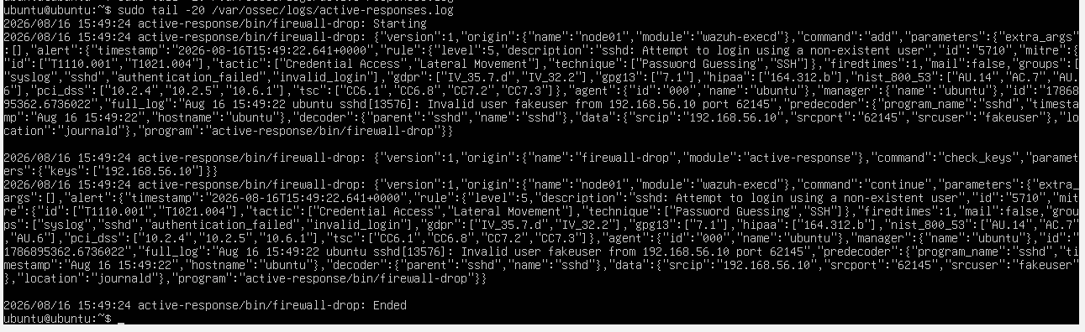
Figure 11. Active-response log showing firewall-drop activity for the SSH authentication event.

3.6 Active Response – Automated IP Blocking
The Active Response log records active-response/bin/firewall-drop starting, the alert/rule information, the source IP 192.168.56.10, and the firewall-drop action ending. This is the evidence chain for the automated response portion of Lab 2.

Figure 12. Detailed Active Response execution log: firewall-drop starts and ends.

3.7 Lab 2 Result & Mitigation
Result:
- Wazuh manager was deployed on Ubuntu and its core manager/indexer services were shown running.
- Windows Wazuh agent was configured to communicate with manager 192.168.56.20.
- Windows endpoint connectivity to the manager was verified with a successful ping.
- The Wazuh dashboard showed one active agent.
- Authentication failures were detected in Threat Hunting.
- Active Response executed the firewall-drop action against the suspicious source IP.
Recommended mitigation steps:
- Use strong, unique passwords and disable unnecessary SSH accounts.
- Prefer SSH keys over password-based authentication where appropriate.
- Restrict SSH exposure using firewall rules and network segmentation.
- Keep Wazuh agents and SIEM components updated.
- Retain and review authentication logs for repeated failures and unusual source addresses.
- Validate Active Response rules carefully so legitimate users are not blocked accidentally.

4. Lab 3 – Threat Hunting & Malware Emulation (Atomic Red Team)
The lab instructions require Atomic Red Team installation on a Windows VM, execution of selected Atomic tests such as T1059 (command execution) and T1003 (credential dumping), documentation of forensic artifacts, and verification of Endpoint Security/Antivirus detection.

4.1 Threat Hunting Evidence
A Wazuh Threat Hunting dashboard is present in the supplied evidence and is useful for the detection side of Lab 3. It demonstrates that the SIEM can display authentication-related events and map activity to MITRE ATT&CK techniques.

Figure 13. Wazuh overview used as the SIEM monitoring interface.

Figure 14. Threat Hunting view with MITRE ATT&CK classifications.

4.2 Atomic Red Team Evidence Status
Status: NOT VERIFIED FROM THE SUPPLIED SCREENSHOTS
No supplied screenshot clearly shows Atomic Red Team being installed or a specific Atomic test being executed. There is also no screenshot proving an antivirus/endpoint-security detection of T1059 or T1003. Accordingly, this report intentionally does not claim that those tests were completed.

4.3 Required Forensic/Detection Evidence
- Screenshot of Atomic Red Team installation on the Windows VM.
- Screenshot/console output identifying the exact Atomic test executed (for example T1059 or T1003).
- Wazuh/Endpoint Security alert showing the resulting activity.
- Forensic artifacts created by the test, such as process execution records, PowerShell/command logs, files, registry changes, or authentication artifacts, as applicable to the selected test.
- A short mapping between the test, MITRE ATT&CK technique, observed artifact, Wazuh rule/alert, and mitigation.

5. Deliverables Checklist
Deliverable | Status | Evidence / Note
System architecture & IP mapping | Complete | Ubuntu 192.168.56.20/24; Windows 192.168.56.10/24; ping verified.
Lab 2 SIEM Manager deployment | Complete | Wazuh manager/indexer service evidence.
Windows/Linux log forwarding | Complete for supplied evidence | Windows Wazuh agent installed and running; dashboard shows 1 active agent.
SSH brute-force/authentication detection | Complete | Threat Hunting shows 6 authentication failures.
Active Response IP blocking | Complete | firewall-drop execution is recorded in active-response logs.
Lab 3 Threat Hunting | Partially evidenced | Threat Hunting dashboard is present.
Atomic Red Team installation | Not evidenced | No supplied screenshot proves installation.
Atomic test execution / forensic artifacts | Not evidenced | No supplied screenshot proves T1059/T1003 execution or artifacts.
Endpoint/Antivirus detection for Lab 3 | Not evidenced | No supplied detection screenshot available.

6. Conclusion
The supplied evidence demonstrates a functional Wazuh SIEM workflow for Lab 2: the manager is running, the Windows agent is running, the private network connection is working, authentication failures are visible in Threat Hunting, and the Active Response mechanism executes a firewall-drop action against the source of the suspicious SSH activity. These screenshots provide a coherent evidence chain from endpoint connectivity → agent registration → event detection → automated response.
Lab 3 is only partially represented. The Threat Hunting interface is available, but the supplied evidence does not prove Atomic Red Team installation, execution of T1059/T1003, collection of forensic artifacts, or antivirus/endpoint-security detection. Those items should be added before presenting Lab 3 as fully complete.

