CYBERSECURITY LAB REPORT
Lab 3: Endpoint Detection and Response Verification

Atomic Red Team + Microsoft Defender + Windows Event Logs

Student Name | Shumaila Arif
Lab | 3
Platform | Windows / PowerShell
Security Tools | Atomic Red Team, Microsoft Defender, Windows Event Logs
Date | 17 August 2026

Submitted as practical evidence of endpoint security monitoring and detection.

1. Executive Summary
This lab focused on verifying whether endpoint security controls can detect and respond to simulated adversary behaviors represented by Atomic Red Team tests. The work used the Invoke-AtomicRedTeam PowerShell module, Microsoft Defender Antivirus, PowerShell Operational logs, Windows Security logs, and Microsoft Defender Operational logs. The screenshots show that the Atomic Red Team module was available, Microsoft Defender and Real-Time Protection were enabled, PowerShell activity generated ScriptBlock logging events, and Microsoft Defender recorded multiple threat detections. One PowerShell XML-request test was also prevented with an 'Access is denied' exception, while Windows Security displayed a 'Threats found' notification.

2. Objectives
- Verify that the Invoke-AtomicRedTeam PowerShell module is installed and available.
- Review the T1059 Command and Scripting Interpreter technique and the T1059.001 PowerShell sub-technique tests.
- Check whether Microsoft Defender and related endpoint protections are active.
- Execute/attempt the lab's Atomic Red Team simulations and observe the endpoint response.
- Collect evidence from Microsoft Defender, PowerShell Operational logs, and Windows Security logs.
- Document the detections, remediation status, and security observations.

3. Tools and Technologies Used
Tool / Component | Purpose | Evidence
PowerShell | Run verification and Atomic Red Team commands. | PowerShell screenshots
Invoke-AtomicRedTeam | Run and inspect Atomic Red Team tests. | Module/test screenshots
Microsoft Defender | Detect and remediate simulated malicious or unwanted activity. | Threat and operational-log screenshots
PowerShell Operational Log | Record PowerShell ScriptBlock activity. | Event ID 4104 screenshot
Windows Security Log | Record account/logon and privilege-related security events. | Security event screenshot

4. Lab Procedure and Evidence

4.1 Verify Atomic Red Team Module
The installed module was checked using Get-Module -ListAvailable. The evidence shows Invoke-AtomicRedTeam version 2.3.0 in the user's WindowsPowerShell Modules directory, with commands including Invoke-AtomicTest and Get-AtomicTechnique available.
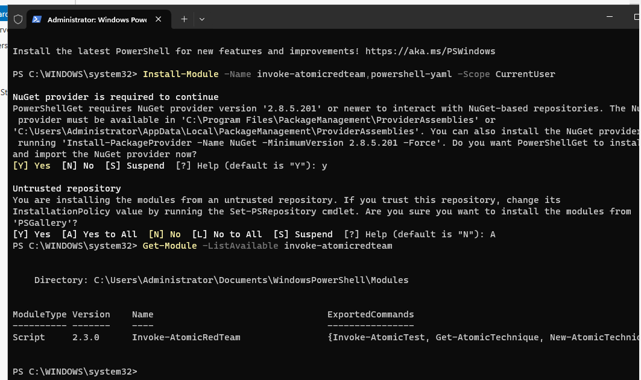
Figure 1: Verification of the Invoke-AtomicRedTeam PowerShell module (version 2.3.0).

4.2 Inspect T1059 Command and Scripting Interpreter
Invoke-AtomicTest T1059 -ShowDetails was used to inspect the available T1059 content. The screenshot identifies the technique as Command and Scripting Interpreter and shows an AutoIt Script Execution atomic test. Its description states that an adversary may attempt to execute suspicious or malicious scripts using AutoIt instead of a terminal such as PowerShell or cmd.
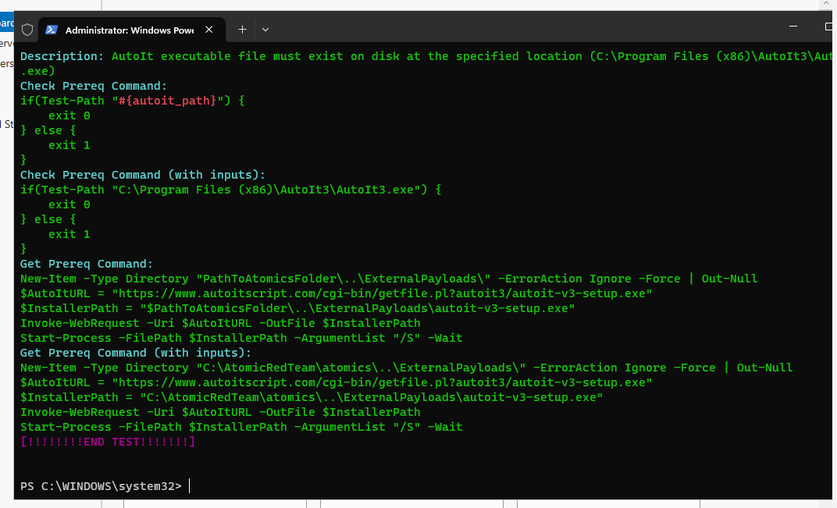
Figure 2: Atomic Red Team installation/test output showing the Atomic Red Team folder and T1059 test details.
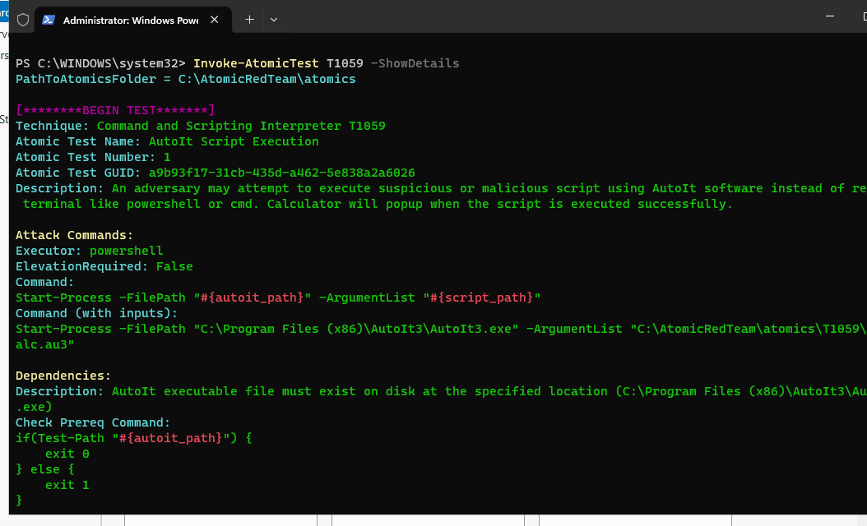
Figure 3: T1059 Command and Scripting Interpreter atomic test details, including the AutoIt Script Execution test.

4.3 Inspect T1059.001 PowerShell Tests
The T1059.001 PowerShell sub-technique was reviewed. The evidence includes a PowerShell XML request test. The test description indicates that it uses a PowerShell MSXML/HTTP request and is intended to demonstrate a simulated download/cradle behavior.
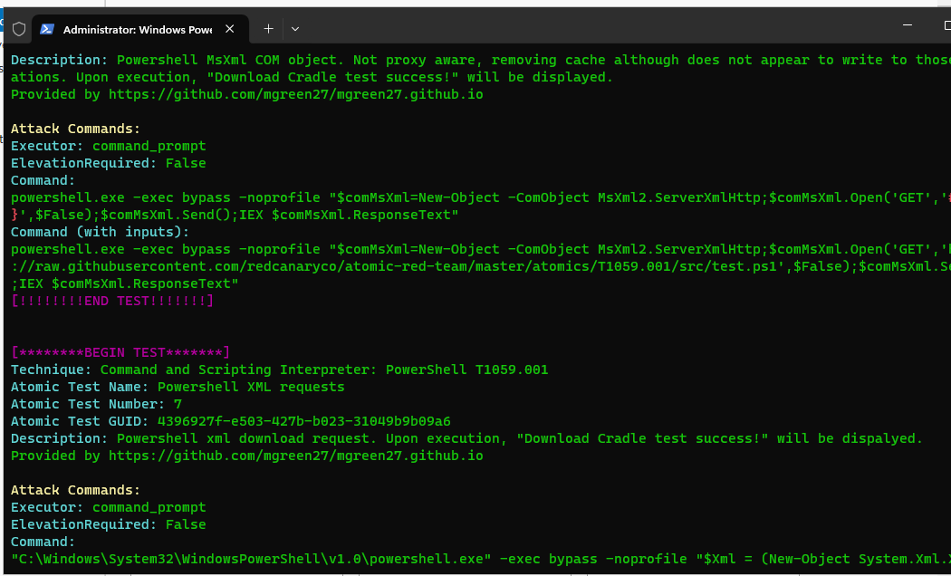
Figure 4: T1059.001 PowerShell XML requests atomic test details.

4.4 Verify Endpoint Security Status
The endpoint protection status was checked with Get-MpComputerStatus. The displayed results show AntivirusEnabled = True, RealTimeProtectionEnabled = True, and AMSServiceEnabled = True. This confirms that the main Microsoft Defender protections visible in the screenshot were active.
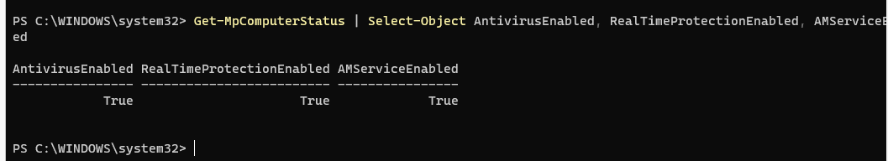
Figure 5: Microsoft Defender, Real-Time Protection, and AMSI service status—all enabled.

4.5 Verify Endpoint Detection
The lab then checked whether endpoint security detected the simulated actions. The evidence shows multiple Microsoft Defender detections. The threat list contains several threat names, including Backdoor:ASP/Ace.T, HackTool:JS/Jspat, Trojan:Win32/Vigorf.A, Exploit:O97M/DDEDownloader.B, Trojan:PowerShell/Powersploit.M, and other entries. The IsActive field is False in the displayed results, indicating that the listed detections were not active at the time of the query.
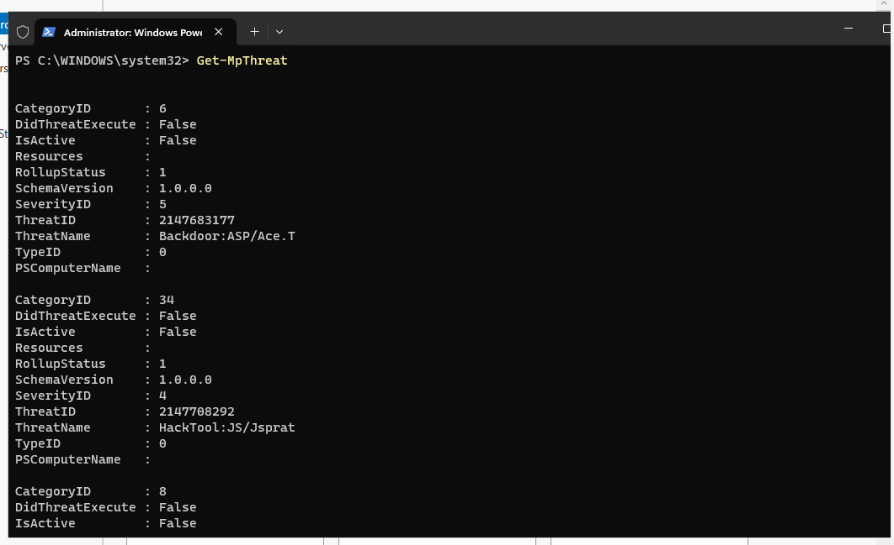
Figure 6: Endpoint-security verification activity for the Atomic Red Team tests.
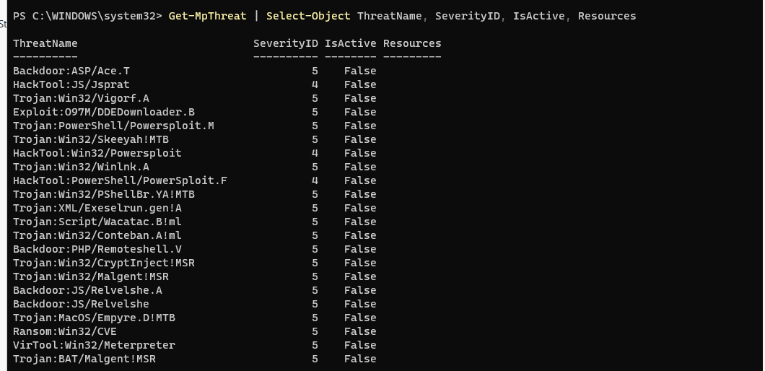
Figure 7: Microsoft Defender threat list showing multiple detected threats; all shown as inactive.

4.6 Review Detailed Defender Remediation Evidence
Get-MpThreatDetection was reviewed in detail. The evidence shows ActionSuccess = True, a DetectionID, an initial detection time of 8/16/2026 9:38:38 AM, a remediation time of 8/16/2026 9:40:00 AM, and a PowerShell process path. This supports the conclusion that Microsoft Defender successfully performed an action associated with the detected test activity.
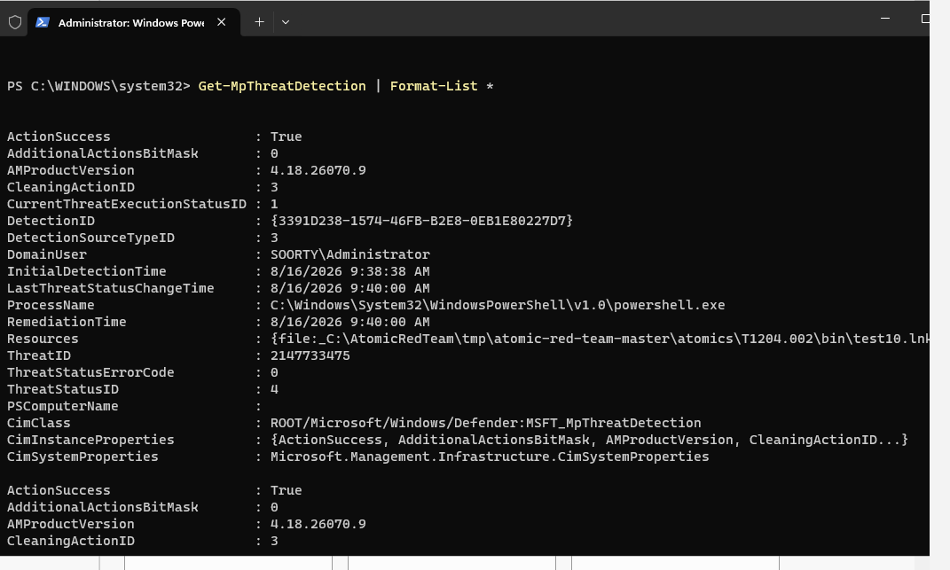
Figure 8: Detailed Microsoft Defender detection/remediation evidence. ActionSuccess is True and remediation time is recorded.

4.7 Review PowerShell Operational Logs
The Microsoft-Windows-PowerShell/Operational log was queried for the latest events. The screenshot shows Event ID 4104 with Warning level entries and messages beginning with 'Creating ScriptBlock text'. This provides evidence that PowerShell ScriptBlock activity was logged.
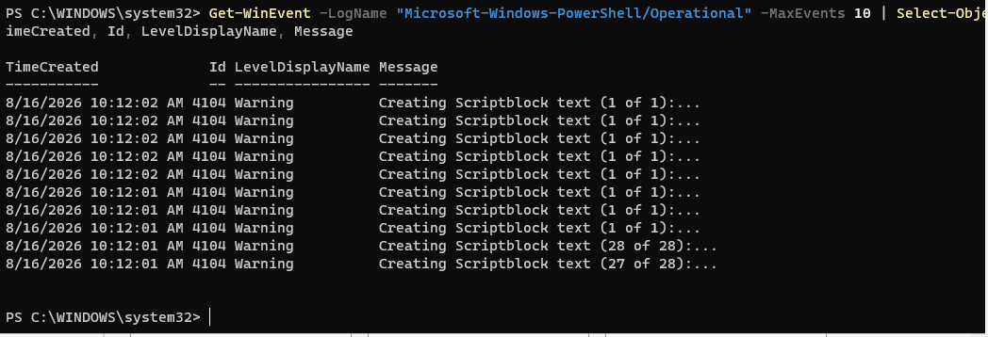
Figure 9: PowerShell Operational log showing Event ID 4104 warnings for ScriptBlock creation.

4.8 Review Windows Security Events
The Windows Security log was reviewed. The displayed events include Event ID 4624 for successful logons, Event ID 4634 for logoffs, and Event ID 4672 for special privileges assigned to a new logon. These records provide additional endpoint audit evidence around the lab activity.
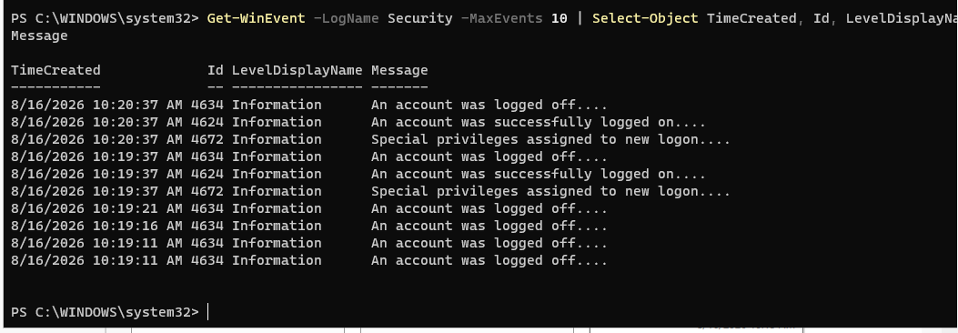
Figure 10: Windows Security log showing successful logons, logoffs, and special-privilege assignments.

4.9 Review Microsoft Defender Operational Logs
The Microsoft Defender Operational log shows Event ID 1117 detections of malware or potentially unwanted software, Event ID 1116 warning/detection activity, Event ID 2010 cloud protection activity, and Event ID 5007 indicating a Defender configuration change.
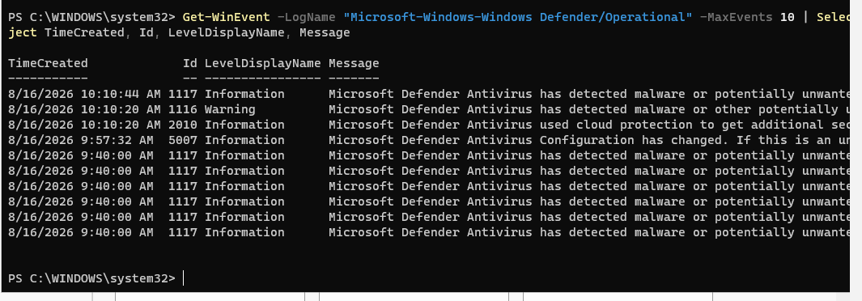
Figure 11: Microsoft Defender Operational log showing malware/potentially unwanted software detections and a configuration change.

4.10 T1059.001 PowerShell XML Request Test Result
The T1059.001 test was attempted and the execution output shows an 'Access is denied' exception from Process.Start. At the same time, a Windows Security notification displayed 'Threats found' and stated that Microsoft Defender Antivirus found threats. Therefore, the test did not complete as a normal successful execution; the observed security response itself is important evidence of endpoint protection.
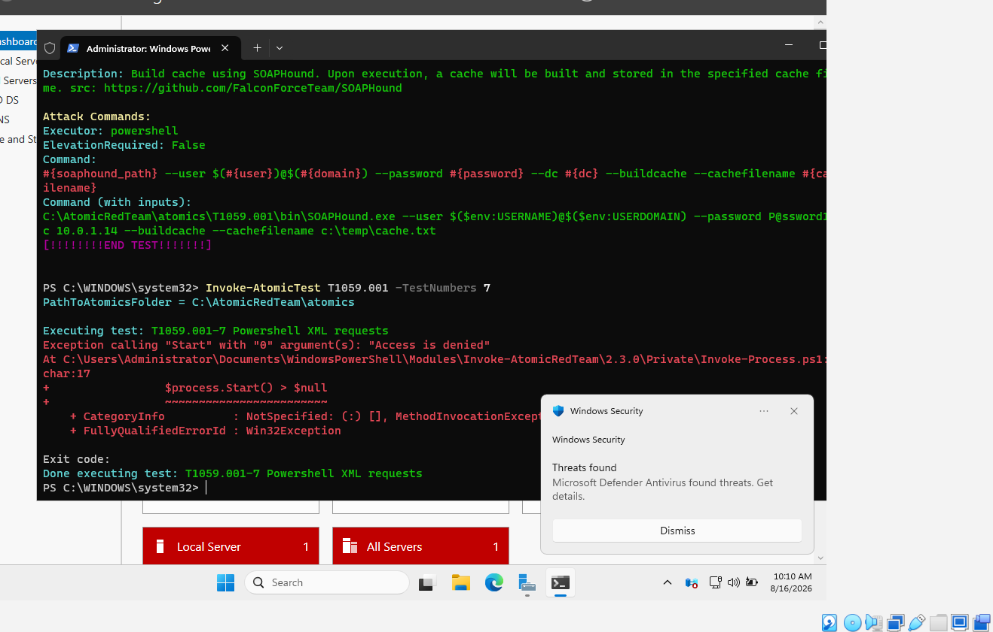
Figure 12: T1059.001 PowerShell XML request test execution; the test was blocked with an Access Denied exception while Windows Security reported threats found.

5. Results
Check | Observed Result | Status | Evidence
Atomic Red Team module | Invoke-AtomicRedTeam v2.3.0 was available. | Passed | Fig. 1
T1059 details | Command and Scripting Interpreter tests were displayed. | Passed | Figs. 2–3
T1059.001 details | PowerShell XML request test was displayed. | Passed | Fig. 4
Defender status | Antivirus, Real-Time Protection and AMS service were enabled. | Passed | Fig. 5
Threat detection | Multiple threats were detected and listed as inactive. | Detected | Figs. 7–8
PowerShell logging | Event ID 4104 ScriptBlock warnings were recorded. | Logged | Fig. 9
Windows Security logging | 4624, 4634 and 4672 events were visible. | Logged | Fig. 10
Defender operational logging | 1117/1116 detections and related events were visible. | Logged | Fig. 11
T1059.001 execution | Execution returned Access Denied while Defender reported threats found. | Blocked/Detected | Fig. 12

6. Findings and Analysis
- The endpoint had Microsoft Defender Antivirus and Real-Time Protection enabled before the verification activity.
- Atomic Red Team was successfully available through the Invoke-AtomicRedTeam PowerShell module (version 2.3.0).
- The T1059 and T1059.001 technique content could be inspected successfully.
- Microsoft Defender generated multiple threat detections during the lab activity.
- The detailed detection record reports ActionSuccess = True and includes a remediation time, supporting successful security response.
- PowerShell ScriptBlock logging generated Event ID 4104 warnings, providing useful telemetry for investigation.
- Windows Security events provided additional authentication and privilege information.
- The T1059.001 PowerShell XML request test produced an Access Denied error. Because Defender simultaneously reported threats found, the blocked execution should be treated as a security-control result rather than as a successful execution.
- The screenshots demonstrate layered endpoint visibility: prevention/detection through Defender plus logging through PowerShell and Windows Security.

7. Learning Outcomes
- Learned how Atomic Red Team can be used to simulate ATT&CK-aligned behaviors in a controlled lab.
- Learned how to inspect Atomic Red Team techniques and test details from PowerShell.
- Learned how to verify Microsoft Defender protection status from PowerShell.
- Learned how to inspect Defender threat and remediation records.
- Learned how PowerShell ScriptBlock events can provide investigation evidence.
- Learned how Windows Security and Defender Operational logs can be correlated with endpoint activity.
- Understood that a security test can be considered successful from a defensive perspective even when the simulated action itself is blocked.

8. Conclusion
Lab 3 successfully demonstrated endpoint security verification using Atomic Red Team and Microsoft Defender. The collected screenshots provide evidence of the installed Atomic Red Team module, inspected T1059/T1059.001 tests, active Microsoft Defender protections, threat detections, remediation information, PowerShell ScriptBlock logging, Windows Security events, and Defender Operational events. The T1059.001 PowerShell XML request test was blocked with an Access Denied error while Defender reported threats found, demonstrating that the endpoint security controls were able to detect and/or prevent the simulated activity.

9. Recommendations
- Keep Microsoft Defender Antivirus and Real-Time Protection enabled on endpoints.
- Retain PowerShell ScriptBlock logging because Event ID 4104 can provide valuable investigation telemetry.
- Regularly review Defender detections and remediation records after security testing.
- Correlate Defender, PowerShell, and Windows Security events when investigating suspicious activity.
- Run Atomic Red Team tests only in an authorized, isolated lab environment and document the expected detection before execution.
- For future labs, record the exact test number, timestamp, detection name, and final action in a structured evidence table.

10. Evidence Index
- Figure 1: Verification of the Invoke-AtomicRedTeam PowerShell module (version 2.3.0).
- Figure 2: Atomic Red Team installation/test output showing the Atomic Red Team folder and T1059 test details.
- Figure 3: T1059 Command and Scripting Interpreter atomic test details, including the AutoIt Script Execution test.
- Figure 4: T1059.001 PowerShell XML requests atomic test details.
- Figure 5: Microsoft Defender, Real-Time Protection, and AMSI service status—all enabled.
- Figure 6: Endpoint-security verification activity for the Atomic Red Team tests.
- Figure 7: Microsoft Defender threat list showing multiple detected threats; all shown as inactive.
- Figure 8: Detailed Microsoft Defender detection/remediation evidence. ActionSuccess is True and remediation time is recorded.
- Figure 9: PowerShell Operational log showing Event ID 4104 warnings for ScriptBlock creation.
- Figure 10: Windows Security log showing successful logons, logoffs, and special-privilege assignments.
- Figure 11: Microsoft Defender Operational log showing malware/potentially unwanted software detections and a configuration change.
- Figure 12: T1059.001 PowerShell XML request test execution; the test was blocked with an Access Denied exception while Windows Security reported threats found.

