Reverse Engineering, Component Modification, and
Cryptographic Re-signing of the Oversecured Vulnerable Android App (OVAA)
Mobile / Android Application Security — Lab Report
Environment: Kali Linux

1. Objective
This report documents the reverse engineering, modification and re-signing of the Oversecured Vulnerable Android App (app-debug.apk) — an intentionally vulnerable Android application used for training purposes. The application was decompiled, statically analysed, patched across its resources and manifest, recompiled, signed with a custom key, and verified to produce the final artifact ovaa_patched.apk.

Tools and Environment
Operating System | Kali Linux
Target Application | app-debug.apk (Oversecured Vulnerable Android App – OVAA)
Decompiler / Rebuilder | apktool
Static Analysis | jadx-gui
Text Editor | GNU nano 9.0
Key Generation | Java keytool (RSA, 2048-bit)
Signing Tool | apksigner
Final Artifact | ovaa_patched.apk

2. Step 1: Decompiling the APK with Apktool
The target package was decompiled using apktool, which disassembles the DEX bytecode into smali and decodes the manifest and resources into an editable project directory.
cd ~/Downloads
apktool d app-debug.apk -o ovaa_decompiled
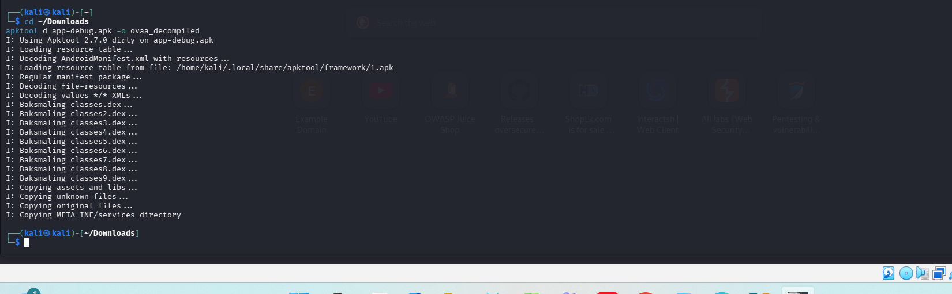
Figure 1 – apktool decompiling app-debug.apk into ovaa_decompiled/

3. Static Analysis & Original Resources
The APK was also opened directly in jadx-gui to cross-verify the decompiled output at the Java source level, and the original res/values/strings.xml was reviewed before any changes were made.
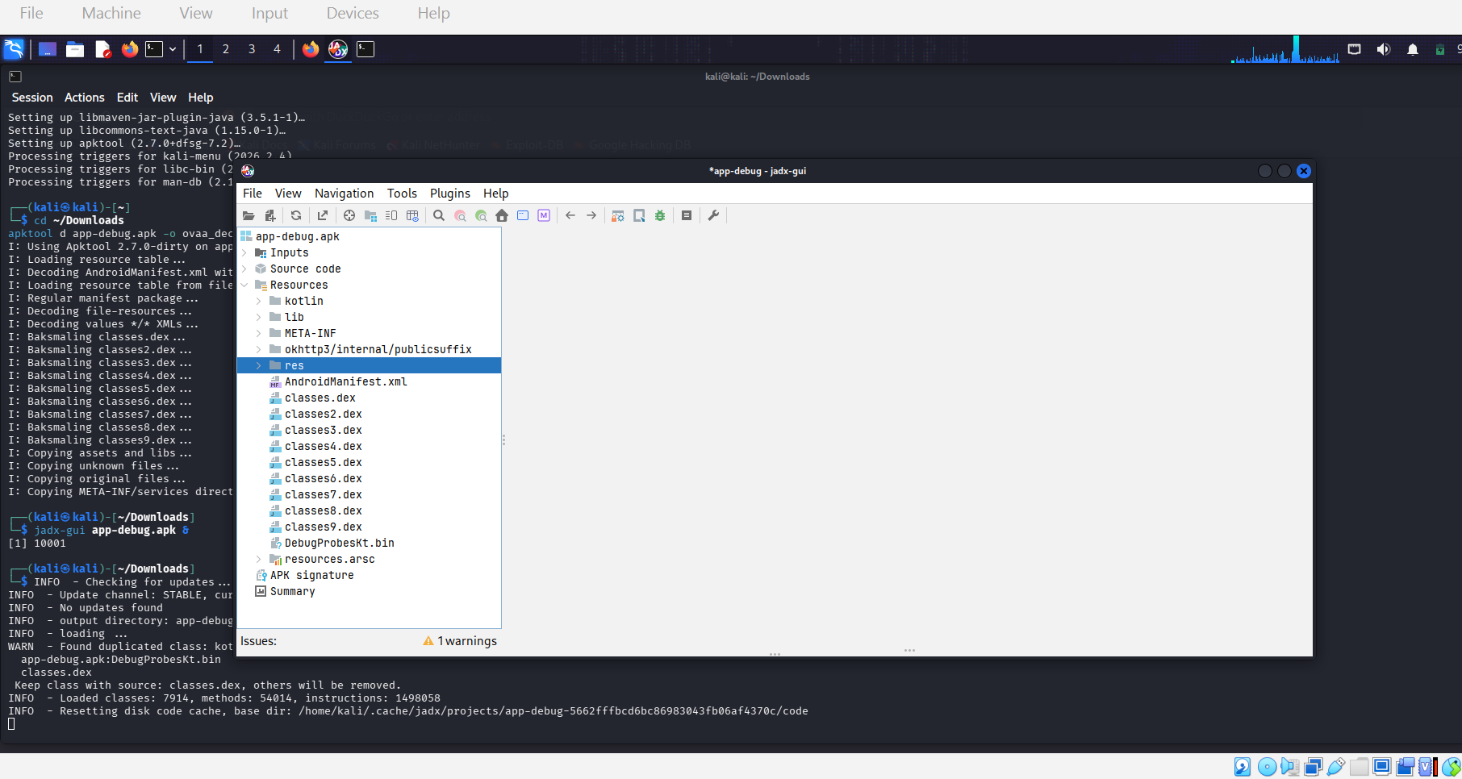
Figure 2 – jadx-gui project tree for app-debug.apk
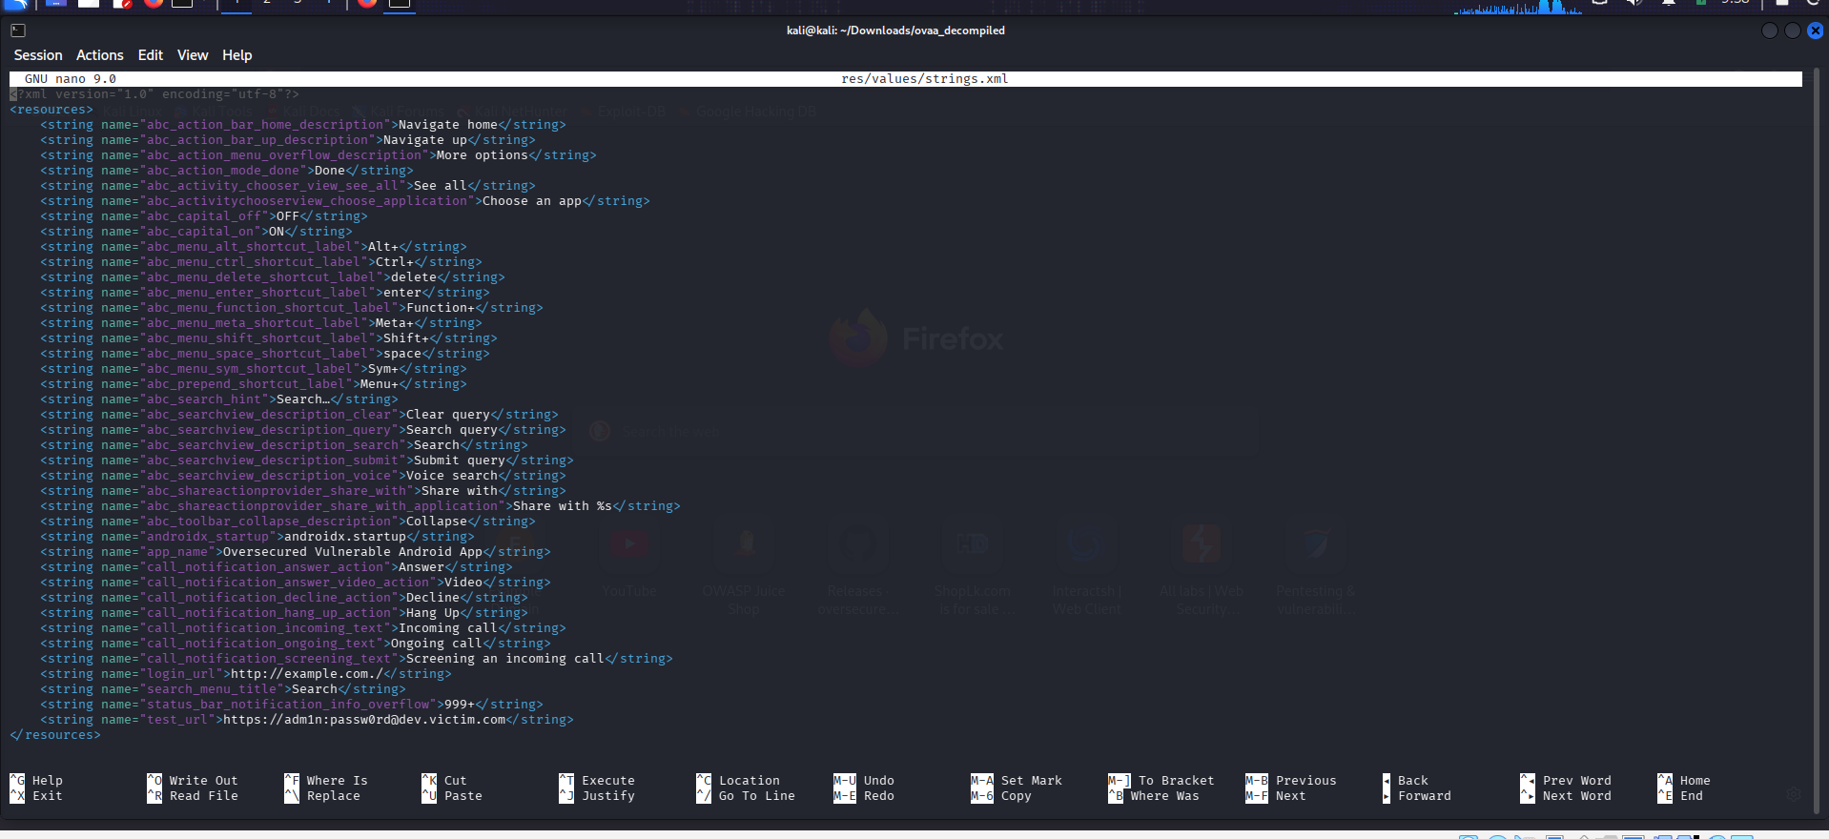
Figure 3 – Original res/values/strings.xml before modification

4. Code Modification / Patching
The app_name string was updated to brand the rebuilt package, and WebViewActivity's android:exported attribute in AndroidManifest.xml was changed from "false" to "true" to audit how an improperly exported component widens the app's attack surface.
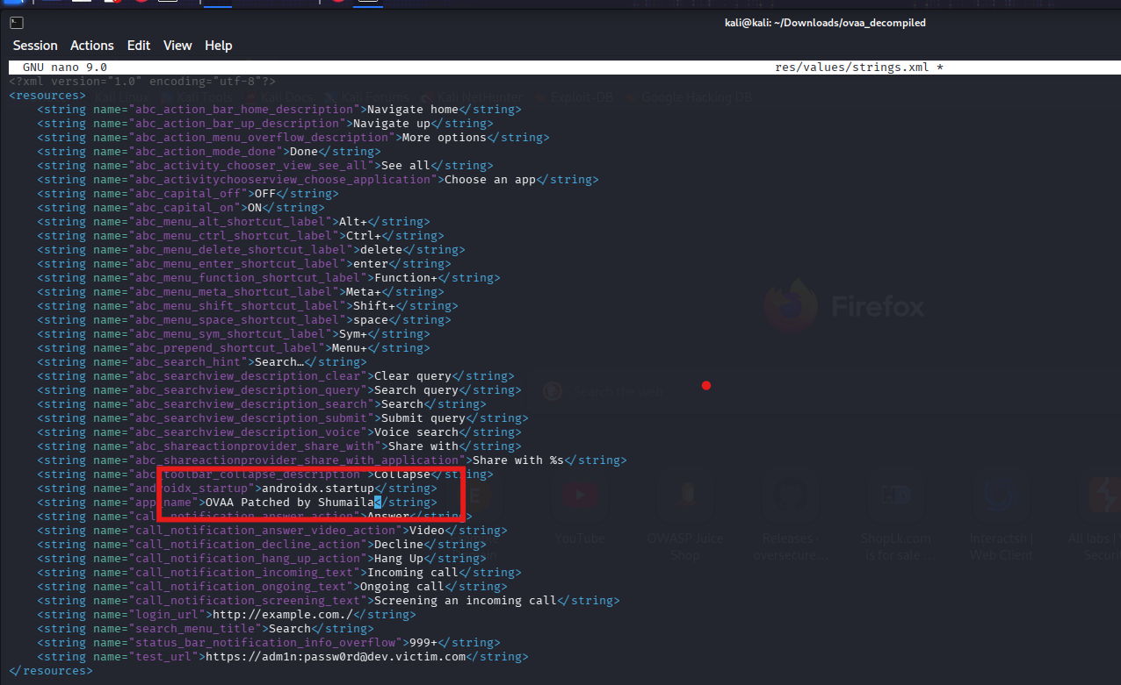
Figure 4 – app_name updated to identify the patched build
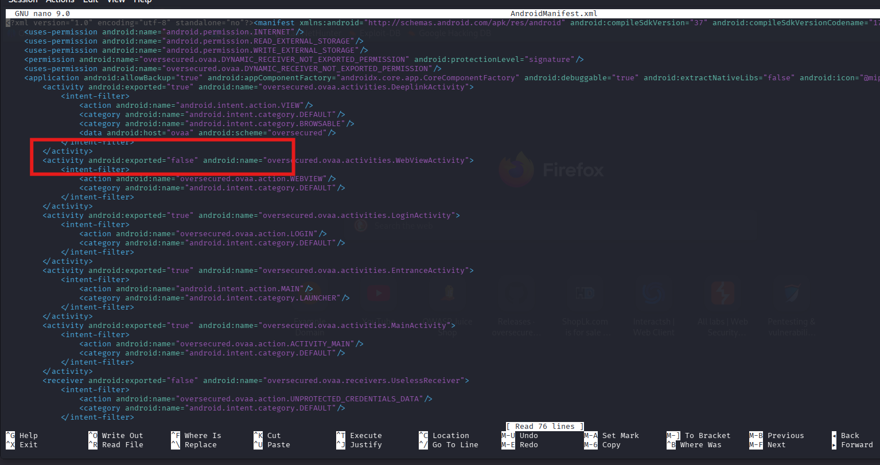
Figure 5 – WebViewActivity originally declared android:exported="false"
Figure 6 – WebViewActivity after patching, now android:exported="true"

5. strings.xml – Hardcoded URL Remediation
res/values/strings.xml also contained hardcoded login_url and test_url values, the latter embedding an admin credential. Both were replaced with patched placeholder values, alongside the app_name change.
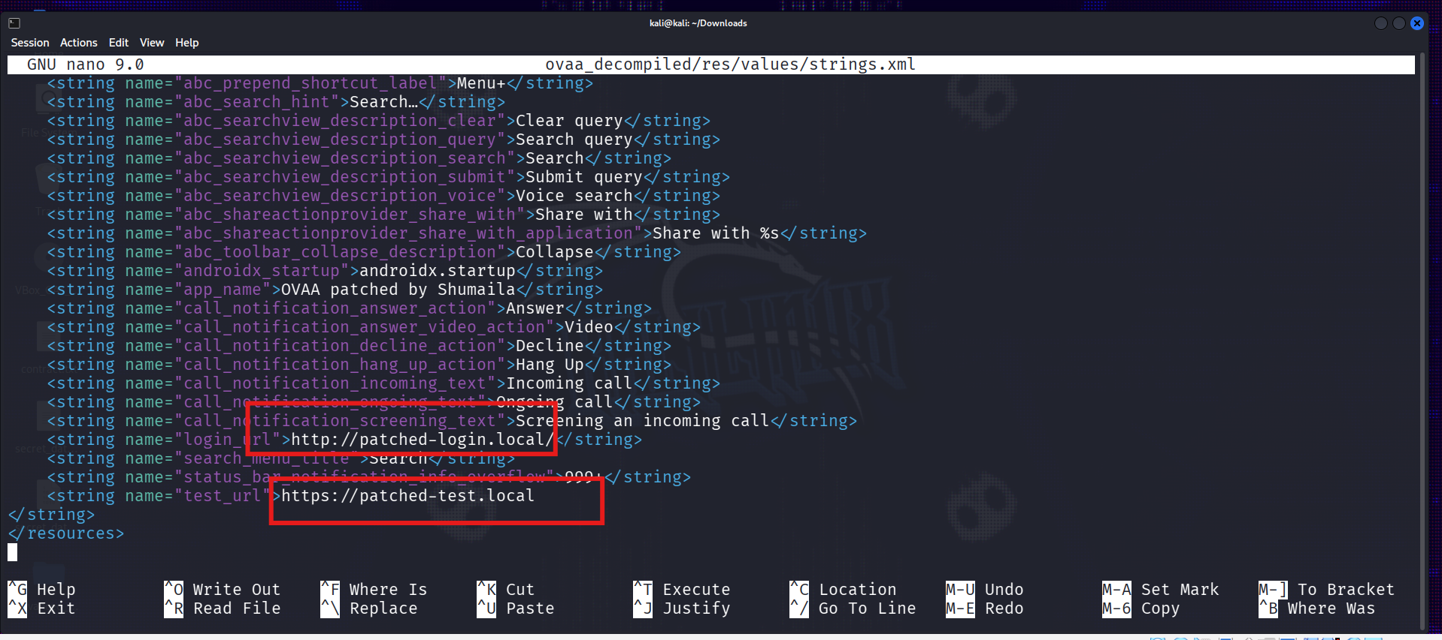
Figure 7 – app_name, login_url and test_url all updated in strings.xml
grep -E "login_url|test_url" ovaa_decompiled/res/values/strings.xml
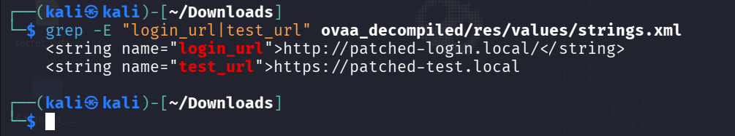
Figure 8 – login_url and test_url changes confirmed via grep

6. Manifest Hardening – allowBackup & debuggable
Two further manifest-level hardening changes were made on the <application> tag: android:allowBackup was changed from "true" to "false" (blocking ADB-backup data extraction), and android:debuggable was changed from "true" to "false" (preventing runtime debugger attachment).
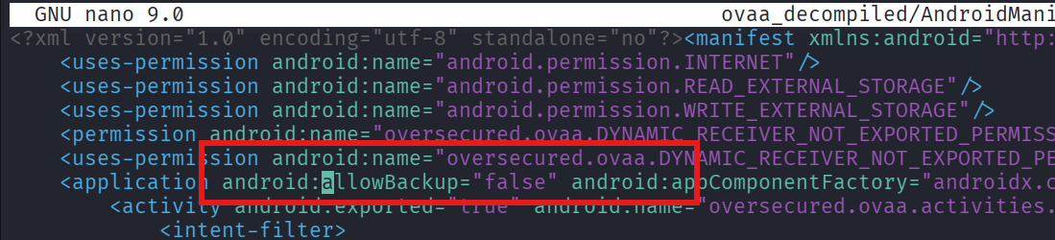
Figure 9 – android:allowBackup changed to "false"
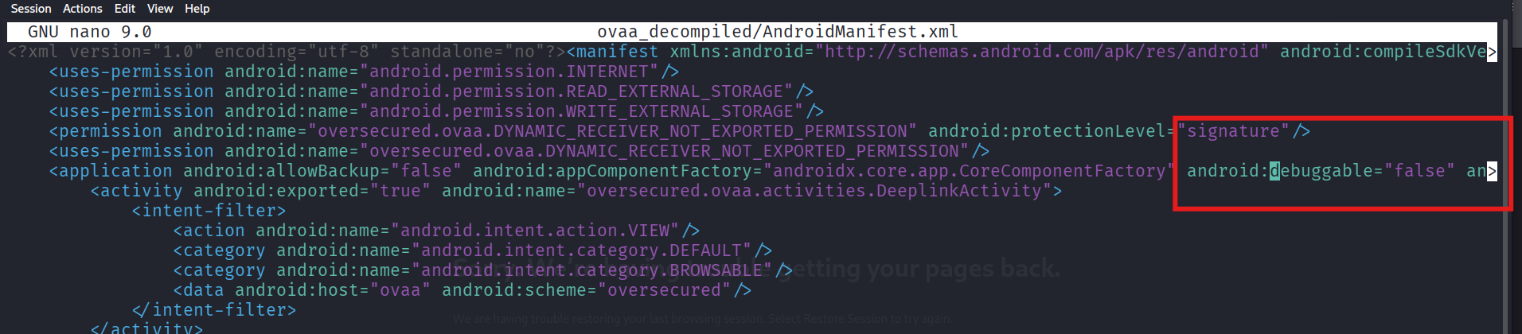
Figure 10 – android:debuggable changed to "false"

7. Branding Colour Update (colors.xml)
As an additional branding/UI change, the material_grey_900 colour value in res/values/colors.xml was updated from its default shade to a custom hex value.
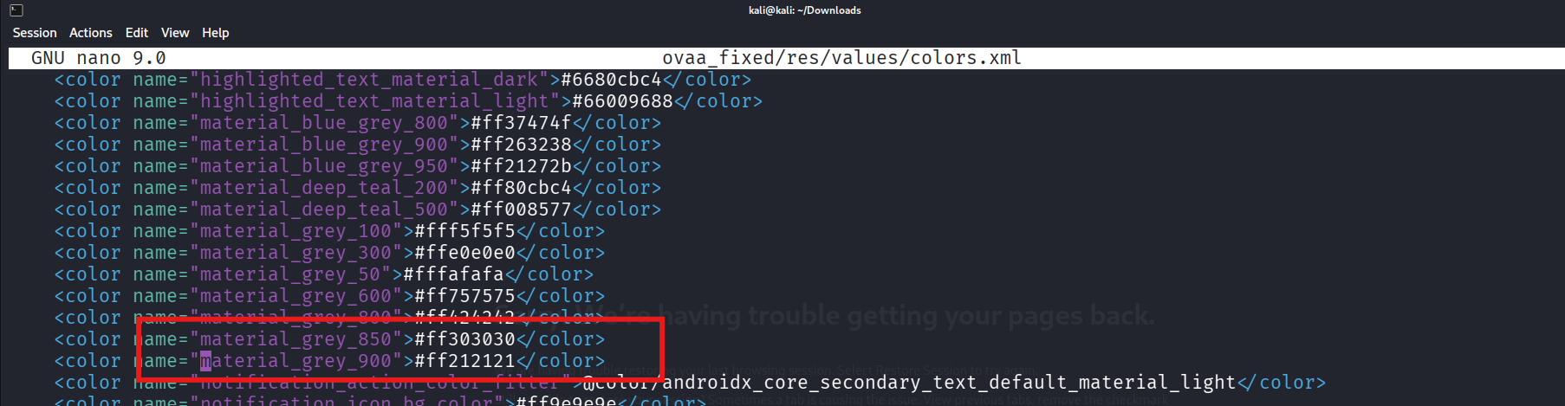
Figure 11 – res/values/colors.xml before editing material_grey_900
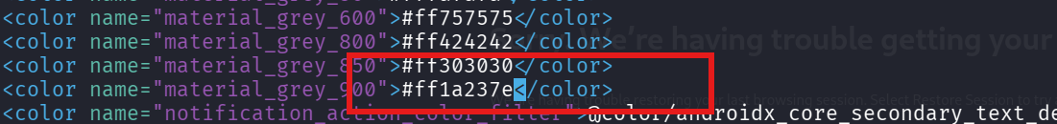
Figure 12 – material_grey_900 updated to #ff1a237e
grep "material_grey_900" ovaa_fixed/res/values/colors.xml
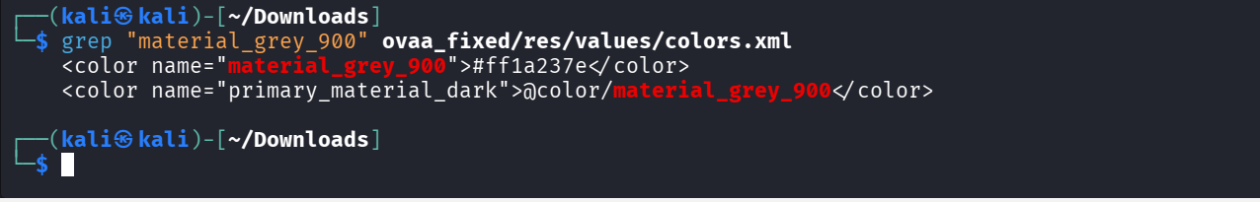
Figure 13 – Colour change confirmed via grep

8. Verifying All Changes
Before rebuilding, every resource and manifest change was re-verified directly from the shell:
grep -E "app_name|login_url|test_url" ovaa_decompiled/res/values/strings.xml
grep -E "WebViewActivity|UselessReceiver|allowBackup|debuggable" ovaa_decompiled/AndroidManifest.xml
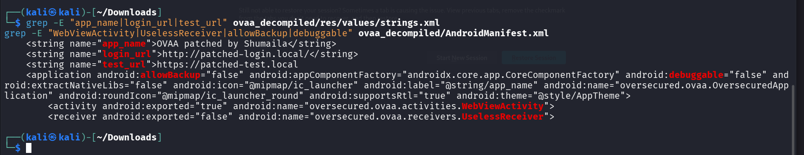
Figure 14 – All resource and manifest changes confirmed together

9. Rebuilding the APK
The patched project was recompiled with apktool. An initial build attempt failed due to an apktool/aapt toolchain issue when compiling an auto-generated adaptive-icon resource; this was resolved by using an updated apktool release, after which the project rebuilt cleanly into ovaa_patched.apk.
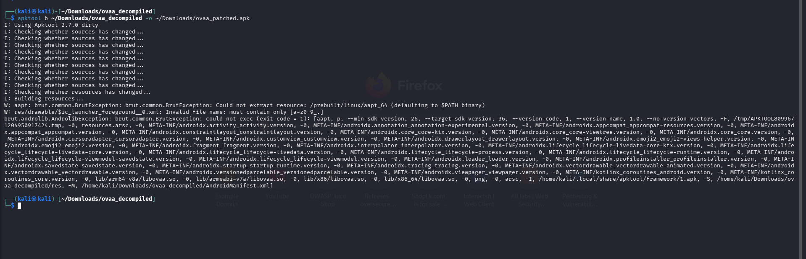
Figure 15 – Build attempt showing the apktool/aapt resource-compilation issue encountered during rebuilding

10. Key Generation & Signing
A custom RSA-2048 signing key pair was generated with keytool, after which the rebuilt APK was signed with apksigner and verified.
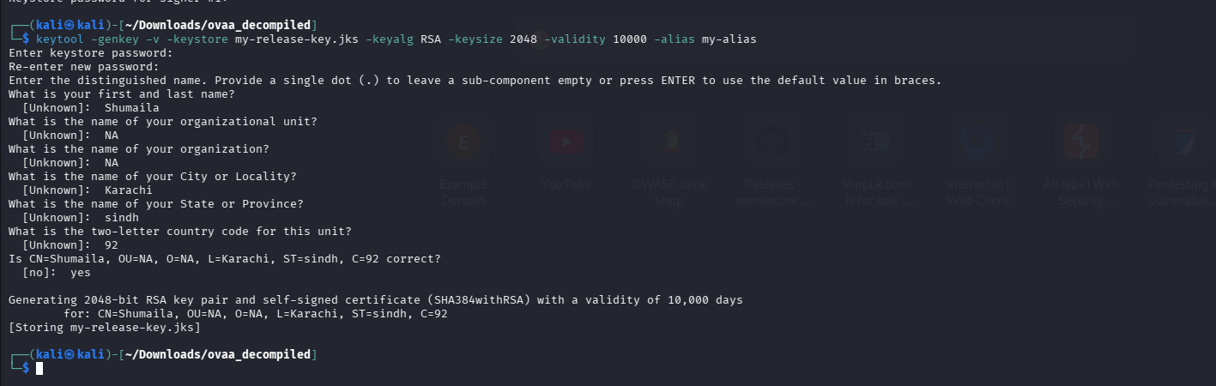
Figure 16 – RSA-2048 keystore generation with keytool
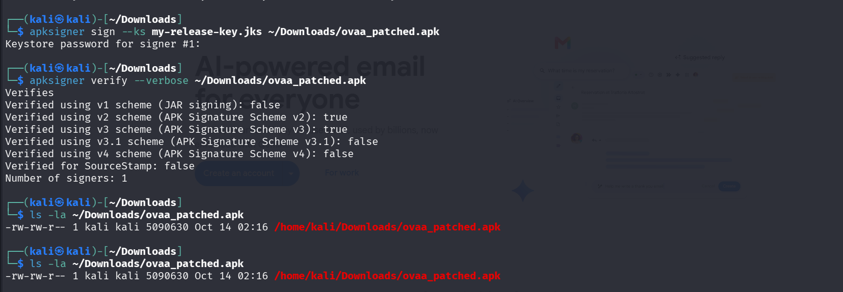
Figure 17 – apksigner sign and verify confirming "Verifies", and the final ovaa_patched.apk written to disk

11. Installation Check (adb)
As an optional final step, android-tools-adb was installed and an installation of the signed APK onto a connected device/emulator was attempted.
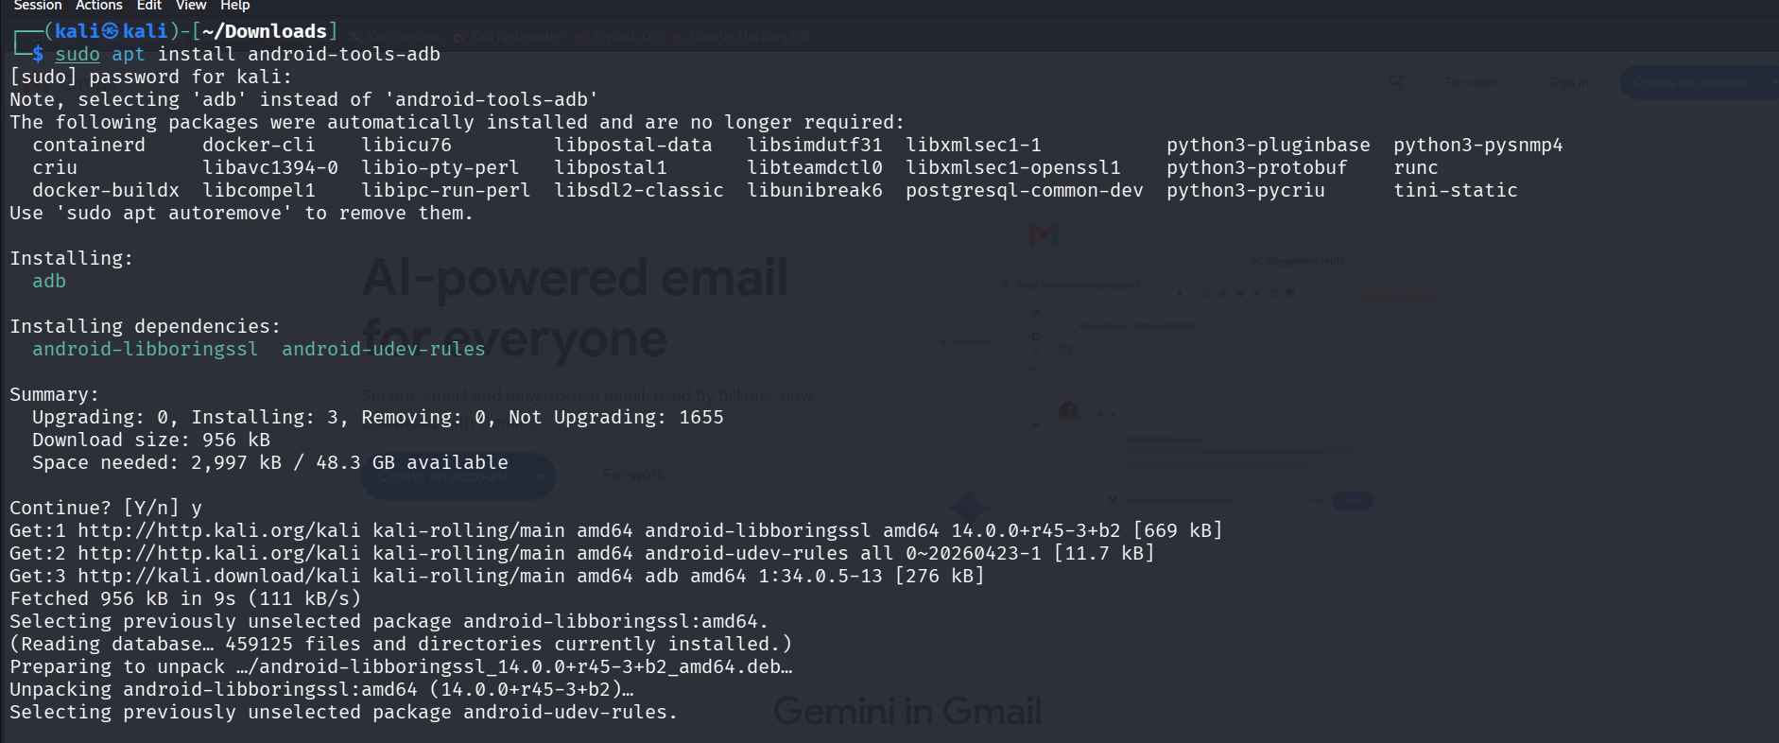
Figure 18 – Installing android-tools-adb
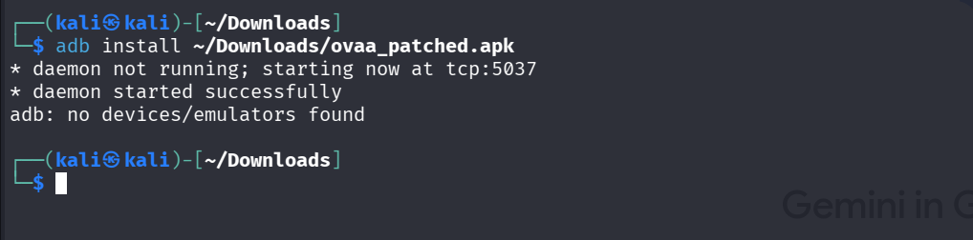
Figure 19 – adb install reporting no connected device/emulator (apksigner verify already confirms the APK itself is valid)

12. Conclusion
This exercise covered the complete APK modification lifecycle — decompilation, static inspection, resource and manifest patching, recompilation, key generation and re-signing — using the Oversecured Vulnerable Android App as a safe, purpose-built training target. The combination of exposing WebViewActivity (an attack-surface audit) alongside remediating hardcoded URLs and disabling allowBackup/debuggable (real hardening fixes) demonstrates both sides of Android component security review. The resulting ovaa_patched.apk, verified via apksigner, along with this documentation and the accompanying demonstration recording, constitutes the deliverables for this assignment.

