# **PREFACE**

This report has been prepared as part of project work to fulfill the requirement of course syllabus prescribed to Civil Engineering final year course. Our project group has chosen to do analysis and design of Reinforced Concrete framed building under the guidance of our dedicated supervisor and department of Civil Engineering.

Among the two category of building structure, viz, load bearing and framed structures, here, in the project work the frame structure is practiced. Building frame is the three dimensional structure as space which consist of rigidly interconnected beams, slab and columns. It produces greater number of the redundancy thus reduces the moments and facilitates the even distribution of the load.

Building frame is the three dimensional structure as space which consist of rigidly interconnected beams, slab and columns. It produces greater number of the redundancy thus reduces the moments and facilitates the even distribution of the load.

This project enabled us to acquire knowledge on proper analysis and design of building for earthquake safety including the capability of solving and tackling the field problem to somewhat. It has taught us to work in team which will surely help us in the future to come.

The results of calculation are presented in tabular form and sample calculations are provided in details to reduce the bulkiness of the report. Sufficient figure and sketches have been introduced to illustrate the theories. Reference to the appropriate clauses of standard codes of practices has been made wherever necessary. It is clear that for understanding the process physically and realizing the structure behavior, manual steps by steps procedure is necessary. However due to the time constraint and to be familiar to the modern technology, the structural analysis and design part is performed using computer software “ETABS”. The burden of repeated calculations in analysis has been reduced due to use of computer software. Report is focused on the design of slab, beam (primary), column (square), staircase (dog legged) and foundation (mat footing).

# **ACKNOWLEDGEMENT**

The trend of getting structures analyzed scientifically for structural safety and economic reasons is getting more and more popular nowadays. Nearing graduation, after which we would qualify as full engineers, the desire to learn about such an analysis and design has motivated us for this project, entitled *“Structural Analysis and Design of Office Building”*.

At the outset we will like to forward our sincere thanks and gratitude to our Respected Supervisor **Er. *Rajiv Manandhar*,** for providing immense guidance and support for our project. We benefited a lot in a great deal from his logical thoughts, experience, and incisive comments. We extend our heartfelt appreciation to our respected teachers of civil department associated with Nepal Engineering College for their valuable suggestions.

We also acknowledge our gratitude towards each other for such a united coordination amongst the group members during the project as well some of the other friend who helps throughout the project.

**Project members**

Rishikesh Neupane (015-104)

Shashi Simkhada (015-114)

Sushil Kumar Chaudhary (015-122)

# **List of Symbols and Abbreviations**

**Symbol Description**

 Diameter of Bar

τc Shear Stress

γm Partial Safety Factor

Ab Area of Each Bar

Ag  Gross Area of Concrete

Ah  Horizontal Seismic Coefficient

Asc Area of Steel in Compression

Ast Area of Steel

Asv  Area of Stirrups

B Width

d Effective Depth

d′ Effective Cover

D Overall Depth

e Structure Eccentricity

E Young’s Modulus of Rigidity

Es Modulus of Elasticity of Steel

fck Characteristics Strength of Concrete

fy Characteristics Strength of Steel

fs  Steel Stress of Service Load

h Height of building

I Importance Factor (For Base Shear Calculation)

I Moment of Inertia

Ip  Polar Moment of Stiffness

k Lateral Stiffness

L Length of Member

Ld Development Length

M Bending Moment

Pc Percentage of Compression Reinforcement

Pt Percentage of Tension Reinforcement

Q Design Lateral Force

R Response Reduction Factor

Sa/g Average Response Acceleration Coefficient

Sv Spacing of Each Bar

T Torsional Moment due to Lateral Force

Ta Fundamental Natural Period of Vibrations

V′ Additional Shear

VB Design Seismic Base Shear

W Seismic Weight of Floor

Xu Actual Depth of Neutral Axis

Xul Ultimate Depth of Neutral Axis

Z Zone Factor

Abbreviations

D.L Dead Load

E.Q Earthquake Load

IS Indian Standard

L.L Live Load

RCC Reinforced Cement Concrete

**Units:**

Force KN

Moment KN-m

Length m

Bar Dia. mm

Spacing mm

The outputs of Etabs are corresponding to force in KN and Length in m.

All dimensions are in mm units unless specified.

**Table of Contents**

PREFACE i

ACKNOWLEDGEMENT ii

List of Symbols and Abbreviations iii

Abbreviations v

**Units:** v

1 INTRODUCTION 1

1.1 Background 1

1.2 Objective of the project work 2

1.3 Scope of the project 2

1.4 Brief description of the proposed project 3

1.5 Units 4

1.6 Interpretation 4

1.7 Detailing 4

2 METHODOLOGY 5

2.1 Load calculation 5

2.2 Gravity load calculation 5

2.2.1 Dead load 5

2.2.2 Live load 5

2.2.3 Lateral load 5

2.3 Loading pattern 6

2.4 Methods and tools for analysis 7

2.5 Design method 7

2.5.1 Limit state method 7

2.5.2 Assumptions for flexural member 8

2.5.3 Limit state of collapse for compression 8

Assumption: 8

2.5.4 Limit state of serviceability 9

2.5.5 Structural system 10

2.5.6 Analysis of building 10

2.5.7 Load cases 10

2.6 Earthquake resistant design philosophy 11

Configuration 11

2.6.1 Connection 12

2.6.2 Construction quality 13

3 PRELIMINARY DESIGN 14

3.1 Design data 14

3.2 Preliminary design of elements 16

a. Preliminary design of slab 16

L/d αβγδλ 16



Where α = 26 for continuous elements IS:456-2000 clause 23.2.1 16

β = 1 16

γ = 1.7 for Pt = 0.20% (assumed) and fs = 224.7N/mm2 (IS:875-2000 clause 23.2.2.c) 16

δ = 1 for Pc = 0% 16

λ = 1 for rectangular section 16

b. Preliminary design of beam 17

c. Preliminary design of column 18

Seismic load 23

3.3 Base Shear Calculation 25

6 STRUCTURAL DESIGN 33

6.1 Design of structural elements 33

6.1.1 Design of slab 33

6.1.2 Design of beam 51

6.1.3 Design of staircase 58

6.1.4 Design of column 68

**6.1.5 Design of foundation** 82

**Foundation Type Selection** 82

8 BIBLIOGRAPHY 91

8.1 REFERENCE BOOKS: 91

8.2REFERENCE CODES: 91

# INTRODUCTION

## Background

With the advancement in technology of the country, the construction work has been carried out rapidly. Earthquake is one of the dominant constraints while designing the frame building in the earthquake prone zone like Nepal. Earthquake is considered to be greatest and unpredictable among all other natural disasters. Loss of lives and properties are huge and unpleasant because of worst scenario it can create. So that the designer‘s emphasis on seismic analysis of engineering structure to prevent from large intensity earthquake.

One being a designer has to deal with various structures ranging from simple ones like the curtain rods, and electric poles to more complex ones like multi-storied frame buildings, shell roofs, bridges etc. These structures are subjected to various loads like concentrated loads, uniformly distributed loads, uniformly varying loads, internal or earthquake load and dynamic forces. The structure transfers its load to the supports and ultimately to the ground. While transferring the loads, the members of the structure are subjected to internal forces like axial forces, shearing forces, bending and torsion moments. So considering all these the project of structures is designed as follows. First of all the most appropriate structural system and initial proportioning of members is done. Generally the initial drawing of architecture is referred. After that the loads are estimated based on functionality and purpose of building based on codes. Then the process of structural analysis and design evolves.

Structural Analysis deals with the prediction of performance of a given structure under stipulated loads and other external effects. The performance characteristics of interest are stresses and stress resultants such as axial forces, shear forces, bending moments, deflections and support reactions. Structural Design deals with sizing various members of the structure of actual proportion (member sizes, reinforcement details) and grades of materials required for safety and serviceability under the calculated member forces. The Indian Standard Code of Practice is thoroughly implemented for proper analysis, design and detailing with respect to safety, economy, stability, strength here in our project.

This project work has been undertaken as a partial requirement for B.E. degree in Civil Engineering. All the theoretical knowledge on analysis and design acquired on the course work are utilized with practical application. The main objective of the project is to acquaint in the practical aspects of Civil Engineering. We, being the budding engineers of tomorrow, are interested in such analysis and design of structures which will, we hope, help us in similar jobs that we might have in our hands in the future.

## Objective of the project work

1. Learn the concept of lateral and vertical loadings on the building.
2. Learn the analysis for earthquake loading on the building.
3. Identification of the structural arrangement of the plan.
4. Modeling of the building for the structural analysis.
5. Detail structural analysis using Etabs.
6. Sectional design of the structural components.
7. Structural detailing of the members and the system.

## Scope of the project

1. The structural analysis of the building is done by Etabs, for different cases of loads.
2. Design of RCC framed members, walls, mat foundation, staircase, and other by limit state method of design.
3. The project is not concerned with existing soil condition of the locality and the bearing capacity of the soil is adopted.
4. In the time of analysis and design all beams are considered as a rectangular beams instead of T-beam or L- beam.

For the design purpose IS codes are followed.

## Brief description of the proposed project

**Title of the Project** : Structural Analysis and Design of Office Building

**Building type** : Commercial Building

**Structural type** : Special moment resisting RCC framed

**Plinth area**  : 3455.04 square ft.

**No. of storey** : 7

**Type of slab** : Two way slab

**Type of beam :** Primary and secondary

**Type of column :** 550*550mm

**Type of staircase** : open well

**Type of foundation** : Mat Foundation

**Method of analysis** : Static Analysis (Etabs)

**Design concept** : limit state design

**Concrete Grade used**

i) For slab, beam, column and staircase : M25

ii) For foundation M30

**Reinforcement**

i) For slab, column, beam and staircase : Fe415

ii) For foundation : Fe500

**Dead load** : calculated as per IS 875 part I 1987

**Live load** : calculated as per IS 875 part II 1987

**Seismic load** : calculated as per IS 1893 (part I) 2016 using

Seismic coefficient method

**Preliminary design** : IS 456:2000

**Soil type** : Medium soil (assumed)

**Seismic zone** **:** V (assumed)

**Bearing capacity of soil** : 125KN/m2 (assumed)

## Units

SI (i.e. metric) units are used in this report. Whenever dimensions are not mentioned in figure and drawing should be taken as mm.

## Interpretation

Whenever reference to the clause of an Indian standard is made, it will be written as IS 456:2000 for structural design. Also some of clauses are written from the IS 1893:2016, SP-16 and other important factors from our book other reference books.

## Detailing

Detailing are done by using code IS 13920:2016, Handbook on concrete reinforcement and detailing and reference books stated in project are extensively used.

# METHODOLOGY

## Load calculation

Load calculations are done using the IS 875:1987 as reference. The exact value of unit weights of the materials from the code is used in the calculation. The thickness of materials is taken as per design requirement.

## Gravity load calculation

There are three types of loads for which are considered in this analysis.

1. Dead load
2. Live load
3. Lateral load

### Dead load

Dead load consists of the self-weight of the column, beam, slab and wall. Dimensions of column, beam, and slab are taken from preliminary design. For wall load, thickness of wall is taken from plan and deduction of opening is done according to the average size of opening in the outer and inner walls and deduction is not made in solid wall. In the case of the partition wall in the middle of slab, the total weight of the wall is calculated as uniformly distributed load and assign over the nearest beam.

### Live load

Live load is taken from IS 875: 1987(Part II). The magnitude of the live load depends upon the occupancy of the building. In the case of different live load in one panel of slab, highest value of the live load is taken for the panel.

### Lateral load

Lateral load acting in the building is earthquake/seismic load and wind load. Only earthquake load analysis is carried out in the project. For the analysis of earthquake load, following methods is generally carried out:

1. Seismic Coefficient method (Static)
2. Response Spectrum method (Dynamic)

In this project we use **seismic coefficient method** (linear static method).

## Loading pattern

The loading is applied to the slab elements directly. The total load (DL and LL) on staircase is equally distributed on both supporting beam and the load is converted to UDL. The load on slab is taken as per the requirement stated in IS875:1987(Part I & II).

Dead loads are computed from the dimensions of the structural member such as walls, beams, slabs, etc. and their material densities confirming to IS 875 (Part I). Similarly, live loads are to be chosen from IS 875 (part II) for various occupancies where required. The uniformly distributed dead and live load acting on the slab are transferred to the beams holding the slab. The slab load is distributed on the floor beams as shown in figure below. The smaller beam holds the triangular load and the longer beams hold the trapezoidal load as shown in figure. The beam element also resists the self-weight and the wall load including all the finish loads on wall such as external and internal plaster.



**Fig. Loading pattern in beam**

## Methods and tools for analysis

1. Creating grid/ model
2. Defining
3. Material
4. Section (beam, column, slab)
5. Load cases
6. Load pattern
7. Load combination
8. Assigning
9. Section
10. Load
11. Analyze the structure

Earthquake loads are calculated using seismic coefficient method.

1. Design of structural elements
2. Limit state design using above mentioned codes.

## Design method

We adopt limit state design method for design.

### Limit state method

It uses the concept of the probability and based on the application of method of statistic to the variation that occurs in the practice in the loads acting in the structures or in the strength of material.

The structures may reach a condition at which it becomes unfit for use for one of many reasons e.g. collapse, excessive deflection, cracking, etc. and each of these conditions is referred to a limit state condition. The aim of limit state design is to achieve an acceptable probability that the structure will not become unserviceable in its life time for the use of which it has been intended i.e. it will not reach a limit state. It means the structure should be able to withstand safely all loads that are liable to act on it throughout its life and it would satisfy the limitations of deflection and cracking.

### Assumptions for flexural member

1. Plane sections normal to the axis of the member remain plane after bending.
2. The maximum strain in concrete at the outermost compression fiber is 0.0035.
3. The relationship between the compressive stress distribution in concrete and the strain in concrete may be assumed to be rectangle, trapezoidal, parabola or any other shape which results in prediction of strength in substantial agreement with the result of test. For design purposes, the compressive strength of concrete in the structure shall be assumed to be 0.67 times the characteristic strength. The partial safety factor γm = 1.5 shall be applied in addition to this.
4. The tensile strength of concrete is ignored.
5. The design stresses in reinforcement are derived from representative stress-strain curve for the type of steel used. For the design purposes the partial safety factor γm = 1.15 shall be applied.
6. The maximum strain in the tension reinforcement in the section at failure shall not be less than:

Where,

fy= characteristic strength of steel

Es = modulus of elasticity of steel

### Limit state of collapse for compression

### Assumption:

In addition to the assumptions given above from i) to v), the following shall be assumed:

1. The maximum compressive strain in concrete in axial compression is taken as 0.002.
2. The maximum compressive strain at highly compressed extreme fibre in concrete subjected to axial compressive and bending and when there is no tension on the section shall be 0.0035 minus 0.75 times the strain at the least compressed extreme fibre.
3. The limiting values of the depth of neutral axis for different grades of steel based on the assumptions are as follows:

**Table 1: Limiting Value of Neutral Axis**

|  |  |
| --- | --- |
| **Fy** | **Xu,max** |
| 250 | 0.53 |
| 415 | 0.48 |
| 500 | 0.46 |

### Limit state of serviceability

This state corresponds to development of excessive deformation and is used for checking members in which magnitude of deformation may limit the use of the structure or its component. This limit may corresponds to

1. Deflection
2. Cracking
3. Vibration

The choice of the degree of reliability should be taken into account the possible consequences of exceeding the limit state of collapse which may be classified according to :

1. Risk to life negligible and economic consequences small or negligible.
2. Risk to life exists and / or economic consequences considerable and
3. Risk to life great and / or economic consequences also great.

### Structural system

The system has been analysed as 3D space frame. Element stresses in beams and columns are calculated by ETABS with provision of special joint frame system. Raft foundation has been constructed looking towards its effectiveness in the construction of building. Due to complexity of the structure, variation of load is high thus the mat foundation is best foundation for the structural system in comparison of other on context of safety, economy and stability.

### Analysis of building

For the static analysis of our building we use the structural analysis program ETABS that has special option for modelling horizontal rigid floor diaphragm system. We have adopted seismic coefficient method in ETABS analysis.

### 2.5.7Load cases

Load cases are independent loading for which the structure is explicitly analysed. Earthquake forces occur in random fashion in all directions. For building whose lateral load resisting elements are oriented in two principal directions. It is usually sufficient to analyze in these two principal directions (X and Y direction) separately one at a time. Thus, the load cases adopted are as follows.

* 1. Dead load(DL)
  2. Live load(LL)
  3. Earthquake load in X direction (EQX)
  4. Earthquake load in Y direction (EQY)

Following load combination are adopted for design

* + - 1. 1.5(DL+LL)
      2. 1.2(DL+LL±EQX)
      3. 1.2(DL+LL±EQY)
      4. 1.5(DL±EQX)
      5. 1.5(DL±EQY)
      6. 0.9(DL±EQX)
      7. 0.9(DL±EQY)

## Earthquake resistant design philosophy

The primary objective of earthquake resistant design is to prevent building collapse during earthquakes thus minimizing the risk of death or injury to people in or around those buildings.

Engineers do not attempt to make earthquake proof buildings that will not get damaged even during the rare but strong earthquake; such buildings will be too robust and also too expensive. Instead the engineering intention is to make buildings earthquake-resistant; such buildings resist the effects of ground shaking, although they may get damaged severely but would not collapse during the strong earthquake. Thus, safety of people and contents is assured in earthquake-resistant buildings, and thereby a disaster is avoided. This is a major objective of seismic design codes throughout the world.

**Design Philosophy**

1. Under minor but frequent shaking, the main members of the buildings that carry vertical and horizontal forces should not be damaged; however buildings parts that do not carry load may sustain repairable damage.
2. Under moderate but occasional shaking, the main members may sustain repairable damage, while the other parts that do not carry load may sustain repairable damage.
3. Under strong but rare shaking, the main members may sustain severe damage, but the building should not collapse.

The earthquake resistant design process involves various factors to be considered

Some of them are sort listed below:-

### Configuration

1. **Symmetry:**

The building as a whole or its various blocks should be kept symmetrical about both the axes. Asymmetry leads to torsion during earthquakes and is dangerous.

1. **Regularity:**

Simple rectangular shapes behave better in an earthquake than shapes with many projections. Torsional effects of ground motion are pronounced in long narrow rectangular blocks. Therefore, it is desirable to restrict the length of a block to three times its width. If longer lengths are required two separate blocks with sufficient separation in between should be provided.

1. 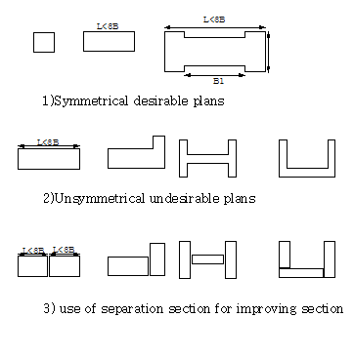**Separate Buildings for Different Functions**

### Connection

Proper selection of the material in proper ratio is needed for the construction of earthquake resistant design. Material properties should match the requirement of earthquake resistant concept. This involves various material properties.

Ductility is the major parameter need to be considered in the building performance during earthquake. Earthquake resistant buildings, particularly their main elements, need

to be built with ductility in them. Such buildings have the ability to sway back-and-forth during an earthquake, and to withstand the earthquake effects with some damage, but without collapse.

Thus, a necessary requirement for good earthquake-resistant design is to have sufficient ductile materials at points of tensile stresses.

Again base isolation of the structure from the ground motions which actually impose the forces on the structure can also be done. For reduction of the coefficient of friction between the structure and its foundation, one suggested technique is to place two layers of good quality plastic or flexible connection between the structure and its foundation.

### Construction quality

Though the connection and configuration of the structure is properly planned, but if the execution of the work is not accomplished using the planned format or specification then it may be difficult to achieve earthquake resistant structure. Proper supervision of the work by expert is required.

# PRELIMINARY DESIGN

The principal purpose for preliminary design of any structure is:

1. Obtained a clear picture of structural action
2. Established the dimensions of structure
3. Use the preliminary design as a check on the final design

Preliminary design includes the approximation of size of the structural component of the buildings for analysis. The preliminary bridges the gap between the design concept and the detail phase.

## Design data

1. Construction Material

Concrete Grade : M25

Steel : Fe415

1. Live Loads

a) Live load on slab:

i)For commercial case : 3KN/m2 (As per IS: 875-1987, table I)

ii)For residential case :2KN/m2 (As per IS:875-1987,table I)

b) Live Load on Stair : 4KN/m2 (As per IS: 875-1987, table I)

c)Live Load on Roof :1.5KN/m2(As per IS: 875-1987, tableII)

1. Screeding : 1 KN/m2 (IS : 875 (Part 1) – 1987)
2. R.C.C. specific weight : 25KN/m3
3. Brick Masonry specific weight : 18.5 KN/m3(As per IS:875-1987, table II)

1. Bearing Capacity of soil : 125 KN/m2 (assumed)
2. Loading Computation for roof slab
3. R.C.C. roof (125mm thick) = 0.125*25 = 3.75 KN/m3
4. Ceiling Plaster = 0.25 KN/m2(As per IS:875, table II)

Total Load = 4.00KN/m2

Adopted intensity of load = 4.00KN/m2

1. Loading Computation for intermediate floors:
2. R.C.C. floor slab (125mm thick) = 3.75KN/m2
3. Ceiling Plaster = 0.25 KN/m2(As per IS:875, table II)
4. Dressed Marble = 0.505KN/m2

Total Dead Load = 5.91 KN/m2

## Preliminary design of elements

### Preliminary design of slab

From limit state of serviceability (deflection) criteria the span depth is given by

### L/d αβγδλ



### Where α = 26 for continuous elements IS:456-2000 clause 23.2.1

Short span of span, lx = 5.9817m

Long span of span, ly = 6.096m

### β = 1

### γ = 1.7 for Pt = 0.20% (assumed) and fs = 224.7N/mm2 (IS:875-2000 clause 23.2.2.c)

### δ = 1 for Pc = 0%

### λ = 1 for rectangular section

Now,

Depth=L/ αβγδλ

=5981.7/(26*1.7)

d =135.33mm

Assume, 10mm dia. Reinforcement steel in slab

Therefore, dia. = 10mm

Assume effective cover, c = 15mm

Now, overall depth, D = 135.33+15+10/2 = 155.33mm>150mm

So provide secondary beam

Again,

Effective depth of slab (d)=150

Then,

Effective depth of slab (d)=5.9817*10^3/(2*26*1.7)

=67.67mm

Total depth(d)=67.67+10/2+15

=87.67mm

Provide(d)=125mm

II. Priliminary design of secondary beam

Effective depth (d) = l/20

= 6.096x103/20

=304.8mm

Depth(D) = d+Ø/2+clear cover

=304.8+20/2+25

=349.8mm

Provided = 450 mm

Width of secondary beam (b) = D/2 to 2D/3

=450/2

=225 < 230 (ok)

Adopt (b) = (225 x 450) mm

# Preliminary design of beam

i) For Alphabetic Grid:

Span length, l = 5943.6mm (Longest span)

Let us consider effective depth of beam be 1/12 to 1/15th of span

.·. Depth (D) =l/12 = 5943.6/12 = 495mm

Assume, dia. of bars in beam = 25mm

Assume, eff. cover = 25mm

Overall depth (D) = 495+25+25/2 = 532.5mm

.·. Adopt depth (D) = 550mm

Width of beam = 1/2 of the depth

= 550/2

= 225mm

Adopt, b = 225mm

Hence, size of beam = 225 mm * 550mm

ii) For Numerical Grid

Span length, l = 6096mm (Longest span)

Let us consider effective depth of beam be 1/12 to 1/15th of span. .·. Depth (D) =l/12 = 6096/12 = 508mm

Assume dia. of bars in beam = 20mm

Assume eff. cover = 25mm

Overall depth (D) = 508+25+20/2 = 543mm

.·. Adopt depth (D) = 550mm

Width of beam = 1/2 of the depth

= 550/2

= 225mm

Adopt, b = 225mm

Hence, size of beam = 225 mm * 550mm

# c. Preliminary design of column

Column is designed for bottommost column with largest loading

**Loading Calculation**

1. Self-Weight of slab=25*(5.96*(4.188*0.125)) =91.039 KN
2. Self-Weight of floor finish=(5.96*4.88)*1=29.13KN
3. Self-Weight of beam=(5.96+4.88)*(0.550*0.250)*25=37.29 KN
4. Self-Weight of column=(3.2*0.6096*0.4572*25)=22.3 KN
5. Self Weight of wall =(2.97+3.048)*0.2286*(3.2-0.55)*20=72.92KN
6. Live load(car and bike)=4KN/m2 to 5KN/m2
7. Live load (human)=3KN/m2

=3*5.96*4.88

=87.40KN

* For Ground Floor

I) Column Load=22.3 KN

II) For wall =72.44 KN

III)Live Load = 223.66 KN

IV)Slab Load = 91.031 KN

∴Total Load= 447.479KN

* For First Floor

1. Column Load =22.3 KN
2. For Wall =72.44 KN
3. Live Load= 69.99KN
4. Floor finish=29.13KN
5. Beam load=37.29KN
6. Slab load=91.031KN

∴Total Load= 322.109 KN

* For Second Floor

1. Column Load=22.3 KN
2. For Wall=72.44KN
3. Beam load=37.29KN
4. Floor finish=29.13KN
5. Slab load=91.039
6. Live Load=61.178KN

∴Total Load=313.33 KN

* For Third Floor ,fourth floor and fifth floor

1. Column Load =22.3 KN
2. For Wall= 72.44KN
3. Live Load=52.43 KN
4. Floor finish =29.13KN
5. Slab load=91.039KN
6. Beam load=37.29KN

∴Total Load= 304.63 KN

* Load calculation For secondary beam

Self wt. of secondary beam =(5.96+4.888)*0.225*0.45*25

=27.499KN

Total load=g.f+1+2+3+4

=137.295KN

Grand total load=1829.473KN

∴factored load=1.5*1829.295

=2744.21KN

For earthquake load increase 30%

=1.3*2744.21=3567.47KN

Now,

Assume, % of steel=3%

3567.47*103=(0.4*25*0.97+0.67*415*0.03)*Ag

or,Ag=197736.88mm2

∴Ratio=L=1.33*B

∴Area(A)=L*B

or,197736.88=1.33*B*B

∴B=388.58mm

∴L=512.238mm

Provide

L=600mm

B=450mm

**Next column**

Assume, continues slab and beam

Load calculation

1. Self load of slab=71.03KN
2. Self load of beam=33.24KN
3. Self weight of column=16.17KN
4. Self weight of wall=24.413KN
5. Live load(human)=68.187KN
6. Live load (cars and bike)=113.46KN
7. Self load of floor finish=22.72KN

* Ground floor

1. Self weight of slab=71.03KN
2. Self load of beam=33.24KN
3. Self weight of column=16.7KN
4. Self weight of wall=24.413KN
5. Live load(human)=61.368KN
6. Live load (cars and bike)=113.696KN

Total load=320.397KN

* First floor

1. Self load of slab=71.03KN
2. Self load of beam=33.24KN
3. Self weight of column=16.17KN
4. Self weight of wall=24.413KN
5. Live load(human)=54.54KN
6. Self weight of floor finish=22.72KN

∴Total load=222.643KN

* Second floor

1. Self load of slab=71.03KN
2. Self load of beam=33.24KN
3. Self weight of column=16.17KN
4. Self weight of wall=24.413KN
5. Live load=47.73KN
6. Self weight of floor finish=22.72KN

Total load=215.83KN

* Third,fourth,fifth floor

1. Self load of slab=71.03KN
2. Self load of beam=33.24KN
3. Self weight of column=16.17KN
4. Self weight of wall=24.413KN
5. Live load(human)=40.99KN
6. Floor finish=22.72KN

Total load=209.013KN

Grand total=1385.909KN

Factored load=2078.8635KN

For earthquake load increase 30%

=1.3*2078.8635KN

=2702.522KN

Assume,% of steel=3%

2702.522*103=(0.4*25*0.97+0.67*415*0.3)*Ag

Ag=149794.75mm2

For square column

L*B=A=(Ag)1/2

=387.03mm2

Provide

L=450mm

B=450mm

**4. LOAD CALCULATION**

## Seismic load

This load on a structure is a function of the site, maximum Earthquake intensity or strong ground motion and the local soil, the stiffness, and its orientation in relation to the incident seismic waves. For design purpose the resultant effect are usually represented by the horizontal and vertical seismic coefficients αh and αy. Alternatively a dynamic analysis of the building is required under the action of the specified ground motion or design response spectra. Since the probable max earthquake occurrence are not so frequent design of buildings for such earthquakes so as to ensure that they remain elastic and damage-free is not considered economically prudent instead, reliance is placed on kinetic energy dissipation in the structure through plastic deformation of the elements and joints. The design forces are reduced accordingly. Thus the philosophy of a seismic design is to obtain no collapse structure rather than a no damage structure. This is a sound economic proportion for not only the poor developing countries, but even for the developed one as well. To achieve a greater degree of protection, the critical and important buildings are designed for higher seismic factor by using an importance factor I, (IS: 1893-6.4.2, table 6) also the local soil and the type of foundation is considered by another β (IS: 1893-6.3.5.2, table 1).

Earthquake causes impulsive ground motion, which is complex and irregular in character, changing in period and amplitude, each lasting for small duration. Horizontal component of ground motion are generally more intense than vertical. The ground motion is random in nature. Suitable seismic coefficients were assigned based on an engineering judgment of the likely intensity zone and variation of these coefficients according to ground condition through a reasonable estimate of the probable maximum in units of the tectonic.

The wind load and earthquake load are assumed not to act simultaneously at a time. A building is designed for worst of two loads.

Seismic weight is the total dead load plus appropriate amount of specified imposed load. While computing the seismic load weight of each floor, the weight of columns and walls in any story shall be equally distributed to the floors above and below the storey. The seismic weight of the whole building is the sum of the seismic weights of all the floors. It has been calculated .

|  |
| --- |
| ccording to IS: 1893(Part I) – 2002. |

**Table 4.1.1 Seismic Weight Calculation**

|  |  |  |  |  |  |  |  |  |  |  |  |
| --- | --- | --- | --- | --- | --- | --- | --- | --- | --- | --- | --- |
| **Discription** | **Weights(KN)** | | | | | | | | | | **Total** |
| **Wall** | **Parapet** | **Column** | **Beam** | **Sec.beam** | **Staircase** | **Slab** | **Lift** | **Live load** | **Floor finish** |  |
| **Roof floor** | 90.229 | 129.997 | 37.8 | 66.17 | 0 | 0 | 105.264 | 28.448 | 0 | 33.6 | 491.632 |
| **Fifth floor** | 503.114 | 122.031 | 205.2 | 373.32 | 136.2868 | 43.2 | 605.18 | 56.976 | 158.276 | 206.112 | 2205.079 |
| **Fourth floor** | 801.708 | 44.526 | 334.8 | 373.32 | 136.868 | 80.325 | 605.18 | 56.976 | 158.276 | 206.112 | 2798.093 |
| **Third floor** | 801.708 | 44.526 | 334.8 | 373.32 | 136.868 | 80.325 | 605.18 | 56.976 | 158.276 | 206.112 | 2798.093 |
| **Second floor** | 801.708 | 44.526 | 334.8 | 373.32 | 136.868 | 80.325 | 605.18 | 56.976 | 158.276 | 206.112 | 2798.093 |
| **First floor** | 801.708 | 0 | 334.8 | 334.8 | 136.886 | 80.325 | 605.18 | 56.976 | 158.276 | 206.112 | 2753.566 |
| **Ground floor** | 711.586 | 0 | 386.1 | 486.786 | 188.413 | 80.325 | 948.794 | 56.976 | 240.041 | 0 | 3099.995 |
| **Total** |  |  |  |  |  |  |  |  |  |  | 16944.5542 |

## Base Shear Calculation

According to IS 1893 (Part I): 2002 Cl. No. 7.7.1 the design base shear (VB) computed above shall be distributed along the height of the building as per the following expression:

 (For relatively flexible structure) ………… eq. 2.1

Where,

Qi  = Design lateral force at floor i

Wi = Seismic weight of floor i

hi = Height of floor I measured from base

n = No. of storey in the building

According to IS 1893 (Part I) : 2002 Cl. No. 7.5.3 the total design lateral force or design seismic base shear (VB) along any principle direction is given by

VB = Ah x W ………… eq. 2.2

Where,

W = Seismic weight of the building

Ah = design horizontal acceleration spectrum value.

According to IS 1893 (Part I): 2002 Cl. No. 6.4.2 the design horizontal seismic coefficient Ah for a structure shall be determined by the following expression:

 ……… eq. 2.3

Where,

Z = Zone factor given by IS 1893 (Part I): 2002 Table 2, Here for Zone V, Z = 0.36

I = Importance Factor, I = 1.2 for high rise garage building

R = Response reduction factor given by IS 1893 (Part I): 2002 Table 7, R = 5.0

Sa/g = Average response acceleration coefficient which depends on Fundamental natural period of vibration (Ta).

According to IS 1893 (Part I): 2002 Cl. No. 7.4.2

Ta = Seconds ………… eq. 2.4

Where,

h = height of building in m, h =22.4m

dx = 19.2087m

dy = 21.082m

Tax = = 0.459Secs

Tay= = 0.439Secs

For Tax = 0.459Secs and Tay  =0.439Secs and medium soil type Sa/g = 2.5

From ETABS, the time period (t) is obtained as 0.704 sec.

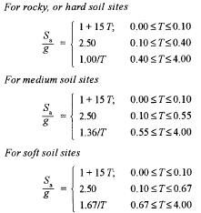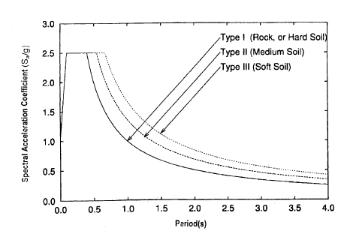

Fig : Chart showing Spectral acceleration coef. Vs Time period

Now,



Therefore,

Base Shear = Ah x W= 0.108*16944.5542= 1830.0118KN

**Q=(*VB**

**Base shear calculation**

|  |  |  |  |  |  |
| --- | --- | --- | --- | --- | --- |
| **S.No** | **Storey** | **Hi (m)** | **Wi (KN)** | **WiHi2** | **Qi (KN)** |
| 1 | Seventh | 22.4 | 491.6327 | 246681.624 | 171.209 |
| 2 | Sixth | 19.2 | 2205.079 | 812880.323 | 564.180 |
| 3 | Fifth | 16 | 2798.0934 | 716311.910 | 497.156 |
| 4 | Fourth | 12.8 | 2798.0934 | 458439.623 | 318.179 |
| 5 | Third | 9.6 | 2798.0934 | 257872.287 | 178.976 |
| 6 | Second | 6.4 | 2753.566 | 112786.088 | 78.279 |
| 7 | First | 3.2 | 3099.995 | 31743.956 | 22.032 |
|  |  | **Total** |  | **2636715.1811** | **1830.011** |
|  |  |  |  |  |

Fig 1: lump mass diagram

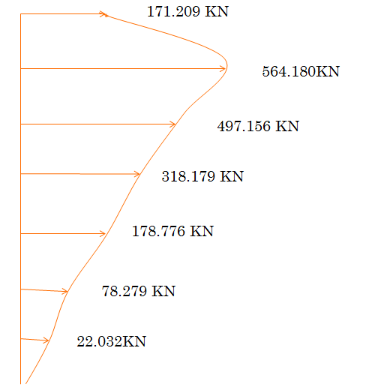

Fig 2: Storey Shear Diagram

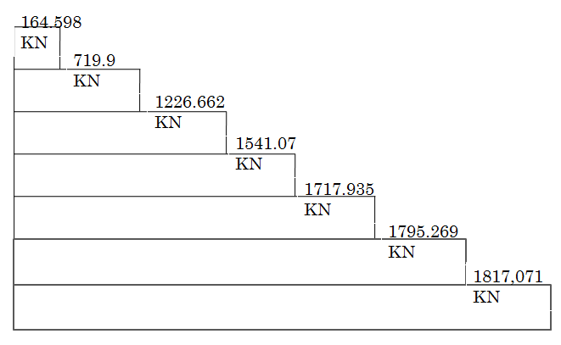

Fig 3: Base Shear Diagram

5. STRUCTURAL ANALYSIS

For the structural analysis of the structure, there considered four load cases which are mentioned below:

1. Dead load (DL)

2. Live load (LL)

3. Earthquake load in X direction (EQX)

4. Earthquake load in Y direction (EQY)

5.1 Salient features of ETABS 17 which is used for the analysis.

ETABS is a programme for linear, non-linear, static and dynamic analysis, and the design of building systems. From an analytical standpoint, multistorey buildings constitute a very special class of structures and therefore deserve special treatment. The concept of special programmes for building type structures was introduced over 40 years ago and resulted in the development of the ETABS series of computer programmes.

5.2 Features and Benefits of ETABS

• The input, output and numerical solution techniques of ETABS are specifically designed to take advantage of the unique physical and numerical characteristics associated with building type structures. As a result, this analysis and design tool expedites data preparation, output interpretation and execution throughput.

• The need for special purpose programmers has never been more evident as Structural Engineers put non-linear dynamic analysis into practice and use the greater computer power available today to create larger analytical models.

• Over the past two decades, ETABS has numerous mega-projects to its credit and has established itself as the standard of the industry. ETABS software is clearly recognized as the most practical and efficient tool for the static and dynamic analysis of multistory frame and shear wall buildings.

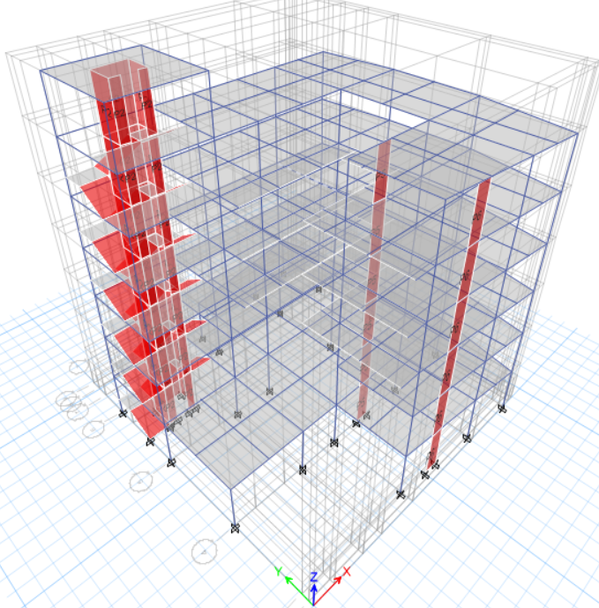

Fig5.1: 3D- Model of the Building for the Analysis in ETAB

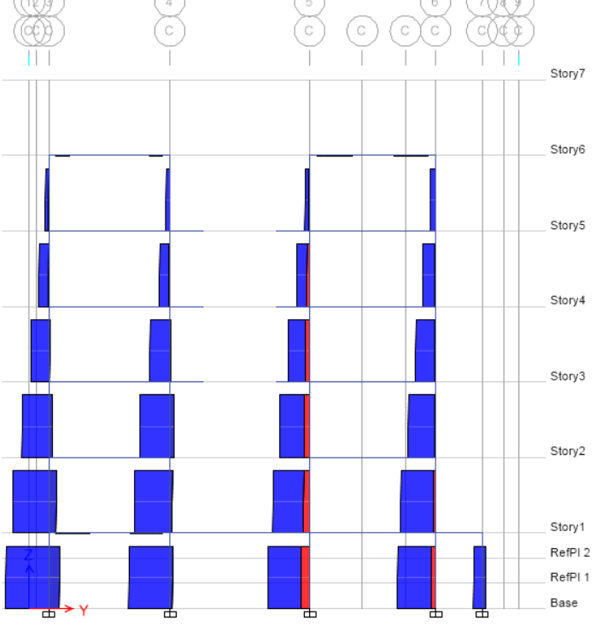

Fig5.2: Axial Force Diagram due to envelope

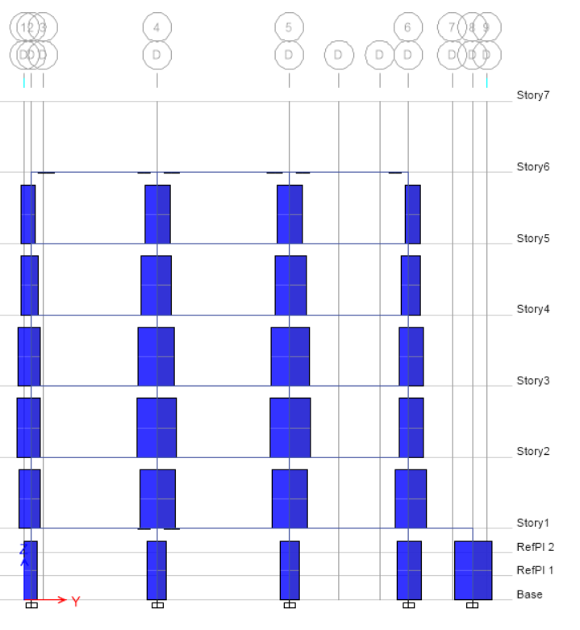

Fig5.3: Shear force diagram due to envelope

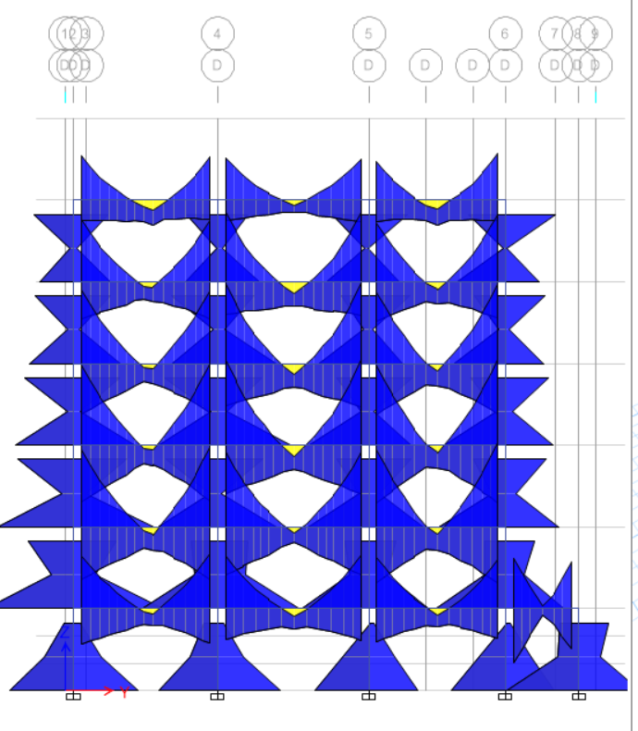

Fig5.4: Bending Moment Diagram due to envelope

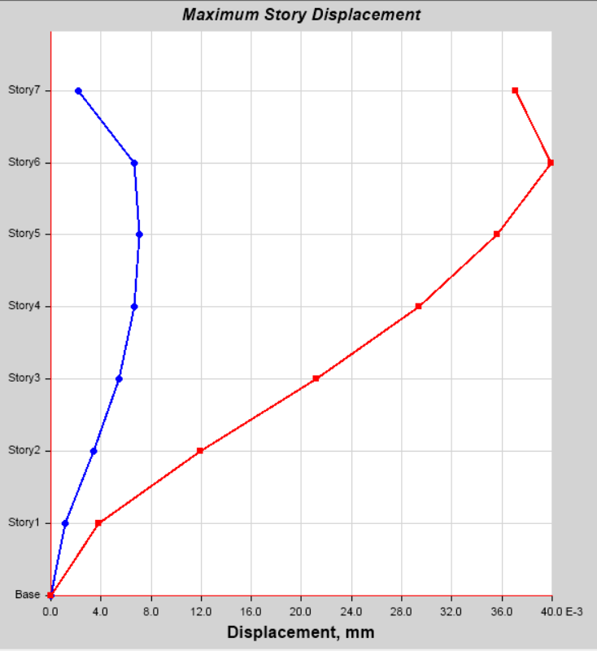

Fig5.5: Maximum Storey Displacement

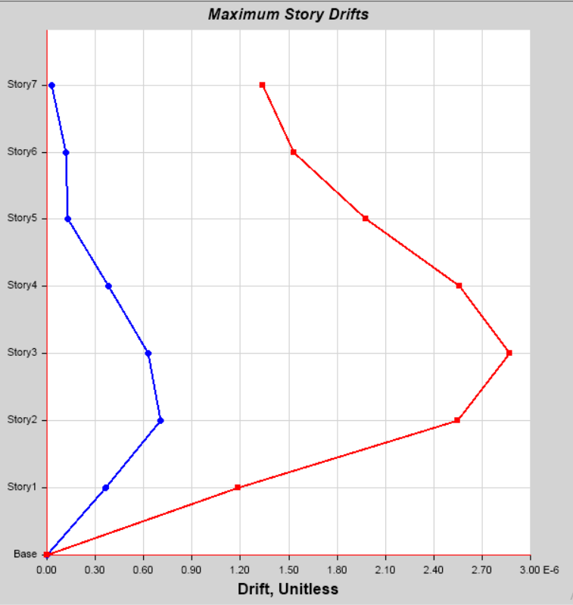

Fig5.6: Maximum Storey Displacement

# STRUCTURAL DESIGN

## 6.1 Design of structural elements

The design section is the most important part. The design of the structural elements should be done for durability, construction and use in entire service life of the structure. The realization of design objectives requires compliance with clearly defined standards for materials, production, workmanship, and also maintenance and use of structure in service.

This chapter includes all the design process of sample calculation for a single element as slab, beam, column, staircase, basement wall, lift wall and mat foundation.

1. Design of slab
2. Design of beam
3. Design of column
4. Design of staircase
5. Design of mat foundation
6. Design of lift wall

### Design of slab

Slabs are the plate elements forming floors and roofs ofbuilding and carrying distributed loads primarily by flexure, which may be supported by beams or walls and may be used as the flange of T or L-beam. Slab may be simply supported or continuous over one or more supports and is classified according to the manner of support as: one way slabs spanning in one direction, two-way slab spanning in directions, circular slabs, and grid floor slabs resting directly on columns with no beams and grid floor and ribbed slabs.

Slabs are designed by using the same theories of bending and shear as are used for beams. The following methods of analysis are available:

1. Elastic analysis-idealization into strips or beams.
2. Semi empirical coefficients as given in the code, and
3. Yield line theory

Slabs are analyzed and designed as having a unit width that is 1 m wide strips. Compression reinforcement is used only in exceptional cases in a slab. Shear stresses are usually very low and shear reinforcements is never provided in slabs .It is preferred to increase the depth of a slab and hence reduce the shear stress rather than provide shear reinforcement. Temperature reinforcement is invariably provided at right angles to the main longitudinal reinforcement in a slab. There are two types of slabs described as follow:

1. **One way slab**

One –way slabs are those in which the length is more than twice the breadth. Aone-way slab may be simply supported or continuous, or can be analyzed in a manner similar to that for continuous beam.

1. **Two way slab**

When slabs are supported on the four sides, two-way spanning actions occur. Such slabs may be simply supported or continuous or any other sides. The deflection and bending moments in a two-way slab are considerably reduced as compared to those in one- way slab .In a square slab, the two-way action is equal in each direction.

A slab may have its few or all edges restrained. The degree of restraints may vary depending whether it is continuous over its supports or cast monolithically with its supporting beams .A hogging or negative moment will develop in the top face of the slab at the supported sides. In these slabs the corners are prevented from lifting and provision is made for torsion. The maximum moments Mx and My at mid span on strips of unit width for spans lx,lyare given by: Mx =βx w lx2

My =βy w lx2­

Where,

βx,βy= moment coefficients that can be obtained from table 26 of IS 456:2000 for different arrangements of slabs.

Types of Slabs designed

* + - 1. Two way slab
      2. One way slab

**Type 1: Two adjacent side discontinuous**

Grade of Concrete M25 Grade of Steel Fe415

|  |  |  |  |
| --- | --- | --- | --- |
| **Ref** | **Step** | **Calculations** | **Output** |
| Slab 1 | **1.**  **2.**  **3.**  **4.**  **5.**    **6.**  **7.**  **8.** | **Thickness of slab and durability consideration**  Clear Spans  Lx = 3.8129 m  Ly = 5.5035m  Provide , d = 105mm  Assuming clear span cover = 15 mm  Providing 10 mm Ø bar  Total depth of slab, D = 105 + 15 + 10/2 = 125mm  Effective length  lx = Lx = 3812.9 mm  ly = Ly = 5503.5 mm  Since  Design as Two Way Slab  **Design Load**  Self load of slab = 0.160 x 25 = 4 KN/m2  Finishing load(including ceiling plaster) = 0.755 KN/m2  Dead load = 4 + 0.755 + 1.91 = 6.665 KN/m2  Live load = 3 KN/m2  Total load = 10.89 KN/m2  Design load , w = 1.5(DL+LL) = 10.89 KN/m2  **Moment Calculation**  -ve Bending moment coefficient at continuous edge  αx = -0.632, αy = -0.047  +ve Bending moment coefficient at mid span  αx = 0.0472, αy = 0.035  **For Short Span**  Support moment , Ms = - αxwlx2 = 0.0632 x 10.89 x3.91752 = -10.5624 KN-m  Mid span moment , Mm = αywlx2 0.0472 x 10.89 x3.91752 = 7.884KN-m  **For Long Span**  -ve moment , Ms = αxwlx2 0.0472 x 10.89 x3.91752 = 7.884KN-m  Mid span moment , Mm = αywlx2 = - 0.035 x 10.89 x 3.91752 = 5.8494 KN-m  Check for depth from Moment Consideration  Depth of Slab, d  Mulim=Mumax  0.138*Fckbd=10.5624*106  0.138*25*1000*d2=10.5624*106  D=55.33<105mm  So,depth is okay  Calculation of Area of Steel **:**  Min Ast = 0.12 % of bD = 0.0012 x 1000 x 125 = 150 mm2  Area of Steel along short span :  Area of Steel at support ( Top Bars)  Ast =  =  = 292.1055 mm2 Min Ast  Providing 10 mm Ø bars  Ab = 78.539mm2  Spacing of Bars, Sv =  =  = 258.9276mm 300 mm  Provide 10 mm Ø @ 200 mm c/c  Actual ,Ast =  mm2  Pt = 0.2992  Area of Steel at mid span (Bottom Bars)  Ast =  =  = 215.417 mm2 Min Ast  So provide Ast = 215.417 mm2  Providing 10mm Ø bars  Ab = 78.539 mm2  Spacing of Bars, Sv =  =  = 364.5905.295 mm >300 mm  Provide 10 mm Ø @ 200 mm c/c  Actual ,Ast =  mm2  Pt = 0.12%  Area of Steel Along Long Span  Ast =  =  = 214.469mm2 Min Ast  So provide Ast = 214.469mm2 mm2  Providing 10 mm Ø bars  Ab = 78.539mm2  Spacing of Bars, Sv =  =  = 226.0282 mm 300 mm  Provide 10 mm Ø @ 200 mm c/c  Actual ,Ast =  mm2  Area of Steel at Mid Span ( Bottom Bars)  Ast =  =  = 282.87 mm2 Min Ast  So provide Ast = 282.87 mm2  Providing 10mm Ø bars  Ab = 78.539 mm2  Spacing of Bars, Sv =  =  = 177.69 mm 300 mm  Provide 10 mm Ø @200 mm c/c  Actual ,Ast =  mm2  **Check for Shear**  For x-direction i.e. short span  Shear force at the face of the support, V =  = 10.89 x  =21.3307KN  Nominal shear stress τ­v= ­  =  =0.203N/mm2  So permissible shear stresss(τc)  % of steel=  =  =0.3743%  % of steel τc(N/mm2)  0.25 0.36  0.3743 τ  0.5 0.49  Τc=0.4246      Vu = 38.2009 KN  *Here, tension reinforcement of slab contribute in shear*  For pt  = 0.2992%  N/mm2  kbd =  = 68.992 KN > Vu  **Distribution Bars**  Asd = 0.12 % of bD = 0.0012 x 1000 x 160 = 192 mm2  Spacing of Bars, Sv =  =  = 261.8 mm  Provide 8 mm Ø @ 250 mm c/c  Act. Ast =  = mm2  **Curtailment of Reinforcement**  Curtailment is done by as per simplified method and Indian Standard Code IS SP 34  **Check for deflection**  Along short span  Since both ends are continuous, the basic valaue α may be taken as 26  fs = 0.58 * 500* (297.995/418.88)  =206.30 mm2  Pt = 0.2992  Modification factor (γ) = 1.8    =(5500)/(1.8*26)  = 118.590mm < 140mm hence safe  **Check for development length**  = (8*0.87*500)/(1.6*4*1.4)  =388.392 mm  **For short span**  = (12.50366)/(40.23056 )+0.128  =0.439 m  =439 mm > 388.392 mm  **For Long span**  = (13.1065)/(41.3178 )+0.128  =0.44521 m  =445.21 mm > 388.392 mm | lx = Lx = 3812.9 mm  ly = Ly = 5503.5 mm |

**Type 2: All side continuous panel**

Grade of Concrete M25 Grade of Steel Fes415

|  |  |  |  |
| --- | --- | --- | --- |
| **Ref** | **Step** | **Calculations** | **Output** |
| Slab 2 | **1.**    **2.**  **3.**  **4.**  **5.**  **6**  **7.**  **8.**  **9.**  **10.** | **All side continuous**  Clear span **:** l­­y= 5.496m.  Ly=5.4939m  = =1.00043< 2  Hence two way slab  Calculation of depth  Effective depth =  = =124.28mm  Overall depth (D)=d+ +clear cover  =130+ +15  = 150mm  **Total design load**  W=γ(Wdeadload +Wliveload)  =1.5(self load +floor finish + live load )  =1.5*(251*0.15+20.40*1+0.025+3*1)  =10.89 KN/m  **Calculation of maximum Bending Moment**  All side contionus  So, BM coefficient are taken from table 26  S αx  αy  0.032 0.032  0.024 0.024  Leffective= clear cover +bearing width  = 5.496+0.13  = 5.626m  **For short span,**  For +ve (Mx)=αx*w*leff.2  = 0.024*10.89*5.626.2  =8.272 KNm  For -ve (Mx)=αx*w*leff.2  = 0.032*10.89*5.626.2  =11.03KNm  **For long span**  For +ve (Mx)=αx*w*leff.2  = 0.024*10.89*5.626.2  =8.272 KNm  For -ve (Mx)=αx*w*leff.2  = 0.032*10.89*5.626.2  =11.03KNm  **Calculation of actual effective depth by using** Mu,lim = Mu,max  0.138*fckbd2=11.03*106  0.138*25*1000*d2=11.03*106  D= 56.54mm  **Calculation of minimum area of steel**  Minimum Ast=12% of bD  =0.0012*1000*150  =180mm2  **Calculation of reinforcement**  For shorter span  -ve moment (Mb)=0.87*fck*Ast*d()  8.272*106=0.87*415*Ast*130()  Ast=180.3934>min (ok)  Now,  Providing 10 mm bar with each bar area =78.539mm2  Spacing required =  =  =435mm  Now,  Let us provide spacing as 3000mm/c/c  Then,  Area of steel provided =78.839*  =262 mm2  For shortest span positive mooment  M0=0.87*fck*Ast*d()  11.03*106=0.87*415*Ast*130()  Ast=242.507 mm2>Min Ast  Now,  Providing 10mm bar  Spacing required(Sr)=*B  =*1000  **=**323.862mm  Now, let us provide spacing as 300mm c/c  Then,  Area of steel provided=78.539*  =262mm2  **For long span**  For +ve (Mx)=αx*w*leff.2  = 0.024*10.89*5.626.2  =8.272 KNm  For -ve (Mx)=αx*w*leff.2  = 0.032*10.89*5.626.2  =11.03KNm  **Check for shear**  For shorter span  Shear force at the face of support (Vu)=  =  =30.633KN  Nominal shrar stress(τv)=  =  =0.2356KN/mm2  Now,  For permissible shear stress(τc)  Percent of steel=*100%  =*100%  =0.17% & M25 concrete   |  |  | | --- | --- | | Percentage of steel | τc(N/mm2) | | 0.15 | 0.29 | | 0.17 | τc | | 0.25 | 0.36 |   τc=0.304 N/mm2  for D=150 mm,K=1.3(IS 456:2000)  τc slab= τc*K  =0.304*1.3  =0.3952 N/mm2  τcmax=3.1N/mm2  τv=0.2356 N/mm2  therefore,  τv< τc< τ c max  hence ok  **curtailment of reinforcement**  curtailment of reinforcement is done by simplified method &IS code (IS SP34)  **check for deflection**  along shorter span  since both end are continuous ,the basic value (α) may be taken as 26 (IS 456:2000)  Fs=0.58*fy*  **=**0.58*415*  =185.306mm2  & pt=0.21%  Modification factor(γ)=1.8  ()max=26*1.8=46.8  Further ,  ()provided=()  =()  =43.27<46.8  **Check for develovement length**  Ld=()  =() ( from 26.2.1.1)  =470.12mm  Now,  Moment of resistance by Ast is  Mr=0.87*fy*Ast*d()  =0.87*415**130*()  =6.046 KN/m  Now,  Ld=1.3*+16*Φ  =1.3*+16*10  =416.579mm <470.12mm  So provide Ld=470.12mm(minimum) |  |

**Type III: One long edge discontinuous**

|  |  |  |  |
| --- | --- | --- | --- |
| **Ref** | **Step** | **Calculations** | **Output** |
| Slab 3 | **1.**  **2.**  **3.**  **4.**  **5.**    **6.**  **7.**  **8.** | **Thickness of slab and durability consideration**  Clear Spans  Lx = 3.851 m  Ly = 4.921 m  Provide , d = 105mm  Assuming clear span cover = 15 mm  Providing 8 mm Ø bar  Total depth of slab, D = 105 + 15 + 10/2 = 125mm  Effective length  lx = Lx = 3851 mm  ly = Ly = 4.921 mm  Since  Design as Two Way Slab  **Design Load**  Self load of slab = 0.160 x 25 = 4 KN/m2  Finishing load(including ceiling plaster) = 0.755 KN/m2  Dead load = 4 + 0.755 + 1.91 = 6.665 KN/m2  Live load = 3 KN/m2  Total load = 10.89 KN/m2  Design load , w = 1.5(DL+LL) = 10.89 KN/m2  **Moment Calculation**  -ve Bending moment coefficient at continuous edge  αx = -0.057, αy = -0.037  +ve Bending moment coefficient at mid span  αx = 0..044, αy = 0.028  **For Short Span**  Support moment , Ms = - αxwlx2 = 0.057 x 10.89 3.8512 = -9.2055KN-m  Mid span moment , Mm = αywlx2 =0.044 x 10.89 x 3.8512 = 7.106KN-m  **For Long Span**  -ve moment , Ms = αxwlx2 =0.037 x 10.89 x 3.8512 = 5.9755KN-m  Mid span moment , Mm = αywlx2 = - 0.028 x 10.89 x 3.8512 = 4.522 KN-m  Check for depth from Moment Consideration  Depth of Slab, d  Mulim=Mumax  0.138*Fckbd=10.5624*106  0.138*25*1000*d2=10.5624*106  D=55.33<105mm  So,depth is okay  Calculation of Area of Steel **:**  Min Ast = 0.12 % of bD = 0.0012 x 1000 x 125 = 150 mm2  Area of Steel along short span :  Area of Steel at support ( Top Bars)  Ast =  =  = 253.07 mm2 Min Ast  Providing 10 mm Ø bars  Ab = 78.539mm2  Spacing of Bars, Sv =  =  = 258.9276mm 300 mm  Provide 10 mm Ø @ 150 mm c/c  Actual ,Ast =  mm2  Pt = 0.2992  Area of Steel at mid span (Bottom Bars)  Ast =  =  = 193.45 mm2 Min Ast  So provide Ast = 193.45 mm2  Providing 10mm Ø bars  Ab = 78.539 mm2  Spacing of Bars, Sv =  =  = 405.99 mm >300 mm  Provide 10 mm Ø @ 200 mm c/c  Actual ,Ast =  mm2  Pt = 0.12%  Area of Steel Along Long Span  Ast =  =  = 161.84mm2 Min Ast  So provide Ast = 161.84mm2 mm2  Providing 10 mm Ø bars  Ab = 78.539mm2  Spacing of Bars, Sv =  =  = 485.28 mm > 300 mm  Provide 10 mm Ø @ 200 mm c/c  Actual ,Ast =  mm2  Area of Steel at Mid Span ( Bottom Bars)  Ast =  =  = 121.68mm2 <Min Ast  So provide Ast = 150 mm2  Providing 10 mm Ø bars  Ab = 78.539 mm2  Spacing of Bars, Sv =  =  = 523.59 mm >300 mm  Provide 10mm Ø @ 200 mm c/c  Actual ,Ast =  mm2  Pt = 0.2992 %  **Check for Shear**  For x-direction i.e. short span  Shear force at the face of the support, V =  = 10.89 x  =20.97KN  Nominal shear stress τ­v= ­  =  =2.097*10^-3N/mm2  So permissible shear stresss(τc)  % of steel=  =  =0.3743%  % of steel τc(N/mm2)  0.25 0.36  0.3743 τ  0.5 0.49  Τc=0.4246      Vu = 38.2009 KN  *Here, tension reinforcement of slab contribute in shear*  For pt  = 0.2992%  N/mm2  kbd =  = 68.992 KN > Vu  **Distribution Bars**  Asd = 0.12 % of bD = 0.0012 x 1000 x 125 = 150 mm2  Spacing of Bars, Sv =  =  = 523.59 mm  Provide 10 mm Ø @ 200mm c/c  Act. Ast =  = mm2  **Curtailment of Reinforcement**  Curtailment is done by as per simplified method and Indian Standard Code IS SP 34  **Check for deflection**  Along short span  Since both ends are continuous, the basic valaue α may be taken as 26  fs = 0.58 * 415* (297.995/418.88)  =206.30 mm2  Pt = 0.2992  Modification factor (γ) = 1.8    =(5500)/(1.8*26)  = 118.590mm < 140mm hence safe  **Check for development length**  = (8*0.87*500)/(1.6*4*1.4)  =388.392 mm  **For short span**  = (12.50366)/(40.23056 )+0.128  =0.439 m  =439 mm > 388.392 mm  **For Long span**  = (13.1065)/(41.3178 )+0.128  =0.44521 m  =445.21 mm > 388.392 mm | lx = Lx = 3812.9 mm  ly = Ly = 5503.5 mm |

## 6.1.2 Design of beam

Design of beams requires determination of the cross-sectional dimensions and reinforcement details to satisfy both serviceability and strength requirements. The serviceability requirement for deflection is controlled by effective span to effective depth ratio. Generally depth of the beam is governed by the strength requirement. The spacing of reinforcement controls the serviceability requirement for crack. In beams, spacing of reinforcement bars are small and governed by the minimum spacing requirement than maximum spacing for crack control. The reinforcements are provided to satisfy strength requirements. The detailing of longitudinal and transverse bars should satisfy the bending, shear and bond requirements. The bending moment and shear are determined from the analysis generally based on the elastic theory.

Beams are designed for the worst condition. So the maximum values from the combination have been used for the design.

|  |
| --- |
| The beam element is designed for the load obtained from envelope. |
| Concrete Grade = M25 |
| Steel Grade = Fe500 |

**Design of Primary Beam**

|  |  |  |  |
| --- | --- | --- | --- |
| **Reference** | **Step** | **Calculation** | **Output** |
| IS 456:2000  IS 456:2000  IS 456:2000  Cl . 40.4  Table 19 & 20  IS 456 -2000  Clause 23.2.1  IS 456:2000  IS 456:2000  Cl.26.5.1.1  IS 456:2000  Cl . 40.4  Table 19 & 20  IS 456 -2000  Clause 23.2.1  IS 456 -2000  Cl. 26.2.1 | **1**  **2**    **3**  **3.1**  **3.3**  **3.4**  **3.5**  **4.**  **4.1**  **4.2**  **4.3**  **4.4**  **5**  **5.1**  **5.2**  **5.3**  **5.4**  **5.5** | **Known Data**  Overall depth of beam D=550 mm  Width of beam B= 300mm  Assuming 20 mm dia rebar  Clear cover =25 mm  Effective depth (deff) = 515mm  fCK = 25 N/mm²  fy= 415 N/mm²  . **Design of Flexure**  For beam B-12  Mulim. = 0.138×fck×B×d²  = 0.138×25×300×515²  = 274.507KN-m  **At End Span**  **for sagging maximum moment(+ve moment)**   |  | | --- | | Mu = 111.7652 KNm |   Here, Mu<Mulim  Hence,Singly reinforced beam section    **Design of Steel section**  Mu= 0.87 fyAst{d-( fy Ast/fck×b)}  111.7652×=0.87×500×Ast{515-}  Output,  Ast = 645.903mm²  Let use 20mm Φ bar  No. of bar = = = 2.055≈3  Provide 3-20mmΦ bars (bottom bars)  Ast provided = 3×314.15 = 942.477  **Check for shear;**  Factored shear force (Vu) = 128.2714KN  Design ;  Nominal shear stress (Tv) = =  = 1.03N/mm²  For Tc  P % = 100Ast/bd = 100×942.47/(515*300)  = 0.57 %  By interpolation ,  Tc = 0.5124 N/mm²  Maximum shear strength of M25 concrete  Tmax = 3.1N/mm²  Tv<Tc & Tc<Tc max  Provide minimum shear reinforcement section  Vus =(Tv-Tc)*b*d  =(1.03-0.5124)*300*515  =79.97 KN >0.5 Vu  So, use one bent up bar for shear reinforcement.  Vsb =0.87*fy* Asv sin α  =0.87*415*π*202*1*sin 45°  =80.205 KN >0.5 Vus  So, shear reinforcement by stirrups.  Vsr = Vus – Vsb  =79.97 - 39.985  =39.985 KN  Let us use 8mm Φ 2-legged vertical stirrups for shear reinforcement  Spacing (x)=0.87* fy* Asv * d/Vsr  =0.87*415*π*82 /4*2*515/(39.985*1000)  =467.495 mm  Check,  Spacing x should not be less than 75mm  X should not be greater than 0.75d = 0.75×515 = 386.25s xmm  Provide 8mm Φ2- legged vertical stirrups @150mm c/c.  **Deflection** ;  d = L/αβγδλ  where, α=26,β=1,λ=1,δ=1  for γ  fs = 0.58fy×Ast required/Ast provided  = 0.58×415×749.4468/942.471  =191.403  P%=100×Ast/bd=0.57 %  Therefore , γ = 1.57  Then,  5.35/0.515 ≤ 20*1.57*1*1  10.39 ≤ 31.4  Hence ok  **Development length (Ld);**  0.87fyΦ/4Tbd = 1.3×m1/v+16Φ  Where,  M1 = 0.87×fy×Ast /2×(d-fyAst/2*fckb)  = 0.87×415×942.47/2×(515-415×942.47/2*25×300)  = 83.185×10^6 N-mm  = 83.185 KN-m  Therefore ,  Lo = d = 515  or  12 Ø = 12* 20= 240  So Lo = 515  (0.87×415×20)/(4×1.4×1.6) < 1.3×[(83.185×10^6)/(128.2714×10^3)]+515  805.91 <1358.06 ( Ok)  **At End Span**  **For hogging maximum moment(-ve moment)**  Mu =187.3205 KNm  Vu = 119.4995 KN  Here, Mu<Mulim  Hence,Singly reinforced beam section.  Now,  Mu= 0.87 fyAst{d-( fy Ast/fck×b)}  187.3205×=0.87×415×Ast{515-}  Output,  Ast =1149.5 mm²  Let use 20mm Φ bar  No. of bar = = = 3.56≈4  Provide 4-20mmΦ bars (bottom bars)  Ast provided = 4×314.15 = 1256.637  **Check for shear;**  Factored shear force (Vu) = 119.4995 KN  Design ;  Nominal shear stress (Tv) = =  =0.77 N/mm²  For Tc,  P % = 100Ast/bd = 100×1256.637/(515*300)  = 0.76 %  By interpolation ,  Tc = 0.6784 N/mm²  Maximum shear strength of M25 concrete  Tmax = 3.1N/mm²  Tv<Tc & Tc<Tc max  Provide minimum shear reinforcement section  Vus =(Tv-Tc)*b*d  =(0.77 -0.6784)*300*515  =14.152 KN < 0.5 Vu  So, shear reinforcement by vertical stirrups.  Let us use 8mm Φ 2-legged vertical stirrups for shear reinforcement  Spacing (x)=0.87* fy* Asv * d/Vsr  =0.87*415*π*82 /4*2*515/(14.152*1000)  =1320.85 mm  Check,  Spacing x should not be less than 75mm  X should not be greater than 0.75d = 0.75×515 = 386.25s xmm  Provide 8mm Φ2- legged vertical stirrups @200mm c/c.  **Deflection** ;  d = L/αβγδλ  where, α=26,β=1,λ=1,δ=1  for γ  fs = 0.58fy×Ast required/Ast provided  = 0.58×415×1149.35/1256.637  =220.149 N/mm2  P%=100×Ast/bd=0.76 %  Therefore , γ = 1.16  Then,  5.35/0.515 ≤ 20*1.16*1*1  10.39 ≤ 23.2  Hence , ok  **Development length (Ld);**  0.87fyΦ/4Tbd = 1.3×m1/v+16Φ  Where,  M1 = 0.87×fy×Ast /2×(d-fyAst/2*fckb)  = 0.87×415×1256.637/2×(515-415×1256.637/2*25×300)  = 108.943×10^6 N-mm  = 108.943 KN-m  Therefore ,  Lo = d = 515  Or  12 Ø = 12* 20= 240  So Lo = 515  (0.87×415×20)/(4×1.4×1.6) < 1.3×[(108.943×10^6)/(119.4995×10^3)]+515  805.91 < 1700.158  ( Ok)   |  | | --- | |  | |  | |  |   **At Mid Span**  **For sagging maximum moment(+ve moment)**  Mu=88.6066 KN-m  Mulim= 274.51 KN-m  Here, Mu<MulimHence, singly reinforced beam    **Design of Steel section**  Mu= 0.87 fyAst{d-( fy Ast/fck×b)}  88.6066×106=0.87×415×Ast{515-(415×Ast/25×250)}  Output,  Ast = 503.8022 mm²  Let use 20mm Φ bar  No. of bar = Ast/a = 503.8022/314.15 = 1.603≈2  Ast provided = 4×3.14×20/4  = 628.318mm²  **Check for shear;**  Factored shear force (Vu) = 73.368 KN  Design ;  Nominal shear stress (Tv) = Vu/bd  =73.368×10^3/250×415  = 1.03 N/mm²  For Tc  P%= 100Ast/bd = 100×628318/250×415  = 0.381%  By interpolation ,  Tc = 0.43N/mm²  Maximum shear strength of M25 concrete  Tmax = 3.1N/mm²  Tv˂Tc & Tc<Tc max  Provide minimum shear reinforcement section  Vus =(Tv-Tc)*b*d  =(1.03-0.43)*300*515  =92.7KN >0.5 Vu  So, use one bent up bar for shear reinforcement.  Vsb =0.87*fy* Asv sin α  =0.87*415*π*202*1*sin 45°  =80.205 KN >0.5 Vus  So, Vsb = 46.35 KN  So, shear reinforcement by stirrups.  Vsr = Vus – Vsb  =92.7 - 46.35  =46.35 KN  Let us use 8mm Φ 2-legged vertical stirrups for shear reinforcement  Spacing (x)=0.87* fy* Asv * d/Vsr  =0.87*415*π*82 /4*2*515/(46.35*1000)  =403.296mm  Check,  Spacing x should not be less than 75mm  X should not be greater than 0.75d = 0.75×515 = 386.25s xmm  Provide 8mm Φ2- legged vertical stirrups @150mm c/c.  **Deflection** ;  d = L/αβγδλ  where, α=26,β=1,λ=1,δ=1  for γ  fs = 0.58fy×Ast required/Ast provided  = 0.58×415×503.8022/628.318  =193 N/mm2  P%=100×Ast/bd= 0.381 %  Therefore , γ = 1.82  Then,  5.35/0.515 ≤ 20*1.82*1*1  10.39 ≤ 36.4  Hence , ok  **Development length (Ld);**  0.87fyΦ/4Tbd = 1.3×m1/v+16Φ  Where,  M1 = 0.87×fy×Ast /2×(d-fyAst/2*fckb)  = 0.87×415×628.318/2×(515-415×628.318/2*25×300)  = 56.44×10^6 N-mm  = 56.44 KN-m  Therefore ,  Lo = d = 515  or  12 Ø = 12* 20= 240  So Lo = 515  (0.87×415×20)/(4×1.4×1.6) < 1.3×[(56.44×10^6)/(73.368×10^3)]+515  805.91 <1515.054 ( Ok)  .   |  |  |  |  |  | | --- | --- | --- | --- | --- | |  | |  |  | | |  |  | |  | |  |  | | |  |  | | |  |  | | | 3-20mm Φ bars  8mm Φ 2- legged vertical stirrups @150mm c/c  safe  4-20mmΦ bars (bottom bars)  8mm Φ 2- legged vertical stirrups @200mm c/c  safe |

### 6.1.3 Design of staircase

Staircase is an inclined structural system for the movement from one level to another. Since it is stepped, it is called staircase. A staircase behaves like an ordinary slab. It may span either in the direction of the steps or in the direction of going. Structurally, staircase may be classified largely into two categories, depending on the predominant direction in which the slab component of the stair undergoes flexure – stair slab spanning transversely and stair slab spanning longitudinally.

The design of staircase requires proportioning of its different components and determination of reinforcement and it’s detailing to satisfy both the serviceability and strength requirements. The design of staircase is made for serviceability requirements of deflection and cracks. The serviceability requirement of deflection is controlled by the effective span to effective depth ratio. The design of reinforcement is made to satisfy the strength requirements for moments and shears. The design for moment is made for maximum moments either by the working stress method or by the limit state method. The area of steel is expressed as diameter and spacing of bars. It is provided along the span of staircase and necessary curtailment is made wherever it is not required as in the case of edge-supported slabs.

Generally, the shear reinforcement is not required in staircase as the shear strength of concrete is much greater than the nominal shear stress. The shear strength of concrete in staircase is determined as in the case of edge- supported slab.The detailing of reinforcement in staircase shall be similar to that of the edge supported slab except at the junction of landing and flight of staircase where it should ensure that the reinforcement bars in tension tending to straighten out do not cause cracking in concrete.

**OPEN WELL STAIRCASE**

Concrete Grade = M25

Steel Grade = Fe415

|  |  |  |  |
| --- | --- | --- | --- |
| **Step** | **Calculations** | **Remarks** | |
| **1.**  **2.**  **i.**  **5.**  **6.**    **7.**        **8.**  **9.**  **10.**  **11.** | **Known Data**  Floor Height=3.2m  Riser , R=190 mm  Tread , T=300 mm  Flight Width, W=1.956m  No. of risers in the flights= 7  No. of treads = 6  Assume slab thickness=300mm  Take d = 25 mm  Clear cover = 25mm  Overall depth = 250+25 = 275mm  **Load Calculation**  **For flight 1 :**  No of riser = 7  No. of tread =6  Effective length of stair = 5.4 m  Length of going = 6*0.3=1.8m  Assume, thickness of waste span  d=(L/20 to L/25 )  d=5.36*10^3/24 =223  Total depth =(D)=223 +c/c+16/2  =223+15+16/2  =250 mm  Adopt total depth of waste slab=273mm  Load per meter length in span of waste slab  =√(T2+R2)*D*25*1/T  =√(0.32+0.152)*250*1/0.3*25  =7.65KN/m  Load per meter length in span of steps  =*R*T*25*  =  Floor Finish  13mm Non-slip procession tile  Assume size of tile =600*600 mm  Unit weight=0.03*0.6*0.6  =0.0108 KN  Load per meter = =0.8307 KN/m  Total dead load  Live load=4KN/m2  =4*1  =4 KN/m  Total load = dead +live load  =7.65+1.8750+0.08307+4  =14.355 KN/m  Factor load flight =1  =21.53 KN/m  Now ,  For loading  Dead load = 0.25*1*25  Live load = 4KN/m  Total load at landing =6.87+5+4  =10.875 KN/m  =11KN/m  Factor load =1.5*11  =16.5KN/m  **Reactions:**  ∑Ma=0  -RB1.5*1.956*+21.53*1.83*(1.956+)+16.5*1.676 * (+1.956+1.83) KN=0  RB=46.30 KN  ∑FY=0  RA-15*1.956-20.033*1.83-15*1.676+R­B=0  RA­=44.84 KN  Let shear force at distance x from A  Shear force =0  44.84-1.5*1.956-21.53*(x-1.956)=0  x=2.73m  Now, Maximum Bending Moment at 2.73 m  =44.84*2.73-1.5*1.956*(+0.774)  =-20.033*0.774*  =65 KNm  Now,maximum for Fy415,M20  Bending Moment=0.138*fckbd2  =0.138*20*1000*250  =172.50 KNm>65 KNm  To find required  65*106=0.138*20*1000*d2  d=153.46mm<dassume ok  **calculation of reinforcement**  Ma=0.87*fy*Ast*250(1-)  Ast require =769.234 mm2  Provided 12mm k ø Bars  Spacing =*1000  =*1000  =147.025  =150 mm  Provides 12 mm ø bars at the rate 150mm center to center  Ast provided = 753.98mm2  Check for mm steel  =0.12% of b*D  =0.12%*1000*245  =330mm2<Ast ­provided  Distribution bar =0.12%*b*D  0.12%*1000*275  =330 mm2  Provided 8 mm ø distribution bars  Spacing =*1000  =*1000  =152.30mm  =150 mm  Check for development length  LD=  =  =565mm  For flight 2  No. of threads =6  Length of going=6*300=1.8m  Effective length=5.183m  Thickness of waist slab =  =215mm  D=215+15+  =250mm  Load per meter length of waist slab  =√(T2+R2)*D*25*  =√(0.32+0.152)*0.25*25*  =6.98KN/m  Load per meter length of slab of steps  =0.5*R*T*25*  =0.5*0.15*0.3*25*  =1.87KNm  Floor finish=0.8307KN/m  Live load=4KN/m2*1m=4KN/m  Total load=dead +live load  =6.98+1.875+0.8307+4  =13.6857KN/m  Factored load=13.6857*1.5=20.52855KN/m  For landing  Dead load =0.25*1*25=6.25KN/m  Live load =4KN/m  Total load=dead load +live load  =10.25KN/m  Factored load of landing=15.375KN/m  Takin moment at A  ∑MA=0  RB*5.182-15.375*-19*1.83*()-(13.87*1.676)*(+1.83+1.676)=0  RB=38.25KN  ∑FY=0  RA+RB-15.375*1.67676-19*1.83-15.375*1.676=0  RA=38.25KN  Now to find maximum moment  Taking moment at center  ∑MMAX=38.25*2.591-15.375*1.676*(1.676/2+0.915)-19*0.915*0.915/2  =50.405KN/m  For Fy=415,F­ck=20Mpa,  MUliim=0.138*20*1000*2502  =172.5KNm>MMAX (OK)  Again,to find DREQ  50.405*106=0.138*20*1000*D2  D=135.139mm<Dasume  **Calculation of reinforcement**  Mmax=0.87*Fy*Ast*d(1-)  Or, 50.405*106=0.87*415*Ast*250(1-)  ∴Ast=587.028mm2  ∴provided 10mm bars  Spacing=*1000  =133.79mm  Adopt 150mm  Ast provide=*1000  =523.598mm2  Provided 10mm @150mm c/c  Check for minimum steel  =0.12%100*250  =300mm2<Ast provided  Distribution bar provided=8mm bar  Spacing=*1000  =167mm  Adopt 200mm  Provide 8mm for @200mm c/c  **Design For Main Reinforcement,**  Area of tension steel is given by the relation  BM = 0.87fyAst (d-0.42xm)  i.e.  .·. Ast = 495.592 mm2  Ast = 495.592mm2 > Amin (0.0012 * 1000 * 175 =210 mm2)  Use 8mm dia. Bars  (Ast=495.592mm2)  Spacing of Bars = 150 mm  **Distribution Reinforcement**  Astmin=0.0012 * 100* 175=210 mm2  Required spacing of 8 mm Bars,  C/C Spacing=150  Provide 8 mmØ @150 mm  **Check for shear**  Nominal shear stress= τv =  =  =0.258 N/mm2  For Pt = 0.56 %  τc’ = 0.509 N/mm2 > τv  OK  **Development Length**    Where,  = 1.6 *1.4= 1.92N/mm2  =0.87 *fy = 0.87* 500 = 435 N/mm2  Ld = 679.68 mm  Provide Development Length = 680 mm | | Provide main bars of 12 mm dia @ 125 mm c/c  Provide distribution bars of 10 mm dia @ 300 mm c/c |

### 6.1.4 Design of column

Columns are vertical structural element used primarily to support the compressive loads. The effective length of column exceeds three times of least lateral dimension. It is reinforced with longitudinal and transverse steel. Reinforced concrete column are used to transfer the load of the structure to its main longitudinal bars to resist compression or bending; and transverse steel to resist bursting force.

The design of column section can be made either by working stress method or by the limit state method. The working stress method of design of column is based on the behavior of the structure at working load ensuring that the stress in concrete and steel do not exceed their allowance values.

It is assumed to possess adequate safety against collapse. The limit state method of design of column is based on the behavior of structure at collapse ensuring adequate margin of safety.

The serviceability limits of deflections and cracks are assumed to be satisfied as the column being primarily a compression member has very small deflections and cracks.

Concrete Grade = M25

Steel Grade = Fe 415

GET IT FROM 1.2 DEAD LOAD EXCEL file 1st five sample design of column.

**6.1.5 Design of foundation**

If the load transmitted by the column in a structure are so heavy or the allowable soil bearing pressure so small that individual footing would cover more than about one half of the area. It may be better to provide a continuous footing under all the columns and walls. Such a footing is called a raft or mat foundation. The raft is divided into series of continuous strips centered on approximate column rows in the both directions. The shear and bending moment diagram may be drawn using continuous beam analysis or coefficients for each strip. The depth is selected to satisfy shear requirements. The steel requirement will vary from strip.

**Foundation Type Selection**

Check For isolated footing

Total vertical load = 23855.21KN

Safe Bearing Capacity of soil =125KN/m2

Area of footing required (A) = 23855.21/125

= 190.842m²

From CAD

Plinth area (Ap) = 320.9843m²

Area covered by the Isolated Footing (A) = 190.9843m²

Total plinth area (Ap) = 320.9843m²

percentage of the area covered by the isolated footing = (190.842/320.9843)×100

= 59.455%

Hence, it is decided to select the Raft foundation since the area covered by the individual isolated footing is more than the 50% of the plinth area and there is the provision .

Now, Eccentricity along X-direction is obtained by taking the moment of the column loads about the grid A-A.

X=

= 10.9126m

Y=

= 10.061m

Here,

ex = 10.912-9.43m

= 1.482m

ey = 10.061-10.395

= -0.334m

We have ,

σ = P/A ± (My/Iy)×x ± (Mx/Ix)×y

Where,

My = P×eX = 23855.21×(1.482)

= 35353.42KNm

Mx = P×eY = 23855.21×(0.334)

= -7967.640KNm

Ix =

=

= 14130.389

Iy =

=

= 11640.964

P = 23855.21KN

A = 320.9843m²

P/A = = 74.3189KN/m²

Now, soil pressure at different points is as follows ,

σ = P/A ± (My/Iy)×x ± (Mx/Ix)×y

At corner,

σ A-1= 74.3189 + _

=95.515 KN/m²

= 95.515KN/m² <125KN/m² Ok

σ E-9 =74.3189 + +

= 107.2783kN/m²

σ 4-A= 74.3189 _ _

= 43.185KN/m²

corner A-6=74.3189-*8.9095+*6.861

=51.1296 KN/ m²

corner C-3 6=74.3189 _ _

=64.7041 kN/m²

corner c-7 (6)= 74.3189-*1.39+*8.835

= 83.5221 kN/m²

grid A-5=74.3189 *9.43 *1.511

=44.828 kN/m²

grid G-5(6)= 74.3189 *9.43 *1.511

=103.8704KN/ m²

gird G-4(6)= 74.3189 *9.43 *4.425

=100.462KN/ m²

Grid F-6 (6)= 74.3189 *9.02 *6.862

=105.555 KN/ m²

In the x-direction the raft is divided into five strips i.e that is equivalent beams.

1.Beam of grid (1,2,3) with 3.40 width and soil pressure =95.515 KN/ m²

2.Beam of grid 4 with 5.538 width and soil pressure=

=97.988 KN/ m²

3.Beam of gird 5 with 5.643 width and soil pressure=

=102.165 KN/ m²

4.Beam of grid 6 with 3.362 width and soil pressure =

= 104.711 KN/ m²

5.Beam of grid 7,8,9 with 2.547 width and soil pressure=

= 106.3952KN/ m²

The bending moment is obtained by using a coefficient of and L as centre of the column distance.

+M= -M=

For strip 1,2,3-1,2,3

Maximum moment= 95.515*

= 354.945 KNm

For strip 4-4

Maximum moment= 97.988*

= 364.135 KNm

For strip 5-5

Maximum moment= 102.165*

= 379.657 KNm

For strip 6-6

Maximum moment= 104.711*

= 389.118 KNm

For strip 7,8,9-7,8,9

Maximum moment= 106.395*

= 395.376 KNm

For strip G-G

Maximum moment= 95.515*

=336.557 KNm

and so on

The depth of raft will be governed by two shear at the one of the exterior columns. In each case location of critical shear is not obvious it may be necessary to check all possible locations.

Let us use M30­­concrete and Fe­­­­­­­­­­­500grade steel

Permissible stress,

(Tc)=K +Tc

Where,

K=0.5+Bs >1.0

Bs===1

K=1.0

Tc=0.25*Fck1/2

=0.25*301/2

=1.3693N/mm2

T­­­c=1.0*1.3693

=1.3693N/mm2

For a cornor column C-3

Tc=*d

bo=2(+450)

=d+900

Tv =1.5*550*1000

Then Tc and Tv

1.3693=

d= 591.019mm

For edge column (A-5)

Tv=*d

Bo=2(d/2+450)+(d+275)

=d+450+d+275

= 2d+1175

1.3693=

D=646.19mm

Adopt the effective depth of 660mm and,

Assume effective clear cover=50mm

Then, overall depth of 710mm

Reinforcement in the long direction is given by

BM=0.87*Fy*Ast(d-)

395.118*106=0.87*500*Ast(600-)

Ast­­= 1427.722 mm2/m

Minimum reinforcement in slabs

=0.12% of B*D

=0.12%*1000*760

=853mm2/m<1427.722 mm2/m(OK)

Let, provide 20mm bar

a= 314.15mm2

No. of bar ===5.54=6

Spacing =*1000

=*1000

=166.67

=150mm c/c

Hence provide 20mm bar @ 150mm c/c

(Ast=2094.33mm2/m) at top and bottom in both ways .

CONCLUSION

This project is the result of group effort of whole group’s member and the valuable guidance of our supervisor. The project work enables us to consolidate the knowledge of analysis and design of structure during our B.E course.

We have given more emphasis on earthquake load rather than others. The seismic coefficient method is used to analysis the building due to more practicable and easy. SAP 2000 V20 provided to be helpful tools in the analysis of frame for various loading condition. In the project, the analysis, design and detailing of all require element of building were done based on 3-D frame analysis by SAP 2000 V20.

Detail structural design of building is important aspect of construction procedure. Practically an engineer employed must have knowledge on designs, construction procedures, site study etc. Design and layout of the building services like pipeline, electrical appliances, sanitary and sewage system were not covered in this project. The environmental, social and economical condition of the locality was not taken into consideration. The project work was only related with the practical application of the studied courses in the field. Detail cost estimate of the project was not included in this report.

Finally we hope that efforts and coordination for the project work will prove much useful in our career and project will be helpful in providing information on the earthquake resistant design and its safe practice and we hope, this project will help us in similar jobs that we might have in our hands in the future.

# BIBLIOGRAPHY

## 8.1 REFERENCE BOOKS:

1. Jain, A. K. - Reinforced Concrete-Limit State Design
2. Sinha, S. N. - Reinforced Concrete Design
3. Varghese, P.C. - Limit State Design of Reinforced Concrete
4. Pillai, S. Unnikrishna and Menon, Devdas - Reinforced Concrete Design
5. Agarwal, Pankaj and Shrikhande, Manish – Earthquake Resistant Design of Structures

## 8.2REFERENCE CODES:

1. IS 456 : 2000 Code of Practice for Plain and Reinforced Concrete
2. IS 875 : 1987 Code of Practice for Design Load for Building and

Structures (Part I – Dead Loads; Part II – Imposed Loads)

1. IS 1893(Part I):2002 Criteria for Earthquake Resistant Design of Structures
2. IS 13920 : 1993 Ductile Detailing of Reinforced Concrete Structures

Subjected to Seismic Forces – Code of Practice

1. SP 16 Design Aids for Reinforced Concrete to IS 456:1978
2. SP 34 Hand book on Concrete Reinforcement and Detailing