MUHAMMAD AL-XORAZMIY NOMIDAGI
TOSHKENT AXBOROT TEXNOLOGIYALARI
UNIVERSITETI



«Telekommunikatsiya injiniringi» kafedrasi
№ 1 laboratoriya ishi bo’yicha hisobot
Variant №24

Bajardi: PRG004-2 guruh talabasi
Fakultet: Telekommunikatsiya texnologiyalari (60611000)
Yo'nalish: Telekommunikatsiya texnologiyalari
F.I.Sh.: Shomuratov Umarbek Qudrat o’g’li

Tekshiruvchi o’qituvchi:
Xaydarova Marxamat Yunusovna

Toshkent 2026

Ishning maqsadi:
1. sodda algoritmlarni ishlab chiqish va C++ dasturlash tilida chiziqli tuzilishga ega dasturlar yaratishni o‘rgatish;
2. C++ dasturlash tilida chiziqli algoritmlarni tashkil etishda foydalaniladigan operatorlar bilan tanishtirish;
3. ishlab chiqilgan dasturni testdan o‘tkazish va sozlashni (debugging) o‘rgatish;
4. olingan natijalarni tahlil qilishni o‘rgatish.

1. Topshiriq
Masalaning berilishi
$$f=\frac{\cos^{7}{bx}^{5}-\left(sina^{2}+cos\left(x^{3}+z^{5}-a^{2}\right)\right)}{\arcsin{a^{2}+arccos\left(x^{7}-a^{2}\right)}}$$

Blok-sxema
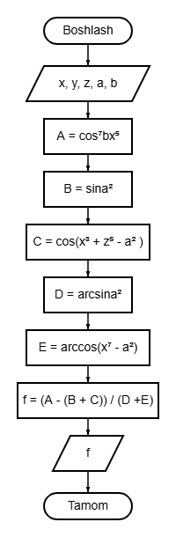
Dastur kodi
#include <iostream>
#include <cmath>
using namespace std;

int main() {
double x, z, a, b, f, A, B, C, D, E;
cout << "x, z, a, b larning qiymatini kiriting:\n";
cin >> x >> z >> a >> b;

A = pow(cos(b), 7) * pow(x, 5);
B = sin(pow(a, 2));
C = cos(pow(x, 3) + pow(z, 5) - pow(a, 2));
D = asin(pow(a, 2));
E = acos(pow(x, 7) - pow(a, 2));
f = (A - (B + C)) / (D + E);

cout << "f= " << f;

return 0;
}

Dasturning natijasi
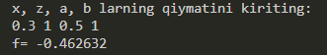
Boshlang‘ich ma’lumotlar x=0.3, z=1, a=0.5, b=1 bo‘lganda, dastur f = -0.462632 natijani chiqaradi.

2. Topshiriq
Masalaning berilishi
Berilgan qiymatlar: y=0.1,
m=4.6x10⁻²;
natija: N=0.106094.

Blok-sxema
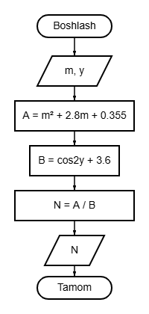
Dastur kodi
#include <iostream>
#include <cmath>
using namespace std;

int main() {
double m, y, A, B, N;
cout << "m, y larning qiymatini kiriting:\n";
cin >> m >> y;

A = pow(m, 2) + 2.8*m + 0.355;
B= cos(2*y) + 3.6;
N = A / B;

cout << "N= " << N;

return 0;
}

Dasturning natijasi
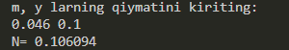
Boshlang‘ich ma’lumotlar m=4.6x10⁻², y=0.1 bo‘lganda, dastur N=0.106094 natijani chiqaradi.

3. Topshiriq
Masalaning berilishi

Blok-sxema
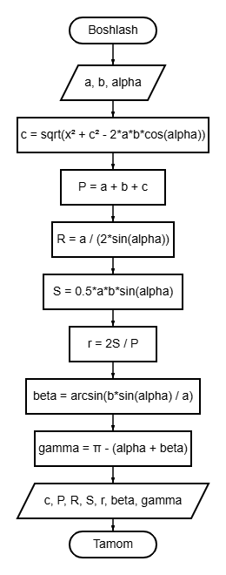
Dastur kodi
#include <iostream>
#include <cmath>
using namespace std;

int main() {
double a=6, b=4, alpha=M_PI/4, c, P, R, S, r, beta, gamma;

beta = asin((b*sin(alpha)) / a);
gamma = M_PI - (alpha + beta);
c = sqrt(pow(a, 2) + pow(b, 2) - 2*a*b*cos(alpha));
P = a + b + c;
S = 0.5 * a * b * sin(alpha);
R = a / (2 * sin(alpha));
r = 2*S / P;

cout << "3-tomon(c): " << c;
cout << "\nPerimetr(P): " << P;
cout << "\nTashqi aylana radiusi(R): " << R;
cout << "\nYuzi(S): " << S;
cout << "\nIchki aylana radiusi(r): " << r;
cout << "\nBeta ni topish: " << beta;
cout << "\nGamma: " << gamma;

return 0;
}

Dasturning natijasi
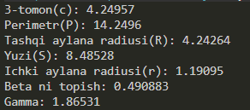
Boshlang‘ich ma’lumotlar a=6, b=4, α=π/4​ bo‘lganda, dastur c=4.24957, P=14.2496, R=4.24264, S=8.48528, r=1.19095, β=0.490883, γ=1.86531 natijani chiqaradi.

4. Topshiriq
Masalaning berilishi

Blok-sxema
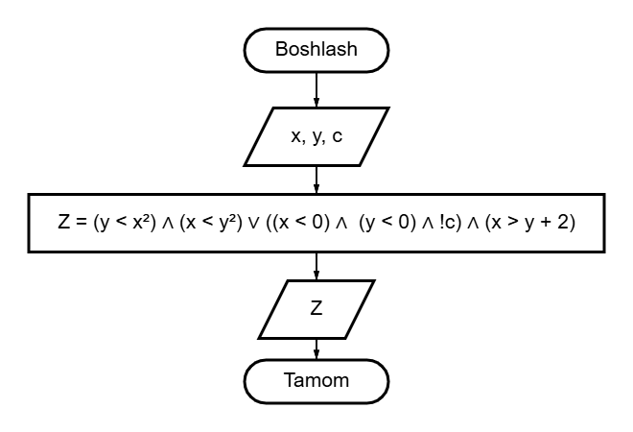
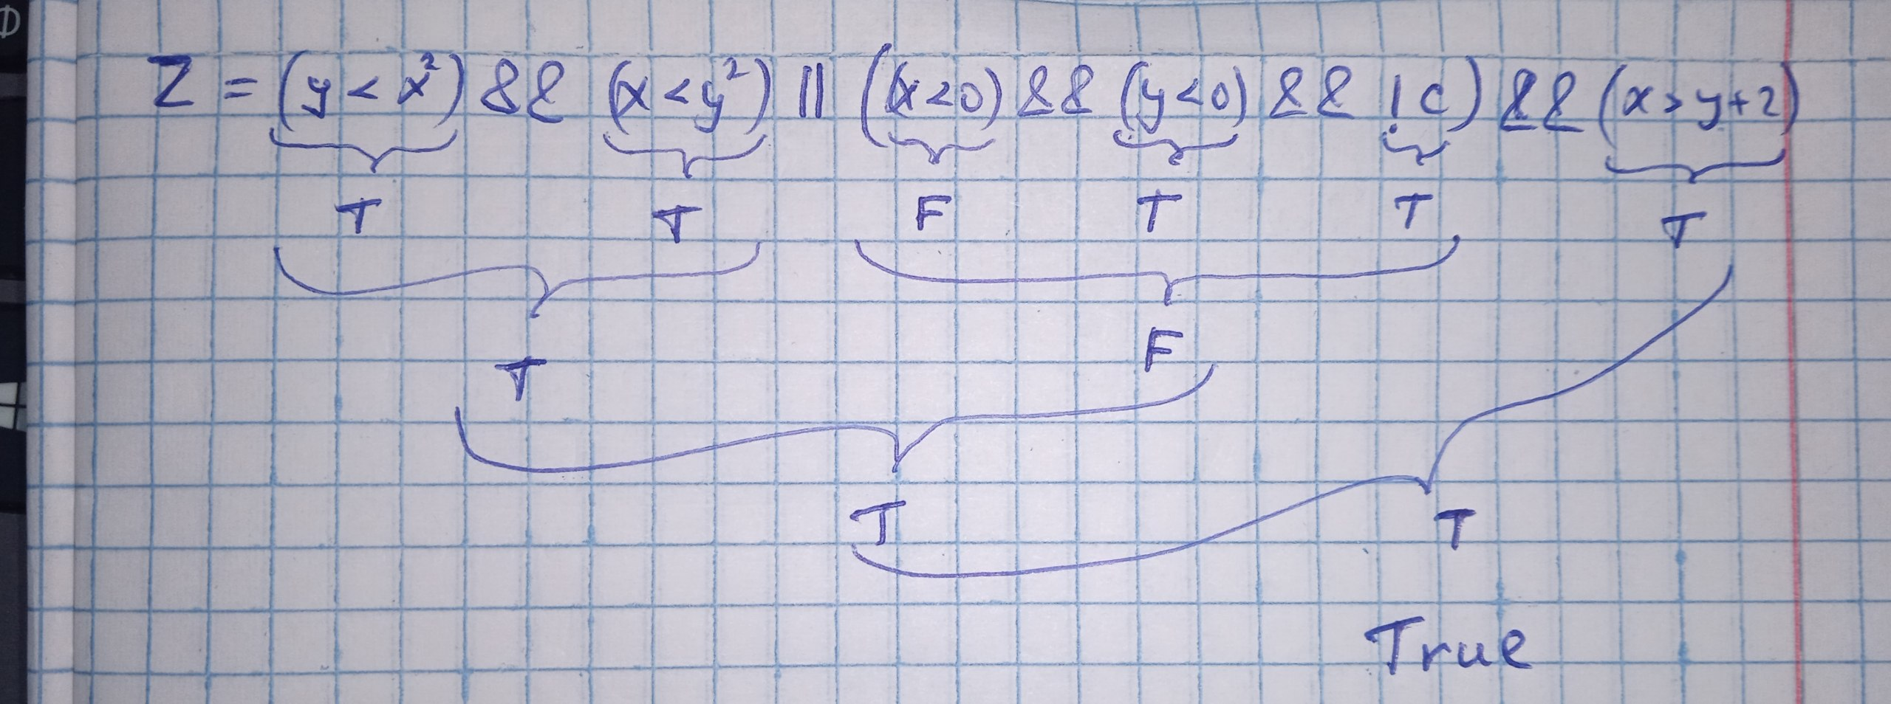
Dastur kodi
#include <iostream>
#include <cmath>
using namespace std;

int main() {
int x=8, y=-4;
bool c=0, Z;

Z = (y < pow(x, 2)) && (x < pow(y, 2)) || ((x < 0) && (y < 0) && !c) && (x > y + 2);
cout << boolalpha << Z;

return 0;
}

Dasturning natijasi
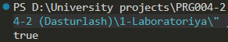
Boshlang‘ich ma’lumotlar x=8, y=-4, c=0 bo‘lganda, dastur Z=true natijani chiqaradi.

