**PROJECT SUBMISSION REPORT**

**Name: Muhammad Hashir Awaiz**

**Reg Number: 2023429**



**Digital Logic Design Project Report**

**Title:** *Braille Writing and Data Display System*

**Introduction:** Braille writing is a tactile writing system used by visually impaired individuals. It consists of patterns of raised dots that represent letters, numbers, and punctuation, allowing users to read and write by touch. The Braille system enhances accessibility to written communication, empowering blind individuals with independence in education, employment, and daily life.

This project involves designing a digital circuit capable of encoding and displaying Braille characters on a 16-segment display (MPX1 CA) using D flip-flops and a DIP switch. By integrating digital logic design principles, this system simulates Braille character encoding and visualization. The circuit employs EPROM (27C64) to store encoded Braille data and hex files for character mapping, showcasing how technology can bridge communication gaps for the visually impaired.

**Objective:** The primary objective of this project is to design a digital circuit that reads data inputs, processes them into Braille characters, and displays them on a 16-segment display. The project emphasizes the importance of inclusive technology, providing practical exposure to memory addressing, flip-flop operations, and display interfacing. Additionally, this project serves as a foundation for future assistive technology development and enhances understanding of digital logic design.

**Components Used:**

1. **D Flip-Flops (7474 IC) - 6 Units**
   * Each flip-flop stores one bit of data, collectively handling 6-bit addresses.
2. **27C64 EPROM (U4, U5)**
   * Memory chips are used to store Braille character data and then the respective character will be addressed and displayed.
3. **16-Segment MPX1 CA Display**
   * Displays encoded Braille characters.
4. **DIP Switch (SW1 - 6 Bit)**
   * Provides manual input for character selection.
5. **Clock Signal Generator**
   * Generates clock pulses for synchronized flip-flop operation.

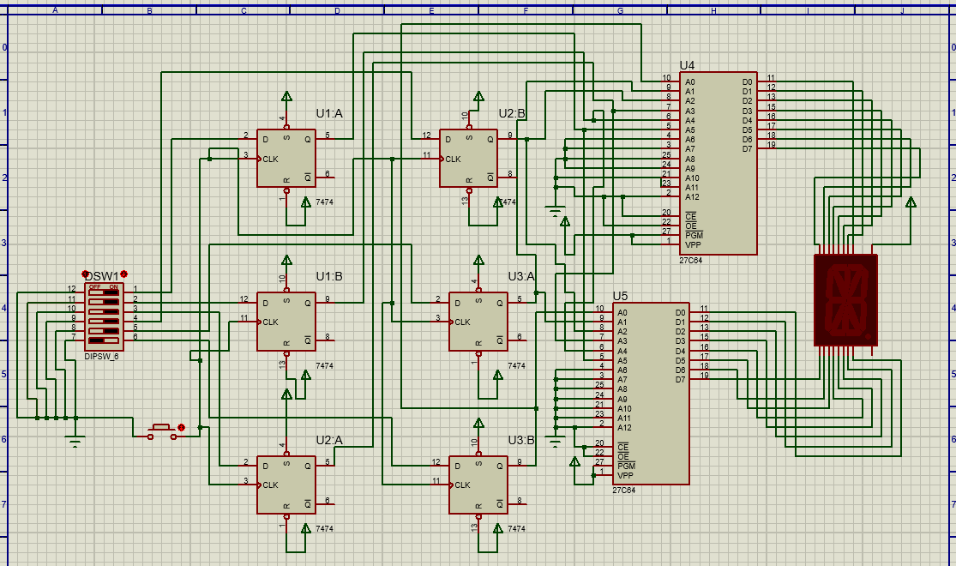

**Circuit Description:**

* **Flip-Flop Configuration:** Six D flip-flops (U1:A, U1:B, U2:A, U2:B, U3:A, U3:B) are arranged to store and transmit 6-bit address data. Each flip-flop captures one bit, and all six combine to form the complete address.
* **DIP Switch Operation:** The 6-bit DIP switch (SW1) allows manual input of Braille characters. Each switch corresponds to one flip-flop, enabling address selection.
* **EPROM Addressing:** Two EPROM chips (U4, U5) decode the address from the flip-flops and retrieve stored Braille character data.

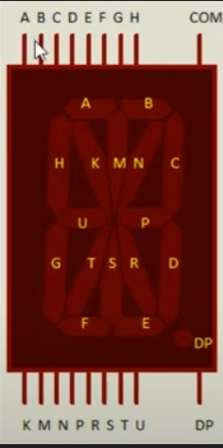

* **Display Output:** The 16-segment MPX1 CA display receives data from the EPROM and displays the corresponding Braille character.

**Working Principle:**

1. The DIP switch sets a 6-bit address, representing a Braille character.
2. D flip-flops latch the address bits upon receiving a clock pulse.
3. Address bits are decoded by the EPROM chips (U4, U5), selecting the corresponding memory location.
4. The data from the selected memory address is sent to the 16-segment display.
5. The display visualizes the Braille character by activating appropriate segments.

The EEPROM (27C64) is programmed with hex files containing binary representations of Braille characters. When a specific DIP switch combination is selected, the EEPROM retrieves the corresponding Braille character, sending binary outputs to light up specific LEDs on the 16-segment display. This setup mimics how real Braille embosser’s function, translating binary data into readable Braille patterns.

**Applications:**

* Educational tools for teaching Braille to visually impaired students.
* Digital Braille display systems in public places.
* Assistive technology development for inclusive communication.
* Embedded systems where character encoding and visual feedback are required.

**Future Improvements:**

1. **Expanded Character Set:** By integrating larger memory capacity, the circuit can store a more extensive range of Braille symbols and alphabets.
2. **Automation and Feedback:** Adding sensors for automated character recognition and audio feedback for each Braille character.
3. **Compact Design:** Implementing microcontroller-based designs to reduce circuit complexity and physical size.
4. **Wireless Input:** Introducing wireless input devices for remote character selection and enhanced accessibility.

**Troubleshooting and Challenges:**

1. **Address Mismatch:** Occasionally, the DIP switch may not correctly latch addresses. This can be resolved by verifying DIP switch connections and clock pulse consistency.
2. **EPROM Programming Errors:** Errors in hex file programming can lead to incorrect character display. Double-checking binary data before programming resolves this issue.
3. **Display Malfunctions:** If segments fail to illuminate, ensure correct wiring to the MPX1 CA display and validate EPROM output.

**Conclusion:** The Braille Writing and Data Display System effectively demonstrates the application of digital logic to assistive technology. By encoding Braille characters into a visual format, this project highlights the intersection of digital design and accessibility. The use of flip-flops, memory addressing, and segment displays provides valuable insights into advanced circuit design and inclusive innovation. The integration of EPROM and segment displays bridges hardware design with meaningful societal impact, paving the way for advanced assistive technologies.

**References:**

1. Brown, S. & Vranesic, Z. (2013). *Fundamentals of Digital Logic with VHDL Design*. McGraw-Hill Education.
2. Tocci, R. J., Widmer, N. S., & Moss, G. L. (2017). *Digital Systems: Principles and Applications*. Pearson.
3. Braille Authority of North America. (2023). *Introduction to Braille and Tactile Reading Systems*. Retrieved from [https://www.brailleauthority.org](https://www.brailleauthority.org/).
4. Microchip Technology. (2022). *27C64 EPROM Datasheet*. Available at [https://www.microchip.com](https://www.microchip.com/).
5. Texas Instruments. (2021). *7474 Dual D-Type Positive-Edge-Triggered Flip-Flop Datasheet*. Retrieved from [https://www.ti.com](https://www.ti.com/).