ER Diagram

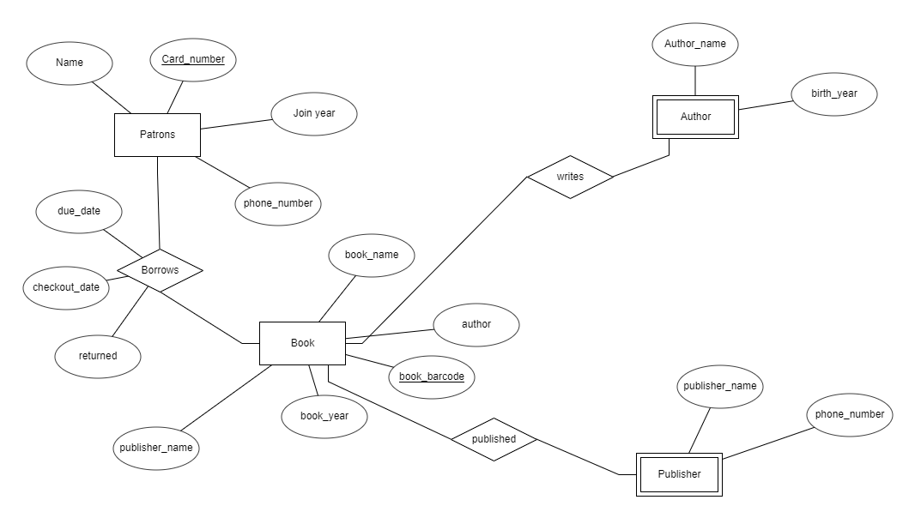

There are four entities in my ER diagram

1. Patron

Has 4 attributes:

* 1. Name
  2. Card numbers (unique, primary key)
  3. Phone number
  4. Join year

1. Book

Has 5 attributes

1. Book name (title)
2. author
3. Book year
4. Publisher’s name
5. Book barcode(unique，primary key)
6. Author

Has 2 attributes:

1. Author’s name
2. Birth year
3. Publisher

Has 2 attributes：

1. Publisher’s name
2. Phone number

The relationship “Borrow” has three attributes: checkout date, due date, and returned.

Patrons borrow book. Publishers published books. Authors write books.

Functional Dependencies:

|  |
| --- |
| Patron List |
| Patron card number |
| Patron name |
| Patron phone number |
| Join year |

Patron card number🡪patron name, patron phone number, join year

|  |
| --- |
| Book List |
| Book barcode |
| Book name |
| Author |
| Book year |
| Publisher name |

Book barcode🡪book name, author, book year, publisher name

|  |
| --- |
| Publisher List |
| Publisher name |
| Publisher phone number |

Publisher name🡪publisher phone number

|  |
| --- |
| Author List |
| author name |
| author phone number |

Author name🡪author phone number

|  |
| --- |
| borrow List |
| Patron card number |
| Book barcode |
| Checkout date |
| Due date |
| return |

Book barcode, patron card number🡪check out date, due date, return