**Explore sustainable, functional, sensorially enriching, and aesthetically pleasing materials for the production of the toys. Materials that are eco-friendly and made with ethical standards will be prioritized.**

Actual prototypes: clay

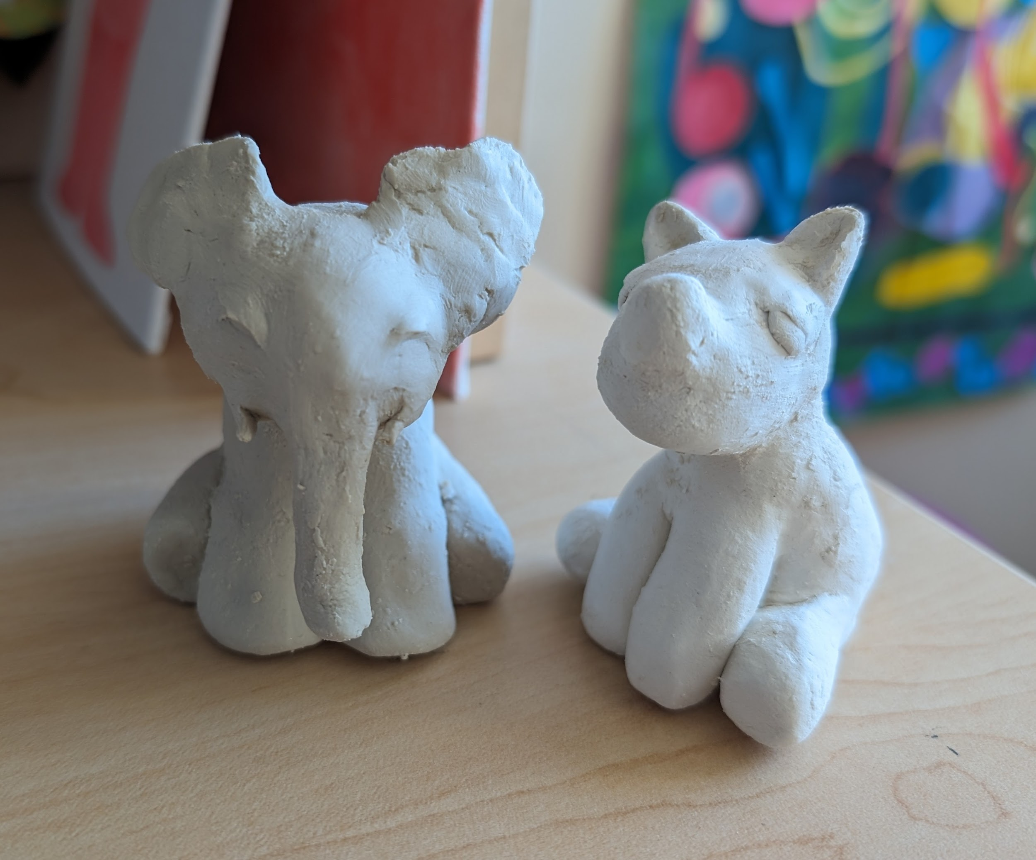

Possible real materials

Wood-plastic

* How different is wood-plastic from pure plastic?
* <https://www.greendotbioplastics.com/materials/wood-composites/>
* Can’t find studies about if children prefer wooden or plastic toys, but websites such as HappyBabyCo, MumsNet, Tom’s of Maine, and Green and Happy Mom, claim that wooden toys are better for children’s, particularly babies’, development. There is also the more eco-friendly aspect to wood.
* There are reasons why plastic has replaced wood as the main material many toys are made of: cheaper to produce, lighter, more durable, easier to mold into different shapes, allow for bright colors, and easier to clean. <https://www.woodenearth.com/blogs/wooden-blog/why-wood-toys-became-plastic-toys>
* The cons of plastic: they can have harmful chemicals in them, they are not biodegradable, and cause pollution when produced

Biodegradable plastic

* Sustainable plastic is biodegradable, made from natural substances instead of petroleum <https://learn.eartheasy.com/guides/the-best-eco-friendly-alternatives-for-the-plastic-in-your-life/>
* Sustainable Plastics <https://www.greendotbioplastics.com/why-sustainable-plastic/>

Biodegradable fabrics:

* <https://goodonyou.eco/most-sustainable-fabrics/> recycled cotton, organic hemp, organic linen, Tencel Lyocell (<https://www.tencel.com/about>), recycled wool, Bananatex (<https://www.bananatex.info/>)
* The Bear Factory, Bearaby, Bears for Humanity, Shore Buddies

In theory, these toy figurines would be made out of biodegradable plastic

* Sustainable plastic is biodegradable, made from natural substances instead of petroleum <https://learn.eartheasy.com/guides/the-best-eco-friendly-alternatives-for-the-plastic-in-your-life/>
* Sustainable Plastics <https://www.greendotbioplastics.com/why-sustainable-plastic/>