~~Research and identify five endangered species as the focal points of the educational toy collection. Evaluate each species’ significance in biodiversity conservation efforts.~~

Explore sustainable, functional, sensorially enriching, and aesthetically pleasing materials for the production of the toys. Materials that are eco-friendly and made with ethical standards will be prioritized.

* Wood-Plastic <https://www.greendotbioplastics.com/materials/wood-composites/>
* Sustainable Plastics <https://www.greendotbioplastics.com/why-sustainable-plastic/>
* How different is wood-plastic from pure plastic?
* Sustainable plastic is biodegradable, made from natural substances instead of petroleum <https://learn.eartheasy.com/guides/the-best-eco-friendly-alternatives-for-the-plastic-in-your-life/>
* Can’t find studies about if children prefer wooden or plastic toys, but websites such as HappyBabyCo, MumsNet, Tom’s of Maine, and Green and Happy Mom, claim that wooden toys are better for children’s, particularly babies’, development. There is also the more eco-friendly aspect to wood.
* There are reasons why plastic has replaced wood as the main material many toys are made of: cheaper to produce, lighter, more durable, easier to mold into different shapes, allow for bright colors, and easier to clean. <https://www.woodenearth.com/blogs/wooden-blog/why-wood-toys-became-plastic-toys>
* The cons of plastic: they can have harmful chemicals in them, they are not biodegradable, and cause pollution when produced
* Alternative: stuffed animals
* <https://goodonyou.eco/most-sustainable-fabrics/> recycled cotton, organic hemp, organic linen, Tencel Lyocell (<https://www.tencel.com/about>), recycled wool, Bananatex (<https://www.bananatex.info/>)
* The Bear Factory, Bearaby, Bears for Humanity, Shore Buddies

Research animal representation in toy design and other media, and use this information to develop an aesthetic for the toys that are realistic, **but also inspiring and allowing children to use their imagination.**

* Anthropomorphism in animal characters research (done last semester)
* <https://ebookcentral.proquest.com/lib/bu/reader.action?docID=4505095>
* <https://web-p-ebscohost-com.ezproxy.bu.edu/ehost/pdfviewer/pdfviewer?vid=0&sid=78d1aabc-14ba-4c73-8bc8-0ef3038cfc89%40redis>
* Discuss differences between humanized animals and realistic animals, but I don’t have to actually find an answer to what is the best way to represent animals to kids

Detailed prototypes will be designed, and will be refined for optimal appeal and educational functionality.

Air dry clay?

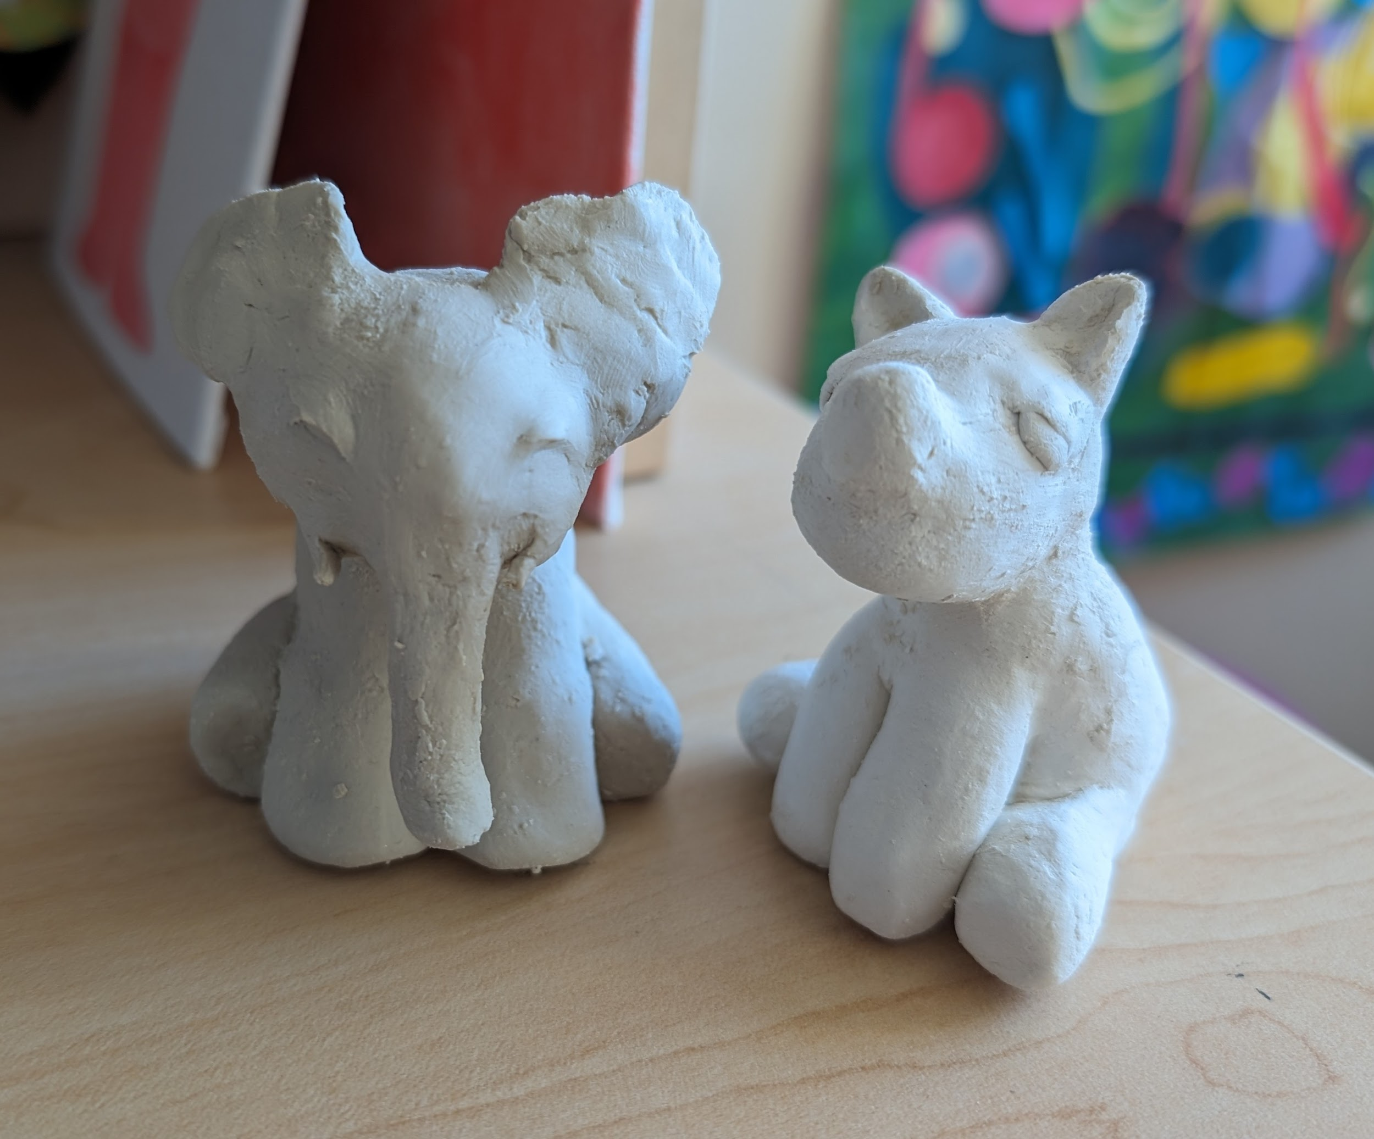

Comprehensive educational materials will be developed to accompany the toys. These materials will promote awareness about endangered species in an engaging, informative way that will enhance the learning experience of children.

* Postcards vs posters vs **trading cards**
* Children enjoy collecting things (stickers, rocks, etc).
* <https://www.childresearch.net/papers/playing/2013_01.html>
* <https://bitescience.com/articles/why-some-kids-love-collecting-toys-more-than-others/>
* <https://kidscreen.com/2016/07/05/why-kids-and-collecting-go-hand-in-hand/>
* <https://www.proquest.com/docview/2267000370?accountid=9676&parentSessionId=R9GXUKXVSzubi9nGP3z3DeqxvMUz8TsKEa3ABRZJVWo%3D&pq-origsite=primo&sourcetype=Scholarly%20Journals>
* <https://gogreentravelgreen.com/what-kids-learn-from-trading-cards/>
* <https://hail.to/belfast-school/article/dSCjcrj>
* <https://es.topps.com/blog/discover-the-thrill-of-card-collectibles-how-kids-can-embrace-card-collecting-as-an-engaging-hobby-with-topps.html>
* Trading cards are cheap to make, but is there a sustainable company?
* <https://www.printmagic.com/trading-card-printing/>
* <https://www.printmagic.com/postcard-printing/>
* <https://www.printmagic.com/sticker-printing/>
* <https://www.allaboutcards.de/en/company/news/eco-friendly-cards-card-suppliers-more-than-just-a-trend>
* **Ask Deb at the Child Cognition Lab about age group/target demographic based on current postcards, maybe ask about gender of toys?**
* Include animal representation in other cultures? Ex. homesphere.com: in europe, rhinos symbolize strength and power. In african folklore, rhinos are portrayed as courageous, wise, and determined protectors. In Hindu mythology, rhinos are known for their strength and resilience, and are also guardians of sacred places. ← theme of protection, symbol of strength, resilience, courage, power, and determination (maybe include on postcard?)

Preliminary packaging and marketing strategies will be identified in order to effectively show not only the inspiring quality of the toy collection, but also its educational and environmental value. This packaging will not only highlight the importance of animal and habitat conservation, but also resonate with children and their parents.

**CURRENT**

Research and identify five endangered species as the focal points of the educational toy collection. Evaluate each species’ significance in biodiversity conservation efforts.

* Done, need to edit the text though

Explore sustainable, functional, sensorially enriching, and aesthetically pleasing materials for the production of the toys. Materials that are eco-friendly and made with ethical standards will be prioritized.

* This is more complicated than it sounds. I found websites offering sustainable alternatives to plastic, such as biodegradable plastic or wood-plastic. I also considered wood, as it is an all natural material and also deemed as better for development. However, it is not viable to use wood, as it would still need to be carved, which takes more labor, and ultimately leads to very expensive wooden toys. In theory, I would like these animal toys to be made with biodegradable plastic that allows the product to be available to a wide range of socio-economic statuses. The biodegradable plastic toys, when thrown away, would be able to break down into natural materials, lessening pollution.

Research animal representation in toy design and other media, and use this information to develop an aesthetic for the toys that are realistic, but also inspiring and allowing children to use their imagination.

* There were many factors to consider in the design of the animals. Through research I discovered that the more human traits an animal character has, the less children will associate it with real animals, instead thinking of the character as a person. Anthropomorphic animals have stood the test of time and remain popular to this day, but I needed my characters to be both engaging and educational. To maximize appeal, the toy figurine was created in a cute chunky aesthetic, but still retains most of the animals’ characteristics, with only the expressions being more people-like.

Detailed prototypes will be designed, and will be refined for optimal appeal and educational functionality.

* Rhino and elephant are done, they need to be painted next

Comprehensive educational materials will be developed to accompany the toys. These materials will promote awareness about endangered species in an engaging, informative way that will enhance the learning experience of children.

* Studies show that children in the target age demographic (7 to 12 year olds) enjoy collecting and completing sets of various objects. It is satisfying to them. Trading cards are a good way to appeal to kids, as they want to complete their set. Using Pokemon cards as inspiration, I created trading cards for each of the animals, including their ‘stats’ and other information.
* The prototype figurines are very stylized, though realism helps children learn and associate characters with real life animals. I’m not sure where to add in my realistic illustrations, but I want to include them for the sake of education. However, part of the appeal of trading cards like Pokemon is that they have cute, visually appealing designs. Unsure of where to go from here, I decided to create both realistic and stylized trading cards for each of the chosen animals. These designs can be rated by children for both cuteness and education, but ultimately the kids will decide which trading card format, stylized or realistic, is more appealing to them.
* A primary concern of mine is that all of my text won’t fit onto a singular trading card. I will consider only including the most crucial information on the trading cards, and then also including a tiny ‘guidebook’ that shows the rest of the information, along with a glossary.

Preliminary packaging and marketing strategies will be identified in order to effectively show not only the inspiring quality of the toy collection, but also its educational and environmental value. This packaging will not only highlight the importance of animal and habitat conservation, but also resonate with children and their parents.

* I wanted to create sustainable packaging, but this presents the same problem as the material of the toys: there is no realistically sustainable alternative. Ideally, I would use one that is made from 100% recycled material.