1.求解非线性规划
min 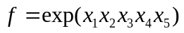
s.t. 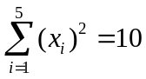
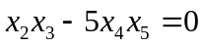
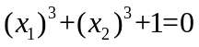
-2.3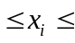2.3 i=1,2
-2.33.2 i=3,4,5
(1)代码如下
fun1.m
function f=fun1(x)
f=exp(x(1)*x(2)*x(3)*x(4)*x(5));

cont.m
function [G,Geq]=cont(x)
G=[];
Geq=[x(1)^2+x(2)^2+x(3)^2+x(4)^2+x(5)^2-10,x(2)*x(3)-5*x(4)*x(5),x(1)^3+x(2)^3+1];

test.m
x0=[1,1,1,1,1];
A=[];b=[];
Aeq=[];beq=[];
lb=[-2.3,-2.3,-2.3,-2.3,-2.3];ub=[2.3,2.3,3.2,3.2,3.2,];
[x,exitflag,fval]=fmincon(@fun1,x0,A,b,Aeq,beq,lb,ub,@cont)

(2)执行结果如下
Warning: Large-scale (trust region) method does not currently solve this type of problem,
switching to medium-scale (line search).
> In fmincon at 274
In test at 5
Optimization terminated: magnitude of directional derivative in search
direction less than 2*options.TolFun and maximum constraint violation
is less than options.TolCon.
No active inequalities.
x =
-1.7172 1.5957 1.8272 0.7640 0.7633
exitflag =
0.0539
fval =
5
>>

