StarScreen Cinemas
MANAGEMENT SYSTEM
User Manual
A guide for cinema staff (Cashiers & Managers)
SOFT605 Group Assignment
Version 1.0

Contents
1. Introduction 3
Who uses the system 3
2. Getting Started 3
2.1 Starting the application and signing in 3
2.2 Your role and what you can access 4
2.3 Finding your way around 4
3. The Dashboard 5
4. Managing Customers 6
4.1 Find a customer 6
4.2 Register a new customer 6
4.3 Edit a customer or view history 6
5. Browsing Movies and Screenings 6
5.1 Movie Browser 6
5.2 Screenings 7
6. Selling Tickets (New Booking) 7
6.1 Step by step 8
6.2 Discounts and points (automatic) 9
7. Manager Tasks 9
7.1 Administration — Movies 10
7.2 Administration — Screenings 10
7.3 Reports 10
8. Quick Reference 11
8.1 How a price is worked out 11
8.2 Payment methods 11
9. Signing Out 11
10. Troubleshooting 11

1. Introduction
StarScreen Cinemas Management System is a desktop application that cinema staff use to sell tickets, manage customer memberships, browse the film catalogue, and (for managers) maintain movies and screenings and view sales reports.
This manual is written for front-desk staff. No technical knowledge is required. It explains every screen and walks through the everyday tasks step by step.

Who uses the system
- Cashier — signs in to sell tickets, look after customers, and browse what is showing.
- Manager — can do everything a Cashier can, and additionally manage the movie/screening catalogue and view reports.

2. Getting Started

2.1 Starting the application and signing in
When the application opens, the Sign In screen appears. Enter your Username and Password and click Login.
1. Type your Username (for example, manager).
2. Type your Password.
3. Click Login. The Dashboard opens.
Note: If you see “Incorrect username or password”, check for typing mistakes (including Caps Lock) and try again. Demo accounts: cashier / cashier123 and manager / manager123.
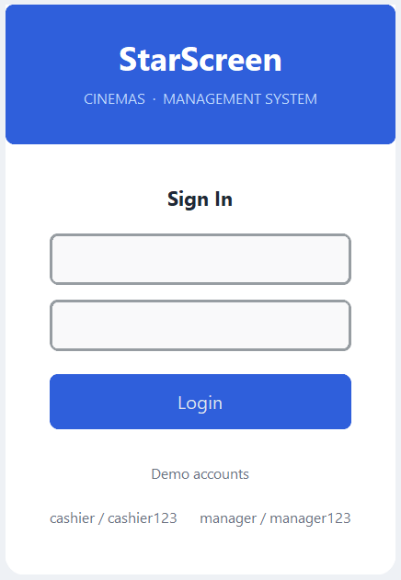

2.2 Your role and what you can access
What you can do depends on whether you are signed in as a Cashier or a Manager:
Feature | Cashier | Manager
Dashboard | ✓ | ✓
New Booking (sell tickets) | ✓ | ✓
Customers (find / register / edit / history) | ✓ | ✓
Movie Browser & Screenings (view) | ✓ | ✓
Administration (manage movies & screenings) | — | ✓
Reports | — | ✓

Note: Manager-only screens show an “Access Denied” message if opened by a Cashier. This is normal — ask a Manager to sign in for those tasks.

2.3 Finding your way around
The dark menu on the left is always visible. Click an item to open that screen. Your name and role are shown at the top of the menu.
Menu item | What it is for | Who
Dashboard | A snapshot of today: revenue, bookings, recent activity | All
Customers | Find, register and edit customers; view booking history | All
Movie Browser | Browse the film catalogue | All
Screenings | See today’s screenings and start a booking | All
New Booking | Sell tickets | All
Administration | Add / edit movies and screenings | Manager
Reports | Sales and membership reports | Manager

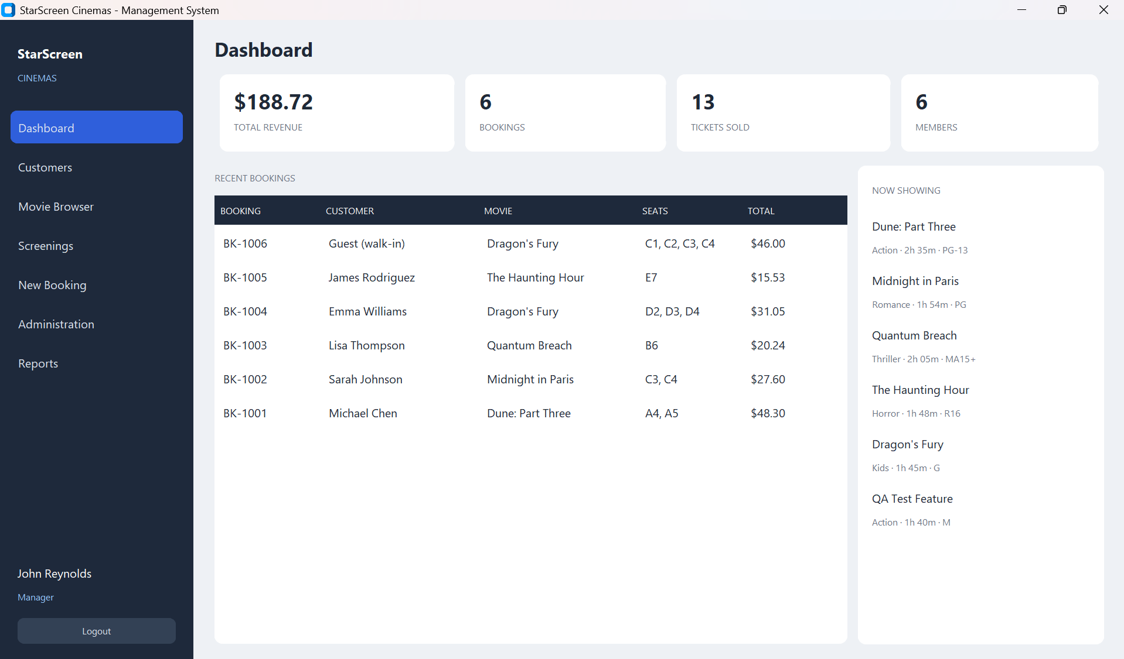

3. The Dashboard
The Dashboard is the first screen after you sign in. It shows four summary figures — Total Revenue, Bookings, Tickets Sold and Members — along with a list of Recent Bookings and what is Now Showing. Use it for a quick overview at the start of a shift.


4. Managing Customers
Open Customers to find, add and edit customers and to view their booking history.

4.1 Find a customer
Type a name or email in the search box at the top. The list filters as you type and shows each customer’s Name, Email, Phone, Tier and Points.

4.2 Register a new customer
1. Click + Register Customer.
2. Enter the Name, Phone and Email, then click Save.
Note: New customers start as Regular Members (10% discount). The tier then changes automatically with points and cannot be edited by hand.

4.3 Edit a customer or view history
- Edit — click Edit on a customer’s row to change their name, phone or email.
- History — click History to see all of that customer’s past bookings.
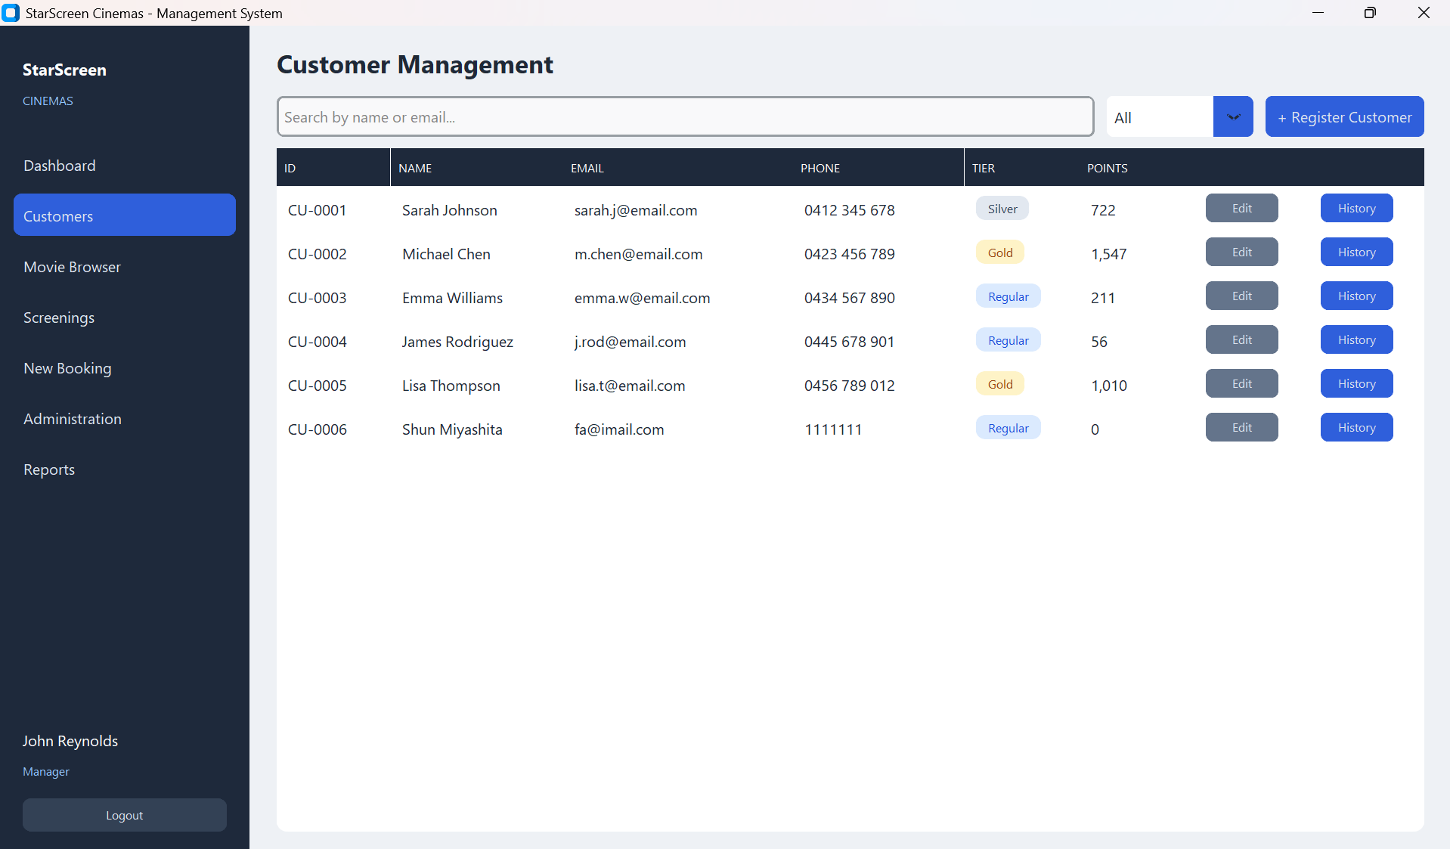

5. Browsing Movies and Screenings

5.1 Movie Browser
Open Movie Browser to see the film catalogue. Search by title or filter by genre. Each film shows its Title, Genre, Duration, Rating and Status (Active or Inactive). This screen is view-only — adding and editing films is a Manager task (see Section 7).
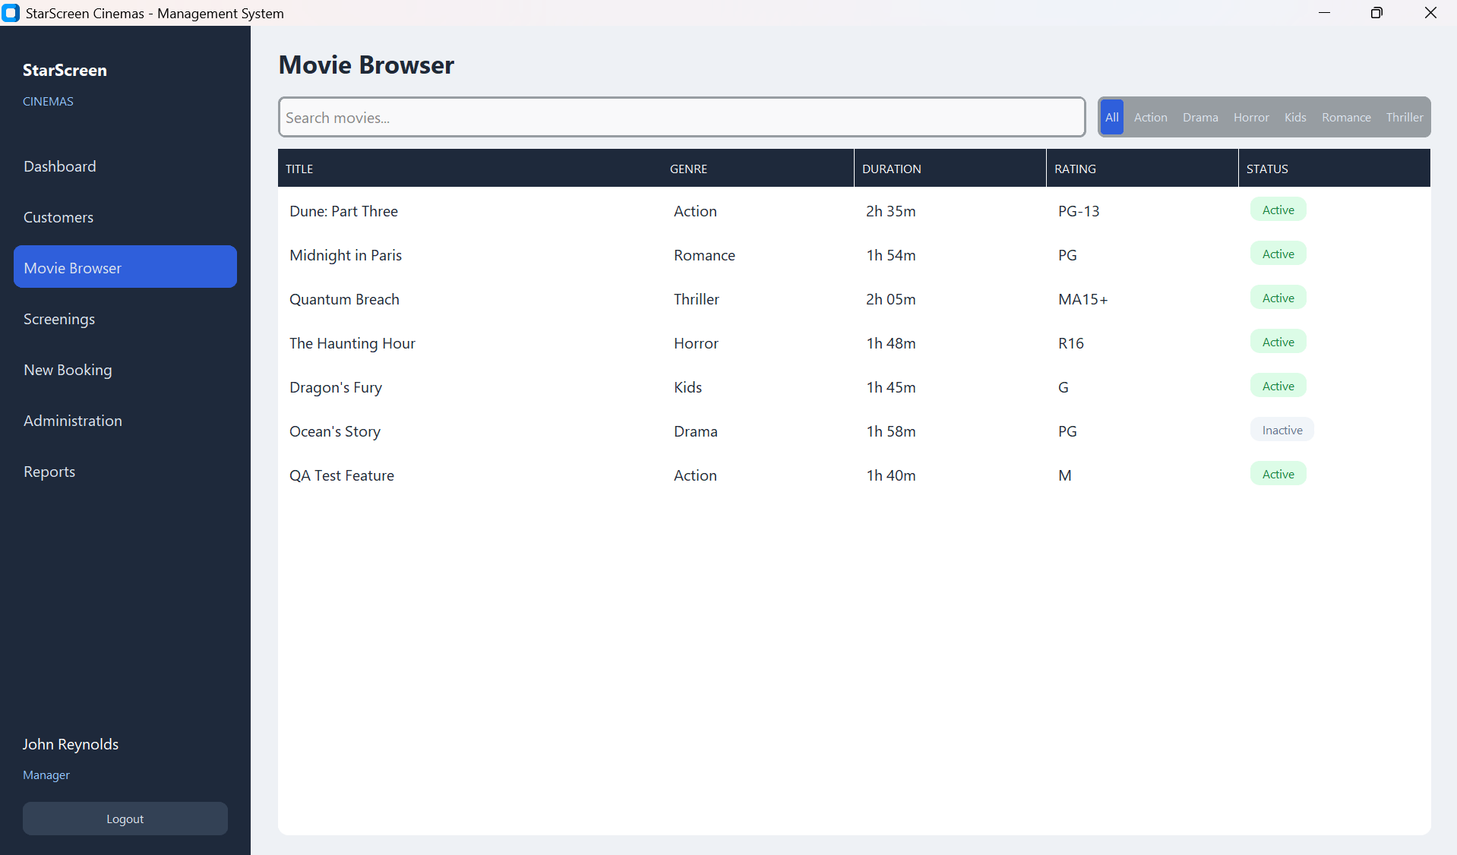

5.2 Screenings
Open Screenings to see today’s sessions with their Movie, Date, Time, Screen, Type and Seats Free. Click Book on any row to start selling tickets for that session.
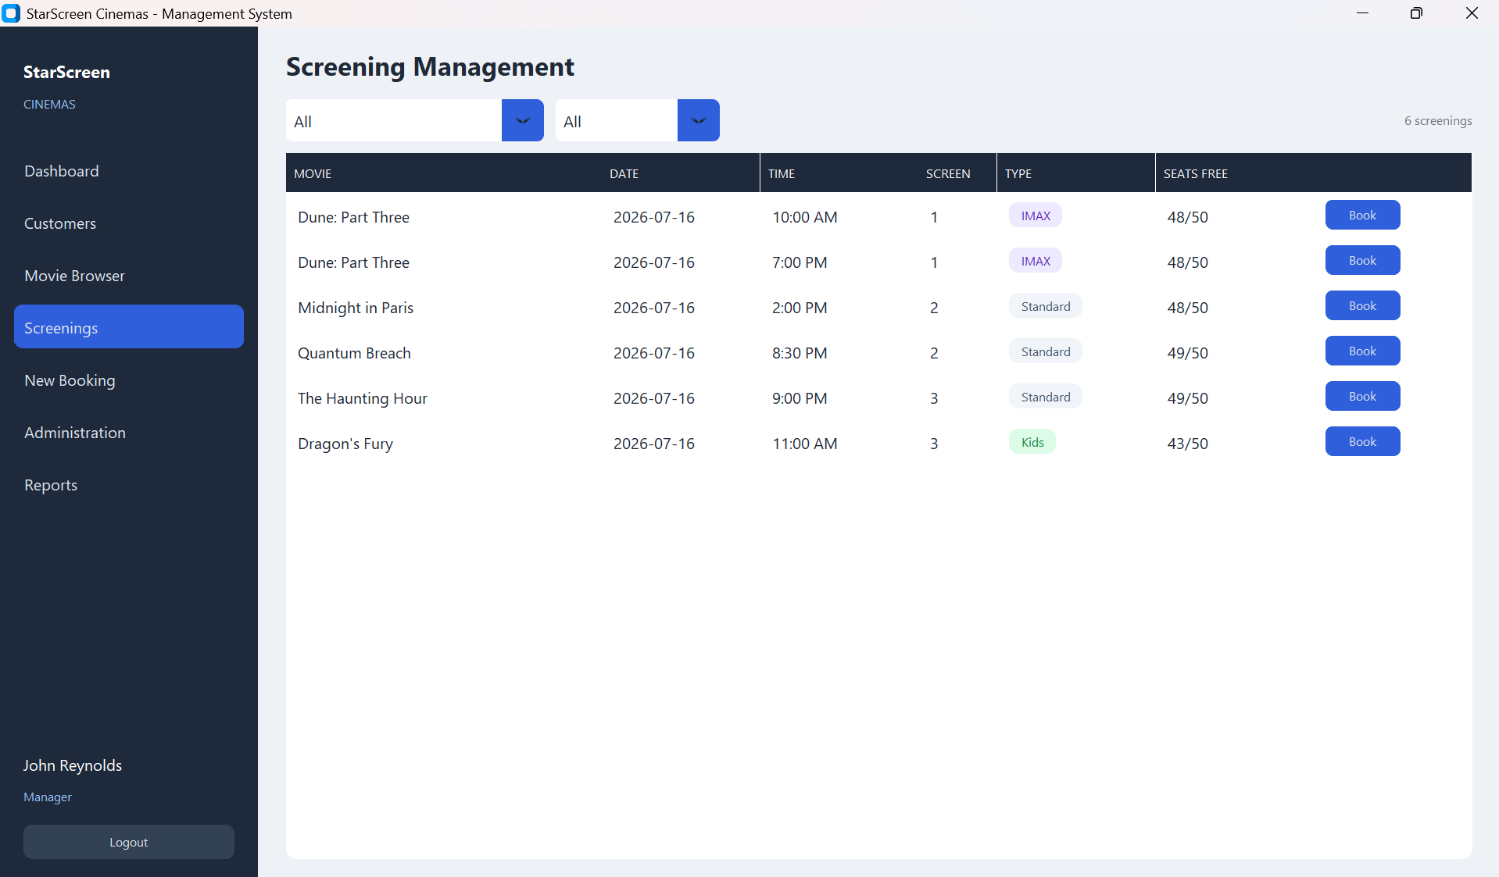

6. Selling Tickets (New Booking)
Selling a ticket is the main task. You can start it either from the Screenings screen (click Book next to a screening) or from the New Booking menu item.

6.1 Step by step
1. Choose the screening. Open Screenings and click Book on the row you want. The booking screen shows the chosen movie, date, time and screen at the top.
2. Select seats. On the seat map, click the seats the customer wants. The legend shows seat colours: Standard, Premium, Selected, and Taken. A seat marked Taken cannot be chosen.
3. Choose the customer. Search for a registered customer by name, or choose Guest (walk-in) for someone without a membership (no discount, no points).
4. Check the price breakdown. The panel shows Seats, Subtotal, Discount (from the customer’s tier), GST (15%) and the Total. The discount is applied automatically — you never type it.
5. Take payment. Choose Card, Cash or Voucher. For Cash, type the amount received (for example 50.00) and the change due is calculated for you.
6. Confirm. Click Confirm Booking. A receipt with the full itemised breakdown is shown, the seats become Taken, and the customer’s points are updated.
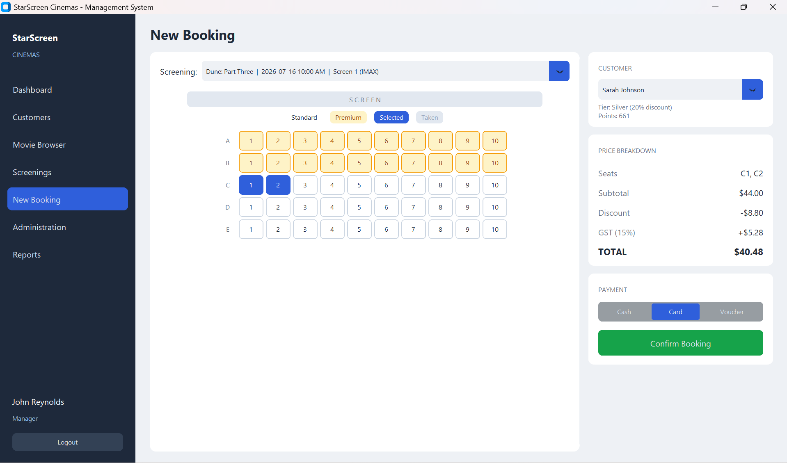
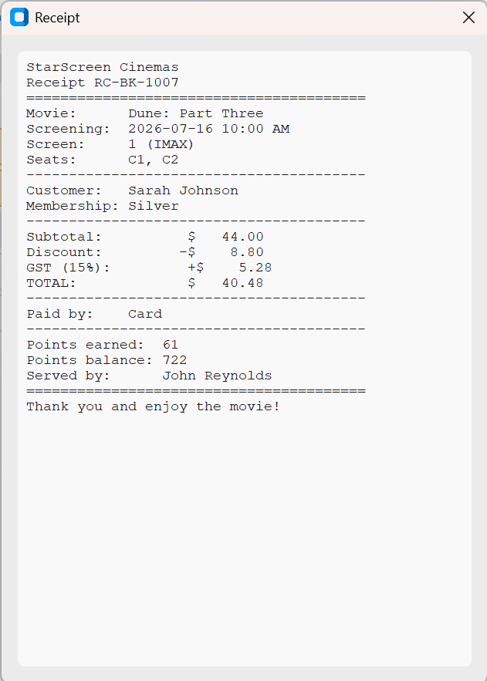
Note: If a seat was taken by someone else between selecting and confirming, the system shows “Cannot Complete Booking” and no ticket is created. Simply pick another seat and try again.

6.2 Discounts and points (automatic)
Members receive a discount based on their tier and earn loyalty points on every purchase. When their points cross a threshold they are upgraded automatically. Staff never change a tier by hand.
Tier | Discount | Points per $1 | Upgrades at
Guest | 0% | 0 | Walk-ins only
Regular | 10% | 1.0 | 500 pts → Silver
Silver | 20% | 1.5 | 1,000 pts → Gold
Gold | 30% | 2.0 | Highest tier

7. Manager Tasks
The following screens are available to Managers only.

7.1 Administration — Movies
Open Administration and choose the Movies tab to manage the catalogue.
- Add a movie — click + Add Movie, fill in Title, Genre, Duration (minutes) and Rating, then Save.
- Edit — change a film’s details.
- Deactivate / Restore — hide a film that is no longer showing, or bring it back. Deactivating asks you to confirm.

7.2 Administration — Screenings
On the Screenings tab you can Add a Screening (+ Add Screening), Edit an existing one, or Delete it. Each screening lists its Movie, Date, Time, Screen, Type and Occupancy.
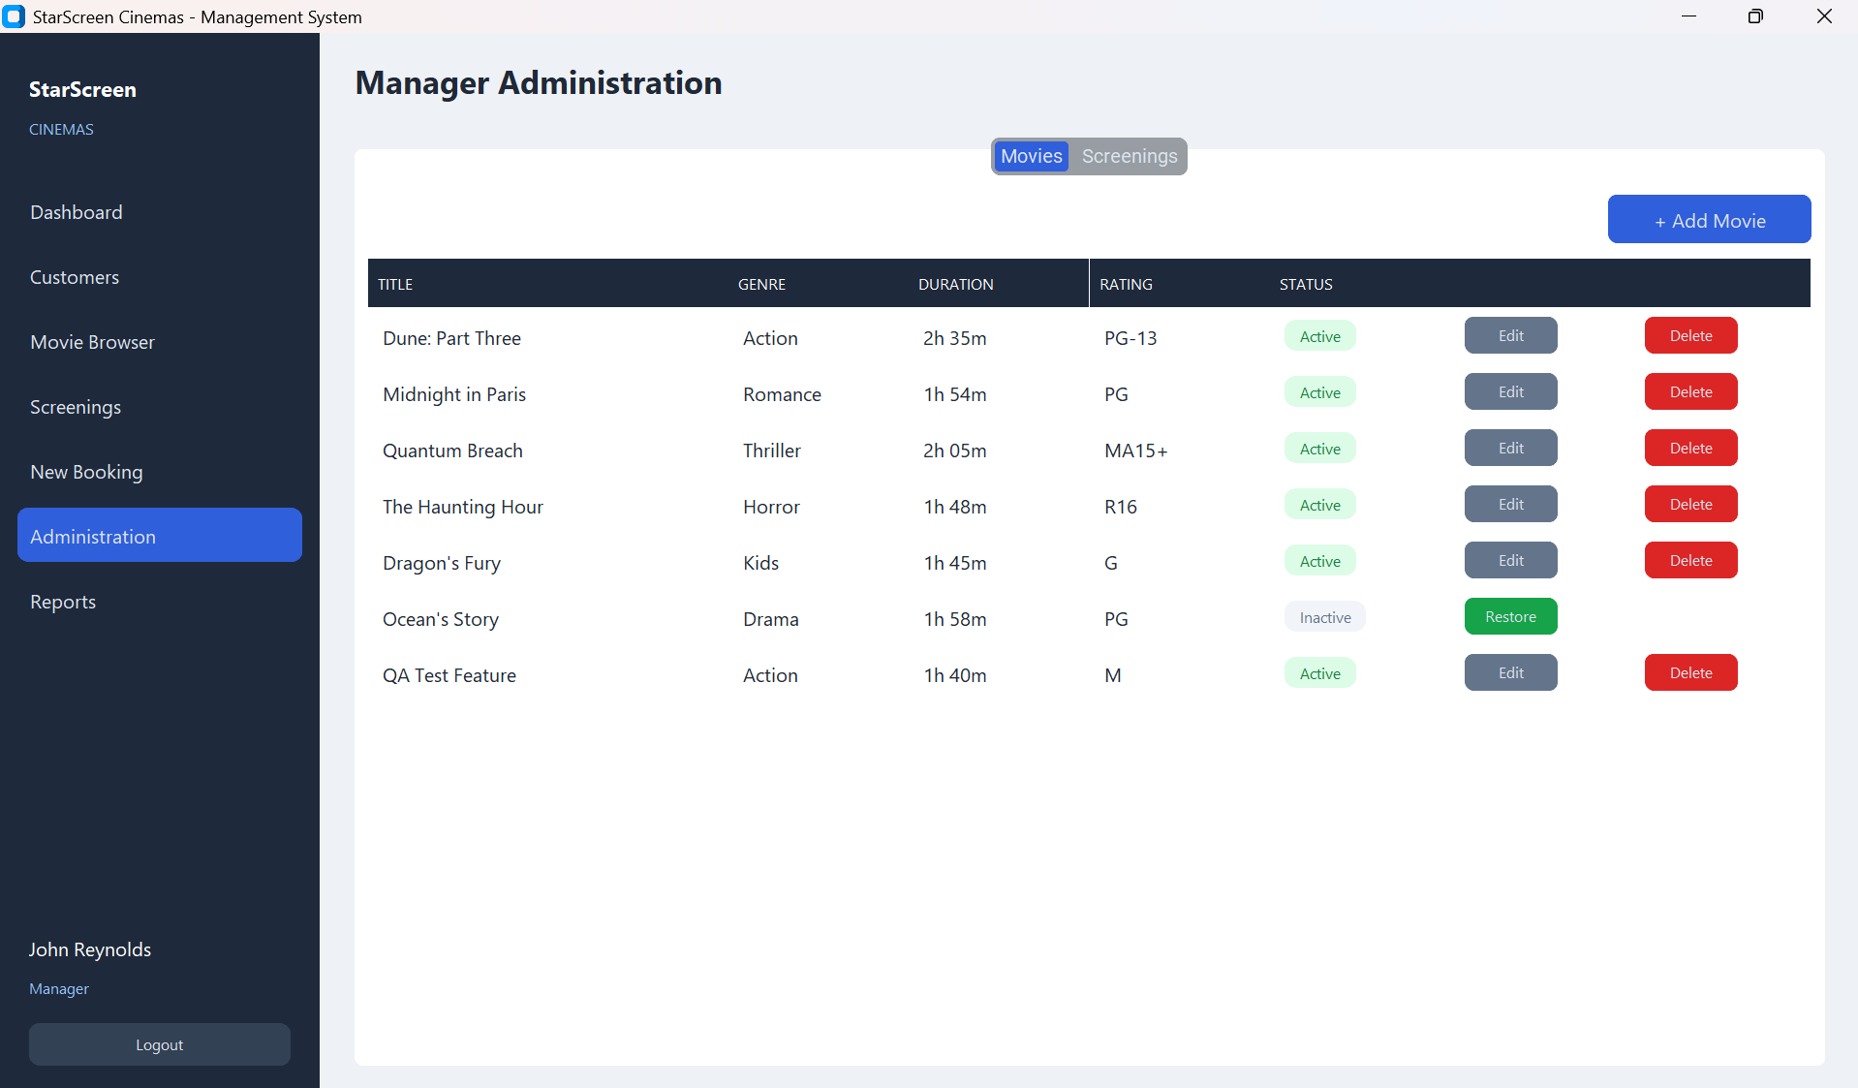
Figure 8. The Administration screen with the Movies and Screenings tabs.

7.3 Reports
Open Reports for a live view of performance. The top of the screen shows Weekly Revenue, Total Bookings, Average Ticket Price and Total Members, followed by four charts:
- Daily Revenue — this week
- Top Movies this week
- Membership Distribution (customers per tier)
- Seat Occupancy by Screen
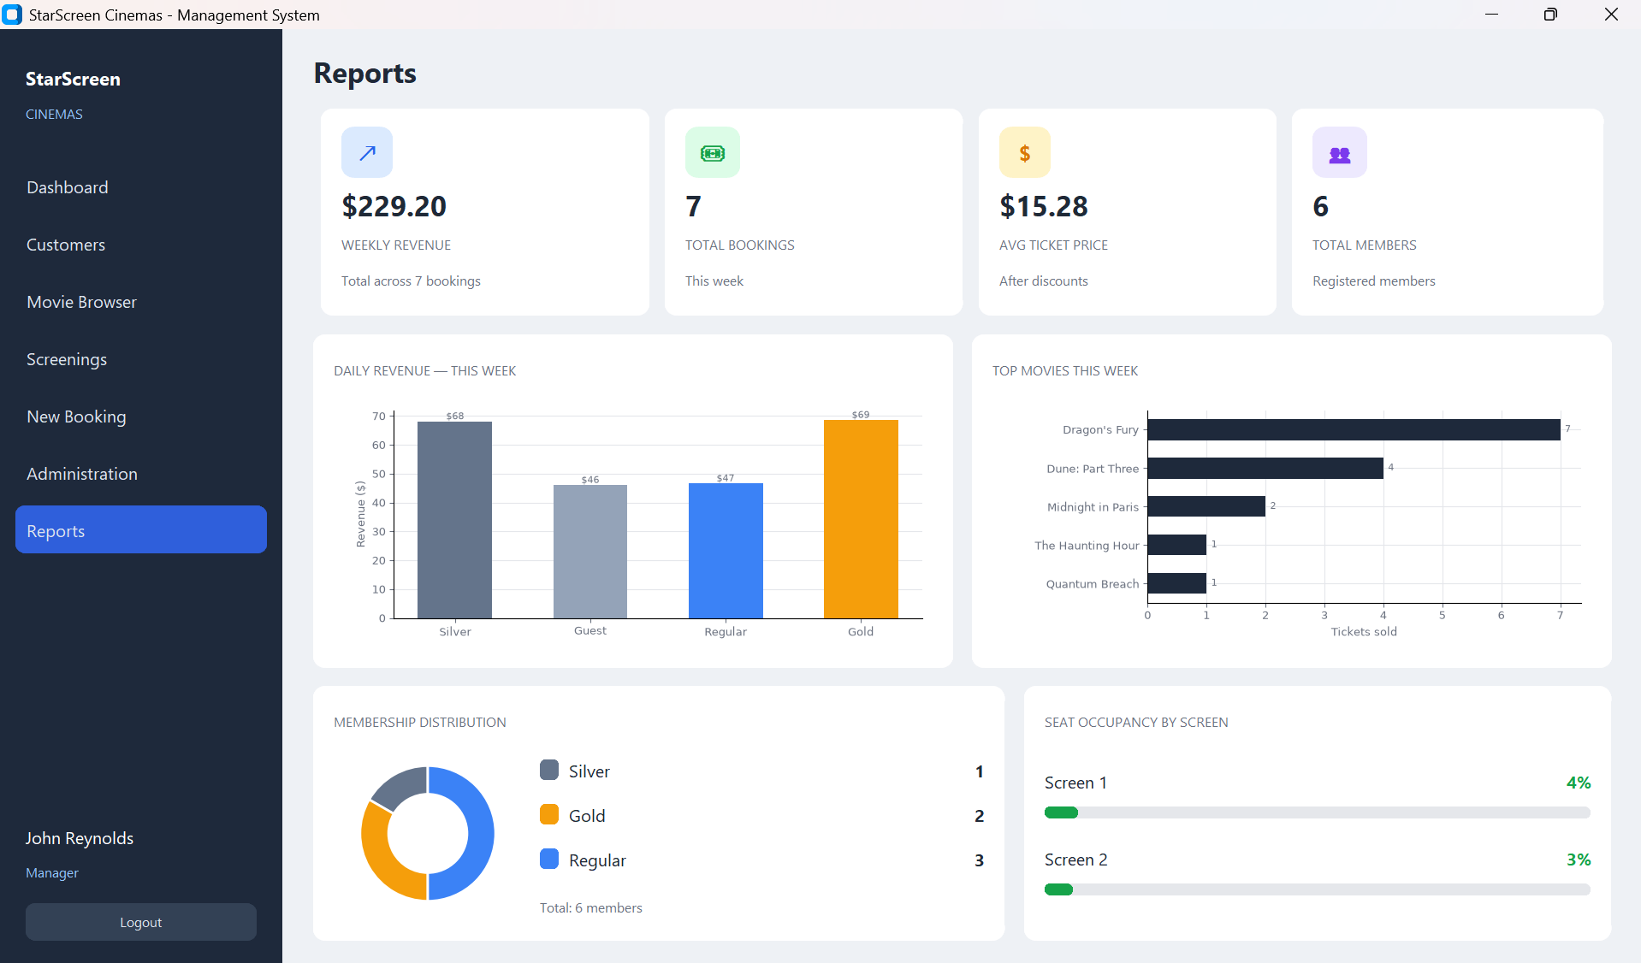
Figure 9. The Reports screen with summary figures and charts.

8. Quick Reference

8.1 How a price is worked out
Price = seat price (by seat type and screening type) − membership discount + 15% GST. The full breakdown is always shown before you confirm.
Example ticket prices (may vary):
Screening type | Standard seat | Premium seat
Standard | $15.00 | $22.00
IMAX | $22.00 | $30.00
Kids | $10.00 | $14.00

8.2 Payment methods
Cash (change due is shown), Card, and Voucher. A receipt is produced after every booking.

9. Signing Out
When you finish your shift, use the sign-out option in the navigation menu to return to the Sign In screen. Always sign out on a shared computer so the next person signs in as themselves.

10. Troubleshooting
Situation | What to do
“Incorrect username or password” | Check Caps Lock and spelling; use the correct account.
“Access Denied” on a screen | That screen is Manager-only. Ask a Manager to sign in.
A seat will not select | It is already Taken (shown in the Taken colour). Choose another.
“Cannot Complete Booking” | A seat was just taken by someone else. Pick another seat and retry.
Cash amount not accepted | Enter a number such as 50.00, not text.

