Student: Bryan Kwong N8891401
Student: Yi Luan N9882871
Student: Shih-Hang Lee N9802614
Student: N9568158 Zhaohui Zhong

Student: Bryan Kwong N8891401
Student: Yi Luan N9882871
Student: Shih-Hang Lee N9802614
Student: N9568158 Zhaohui Zhong


Team 13
IFN645 Case Study 2

Table of Contents
Part 1: Clustering the Manufacturing Data 3
Task 1. Data Preparation for Clustering 3
1. Can you identify data quality issues in this dataset such as unusual data types, missing values etc? 3
2. What variables did you include in the analysis and what were their roles and measurement level set? Justify your choice. 4
3. Identify a car model that is underperforming in sales. 4
Task2. The first clustering model 5
1. Build a default clustering model and answer the followings: 5
2. What is the effect of using the standardization method on the model above? Does the variable normalization process enable a better clustering solution? If it does not, disable the option for rest of the models. 9
3. Using the Graph wizard, interpret the (best out of 2.1 and 2.2) cluster analysis outcome. 10
4. Using the Segment Profile node, interpret the cluster analysis outcome. 11
Task 3. Refining the clustering model 13
1. Refine the best cluster model built in the previous step by adjusting the number of clusters (deleting or adding one or two additional cluster) in order to test small changes to the number of clusters. Evaluate the result. 13
2. What is the best number of clusters that can describe the dataset effectively? Was this obtained with the default setting (i.e. the automated SAS process) or manually specifying a clustering number? 15
3. How the outcome of this study can be used by decision makers? 15
Part 2: Association Mining the Supermarket Data 15
Task 4. Association Mining 15
1. Can you identify data quality issues in this dataset for performing association analysis? 15
2. What variables did you include in the analysis and what were their roles and measurement level set? Justify your choice. 16
3. Conduct association mining and answer the following: 16
4. The store is particularly interested in products that individuals purchase when they buy “Pens”. 19
5. How the outcome of this study can be used by decision makers? 20
Part 3: Text Mining (Clustering) the News Stories 20
Task 5.Text Mining 20
1. What variables did you include in the analysis and what were their roles and measurement level set? Justify your choice. 20
2. Can you identify data quality issues in order to perform text mining? 21
3. Based on the ZIPE plot, list the top 10 terms that will be least useful for clustering purpose. 21
4. Did you disregard any frequent terms in addition to automatically selected by the Filter tool? 21
5. Justify the term weighting option selected. 22
6. What is the number of input features available to execute clustering? (For information: Note how the original text data is now converted into a feature set that can be mined for knowledge discovery?) 22
7. State how many clusters are generated? Name each cluster meaningfully according to the terms that appear in the clutters? 23
8. Identify the first fifteen high frequent terms (that are not stop words or noise) in the start list? 23
9. Describe how these clusters can be useful in the online personalised news story service planned. 24
Part 4: Web Mining the Log Data for a Website 24
1. For each data mining operation: 24
a. Rationale behind selecting the method. 24
b. What variables did you include in the analysis and what were their roles and measurement level set? Justify your choice. 25
c. Can you identify data quality issues in order to perform web mining? 25
d. Discuss the results obtained. Discuss also the applicability of findings of the method. Should include a high-level managerial kind of discussion on the findings, should not be just interpretation of results as shown in results panel. 26
Appendix: 29

Part 1: Clustering the Manufacturing Data

Task 1. Data Preparation for Clustering

Can you identify data quality issues in this dataset such as unusual data types, missing values etc?
By right-click the data source and selecting Explore all of the input names. The sample statistics window has shown that several variables, which are HATCH, K_SALES_TOT, SEDAN, UTE AND WAGON have missing value at 3.259259%.
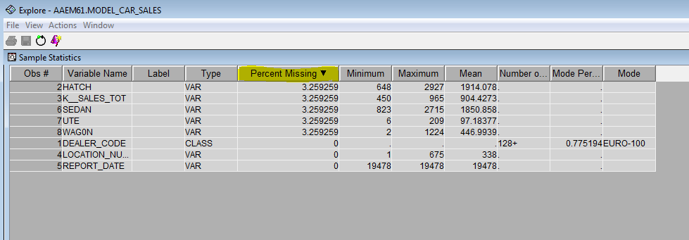
By opening the data explore window, all the values of variables can be displayed. It indicates that there are five variables have the issue of missing value. By examining these variable, there are not unusual data type or outlier in this data source. Therefore, missing value is the only issue in this dataset.
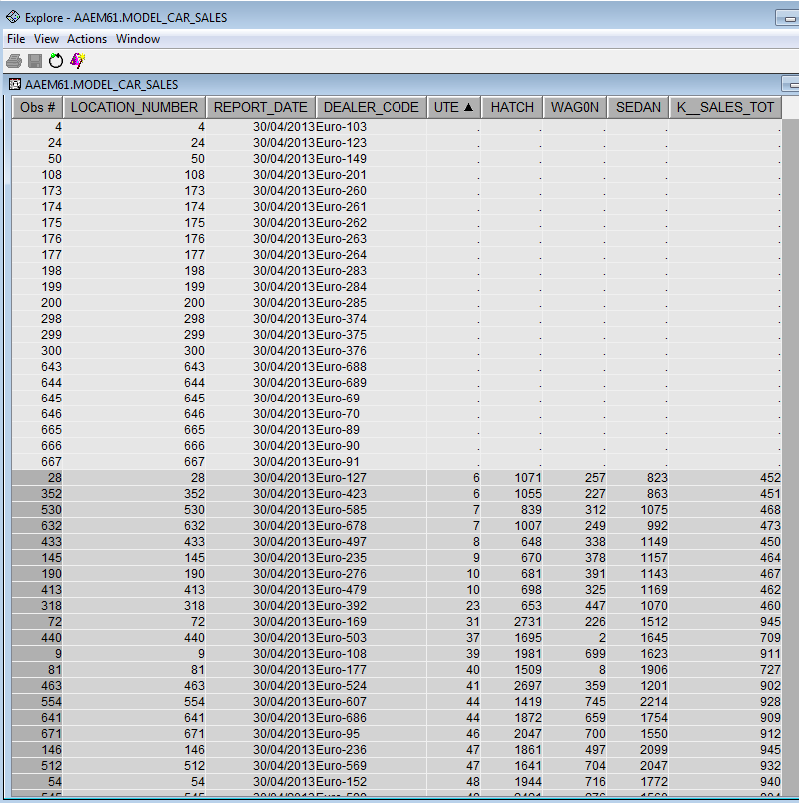

What variables did you include in the analysis and what were their roles and measurement level set? Justify your choice.
- DEALER CODE: This is the text identifier for the store with unique identifier, therefore, the role for this variable is ID which allow different codes of this variable to be utilised to represent different dealer or stores. In this case, Nominal is set for the measurement of ID.
- HATCH, SEDAN, UTE and WAGON: These variables describe the number of different types of cars sold by the different store. Therefore, they should be recognised as Input and plays an important role for task of conducting K-mean clustering. As they represent the numbers of different cars sold by the store, they should be considered as interval variables.
- K_SALES_TOT: this variable should be rejected, as it represents the total sales for the store. However, the task is to find the minimum number of effective cluster, this variable cannot contribute to K-mean clustering.
- Location Number: This variable should be rejected, as it is unique variable as the Dealer Code. Only on variable as the ID is needed for this task to undertake interpretation.
- REPORT DATE: This variable should be rejected, as all the values of this variable are same at 30/04/2013 and not make contribution to clustering.
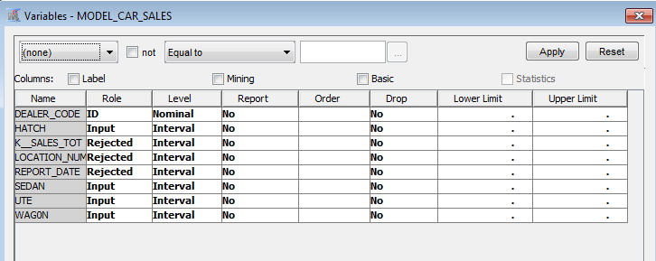

Identify a car model that is underperforming in sales.

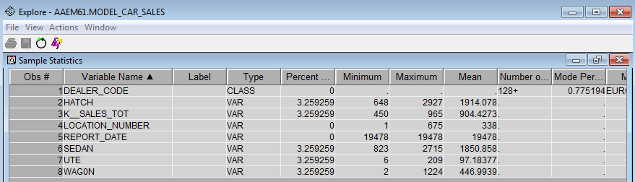
Based on the Sample Statistics, the maximum sales of UTE is 209, which is much lower than the maximum sales of HATCH, SEDAN and WAGON at 2927, 2715 and 1224 respectively. Additionally, the mean sales of UTE is 97, which is lower than the mean sales of HATCH, SEDAN and WAGON. In this case, UTE should be recognised as underperformance in sales. Therefore, the variable of UTE should be rejected.
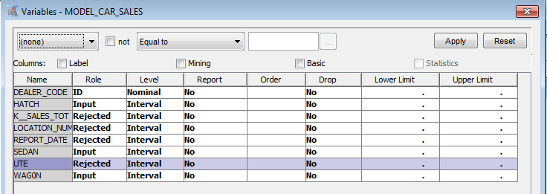

Task2. The first clustering model

Build a default clustering model and answer the followings:

What is the optimal number of clusters?
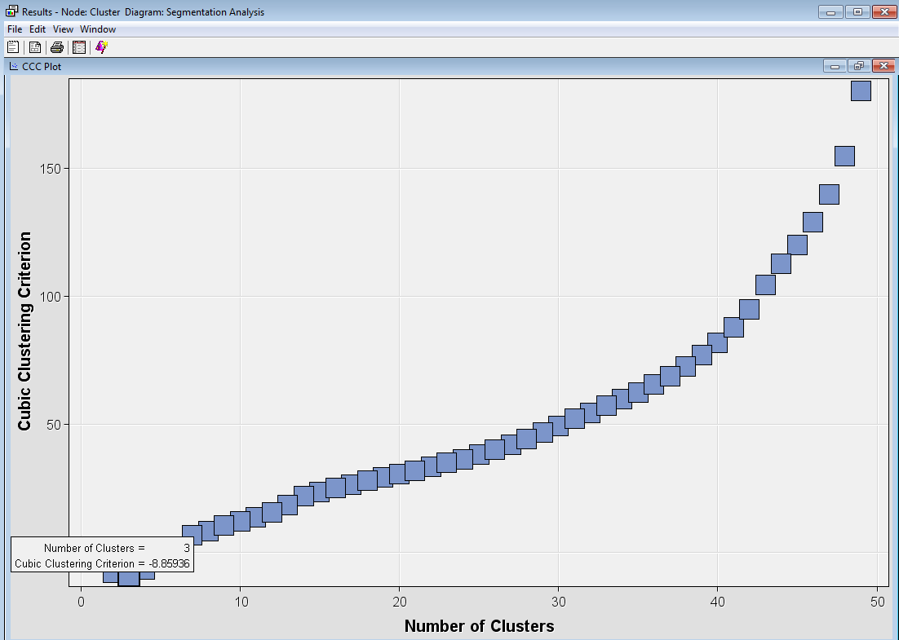

By selecting the view, Summary Statistics, CCC Plot window indicates the smallest number of clusters is three. Therefore, the optimal number of clusters is 3.

For the model with the optimal number of clusters, list the variables that were found important in determining the clusters?
As the optimal number of cluster is 3, the setting properties is changed by changing the specification method to User Specify and setting 3 for the Maximum Number of Cluster.
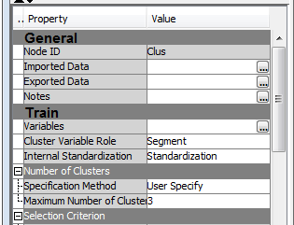
After running the model, then selecting the Variable Importance Window. There are three important variables which are SEDAN, HATCH, and WAGON. The value of importance indicates that SEDAN is the most important variable then followed by HATCH and WAGON.
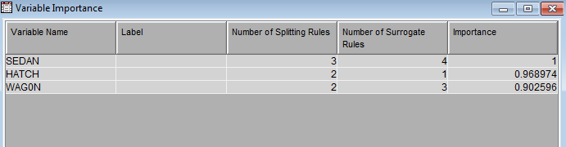

C. Explain the cluster result screen
The cluster result screen window shows four embedded windows: Segment Plot, Mean Statistics, Segment Size and Output.
- Segment Plot Window: this window show the distribution of each input variable including HATCH, SEDAN and WAGON in three clusters.
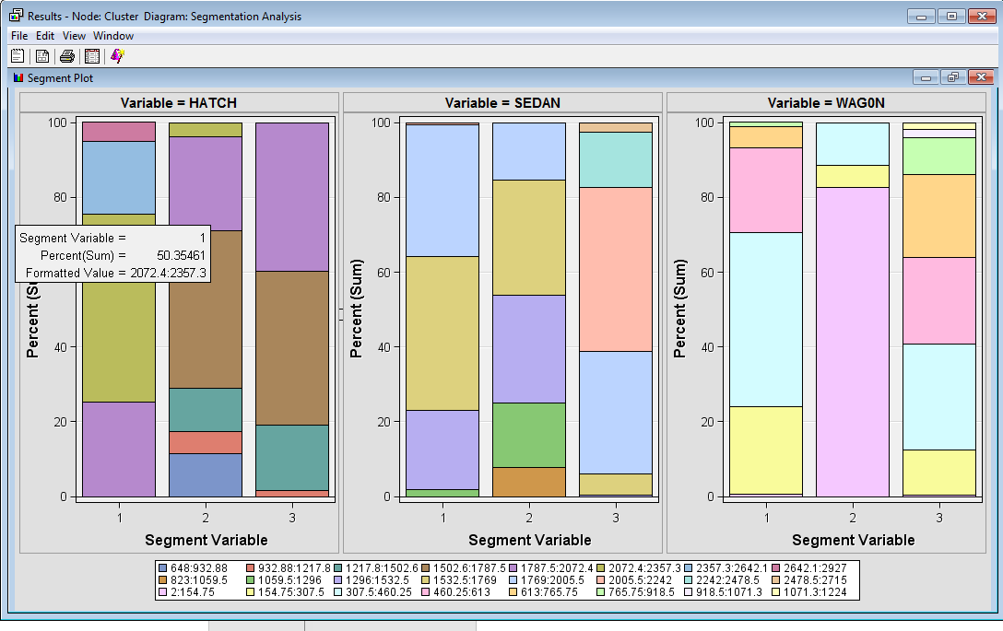
Segment variable 1 means the distribution of the mean for each variable in cluster 1. For Hatch, the proportion of distribution in cluster 1 is nearly 5% of the HATCH is from 2642.1 to 2927, 20% of it from 2357.3 to 2642.1, 50% of it from 2072.4 to 2357.3, and 25% of it from 1787.5 to 2072.4. Therefore, the majority sale value for HATCH is around 2072.4 to 2357.3. The similar format explanation can be utilised for the rest of segment variable and variables.
Additionally, for cluster 1, the majority sale value for HATCH is high from 2072.4 to 2357.3, the value for SEDAN is medium from 1532.5 to 1769 and the value for WAGON is medium from 307.5 to 460.25.
For cluster 2, the majority sale value for HATCH is low to medium from 1502.6 to 1787.5, the value for SEDAN is diverse from 823 to 2005.5 within low to medium and the value for WAGON is low from 2 to 154.75.
For cluster 3, the majority sale value for HATCH is high from 1502.6 to 2072.4, the value for SEDAN is diverse from 1532.5 to 2715 within medium to high and the value for WAGON is diverse within low to medium.
Therefore, the difference between cluster 1 and 2 is the sale value for HATCH and WAGON. The difference between cluster 2 and 3 is the value for SEDAN and WAGON. The difference between cluster 1 and 3 is HATCH and SEDAN.
- Mean Statistics: it illustrates various descriptive statistics among 3 clusters. The three segments are indicated by the Segment Id from 1 to 3 with the frequency of Clusters at 282, 52 and 319 respectively. The maximum distance from cluster seed indicates the largest distance between an element in one cluster and an element in the other. The distance to nearest clusters points out the smallest distance between an element in one cluster and an element in the other.
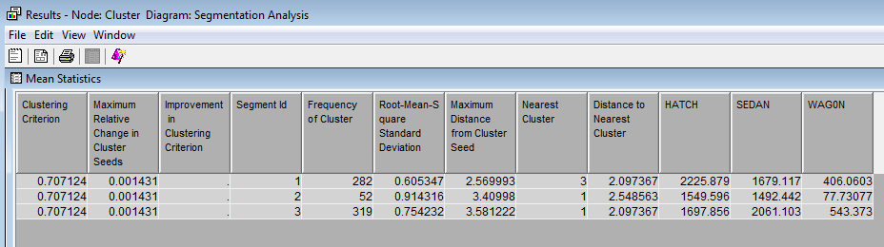
- Segment Size: it shows a pie chart to describe the size of each cluster formed. This pie char has been divided into three parts according to the frequency of cluster in each segment. The segment 3 has the largest part, as it has the largest frequency at 319. Conversely, the segment 2 is recorded at the smallest, at 52.
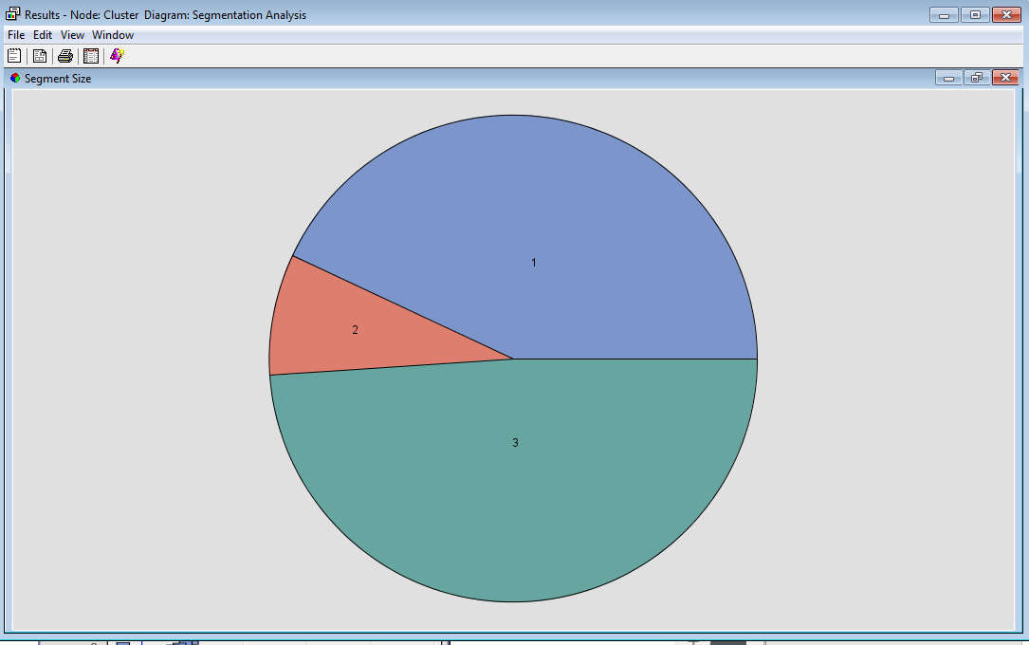
- The output window: shows the output of various SAS procedures run by the Cluster node. The variable summary summarises the variables in this model, which are 1 ID, 3 Input variables and 4 variables which have been rejected. The variable importance section shows SEDAN is the most important variable, then it followed by HATCH. Conversely, WAGON is the least important variable.
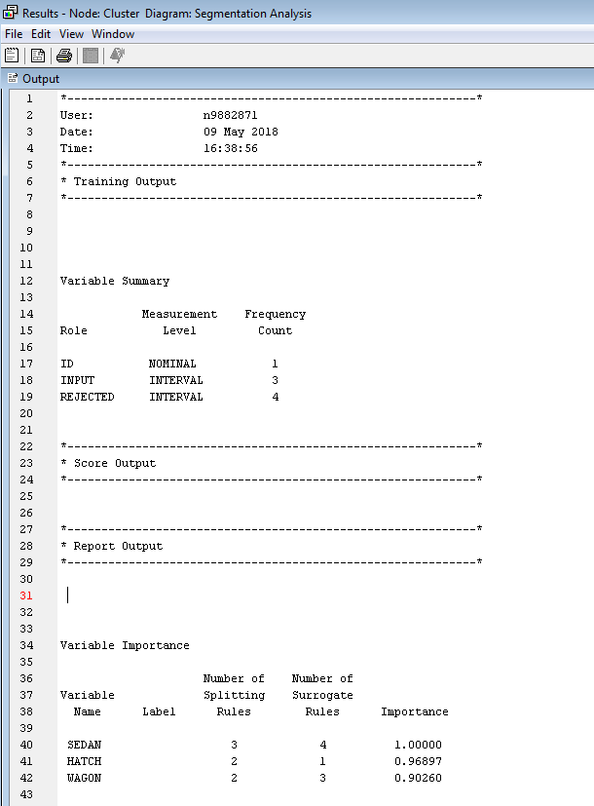

What is the effect of using the standardization method on the model above? Does the variable normalization process enable a better clustering solution? If it does not, disable the option for rest of the models.
In the default model in the previous sector, Standardization has already set as the internal standardization, which allows distances between points are calculated based on standardized measurements. Under this model, the CCC Plot indicates that the minimum number of cluster is 3 with Cubic Clustering Criterion at -8.85936.
Another way to standardize an input is by subtracting the input’s minimum values and dividing by the input’s range, which is known as range standardization to rescales the distribution of each input to the unit interval [0,1]. After running this model, the CCC Plot shows the minimum number of cluster is 4. This indicates that the standardization perform a better clustering solution than the range method.
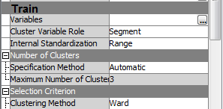
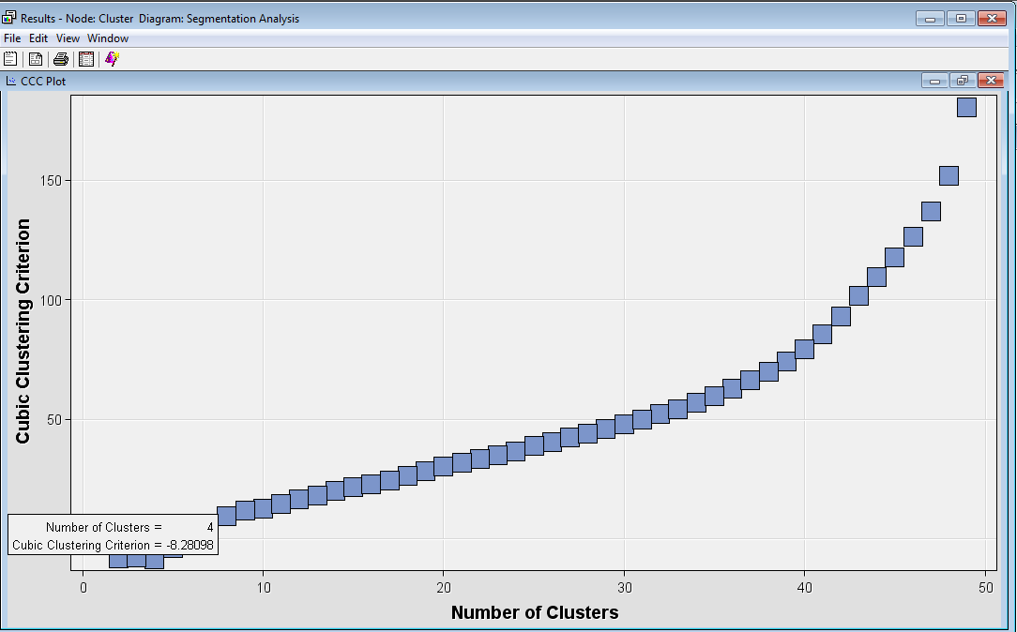

Finally, comparing the standardization with none method. After running this model, the CCC Plot shows the minimum number of cluster is 4. Therefore, the standardization performs a best clustering solution and this method is kept for the rest of the models.
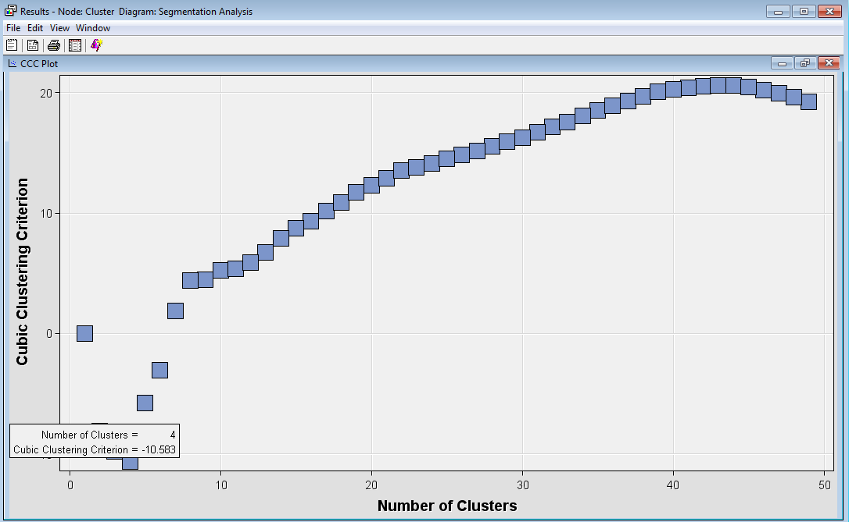

Using the Graph wizard, interpret the (best out of 2.1 and 2.2) cluster analysis outcome.

The Graph wizard can aid in interpreting the cluster analysis. Setting X, Y and Z for HATCH, SEDAN and WGON. The red, blue and grey colour have been utilised to represent different clusters.
The red cluster: It indicates the stores which have the medium to high sales of SEDAN, low to medium sales of HATCH and low to medium sales of WAGON. Therefore, this kind of store should focus on promoting advertising about the sales of HATCH and WAGON.
The blue cluster: It represents the stores which have medium to high sales of SEDAN, high sales of HATCH and low to medium sales of WAGON. In this case, this kind of stores should focus on promoting advertising about the sales of SEDAN and WAGON.
The grey cluster: The stores have low to medium sales of SEDAN, low to medium sales of HATCH and low to medium sales of WAGON. Hence, the stores should enhance advertising about the three types of cars.
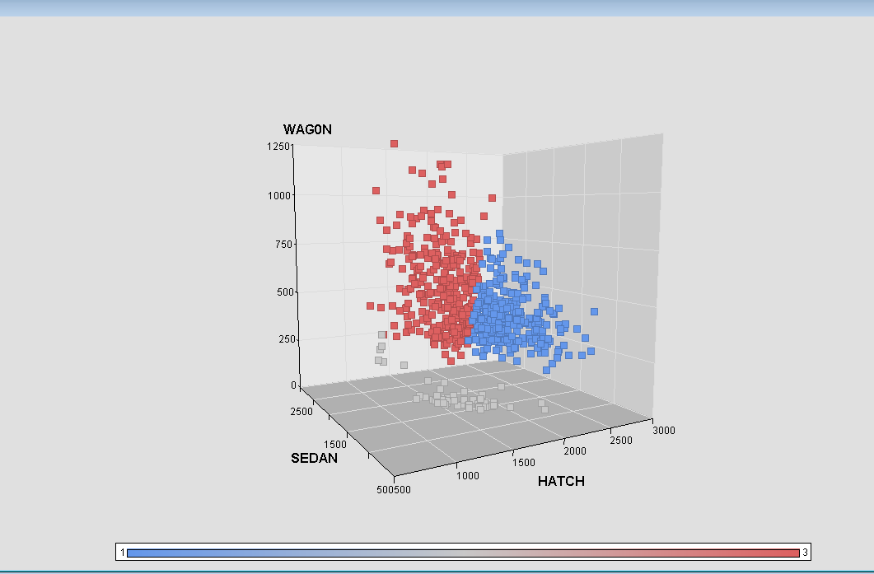

Using the Segment Profile node, interpret the cluster analysis outcome.
As other variables such as DEALER_CODE and LOCATION_NUM are not important, they will not be utilised in the analysis.
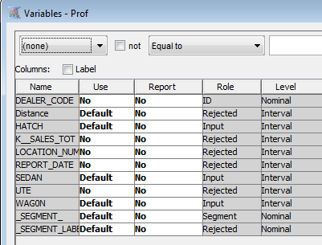
The result of using the segment profile node based on the optimal model with the standardization matched with the conclusions were drew before.
For the profile of segment window: the red bars indicate the total distribution of HATCH, SEDAN and WAGON with a normal distribution, whereas the blue bars are the cluster distribution of these three model cars with a skewed normal distribution. Therefore, a comparison between the distributions of the clusters and all data can be observed.
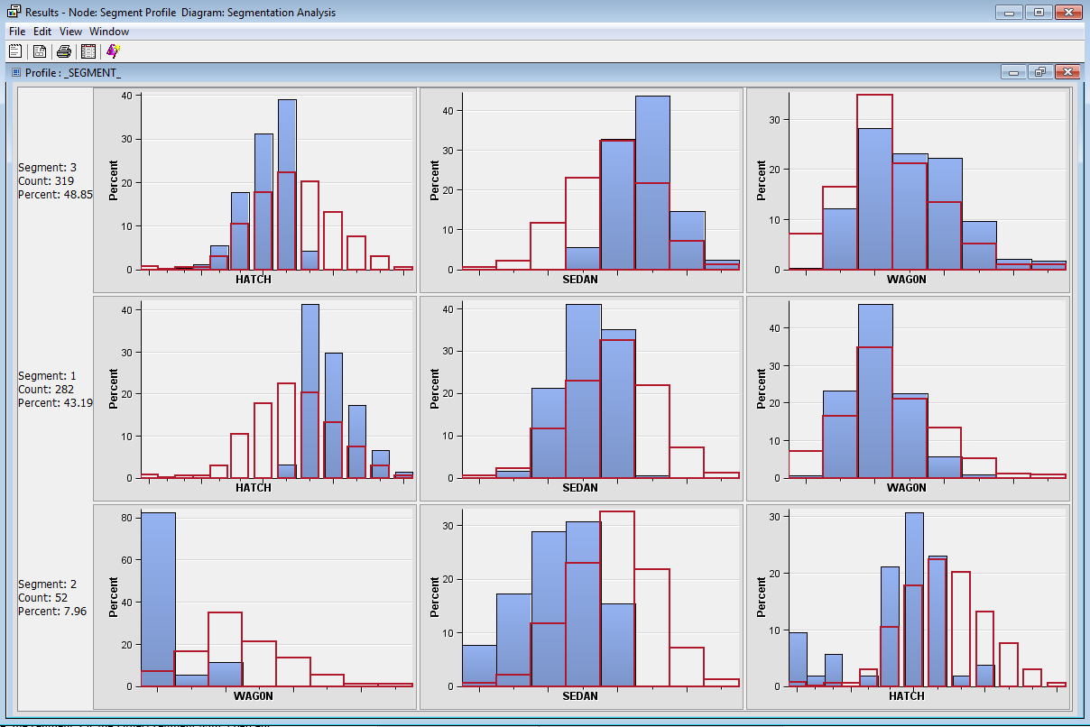
For the Variable Worth:_SEGMENT_window: This shows the relative worth of each variable in characterizing each segment. For instance, segment 3 is largely characterized by the HATCH input, then it was followed by SEDAN and WAGON respectively.
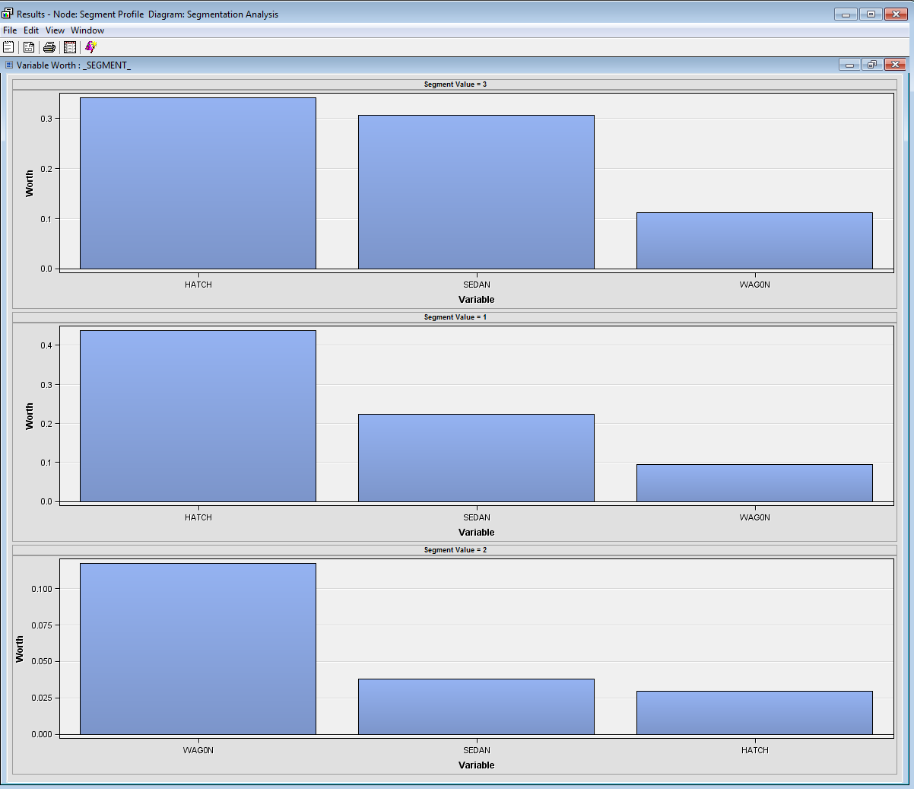
To sum up:
Segment or Cluster 3: This is the largest segment with a total frequency at 48.8515%. There are three variables that are important in this segment namely HATCH, SEDAN and WAGON. In comparison to the overall distributions, Segment 3 has a lower HATCH, higher SEDAN, and a slight higher WAGON. The most important variable in this segment is HATCH. SEDAN is the second important variable and has worth close to the HATCH. In this case, the HATCH and SEDAN is the popular cars in the segment. This segment can represent store having high sales of HATCH, medium to high sale of SEDAN, and low to medium sales of WAGON. Segment or Cluster 1: This is the second large segment with a total frequency at 43.19%. It has the best sales of HATCH. For the segment 2, it only accounted for 7.96% and the worth value for all the variable < 0.1 or near equal, which indicates this segment cannot generate a meaningful result.

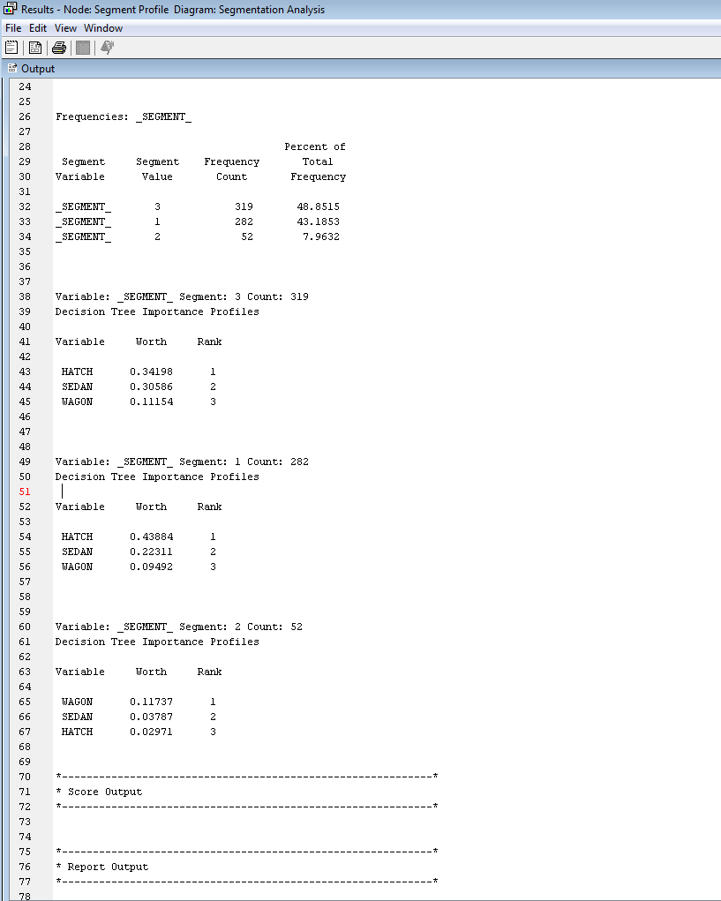

Task 3. Refining the clustering model

Refine the best cluster model built in the previous step by adjusting the number of clusters (deleting or adding one or two additional cluster) in order to test small changes to the number of clusters. Evaluate the result.

During the previous step, the optimal model is used standardization method and three clusters. The following section will use two clusters and four clusters to perform the test.
Two clusters model: the model is divided into two major clusters. This model cannot provide and identify useful information, as the data tend to merge with each other and one of the cluster is extreme large with 601 frequency compared with the small one at 52.

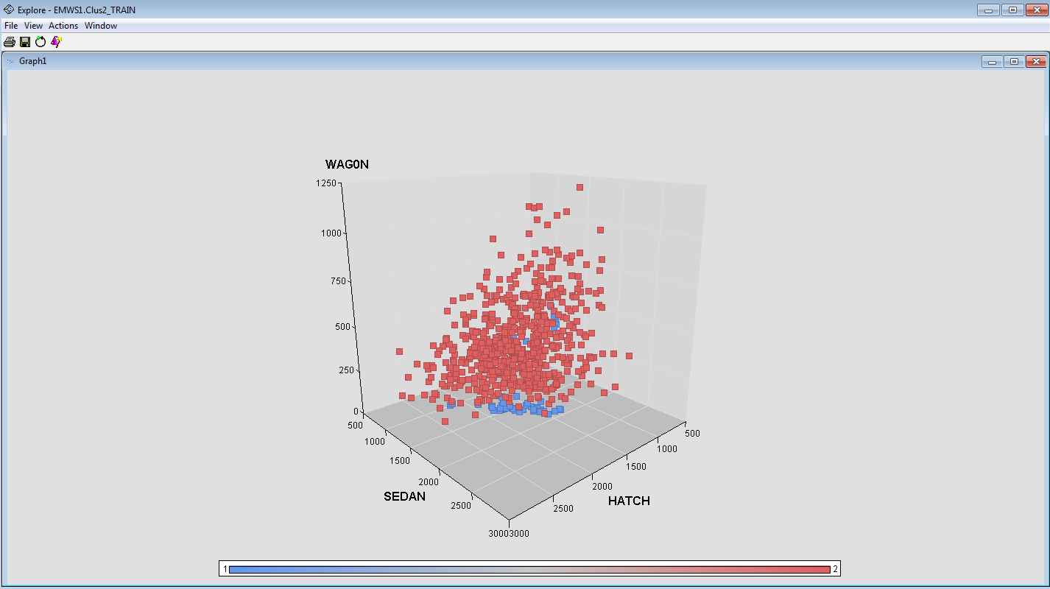
Four clusters model: this model provides a better result. It divided the largest cluster in two clusters model into three smaller cluster, which enables to identify a trend of the car sales and present a clear result.
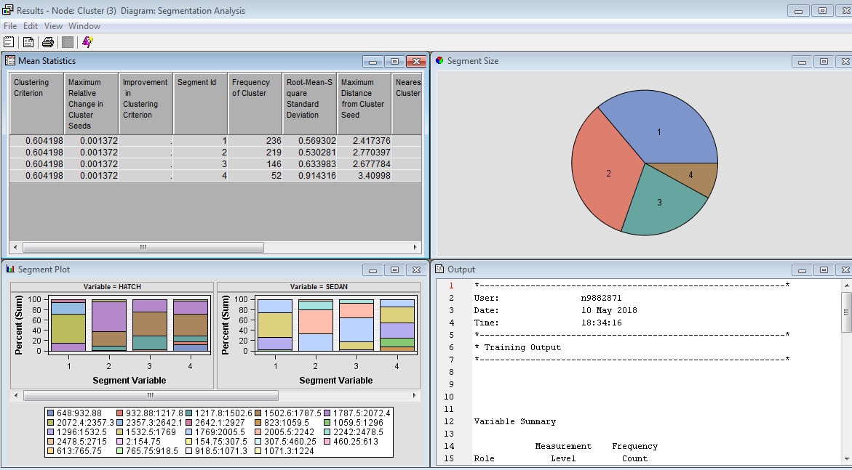
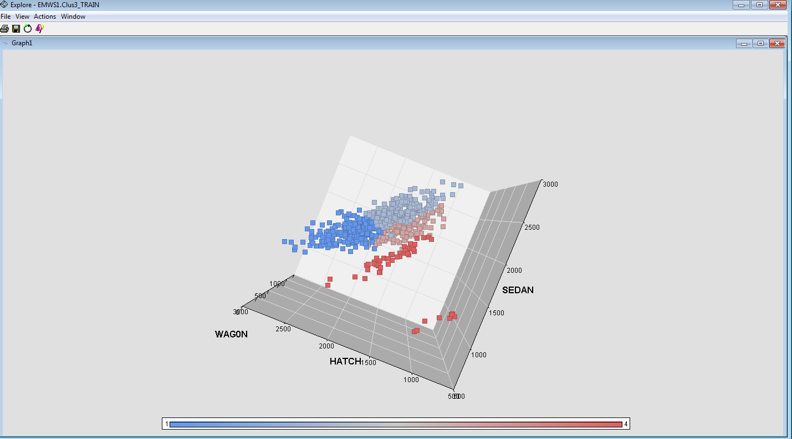
Additionally, the profile of segments for 4 clusters offer a more clear demonstration and result. Therefore, the best cluster model is 4 clusters model.
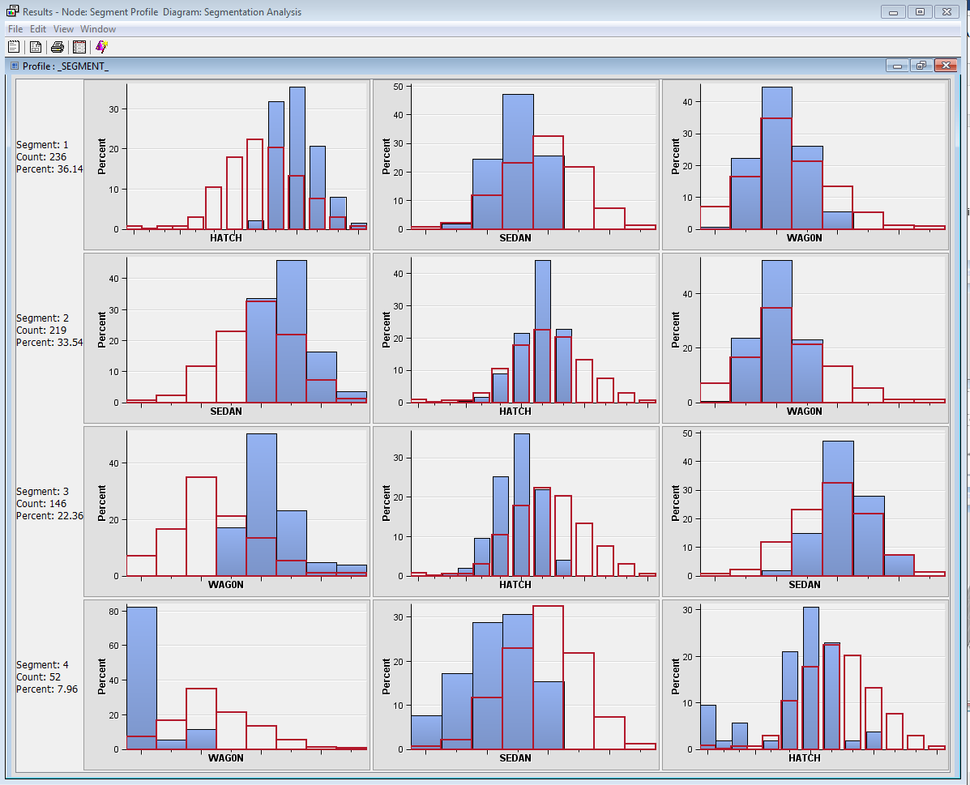

What is the best number of clusters that can describe the dataset effectively? Was this obtained with the default setting (i.e. the automated SAS process) or manually specifying a clustering number?
The best number of clusters that can describe the dataset effectively is four. This is obtained with the manually specifying a clustering number.

How the outcome of this study can be used by decision makers?
By utilising the outcome of this study, the users can understand the sales distribution of three types of cars among stores. For example, the decision makers can know the highest sales type of the car in a store and the lowest sales type. Then, the store allocate more funds to promote the lowest sales types of cars to pursue further promotion. They also can utilise this kind of information to manage their stocks, as they should store more of highest sales type of cars in order to meet the high demand.

Part 2: Association Mining the Supermarket Data

Task 4. Association Mining

Can you identify data quality issues in this dataset for performing association analysis?

By exploring this dataset, it indicates that there are no data quality issues for performing association analysis, as there are no missing values in the dataset. Additionally, the minimum and maximum value for all non-class variables are appropriate, which means there are no errors and outlier values in this dataset.
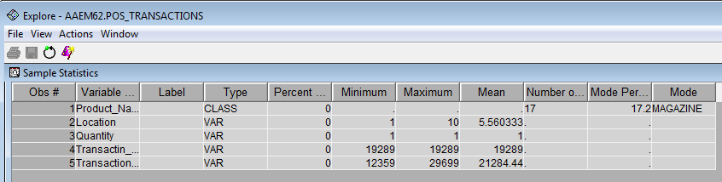

What variables did you include in the analysis and what were their roles and measurement level set? Justify your choice.

Location: This variable should be rejected, as this data is shown as point of sale device identification number from 1 to 10 which means it cannot indicate which store and location it belongs to. This variable is useless.
Product _Name: This task aims to determine the associations between items purchased form the supermarket. This variable is used to represent the various products purchased from shops and should be set as target variable.
Quality: the quality was recorded as 1 for the entire dataset. Hence, it should be set as rejected.
Transactin_Date: This variable shows the data of transaction, which does not any association rules with the type of purchased product. This variable should be rejected.
Transaction_ID: This is the unique transaction identification number for a given sale and each transaction. This should be considered as nominal variable and be set as the ID.
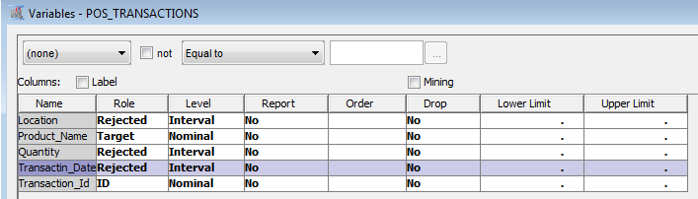

Conduct association mining and answer the following:

What is the highest lift value for the resulting rules? Which rule has this value?

The rules table indicates that the highest lift value for the resulting rules is 3.60, and the following rules have this value:
- Perfume ==> Toothbrush
- Toothbrush ==> Perfume
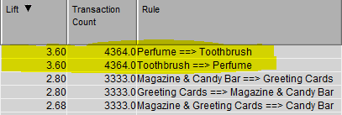

What is the highest confidence value for the resulting rules? Which rule has this value?

By ranking the Confidence in the Rules Table, it shows that the highest value of the confidence is 45.86. The rule Magazine & Greeting Cards ==> Candy Bar has this value.

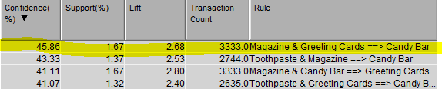

Discuss each of the result node windows – Statistics Plot, Statistics Line Plot, Rule Matrix, and Output – succinctly? Interpret them to discuss the rule-set obtained.

Statistics Plot: clicking on a point or rule offers a dialog box with information about the rule which are the confidence, support, relation and rule. For instance: the rightest point shows the information in the graph. We can see the relative item number equals to three generally have higher confidence value than two items. On the other hand, the rule number equal to 2 are basically got higher support value than three items.

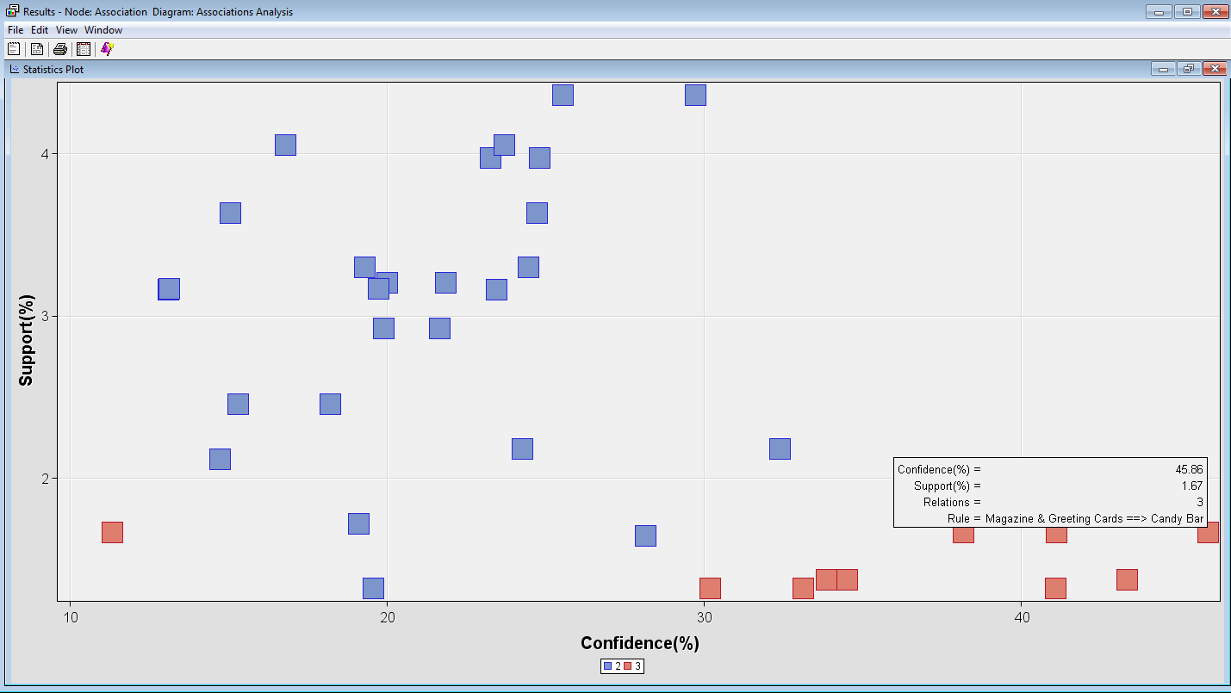
Statistics Line Plot: It graphs the lift, expected confidence, confidence, and support for each of the rules by rule index number. For example: the life of the rule 5 is 2.68. We discovered that rule 4 has the lowest expected confidence (4.05%) and confidence value(11.35%), which means customers who bought greeting cards has a low percentage bought the magazine and candy bar. On the other hand, the rule 5 has the highest confidence value, which means people who bought magazine and greeting card has a high percentage(45.86%) bought candy bar as well.
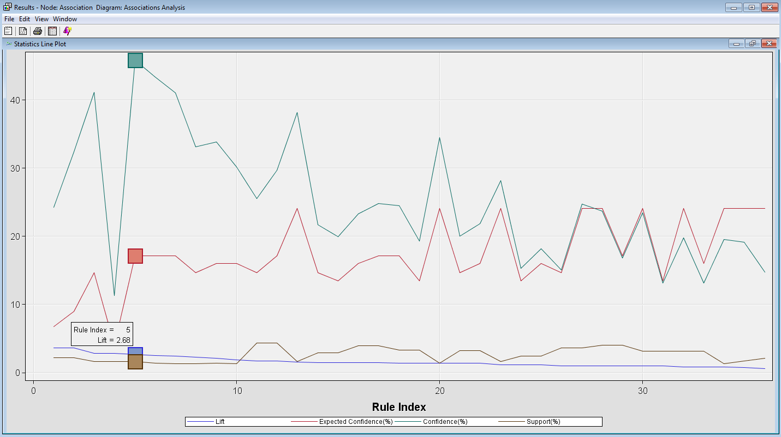
Rule Matrix: It plots the rules according to the items on the left side of the rule and the items on the right side of the rule. Additionally, the points are colored based on the confidence of the rules. For example, the red point in the middle illustrates it generates both sides and has a confidence of 41.07.
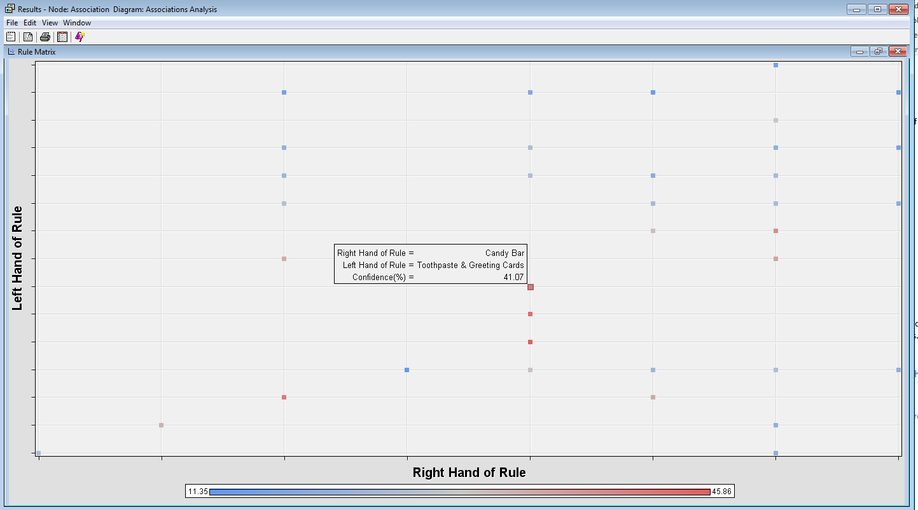

Output: it provides an overall report with all the detailed information.

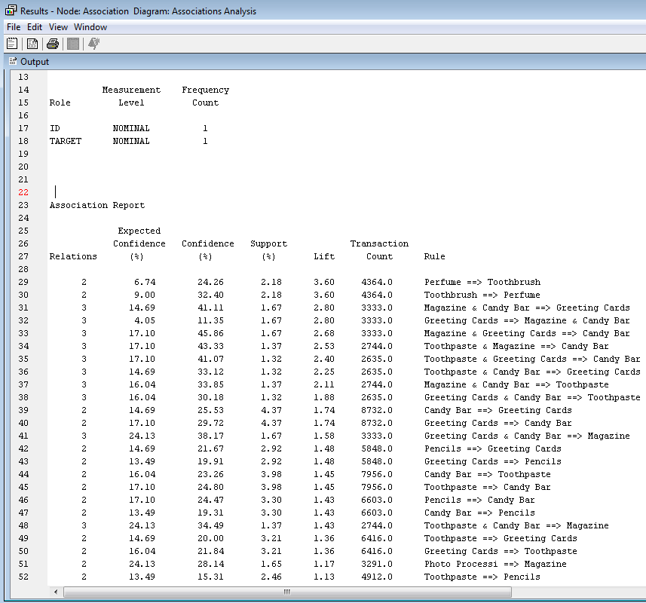

The store is particularly interested in products that individuals purchase when they buy “Pens”.

How many rules are in the subset?
Only one rule in the subset contains pens, which is “Pens ==>Maganize”.
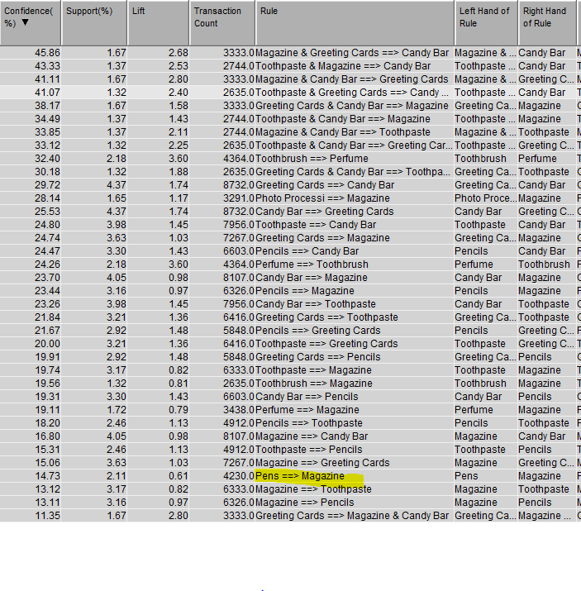

Based on the rules, what are the other products these individuals are most likely to purchase?
According to the rule, individuals who purchase Pens are more likely to purchase Magazine.

How the outcome of this study can be used by decision makers?
The decision makers can utilise the outcome of this study to analyse the purchase behaviours of customers. Then, they can use these results to make appropriate marketing decisions. Generally, if Lift = 2 for the rule A => B, then a customer having A is twice more likely to have B than a customer chosen at random. For instance, this study illustrates that customers purchasing perfume is 3.6 times more likely to purchase toothbrush than a customer chosen at random. In this case, the decision maker should put these two products together to boost the sales and more convenient for customers to pick up their products.

Part 3: Text Mining (Clustering) the News Stories

Task 5.Text Mining

What variables did you include in the analysis and what were their roles and measurement level set? Justify your choice.
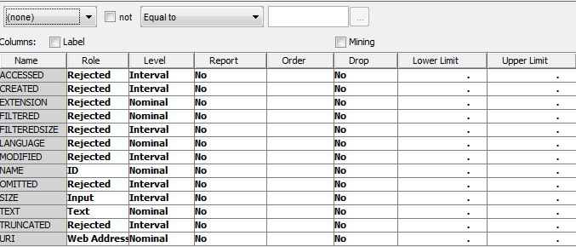
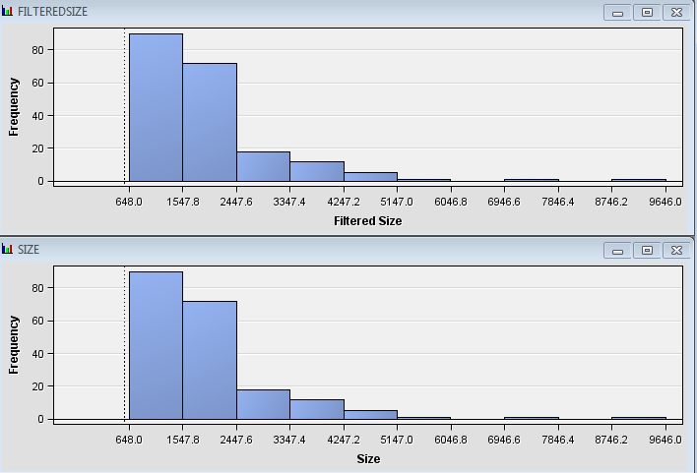
- NAME: This is a nominal variable and set to be ID, as it contains unique information for all the instances.
- SIZE: This is an interval variable and is set to input, as it is utilised as data structure information in the text mining.
- URI: This is a nominal variable and is set to web address to point to the web files.
- TEXT: This is a nominal variable and is set to text, as it included the text used for text mining.
- FILTERREDSIZE: This variable should be rejected, as it contains the same data as the SIZE.
- The rest of variables which are ACCESSED, CREATED, EXTENSION, LANGUAGE, OMITTEM and TRUNCATED should be rejected, as they are irrelevant to this analysis.

Can you identify data quality issues in order to perform text mining?
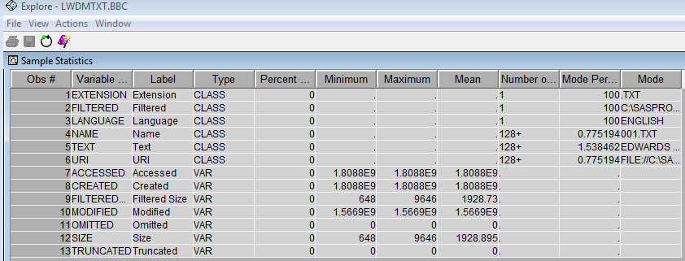
There is no data quality issues, as there is no missing values. Additionally, the minimum and maximum value of the SIZE indicates no errors. For the rejected variable, they have been removed from this analysis.

Based on the ZIPE plot, list the top 10 terms that will be least useful for clustering purpose.
By ranking the number of Docs, users can identify the least useful term for clustering purpose. Generally, the maximum ranking are terms which only exist in few documents and this is of no benefit in clustering documents. At the other end of the scale, the terms appears too frequently in documents to be of benefit. The table of the ZIPE Plot provides more detail information. The top 10 least useful terms are +be, s, + have, +say, +not, +win, +year, +do, +go, +take.
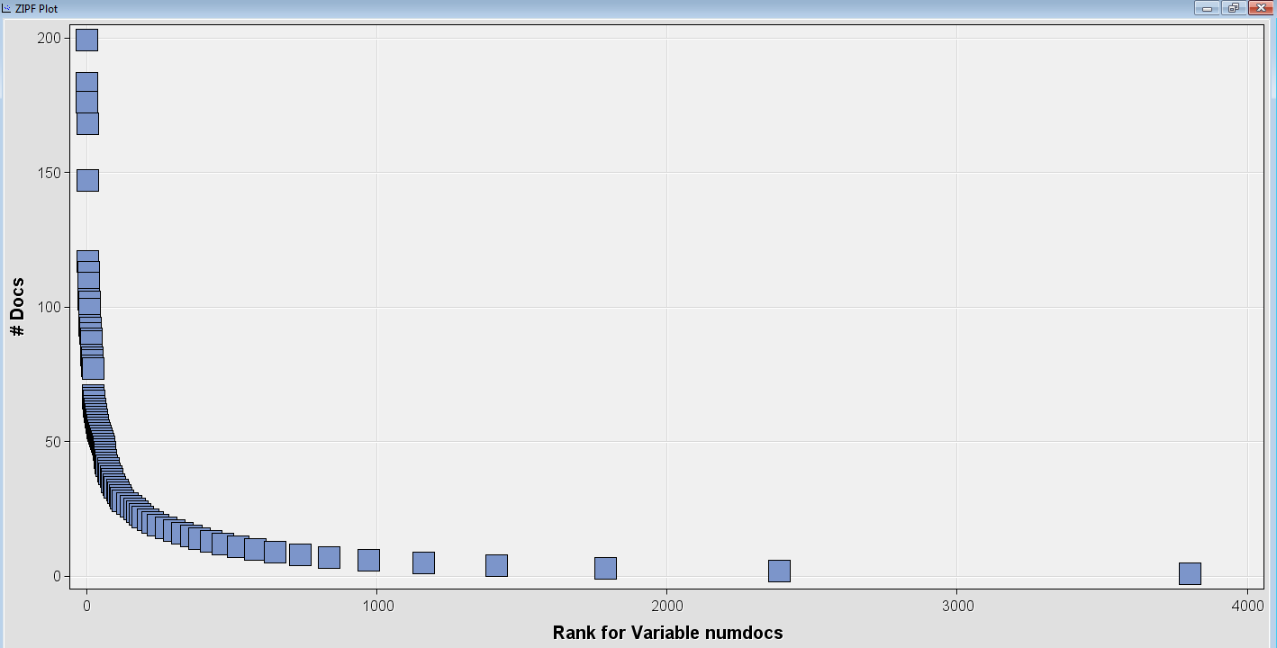
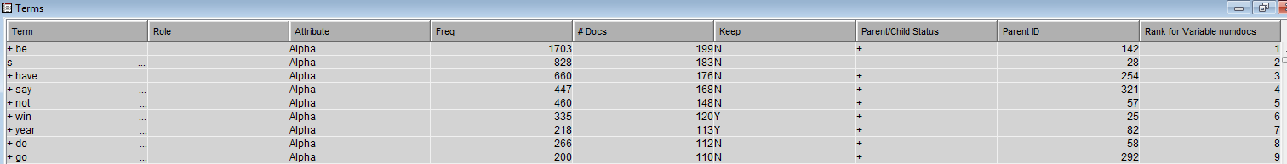

Did you disregard any frequent terms in addition to automatically selected by the Filter tool?
No, we did not. The filter tool has automatically drop all the terms with zero weight.
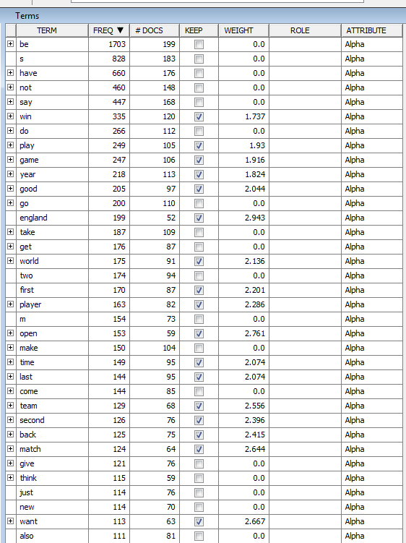

Justify the term weighting option selected.
The Inverse Document Frequency is chose for the weighting option, as if the term’s appearance increases in the different documents, its weight could increase. Conversely, if the term’s frequency increases in the collection of the documents, its weight could decrease. This can produce better results.
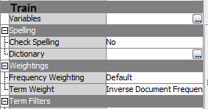

What is the number of input features available to execute clustering? (For information: Note how the original text data is now converted into a feature set that can be mined for knowledge discovery?)

The number of input features available to execute clustering is the number of inputs kept after executing the text filtering. In this case, there are 1565 input features that are kept to be mined for knowledge discovery.
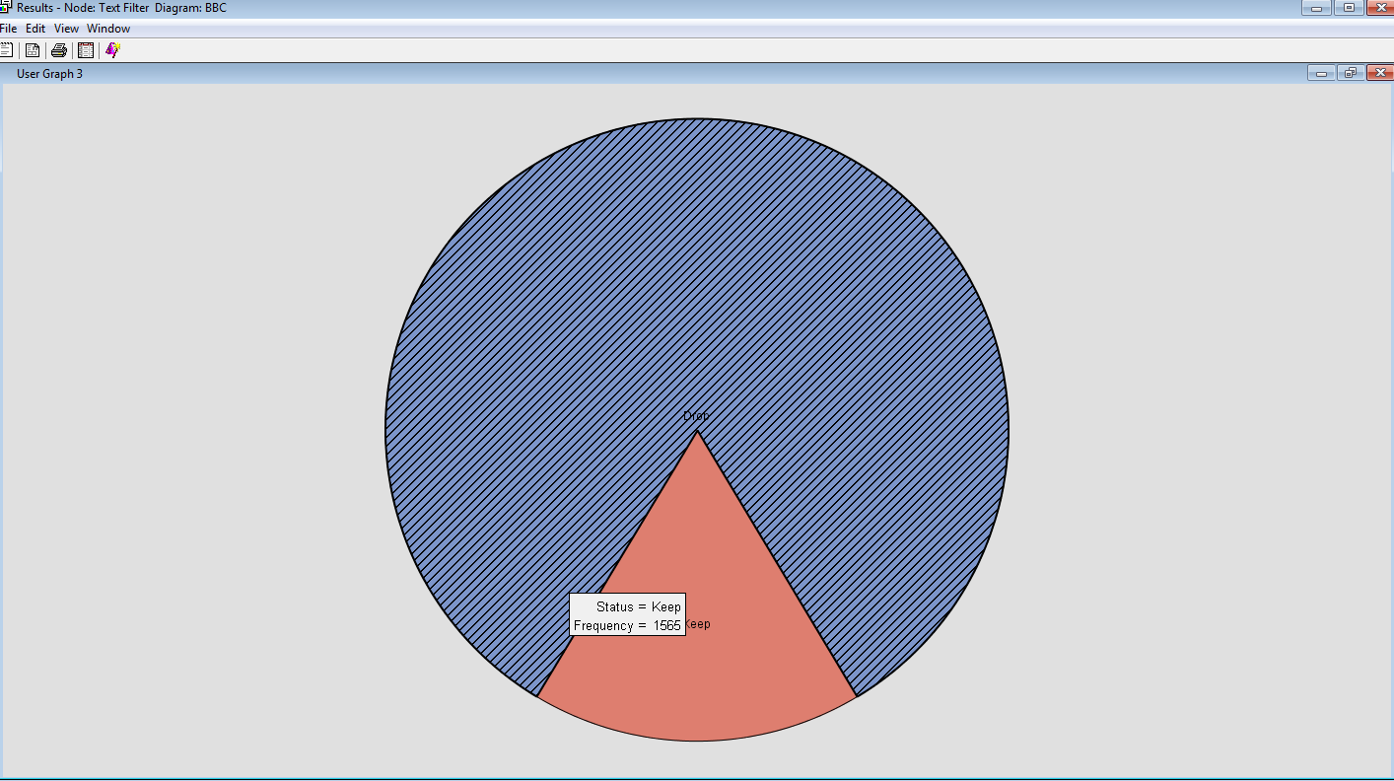

State how many clusters are generated? Name each cluster meaningfully according to the terms that appear in the clutters?
Both of the Expectation-Maximization algorithm and the Hierarchical clustering generate four clusters.
For the Expectation-Maximization algorithm, the names of clusters are injury, rank, decision, and competition.
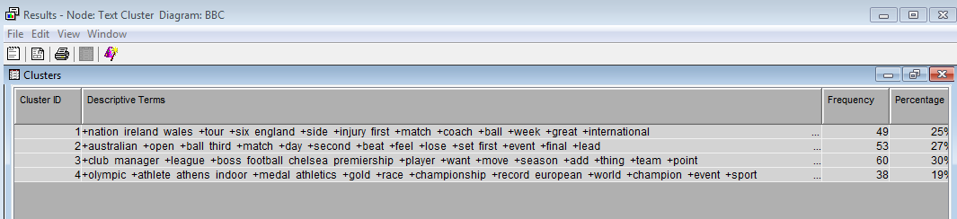
For the Hierarchical clustering approach, the names of the clusters are team, match, player and cricket.
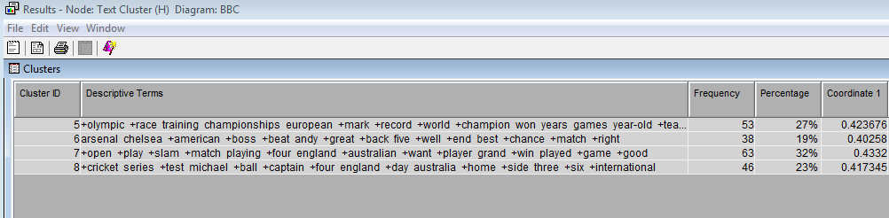

Identify the first fifteen high frequent terms (that are not stop words or noise) in the start list?
There is not elements in the start list.
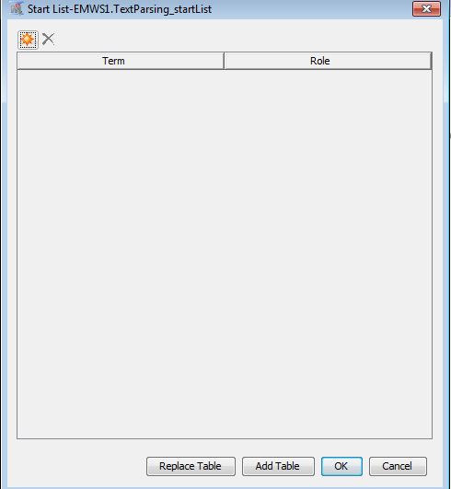

Describe how these clusters can be useful in the online personalised news story service planned.
These clusters can assist users to select specific stories they prefer to see in the online personalised news story. Within a selected cluster, users can acquire and identify the stories related to the topic or content. For instance, if the user want to learn the news and story about a player, this user could choose the player and all the stories shown are about this player, which can assist user to filter information.

Part 4: Web Mining the Log Data for a Website

1. For each data mining operation:

a. Rationale behind selecting the method.
A variety of data mining operations including clustering, sequence analysis and link analysis can be implemented on the pre-processed data set and the results can be analysed. For this assignment, the association and sequential pattern will be used.
Association Mining: this method is more appropriate for this assignment, as the task is to determine the patterns of users browsing the website. In this case, this method can assist the owner to discover interesting usage patterns and discover usages dependencies among sets of page references across transactions, without knowing the attributes of the website. To be specific, if a user clicks and visits a page or link in this website, the association rules based on the weblog data can identify the most popular access path the users could use and provide the highly associated pages to this user. Therefore, association mining can be utilised to identify the dependencies among page references.
Sequential Pattern: This web log data contains timestamp, which means this approach could be utilised to discover and identify the navigations between pages. It is also noticeable that this method has advantage in predicting and pre-fetching the popular pages, which can provide convenient usage for users by reducing the navigation.

b. What variables did you include in the analysis and what were their roles and measurement level set? Justify your choice.
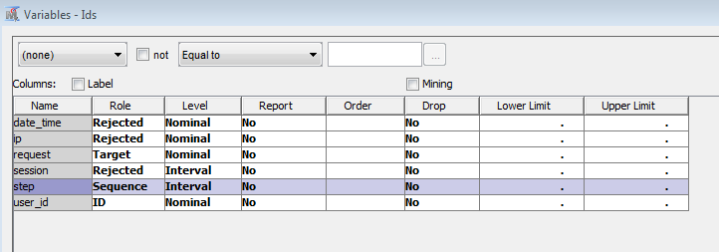
date_time and ip: these two variables should be rejected, as they do not make contribution to the analysis and are irrelevant data.
request: This variable display and illustrate the relevant page visited and requested by the users. The analysis is performed based on this variable. Therefore, this variable should be set as target variable and measured as nominal.
Session: is the id variable. Since user_id is used as the ID, this variable is redundant and should be rejected.
Step: this variable can add time concepts to the analysis, as it describes the number of steps utilised from home page to a specific page. This measurement is interval.

Can you identify data quality issues in order to perform web mining?

There are some data quality issues in order to perform web mining. According to the graph below, there are several users have high steps but no request in the request variable. This type of data will be considered as outlier.

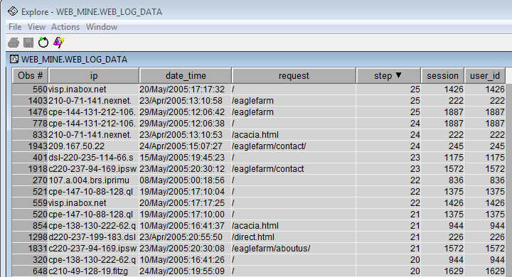
There are also many requests represent the same page, but the steps used to visit them are inconsistence.
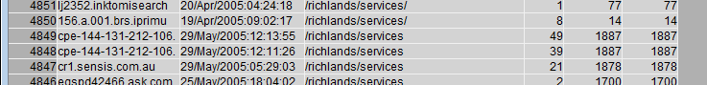
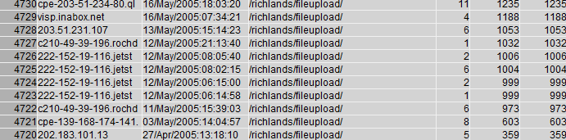

Discuss the results obtained. Discuss also the applicability of findings of the method. Should include a high-level managerial kind of discussion on the findings, should not be just interpretation of results as shown in results panel.
Association Mining:
By implementing the association mining, it indicates most of customers accessed the page of pricelist also visited the page of special. This result illustrates that the majority of customers prefer to purchase the products with a special price. Therefore, the owner could add more products with special prices in the pricelist to increase the sales of certain products.
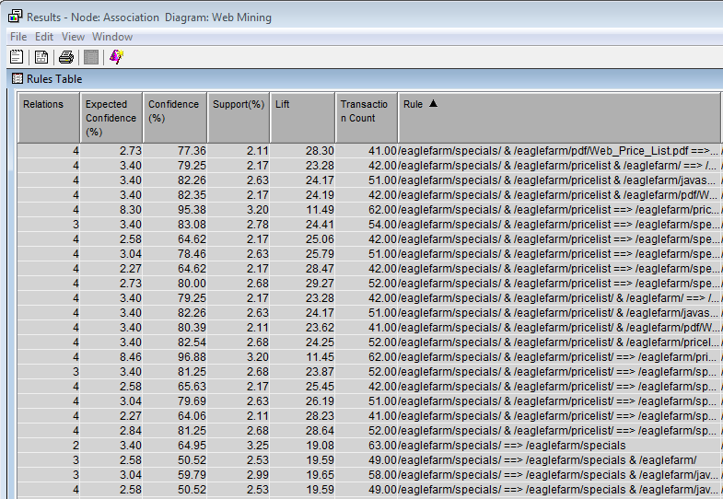
The result in the following table indicated that the majority of customers visited the page of menu also accessed the pricelist page. The owner should design the website by putting the menu and pricelist options in the same level which can improve efficient and allow users to easy find the information they need. In this case, it is the pricelist.
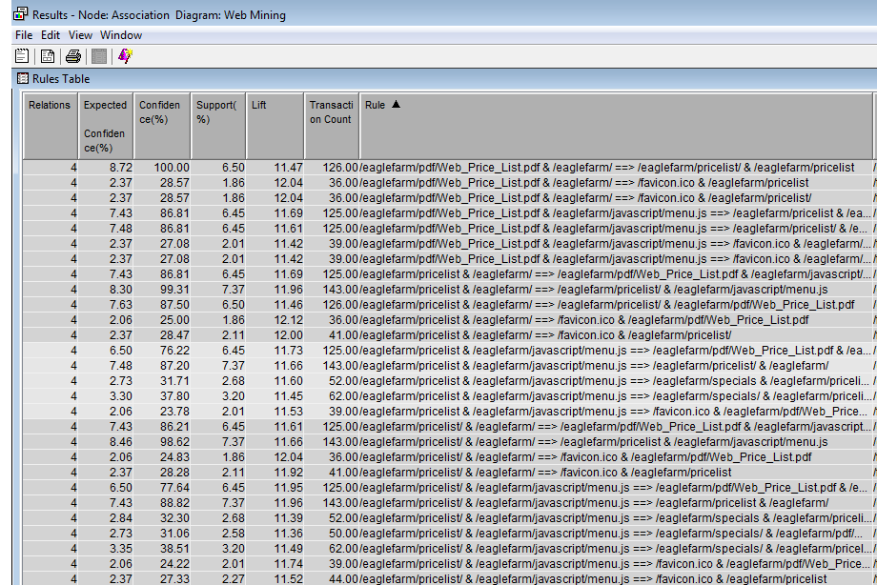

Sequential pattern:
The results of this method indicated that the majority of customers accessed the pricelist. However, many of them access the pricelist from the menu. In this case, the owner should add the pricelist into the home page to allow users to find this information easier.
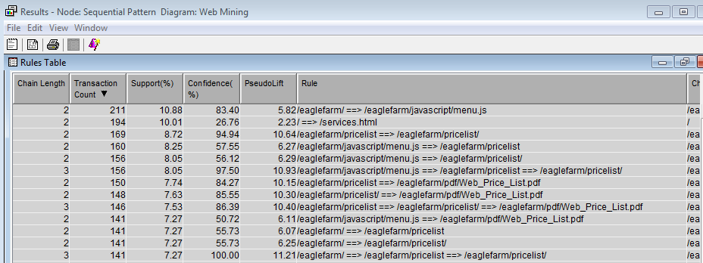

The result also illustrated that most of the customers chose to view the price list in pdf. The owner should make the pdf version easy to be discovered by the customer when they access the website.
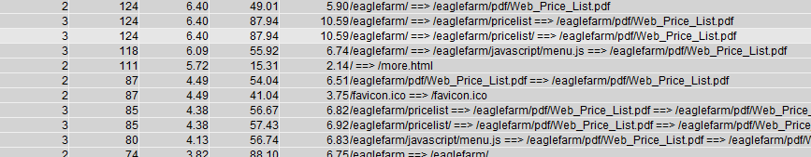

Appendix:

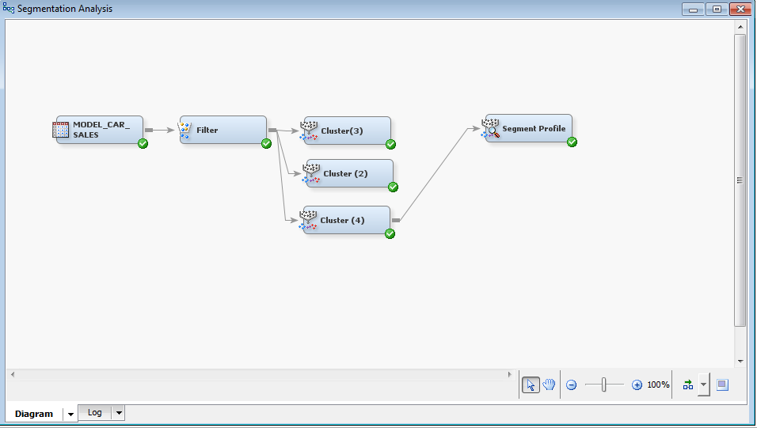
Clustering the Manufacturing Data
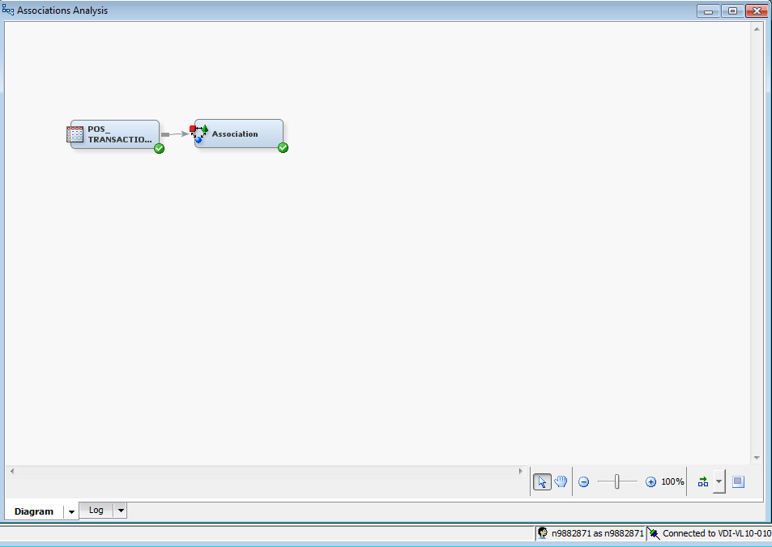

Association Mining
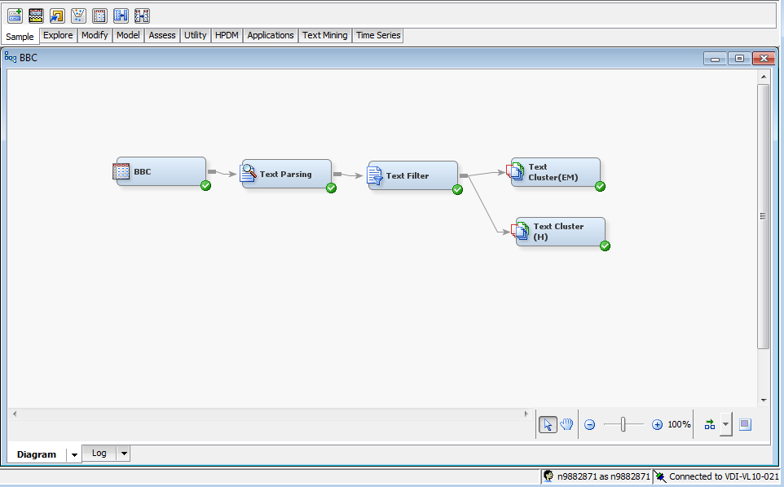
Text Mining

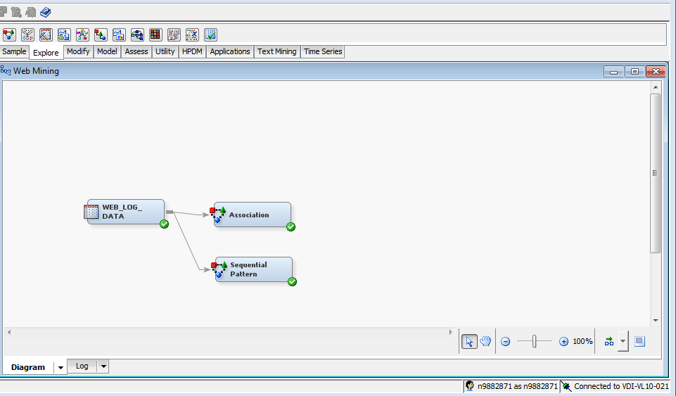
Web Mining

