

**Very Simple Rate Us**



**Thanks for your purchase.**

--------------------------------------------------------------------------------

--------------------------------------------------------------------------------

**Drag and drop the prefab “RateUsCanvas” in your scene:**

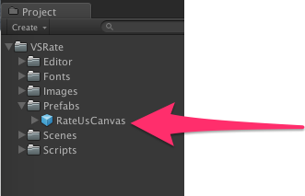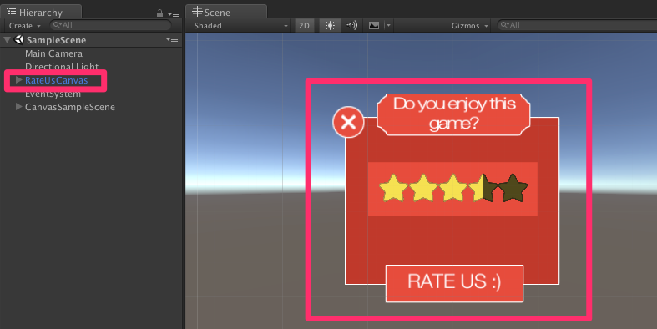

**Edit the link to redirect to the mobile app stores:**

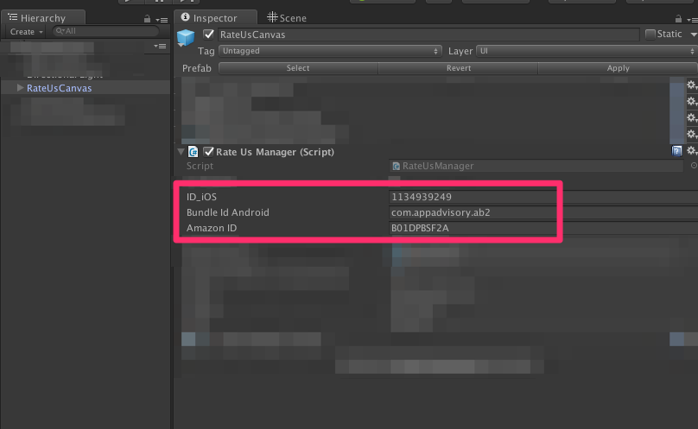

* iOS:

You can find the iOS id on iTunes Connect:

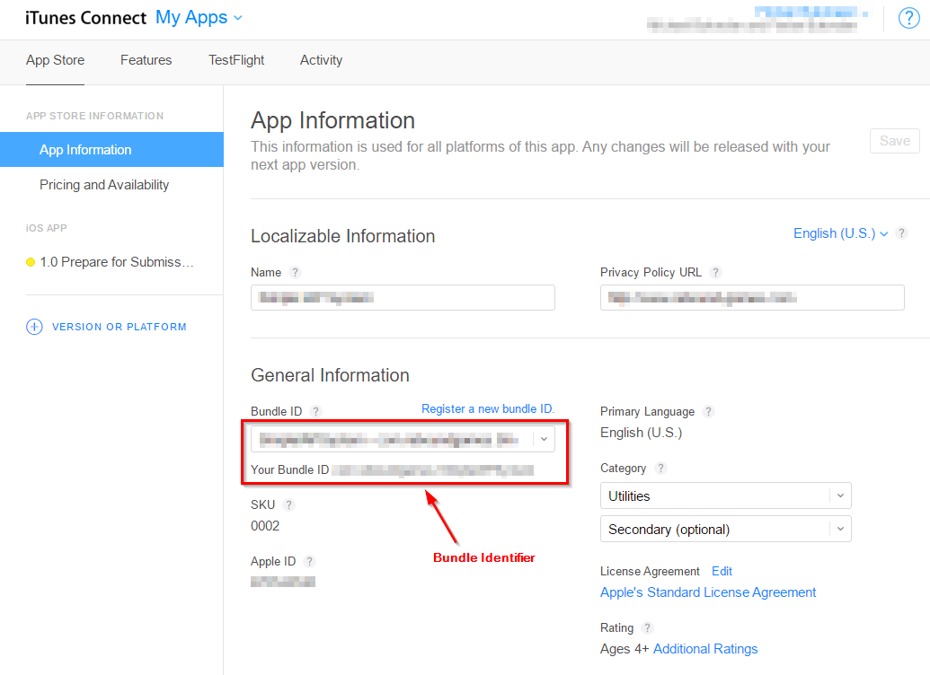

* Android:

It’s simply your bundle identifier of your app: com.company.name

* Amazon:

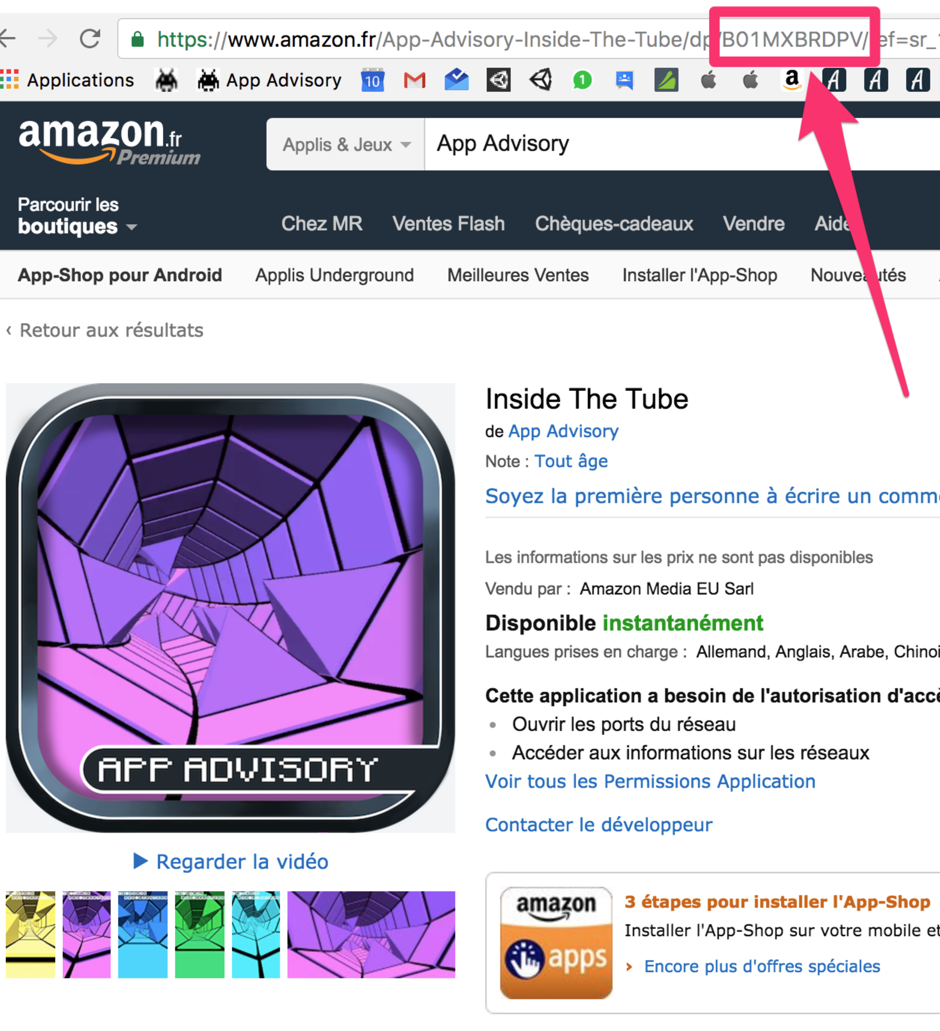

**How many stars do you want to redirect the player to the mobile app store?**

By default: 3.5 stars to display the “RATE US” button.

It means if the player rate the game in Very Simple rate Us 3.5 stars or more, we want to let him rated the game in the mobile app store.

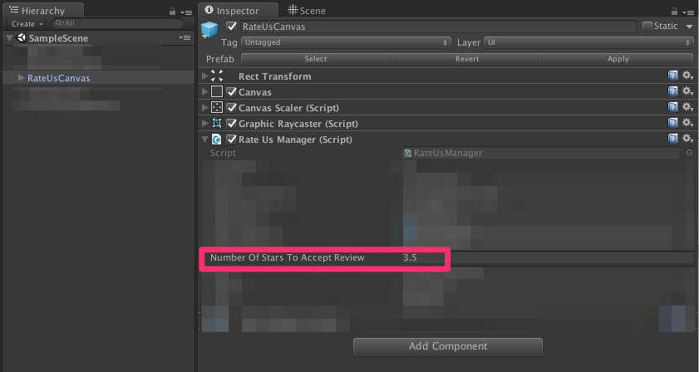

If the player rate us less than 3.5 stars (so the player is not happy!), we really don’t want to let him rated us on the app store. So we will display the button “Send Us An Email” who will open the default email client of the player.

For that, you have to change the default email, subject and body of the default email:

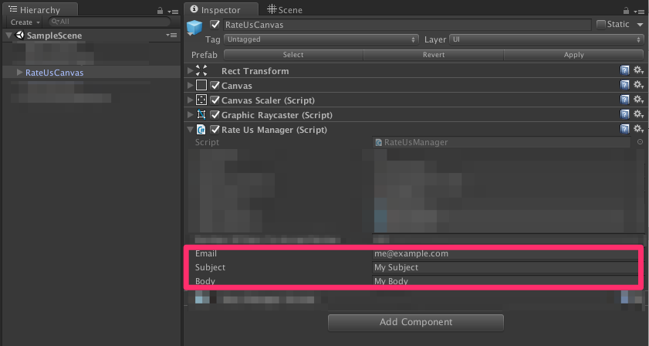

**To show the rate us window:**

RateUsManager.ShowRateUsWindows();

**To Hide it:**

RateUsManager.HideRateUsWindows();

**That’s it!**

Thanks!

Please rate my file, I’d appreciate it! <http://u3d.as/Dt2>

Produced by App Advisory - <http://app-advisory.com>

Facebook: <https://facebook.com/appadvisory>

Contact us: <https://appadvisory.zendesk.com/hc/en-us/requests/new>

App Advisory Unity Asset Store catalog: <http://u3d.as/9cs>

Developed by Gilbert Anthony Barouch - <https://www.linkedin.com/in/ganbarouch>

Inquiries: <https://appadvisory.zendesk.com/>

**Very Simple Ads:**

Everything is done for you: « Very Simple Ad » is already implemented.

Get it here:<http://u3d.as/oWD>

**Very Simple Leaderboard:**

Everything is done for you: « Very Simple Leaderboard » is already implemented.

Get it here:<http://u3d.as/qxf>

**Very Simple Share:**

Everything is done for you: « Very Simple Share » is already implemented.

Get it here:<http://u3d.as/u3N>

**Very Simple GIF:**

Everything is done for you: « Very Simple GIF » is already implemented.

Get it here:<http://u3d.as/ACQ>

