Machine-Learning-Guided Design of Random Copolymers that Enhance Enzyme Thermal Stability
251226 group discussion M1 Shunya Sudo
Research Objectives
Our objective is to engineer composition-optimized random copolymers that form a compliant, chaperone-like shell around enzymes—primarily glucose oxidase (GOx) and, additionally, β-Galactosidase (β-Gal)—to maximize thermal resistance without sacrificing native activity¹. To form such a shell, protein–polymer interactions should be “strong enough to favor adsorption yet soft enough not to outcompete the forces governing protein folding.” ¹ Because protein surfaces present chemical patches with characteristic length scales of ~1–2 nm, we prioritize controlling the statistical monomer distribution rather than the specific sequence in our polymer design¹.
Operationally, we explore a ternary MPC/MTAC/BMA space tailored to GOx and use active ML: “five iterations of a Learn–Design–Build–Test cycle” with an enzyme-specific GPR surrogate and Bayesian optimization of copolymers to propose high-performing candidates that “preserve, or even enhance, the activity” after heating².
We then generalize by substituting the hydrophobic unit (EHMA, LMA, MPTSSi) and leveraging Bayesian optimization as a proven alternative to high-throughput screening in polymer composition problems³.
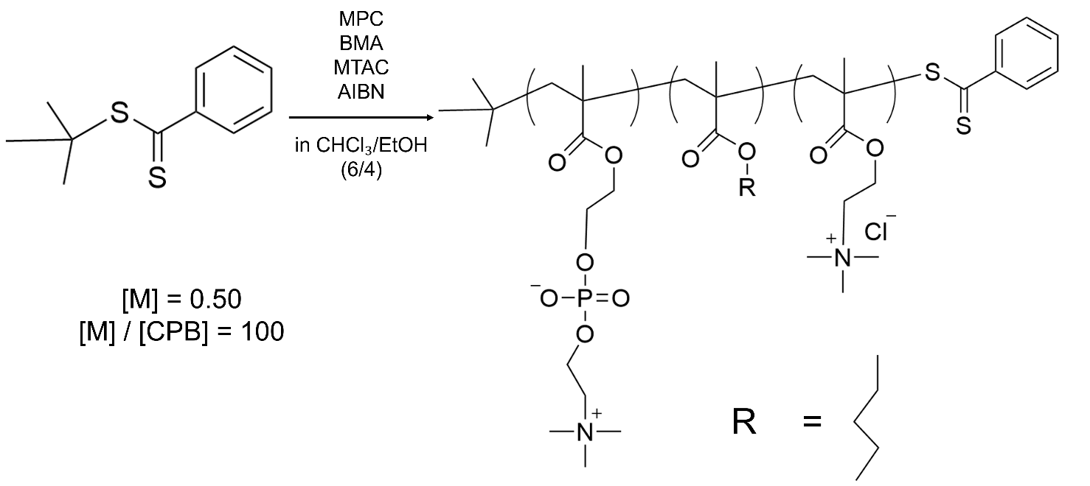
 | $$x$$ | $$y$$ | Feed Ratio (mol %) |  |  | Composition Ratio (mol %)
 | $$\frac{\left[BMA\right]}{\left[BMA\right]+ \left[MTAC\right]}$$ | $$\frac{\left[BMA\right]+ \left[MTAC\right]}{\left[MPC\right]+ \left[BMA\right]+ \left[MTAC\right]}$$ | MPC | BMA | MTAC | MPC | BMA | MTAC
PMBTA-1 | 0.2 | 0.2 | 80 | 4 | 16 | 84.4 | 2.5 | 13.1
PMBTA-2 | 0.8 | 0.2 | 80 | 16 | 4 | 78.6 | 15.9 | 5.5
PMBTA-3 | 0.2 | 0.7 | 30 | 14 | 56 | 30.4 | 14.2 | 55.4
PMBTA-4 | 0.8 | 0.7 | 30 | 56 | 14 | 34.8 | 58.7 | 6.5
PMBTA-5 | 0.5 | 0.45 | 55 | 22.5 | 22.5 | 50.3 | 22.4 | 22.4
PMPC | - (0.5) | 0 | 100 | 0 | 0 | 100 | 0 | 0
PMTAC | 0 | 1 | 0 | 0 | 100 | 0 | 0 | 100
PMBTA-6 | 0.680 | 0.652 | 29.4 | 44.3 | 20.9 | 29.4 | 49.0 | 21.2
PMBTA-7 | 0.773 | 0.877 | 12.3 | 67.8 | 19.9 | 11.8 | 74.5 | 13.7
PMBTA-8 | 0.831 | 0.905 | 9.5 | 75.2 | 15.3 | 6.6 | 79.6 | 13.8
PMBTA-9 | 0.858 | 0.621 | 37.9 | 53.3 | 8.8 | 38.1 | 52.4 | 9.5
PMBTA-10 | 0.346 | 0.996 | 12.3 | 34.4 | 65.1 | 23.3 | 23.6 | 53.0
PMBTA-11 | 0.981 | 0.627 | 37.3 | 61.5 | 1.2 | 37.1 | 60.6 | 2.2

Summary of this report
- Chage objective (anchor corrected FoG → FoG) for bayesian optimization (Rounds 1, 2, and 3)
- Examination of Methods for Eliminating Experimental Error
  - Delete Inter-round calibration in Bayesian optimization
- NMR measurement to verify the actual composition ratio

- UV-VISによるGOxの濃度調整
I had been using statistical methods to correct data between rounds with limited data, but this is difficult in the biological (enzyme) world. We will ensure that no concentration differences in GOx arise between rounds at the time of the experiment.

  - Experimental Methods
    - Preparation of the enzyme solution
- 1 mg/mL GOx solution was prepared (weighed using an electronic balance).

    - 測定
- Add 780 μL of buffer (pH 7.0 PBS) to the standard cell (S10-UV-10).
- Add the GOx solution to the special microcell (M20-UV-2).
- Following the manual, baseline measurements were taken with both sample compartments empty.
- The buffer cell was placed in the rear sample compartment and the GOx solution in the front sample compartment, then sample measurements were performed.
Measurement Conditions
Measurement Range: 200 – 340
Scanning Speed: 400 nm/min

  - Results
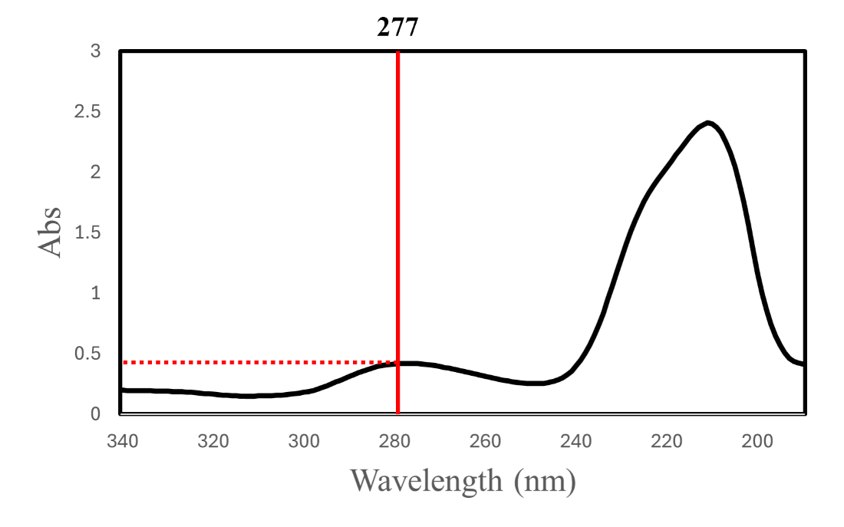
Figure 1. Measurement wavelength and absorbance

(Wavelength, Abs) = (277, 0.42118)
For each round, dilute the solution to adjust the absorbance to 0.3 (Ref: Lambert-Beer Law).
$$Abs= ε ×c ×l$$
(ε: molar absorptivity, c: concentration, l: cell length)
Absorbance is proportional to concentration.
For the GOx used in this study, the volume should be multiplied by 0.42118/0.3 and treated as 1 mg/mL.

- Reliability of the enzyme activity assay
To evaluate the reliability of the thermal stability assay of GOx, the experiment was repeated three additional times under identical conditions.
  - Experimental Methods
    - Preparation of the enzyme solution
- GOx was dissolved in 0.1 mol/L phosphate buffer solution (pH 7.0) and adjusted to a concentration of 1.6 ng/mL (A 1 mg/mL solution prepared by UV-VIS was used. → Compared to previous measurements, the concentration is 0.3/0.4118 = 0.7129 times higher).
- The polymer was dissolved in EtOH and adjusted to a concentration of 4.0 mg/mL.
- 25 µL of solution (2) was added to 2475 µL of solution (1).
- The mixture was dispensed into 1.0 mL microtubes in 300 µL aliquots and incubated at 60 °C for 0, 5, 10, 15, 20, 40, and 60 min.
- After heating, 100 µL of each sample was transferred into a 96-well microplate.

    - Preparation of the substrate solution
- D (+)-glucose was dissolved in 0.1 mol/L phosphate buffer solution (pH 7.0) and adjusted to a concentration of 0.01 mol/L.
- HRP was dissolved in 0.1 mol/L phosphate buffer solution (pH 7.0) and adjusted to a concentration of 1 mg/mL.
- To 19.8 mL of 0.1 mol/L phosphate buffer solution (pH 7.0), 20 mL of solution (1), 20 µL of solution (2), and 200 µL of Amplex Red solution were added.

    - Plate reader measurements
- The plate reader protocol was set to “GOx-resorufin-540/590” with the following conditions:
Interval: 0 s, Time: 30.
- Using an 8-channel pipette, 100 µL of the substrate solution was rapidly added to each well, starting from the wells corresponding to the longest heating time.
- The fluorescence of resorufin was measured.
- The rate of increase in absorbance (slope obtained by fitting the initial linear region) was defined as the absolute activity.

  - Results
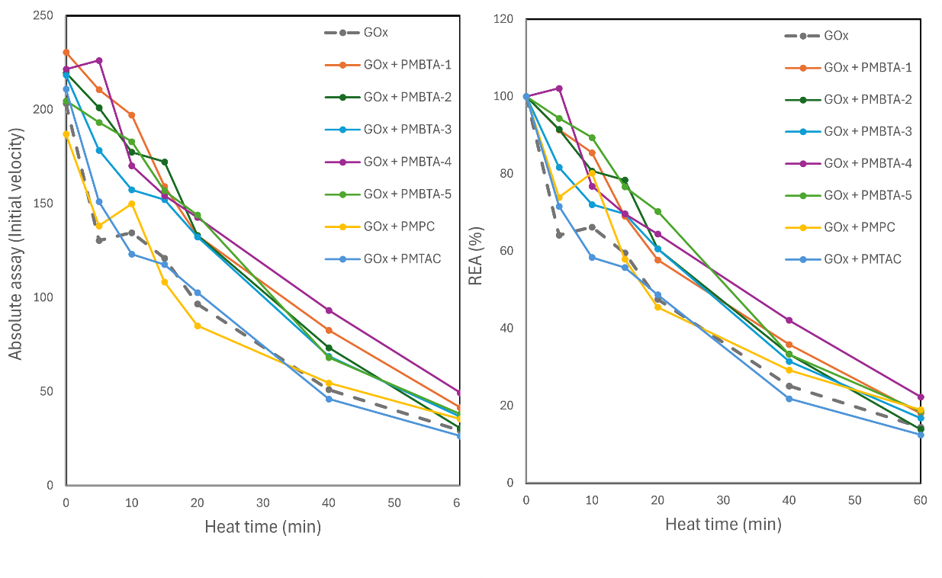
Figure 1. Round 1: GOx assay with PMBTA (left: Absolute activity, right: Retain Enzyme Activity)
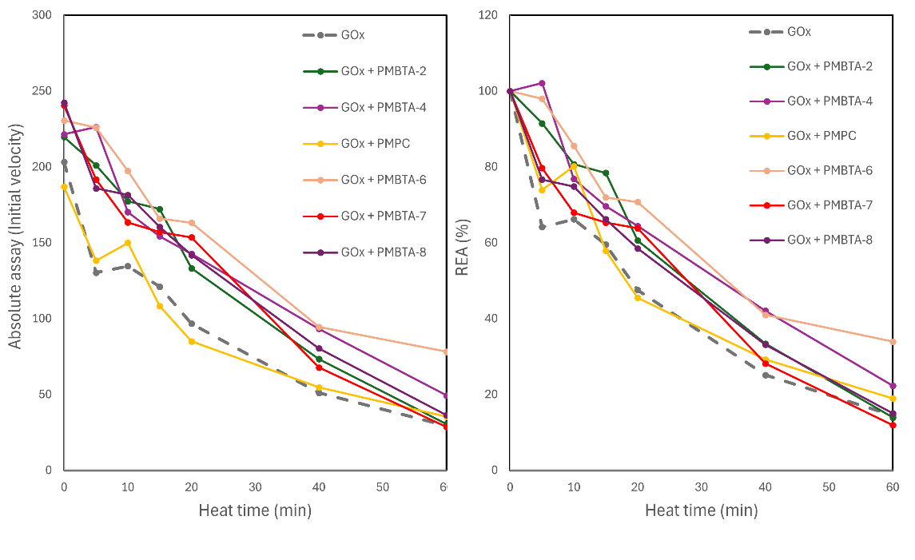
Figure 2. Round 2: GOx assay with PMBTA (left: Absolute activity, right: Retain Enzyme Activity)
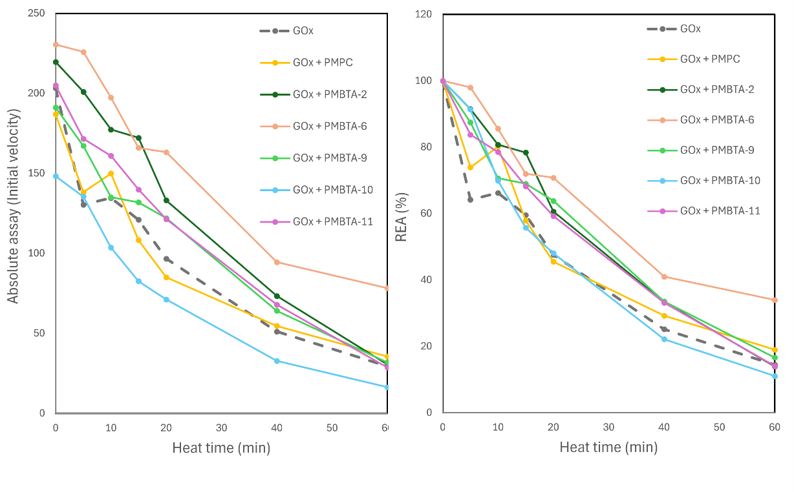
Figure 3. Round 3: GOx assay with PMBTA (left: Absolute activity, right: Retain Enzyme Activity)

- After resynthesizing, PMBTA-4 and 6 exhibited high performance similar to the November measurements.
- PMBTA-4, 6, and 9 showed favorable results.
  - The actual compositions measured by NMR for PMNBTA-4 and 9 were nearly identical.
  - Only PMBTA-6 possesses a large positive charge patch (MTAC).
- When homopolymers of PMPC or PMTAC were added, the activity of GOx showed almost no change.

- Bayesian optimization for GOx
Bayesian optimization was performed on GOx activity.
- The objective function was the half-life, i.e., the time until the activity decreased to half of its initial value (to be maximized).
  - This objective could, in principle, be replaced by the residual activity after 20 min of heating, etc.
  - Because we collected time-course data at 5, 10, 15, 20, 40, and 60 min, we chose the time required for the activity to decrease to half its initial value as the objective.
  - Half-life of GOx activity
On 251025, three independent datasets were acquired, and the half-life was calculated for each dataset.
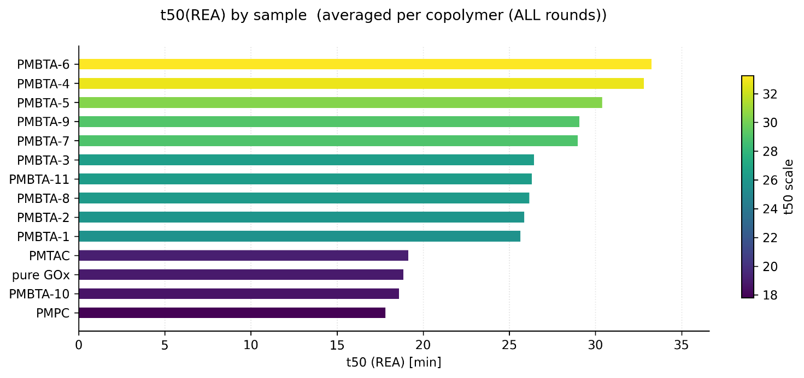
Figure 4. Half-life of GOx activity.
- The half-life when PMPC, PMTAC, and PMTAC were added was nearly identical to that of pure GOx.
  - This indicates that PMPC and PMTAC do not significantly affect the thermal stability of GOx.
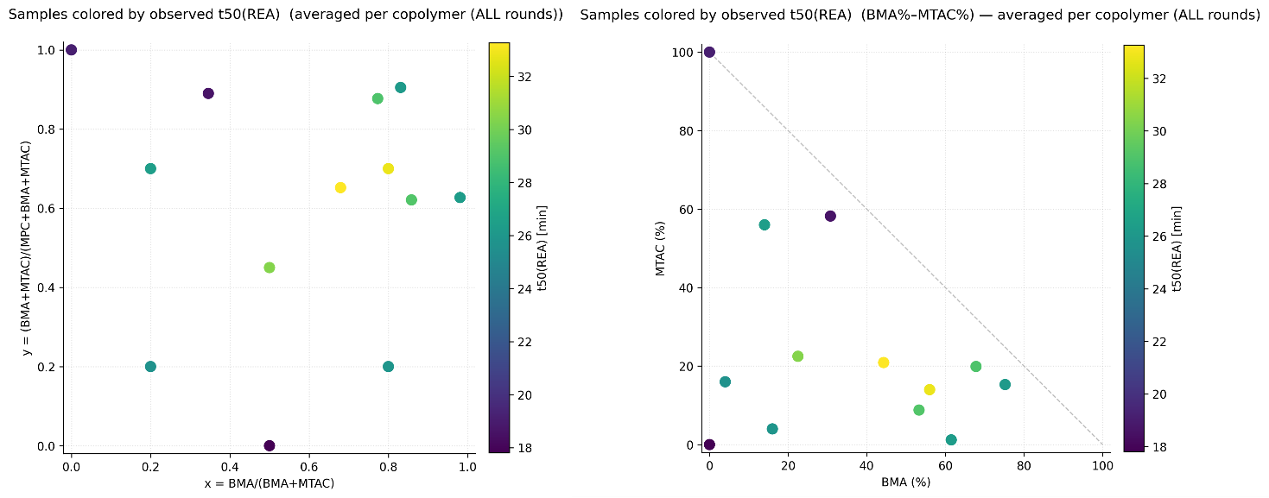
Figure 5. Half-life of GOx activity t50 map.

  - 目的変数の定義
In this study, to suppress systematic differences between measurement rounds (plate-to-plate and day-to-day variability), we followed the approach of Tamasi et al., who normalized the enzyme activity (REA) in each assay as a ratio relative to the positive and negative controls (PC/NC-based standardization). In addition, we calculated the ratio of the t50 value relative to that of pure GOx measured in the same round (FoG = t50(sample)/t50(pure GOx)) to cancel out round-to-round scaling offsets. Tamasi et al. conducted their experiments over multiple iterations, and we similarly adopted round-wise normalization and model training in the present work.

FoG（Fold over GOx）: The fold change relative to the reference value of pure GOx (control) in the same round.
- $FoG= \frac{t_{50} (Sample)}{t_{50} (Pure GOx)}$（t₅₀ is derived from the REA）: A value of 1.0 indicates the same thermal stability as pure GOx, and values greater than 1 indicate higher thermal stability.
- Pure GOx was measured in every round (RoundID) as an internal reference.
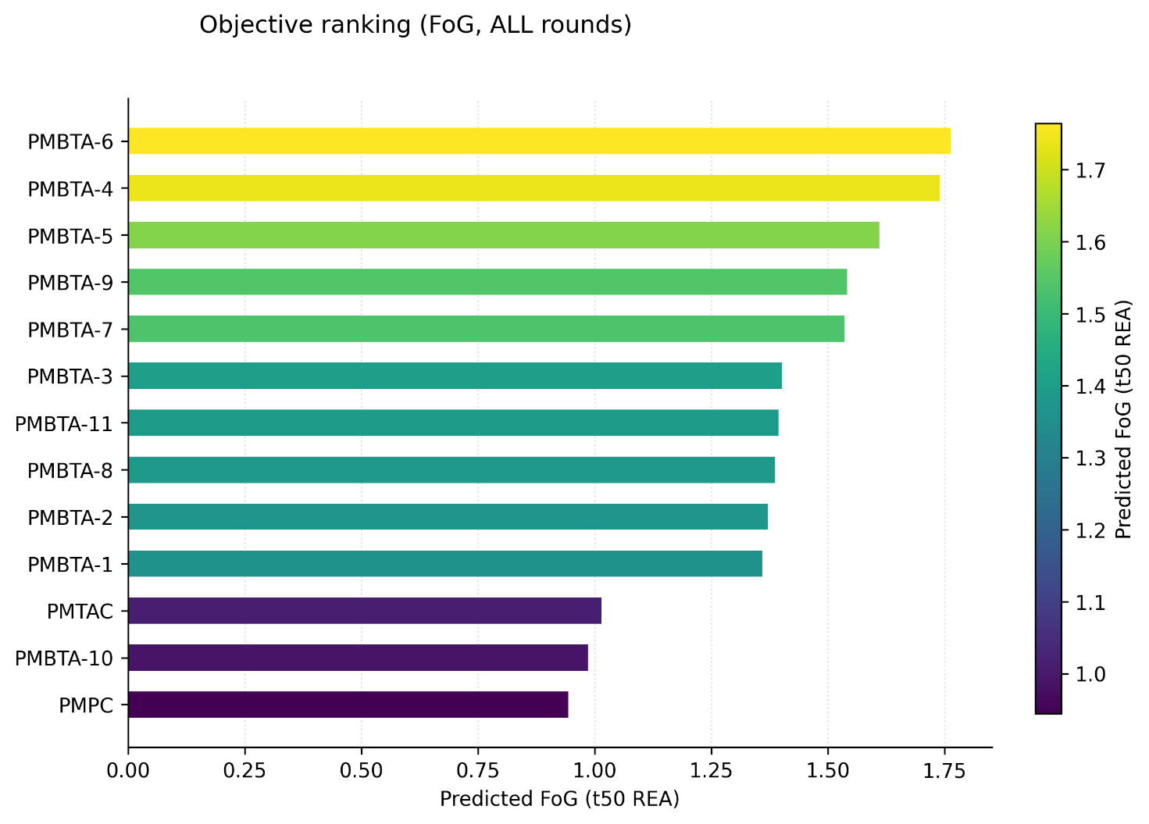
Figure 6. Fold over GOx for each polymer.
- When PMBTA4, 5, 7, and 9 were added together with GOx, the half-life became more than 1.5 times longer than that of pure GOx.

- Bayesian optimization (GOx, Round 1, 2, 3)
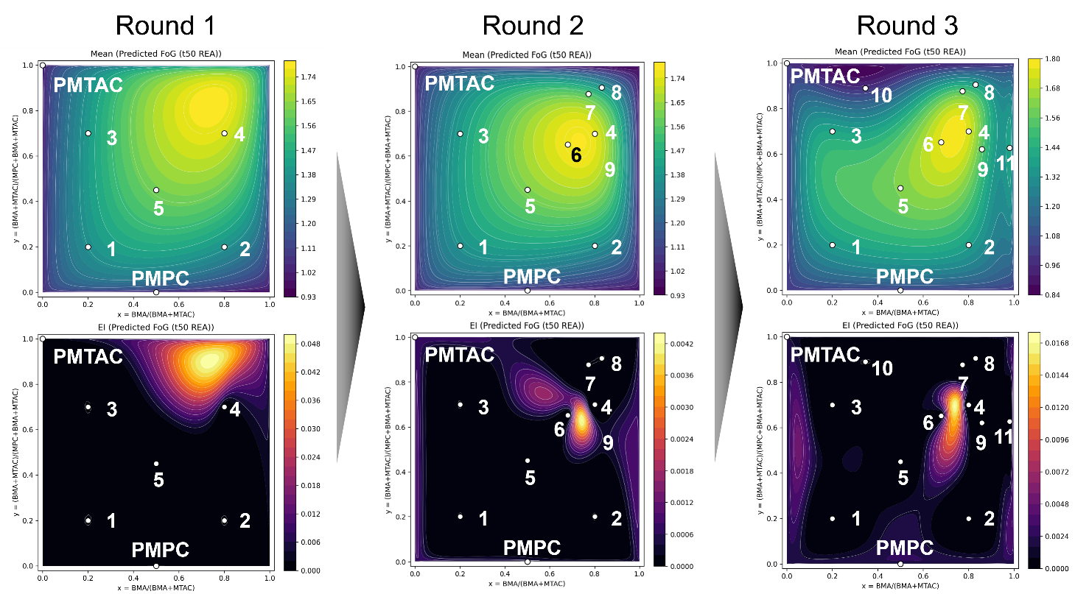
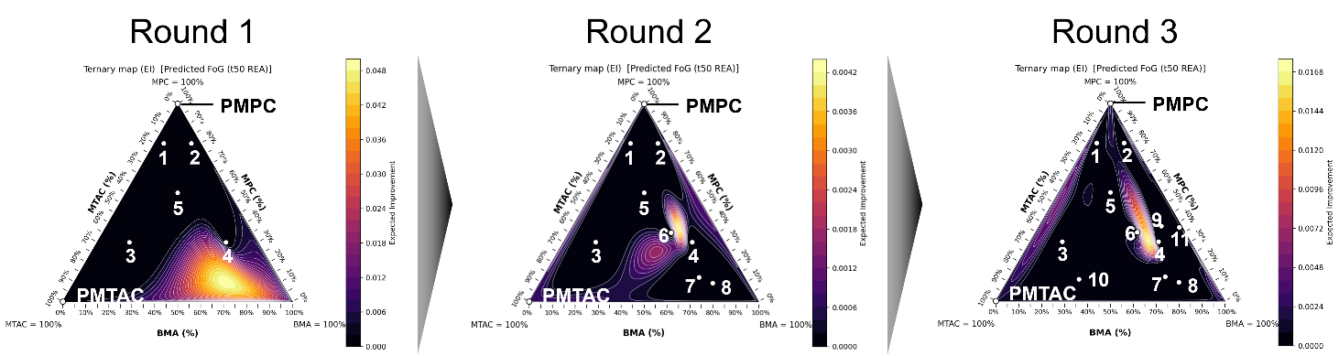
Figure 7. Map changes per round (Mean /EI).
- Mean (μ):
The Gaussian Process (GP) surrogate’s predicted average of the objective (here, Predicted t50 (REA)). Think of it as the “performance map.”
- EI (Expected Improvement):
Expected gain over the current best. It becomes large where μ is high and σ is non-negligible. Good for picking the “next best” experiments.
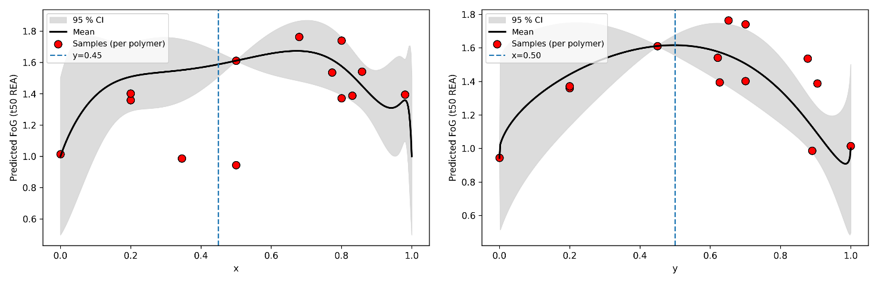
Figure 6. One-dimensional response profiles along composition axes (predictive mean with 95% CI).

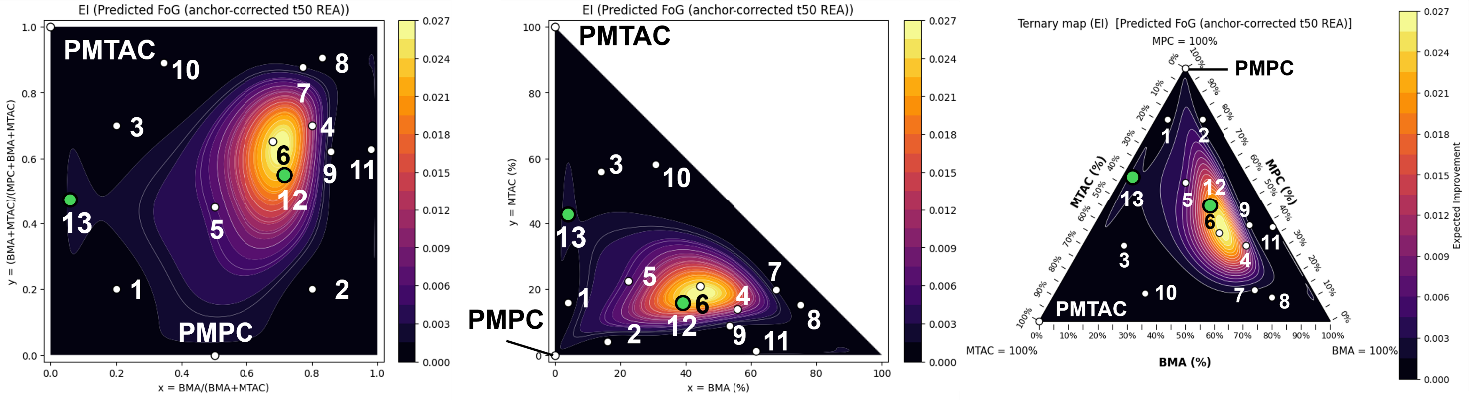
Figure 8. Mapping of candidates proposed by Bayesian optimization as having high EI
 | $$x$$ | $$y$$ | Feed Ratio (mol %)
 | $$\frac{\left[BMA\right]}{\left[BMA\right]+ \left[MTAC\right]}$$ | $$\frac{\left[BMA\right]+ \left[MTAC\right]}{\left[MPC\right]+ \left[BMA\right]+ \left[MTAC\right]}$$ | MPC | BMA | MTAC
PMBTA-12 | 0.732 | 0.545 | 45.5 | 39.9 | 14.6
PMBTA-13 | 0.087 | 0.460 | 54.0 | 4.0 | 42.0

- ¹NMR
  - Experimental method
Each polymerized copolymer (600 mg) was dissolved in methanol-d₄ (600 μL) and measured.
  - Result
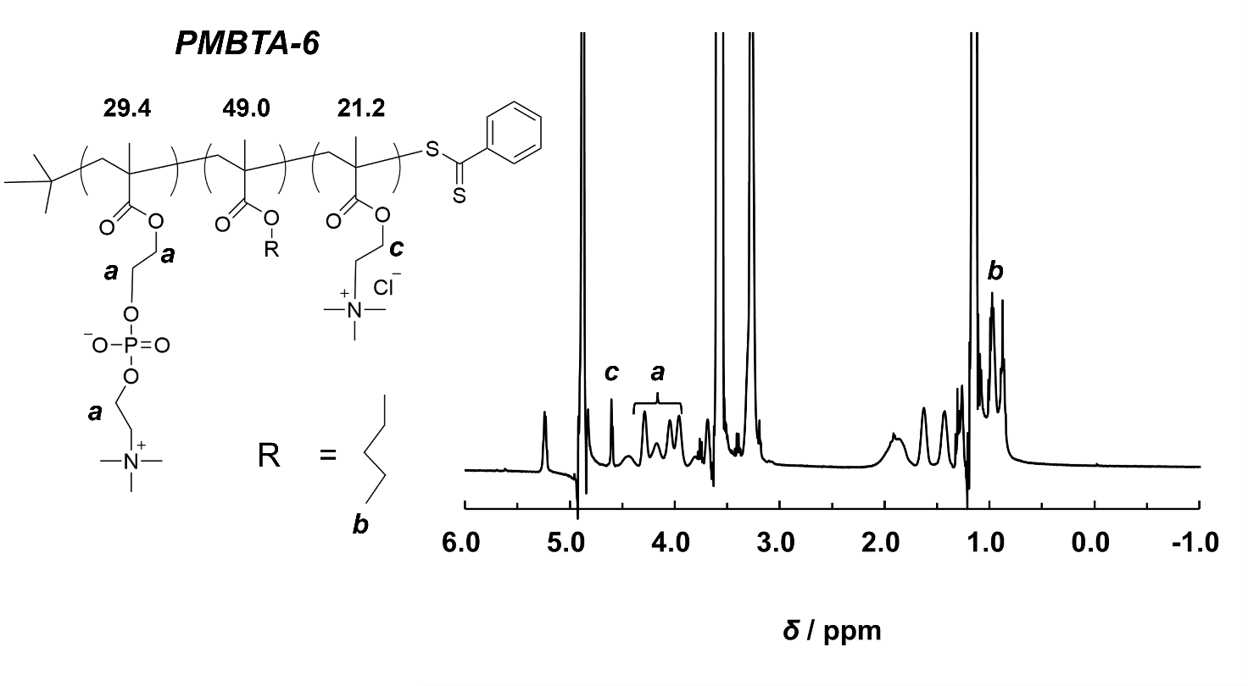
Figure 7. ¹H NMR spectrum for PMBTA-6.
Table 1. Feed Ratio vs Competition Ratio
 | Feed Ratio (mol %) |  |  | Composition Ratio (mol %)
 | MPC | BMA | MTAC | MPC | BMA | MTAC
PMBTA-1 | 80 | 4 | 16 | 84.4 | 2.5 | 13.1
PMBTA-2 | 80 | 16 | 4 | 78.6 | 15.9 | 5.5
PMBTA-3 | 30 | 14 | 56 | 30.4 | 14.2 | 55.4
PMBTA-4 | 30 | 56 | 14 | 34.8 | 58.7 | 6.5
PMBTA-5 | 55 | 22.5 | 22.5 | 50.3 | 22.4 | 22.4
PMPC | 100 | 0 | 0 | 100 | 0 | 0
PMTAC | 0 | 0 | 100 | 0 | 0 | 100
PMBTA-6 | 29.4 | 44.3 | 20.9 | 29.4 | 49.0 | 21.2
PMBTA-7 | 12.3 | 67.8 | 19.9 | 11.8 | 74.5 | 13.7
PMBTA-8 | 9.5 | 75.2 | 15.3 | 6.6 | 79.6 | 13.8
PMBTA-9 | 37.9 | 53.3 | 8.8 | 38.1 | 52.4 | 9.5
PMBTA-10 | 12.3 | 34.4 | 65.1 | 23.3 | 23.6 | 53.0
PMBTA-11 | 37.3 | 61.5 | 1.2 | 37.1 | 60.6 | 2.2

- The composition obtained was nearly the same as the feed ratio for all composition ratios.

- Future Plan
- Synthesize the newly proposed copolymers PMBTA-12 and PMBTA-13.
- Evaluate the activity using β-D-galactosidase.
- Measure DLS for the re-synthesized polymer.

- References
- Panganiban, B.; Qiao, B.; Jiang, T.; DelRe, C.; Obadia, M. M.; Nguyen, T. D.; Smith, A. A. A.; Hall, A.; Sit, I.; Crosby, M. G.; Dennis, P. B.; Drockenmuller, E.; Olvera de la Cruz, M.; Xu, T. Random Heteropolymers Preserve Protein Function in Foreign Environments. Science 2018, 359, 1239–1243.
- Tamasi, M. J.; Patel, R. A.; Borca, C. H.; Kosuri, S.; Mugnier, H.; Upadhya, R.; Murthy, N. S.; Webb, M. A.; Gormley, A. J. Machine Learning on a Robotic Platform for the Design of Polymer–Protein Hybrids. Adv. Mater. 2022, 34, 2201809.
- Nagao, M.; Nakahara, O.; Zhou, X.; Matsumoto, H.; Miura, Y. Bayesian Optimization of Glycopolymer Structures for the Interaction with Cholera Toxin B Subunit. Nanoscale 2024, 12406-12410.

