**8-DOF quadruped bionic spider robot**

Catalogue

0 Statement 2

0.1 Use statement 2

0.2 Warranty statement 2

0.3 Material statement 2

1.Kit List 3

1.1. Accessories Collection 3

1.2 List of structural 4

1.3 Circuit Description 4

2. Assembly steps 5

3 Control experience 22

3.1 Using web page control 23

3.2 Control with Android APP 27

4 Graphical programming course 36

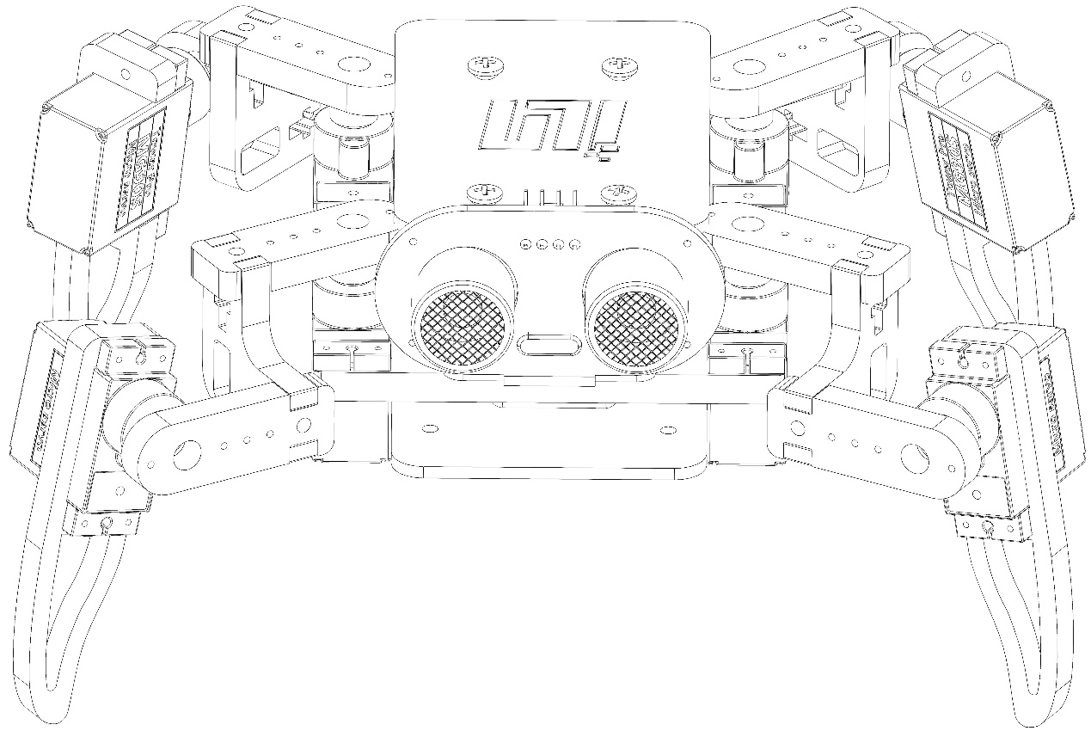

## 0 Statement

### 0.1 Use statement:

0.1.1 Please read this manual before use;；

0.1.2 The product appearance in the picture is for reference, please refer to the actual product;

0.1.3 The company reserves the right to interpret this manual. In case of product updates or upgrades, there without notification, please refer to the actual product you purchased,

### 0.2 Warranty statement:

0.2.1 Please check the quality of the product carefully after receiving the product. we will not provide warranty once used.;

### 0.3 Material statement

0.3.1 The copyright of this product material belongs to our company. “XINZHILI” is the brand and trademark, we will be held legally responsibility If copy or disseminate the matirial without authorization,

## 1 Kit list

### 1.1. Accessories Collection

|  |  |  |
| --- | --- | --- |
| No | name | quantity |
| 1 | NodeMcu | 1 |
| 2 | Servo motors extension board | 1 |
| 3 | MG90S servo motors (rudder blade processing) | 8 |
| 4 | Battery (702035) | 1 |
| 5 | MicroUSB cable | 1 |
| 6 | Charging cable | 1 |
| 7 | Screwdriver | 1 |
| 8 | M1.4 * 6 screw | 16 |
| 9 | M2.5 * 10 screw | 4 |
| 10 | M2.5 * 12 screw | 8 |
| 11 | M2.5 * 6 screw | 8 |
| 12 | M2.5 nut | 16 |
| 13 | M2.5 * 8+6 single-way copper pillar | 4 |
| 14 | M2.5 * 10 two-way copper pillar | 4 |
| 15 | Acrylic | 1 |
| 16 | Ligature | some |
| 17 | Bundle tube | 2 |
| 18 | 3M glue | 1 |
| 19 | 3D printing eyes | 1 |

### 1.2 List of structural

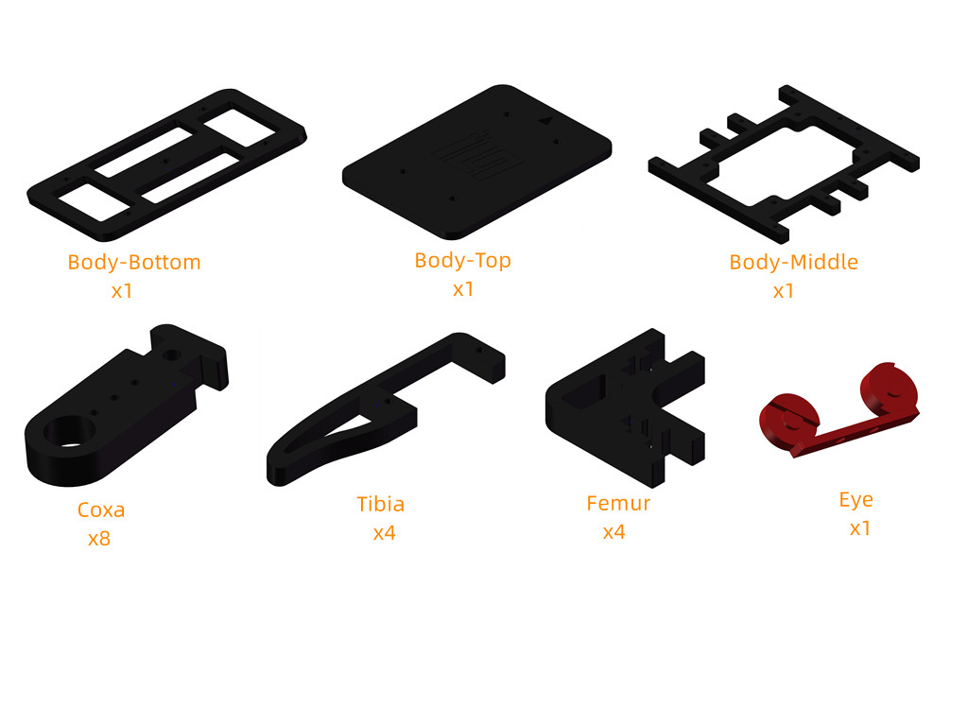

### 1.3 Circuit description

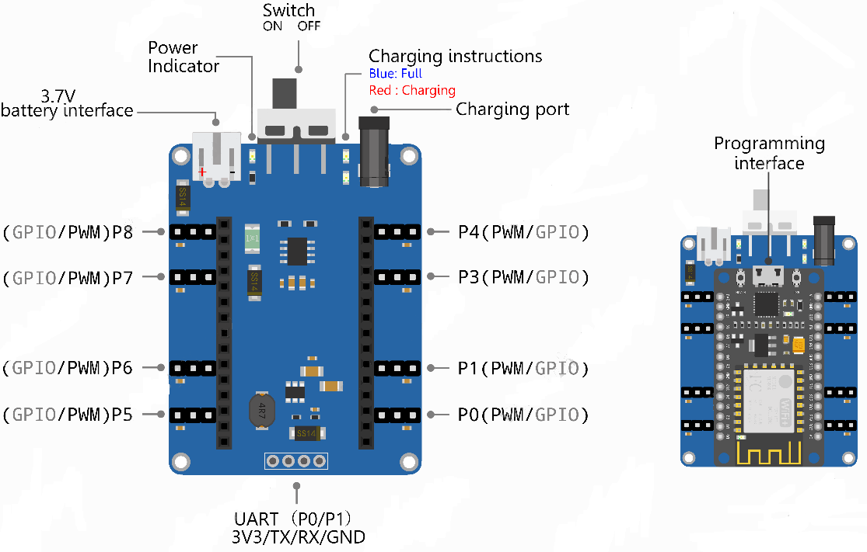

The name of the servo motors extension board is “NodeMcu Servo Shield”.

When the battery is not connected and the switch is turned to OFF, connect the USB charging cable and expansion board. Normally, the green LED on the expansion board is always on, the red LED is flashing, and the power indicator light is not on;

When the battery is not connected and the switch is turned to ON, connect the USB charging cable and expansion board. Normally, the green LED is always on, the red LED is flashing, and the power indicator light is always on;

When the battery is connected and the switch is turned to OFF, connect the USB charging cable and expansion board, keep charging status. normally you can see that the green LED is off and the red LED is always on. Note that the switch should be turned to OFF during charging.

## 2. Assembly steps

#### Step 1. Test the servo motors

Before testing the servo motors, you need to set up a development environment on the computer. Please open the tutorials provided by us and enter "Lesson0 Setting Development Environment.pdf" under "**03 Tutorial & Code 🡪 Arduino 🡪 Lesson 0 Setting Development Environment**". Follow the instructions of the tutorial and complete the construction of the development environment.

After successfully completing the construction of the development environment, please open the tutorials and enter "**Lesson1 Drives a Single Servo motors.pdf**" under "**03 Tutorial & Code 🡪 Arduino 🡪 Lesson1 Drives a Single Servo motors**". Follow the instructions in the tutorial to complete the test of the servo motors.

After completing Lesson1, open the tutorials, enter "**03 Tutorial & Code 🡪 Arduino 🡪 Lesson2 Wifi Control 🡪** **Quadbot-E-V1.4**", double-click to open QuadBot-E-V1.4.ino, and download the program into the singlechip as the same with previous two Lessons.

#### Step 2. Prepare for assembly

Tear off the protective paper stuck on the acrylic structure.

#### Step 3. Install the servo motors on the Body Middle

Install the servo motors on the body spindle and fixed by M1.7 * 9 screws from servo bag, shown as below picture (notice：The rotation axis direction of the servo motors shall be in the same direction as shown in the picture, the rotating shaft of the servo motors is closer to the outer edge of the long shaft of the Body Middle)

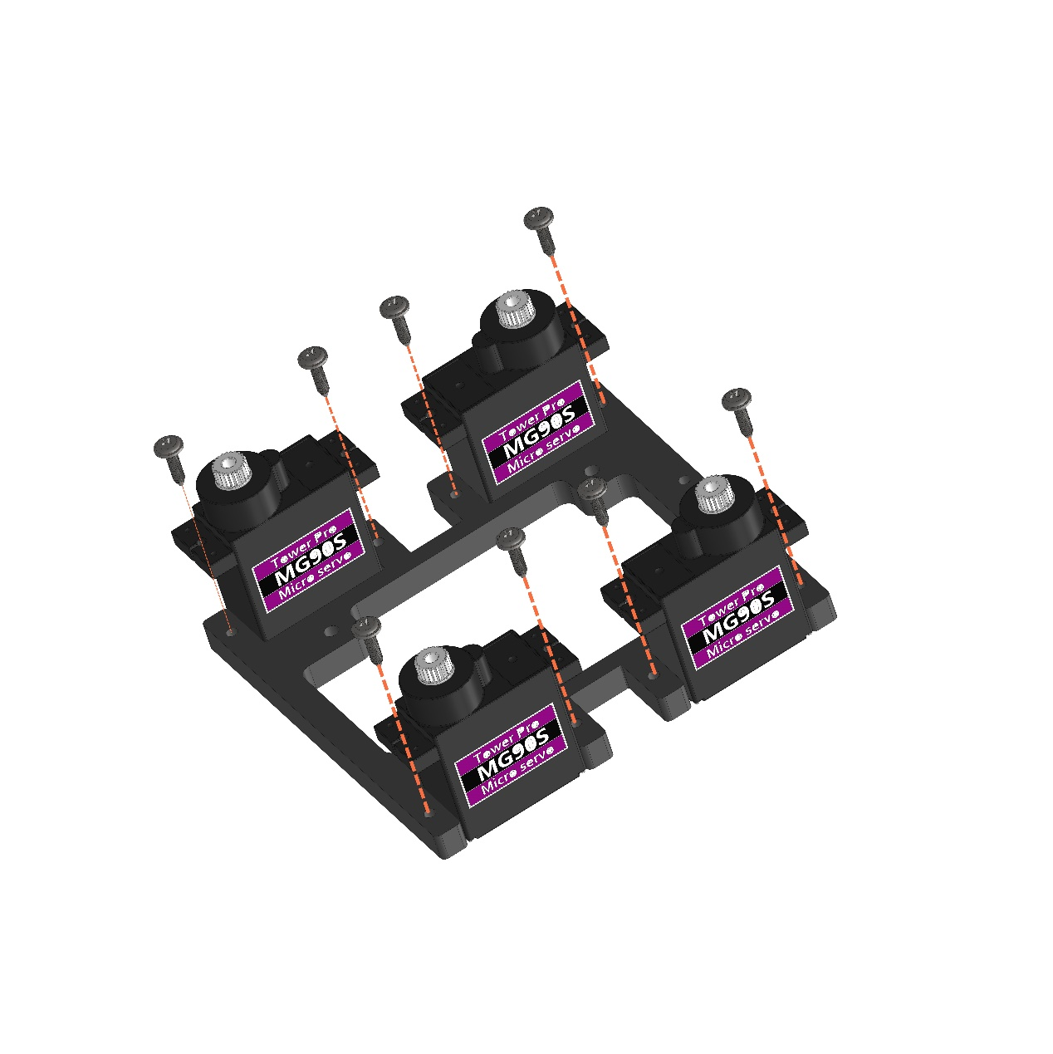

The appearance after installation is shown as below picture

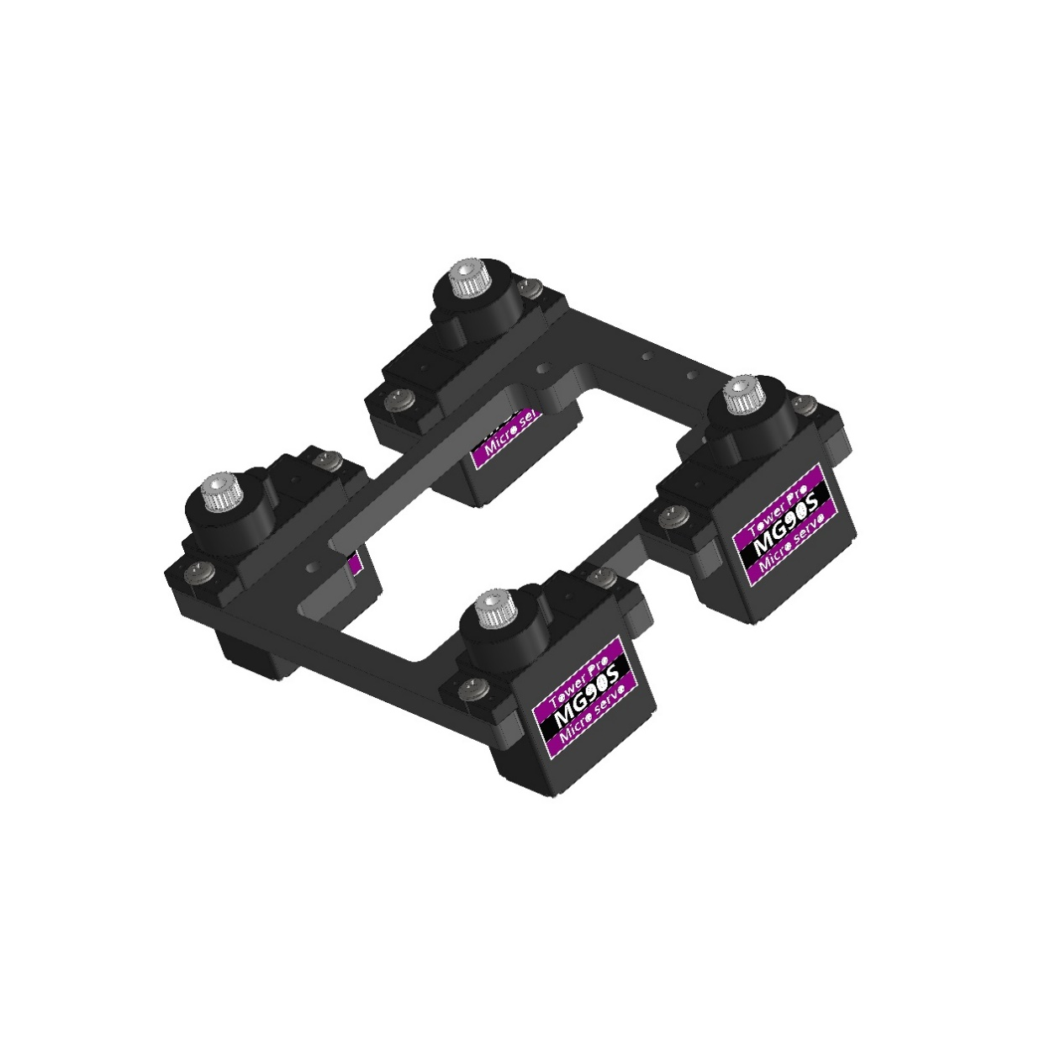

#### Step 4. Install the servo motors extension board

Turn the switch to OFF, and connect the battery to the servo motors expansion board, shown as below picture.

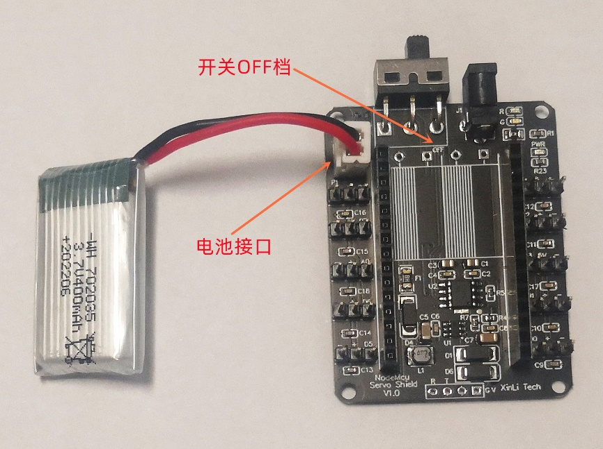

Firstly, using 3M glue to stick the battery to the back of the servo motors expansion board. Then use four M2.5 * 10 screws and four M2.5 * 10 two-way copper pillar to fix the expansion board on the Body-Middle, shown as below picture

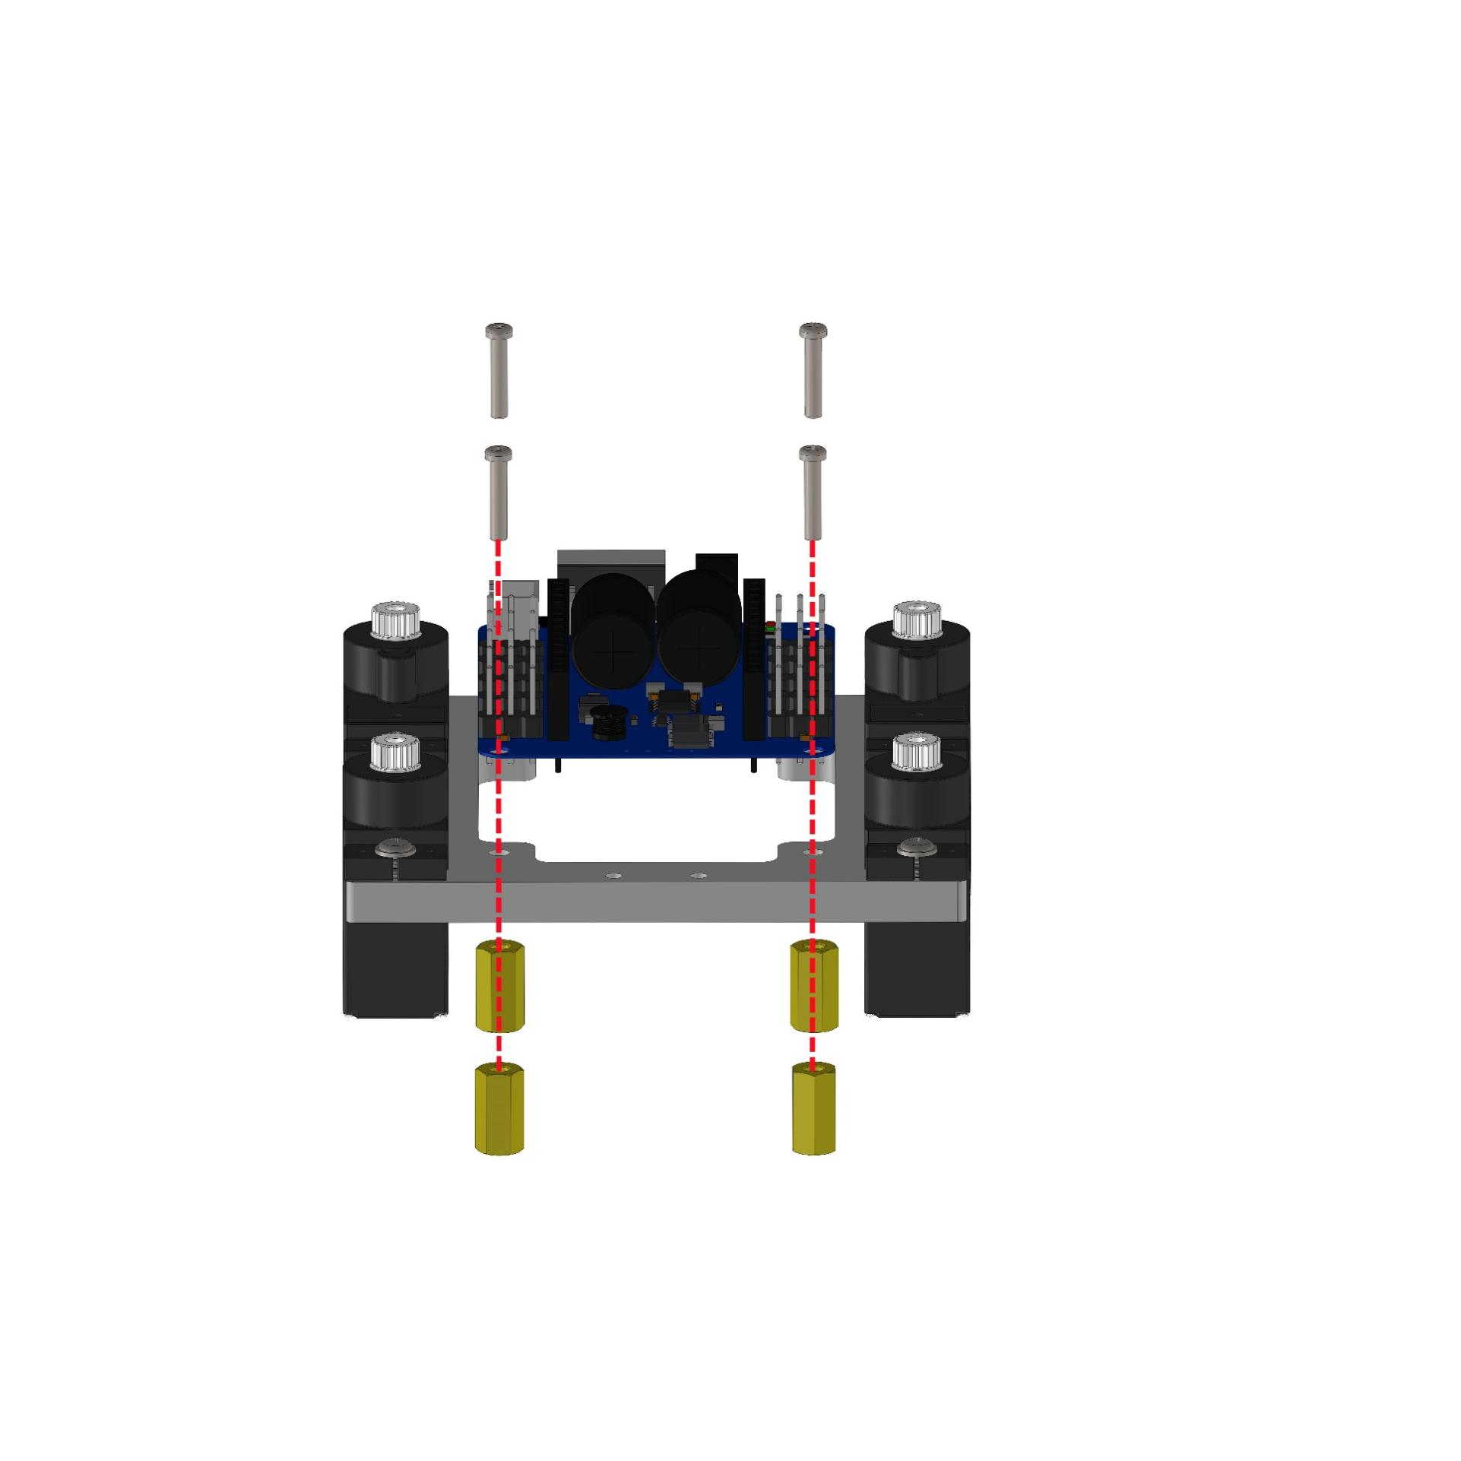

The appearance after installation is shown as below picture

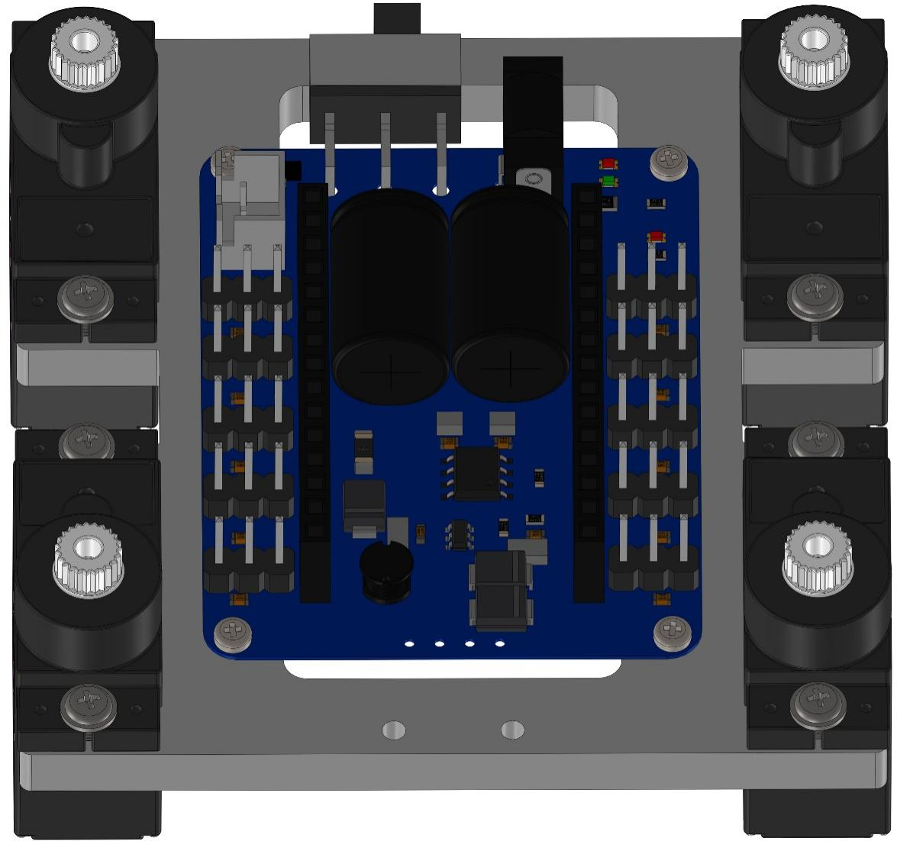

#### Step 5. Install NodeMCu

Fix four M2.5 * 8+5 single-way copper pillar and four M2.5 nuts on the circuit board through the four positioning holes of the NodeMCu circuit board, shown as below picture.

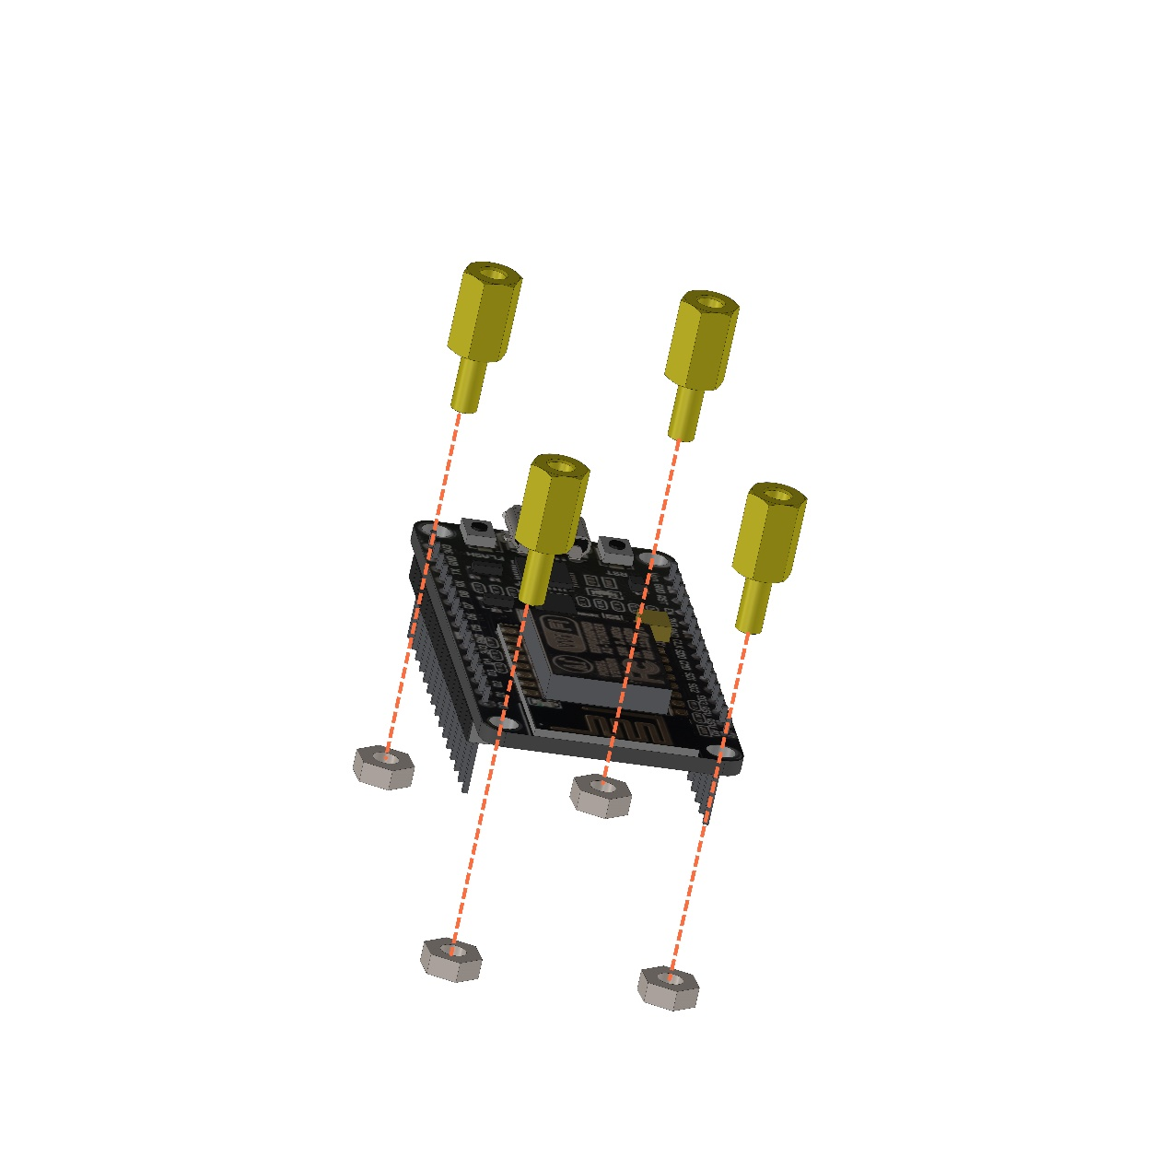

The appearance after installation is shown as below picture

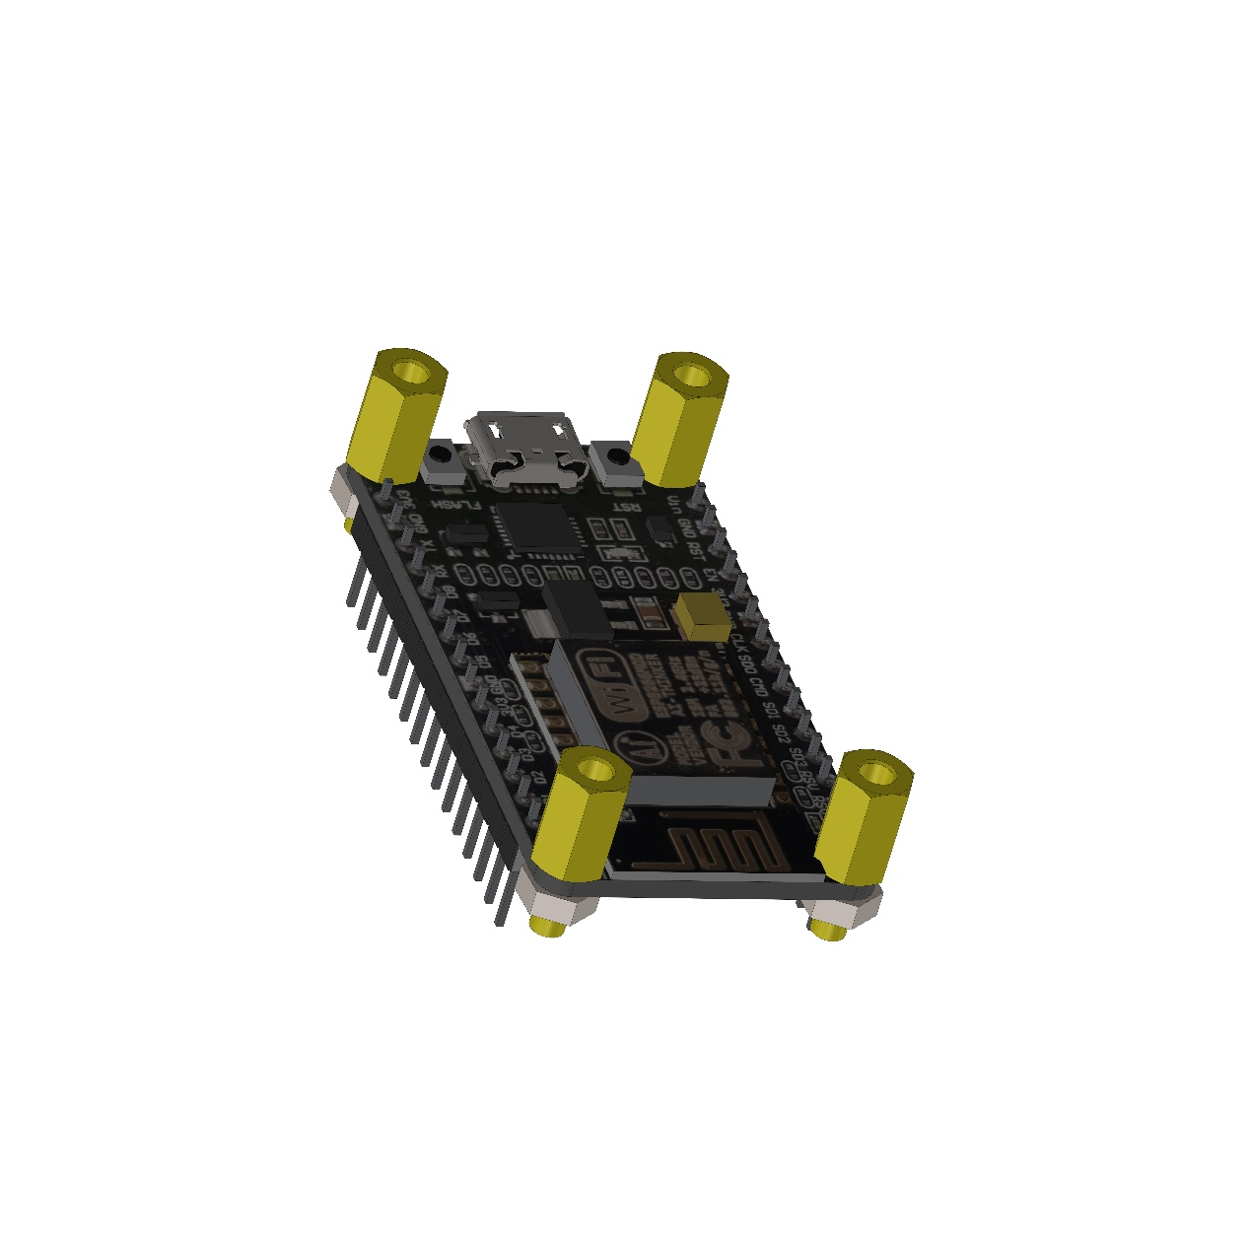

Then plug it into the socket of the servo motors expansion board, the USB port on the NodeMCu circuit board and the switch on the servo motors expansion board are on the same side, shown as below picture

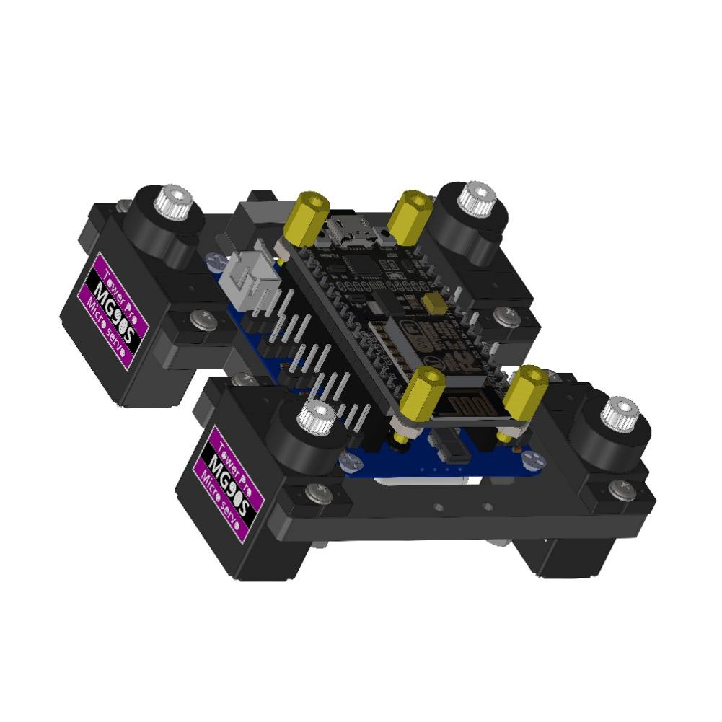

#### Step 6. Install the rudder blade on Coxa

Fix 8 servo motors rockers and 8 Coxa structural together with three M1.4 * 6 screws, shown as below picturein the figure below

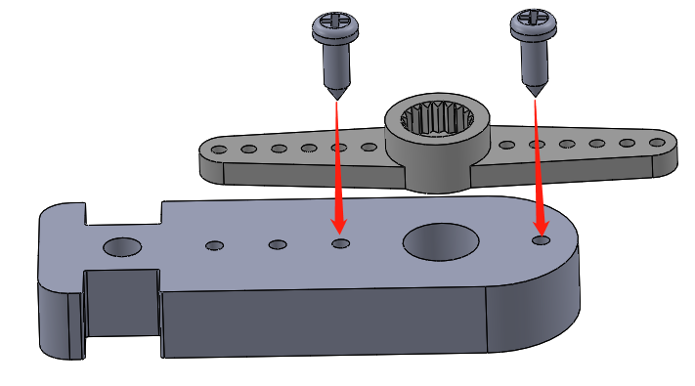

The appearance after installation is shown as below picture

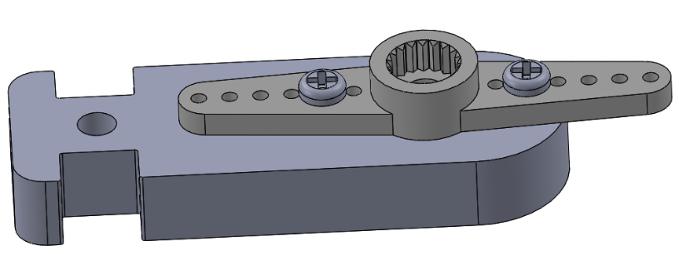

Cut the rudder blade extending out of the structure

The appearance after installation is shown as below picture

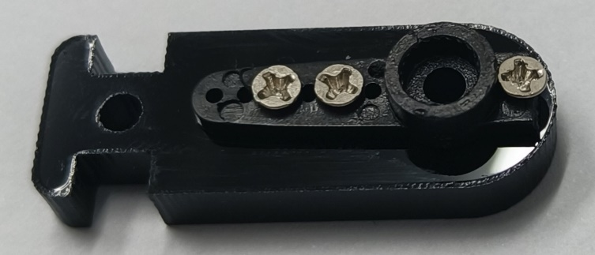

#### Step 7. Install Coxa and Femur

Fix the structural Coxa and structural Femur together by M2.5 * 12 screws, shown as below picture

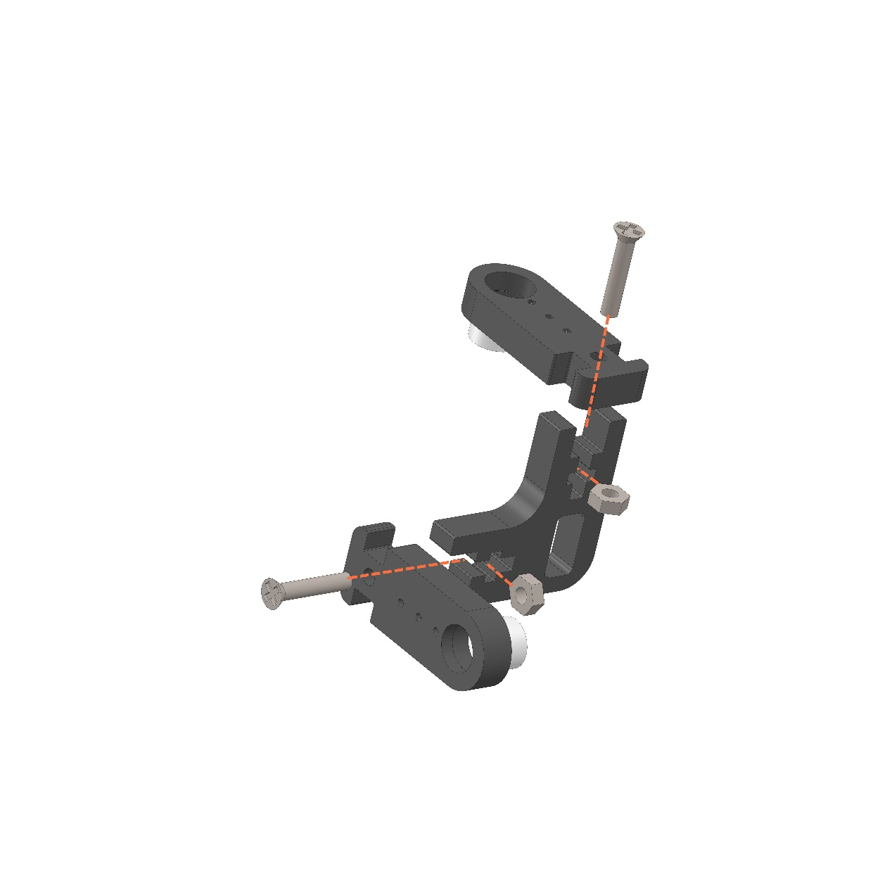

The appearance after installation is shown as below picture

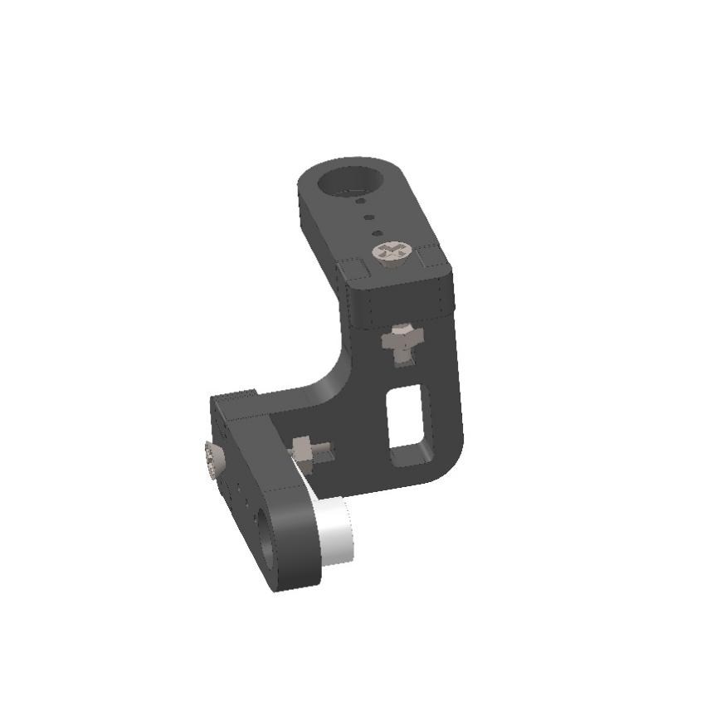

Complete install the other three as the same with previous step, Pay attention to the direction, be sure same with the picture. The appearance after installation is shown as below picture

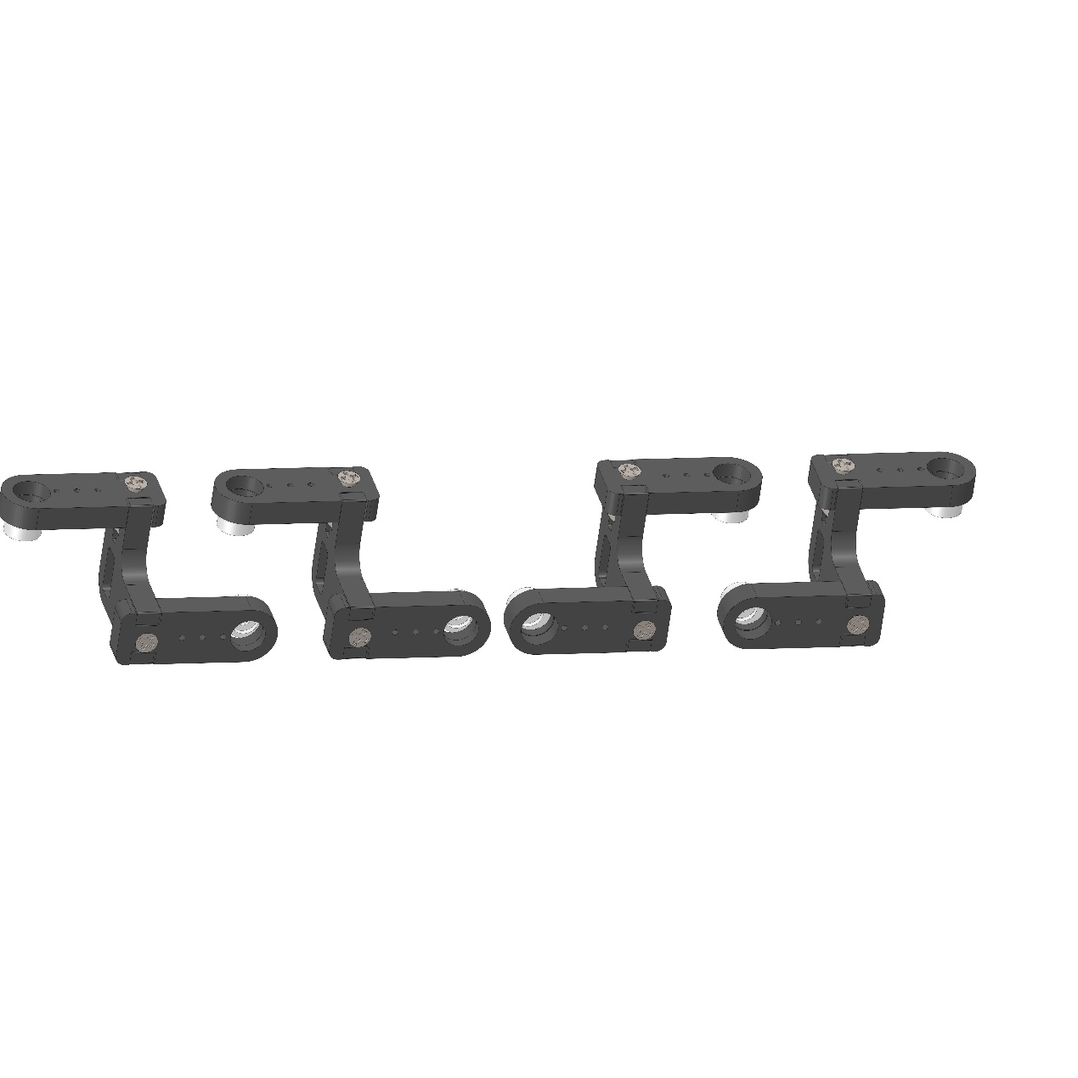

#### Step 8. Connect the four servo motors on the Body Middle with the steering gare expansion board

Connect the battery, insert the servo motors cable into the board, pay attention to the color! Then turn on the switch and turn it off after 5 seconds! The purpose is to reset the servo motors angle! If not, the posture will be wrong after installation! shown as below picture

(please in sure that the steps of servo motors connecting cable in turn! on the basis of marked color the brown is GND, the red is VCC, and the yellow is the signal line.)

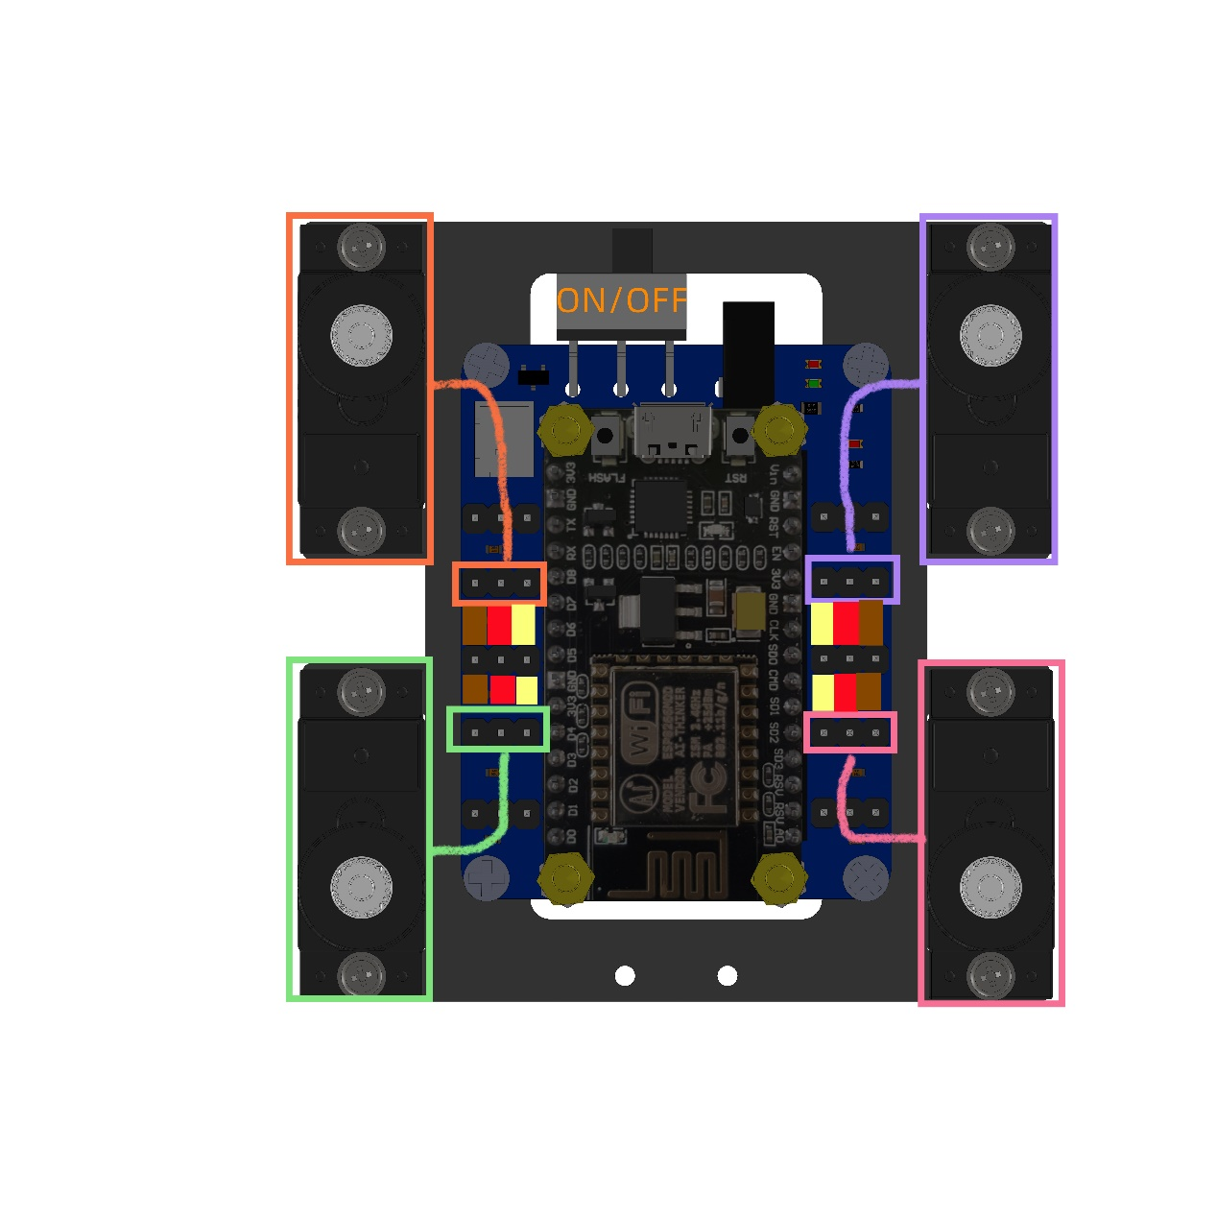

#### Step 9. Connect the four legs

Install the servo motors rocker according to the angle shown as below picture, and the servo motors shall be vertically with the servo motors rocker as far as possible. (Note: Do not rotate the servo motors when installing the servo motors rocker, or repeat the previous step.) Fix the rocker with screws

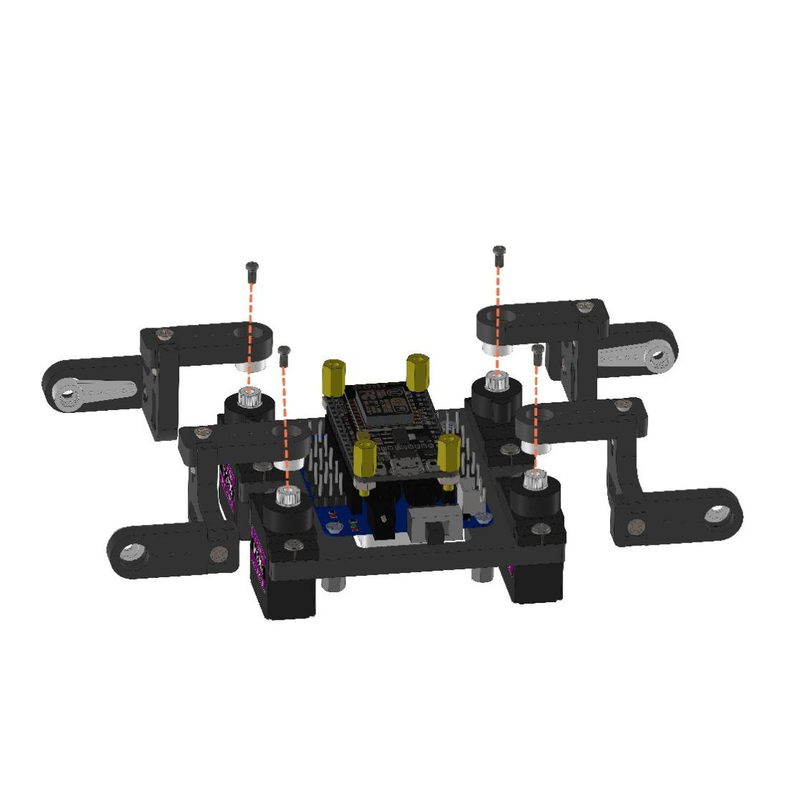

The appearance after installation is shown as below picture

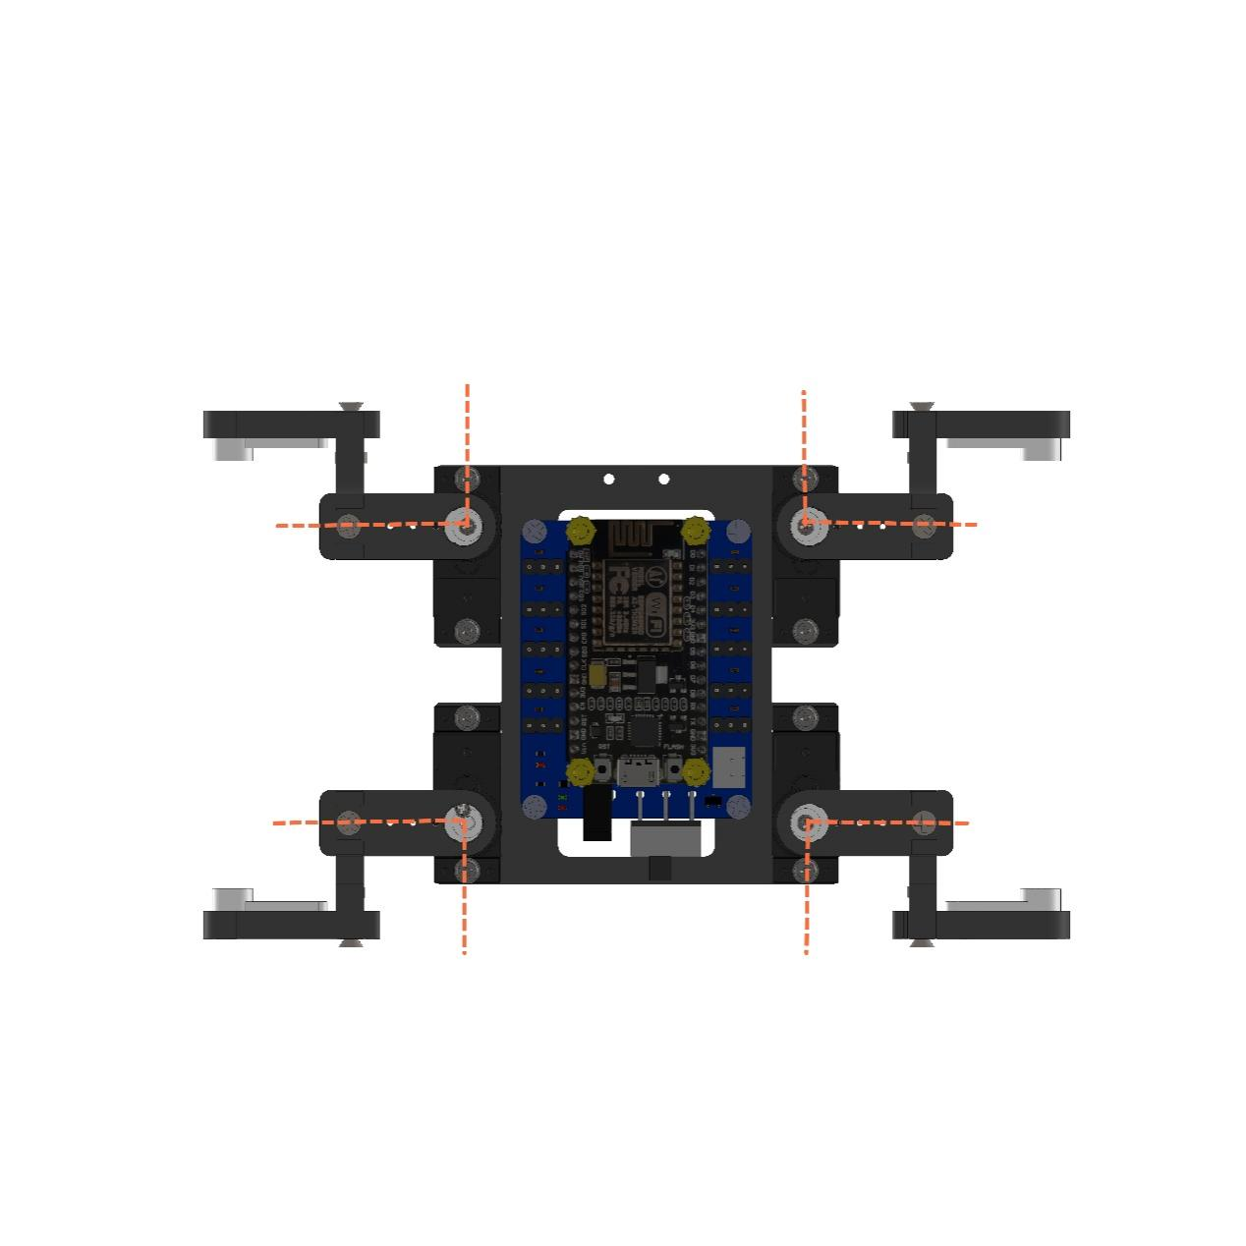

#### Step 10. Connect the other four servo motorss to the servo motors expansion boards

Insert the servo motors cable into the board, pay attention to the color! Then turn on the switch and turn it off after 5 seconds! The purpose is to reset the servo motors angle! If not, the posture will be wrong after installation! This step is necessarily

(please in sure that the steps of servo motors connecting cable in turn! on the basis of marked color the brown is GND, the red is VCC, and the yellow is the signal line.)

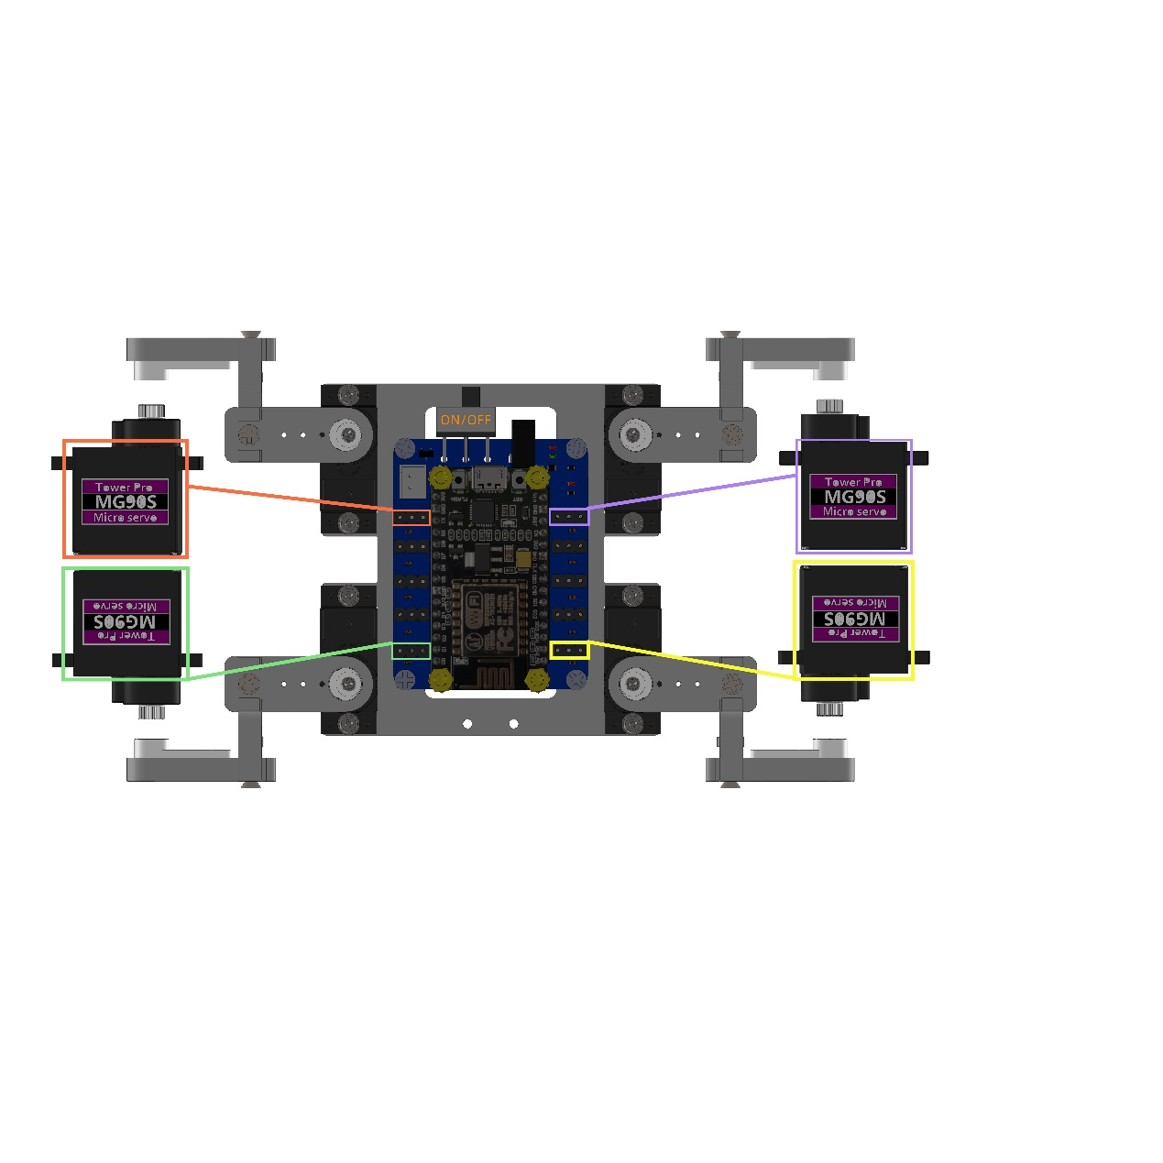

#### Step 11. Install the other four servo motorss

Before fixing, please pass the cables on the servo motors through the holes in the leg structure, shown as below picture.

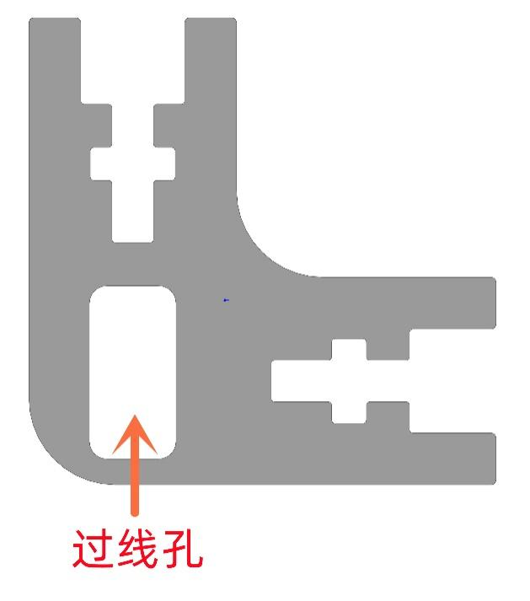

Install the servo motors according to the angle shown as below picture

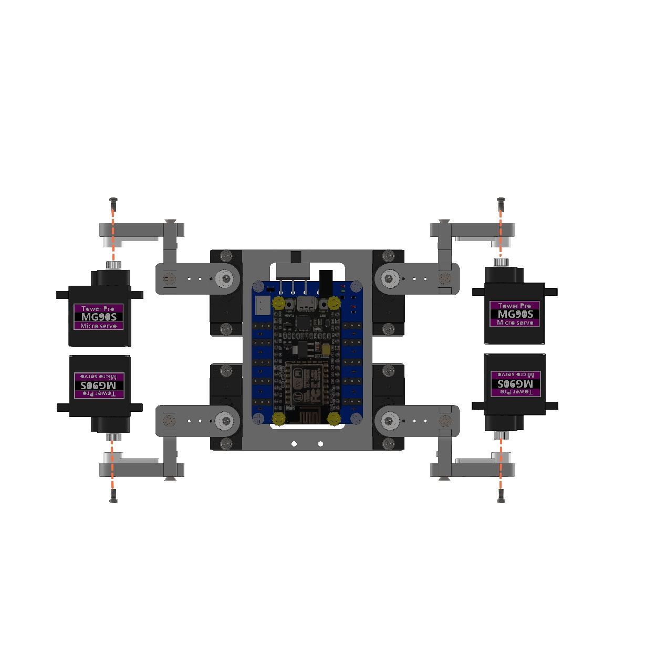

The appearance after installation is shown as below picture

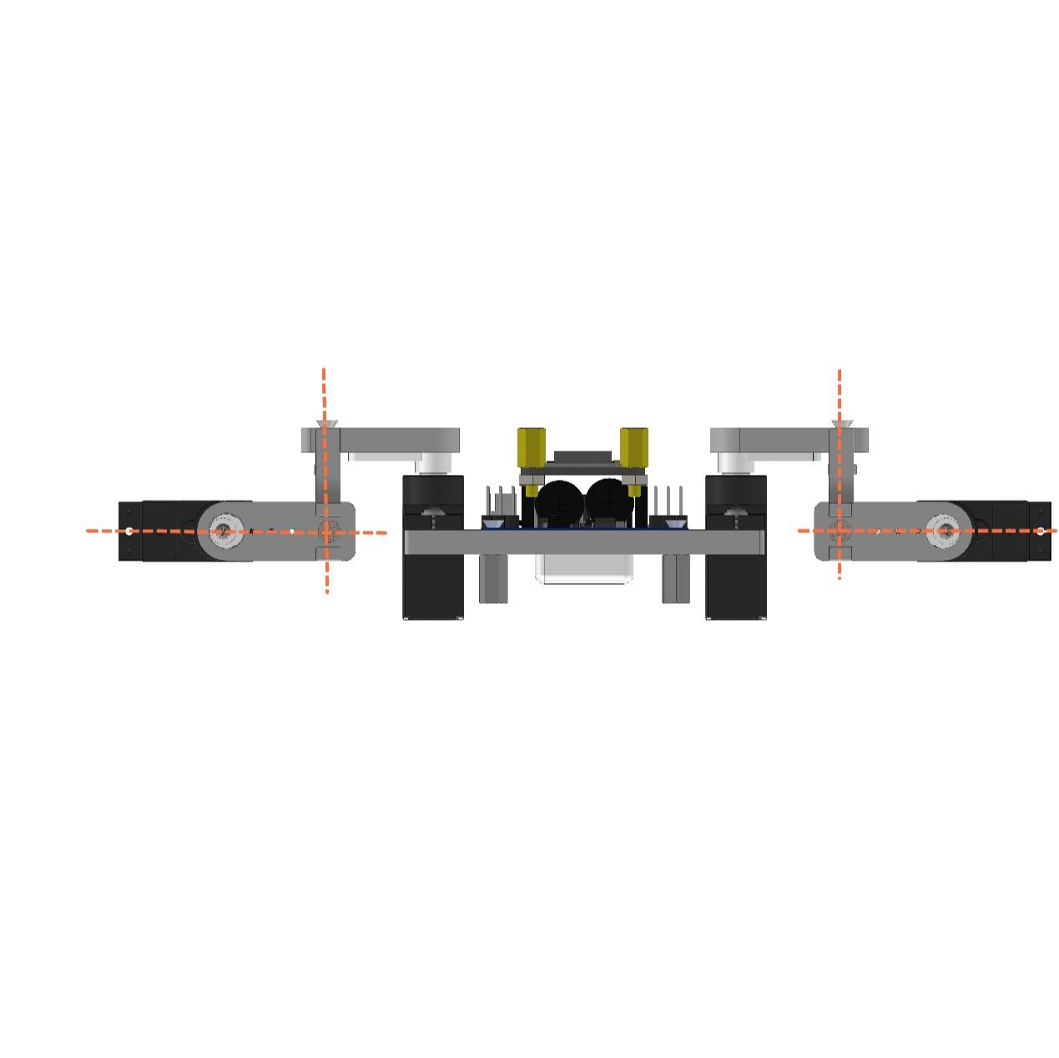

#### Step 12. Install the four legs

Install the structural Tibia with pointed screws from the servo bag, for example, shown as below picture

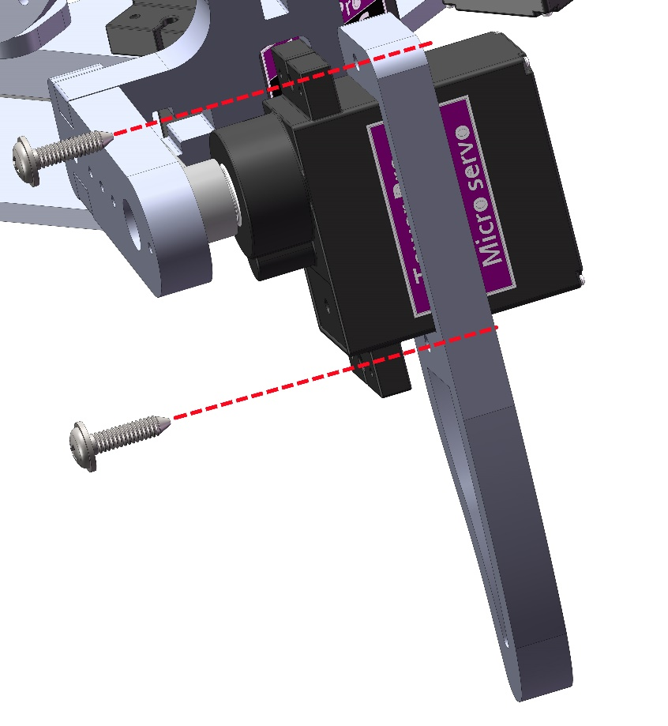

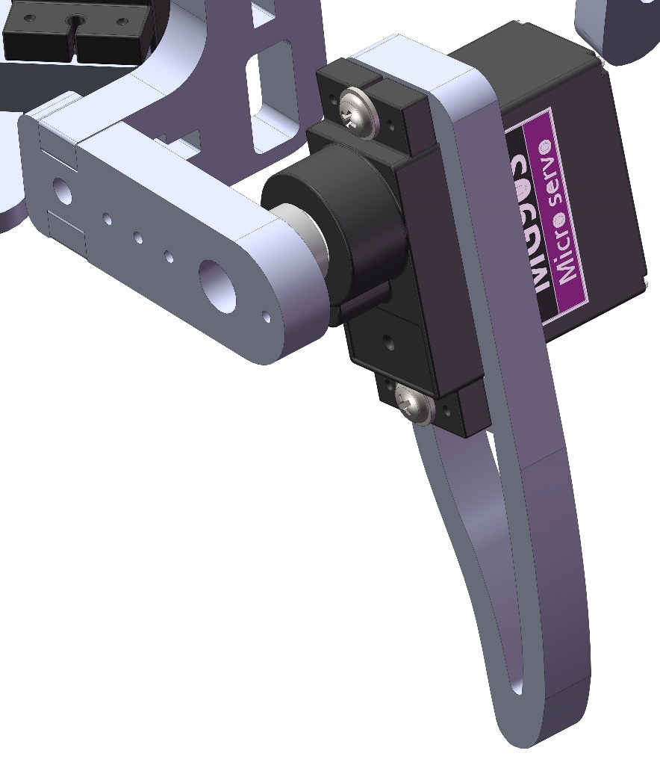

#### Step 13. Install the Body Top and Body Bottom

Arrange the cables and install the structural Body Top and Body Bottom, shown as below picture

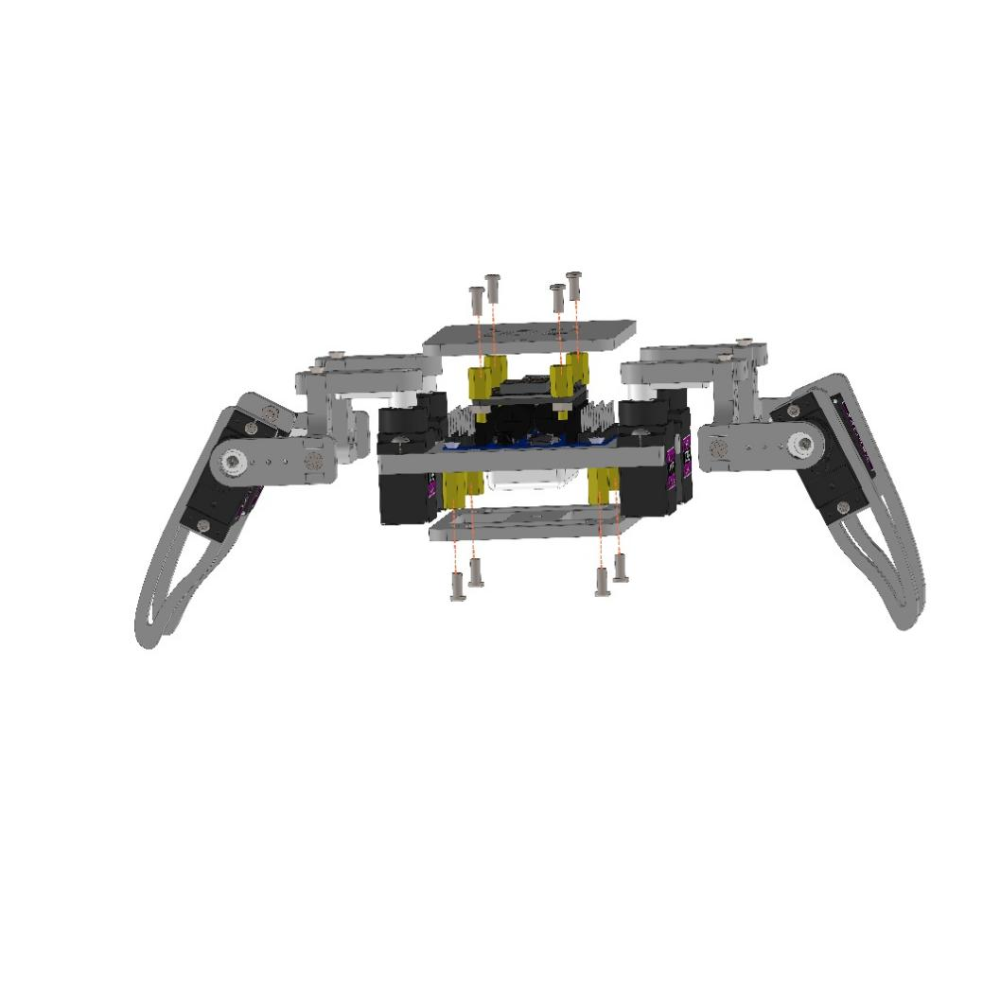

The appearance after installation is shown as below picture

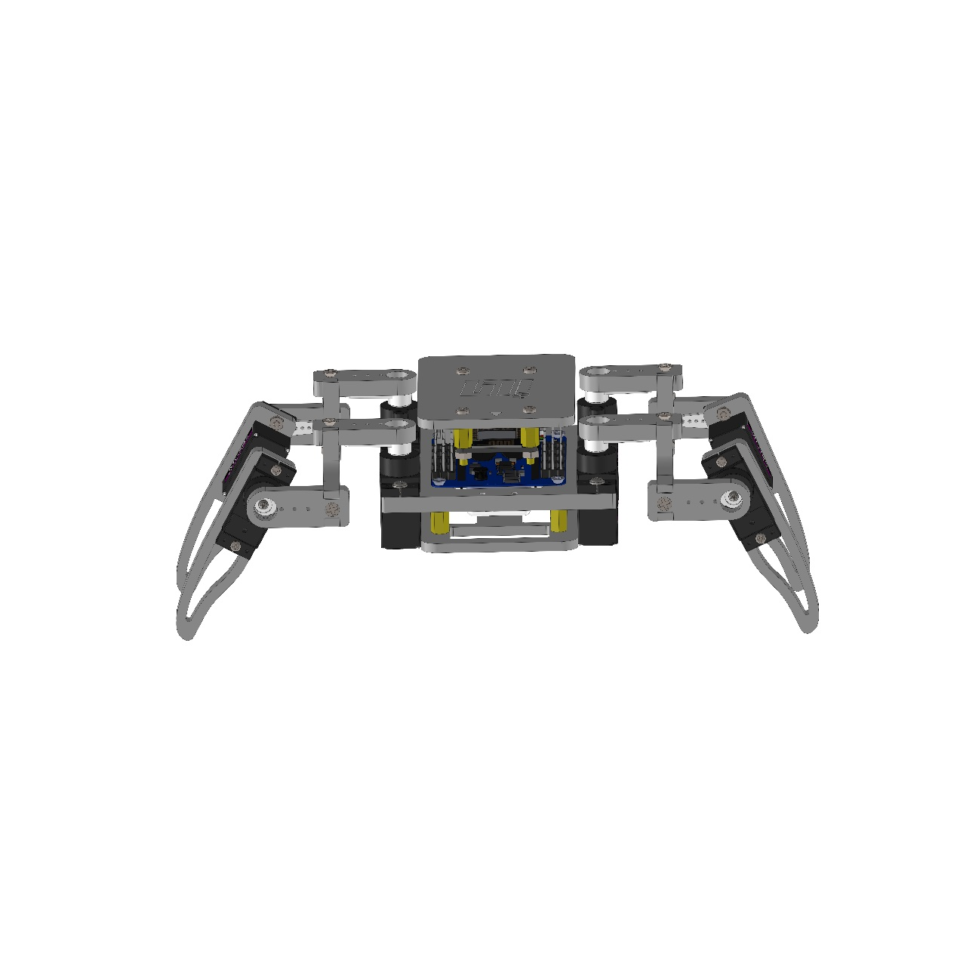

#### Step 14. Install the eyes

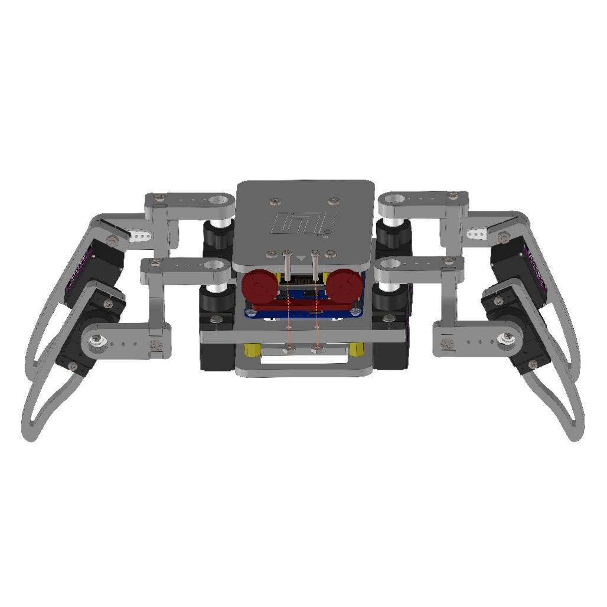

The appearance after installation is shown as below picture

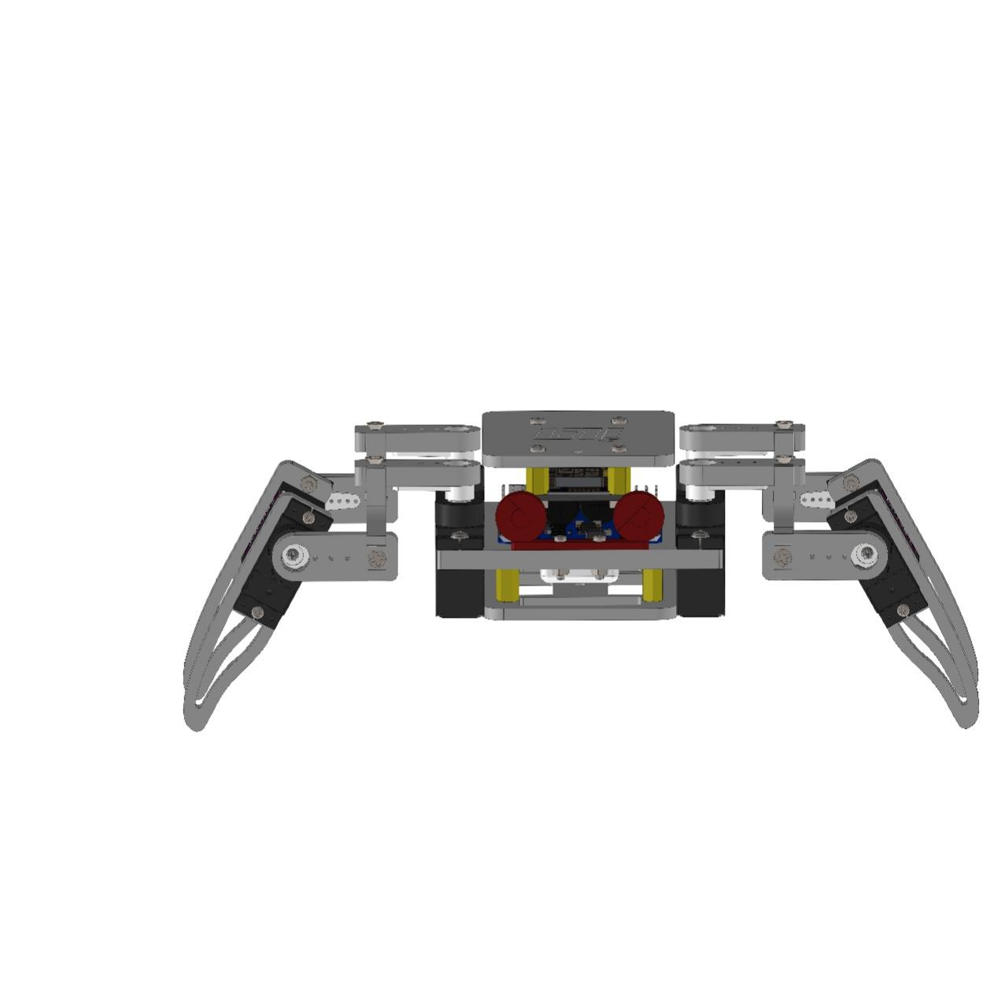

Finally congratulate that you finish installing the quadruped robot

## 3 Control experience

Fully charge the battery. Turn on the switch. If you use the iPhone to control, it is only supported use the web app to control temporarily, we will update the ios app as soon as possible; If you use an Android phone, you can use both web page and APP to control.

### 3.1 Use web page control

Use the mobile phone or computer scans WIFI (turn off shared networks such as GPRS and make sure that WIFI is the only network used)， connects the wifi hotspot named “Robot XXX”, the password is 12345678, shown as below picture

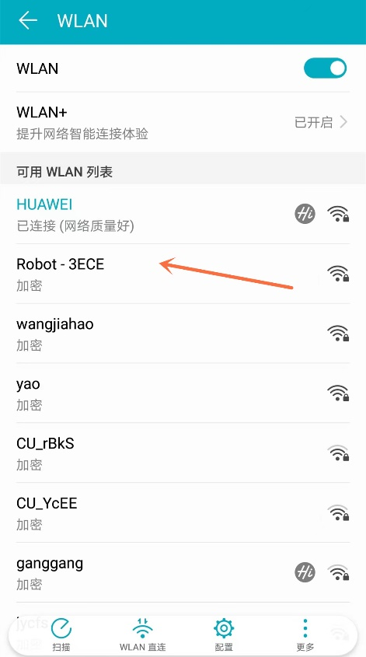

#### 3.1.1 Calibration

#### After connecting successfully, open the mobile phone or computer's web browser (finishing this step by computer is recommended), and enter the website http://192.168.4.1/setting ,And the interface as shown in below picture

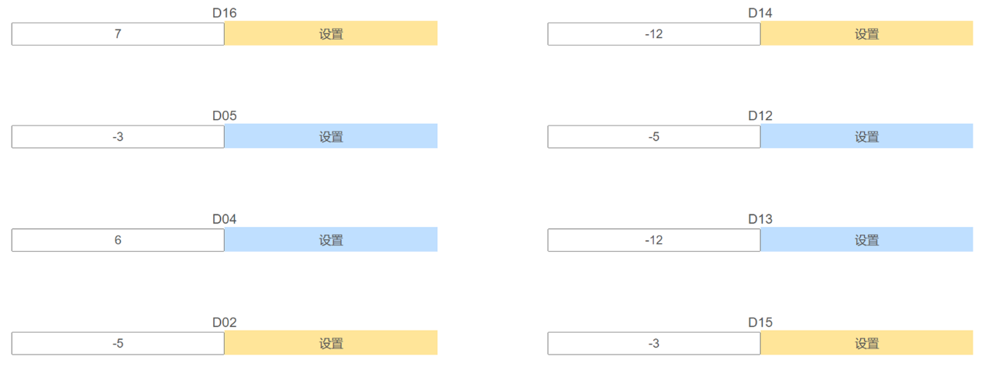

Open another page at the same time and enter the website address http://192.168.4.1/zero , the interface as shown in below picture

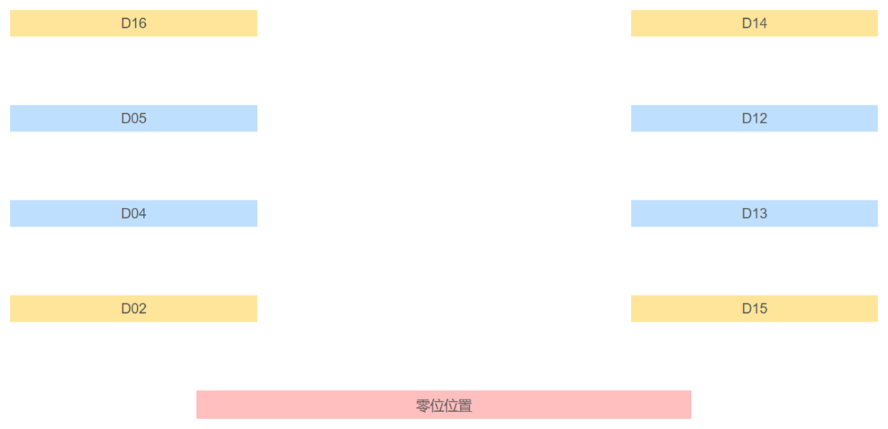

Forward the robot head, for example with the servo motors calibration in the upper left, the other servo motorss are the same.

Enter a number in the D16 input box, (it can support both positive and negative, they are represent turn around to positive or negative). Then click the "Setting" button, and switch web to http://192.168.4.1/zero, click D16 and you can see the vision adjusted . By analogy, calibrate the other 7 servo motorss， the final calibration is shown as below picture

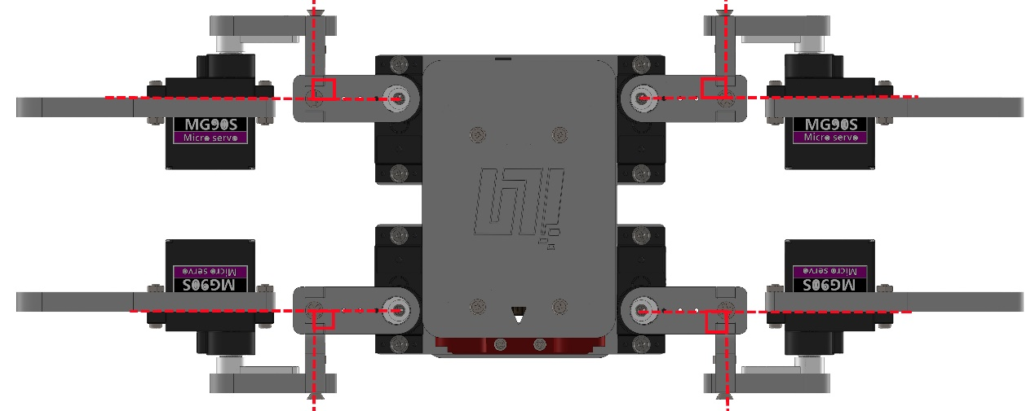

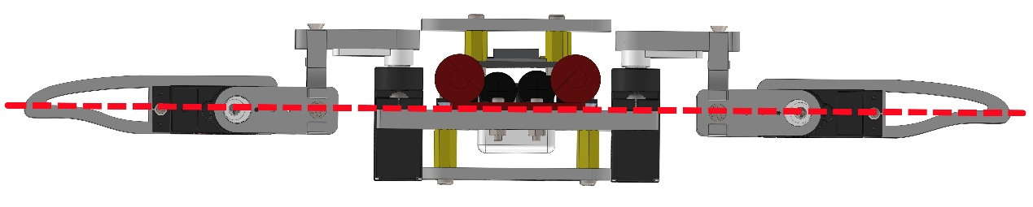

#### 3.1.2 Key remote control

Enter the control page address:192.168.4.1in the mobile phone or computer web browser, and the following interface will appear if it is correct

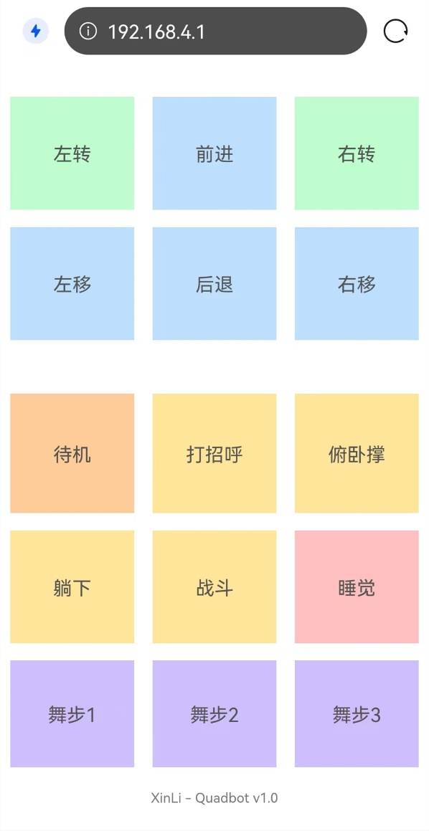

At this time, you can control the robot according to the text prompts on the page.

### 3.2 Control with Android APP

If you need to experience the voice control function, please search and install XunfeiYuJi or iFLYTEK Voice+in the application market, after setting. locate the APP directory in the tutorials and install QuanBot-E.apk. The interface shown as below picture

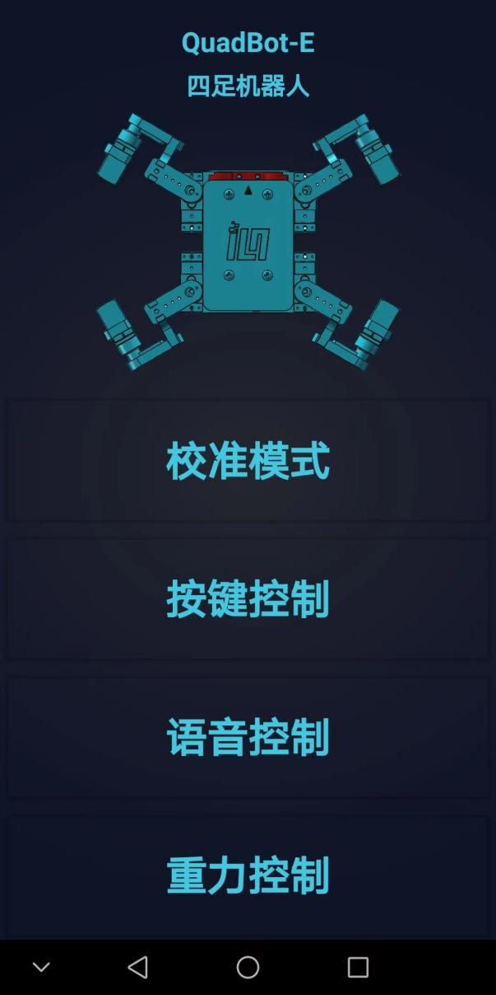

The mobile phone or computer wireless network scans WIFI (turn off shared networks such as GPRS and make sure that WIFI is the only network used), connects the wifi hotspot named “Robot XXX”, and the password is 12345678, shown as below picture🡪



#### 3.2.1 Calibration mode

#### 3.2.2 Key control mode

Click the "Key Control" button to enter the key control mode and get the following interface

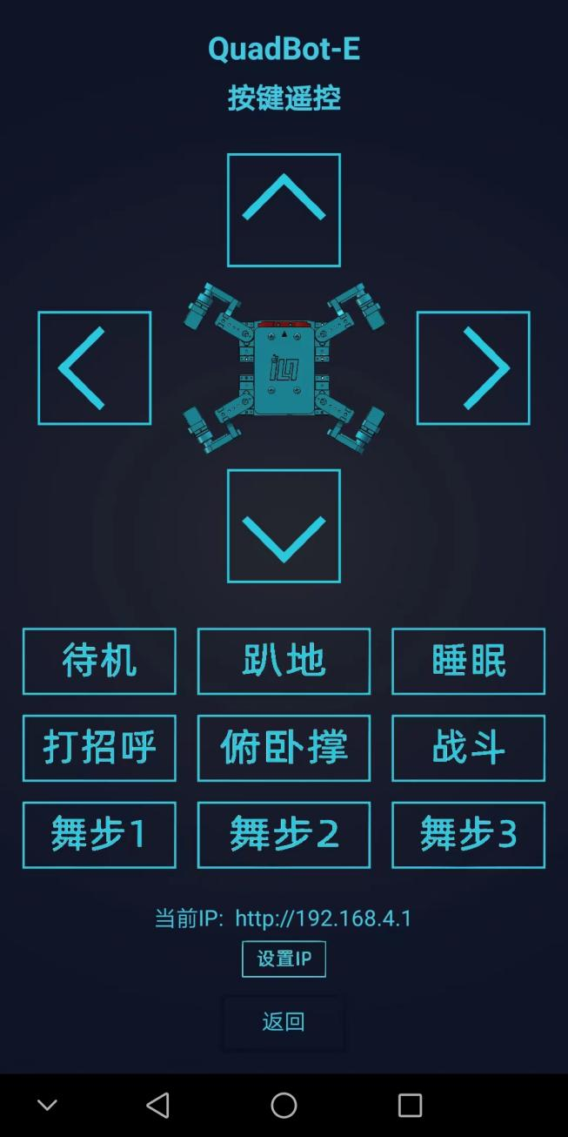

Then you can control the robot according to the key prompts.

3.2.3 Gyro mode

Enter the homepage, click the "Gravity Control" button to enter the Gyro mode, and get the following interface

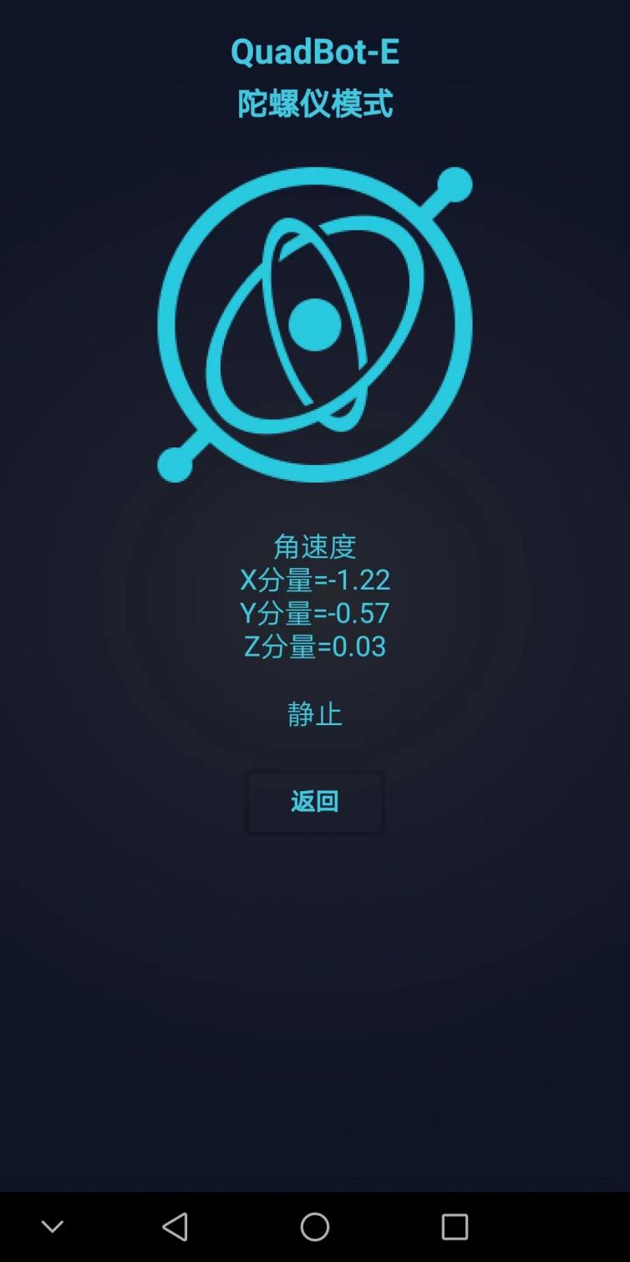

Rotate the mobile phone forward substantially, the robot moves forward; Rotating backward, and the robot backward; The mobile phone rotates to the left and the robot moves to the left; The mobile phone rotates to the right and the robot moves to the right; Make the mobile phone Lay flat and rotate clockwise, the robot turn right, make the mobile phone Lay flat and rotate anti-clockwise, the robot turn left.

#### 3.2.4 Voice control mode

Here we need using the online voice-recognition, so please install google speech in the APP shop advance, after setting. You need to switch the robot from wireless hotspot mode to router mode,the operations are as follows:

Firstly, enter to the tutorials package provided by us, locate "**03 Tutorial & Code 🡪 Arduino 🡪 Lesson4 WIFI_STA Mode🡪 QuadBot-E-V1.5**", and double-click to open **QuadBot-E-V1.5.ino**,shown as below picture

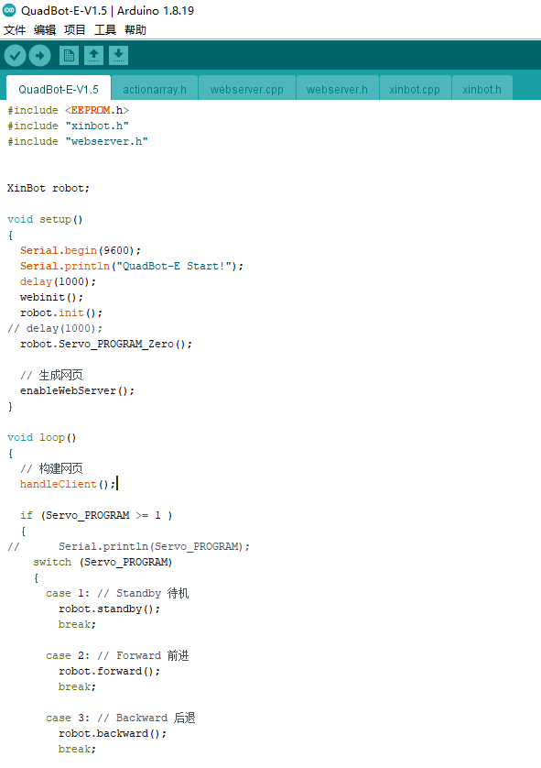

Click "webserver.cpp", shown as below picture

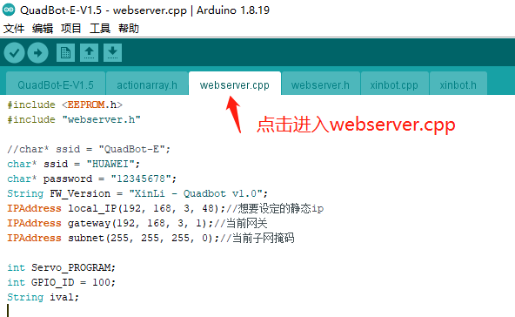

Modify the SSID password, customize IP and gateway information according to your router information. shown as below picture,

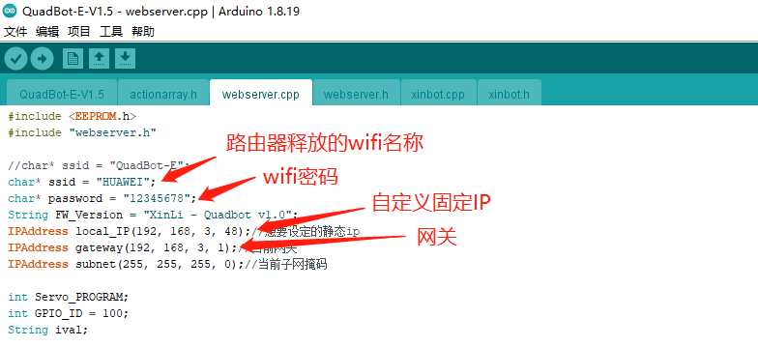

For the gateway query method, click the keyboard “win+r”, and the following page pops up at the lower left corner of the computer,

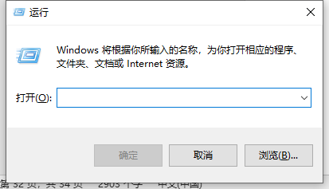

Input “cmd” in the input box

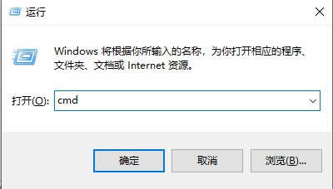

Click OK to open the following interface

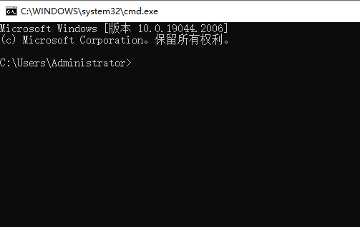

Input “ipconfig” on the terminal, and then press Enter to get the network information

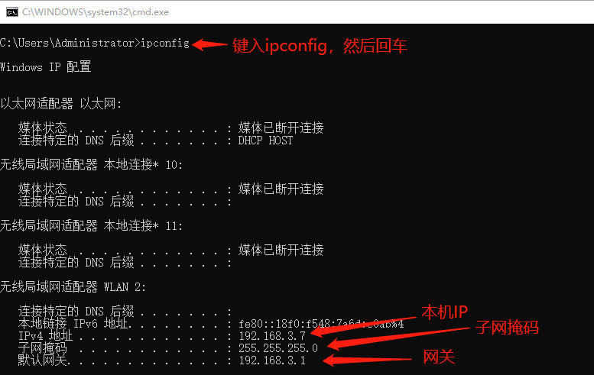

Fill the gateway and subnet mask queried here into the above program， customized fixed IP must be different from the local IP, but it needs to be in the same network segment as the gateway. For example, if the gateway is 192.168.3.1, the customized IP should be 192.168.3.xxx

After setting, upload the program code to the motherboard one-chip Computer.

After uploading the program code, enter the APP home page and click the "Voice Control" button, and turn to the following interface

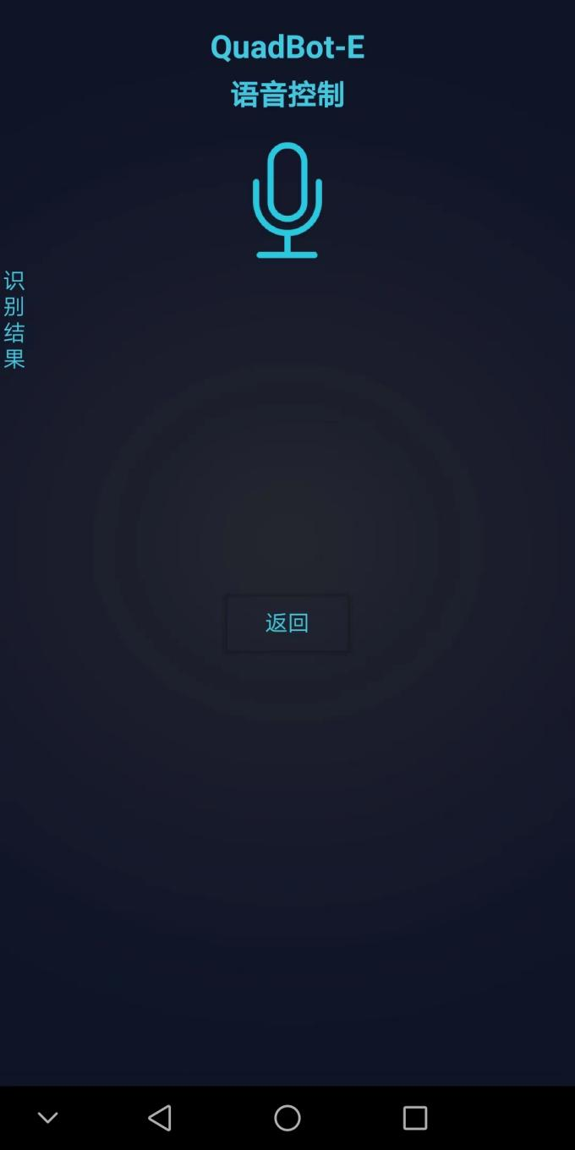

Press the microphone, and speak the word "forward", "backward", "turn left", "turn right" and "standby" to the mobile phone. After releasing the button, the robot will act according to the instructions.

## 4 Graphic courses

The graphical course need using Mixly graphical programming. For details, please refer the tutorials "Mixly Playing QuadBot-E Quadruped Spider Robot.pdf" in the "Course" and "Graphical Programming"