Retail Customer Segmentation Data lake and Analytics

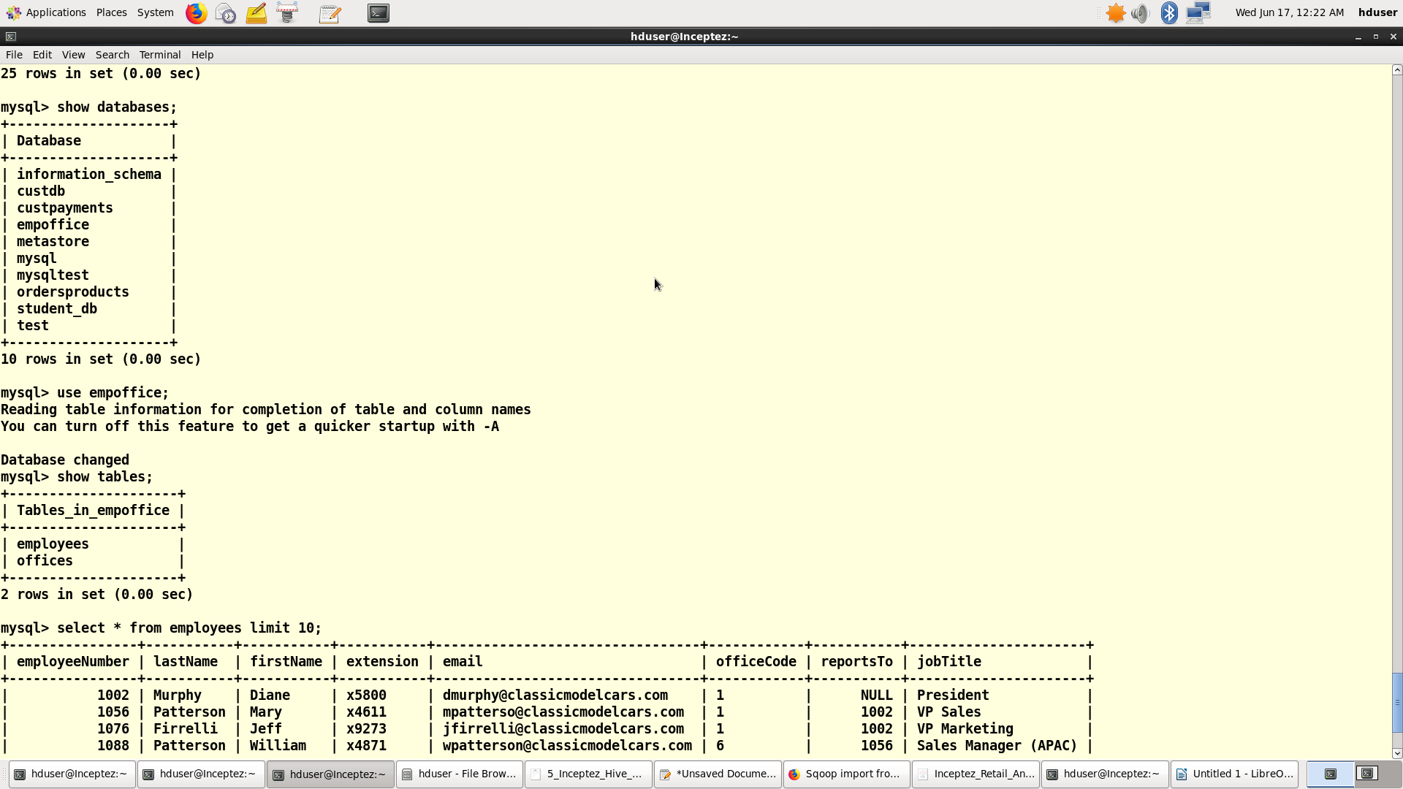

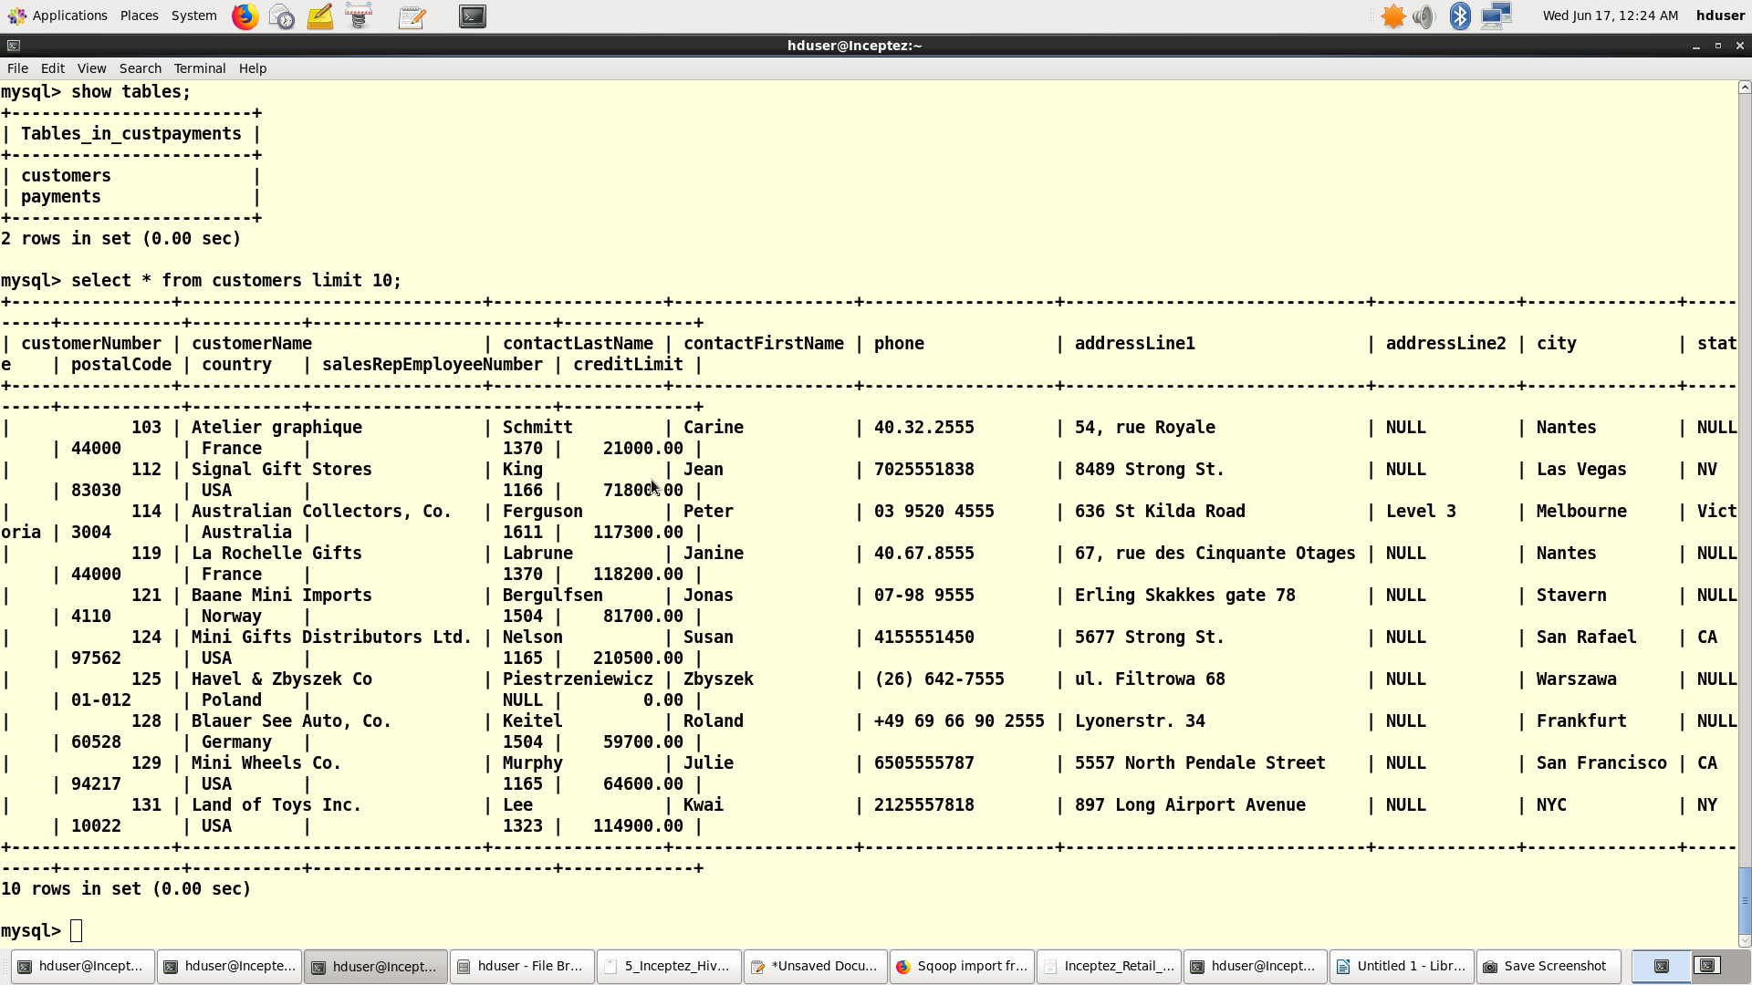

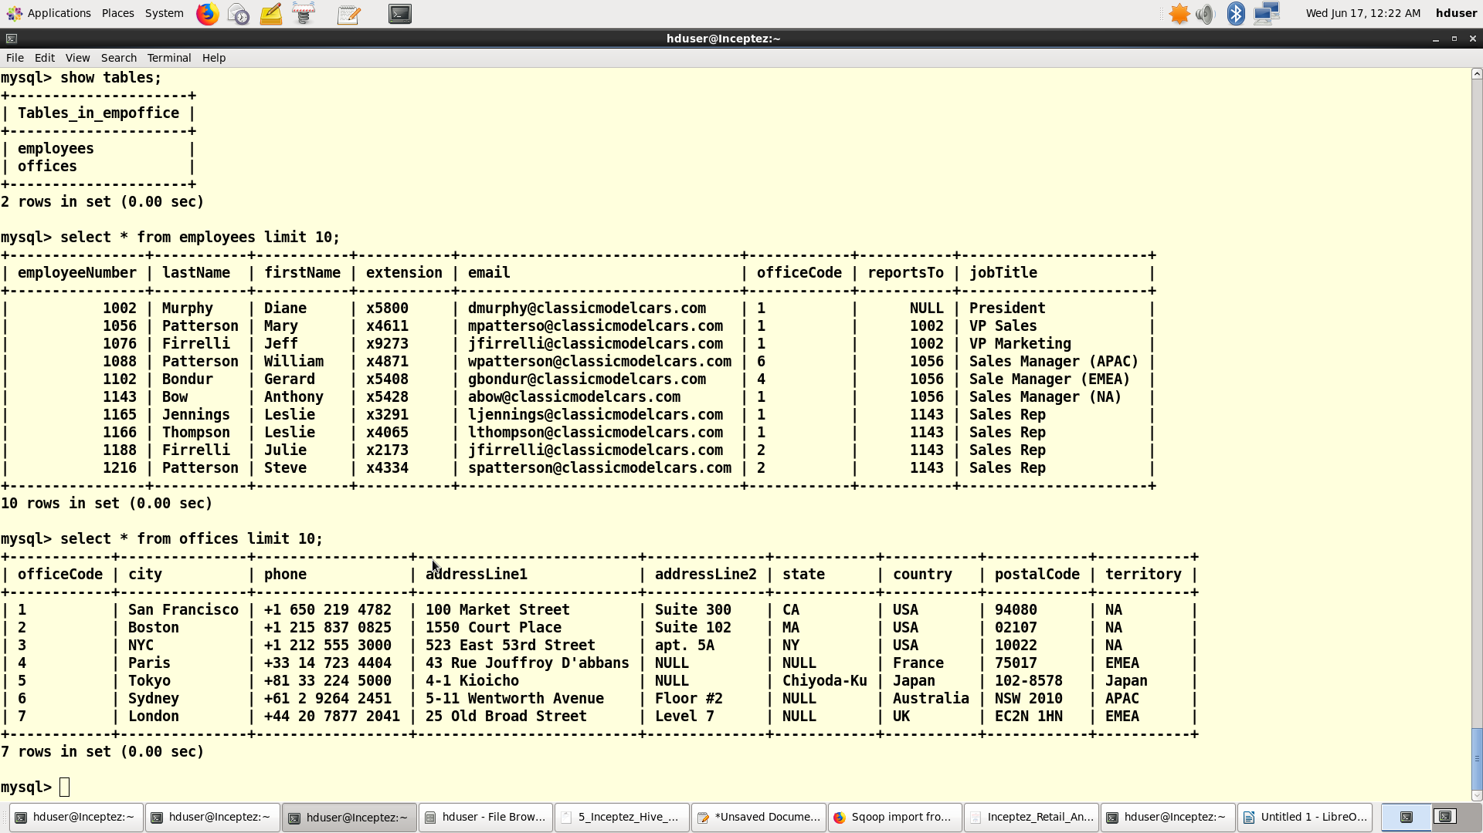
Run the below Sqoop import commands with options file, password file, boundary query, query, split by,delete target directory, null string, direct mode, ~ delimiter, reading without splitby column with primary key as split by

Import the employees table from the DB
sqoop --options-file /home/hduser/retailorders/empofficeoption --password-file /user/hduser/retailorders/root.password -table employees -m 2 --delete-target-dir --target-dir employees/ -fields-terminated-by '~' --lines-terminated-by '\n';

[hduser@Inceptez ~]$ hadoop fs -cat /user/hduser/employees/* |head -2
20/06/17 01:04:53 WARN util.NativeCodeLoader: Unable to load native-hadoop library for your platform... using builtin-java classes where applicable
1002~Murphy~Diane~x5800~dmurphy@classicmodelcars.com~1~null~President
1056~Patterson~Mary~x4611~mpatterso@classicmodelcars.com~1~1002~VP Sales

Import the offices table from the DB
sqoop --options-file /home/hduser/retailorders/empofficeoption --password-file /user/hduser/retailorders/root.password -table offices -m 1 --delete-target-dir --target-dir offices/ --fields-terminated-by '~' --lines-terminated-by '\n';

[hduser@Inceptez ~]$ hadoop fs -cat /user/hduser/offices/* |head -2
20/06/17 01:05:59 WARN util.NativeCodeLoader: Unable to load native-hadoop library for your platform... using builtin-java classes where applicable
1~San Francisco~+1 650 219 4782~100 Market Street~Suite 300~CA~USA~94080~NA
2~Boston~+1 215 837 0825~1550 Court Place~Suite 102~MA~USA~02107~NA

Import the Customer and payments data joined with most of the options used for better optimization and best
practices
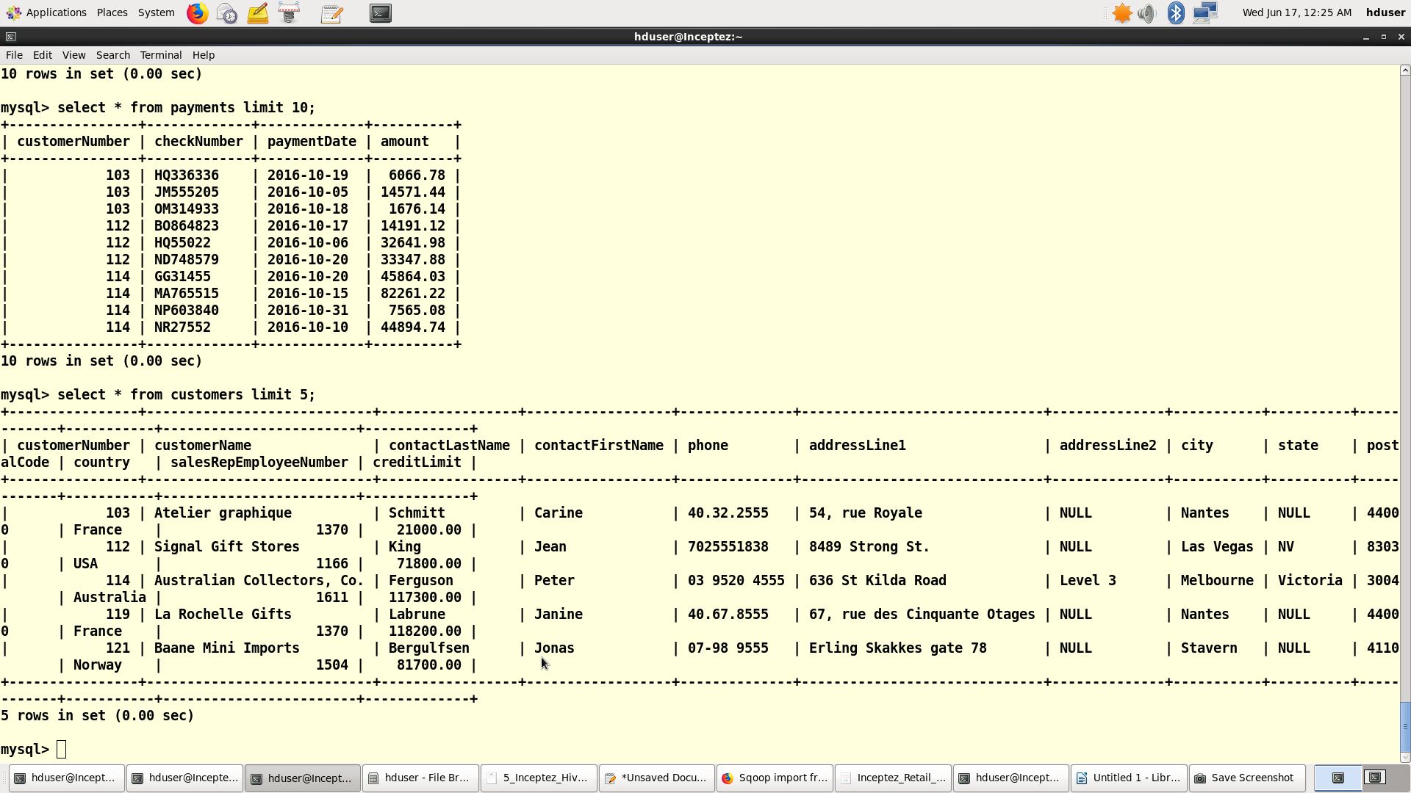
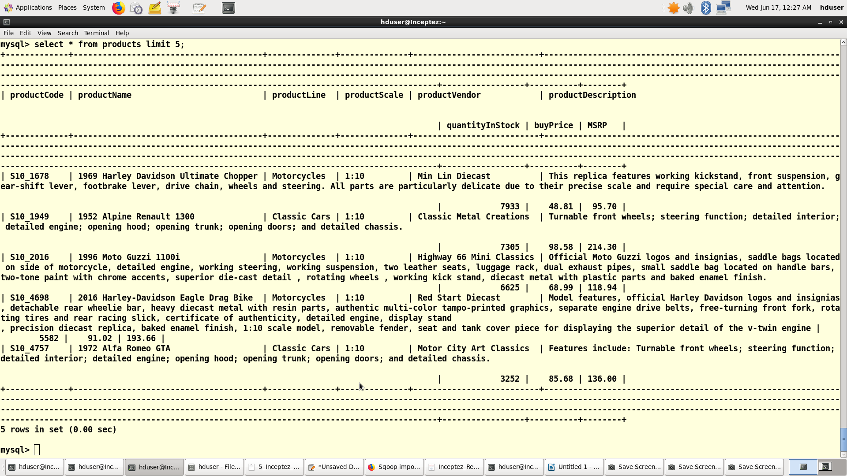
sqoop --options-file /home/hduser/retailorders/custoption --password-file /user/hduser/retailorders/root.password --boundary-query " select min(customerNumber),max(customerNumber) from payments " --query 'select c.customerNumber,upper(c.customerName),c.contactFirstName,c.contactLastName,c.phone,c.addressLine1,c.city,c.state,c.postalCode,c.country ,c.salesRepEmployeeNumber,c.creditLimit ,p.checknumber,p.paymentdate,p.amount from customers c inner join payments p on c.customernumber=p.customernumber where $CONDITIONS' --split-by c.customernumber --delete-target-dir --target-dir custdetails/2016-10/ --null-string 'NA' --direct --num-mappers 2 --fields-terminated-by '~' --lines-terminated-by '\n';

[hduser@Inceptez ~]$ hadoop fs -cat /user/hduser/custdetails/*/* |head -2
20/06/17 00:47:31 WARN util.NativeCodeLoader: Unable to load native-hadoop library for your platform... using builtin-java classes where applicable

103~ATELIER GRAPHIQUE~Carine ~Schmitt~40.32.2555~
54, rue Royale~Nantes~NA~44000~France~1370~21000.00~HQ336336~2016-10-19~6066.78

103~ATELIER GRAPHIQUE~Carine ~Schmitt~40.32.2555~
54, rue Royale~Nantes~NA~44000~France~1370~21000.00~JM555205~2016-10-05~14571.44

Import the orders, orderdetail and products data joined with most of the options used for better optimization
and best practices
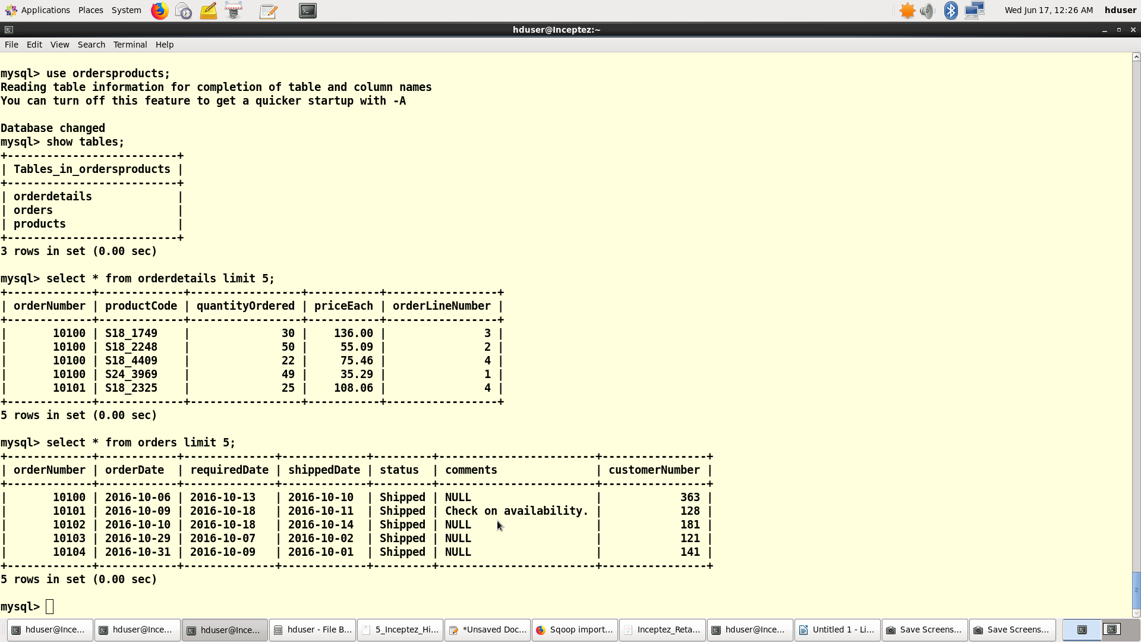

sqoop --options-file /home/hduser/retailorders/ordersoption --password-file /user/hduser/retailorders/root.password --boundary-query "select min(customerNumber),max(customerNumber) from orders" --query 'select o.customernumber,o.ordernumber,o.orderdate,o.shippeddate,o.status,o.comments,od.productcode,od.quantityordered, od.priceeach,od.orderlinenumber,p.productCode,p.productName,p.productLine,p.productScale,p.productVendor, p.productDescription,p.quantityInStock,p.buyPrice,p.MSRP from orders o inner join orderdetails od on o.ordernumber=od.ordernumber inner join products p on od.productCode=p.productCode where $CONDITIONS' --split-by o.customernumber --delete-target-dir --target-dir orderdetails/2016-10/ --null-string 'NA' --direct --num-mappers 4 --fields-terminated-by '~' --lines-terminated-by '\n';

[hduser@Inceptez ~]$ hadoop fs -cat /user/hduser/orderdetails/*/* |head -2
128~10101~2016-10-09~2016-10-11~Shipped~Check on availability.~S18_2325~25~108.06~4~S18_2325~1932 Model A Ford J-Coupe~Vintage Cars~1:18~Autoart Studio Design~This model features grille-mounted chrome horn, lift-up louvered hood, fold-down rumble seat, working steering system, chrome-covered spare, opening doors, detailed and wired engine~9354~58.48~127.13

128~10101~2016-10-09~2016-10-11~Shipped~Check on availability.~S18_2795~26~167.06~1~S18_2795~1928 Mercedes-Benz SSK~Vintage Cars~1:18~Gearbox Collectibles~This 1:18 replica features grille-mounted chrome horn, lift-up louvered hood, fold-down rumble seat, working steering system, chrome-covered spare, opening doors, detailed and wired engine. Color black.~548~72.56~168.75

Hive
1. Load the cust and order details data into hive tables from the above sqoop imported location.
2. Convert the custdetails data into complex data types (struct in hive).

1. Managed Table use case: Under staging retail_stg Database create temporary managed tables, Load the
sqoop imported data into the below managed table that will be dropped and recreated on daily basis so
data will be cleaned when dropped, if we use external table we have to manage the data cleanup
separately as given below using the truncate statement.

create table custdetails(customerNumber string,customerName string,contactFirstName string,contactLastName
string,phone bigint,addressLine1 string,city string,state string,postalCode bigint,country
string,salesRepEmployeeNumber string,creditLimit float,checknumber string,paymentdate date, checkamt float)
row format delimited fields terminated by '~'
location '/user/hduser/custdetails/2016-10';

hive> show tables;
OK
custdetails
custdetstg
Time taken: 0.096 seconds, Fetched: 2 row(s)

hive> select * from custdetails limit 5;
OK
103 ATELIER GRAPHIQUE Carine Schmitt NULL 54, rue Royale Nantes NA 44000 France 1370 21000.0 HQ336336 2016-10-19 6066.78
103 ATELIER GRAPHIQUE Carine Schmitt NULL 54, rue Royale Nantes NA 44000 France 1370 21000.0 JM555205 2016-10-05 14571.44
103 ATELIER GRAPHIQUE Carine Schmitt NULL 54, rue Royale Nantes NA 44000 France 1370 21000.0 OM314933 2016-10-18 1676.14
112 SIGNAL GIFT STORES Jean King 7025551838 8489 Strong St. Las Vegas NV 83030 USA 1166 71800.0 BO864823 2016-10-17 14191.12
112 SIGNAL GIFT STORES Jean King 7025551838 8489 Strong St. Las Vegas NV 83030 USA 1166 71800.0 HQ55022 2016-10-06 32641.98
Time taken: 0.221 seconds, Fetched: 5 row(s)

create table custdetstg(customernumber STRING, customername STRING, contactfullname string, address
struct<addressLine1:string,city:string,state:string,postalCode:bigint,country:string,phone:bigint>, creditlimit
float,checknum string,checkamt int,paymentdate date)
row format delimited fields terminated by '~'
stored as textfile;

insert overwrite table custdetstg select customernumber,contactfirstname, concat(contactfirstname, ' ',
contactlastname) , named_struct('addressLine1', addressLine1, 'city', city, 'state', state, 'postalCode', postalCode,
'country', country, 'phone',phone), creditlimit,checknumber,checkamt,paymentdate from custdetails;

hive> select * from custdetstg limit 5;
OK
103 Carine Carine Schmitt {"addressline1":"54, rue Royale","city":"Nantes","state":"NA","postalcode":44000,"country":"France","phone":null} 21000.0 HQ336336 6066 2016-10-19
103 Carine Carine Schmitt {"addressline1":"54, rue Royale","city":"Nantes","state":"NA","postalcode":44000,"country":"France","phone":null} 21000.0 JM555205 14571 2016-10-05
103 Carine Carine Schmitt {"addressline1":"54, rue Royale","city":"Nantes","state":"NA","postalcode":44000,"country":"France","phone":null} 21000.0 OM314933 1676 2016-10-18
112 Jean Jean King {"addressline1":"8489 Strong St.","city":"Las Vegas","state":"NV","postalcode":83030,"country":"USA","phone":7025551838} 71800.0 BO864823 14191 2016-10-17
112 Jean Jean King {"addressline1":"8489 Strong St.","city":"Las Vegas","state":"NV","postalcode":83030,"country":"USA","phone":7025551838} 71800.0 HQ55022 32641 2016-10-06
Time taken: 0.15 seconds, Fetched: 5 row(s)

truncate table orddetstg;

create external table orddetstg (customerNumber string, ordernumber string,orderdate date, shippeddate
date,status string, comments string, quantityordered int,priceeach decimal(10,2),orderlinenumber int,
productcode string, productName STRING,productLine STRING, productScale STRING,productVendor
STRING,productDescription STRING,quantityInStock int,buyPrice decimal(10,2),MSRP decimal(10,2))
row format delimited fields terminated by '~'
location '/user/hduser/orderdetails/2016-10/';

hive> select * from orddetstg limit 5;
OK
128 10101 2016-10-09 2016-10-11 Shipped Check on availability. NULL 25 108 4 S18_2325 1932 Model A Ford J-Coupe Vintage Cars1:18 Autoart Studio Design NULL 9354 58.48
128 10101 2016-10-09 2016-10-11 Shipped Check on availability. NULL 26 167 1 S18_2795 1928 Mercedes-Benz SSK Vintage Cars 1:18Gearbox Collectibles NULL 548 72.56
128 10101 2016-10-09 2016-10-11 Shipped Check on availability. NULL 45 32 3 S24_1937 1939 Chevrolet Deluxe Coupe Vintage Cars1:24 Motor City Art Classics NULL 7332 22.57
128 10101 2016-10-09 2016-10-11 Shipped Check on availability. NULL 46 44 2 S24_2022 1938 Cadillac V-16 Presidential Limousine Vintage Cars 1:24 Classic Metal Creations NULL 2847 20.61
181 10102 2016-10-10 2016-10-14 Shipped NA NULL 39 95 2 S18_1342 1937 Lincoln Berline Vintage Cars 1:18 Motor City Art Classics NULL 8693 60.62
Time taken: 0.163 seconds, Fetched: 5 row(s)

// Additional information :

To run as the above cmd using file:
hive -f /home/hduser/retailorders/staging_tbls.hql

use retail_stg;

drop table if exists custdetstg;

create table custdetstg(customernumber STRING, customername STRING, contactfullname string, address struct<addressLine1:string,city:string,state:string,postalCode:bigint,counrtry:string,phone:bigint>, creditlimit float,checknum string,checkamt int,paymentdate date)
row format delimited
fields terminated by '~'
collection items terminated by '$'
stored as textfile;

load data inpath '/user/hduser/retailsorders/custdetcomplextypes' overwrite into table custdetstg;

drop table if exists orddetstg;

create table orddetstg(customernumber STRING, ordernumber STRING, shippeddate date,status string, comments string,productcode string,quantityordered int,priceeach decimal(10,2),orderlinenumber int,productName STRING,productLine STRING,
productScale STRING,productVendor STRING,productDescription STRING,quantityInStock int,buyPrice decimal(10,2),MSRP decimal(10,2),orderdate date)
row format delimited
fields terminated by '~'
stored as textfile;

load data inpath '/user/hduser/retailsorders/orddetails/' overwrite into table orddetstg;

To run the above statements one after another by running outside hive cli ie from the linux terminal:
$ hive -e “use retail_stg; drop table if exists custdetstg;”

2. External tables with partition/bucketing usecases : Under retail_mart database create and load external
tables which is partitioned for applying where clauses and bucketed to join with the other external tables
more efficiently. Why we are creating as external table because we may keep on adding more data in this
table or performing more iterative queries without dropping it as we have to join these tables to produce
the final mart.

create external table custdetpartbuckext (customernumber STRING, customername STRING, contactfullname
string, address
struct<addressLine1:string,city:string,state:string,postalCode:bigint,country:string,phone:bigint>,creditlimit
float,checknum string,checkamt int) partitioned by (paymentdate date) clustered by (customernumber) INTO
3 buckets row format delimited fields terminated by '~' collection items terminated by '$'
stored as textfile location
'/user/hduser/custorders/custdetpartbuckext';

insert into table custdetpartbuckext partition(paymentdate) select customernumber,customername,
contactfullname, address ,creditlimit,checknum,checkamt,paymentdate from retail_stg.custdetstg ;

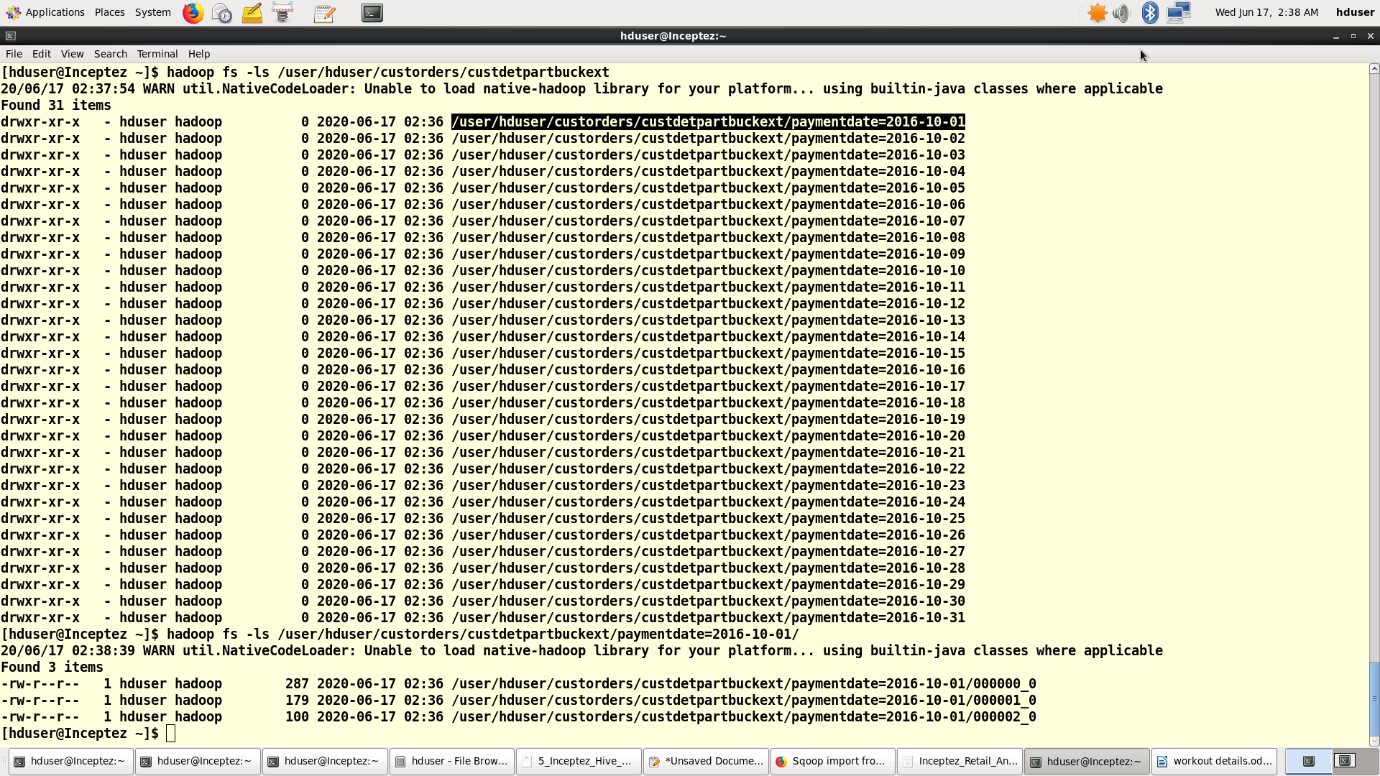
hive> select * from custdetpartbuckext limit 3;
OK

custdetpartbuckext.customernumber custdetpartbuckext.customername custdetpartbuckext.contactfullname custdetpartbuckext.address custdetpartbuckext.creditlimit custdetpartbuckext.checknum custdetpartbuckext.checkamt custdetpartbuckext.paymentdate
189 Dean Dean Cassidy {"addressline1":"25 Maiden Lane","city":"Dublin","state":"NA","postalcode":2,"country":"Ireland","phone":null} 69400.0 NM916675 325382016-10-01
141 Diego Diego Freyre {"addressline1":"C/ Moralzarzal, 86","city":"Madrid","state":"NA","postalcode":28034,"country":"Spain","phone":null} 227600.0 DB583216 36140 2016-10-01
333 Ben Ben Calaghan {"addressline1":"31 Duncan St. West End","city":"South Brisbane","state":"Queensland","postalcode":4101,"country":"Australia","phone":null} 51600.0 NF959653 21432 2016-10-01
Time taken: 0.17 seconds, Fetched: 3 row(s)

create external table orddetpartbuckext(customernumber STRING, ordernumber STRING, shippeddate
date,status string, comments string,productcode string,quantityordered int,priceeach
decimal(10,2),orderlinenumber int,productName STRING,productLine STRING, productScale
STRING,productVendor STRING,productDescription STRING,quantityInStock int,buyPrice
decimal(10,2),MSRP decimal(10,2)) partitioned by (orderdate date)
clustered by (customernumber) INTO 3 buckets
row format delimited fields
terminated by '~' collection items
terminated by '$'
stored as textfile location
'/user/hduser/custorders/orddetpartbuckext';

insert into table orddetpartbuckext partition(orderdate) select customernumber,ordernumber,
shippeddate,status,comments,productcode,quantityordered ,priceeach ,orderlinenumber ,productName
,productLine,
productScale,productVendor,productDescription,quantityInStock,buyPrice,MSRP,orderdate from
retail_stg.orddetstg ;

[hduser@Inceptez ~]$ hadoop fs -ls /user/hduser/custorders/orddetpartbuckext/
20/06/17 02:19:25 WARN util.NativeCodeLoader: Unable to load native-hadoop library for your platform... using builtin-java classes where applicable
Found 2 items
drwxr-xr-x - hduser hadoop 0 2020-06-17 02:19 /user/hduser/custorders/orddetpartbuckext/.hive-staging_hive_2020-06-17_02-18-21_437_2179437229204903098-1
drwxr-xr-x - hduser hadoop 0 2020-06-17 02:19 /user/hduser/custorders/orddetpartbuckext/orderdate=2016-10-14

[hduser@Inceptez ~]$ hadoop fs -ls /user/hduser/custorders/orddetpartbuckext/orderdate=2016-10-14/
20/06/17 02:21:12 WARN util.NativeCodeLoader: Unable to load native-hadoop library for your platform... using builtin-java classes where applicable
Found 3 items
-rw-r--r-- 1 hduser hadoop 3456 2020-06-17 02:19 /user/hduser/custorders/orddetpartbuckext/orderdate=2016-10-14/000000_0
-rw-r--r-- 1 hduser hadoop 3869 2020-06-17 02:19 /user/hduser/custorders/orddetpartbuckext/orderdate=2016-10-14/000001_0
-rw-r--r-- 1 hduser hadoop 2609 2020-06-17 02:19 /user/hduser/custorders/orddetpartbuckext/orderdate=2016-10-14/000002_0

hive> select * from orddetpartbuckext limit 5;
OK
orddetpartbuckext.customernumber orddetpartbuckext.ordernumber orddetpartbuckext.shippeddate orddetpartbuckext.status orddetpartbuckext.comments orddetpartbuckext.productcode orddetpartbuckext.quantityordered orddetpartbuckext.priceeach orddetpartbuckext.orderlinenumber orddetpartbuckext.productnameorddetpartbuckext.productline orddetpartbuckext.productscale orddetpartbuckext.productvendor orddetpartbuckext.productdescription orddetpartbuckext.quantityinstock orddetpartbuckext.buyprice orddetpartbuckext.msrp orddetpartbuckext.orderdate

141 10386 2016-10-06 Resolved Disputed then Resolved on 3/15/2016. Customer doesn't like the craftsmaship of the models. 7 NULL 25 130 S18_1662 1980s Black Hawk Helicopter Planes 1:18 Red Start Diecast NULL 5330 77.27 2016-10-01
141 10386 2016-10-06 Resolved Disputed then Resolved on 3/15/2016. Customer doesn't like the craftsmaship of the models. 18 NULL 21 72 S18_2581 P-51-D Mustang Planes 1:72 Gearbox Collectibles NULL 992 49 2016-10-01
141 10386 2016-10-06 Resolved Disputed then Resolved on 3/15/2016. Customer doesn't like the craftsmaship of the models. 5 NULL 37 73 S18_3029 1999 Yamaha Speed Boat Ships 1:18 Min Lin Diecast NULL 4259 51.61 2016-10-01
Time taken: 0.204 seconds, Fetched: 3 row(s)

3. Create a final external tables with orc and text format because it saves space and query will be executed
much faster, and why we are loading this final table with orc format is due to intermediate tables like staging
doesn’t require serialized data and is partitioned because we may apply date filter for querying this table and
not bucketed because we will not joining this final table with any other table.

4. Index the high cardinal values.
The below table marked in red is a orc table without partition and the later table marked in blue is partitioned
table without orc, do a benchmark after creating and loading tables running queries.
create external table custordfinal (

customernumber STRING, customername STRING, contactfullname string, addressLine1 string,city string,state
string,country string,phone bigint,creditlimit float,checknum string,checkamt int,ordernumber STRING,
shippeddate date,status string, comments string,productcode string,quantityordered int,priceeach
decimal(10,2),orderlinenumber int,productName STRING,productLine STRING,productScale
STRING,productVendor STRING,productDescription STRING,quantityInStock int,
buyPrice decimal(10,2),MSRP decimal(10,2),orderdate date)
row format delimited fields terminated by '~' stored as orcfile
location '/user/hduser/custorders/custordfinal';

insert into table custordfinal
select cd.customernumber,cd.customername, cd.contactfullname,
cd.address.addressLine1,cd.address.city,cd.address.state,cd.address.counrtry,cd.address.phone
,cd.creditlimit,cd.checknum,cd.checkamt,
o.ordernumber,
o.shippeddate,o.status,o.comments,o.productcode,o.quantityordered ,o.priceeach
,o.orderlinenumber ,o.productName ,o.productLine,
productScale,o.productVendor,o.productDescription,o.quantityInStock,o.buyPrice,o.MSRP,o.orderdate from
custdetpartbuckext cd inner join orddetpartbuckext o on cd.customernumber=o.customernumber ;

create external table custordpartfinal (
customernumber STRING, customername STRING, contactfullname string, addressLine1 string,city string,state
string,country string,phone bigint,creditlimit float,checknum string,checkamt int,ordernumber STRING,
shippeddate date,status string, comments string,productcode string,quantityordered int,priceeach
decimal(10,2),orderlinenumber int,productName STRING,productLine STRING,productScale
STRING,productVendor STRING,productDescription STRING,quantityInStock int,buyPrice decimal(10,2),MSRP
decimal(10,2),orderdate date) partitioned by (paymentdate date) row format delimited fields terminated by '~'
stored as textfile
location '/user/hduser/custorders/custordpartfinal';

create index idx_custordpartfinal_phone on table custordpartfinal(phone) AS
'org.apache.hadoop.hive.ql.index.compact.CompactIndexHandler' WITH DEFERRED REBUILD;
insert into table custordpartfinal partition(paymentdate) select
cd.customernumber,cd.customername, cd.contactfullname,
cd.address.addressLine1,cd.address.city,cd.address.state,cd.address.counrtry,cd.address.phone
,cd.creditlimit,cd.checknum,cd.checkamt,
o.ordernumber, o.shippeddate,o.status,o.comments,o.productcode,o.quantityordered ,o.priceeach
,o.orderlinenumber ,o.productName ,o.productLine,
productScale,o.productVendor,o.productDescription,o.quantityInStock,o.buyPrice,o.MSRP,o.orderdate,cd.payme
ntdate
from custdetpartbuckext cd inner join orddetpartbuckext o on cd.customernumber=o.customernumber ;

Result:
Table with Orc is faster than Table with Partition while runnig quries.

From Step 5: Customer Frustration use case is available in Customer frustration.odt file.

Hive – Hbase Integeration

6. Linux - Copy all hbase lib files to hive lib directories and add the below env variable:

cp /usr/local/hbase/lib/hbase-common-0.98.4-hadoop2.jar /usr/local/hive/lib/
cp /usr/local/hbase/lib/zookeeper-3.4.6.jar /usr/local/hive/lib/
cp /usr/local/hbase/lib/guava-12.0.1.jar /usr/local/hive/lib/
cp /usr/local/hbase/lib/hbase-protocol-0.98.4-hadoop2.jar /usr/local/hive/lib/
cp /usr/local/hbase/lib/hbase-server-0.98.4-hadoop2.jar /usr/local/hive/lib/

cd /usr/local/hive/conf/
mv hive-env.sh.template hive-env.sh

vi hive-env.sh
export HIVE_AUX_JARS_PATH=/usr/local/hbase/lib

# Ensure zookeeper and hbase are started:
zkServer.sh start
start-hbase.sh

7. Start Hive cli invoking hbase libraries to connect to hbase and zookeeper with hive.
Comments : To use hbase handler using hive if habse lib are not included hive aux path

hive --auxpath /usr/local/hive/lib/hive-hbase-handler-0.14.0.jar , /usr/local/hive/lib/hbase-common-
0.98.4hadoop2.jar , /usr/local/hive/lib/zookeeper-3.4.6.jar , /usr/local/hive/lib/guava-12.0.1.jar
,/usr/local/hive/lib/hbase-protocol-0.98.4-hadoop2.jar , /usr/local/hive/lib/hbase-server-0.98.4-hadoop2.jar
hiveconf hbase hbase.master=masternode:60000 hive.root.logger=INFO,console
hbase.zookeeper.quorum=localhost:2181

8. Create the hive hbase handler table and load the data into hive table by insert select, which in turns loads to
hbase table mapping the column family and columns. Here reflect("java.util.UUID", "randomUUID") is used to
create sequence number.

use retail_mart;

CREATE TABLE custordprodtbl (key varchar(100),customernumber varchar(100),productLine varchar(100),state
varchar(100),city varchar(100),creditlimit float,checknum varchar(200),checkamt float,ordernumber
varchar(200),status varchar(100),
comments varchar(4000),productcode varchar(100),quantityordered int,priceeach decimal(10,2),productName
varchar(1000),buyPrice decimal(10,2),MSRP decimal(10,2),orderdate date,paymentdate date)
STORED BY 'org.apache.hadoop.hive.hbase.HbaseStorageHandler' WITH SERDEPROPERTIES
("hbase.columns.mapping" = ":key,cust:custno,prod:prodline,cust:state,cust:city,cust:creditlimit,cust:checknum, cust:checkamt,ord:ordnum,ord:status,ord:comments,prod:prodcd,prod:qty,prod:price,prod:prodname,prod:buyprice,
prod:msrp,ord:orddt,cust:paydt")
TBLPROPERTIES ("hbase.table.name" = "custordproodtbl", "hbase.mapred.output.outputtable" ="custordprodtbl");

insert into table custordprodtbl SELECT reflect("java.util.UUID", "randomUUID") as
key,customernumber,productLine,state,city,creditlimit,checknum,checkamt,ordernumber,
status,comments,productcode,quantityordered ,priceeach ,productName,
buyPrice,MSRP,orderdate,paymentdate
from custordpartfinal;

// Table created successfully from hive into hbase;

9. Login to HBase to view the data generated in the hive handler table.

hbase shell
scan 'custordprodtbl'

10. Phoenix to create a table on top of hbase table to perform low latency queries.

stty cols 200
sqlline.py localhost
!set maxwidth 1000
create TABLE "custordprodtbl" ("key" varchar(100) PRIMARY KEY,"cust"."custno"
varchar(100),"prod"."prodline" varchar(100),"cust"."state" varchar(100),"cust"."city"
varchar(100),"cust"."creditlimit" float,"cust"."checknum" varchar(200),"cust"."checkamt" float,"ord"."ordnum"
varchar(200),"ord"."status" varchar(100),"ord"."comments" varchar(4000),"prod"."prodcd"
varchar(100),"prod"."qty" integer,"prod"."price" float,"prod"."prodname" varchar(1000),"prod"."buyprice"
float,"prod"."msrp" float,"ord"."orddt" varchar(10),"cust"."paydt" varchar(10));

select "cust"."custno","prod"."prodline","cust"."state","cust"."city","cust"."creditlimit","cust"."checkamt" from "custordprodtbl" WHERE "ord"."comments" like 'Custom%' limit 5;
