SRH University Heidelberg
Master's Thesis

AI-Assisted Design and Optimization using AutoML and Metaheuristic Algorithms
Master of Science (M.Sc.)
Applied Data Science and Analytics
Submitted by
Shunmugapriya Swamy
Enrollment No.: 100003722
Supervisors
Supervisor: Prof. Dr. Mehrdad Jalali
SRH University Heidelberg
Heidelberg, Germany
September 2026

Table of Contents
- Introduction
1.1 Introduction
1.2 Motivation
1.3 Problem Statement
1.4 Objectives
1.4.1 General Objective
1.4.2 Specific Objectives
1.5 Contributions
- Experimental Methodology and Evaluation Framework
2.1 Experimental Framework
2.2 Experimental Phases
- Methodology
3.1 Dataset-Specific Experimental Methodology
3.1.1 Water Potability Dataset
3.2 Solar Flare Dataset
3.3 Energy Efficiency Dataset
3.4 Electricity Dataset
3.5 Smart Grid Stability Dataset
3.6 Appliance Energy Prediction Dataset
3.7 Evaluation and Comparison of Optimization Methods
- Results
4.1 Water Potability Prediction
4.2 Solar Flare Prediction
4.3 Energy Efficiency Prediction
4.4 Electricity Prediction
4.5 Smart Grid Stability Prediction
4.6 Appliance Energy Prediction
- Discussion
- Conclusion and Future Work
- References
- Appendices

Introduction
The rapid development of Artificial Intelligence (AI) and Machine Learning (ML) has led to the widespread use of data-driven models in areas such as energy systems, smart grids, household energy consumption, and environmental monitoring. Developing an effective machine learning model, however, involves more than selecting an appropriate learning algorithm. The performance of a model can depend strongly on data preprocessing, feature representation, model architecture, and the selection of hyperparameters. Consequently, developing machine learning models can require substantial experimentation and computational resources.
Automated Machine Learning (AutoML) has emerged as an approach for reducing the amount of manual effort required during machine learning development. AutoML methods can automate tasks such as model configuration and hyperparameter optimization, allowing a search procedure to identify suitable configurations within a predefined search space. Common optimization approaches used in AutoML include Random Search, Bayesian Optimization, and Hyperband. Random Search explores configurations through stochastic sampling, Bayesian Optimization uses information from previous evaluations to guide subsequent evaluations, while Hyperband allocates computational resources adaptively among candidate configurations. These approaches provide different mechanisms for exploring and exploiting a machine learning hyperparameter search space.
However, hyperparameter optimization can become computationally demanding when the search space contains multiple architectural and training parameters. The optimization problem may also exhibit non-linear relationships between hyperparameters and model performance. In such settings, optimization methods that explore the search space differently can produce different convergence behaviours and computational requirements. This makes the systematic comparison of optimization strategies an important aspect of automated machine learning research.
Metaheuristic optimization methods provide another class of search strategies for complex optimization problems. These methods generally perform guided exploration of a search space using mechanisms designed to balance exploration and exploitation. The original research proposal therefore considered the integration of metaheuristic algorithms into an AutoML-oriented optimization framework, with particular interest in algorithms such as LEA and SOCIAL.
During the development of this thesis, the experimental framework was refined to investigate a broader set of optimization strategies. The implemented experiments include conventional search methods such as Random Search, Bayesian Optimization, and Hyperband, together with metaheuristic approaches including LEA, Teaching–Learning-Based Optimization (TLBO), Simulated Annealing (SA), and Differential Evolution (DE). The experiments were implemented across several benchmark datasets and were organized into multiple phases to progressively investigate baseline performance, hyperparameter optimization, extended optimization strategies, and controlled comparisons under computational resource constraints.
A further focus of the research is the fairness of optimizer comparison. Directly comparing optimization methods based only on their final performance can be misleading when the methods consume different amounts of computational resources. Therefore, the later experimental phase introduces controlled resource budgets so that optimization strategies can be compared according to their observed performance and convergence behaviour under comparable computational expenditure. This experimental design is particularly relevant for understanding whether an optimization strategy reaches useful configurations efficiently rather than simply obtaining a strong result after using substantially more computational resources.
The experimental study uses benchmark datasets representing different machine learning problems, including energy efficiency, appliance energy consumption, smart-grid stability, electricity-related prediction, solar flare classification, water quality prediction, and household electricity consumption. The datasets therefore provide different characteristics in terms of feature types, target distributions, class structure, temporal dependencies, and class imbalance. The implemented methodology adapts preprocessing and evaluation procedures to these characteristics while maintaining a common objective of investigating machine learning model optimization.
Overall, this thesis investigates the use of automated and metaheuristic optimization strategies for machine learning model development and evaluates their behaviour through predictive performance, convergence, and computational-resource considerations. The study is structured as a sequence of experimental phases, beginning with reproducible baseline models and progressing toward optimization and controlled optimizer comparison.

Motivation
The motivation for this research arises from the increasing computational complexity associated with developing and optimizing machine learning models. Although AutoML reduces the need for manual hyperparameter selection, the optimization process itself can require numerous model evaluations. As the number of possible configurations increases, determining an effective configuration within a limited computational budget becomes an important practical challenge.
Different optimization algorithms employ different search mechanisms and therefore may behave differently during the optimization process. A method that obtains a good configuration early in the search may be preferable in a resource-constrained setting to a method that requires substantially more evaluations before reaching a similar performance level. Consequently, evaluating only the final model performance does not provide a complete view of optimizer behaviour.
Another motivation is the need for controlled comparison. Optimization algorithms are often evaluated using different numbers of iterations, configurations, or computational resources, making direct comparisons difficult. This thesis therefore investigates optimizer convergence in addition to final predictive performance and introduces equal-resource-budget experiments in the later stage of the study.
The research is also motivated by the diversity of machine learning datasets. Optimization strategies may behave differently depending on the characteristics of the underlying data, including class imbalance, categorical variables, feature distributions, and temporal dependencies. Evaluating multiple benchmark datasets provides an opportunity to examine the behaviour of optimization strategies across different machine learning settings rather than drawing conclusions from a single dataset.
Finally, the research is motivated by the need to understand the practical relationship between model performance and optimization cost. Rather than treating hyperparameter optimization as an isolated search problem, this thesis examines the complete experimental process, including baseline establishment, optimization, convergence behaviour, computational resource usage, and final model evaluation.

Problem Statement
The development of machine learning models involves several decisions concerning preprocessing, model configuration, and hyperparameter selection. Although AutoML techniques can automate parts of this process, hyperparameter optimization can still require substantial computational resources, particularly when the search space contains multiple architectural and training parameters.
A further challenge arises when different optimization algorithms are compared. Differences in search mechanisms, numbers of evaluations, training resources, and stopping criteria can make it difficult to determine whether an observed performance difference is attributable to the optimization strategy itself or to differences in computational expenditure.
In addition, machine learning datasets can have substantially different characteristics. Class imbalance, categorical variables, temporal dependencies, and different target structures may require dataset-specific preprocessing and evaluation procedures. Consequently, an optimization approach that performs well for one dataset or problem formulation cannot automatically be assumed to behave similarly across other datasets.
The problem addressed in this thesis is therefore the systematic investigation of machine learning hyperparameter optimization strategies across heterogeneous benchmark datasets, with particular emphasis on predictive performance, convergence behaviour, and computational resource usage. The study further addresses the challenge of obtaining a controlled comparison between optimization strategies by introducing resource-budget-matched experiments in the later experimental phase.

1.4 Objectives

1.4.1 General Objective
The main objective of this thesis is to investigate and experimentally compare automated and metaheuristic optimization strategies for machine learning model development across multiple benchmark datasets, with emphasis on predictive performance, convergence behaviour, and computational resource usage.

1.4.2 Specific Objectives
- To establish reproducible baseline machine learning models for the selected benchmark datasets.
- To define consistent preprocessing, model-training, and evaluation procedures appropriate to the characteristics of each dataset.
- To investigate hyperparameter optimization using conventional approaches including Random Search, Bayesian Optimization, and Hyperband.
- To investigate metaheuristic optimization approaches including LEA, TLBO, Simulated Annealing, and Differential Evolution where implemented.
- To examine the convergence behaviour of the different optimization strategies during the search process.
- To compare optimization strategies using controlled computational resource budgets where implemented.
- To evaluate the optimized models using appropriate predictive performance metrics and independent evaluation data.
- To examine dataset-specific factors, including class imbalance and temporal structure, that affect the optimization and model evaluation process.
- To analyse the relationship between predictive performance and computational optimization cost.

1.5 Contributions
The contributions of this thesis are:
- A structured experimental framework for machine learning optimization.
The thesis organizes model development and optimization into sequential experimental phases covering baseline establishment, hyperparameter optimization, extended optimization experiments, and controlled resource-budget comparison.
- Comparative evaluation of multiple optimization strategies - Conventional optimization methods and metaheuristic approaches are implemented and evaluated within a common experimental setting where applicable.
- Controlled optimizer comparison - The later experimental phase introduces resource-budget matching to provide a more controlled comparison of optimization convergence and performance.
- Multi-dataset evaluation - The framework is evaluated across benchmark datasets representing different machine learning characteristics and application domains.
- Dataset-specific experimental treatment - The methodology accounts for characteristics such as class imbalance, categorical variables, and temporal dependencies rather than applying an identical preprocessing procedure to every dataset.
- Analysis of optimization convergence - The study records and analyses optimization trajectories and training behaviour in addition to final predictive metrics.
2. Experimental Methodology and Evaluation Framework

2.1 Experimental Framework
The experimental framework was designed to evaluate machine learning model optimization systematically across multiple benchmark datasets. Rather than evaluating a single model configuration, the study follows a sequence of experimental phases that progressively extend the initial baseline. The first phase establishes the dataset characteristics, preprocessing pipeline, baseline machine learning model, and reference performance. Subsequent phases investigate hyperparameter optimization, additional optimization strategies, model refinement, and controlled comparisons under defined computational budgets.
The experiments are conducted separately for each dataset because the datasets exhibit different characteristics, including binary and multiclass classification, regression, class imbalance, categorical variables, and temporal dependencies. Therefore, the preprocessing and evaluation procedures are adapted to the characteristics of the individual prediction task while maintaining a consistent experimental objective.
The initial baseline experiments provide the reference point against which subsequent optimization experiments are evaluated. The later phases use the baseline configuration and experimental observations to define the search space, optimization procedures, and evaluation protocols.
2.2 Experimental Phases

The experimental study is organized into sequential phases. Phase 1 establishes the baseline by performing dataset analysis, exploratory data analysis, preprocessing, model training, and baseline evaluation. Phase 2 investigates hyperparameter optimization and model-selection strategies based on the baseline configuration. Phase 3 extends the optimization experiments and addresses dataset-specific modelling considerations where required. Phase 4 introduces controlled comparisons between optimization methods under a defined computational resource budget.

This phased structure allows the effect of each methodological extension to be examined relative to the preceding experimental stage. The final evaluation therefore does not rely only on the predictive performance of a single optimized model, but also considers optimization behaviour, convergence, computational cost, and consistency across datasets.

3. Methodology

This chapter describes the experimental methodology used to investigate machine learning model optimization across the selected benchmark datasets. The methodology is organized as a sequence of experimental phases, beginning with the establishment of a reproducible baseline and progressing through hyperparameter optimization, extended optimization strategies, dataset-specific model refinement, and controlled resource-budget comparisons.
The experiments are performed independently for each dataset because the datasets differ in terms of prediction task, feature characteristics, class distribution, missing values, categorical variables, and temporal structure. Consequently, preprocessing, model configuration, optimization procedures, and evaluation strategies are adapted to the characteristics of each dataset while maintaining a common experimental objective.
The overall experimental process consists of four phases. Phase 1 establishes the baseline by examining the dataset, performing exploratory analysis, preparing the input features, training a baseline machine learning model, and evaluating its predictive performance. Phase 2 investigates hyperparameter optimization and model-selection strategies using the baseline experiment as the reference. Phase 3 extends the optimization experiments and introduces additional optimization strategies or dataset-specific modelling procedures where required. Phase 4 performs controlled comparisons between optimization methods under a defined computational resource budget.
The methodology separates model development from final evaluation by using dedicated training, validation, and test data. The validation data are used during model development and, where applicable, optimization, whereas the test set is retained for final performance assessment. This separation is intended to reduce the risk of using the test data during model selection.
The subsequent sections describe the dataset-specific experimental procedures, including data preparation, model construction, optimization methods, evaluation metrics, and computational-cost measurements.

3.1 Dataset-Specific Experimental Methodology
The experimental framework is applied separately to each benchmark dataset. Although the overall workflow remains consistent, the detailed preprocessing and modelling procedures are determined by the characteristics of the individual prediction task.
For each dataset, the methodology considers the following stages:
- Dataset loading and structural examination
- Target-variable definition
- Exploratory data analysis
- Missing-value and duplicate analysis
- Feature preparation and preprocessing
- Training, validation, and test partitioning
- Baseline model construction
- Model training and validation
- Final test-set evaluation
Subsequent optimization experiments in Phases 2–4

3.1.1 Water Potability Dataset

3.1.1 Dataset and Prediction Objective
The Water Potability dataset is formulated as a binary classification problem. Each observation represents a water sample described by nine physicochemical measurements. The objective is to predict whether the water sample is classified as potable or non-potable.
The dataset contains 3,276 observations and 10 variables, consisting of nine input features and one target variable. The input features are numerical, while the target variable Potability contains two classes.

What are the input variables?
The nine input variables used by the model are:
Feature | Meaning | Role in the model
pH | Measurement of the acidity or alkalinity of the water | Input feature
Hardness | Measure of the concentration of dissolved minerals associated with water hardness | Input feature
Solids | Amount of dissolved solids present in the water | Input feature
Chloramines | Concentration of chloramine-related compounds in the water | Input feature
Sulfate | Concentration of sulfate in the water | Input feature
Conductivity | Electrical conductivity of the water, related to the concentration of dissolved ions | Input feature
Organic carbon | Amount of organic carbon measured in the water | Input feature
Trihalomethanes | Concentration of trihalomethane compounds | Input feature
Turbidity | Measure associated with the cloudiness or optical clarity of water | Input feature
These are the nine variables used to construct the feature matrix $X$. The implementation separates Potability from the remaining columns, resulting in a feature matrix of shape $3276×9$.

What is the target variable?
The target variable is Potability.
It represents the class that the MLP classifier must predict:
$$y=\left\{\begin{matrix}0, & \text{Non-Potable} \\ 1, & \text{Potable}\end{matrix}\right.$$
Thus, for each water sample $i$, the model receives nine input measurements and predicts one binary class:
$$x_{i}=[pH_{i}, Hardness_{i}, Solids_{i}, Chloramines_{i}, Sulfate_{i}, Conductivity_{i},$$
$$OrganicCarbon_{i}, Trihalomethanes_{i}, Turbidity_{i}]$$
and produces:
$${\hat{y}}_{i}=f(x_{i})$$
where $f$represents the trained MLP classifier and ${\hat{y}}_{i}$is the predicted potability class.
The dataset contains 1,998 non-potable samples (60.99%) and 1,278 potable samples (39.01%), meaning that the two classes are not equally represented. This class distribution is therefore considered during the data-splitting and evaluation procedures.

Why are all nine measurements used as input?
The baseline experiment does not remove features based only on their individual correlation with the target. Instead, all nine available measurements are retained as model inputs.
This is important because the MLP can learn non-linear relationships and interactions between variables that may not be apparent from a simple pairwise correlation analysis.

3.1.2 Dataset and Data Quality Analysis
Before model training, the dataset is examined to understand its structure, data types, target distribution, missing values, duplicate observations, feature distributions and relationships between variables.

Why is data-quality analysis performed first?
The purpose is to determine whether the raw dataset can be directly supplied to the machine-learning model or whether preprocessing is required.
The analysis investigates:
- number of observations;
- number and type of variables;
- target classes;
- missing values;
- duplicate observations;
- feature ranges and distributions;
- relationships between input features;
- relationships between features and the target.
The analysis showed that the dataset contains missing values in pH, Sulfate, and Trihalomethanes, while the other features do not contain missing observations. In total, 1,434 missing values were identified.

3.1.3 Missing-Value Handling
Three input variables contain missing observations:
- pH
- Sulfate
- Trihalomethanes
The implemented preprocessing uses median imputation through SimpleImputer(strategy="median").

Why is median imputation used?
Removing incomplete observations would reduce the amount of available training data. Instead, missing numerical values are replaced using the median calculated from the training data.
For a feature $X_{j}$, the imputed value can be represented as:
$$x_{ij}^{imp}=\left\{\begin{matrix}x_{ij}, & \text{if }x_{ij}\text{ is observed} \\ median⁡(X_{train,j}), & \text{if }x_{ij}\text{ is missing}\end{matrix}\right.$$
The important methodological point is that the median is not calculated independently for validation and test data.

Why is the imputer fitted only on the training data?
The implementation explicitly fits the imputer only on the training subset and subsequently applies the same fitted transformation to validation and test data.
The procedure is:
$$X_{train}^{imp}=Imputer.fit_transform⁡(X_{train}) \\ X_{val}^{imp}=Imputer.transform⁡(X_{val}) \\ X_{test}^{imp}=Imputer.transform⁡(X_{test})$$

Why is this important?
If the median were calculated using the validation or test observations, information from those datasets would influence the preprocessing stage. Fitting the imputer only on the training data prevents this form of data leakage.
Therefore, the validation and test sets remain unseen with respect to the estimation of preprocessing parameters.

3.1.4 Duplicate Analysis
Duplicate observations are also examined before modelling.
The experiment checks both:
- duplicate rows based on the input features;
- duplicate rows including the target variable.
The analysis found zero duplicate feature rows and zero duplicate complete rows.

Why is duplicate analysis performed?
Duplicate observations can unintentionally give repeated examples greater influence during model training. Checking for duplicates therefore helps establish whether repeated records need to be removed or otherwise considered.
Since no duplicates were detected, no duplicate-removal operation was required.

3.1.5 Exploratory Feature Analysis
The numerical features are examined through:
- feature-distribution plots;
- boxplots;
- correlation analysis;
- feature–target correlation analysis.

Why are feature distributions examined?
The distributions provide information about the range and spread of each measurement.
For example, the features do not operate on the same numerical scale. The descriptive statistics show substantial differences in magnitude between variables such as Solids, Conductivity, Hardness, pH, and Turbidity.
This observation provides motivation for the later feature-standardization step.

Why are boxplots used?
Boxplots help identify:
- the central tendency of a feature;
- the spread of observations;
- potential extreme observations;
- differences in numerical ranges.
This is useful before applying a neural network because large differences in feature magnitude can influence optimization.

3.1.6 Feature and Feature–Target Relationship Analysis
The experiment calculates a correlation matrix between the nine input variables and separately examines the correlation of each feature with Potability.
The feature–target correlations obtained in the experiment were relatively small in magnitude. For example:
$$r_{\text{Solids, Potability}}=0.0337 \\ r_{\text{Chloramines, Potability}}=0.0238 \\ r_{\text{Organic Carbon, Potability}}=-0.0300$$
The complete analysis is used to understand the structure of the dataset rather than as a feature-selection rule.

What does this tell us?
A weak individual linear correlation does not necessarily mean that a feature is useless for an MLP.
The relationship between water-quality measurements and potability may involve:
- non-linear relationships;
- interactions between multiple measurements;
- combinations of features that are not captured by individual correlation coefficients.
Therefore, the nine features are retained for the baseline model.

3.1.7 Training, Validation and Test Split
The dataset is divided using a two-stage stratified splitting procedure.

Why 64% / 16% / 20%?
First, 20% of the complete dataset is reserved as the final test set:
$$80\%→Development \\ 20\%→Test$$
The development portion is then divided again:
$$80\%×80\%=64\%$$
for training and:
$$80\%×20\%=16\%$$
for validation.
Therefore:
$$\boxed{64\% Training+16\% Validation+20\% Test}$$
For $N=3276$observations, the resulting dataset sizes are:
$$N_{train}=2096 \\ N_{val}=524 \\ N_{test}=656$$
These are the actual sample counts produced by the implementation.

Why is the dataset split in two stages?
Each subset has a different methodological purpose:
Training set 64%
Used to:
- fit the MLP;
- estimate imputation parameters;
- estimate scaling parameters.
Validation set 16%
Used to:
- evaluate the model during development;
- compare configurations in later optimization phases;
- guide methodological decisions without using the final test set.
Test set 20%
Reserved for the final evaluation.
The implementation explicitly keeps the test set separate and evaluates it after model training.

Why is stratification used?
The target contains two classes with different frequencies:
$$P(y=0)=60.99\% \\ P(y=1)=39.01\%$$
Therefore, stratified splitting is used to maintain a similar class composition across training, validation and test subsets.

3.1.8 Feature Imputation and Standardization
After splitting, the missing values are imputed and the resulting numerical features are standardized.

Why is the order important?
The implemented order is:
$$\boxed{Raw Data→Train/Validation/Test Split→Imputation→Standardization→MLP}$$
This prevents preprocessing parameters from being estimated using validation or test observations.

Median Imputation
The transformation is:
$$X_{train}^{imp}=Imputer.fit_transform⁡(X_{train}) \\ X_{val}^{imp}=Imputer.transform⁡(X_{val}) \\ X_{test}^{imp}=Imputer.transform⁡(X_{test})$$

Standardization
The experiment uses StandardScaler.
For each feature $j$, standardization can be represented as:
$$z_{ij}=\frac{x_{ij}-μ_{j}}{σ_{j}}$$
where:
- $x_{ij}$= original value of feature $j$for observation $i$;
- $μ_{j}$= mean of feature $j$calculated from the training data;
- $σ_{j}$= standard deviation of feature $j$calculated from the training data;
- $z_{ij}$= standardized feature value.
The actual transformation is:
$$X_{train}^{scaled}=Scaler.fit_transform⁡(X_{train}^{imp}) \\ X_{val}^{scaled}=Scaler.transform⁡(X_{val}^{imp}) \\ X_{test}^{scaled}=Scaler.transform⁡(X_{test}^{imp})$$

Why is standardization important for the MLP?
The input variables have substantially different numerical ranges. Standardization places the features on a comparable scale, which helps the neural-network optimization process operate more consistently across input variables.

3.1.9 Baseline MLP Configuration
After preprocessing, a baseline Multilayer Perceptron (MLP) classifier is trained.
The baseline configuration is:
Parameter | Baseline value
Hidden layers | (64, 32)
Activation | ReLU
Solver | Adam
$$α$$ | 0.0001
Initial learning rate | 0.001
Batch size | Automatic
Maximum iterations | 500
Random state | 42
These settings are defined directly in the Phase 1 implementation.

What does (64, 32) mean?
The MLP contains two hidden layers:
$$Input(9)→Hidden_{1}(64)→Hidden_{2}(32)→Output(2)$$
The first hidden layer contains 64 neurons and the second contains 32 neurons.

Why is this called a baseline?
The objective of Phase 1 is not to search extensively for the best hyperparameters.
Instead, the baseline establishes a reference configuration and reference performance.
Later phases can then ask:
Can systematic hyperparameter optimization find configurations that improve upon this reference while following the defined experimental protocol?
This is why the baseline should be established before optimization.

3.1.10 Baseline Evaluation Metrics
Because the task is binary classification and the class distribution is not perfectly balanced, multiple evaluation metrics are used.

Accuracy
Accuracy measures the proportion of correctly classified observations:
$$Accuracy=\frac{TP+TN}{TP+TN+FP+FN}$$
It provides an overall measure of classification correctness.

Precision
Precision measures how many observations predicted as a particular class actually belong to that class:
$$Precision=\frac{TP}{TP+FP}$$

Recall
Recall measures how many observations belonging to a class are correctly identified:
$$Recall=\frac{TP}{TP+FN}$$

F1-score
F1 combines precision and recall:
$$F1=2\frac{Precision×Recall}{Precision+Recall}$$

Macro F1
The experiment calculates Macro F1 by calculating the F1-score separately for each class and then giving each class equal weight:
$$F1_{macro}=\frac{F1_{0}+F1_{1}}{2}$$
This is particularly useful when the classes do not have exactly the same number of observations.

Weighted F1
Weighted F1 accounts for the number of observations belonging to each class:
$$F1_{weighted}=\sum_{c=1}^{C}{w_{c}}F1_{c}$$
where $w_{c}$represents the proportion of observations belonging to class $c$.

Balanced Accuracy
Balanced accuracy calculates the average recall across classes:
$$Balanced Accuracy=\frac{Recall_{0}+Recall_{1}}{2}$$

Why use multiple metrics?
No single metric provides a complete description of classification behaviour.
For example:
- Accuracy describes overall correctness.
- Precision describes the reliability of positive predictions.
- Recall describes the ability to identify observations belonging to a class.
- Macro F1 treats both classes equally.
- Weighted F1 reflects class frequencies.
- Balanced Accuracy provides a class-balanced view of recall.
Using these metrics together makes it possible to determine whether an apparent improvement in overall accuracy is also reflected in class-level performance.

3.1.11 Classification Report and Confusion Matrix
The experiment also generates a classification report and confusion matrix.

What does the confusion matrix show?
For binary classification:
$$\begin{matrix} & Predicted 0 & Predicted 1 \\ Actual 0 & TN & FP \\ Actual 1 & FN & TP\end{matrix}$$
This provides a direct view of the types of classification errors produced by the model.
The classification report provides class-specific:
- precision;
- recall;
- F1-score;
- support.

What do we learn from this?
The overall metrics may hide differences between the two classes.
The confusion matrix therefore allows the analysis to determine whether the model:
- correctly identifies non-potable water;
- correctly identifies potable water;
- incorrectly labels non-potable samples as potable;
- incorrectly labels potable samples as non-potable.
This becomes particularly important when interpreting the baseline and deciding whether subsequent optimization should be investigated.

3.1.12 Training-Loss and Convergence Analysis
The training process also records the MLP loss over successive iterations.
The loss curve is represented as:
$$L^{\left(1\right)},L^{\left(2\right)},L^{\left(3\right)},…,L^{\left(T\right)}$$
where $L^{\left(t\right)}$represents the training loss at iteration $t$.
The experiment records the initial and final loss and generates a training-loss plot.

Why is the loss curve important?
Predictive metrics alone do not explain how the neural network learned.
The loss curve can indicate:
- whether the loss decreases during training;
- whether learning is progressing;
- whether convergence appears to be approaching;
- whether the maximum iteration limit may be restricting training.
This is particularly relevant because the baseline experiment reports that the MLP reached the configured maximum of 500 iterations without fully converging.
Therefore, the convergence behaviour itself becomes an observation that can inform the subsequent optimization phase.

3.1.13 Baseline Assessment and Motivation for Optimization
The baseline experiment serves as the reference point for subsequent experiments.
The decision to investigate optimization should not be based on an arbitrary statement such as:
“Accuracy must exceed 90%.”
Unless a 90% target was defined before the experiments as a research requirement, it should not be introduced retrospectively as a success threshold.
Instead, the baseline should be assessed using several questions:

What did the baseline tell us?
- How well does the initial MLP configuration classify the two classes?
- Are the two classes treated similarly, or is there a difference in class-level performance?
- Does Macro F1 provide a different picture from Accuracy?
- Does the confusion matrix reveal systematic classification errors?
- Does the training-loss curve indicate satisfactory convergence?
- Is there evidence that changing the MLP hyperparameters could improve the observed performance?
The answers to these questions provide the methodological motivation for the next experimental phase.
Thus, the purpose of Phase 1 is not simply to obtain a high score. It establishes:
$$\boxed{\begin{aligned}Dataset→Data Quality→EDA→Preprocessing→ \\ Baseline Model→Baseline Performance→Evidence for Next Phase\end{aligned}}$$
This makes the transition from baseline modelling to optimization evidence-based rather than arbitrary.

3.1.2 Phase 2 – Diagnostic Analysis

3.1.2.1 Convergence Analysis
The convergence analysis was performed to determine whether the Phase 1 MLP required additional training iterations to improve its performance. The same model configuration was evaluated with maximum iterations of 500, 1000 and 1500 while keeping the data split and other settings unchanged. Validation Macro F1 decreased from 0.6127 at 500 iterations to 0.6057 and 0.6083, while test Macro F1 decreased from 0.5600 to 0.5552 and 0.5417, respectively. These results indicate that increasing the training duration did not improve generalization; therefore, 500 iterations were retained for subsequent experiments.

3.1.2.2 Imputation Strategy Analysis
Different imputation strategies were evaluated to determine whether the treatment of missing values affected model performance. Median, KNN and K-Means imputation were compared using the same MLP configuration and data split. Median imputation achieved the highest validation Macro F1 of 0.6127, compared with 0.5841 for KNN and 0.6093 for K-Means, while the corresponding test Macro F1 values were 0.5600, 0.5604 and 0.5515. Since the alternative methods did not provide a consistent improvement, the simpler median imputation strategy was retained.

3.1.2.3 Class Imbalance Analysis
Random Oversampling was evaluated to determine whether the lower representation of the Potable class affected model performance. The minority class in the training set was increased from 818 to 1,278 samples, while the validation and test sets remained unchanged. Oversampling slightly increased validation Macro F1 from 0.6127 to 0.6168, but test Macro F1 decreased from 0.5600 to 0.5412, while Potable Recall decreased from 0.4219 to 0.4023. This indicates that balancing the training distribution did not improve performance on unseen data, and therefore Random Oversampling was not retained.

3.1.2.4 Spearman Feature–Target Analysis
Spearman correlation was used to investigate monotonic relationships between the input features and Potability beyond the linear relationships examined in Phase 1. The analysis produced very weak correlations for all features, with the highest values observed for Chloramines (0.0237), Solids (0.0225) and Trihalomethanes (0.0196). Since all coefficients were close to zero, the results indicate that no individual feature has a strong monotonic relationship with Potability, suggesting that the prediction task may depend more on combinations of features than on individual variables.

3.1.2.5 Mutual Information Analysis
Mutual information was calculated to identify statistical dependencies between the features and Potability that may not be captured by correlation measures. Hardness (0.0147), Sulfate (0.0132), Organic carbon (0.0123) and Conductivity (0.0073) produced the highest values, while several features produced values close to zero. Although these features showed relatively greater statistical dependence with the target, the overall values remained small, indicating that individual features provide limited information about Potability and that interactions between multiple features may be more relevant to prediction.

3.1.2.6 Class-Wise Feature Distribution Analysis
Class-wise boxplots were used to examine the distribution and separation of the nine input features between the Non-Potable and Potable classes. The visualizations show substantial overlap between the two classes across most features, although differences in medians and spread can be observed for individual variables. The considerable overlap indicates that individual features do not provide clear separation between the classes and supports the need for a model capable of learning combinations and potentially nonlinear relationships among multiple features.

3.1.2.7 PCA Class Separability Analysis
PCA was applied to the standardized features to examine the overall multivariate structure and class separability in a two-dimensional space. The first principal component explained 13.80% of the variance and the second explained 12.60%, giving a combined explained variance of 26.40%. The resulting visualization shows substantial overlap between the Non-Potable and Potable observations rather than clearly separated clusters. This indicates that the two classes do not exhibit a simple low-dimensional separation and provides further evidence that prediction may require the model to capture more complex multivariate relationships.

3.1.2.8 Phase 2 Conclusion
Overall, Phase 2 showed that increasing the training duration, changing the imputation strategy, and applying Random Oversampling did not provide a consistent improvement in test performance. The feature analyses also revealed very weak individual feature–target relationships, limited statistical dependencies, substantial distributional overlap and weak visual class separation. Based on these findings, median imputation, StandardScaler, the original class distribution, MLP (64,32), ReLU activation, Adam optimization and 500 maximum iterations were retained as the fixed configuration, providing the basis for the systematic optimization experiments in Phase 3.

3.1.3 Phase 3 – Hyperparameter Optimization for Water Potability

3.1.3.1 Context and Motivation
Phase 2 showed that changes to training duration, imputation, and class balancing did not consistently improve the Water Potability model. Therefore, Phase 3 focuses on optimizing the MLP hyperparameters while keeping the preprocessing pipeline fixed. The Phase 2 MLP configuration is used as the reference model, and different optimization strategies are applied to identify potentially better configurations.

3.1.3.2 Experimental Setup
The same nine Water Potability features were used as inputs:
$$X=[pH,Hardness,Solids,Chloramines,Sulfate,$$
$$Conductivity,OrganicCarbon,Trihalomethanes,Turbidity]$$
The target variable represents two classes:
$$y=\left\{\begin{matrix}0 & \text{Non-Potable} \\ 1 & \text{Potable}\end{matrix}\right.$$
Median imputation and StandardScaler from Phase 2 were retained. The optimization therefore focuses specifically on the MLP configuration rather than changing the data-processing procedure.

3.1.3.3 Hyperparameter Optimization
The search space included hidden-layer architecture, activation function, learning rate, regularization parameter ($α$), and batch size. The candidate architectures were (32,), (64,), (128,), (64,32), (128,64), and (128,64,32), with ReLU and tanh activation functions.
Six optimization strategies were evaluated: Random Search, Bayesian Optimization, Hyperband, Learning Evolutionary Algorithm (LEA), Teaching-Learning-Based Optimization (TLBO), and Simulated Annealing (SA). Each method searched the same general hyperparameter space but used a different search mechanism.

3.1.3.4 Optimization Objective
Validation Macro F1 was used as the optimization objective because the task contains both Non-Potable and Potable classes. Macro F1 gives equal importance to the two classes:
$$F1_{Macro}=\frac{F1_{Non-Potable}+F1_{Potable}}{2}$$
For each candidate configuration, the model was trained on the training data and evaluated on the validation set. The configuration achieving the strongest validation Macro F1 was selected for final evaluation.

3.1.3.5 Final Evaluation
After optimization, the selected configuration from each method was evaluated on the untouched test set. Accuracy, Macro Precision, Macro Recall, Macro F1, Weighted F1, Balanced Accuracy, and Potable Recall were recorded. Optimization histories, training behaviour, and confusion matrices were also retained for subsequent analysis in Chapter 4.

3.1.3.6 Phase 3 Analysis
The Phase 3 analysis compares the optimization methods in terms of validation performance, test-set generalization, selected hyperparameters, convergence behaviour, and computational effort. These results are used to examine whether hyperparameter optimization provides an improvement over the Phase 2 reference model and to establish the basis for the controlled optimization comparison in Phase 4.

4. Results

4.1 Water Potability Prediction – Phase 1 Results

4.1.1.1 Exploratory Feature Analysis
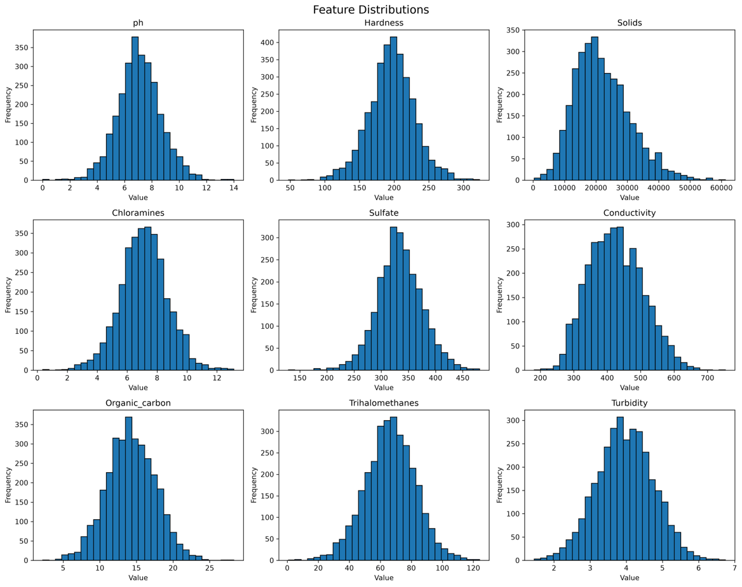The feature-distribution analysis shows that the nine input variables operate across substantially different numerical ranges and exhibit different levels of variability. Solids has by far the largest numerical range, reaching values above 60,000, while features such as pH and Turbidity operate on much smaller scales. Conductivity and Solids also show relatively large absolute variation compared with the other features. The distributions additionally indicate that the observations are not concentrated within a common numerical scale. These differences are important for neural-network training because features with larger numerical magnitudes can influence the optimization process differently from smaller-scale features. Therefore, the exploratory analysis supports the use of feature standardization before training the MLP, with the scaler fitted only on the training data to prevent information leakage.

4.1.1.2 Feature Range and Outlier Analysis
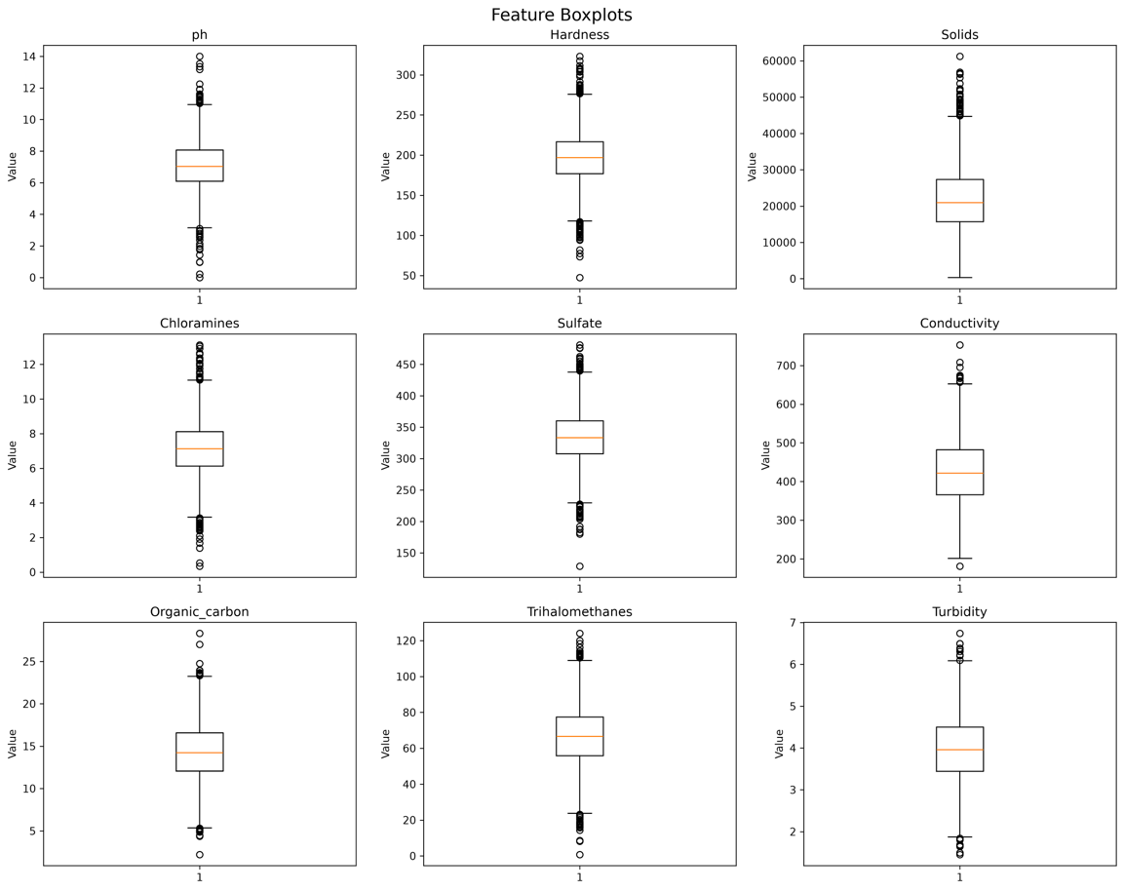
The boxplots provide a clearer view of the spread, central tendency and potentially extreme observations within the nine features. Several variables contain observations that extend considerably beyond their central ranges, indicating the presence of potentially extreme values. However, these observations were not automatically treated as errors because the analysis did not establish that they represented invalid measurements. Consequently, no arbitrary outlier-removal procedure was applied in Phase 1. Retaining these observations preserves the original dataset while allowing subsequent modelling experiments to determine whether the model configuration can handle the observed feature variability effectively.

4.1.1.3 Feature and Feature–Target Correlation Analysis
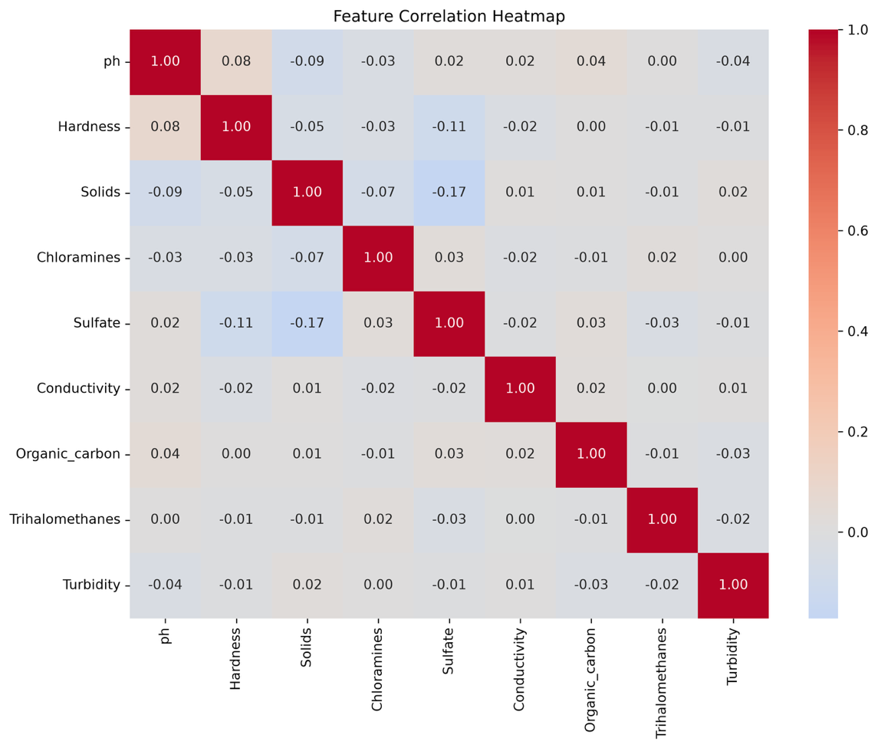
The feature correlation heatmap shows that the input variables do not exhibit uniformly strong linear relationships with one another, suggesting that the features are not simply redundant measurements of the same information. The feature–target correlation analysis also shows relatively weak individual linear relationships between the input variables and Potability. However, weak Pearson correlation does not imply that a feature has no predictive value, since the relationship may be nonlinear or dependent on interactions with other variables. Therefore, all nine features were retained for the MLP, allowing the model to learn possible multivariate and nonlinear relationships that cannot be captured through individual linear correlations alone.

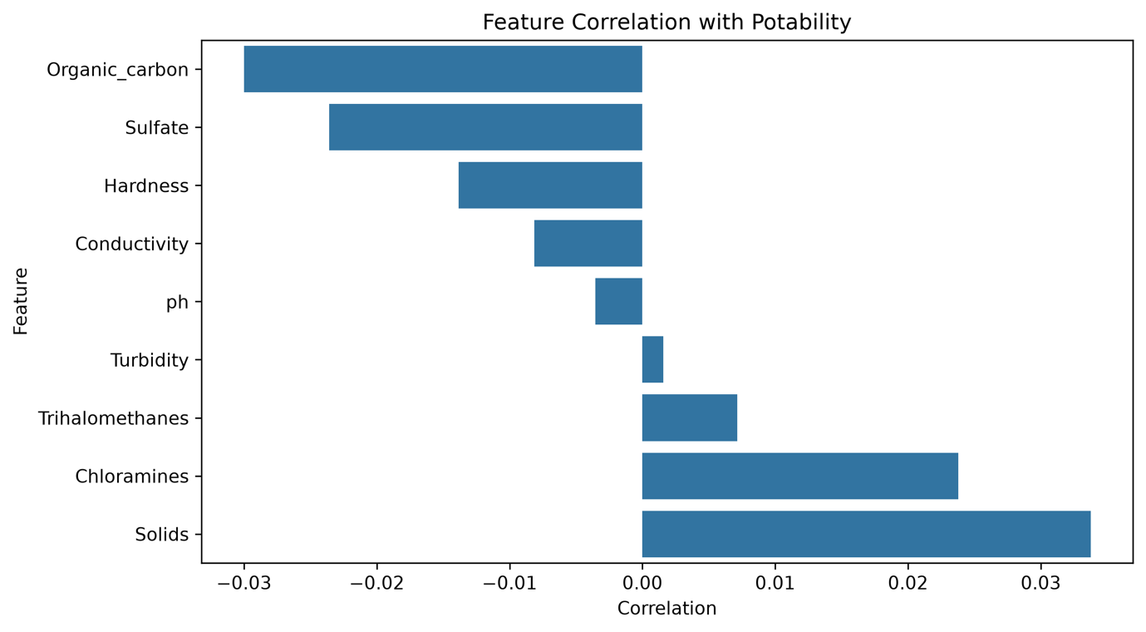4.1.1.4 Baseline MLP Performance
The baseline MLP achieved a validation Accuracy of 0.6298, Macro F1 of 0.6127 and Balanced Accuracy of 0.6134. On the untouched test set, performance decreased to an Accuracy of 0.5899, Macro F1 of 0.5600 and Balanced Accuracy of 0.5597. The difference between validation and test performance indicates that the validation results did not transfer completely to unseen data. The baseline therefore provides a reference point for subsequent experiments, while the relatively modest test performance indicates that there is scope to investigate whether alternative model configurations and optimization strategies can improve predictive performance.

4.1.1.5 Classification Performance

Class | Precision | Recall | F1-Score | Support
Non-Potable (0) | 0.65 | 0.70 | 0.67 | 400
Potable (1) | 0.47 | 0.42 | 0.45 | 256
Accuracy |  |  | 0.59 | 656
Macro Average | 0.56 | 0.56 | 0.56 | 656
Weighted Average | 0.58 | 0.59 | 0.59 | 656
The classification report shows that the model performs differently across the two target classes. For the Non-Potable class, the model achieved a precision of 0.65, recall of 0.70 and F1-score of 0.67, whereas the Potable class achieved a precision of 0.47, recall of 0.42 and F1-score of 0.45. This indicates that the baseline model identifies non-potable samples more effectively than potable samples. The class-level difference also demonstrates why accuracy alone is insufficient for evaluating this dataset and supports the use of Macro F1, Macro Recall and Balanced Accuracy in addition to overall accuracy.

4.1.1.6 Confusion Matrix Analysis
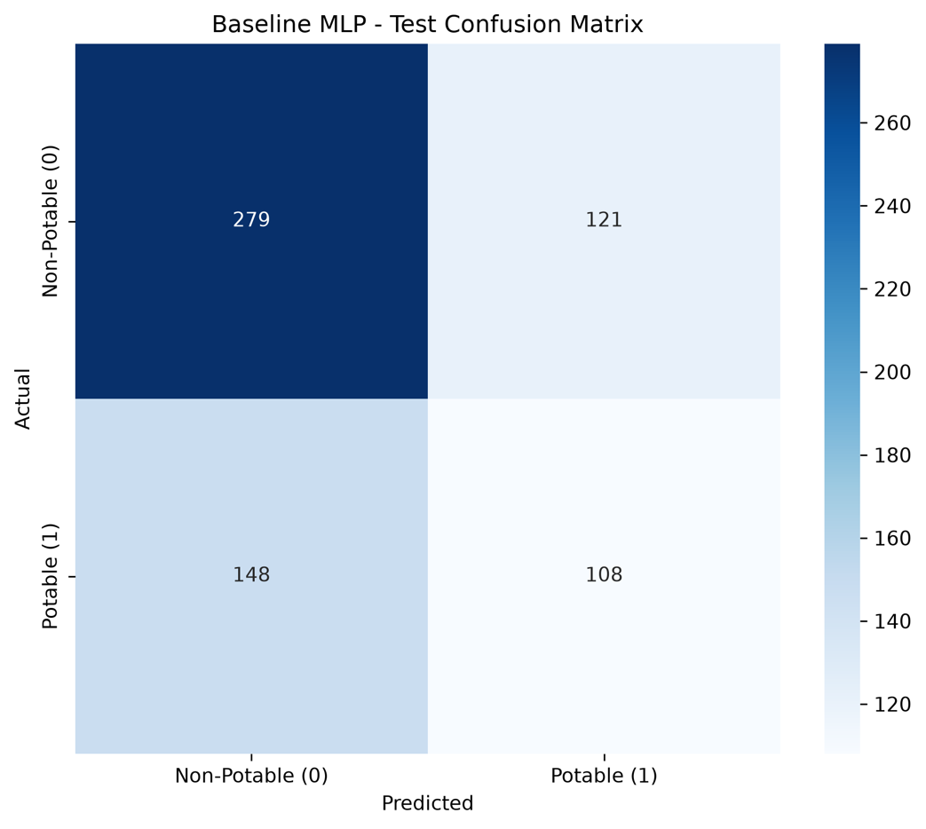
The test confusion matrix shows that 279 non-potable samples were correctly classified as non-potable, while 121 were incorrectly classified as potable; for the potable class, 108 samples were correctly classified and 148 were incorrectly classified as non-potable. Thus, the model produces errors in both directions, but it misclassifies more potable samples as non-potable than non-potable samples as potable. This observation is consistent with the lower recall of the Potable class in the classification report and provides more detailed information about the model's error pattern than overall accuracy alone.

4.1.1.7 Training Behaviour and Convergence
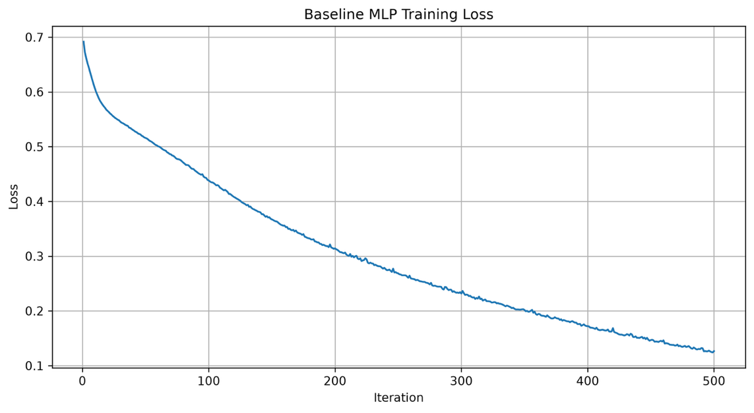
The training loss decreased from 0.691789 at the beginning of training to 0.126606 after 500 iterations, showing that the MLP was learning from the training data during optimization. However, the model reached the configured maximum of 500 iterations and generated a convergence warning, indicating that the convergence criterion had not been fully satisfied within the available iterations. This suggests that the baseline configuration had not necessarily reached a stable optimum and provides evidence for investigating parameters such as learning rate, network architecture, regularization and other hyperparameters in the subsequent optimization experiments.

4.1.1.8 Phase 1 Findings
The Phase 1 experiment established the reference performance for the Water Potability prediction task and identified several characteristics relevant to later optimization. The analysis showed substantial differences in feature scales, missing values requiring imputation, potentially extreme observations, relatively weak individual feature–target correlations and different predictive performance across the two classes. The baseline MLP achieved 0.5899 test Accuracy, 0.5600 Macro F1 and 0.5597 Balanced Accuracy, while also reaching the maximum 500 iterations without full convergence. These observations provide the basis for the next phase, where systematic optimization of the MLP configuration can be investigated while retaining the established data-splitting, imputation and standardization procedures.

4.1.2 Water Potability Prediction – Phase 2 Results
Phase 2 was conducted to investigate the main limitations identified from the Phase 1 baseline and to determine which modelling and preprocessing choices should be retained before proceeding to the systematic optimization experiments in Phase 3. The analysis examined training convergence, missing-value imputation, class imbalance, feature–target relationships, class-wise feature distributions, and multivariate class separability. The experiments used the same train, validation, and test split as Phase 1, while the feature-relationship analyses were performed using only the training data to avoid using test-set information when defining the subsequent optimization strategy.

4.1.2.1 Convergence Analysis
The convergence experiment evaluated whether the relatively modest Phase 1 performance was related to insufficient training. The MLP was trained using maximum iteration values of 500, 1000, and 1500 while keeping the remaining configuration unchanged. The validation Macro F1 was 0.6127 at 500 iterations, decreasing to 0.6057 at 1000 iterations and 0.6083 at 1500 iterations. On the test set, Macro F1 similarly decreased from 0.5600 to 0.5552 and 0.5417, respectively. Although increasing the maximum number of iterations allowed the model to train for longer, it did not produce better generalization performance. Therefore, increasing training duration was not considered an effective solution to the baseline limitation, and 500 maximum iterations was retained for subsequent experiments.

4.1.2.2 Imputation Strategy Comparison
Three missing-value imputation strategies were compared to determine whether the median imputation used in Phase 1 was limiting predictive performance. The validation Macro F1 obtained with Median, KNN, and K-Means imputation was 0.6127, 0.5841, and 0.6093, respectively. On the test set, the corresponding Macro F1 values were 0.5600, 0.5604, and 0.5515. Although KNN produced a marginally higher test Macro F1 than median imputation, its validation performance was considerably lower, while K-Means produced lower performance on both validation and test data. The results therefore did not provide a consistent advantage for either alternative strategy, supporting the retention of median imputation as the fixed preprocessing approach.
Table - Comparison of Imputation Strategies
Imputation Strategy | Validation Macro F1 | Test Macro F1
Median | 0.6127 | 0.5600
KNN | 0.5841 | 0.5604
K-Means | 0.6093 | 0.5515
The results indicate that changing the imputation method alone did not resolve the predictive limitation observed in Phase 1. Consequently, the simpler median-based approach was retained rather than introducing additional preprocessing complexity.

4.1.2.3 Class Imbalance Analysis
Random Oversampling was evaluated because the training data contained fewer Potable observations than Non-Potable observations. The training distribution was changed from 1,278 Non-Potable and 818 Potable samples to 1,278 samples for each class, while the validation and test sets remained unchanged. On the validation set, oversampling increased Accuracy from 0.6298 to 0.6393 and Macro F1 from 0.6127 to 0.6168, but Potable Recall decreased from 0.5392 to 0.5098. More importantly, performance on the unseen test set decreased: Accuracy fell from 0.5899 to 0.5716, Macro F1 from 0.5600 to 0.5412, Balanced Accuracy from 0.5597 to 0.5412, and Potable Recall from 0.4219 to 0.4023. Thus, although oversampling successfully balanced the training distribution, the improvement observed on validation data did not transfer to the test data.
Table – Fixed Baseline and Random Oversampling
Metric | Baseline Validation | Oversampling Validation | Baseline Test | Oversampling Test
Accuracy | 0.6298 | 0.6393 | 0.5899 | 0.5716
Macro F1 | 0.6127 | 0.6168 | 0.5600 | 0.5412
Balanced Accuracy | 0.6134 | 0.6158 | 0.5597 | 0.5412
Potable Recall | 0.5392 | 0.5098 | 0.4219 | 0.4023
The comparison shows that the small validation improvement in Macro F1 was accompanied by a decrease in Potable Recall, while all principal test metrics became lower. Based on these results, Random Oversampling was not retained, and the original class distribution was kept as part of the fixed Phase 2 configuration.
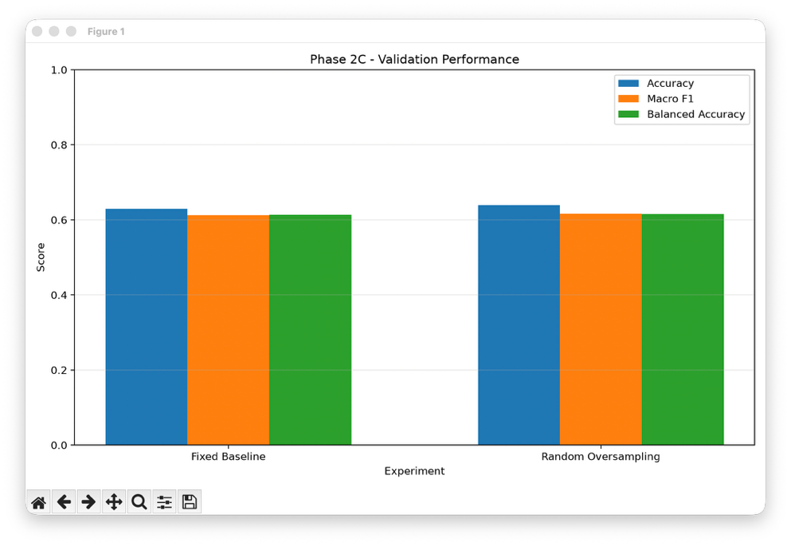
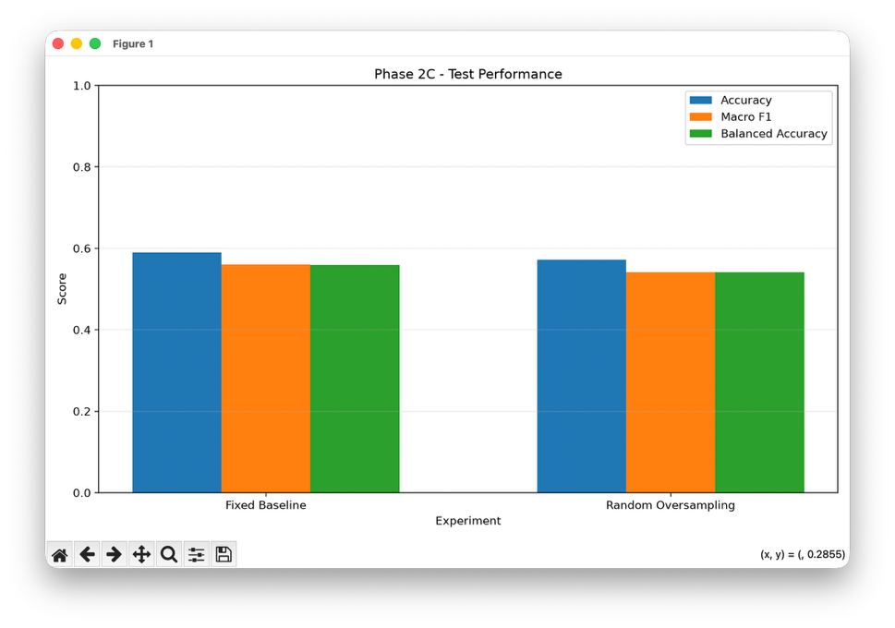
The test-set comparison provides a clearer indication of the effect of oversampling on unseen data. Unlike the small changes observed on the validation set, Random Oversampling reduced Accuracy, Macro F1, Balanced Accuracy, and Potable Recall on the test set. This indicates that balancing the training observations did not improve generalization for the water potability task and therefore did not justify replacing the original training distribution.

4.1.2.4 Spearman Feature–Target Analysis
Spearman correlation was used to determine whether the weak Pearson correlations observed in Phase 1 could be explained by monotonic relationships between individual features and Potability. The results remained very small across all nine features. The largest absolute correlations were observed for Chloramines (0.0237), Solids (0.0225), and Trihalomethanes (0.0196), while the remaining features were even closer to zero. These results indicate that no individual feature exhibited a strong monotonic relationship with Potability in the training data. Therefore, the results provide limited evidence that the classification task can be explained through a simple individual feature–target relationship.
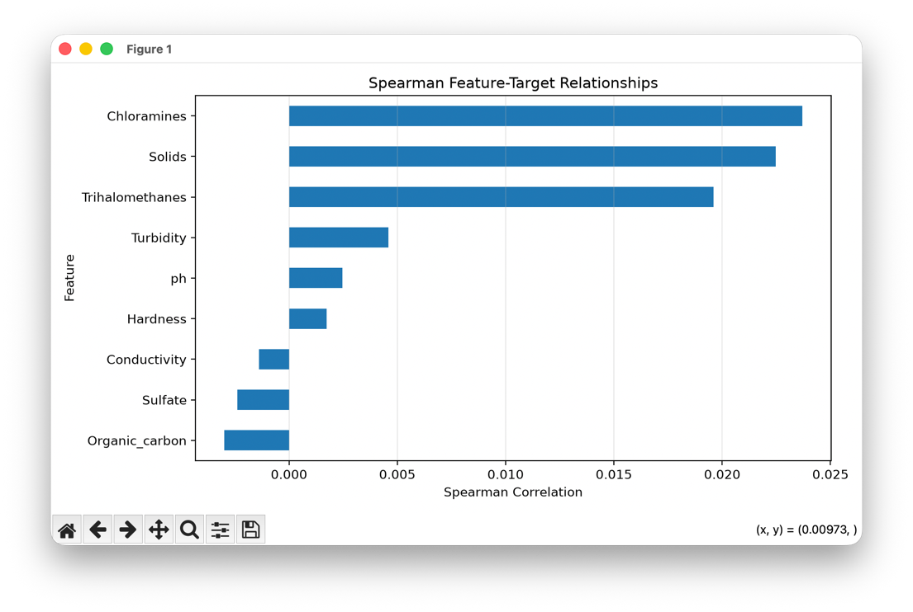
The Spearman analysis confirms that the individual relationships between the measured water-quality variables and Potability are weak. The absence of a strong monotonic relationship does not imply that the features contain no predictive information, but it suggests that model performance is unlikely to be substantially improved through reliance on a single feature alone.

4.1.2.5 Mutual Information Analysis
Mutual information was used to investigate whether individual features contained statistical dependencies with Potability that were not captured by correlation analysis. The highest mutual-information values were obtained for Hardness (0.0147), Sulfate (0.0132), Organic carbon (0.0123), and Conductivity (0.0073), while several other features produced values of approximately zero. Although these features showed relatively higher mutual-information values than the remaining variables, the overall values were small. The results therefore indicate that the individual features provide limited detectable information about the target when considered independently.
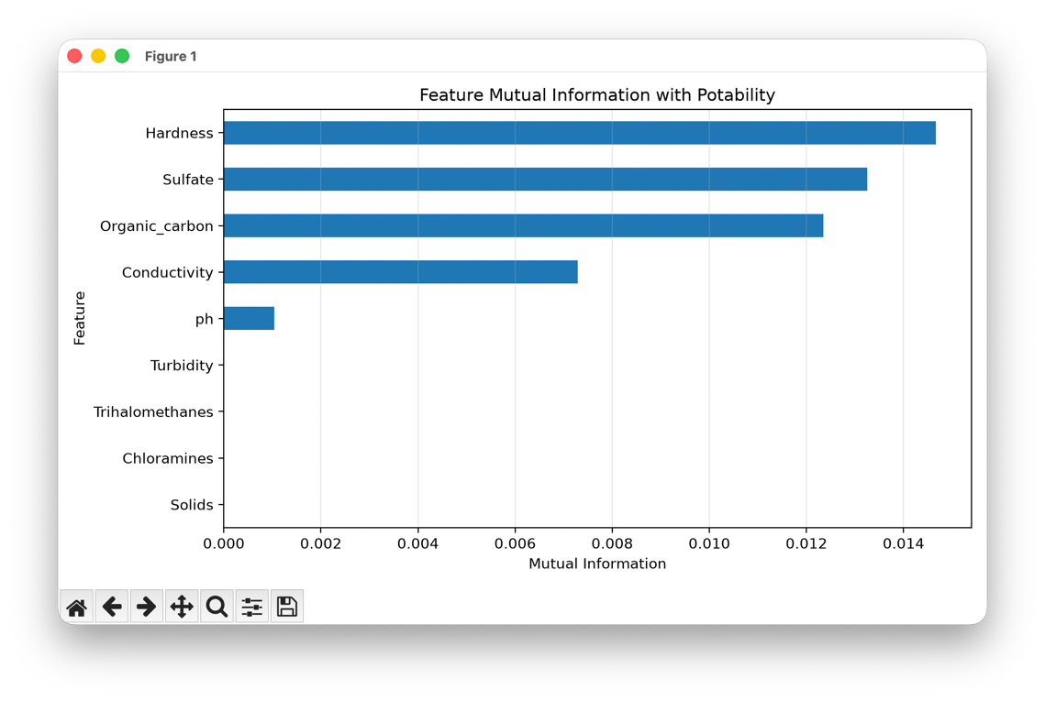
The mutual-information results provide some evidence of differences in the amount of statistical dependence across features, particularly for Hardness, Sulfate, and Organic carbon. However, the generally low values indicate that no individual feature provides a strong standalone relationship with Potability. This supports investigating model configurations capable of learning combinations of features rather than assuming that a small number of individual variables can explain the classification outcome.

4.1.2.6 Class-Wise Feature Distribution Analysis
The class-wise feature distributions were examined to determine whether the Non-Potable and Potable observations could be clearly distinguished using individual features. The resulting boxplots show considerable overlap between the two classes across most of the nine variables, although differences in medians and distributional spread can be observed for some features. The substantial overlap indicates that individual measurements do not provide a clear separation between the two classes. This observation is consistent with the weak correlation and mutual-information results and suggests that the classification boundary is not readily defined by a single water-quality variable.
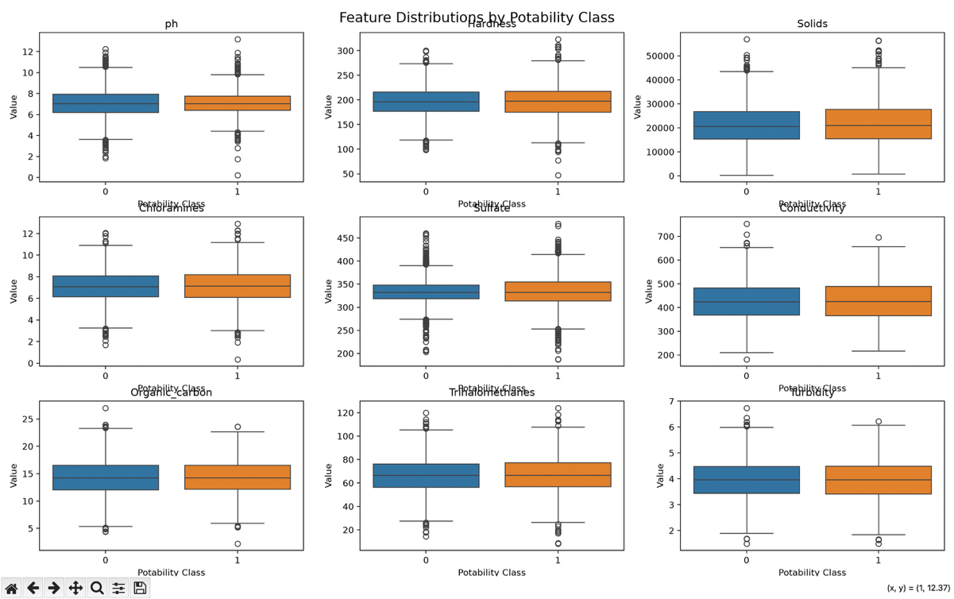
The substantial overlap between the two classes demonstrates that the same or similar feature values can occur for both Potable and Non-Potable observations. Therefore, classification based on simple individual-feature thresholds is unlikely to provide clear separation, supporting the use of a multivariate model that can consider several features simultaneously.

4.1.2.7 PCA Class Separability Analysis
Principal Component Analysis was applied to examine the multivariate structure of the standardized feature space and to visualize the degree of separation between the two Potability classes. The first principal component explained 13.80% of the variance, while the second explained 12.60%, giving a combined explained variance of 26.40%. The resulting two-dimensional representation showed substantial overlap between the Non-Potable and Potable observations rather than clearly separated clusters. This indicates that the two classes do not form distinct groups within the first two principal components and provides further evidence that the classification problem does not have a simple low-dimensional separation.
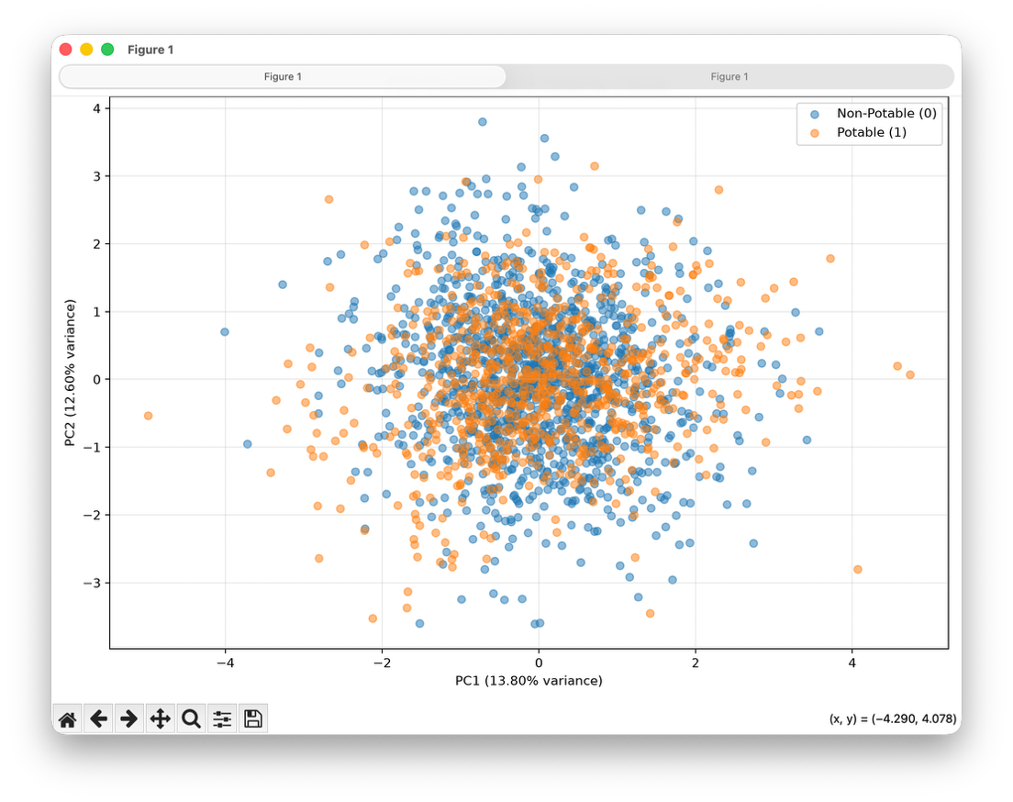
The PCA visualization shows that the two Potability classes occupy largely overlapping regions of the projected feature space. Since PC1 and PC2 together represent only 26.40% of the total variance, the visualization does not describe the complete feature space; nevertheless, the observed overlap provides additional evidence that straightforward separation of the classes is difficult.

4.1.2.8 Phase 2 Findings
Overall, the Phase 2 experiments showed that the main limitation of the Phase 1 model could not be addressed simply by extending training, changing the imputation method, or balancing the training classes. Increasing the maximum number of iterations reduced rather than improved test Macro F1, alternative imputation strategies did not provide a consistent improvement, and Random Oversampling improved some validation metrics but reduced all principal test metrics. The feature analysis further showed very weak Spearman relationships, low mutual-information values, substantial class-wise distribution overlap, and limited visual separation in the PCA representation. Based on these observations, the fixed configuration for the subsequent optimization experiments was retained as median imputation, StandardScaler, the original class distribution, MLP architecture (64, 32), ReLU activation, Adam solver, learning rate 0.001, alpha 0.0001, and maximum 500 iterations. The findings therefore provided the diagnostic basis for moving from baseline refinement to systematic hyperparameter and optimization experiments in Phase 3.

4.1.3 Phase 3 Results – Water Potability Prediction
Phase 3 evaluated six hyperparameter optimization strategies for the Water Potability MLP: Random Search, Bayesian Optimization, Hyperband, Learning Evolutionary Algorithm (LEA), Teaching-Learning-Based Optimization (TLBO), and Simulated Annealing (SA). The baseline MLP was retained as the reference configuration. Validation Macro F1 was used as the optimization objective, while the final selected configurations were subsequently evaluated on the untouched test set. The results therefore allow the optimization methods to be examined from both the perspective of validation performance and their generalization to unseen water-quality observations. The Phase 3 implementation also recorded optimization time, training time, number of evaluations, convergence behaviour, and training-loss curves for further analysis.

4.1.3.1 Overall Optimization Performance

Table - Comparison of Phase 3 optimization methods for Water Potability prediction
Method | Validation Macro F1 | Test Accuracy | Test Macro Precision | Test Macro Recall | Test Macro F1 | Test Weighted F1 | Balanced Accuracy | Potable Recall
Baseline MLP | 0.6127 | 0.6052 | 0.5749 | 0.5680 | 0.5678 | 0.5957 | 0.5680 | 0.3984
Random Search | 0.6649 | 0.6433 | 0.6177 | 0.5978 | 0.5972 | 0.6271 | 0.5978 | 0.3906
Bayesian Optimization | 0.6538 | 0.6113 | 0.5841 | 0.5786 | 0.5792 | 0.6047 | 0.5786 | 0.4297
Hyperband | 0.6537 | 0.5915 | 0.5630 | 0.5595 | 0.5598 | 0.5857 | 0.5595 | 0.4141
LEA | 0.6604 | 0.6570 | 0.6361 | 0.6077 | 0.6065 | 0.6375 | 0.6077 | 0.3828
TLBO | 0.6663 | 0.6052 | 0.5805 | 0.5778 | 0.5785 | 0.6018 | 0.5778 | 0.4531
Simulated Annealing | 0.6211 | 0.6204 | 0.5934 | 0.5861 | 0.5869 | 0.6127 | 0.5861 | 0.4297
The validation results show that all optimization methods except Simulated Annealing produced higher validation Macro F1 than the baseline value of 0.6127. TLBO achieved the highest validation Macro F1 of 0.6663, followed by Random Search at 0.6649 and LEA at 0.6604. However, the validation ordering was not reproduced directly on the independent test set. LEA produced a test Macro F1 of 0.6065 and a test accuracy of 0.6570, while Random Search produced 0.5972 Macro F1 and 0.6433 accuracy. TLBO, despite obtaining the highest validation Macro F1, produced a test Macro F1 of 0.5785. This difference between validation and test performance demonstrates why the final evaluation on the untouched test set is necessary rather than relying solely on the optimization objective. The complete Phase 3 results were saved by the implementation as the comparative results table.
The results also show that the optimized models produced different behaviour for the Potable class. TLBO obtained the highest Potable Recall among the Phase 3 configurations at 0.4531, followed by Bayesian Optimization and Simulated Annealing at 0.4297. LEA produced the highest overall test Macro F1 among the optimized configurations, but its Potable Recall was 0.3828. Therefore, improvements in overall classification performance did not necessarily correspond to improvements in the detection of Potable samples. This difference is important because Macro F1 and Potable Recall capture different aspects of model behaviour.

4.1.3.2 Optimized Hyperparameter Configurations

Table - Hyperparameter configurations selected during Phase 3
Method | Hidden Layers | Activation | Learning Rate | Alpha | Batch Size | Validation Macro F1
Baseline MLP | (64, 32) | ReLU | 0.001 | 0.0001 | auto | 0.6127
Random Search | (128, 64) | ReLU | 0.0001 | 0.0001 | auto | 0.6649
Bayesian Optimization | (128,) | ReLU | 0.001 | 0.001 | 32 | 0.6538
Hyperband | (128, 64) | ReLU | 0.003 | 0.00001 | 32 | 0.6537
LEA | (32,) | tanh | 0.0003 | 0.01 | 64 | 0.6604
TLBO | (128, 64) | ReLU | 0.005 | 0.01 | 32 | 0.6663
Simulated Annealing | (128, 64, 32) | ReLU | 0.0001 | 0.00001 | auto | 0.6211
The optimization procedures selected substantially different MLP configurations from the Phase 2 baseline. Random Search and Hyperband selected the two-hidden-layer architecture (128, 64), while TLBO selected the same architecture with a larger learning rate of 0.005 and stronger regularization with an alpha value of 0.01. Bayesian Optimization selected a single hidden layer with 128 neurons, whereas LEA selected the smaller (32,) architecture with tanh activation. Simulated Annealing selected the deepest architecture, (128, 64, 32), with a learning rate of 0.0001 and alpha of 0.00001. These results demonstrate that the search process explored different combinations of model capacity, activation function, learning rate, regularization and batch size rather than simply increasing network complexity. The selected configurations and their validation scores are directly recorded in the Phase 3 results generated by the implementation.

4.1.3.3 Optimizer Convergence Under the Resource Budget
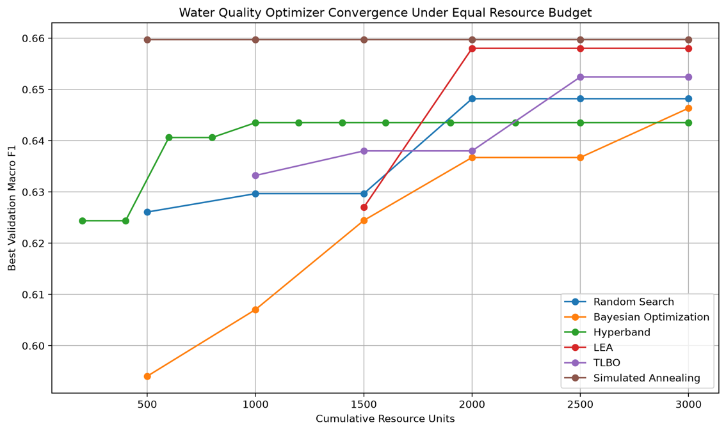
The convergence plot compares the best observed validation Macro F1 as the cumulative computational resource increases. The curves show that the optimization methods followed different search trajectories rather than improving at the same rate. Hyperband reached approximately 0.643 at an early resource level and remained relatively stable, whereas Random Search increased progressively to approximately 0.648. Bayesian Optimization showed a gradual increase and reached approximately 0.666 toward the final resource level. LEA increased sharply after approximately 2,000 resource units and reached approximately 0.658, while TLBO continued improving toward approximately 0.653. Simulated Annealing remained close to approximately 0.660 across the plotted resource levels. The figure therefore illustrates that optimizer behaviour depends not only on the final score obtained but also on how efficiently promising configurations are discovered during the search.

4.1.3.4 Training-Loss Behaviour of the Baseline MLP
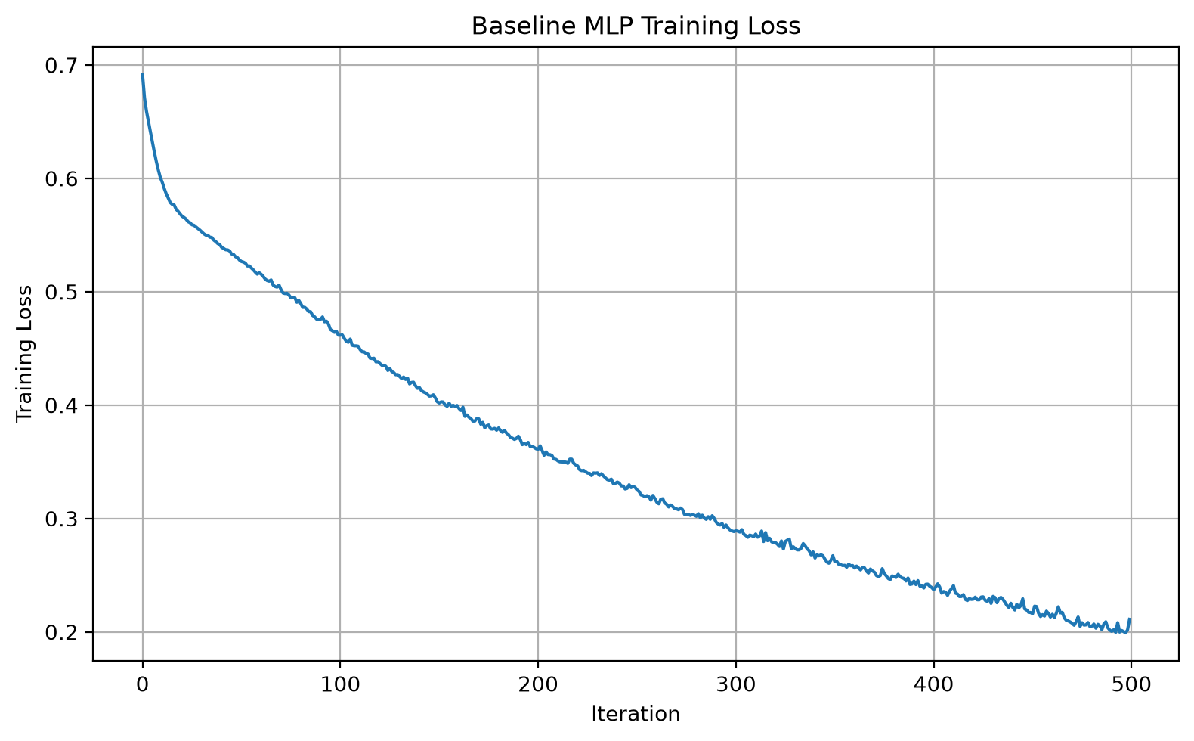
The baseline training-loss curve decreases continuously from approximately 0.69 at the beginning of training to approximately 0.20 near the final iteration. The decrease is steep during the initial iterations and becomes progressively slower as training proceeds. This indicates that the baseline MLP continued to reduce its training loss throughout the available training iterations. The curve therefore provides evidence of continued optimization of the training objective, while the comparatively lower validation and test Macro F1 values indicate that decreasing training loss alone did not guarantee improved generalization to unseen water-quality samples. The baseline configuration consequently provides a useful reference for evaluating the loss behaviour of the optimized models.

4.1.3.5 Bayesian Optimization Training-Loss Behaviour
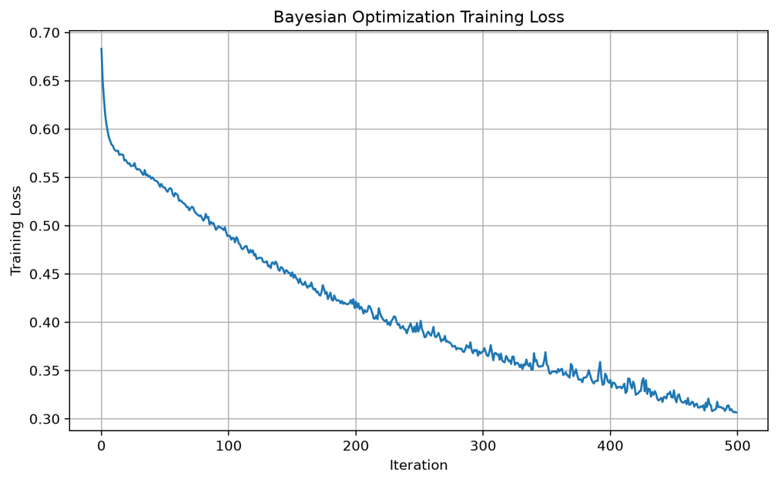
The Bayesian-optimized model shows a steady decline in training loss from approximately 0.68 to approximately 0.31 over the training iterations. The curve follows a generally smooth downward trajectory, although small fluctuations are visible throughout training. The selected configuration used a single hidden layer with 128 neurons, ReLU activation, a learning rate of 0.001, alpha of 0.001 and batch size 32. The corresponding test Macro F1 was 0.5792, indicating that the reduction in training loss was accompanied by a moderate level of generalization but did not translate into a large improvement over the baseline test Macro F1.
4.1.3.6 Hyperband Training-Loss Behaviour
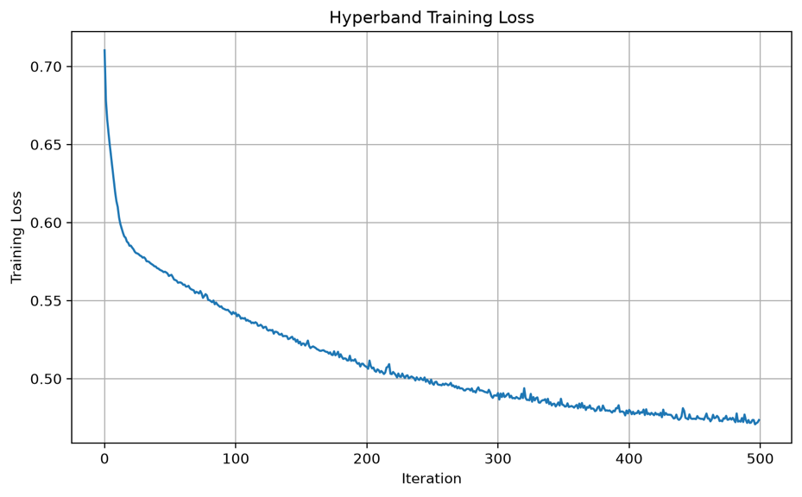
The Hyperband training-loss curve decreases from approximately 0.71 to approximately 0.47. Compared with the other training curves, the reduction remains more gradual toward the later iterations. Hyperband selected (128, 64) hidden layers, ReLU activation, a learning rate of 0.003, alpha of 0.00001 and batch size 32, with a selected maximum iteration value of 243 during the resource-aware search. Its validation Macro F1 was 0.6537, while its test Macro F1 was 0.5598. Thus, although Hyperband identified a comparatively strong validation configuration, the final test performance remained close to the baseline level.

4.1.3.7 LEA Training-Loss Behaviour
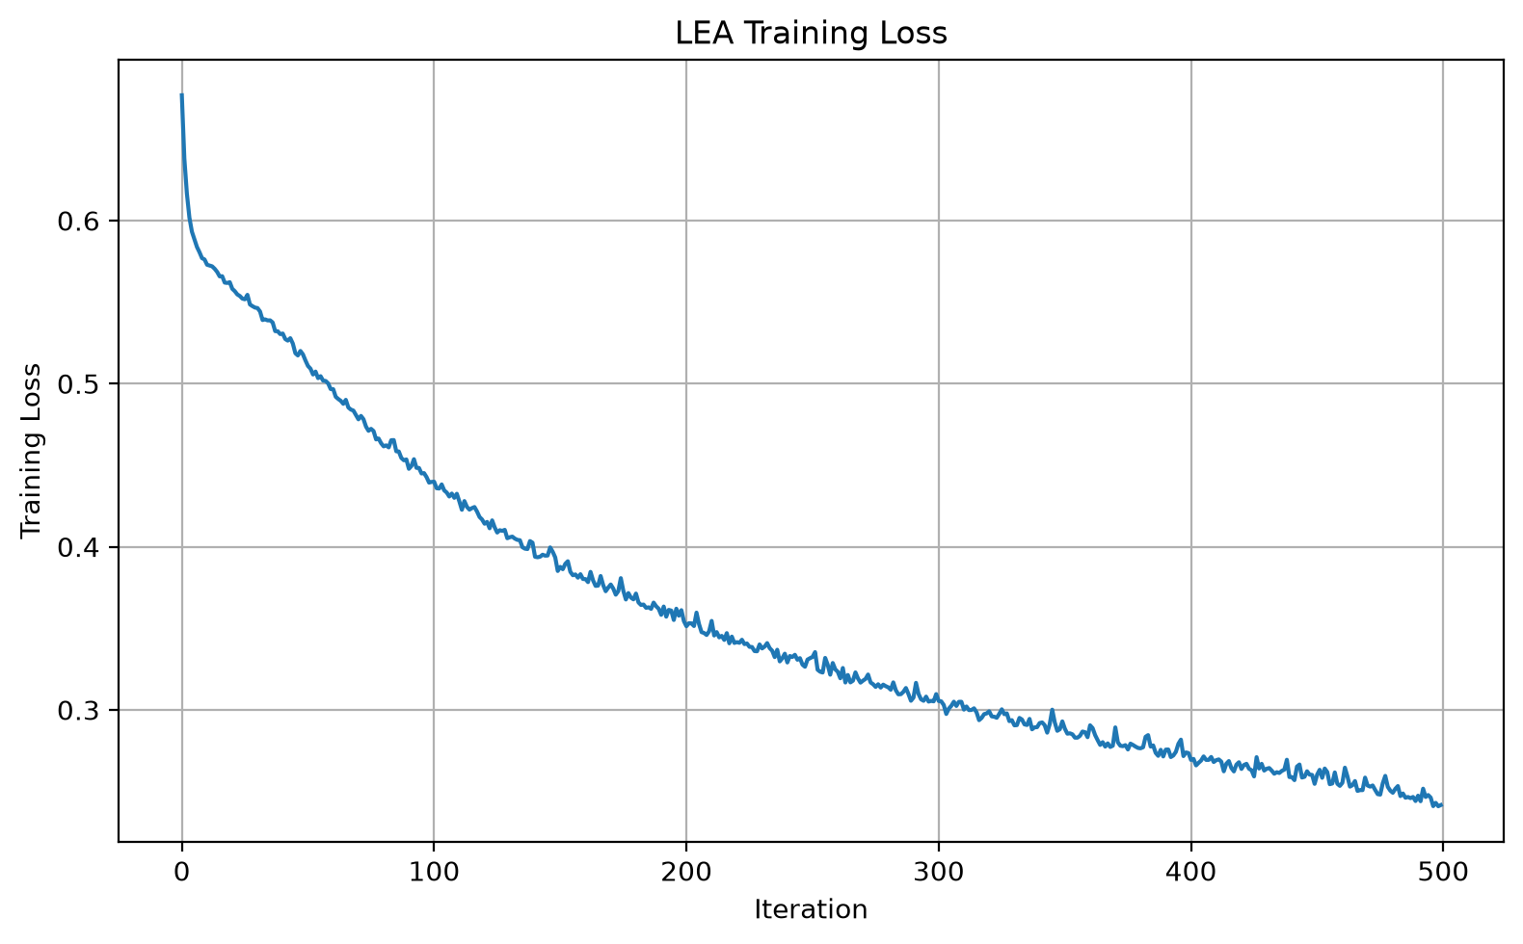
The LEA training-loss curve decreases from approximately 0.67 to approximately 0.24 and exhibits a sustained downward trend throughout training. The selected LEA configuration was comparatively compact, using a single hidden layer with 32 neurons and tanh activation, together with a learning rate of 0.0003, alpha of 0.01 and batch size 64. This configuration achieved a validation Macro F1 of 0.6604 and a test Macro F1 of 0.6065. The test result was accompanied by a test accuracy of 0.6570 and balanced accuracy of 0.6077, showing that the selected configuration generalized reasonably well relative to the other optimized models.

4.1.3.8 Random Search Training-Loss Behaviour
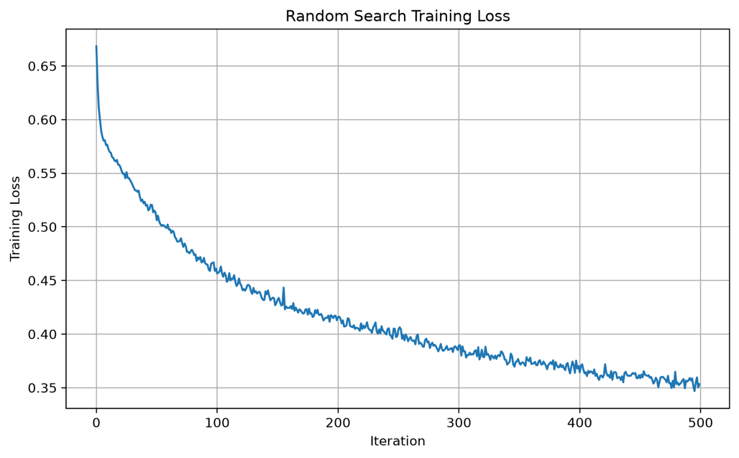
The Random Search training-loss curve decreases from approximately 0.67 to approximately 0.35, with the largest reduction occurring during the earlier part of training and a more gradual decline afterward. Random Search selected a (128, 64) architecture with ReLU activation, a learning rate of 0.0001, alpha of 0.0001 and automatic batch size. The configuration achieved a validation Macro F1 of 0.6649 and a test Macro F1 of 0.5972. Its test accuracy was 0.6433 and balanced accuracy was 0.5978. These results indicate that the configuration identified through random sampling improved the validation score substantially relative to the baseline while also producing higher test performance than the baseline Phase 3 model.

4.1.3.9 Simulated Annealing Training-Loss Behaviour
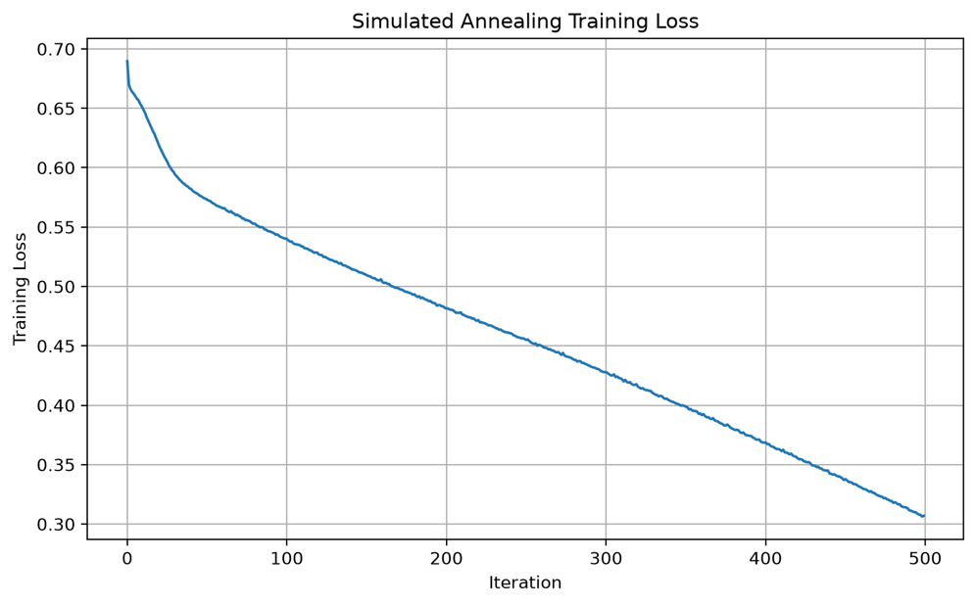
The Simulated Annealing training-loss curve decreases from approximately 0.69 to approximately 0.31 over the training process. The selected configuration contained three hidden layers (128, 64, 32), ReLU activation, a learning rate of 0.0001, alpha of 0.00001 and automatic batch size. The validation Macro F1 reached 0.6211, while the test Macro F1 was 0.5869. Although the training loss decreased substantially, the relatively lower validation score demonstrates that a strong reduction in the training objective did not necessarily correspond to a comparable improvement in validation performance.

4.1.3.10 TLBO Training-Loss Behaviour
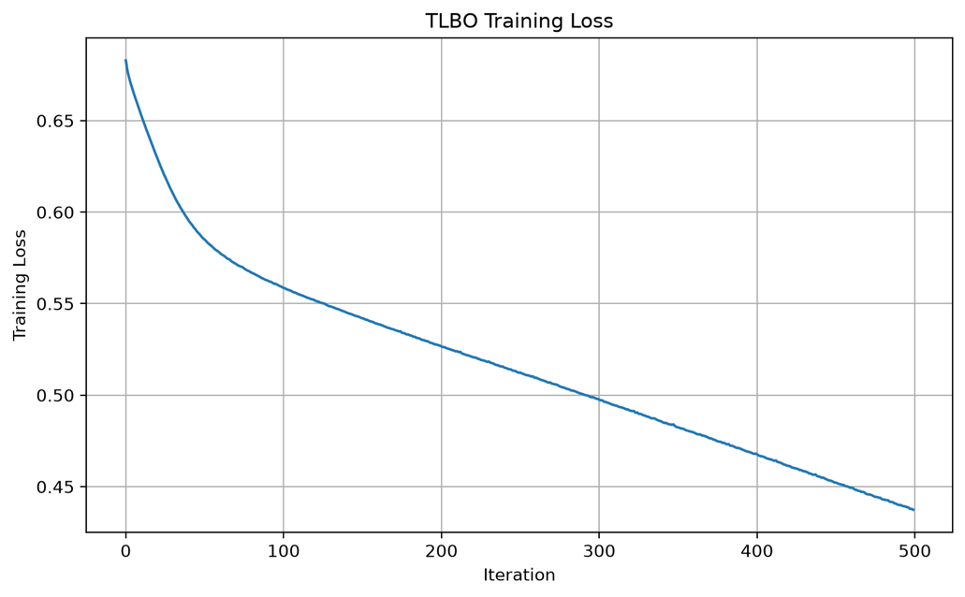
The TLBO training-loss curve decreases from approximately 0.68 to approximately 0.44, showing a consistent reduction over the training iterations. TLBO selected the (128, 64) architecture with ReLU activation, a learning rate of 0.005, alpha of 0.01 and batch size 32. The configuration produced the highest validation Macro F1 of 0.6663 among the Phase 3 methods. However, its test Macro F1 was 0.5785, illustrating a noticeable difference between validation performance and independent test performance. The result demonstrates that a configuration selected according to validation performance should still be examined carefully using the untouched test set.

4.1.3.11 Simulated Annealing Convergence
The Simulated Annealing search was additionally analysed through its evaluation-by-evaluation best validation Macro F1. The optimizer started with a Macro F1 of 0.5752. The best score increased to 0.5969 during the second evaluation, reached 0.6115 at evaluation 9, increased to 0.6140 at evaluation 12, and reached 0.6211 at evaluation 17. The best score remained at 0.6211 through evaluations 18 and 19 before the final evaluation produced a lower current score of 0.6170. Because the algorithm retained the best solution encountered during the search, the final reported validation score remained 0.6211.
If your SA convergence figure is available, paste it immediately after the paragraph above. The uploaded figures currently include the SA cooling schedule but not a separate SA best-Macro-F1 convergence figure.

4.1.3.12 Simulated Annealing Cooling Schedule
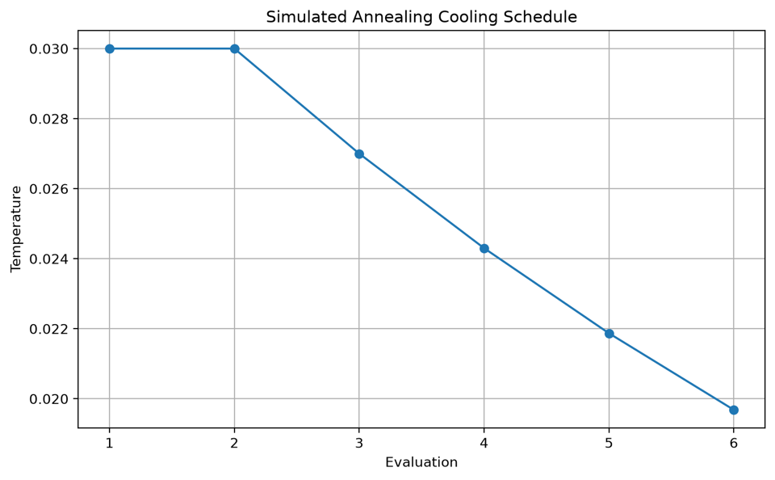
The cooling schedule shows the temperature decreasing from 0.0300 during the first two evaluations to approximately 0.0197 by the sixth evaluation. The reduction follows the predefined cooling mechanism used by the Simulated Annealing search, where the temperature is progressively reduced as the number of evaluations increases. This transition controls the balance between exploration and exploitation: the higher initial temperature permits greater exploration of neighbouring hyperparameter configurations, while the lower temperature later in the search reduces the probability of accepting less favourable configurations. The Phase 3 implementation used an initial temperature of 0.03 and a cooling rate of 0.90.

4.1.3.13 Optimization and Computational Cost

Table - Optimization and training computational cost
Method | Optimization Time (s) | Final Training Time (s) | Evaluations
Baseline MLP | 0.00 | 1.10* | 1
Random Search | 9.44 | 2.12 | 20
Bayesian Optimization | 40.07 | 3.72 | 20
Hyperband | 8.15 | 1.33 | Resource-based
LEA | 235.66 | 1.46 | 100
TLBO | 623.76 | 1.05 | 295
Simulated Annealing | 27.86 | 1.96 | 20
*Approximately 1.10 seconds based on the baseline training execution.
The computational results show considerable variation in the time required by the optimization procedures. Random Search required 9.44 seconds, while Hyperband required 8.15 seconds. Bayesian Optimization required 40.07 seconds, and Simulated Annealing required 27.86 seconds. LEA required 235.66 seconds for 100 evaluations, whereas TLBO required 623.76 seconds for 295 evaluations. The final MLP training times were comparatively small for all methods, ranging from approximately one to four seconds. Therefore, the main computational difference between the optimization strategies originated from the search process rather than from the final model training itself. The recorded optimization times and evaluation counts are part of the Phase 3 comparison output.

4.1.3.14 Final Test Classification Behaviour
The final test results show that the optimized models behaved differently across the two Water Potability classes. The Random Search model classified 322 Non-Potable samples correctly and 100 Potable samples correctly, while the LEA model classified 333 Non-Potable and 98 Potable samples correctly. TLBO classified 281 Non-Potable and 116 Potable samples correctly. Simulated Annealing classified 297 Non-Potable and 110 Potable samples correctly. The corresponding Potable Recall values were 0.3906 for Random Search, 0.3828 for LEA, 0.4531 for TLBO and 0.4297 for Simulated Annealing. These results demonstrate that the optimization methods produced different balances between the recognition of Non-Potable and Potable observations rather than producing uniform improvements across both classes.

Table - Classification performance of the Phase 3 optimized models
Method | Non-Potable Precision | Non-Potable Recall | Non-Potable F1 | Potable Precision | Potable Recall | Potable F1
Baseline MLP | 0.66 | 0.74 | 0.69 | 0.49 | 0.40 | 0.44
Random Search | 0.67 | 0.81 | 0.73 | 0.56 | 0.39 | 0.46
Bayesian Optimization | 0.67 | 0.73 | 0.70 | 0.50 | 0.43 | 0.46
Hyperband | 0.65 | 0.70 | 0.68 | 0.47 | 0.41 | 0.44
LEA | 0.68 | 0.83 | 0.75 | 0.59 | 0.38 | 0.47
TLBO | 0.67 | 0.70 | 0.68 | 0.49 | 0.45 | 0.47
Simulated Annealing | 0.67 | 0.74 | 0.70 | 0.52 | 0.43 | 0.47
The classification-level results show a consistent difference between the two classes. Across the optimized configurations, Non-Potable observations generally achieved higher recall and F1 values than Potable observations. LEA obtained a Non-Potable recall of 0.83, whereas its Potable recall was 0.38. TLBO showed a more balanced class-level behaviour in terms of Potable recall, reaching 0.45, although its overall test Macro F1 remained below the LEA result. The results therefore confirm that aggregate performance measures should be interpreted together with class-specific metrics, particularly because the Water Potability target contains unequal class representation.

4.1.3.15 Phase 3 Findings
Phase 3 demonstrated that hyperparameter optimization substantially changed the validation behaviour of the Water Potability MLP, but the resulting improvements were not uniform across the independent test set. The validation Macro F1 increased from 0.6127 for the baseline configuration to 0.6649 for Random Search, 0.6538 for Bayesian Optimization, 0.6537 for Hyperband, 0.6604 for LEA and 0.6663 for TLBO. Simulated Annealing produced a validation Macro F1 of 0.6211. On the untouched test set, LEA obtained a Macro F1 of 0.6065, followed by Random Search at 0.5972 and Simulated Annealing at 0.5869, while TLBO obtained 0.5785 despite its higher validation score.
The difference between validation and test behaviour is particularly relevant to the subsequent experimental phase. The results indicate that selecting a configuration solely according to the highest validation Macro F1 does not guarantee the same ordering on unseen data. In addition, the training-loss curves show that all MLP configurations were able to reduce their training losses, but the magnitude of training-loss reduction did not directly correspond to test Macro F1. Consequently, Phase 3 provides evidence that optimizer comparison should consider not only the final validation score, but also generalization, computational cost and convergence behaviour. These observations provide the basis for the controlled resource-based comparison introduced in the subsequent phase.

4.1.4 Phase 4 – Equal Computational Budget Comparison
Phase 4 extends the Water Potability optimization experiment by introducing a controlled equal-resource comparison between the optimization methods used in Phase 3. The dataset, binary classification task, stratified train-validation-test split, median imputation, StandardScaler preprocessing, MLP architecture search space, and validation Macro F1 objective were retained from the previous phase. The additional component is that each optimizer was allocated the same computational budget of 3,000 training-iteration resource units, allowing their optimization behaviour to be compared under equivalent computational constraints. The methods compared were Random Search, Bayesian Optimization, Hyperband, LEA, TLBO, and Simulated Annealing.
For the Water Potability dataset, the equal budget was implemented by controlling the number of model training iterations used by each optimizer. Convergence histories were recorded using cumulative resource units and the best validation Macro F1 obtained at each stage. This provides a common basis for examining how quickly each optimization method improves its validation performance as computational resources are consumed. Simulated Annealing was additionally evaluated using its cooling schedule, with an initial temperature of 0.03 and a cooling rate of 0.90.
After the equal-budget optimization, the optimizer with the highest validation Macro F1 was identified using only the validation data. The test set remained untouched during optimizer selection and was used only for the final evaluation. This additional control was introduced to distinguish differences in optimization performance from differences caused by unequal computational effort.
Formula used for the additional Phase 4 comparison
The computational resource assigned to each optimizer was defined as:
$$R=\text{Number of training evaluations}×\text{Maximum training iterations}$$
For the Water Potability experiment:
$$R=6×500=3000$$
Thus,
$$R_{\text{Random}}=R_{\text{Bayesian}}=R_{\text{Hyperband}}=R_{\text{LEA}}=R_{\text{TLBO}}=R_{\text{SA}}=3000$$
The optimizer convergence was then analysed as:
$$R_{t}→{\text{Best Validation Macro F1}}_{t}$$
where $R_{t}$represents the cumulative training resources consumed by an optimizer.

3.2 Solar Flare Dataset

3.2.1 Dataset and Prediction Objective

The Solar Flare dataset is formulated as a four-class classification problem. Each observation represents a solar active region described by ten predictor variables. The dataset contains 1,389 observations and 13 original variables, including ten predictors and three original flare-count target variables. No missing values are present in the dataset.

What are the input variables?
The ten input variables used in the model are:
Feature | Meaning | Role
Modified Zurich class | Classification of the solar active region | Input
Largest spot size | Size category of the largest sunspot | Input
Spot distribution | Distribution pattern of spots in the active region | Input
Activity | Current activity level of the region | Input
Evolution | Indicates whether the region is growing, stable, or decaying | Input
Previous 24 hour flare activity | Flare activity observed during the previous 24 hours | Input
Historically-complex | Indicates whether the region has historically been complex | Input
Became complex on this pass | Indicates whether the region became complex during the current passage | Input
Area | Size category of the active region | Input
Area of largest spot | Size category of the largest spot | Input
The first three variables are categorical, while the remaining seven predictors are integer-coded variables. The categorical variables are therefore converted into numerical features using one-hot encoding before training.

What are the target variables?
The original dataset contains three flare-related target variables representing common, moderate, and severe flare activity. For this study, these variables are combined into a single categorical variable named Target.
The resulting four classes are:
Target Class | Description
No Flare | No flare activity
Common Flare | Common flare activity
Moderate Flare | Moderate flare activity
Severe Flare | Severe flare activity
The resulting class distribution is 1,203 No Flare (86.61%), 125 Common Flare (9.00%), 50 Moderate Flare (3.60%), and 11 Severe Flare (0.79%). This results in a highly imbalanced classification problem, with a majority-to-minority ratio of approximately 109:1.
After constructing the combined target, the three original flare-count variables are removed. The final processed dataset therefore contains 10 predictor variables and one Target variable, resulting in 11 columns.

Why are all ten variables retained?
All ten available predictors are retained in the baseline experiment because they provide information about the characteristics, size, evolution, and previous activity of the solar region. Rather than removing variables before modelling, the study evaluates the complete predictor set and investigates encoding and class-imbalance handling in the subsequent experimental phases.
The Solar Flare dataset from the UCI Machine Learning Repository contains 1,389 observations and 13 original variables, including three categorical and seven numerical predictor variables. No missing values were identified, while 862 duplicate rows were detected during the data-quality analysis.
The three original flare-related target variables were combined into a four-class target consisting of No Flare, Common Flare, Moderate Flare, and Severe Flare. The resulting classes were highly imbalanced, with 1,203 No Flare (86.61%), 125 Common Flare (9.00%), 50 Moderate Flare (3.60%), and 11 Severe Flare (0.79%) observations, giving a majority-to-minority ratio of approximately 109:1.
Exploratory analysis examined the categorical and numerical predictors across the target classes. Several feature distributions varied between flare categories, while the severe-flare class remained particularly limited in size. These findings motivated the use of categorical encoding and dedicated class-imbalance handling in the subsequent experimental phases.
The final processed dataset contained 1,389 observations and 11 variables, consisting of the ten predictors and the combined target variable.

3.2.2 Phase 2 – Hyperparameter Optimization for Solar Flare Classification
Phase 2 investigated whether systematic hyperparameter optimization could improve the performance of the baseline MLP model established in Phase 1. The same processed Solar Flare dataset and preprocessing pipeline were retained, while five optimization approaches Random Search, Bayesian Optimization, Hyperband, Learning Evolutionary Algorithm (LEA), and Teaching-Learning-Based Optimization (TLBO) were used to identify improved MLP configurations. The optimization objective was based on the weighted F1-score, while the final models were evaluated on the independent test set using accuracy, precision, recall, and weighted F1-score.

3.2.2.1 Optimization Objective
The optimization process can be represented as:
$$\boxed{θ^{*}=arg⁡\underset{θ∈Θ}{max⁡}F1_{\text{weighted}}(θ)}$$
where $θ$represents an MLP hyperparameter configuration and $Θ$represents the defined search space. Weighted F1 was used to account for the unequal representation of the four Solar Flare classes.

3.2.2.2 Baseline and Optimized Model Performance
The baseline MLP achieved a test accuracy of 81.65% and a weighted F1-score of 0.7883. Hyperparameter optimization increased the overall test performance across the optimization approaches. Random Search achieved an accuracy of 84.53%, while Bayesian Optimization and Hyperband both achieved 84.89%. LEA produced an accuracy of 85.61% and a weighted F1-score of 0.8013, while TLBO achieved 84.89% accuracy and a weighted F1-score of 0.7992.

Table - Performance comparison of Phase 2 Solar Flare models
Method | Accuracy | Precision | Recall | Weighted F1
Baseline MLP | 0.8165 | 0.7629 | 0.8165 | 0.7883
Random Search | 0.8453 | 0.7517 | 0.8453 | 0.7958
Bayesian Optimization | 0.8489 | 0.7549 | 0.8489 | 0.7992
Hyperband | 0.8489 | 0.7549 | 0.8489 | 0.7992
LEA | 0.8561 | 0.7530 | 0.8561 | 0.8013
TLBO | 0.8489 | 0.7549 | 0.8489 | 0.7992
The improvement can be summarized as:
$$81.65\%→85.61\%$$
for test accuracy, corresponding to an increase of approximately 3.96 percentage points.
For weighted F1:
$$0.7883→0.8013$$
giving an improvement of:
$$ΔF1=0.8013-0.7883=\boxed{0.0130}$$

Key Performance Finding
Baseline MLP: Accuracy = 81.65%, Weighted F1 = 0.7883
↓ Hyperparameter Optimization
LEA configuration: Accuracy = 85.61%, Weighted F1 = 0.8013
The results therefore show that changing the MLP hyperparameters provided a measurable improvement over the manually selected baseline configuration. However, the improvement in weighted F1 was relatively moderate compared with the improvement in accuracy.

Training-Loss Behaviour
The training-loss curves were recorded for the baseline and each optimized configuration to examine how the models learned during training.

Baseline MLP Training Loss
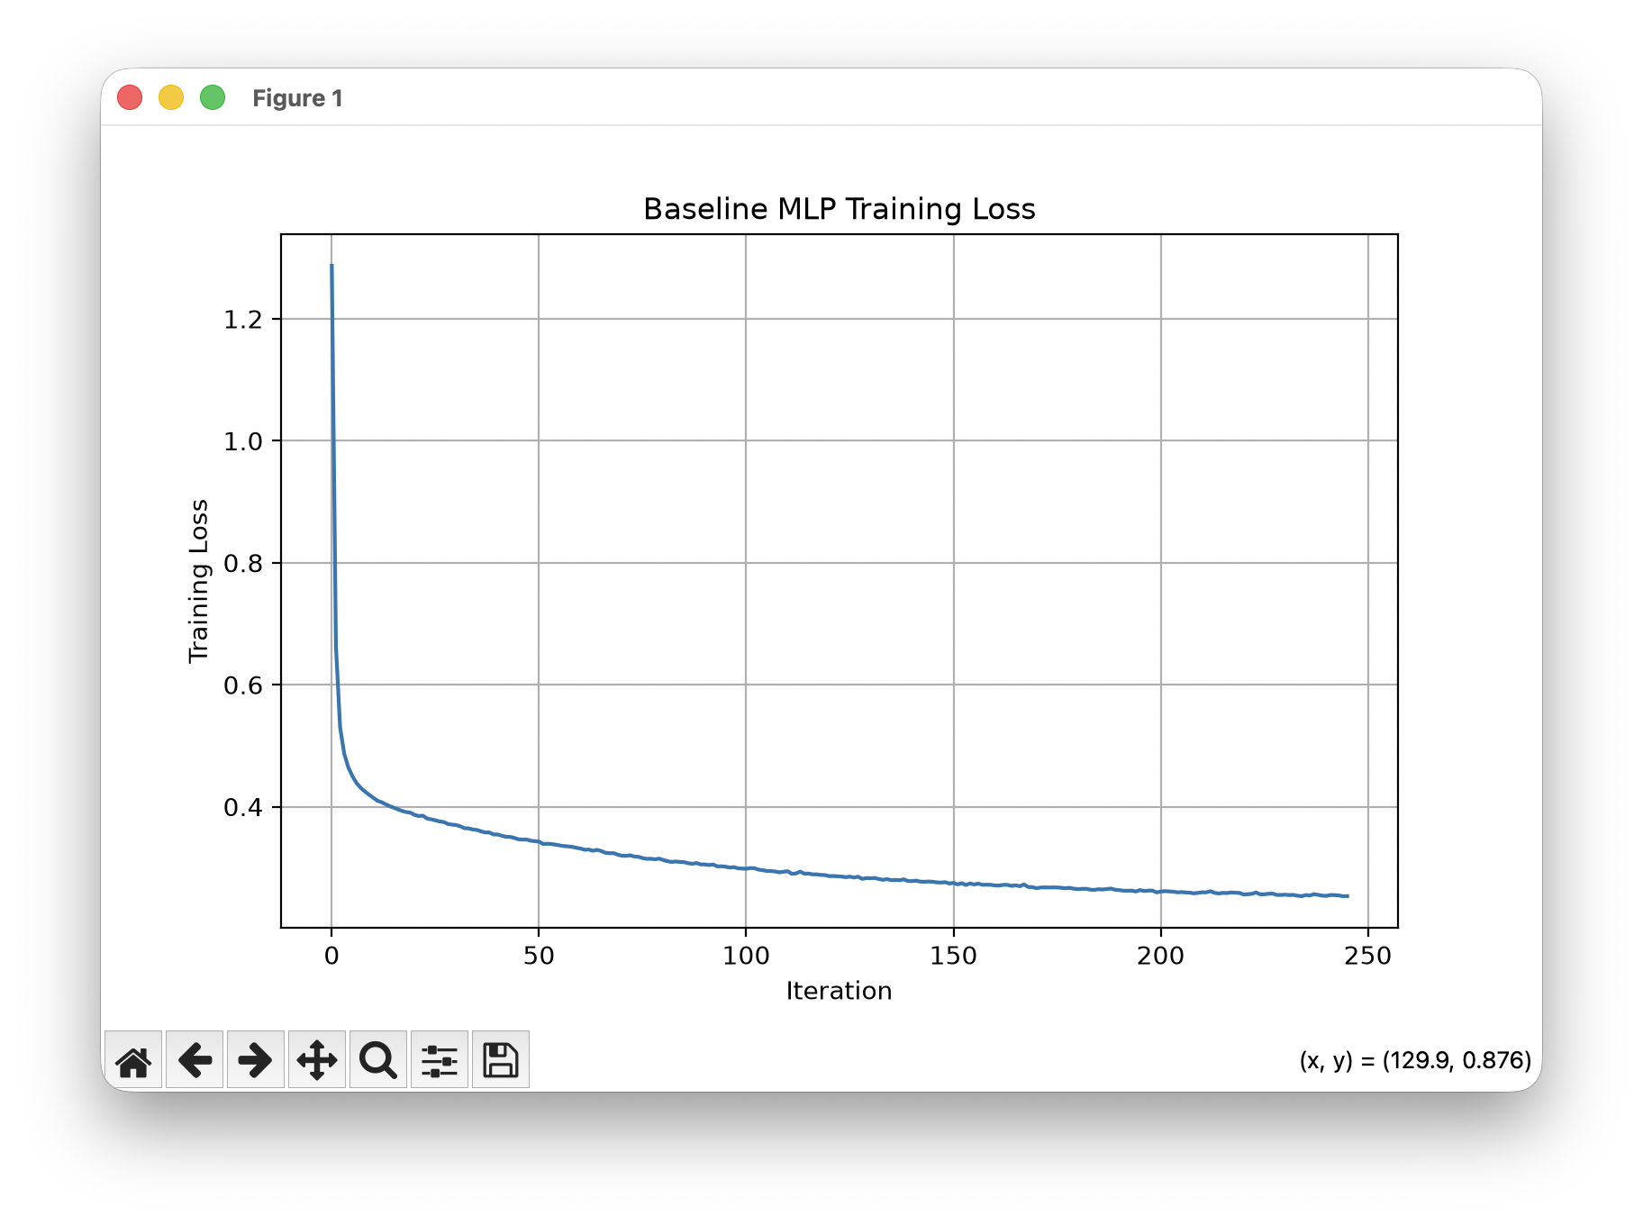
The baseline model shows a sharp reduction in training loss during the initial iterations. After this initial decrease, the loss declines more gradually and approaches a lower, relatively stable region toward the end of training. This indicates that the model learned the major patterns in the training data relatively quickly, followed by slower parameter adjustments during later iterations.

3.2.2.3 Random Search Optimized MLP Training Loss
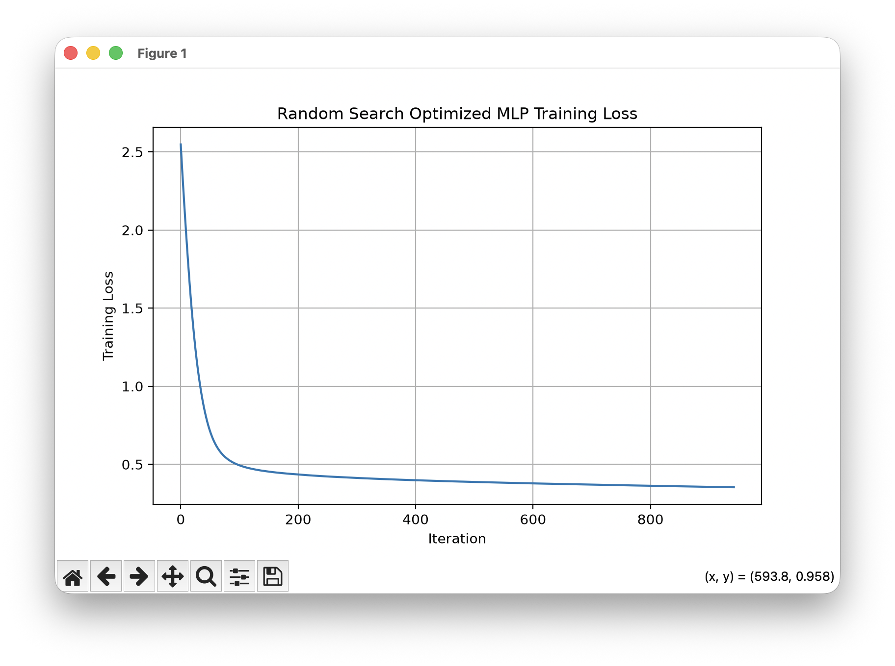
The Random Search configuration also demonstrates a rapid decrease in training loss during the early iterations, followed by a gradual decline. Compared with the baseline, the optimized configuration was trained for a larger number of iterations and maintained a continuous reduction in loss throughout the later training period.

Figure - Bayesian Optimized MLP Training Loss
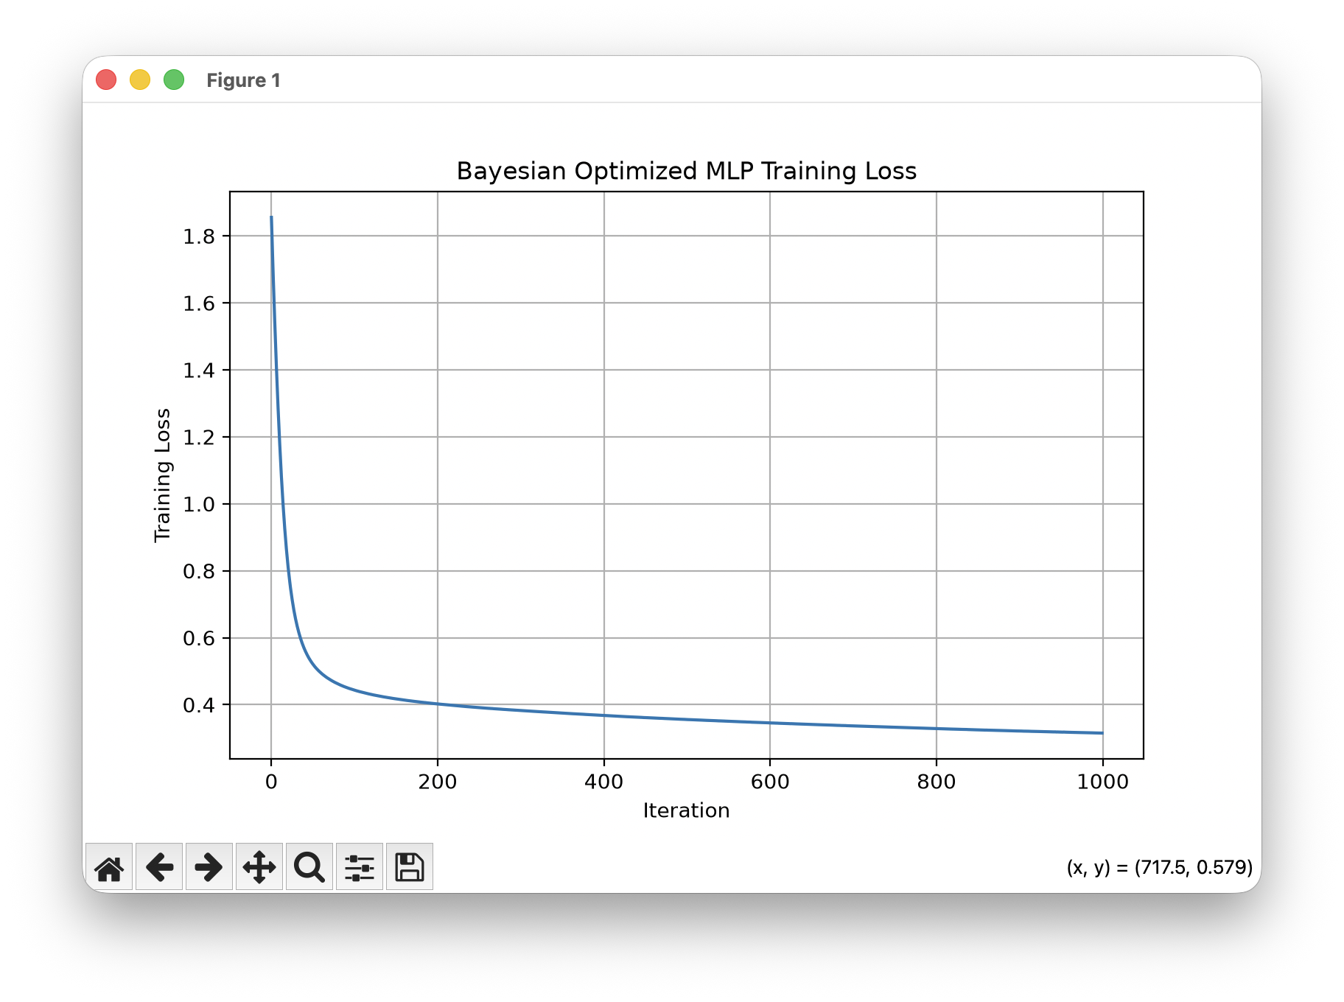
The Bayesian-optimized model shows a pronounced reduction in loss during the early training stage. The loss then decreases progressively at a slower rate until the end of approximately 1,000 iterations. The curve indicates stable training behaviour without a pronounced increase in training loss during the later iterations.

Figure - Hyperband Optimized MLP Training Loss
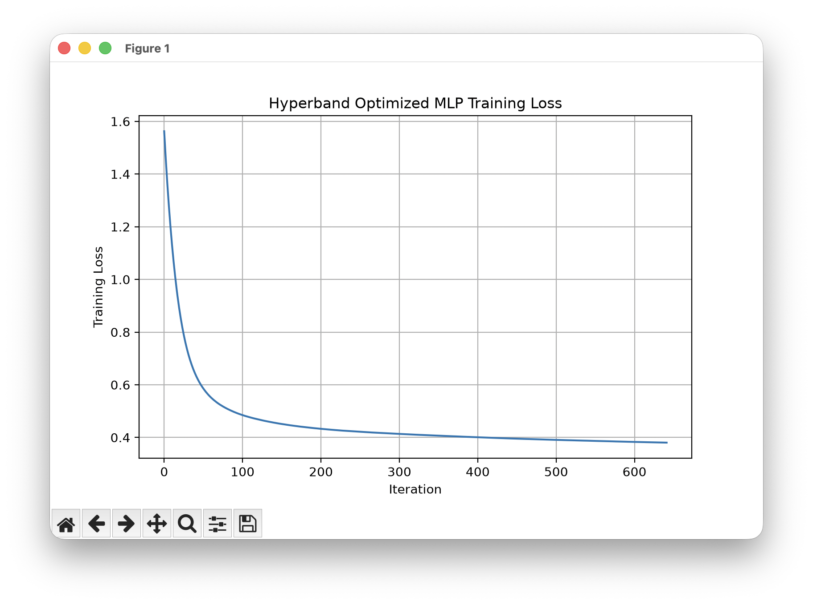
The Hyperband configuration exhibits a steep initial reduction in training loss followed by a gradual convergence. The curve terminates earlier than several of the other configurations, reflecting the resource allocation and selected configuration produced by the Hyperband procedure.

Figure - LEA Optimized MLP Training Loss
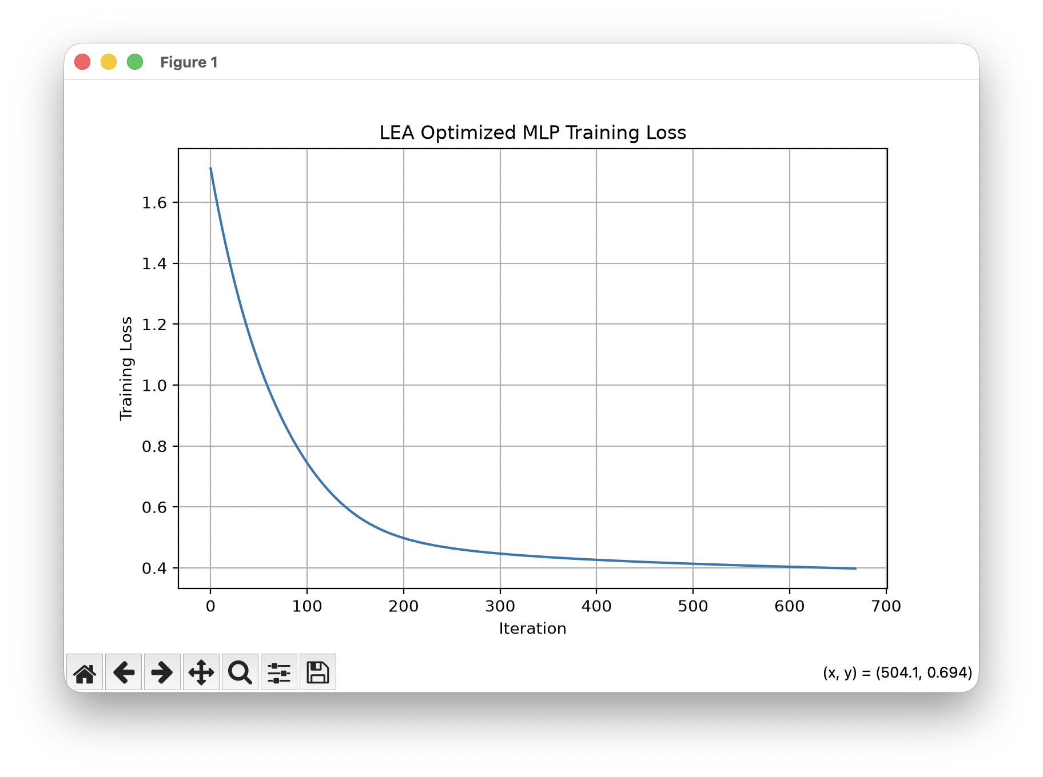
The LEA configuration shows a gradual but consistent reduction in training loss. The initial decline is less abrupt than that of some other configurations, after which the loss continues to decrease steadily before approaching a relatively stable region. This configuration produced the highest test accuracy and weighted F1-score among the Phase 2 models.

Figure - TLBO Optimized MLP Training Loss
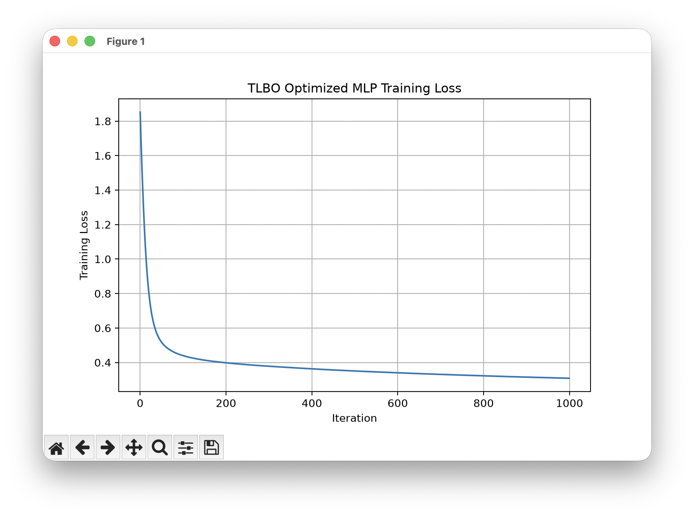
The TLBO model shows a rapid initial reduction in training loss followed by a longer period of gradual decrease. The continued decline indicates that the model continued adjusting its parameters throughout the later training iterations.

Overall Training Behaviour
Across the six training-loss curves, a common pattern can be observed:
$$\boxed{\text{Rapid Initial Learning}→\text{Gradual Loss Reduction}→\text{Convergence}}$$
The optimized configurations therefore exhibited stable training behaviour, with substantial reductions in loss from their initial values. However, the training-loss curves also demonstrate that a lower training loss does not necessarily correspond directly to improved generalization. The final comparison therefore relies on the independent test-set metrics rather than training loss alone.

Computational Cost of Optimization
In addition to predictive performance, the computational cost of the optimization procedures was recorded. The optimization times varied substantially between methods.

Table - Computational cost of Phase 2 optimization
Optimization Method | Optimization Time
Hyperband | 21.4 s
Random Search | 42.7 s
Bayesian Optimization | 134.4 s
LEA | 1026.9 s
TLBO | 2935.7 s
The results show a substantial difference in computational requirements. Hyperband required approximately 21.4 seconds, whereas LEA and TLBO required approximately 1026.9 seconds and 2935.7 seconds, respectively. The final MLP training itself required considerably less time, approximately a few seconds for the selected configurations.

Computational Observation
$$\boxed{\text{Optimization Cost}≫\text{Final Model Training Cost}}$$
for the more computationally intensive optimization approaches.
This distinction is important because the optimization procedure may require substantially more computational resources than training the final selected MLP configuration. It also provides motivation for the resource-controlled comparison introduced in the later experimental phase.

Class-wise Performance and Class Imbalance
Although the weighted metrics improved after optimization, the class-wise results reveal an important limitation. The Solar Flare dataset contains a highly dominant No Flare class and substantially fewer Common, Moderate, and Severe Flare observations. Consequently, weighted metrics can remain relatively high even when the minority classes are poorly recognized.
For example, the reported TLBO classification results show an F1-score of approximately 0.92 for the dominant No Flare class, while the minority classes received substantially weaker performance, including reported zero F1-scores for some minority classes.
This can be represented as:
$$\boxed{\text{High Weighted F1} ⇏ \text{Strong Minority-Class Recognition}}$$
The confusion matrix further illustrates that a substantial proportion of minority-class observations were assigned to the dominant class. Therefore, although hyperparameter optimization improved the overall weighted metrics, it did not by itself resolve the underlying class-imbalance problem.

Key Findings from Phase 2

Finding 1 Hyperparameter optimization improved overall performance
$$\text{Accuracy: }81.65\%→85.61\% \\ \text{Weighted F1: }0.7883→0.8013$$
The optimized MLP configurations therefore provided higher overall test performance than the baseline.

Finding 2 LEA produced the highest recorded test metrics
The LEA configuration achieved 85.61% test accuracy and 0.8013 weighted F1, compared with 81.65% and 0.7883 for the baseline.

Finding 3 Optimization methods differed substantially in computational cost
Hyperband required considerably less optimization time than Bayesian Optimization, LEA, and TLBO, while achieving the same recorded test accuracy and weighted F1 as Bayesian Optimization.

Finding 4 Class imbalance remained unresolved
Despite improvements in weighted metrics, minority Solar Flare classes continued to receive weak class-wise recognition. Therefore, hyperparameter optimization alone was insufficient to address the imbalance identified during Phase 1.

Transition from Phase 2 to Phase 3
The Phase 2 results demonstrate that hyperparameter optimization can improve the overall performance of the Solar Flare MLP, but they also reveal that improved weighted metrics do not necessarily translate into adequate recognition of the minority flare classes. This finding motivated the next experimental phase.
Therefore, Phase 3 introduced SMOTENC-based class balancing while retaining the MLP modelling framework. The purpose was to determine whether explicitly addressing the imbalance in the training data could improve recognition of the less frequent Solar Flare classes while maintaining or improving the overall predictive performance.
$$\boxed{\text{Phase 1}→\text{Baseline}} \\ \boxed{\text{Phase 2}→\text{Hyperparameter Optimization}} \\ \boxed{\text{Phase 3}→\text{Class-Imbalance Handling with SMOTENC}}$$

This gives us a clear experimental progression: baseline performance → optimization → imbalance handling, which is exactly what we want the reader to understand before moving to Phase 3.

3.2.3 Phase 3 – Differential Evolution Optimization
Phase 3 extends the Solar Flare experiments by introducing Differential Evolution (DE) as an additional hyperparameter optimization method for the MLP classifier. Unlike the previous optimization approaches, DE generates new candidate solutions using differences between existing population members. The purpose of this phase is to investigate whether this population-based evolutionary strategy can identify an improved MLP configuration for the highly imbalanced Solar Flare classification problem.

3.2.3.1 Differential Evolution Strategy
Differential Evolution represents each candidate MLP configuration as a numerical vector. New candidate solutions are generated by combining existing solutions using a differential mutation operation:
Mutant = X₁ + F × (X₂ − X₃)
where $X_{1}$, $X_{2}$, and $X_{3}$are different candidate solutions and $F$is the differential mutation factor. A recombination step is then used to construct the candidate configuration evaluated by the objective function.
Key configuration used in this experiment:
Parameter | Setting
Population size | 10
Maximum generations | 5
Cross-validation | 5-fold Stratified CV
Mutation factor | 0.5–1.0
Recombination | 0.7
Optimization objective | Macro F1
Random state | 42

3.2.3.2 MLP Hyperparameter Search
Differential Evolution searches over the following MLP parameters:
Hyperparameter | Search range
Hidden layers | (16,), (32,), (64,), (128,), (32,16), (64,32), (128,64)
Activation | ReLU, tanh
Solver | Adam
Learning rate | 0.0001–0.005
Alpha | 0.00001–0.01
Batch size | 16–64
Maximum iterations | 500–1000
The categorical hyperparameters are represented internally using numerical indices so that they can be processed by the Differential Evolution algorithm. The continuous parameters are directly optimized, while integer-valued parameters such as batch size and maximum iterations are rounded to valid values.

3.2.3.3 Handling of Class Imbalance
The original class imbalance is intentionally retained in this phase. No SMOTE, SMOTENC, artificial oversampling, or class-based resampling is applied. The training data therefore maintains the original distribution of 962 No Flare, 100 Common Flare, 40 Moderate Flare, and 9 Severe Flare observations after the stratified 80:20 split.
This design allows the effect of Differential Evolution to be examined independently from additional class-balancing techniques.

3.2.3.4 Optimization and Evaluation
Each candidate configuration is evaluated using 5-fold Stratified Cross-Validation on the training data. Macro F1 is used as the optimization objective because it gives equal importance to all four classes and is therefore more informative than accuracy for this highly imbalanced dataset.
The objective function can be represented as:
Objective = − Mean 5-Fold Macro F1
Since Differential Evolution minimizes the objective function, a configuration producing a higher Macro F1 receives a lower objective value. After optimization, the selected configuration is retrained on the complete training partition and evaluated once on the untouched test set.

4.2.3 Phase 3 Results – Differential Evolution
The Differential Evolution search required 1,562.17 seconds and evaluated 367 candidate configurations. The best configuration obtained during optimization achieved a 5-fold Cross-Validation Macro F1 of 0.3477.

4.2.3.1 Selected Differential Evolution Configuration
The optimized MLP configuration was:
Hyperparameter | Selected value
Hidden layers | (16,)
Activation | tanh
Solver | Adam
Learning rate | 0.002885
Alpha | 0.000762
Batch size | 21
Maximum iterations | 657
CV Macro F1 | 0.3477
The optimized model was then trained on the complete imbalanced training set. Final training required only 1.05 seconds, compared with the substantially longer optimization process.

4.2.3.2 Test Performance
The final Differential Evolution model achieved:
Metric | Score
Accuracy | 0.7878
Weighted Precision | 0.7625
Weighted Recall | 0.7878
Weighted F1 | 0.7746
Macro F1 | 0.2442
The difference between the weighted F1 (0.7746) and Macro F1 (0.2442) is important. The weighted metrics are strongly influenced by the dominant No Flare class, whereas Macro F1 gives equal weight to all four classes.

4.2.3.3 Classification Performance by Class
The test classification results were:
Class | Precision | Recall | F1-score | Support
Common Flare | 0.11 | 0.08 | 0.09 | 25
Moderate Flare | 0.00 | 0.00 | 0.00 | 10
No Flare | 0.87 | 0.90 | 0.88 | 241
Severe Flare | 0.00 | 0.00 | 0.00 | 2
The model recognized the dominant No Flare class relatively well, with a recall of 0.90. However, recognition of the minority classes remained weak. Moderate and Severe Flare received an F1-score of 0.00, while Common Flare achieved only 0.09.
The confusion matrix further demonstrates this behaviour:
$$\left[\begin{matrix}2 & 0 & 23 & 0 \\ 2 & 0 & 8 & 0 \\ 14 & 9 & 217 & 1 \\ 0 & 0 & 2 & 0\end{matrix}\right]$$
A large proportion of minority-class observations were classified as No Flare, indicating that Differential Evolution optimization alone did not resolve the class-imbalance problem.
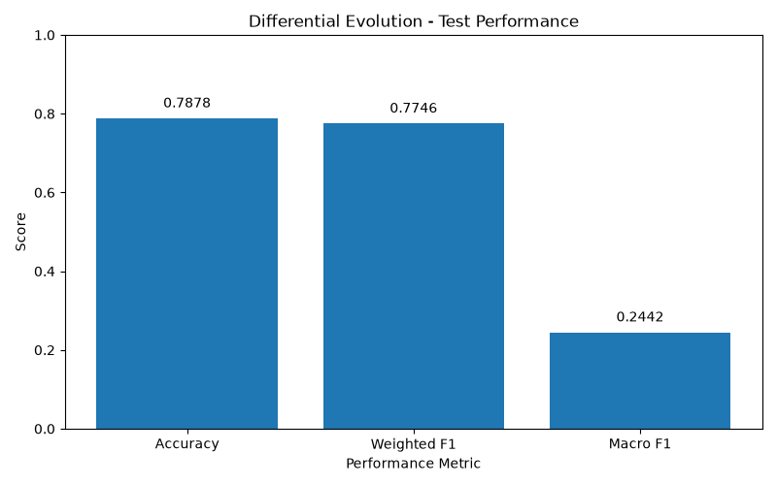
The figure shows an accuracy of 0.7878 and weighted F1 of 0.7746, while Macro F1 is substantially lower at 0.2442. This visual difference highlights the effect of the dominant No Flare class on the aggregate weighted metrics.
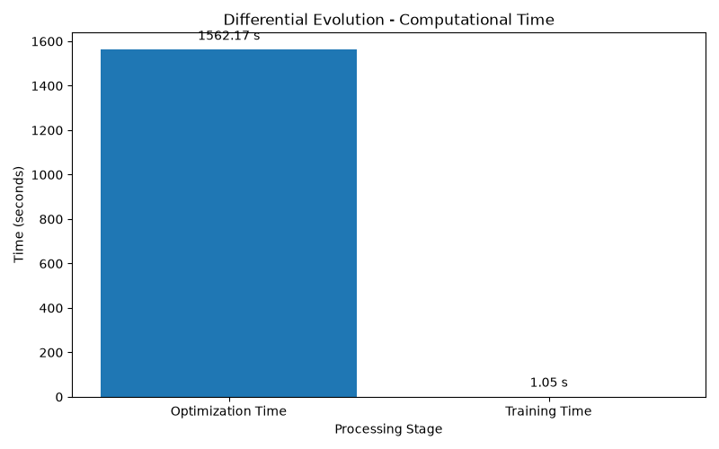
The optimization required approximately 1,562.17 seconds, whereas final model training required only 1.05 seconds. Therefore, most of the computational cost was associated with repeatedly evaluating candidate hyperparameter configurations through five-fold cross-validation rather than training the final MLP itself.

Phase 3 Finding
The Differential Evolution experiment demonstrates that evolutionary hyperparameter optimization can identify an MLP configuration with a reasonable overall accuracy and weighted F1. However, the substantially lower Macro F1 of 0.2442 and the weak recognition of Common, Moderate, and Severe Flare classes show that hyperparameter optimization alone was not sufficient to address the severe class imbalance in the Solar Flare dataset. This observation provides the motivation for incorporating explicit class-balancing strategies in the subsequent experimental stage.

3.2.4 Phase 3 – Imbalance Handling and MLP Evaluation
Phase 3 extends the Solar Flare experiments by explicitly addressing the severe class imbalance identified in the earlier phases. The original training data contains 962 No Flare samples, compared with 100 Common Flare, 40 Moderate Flare, and only 9 Severe Flare samples. Three imbalance-handling strategies were therefore investigated while keeping the MLP architecture unchanged.
The dataset was first divided into 80% training and 20% testing data using stratified sampling. The test set contained 278 observations and was not used during resampling or model training. The three categorical variables were handled explicitly so that SMOTENC could operate on the original mixed feature representation.

3.2.4.1 Full SMOTENC
The first approach applies SMOTENC (Synthetic Minority Over-sampling Technique for Nominal and Continuous features) to the training data. SMOTENC was selected because the Solar Flare dataset contains both categorical and numerical predictors.
The original training distribution was:
$$\text{Common}=100,\text{Moderate}=40,\text{No Flare}=962,\text{Severe}=9$$
Full SMOTENC increased every class to the majority-class size:
$$100, 40, 962, 9→962, 962, 962, 962$$
Thus, the training set increased from 1,111 to 3,848 observations. SMOTENC was applied only to the training data, while the test set remained unchanged.
After resampling, the categorical variables were one-hot encoded and the resulting features were standardized. The same baseline MLP configuration was retained:
$$\boxed{(64), ReLU, Adam, lr=0.001, α=0.0001, batch=32, max_iter=1000}$$
This controlled the experiment so that the principal change was the treatment of class imbalance rather than the model architecture.

3.2.4.2 Controlled SMOTENC
The second experiment investigates whether partial rather than complete oversampling can reduce the extreme synthetic expansion caused by full SMOTENC.
The controlled strategy uses the following target class sizes:
Class | Original training samples | Controlled target
Common Flare | 100 | 400
Moderate Flare | 40 | 250
No Flare | 962 | 962
Severe Flare | 9 | 100
This approach particularly limits the expansion of the extremely rare Severe Flare class. Instead of generating 953 additional synthetic Severe Flare observations as in full SMOTENC, the class is increased only from 9 to 100 samples.
The same MLP configuration is retained after controlled SMOTENC. One-hot encoding and standardization are performed using the resampled training data, while the original test data remains untouched.

3.2.4.3 Imbalance-Aware Weighted Training
The third strategy takes a different approach by repeating original training observations according to predefined class importance rather than generating synthetic observations.
The class weights used were:
$$\boxed{w_{Common}=3,w_{Moderate}=5,w_{No Flare}=1,w_{Severe}=8}$$
Thus, minority-class observations are presented more frequently during training, while the No Flare class retains its original representation. Unlike SMOTENC, this method does not create new synthetic feature combinations.
The same MLP architecture and hyperparameters are again retained. The weighted training data is encoded and standardized, and predictions are finally generated on the original untouched test set.

4.2.4 Phase 3 Results – Imbalance Handling
4.2.4.1 Full SMOTENC Results

The Full SMOTENC experiment produced the following test results:
Metric | Score
Accuracy | 0.7230
Weighted Precision | 0.7724
Weighted Recall | 0.7230
Weighted F1 | 0.7456
Macro F1 | 0.2659
The classification results were:
Class | Precision | Recall | F1-score | Support
Common Flare | 0.10 | 0.08 | 0.09 | 25
Moderate Flare | 0.00 | 0.00 | 0.00 | 10
No Flare | 0.88 | 0.82 | 0.85 | 241
Severe Flare | 0.07 | 0.50 | 0.12 | 2
The confusion matrix was:
$$\left[\begin{matrix}2 & 3 & 19 & 1 \\ 3 & 0 & 7 & 0 \\ 15 & 16 & 198 & 12 \\ 0 & 0 & 1 & 1\end{matrix}\right]$$
An important observation is that Severe Flare recall increased to 0.50, indicating that the model identified one of the two Severe Flare test observations. However, Moderate Flare remained completely unrecognized, and the overall Macro F1 remained low at 0.2659.

4.2.4.2 Comparison of Imbalance Strategies
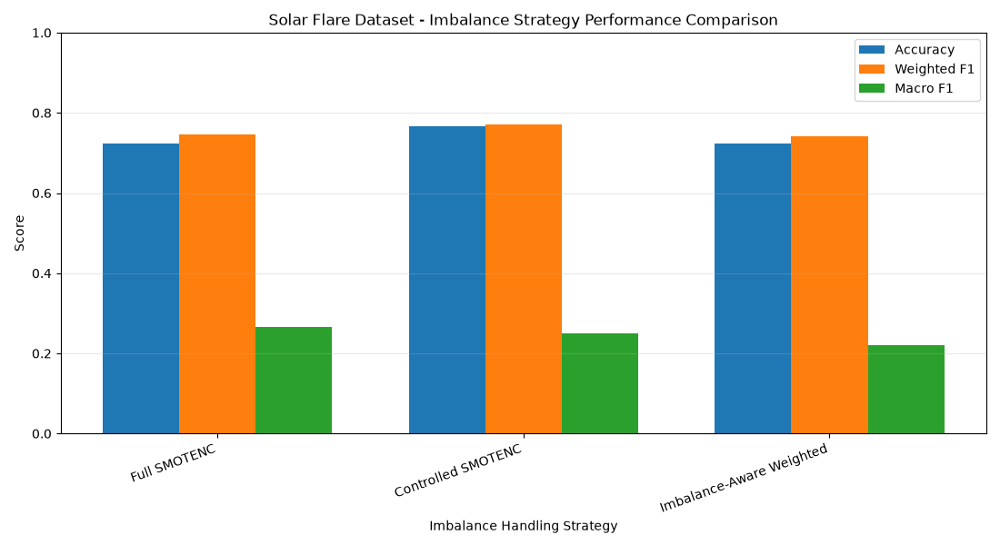

Figure - Comparison of imbalance-handling strategies for the Solar Flare dataset.
The figure compares Accuracy, Weighted F1, and Macro F1 for Full SMOTENC, Controlled SMOTENC, and Imbalance-Aware Weighted training.
The comparison shows that the three strategies produce relatively similar accuracy and weighted F1 values, whereas Macro F1 remains substantially lower for all approaches. This difference is important because accuracy and weighted F1 are strongly affected by the dominant No Flare class, while Macro F1 gives equal importance to all four classes.
The results therefore indicate that increasing the representation of minority classes does not automatically lead to strong recognition of all flare categories. In particular, the extremely small number of Severe Flare observations makes the classification problem difficult even after imbalance handling.

4.2.4.3 Phase 3 Interpretation
The Phase 3 experiments demonstrate the effect of changing the training-data distribution while keeping the MLP configuration constant. Full SMOTENC increased the training set substantially and improved recognition of the Severe Flare class, but Moderate Flare remained difficult to identify. Controlled SMOTENC was introduced to reduce the aggressive synthetic expansion associated with the rarest classes, while the imbalance-aware weighted strategy provided an alternative based on repeated original observations rather than synthetic samples.
Overall, the consistently lower Macro F1 compared with the weighted metrics confirms that the main challenge in the Solar Flare dataset is minority-class recognition rather than overall prediction of the dominant No Flare class. These observations motivate the subsequent experiments involving further model optimization and comparison of optimization strategies.

3.2.4 Controlled SMOTENC with Random Search and Bayesian Optimization

Following the initial SMOTENC experiment, this phase combined controlled SMOTENC with hyperparameter optimization to investigate whether improved MLP configurations could be obtained while explicitly considering the severe class imbalance of the Solar Flare dataset.
The original training set contained 962 No Flare, 100 Common Flare, 40 Moderate Flare, and 9 Severe Flare observations. Instead of applying full oversampling, controlled SMOTENC was used to increase the minority classes to predefined levels while keeping the majority class unchanged. The test set was not oversampled.
The optimization process used the same MLP hyperparameter search space established in the previous phase, including hidden-layer architecture, activation function, learning rate, regularization parameter, and batch size. Both Random Search and Bayesian Optimization were evaluated using 5-fold stratified cross-validation. SMOTENC was applied only within the training portion of each fold, while the corresponding validation fold remained unchanged.
The optimization objective was based on Macro F1, since the four Solar Flare classes are highly imbalanced and Macro F1 gives equal importance to each class.

Key Experimental Settings
$$\text{Training Data}→\text{5-Fold Stratified CV}→\text{Controlled SMOTENC}→\text{Encoding}→\text{Scaling}→\text{MLP} \\ \boxed{\text{Optimization Objective}=\text{Macro F1}} \\ \boxed{\text{Test Set remains untouched}}$$
Random Search evaluates randomly selected hyperparameter configurations, whereas Bayesian Optimization uses information from previous evaluations to guide subsequent configurations. Both methods were therefore applied under the same preprocessing and evaluation framework to allow their behaviour to be compared.

4.2.4 Controlled SMOTENC with Random Search and Bayesian Optimization
The results of this phase were evaluated using test accuracy, weighted F1, and Macro F1, together with the computational time required by each optimization method.

Table 4.2.4. Performance comparison of Random Search and Bayesian Optimization
Optimization Method | Test Accuracy | Weighted F1 | Macro F1
Random Search | 0.6970 | 0.7250 | 0.2290
Bayesian Optimization | 0.6690 | 0.7110 | 0.2190
The results show that the two optimization strategies produced different test performance under the controlled SMOTENC setting. Random Search achieved a test accuracy of approximately 0.697 and a weighted F1-score of 0.725, while Bayesian Optimization achieved approximately 0.669 accuracy and 0.711 weighted F1.
However, the Macro F1 values remained considerably lower, at approximately 0.229 for Random Search and 0.219 for Bayesian Optimization. This indicates that the improvement in overall and weighted performance did not translate into equally strong recognition across all four Solar Flare classes. The severe class imbalance therefore remained an important limitation even after controlled oversampling and hyperparameter optimization.

Figure 4.2.4. Random Search vs Bayesian Optimization – Performance Comparison
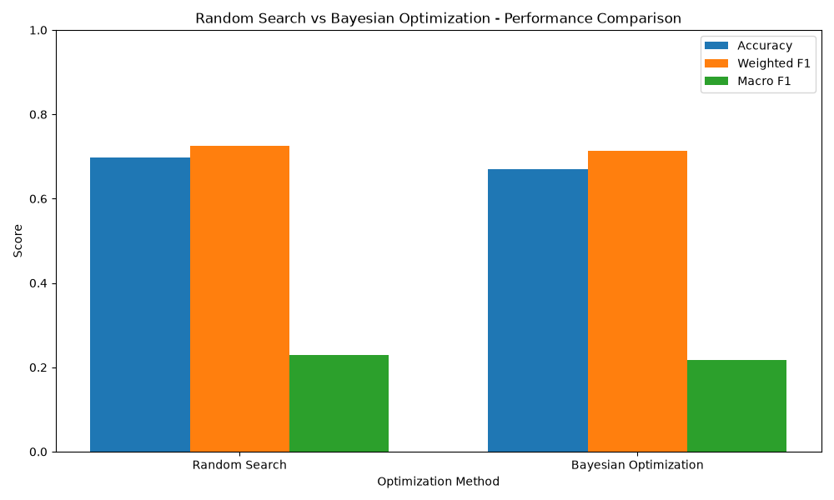
The figure provides a visual comparison of accuracy, weighted F1, and Macro F1 for the two optimization strategies. The relatively higher weighted scores compared with Macro F1 also illustrate the effect of the dominant No Flare class on aggregate performance.

Computational Cost
The optimization time was also recorded to examine the computational cost of the two approaches.
Optimization Method | Optimization Time
Random Search | ≈44 seconds
Bayesian Optimization | ≈67 seconds

Figure 4.2.5. Random Search vs Bayesian Optimization – Optimization Time

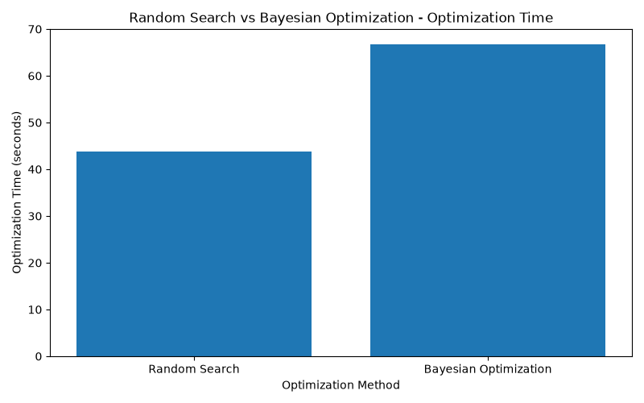
Random Search required approximately 44 seconds, whereas Bayesian Optimization required approximately 67 seconds. The difference reflects the additional sequential search process used by Bayesian Optimization.
Overall, this experiment showed that controlled SMOTENC could be combined with hyperparameter optimization, but the relatively low Macro F1 values indicated that class imbalance remained unresolved, particularly for the minority flare categories. This observation provided motivation for evaluating additional optimization and imbalance-handling strategies in the subsequent experimental phase.

3.2.5 Solar Flare Dataset – Phase 4
Phase 4 introduced a controlled comparison of the hyperparameter optimization methods for the Solar Flare MLP classifier. The experiment retained the four-class classification task, stratified 80:20 train-test split, five-fold stratified cross-validation, and controlled SMOTENC preprocessing from the previous phase. SMOTENC was applied only within the training portion of each cross-validation fold, followed by one-hot encoding and feature standardization. Macro F1 was used as the primary optimization metric because the Solar Flare dataset contains substantial class imbalance.
The main addition in Phase 4 was an equal computational resource budget for all optimization methods. Each optimizer was allocated 15,000 resource units. For the standard optimizers, this corresponded to six evaluations using five-fold cross-validation and a maximum of 500 MLP iterations per evaluation. Hyperband used successive-halving stages with 200, 300, and 500 iterations while maintaining the same total budget. The compared methods were Random Search, Bayesian Optimization, Hyperband, LEA, TLBO, Simulated Annealing, and a budget-limited Differential Evolution approach.
After optimization, the selected configurations were retrained using the complete training partition with the same controlled SMOTENC procedure. The untouched test set was then used only for final evaluation, ensuring that test performance did not influence optimizer selection.

4.2.5 Solar Flare Dataset – Phase 4 Results
Phase 4 evaluated the optimization methods under the common computational budget of 15,000 resource units per optimizer. The budget check confirmed that all seven optimization methods received the same total resource allocation, although Hyperband used a larger number of partial evaluations through successive halving.

Table 4.2.5. Phase 4 Optimizer Performance on the Solar Flare Dataset
Method | Validation Macro F1 | Test Accuracy | Test Weighted F1 | Test Macro F1 | Optimization Time (s)
Baseline MLP | 0.2953 | 0.7302 | 0.7473 | 0.2300 | 0.00
Random Search | 0.2818 | 0.6511 | 0.6974 | 0.2011 | 166.56
Bayesian Optimization | 0.3074 | 0.7158 | 0.7349 | 0.2192 | 129.89
Hyperband | 0.3037 | 0.6475 | 0.6935 | 0.2000 | 157.12
LEA | 0.2946 | 0.7158 | 0.7349 | 0.2192 | 138.09
TLBO | 0.2942 | 0.6475 | 0.6936 | 0.2059 | 92.71
Simulated Annealing | 0.2931 | 0.6691 | 0.7072 | 0.2039 | 164.86
Differential Evolution | 0.3065 | 0.6259 | 0.6841 | 0.1973 | 114.45
The results show that the optimization methods produced different validation and test behaviour under the same computational budget. The highest recorded validation Macro F1 among the optimizers was 0.3074 for Bayesian Optimization, while Differential Evolution reached 0.3065 and Hyperband reached 0.3037. The baseline MLP recorded a validation Macro F1 of 0.2953. The implementation therefore selected Bayesian Optimization using the validation criterion, without using the test set during optimizer selection.
On the test set, the baseline achieved an accuracy of 0.7302, weighted F1 of 0.7473, and Macro F1 of 0.2300. The optimized configurations produced lower Macro F1 values, ranging from 0.1973 to 0.2192. Bayesian Optimization and LEA both produced a test Macro F1 of 0.2192, while Differential Evolution produced 0.1973. This difference between validation and test performance indicates that the configuration selected from cross-validation did not translate into higher test Macro F1 for this dataset. The final test metrics were generated separately for every optimizer after retraining on the complete development partition.

Figure 4.2.5.1. Solar Flare Phase 4 – Optimizer Convergence Under Equal Budget
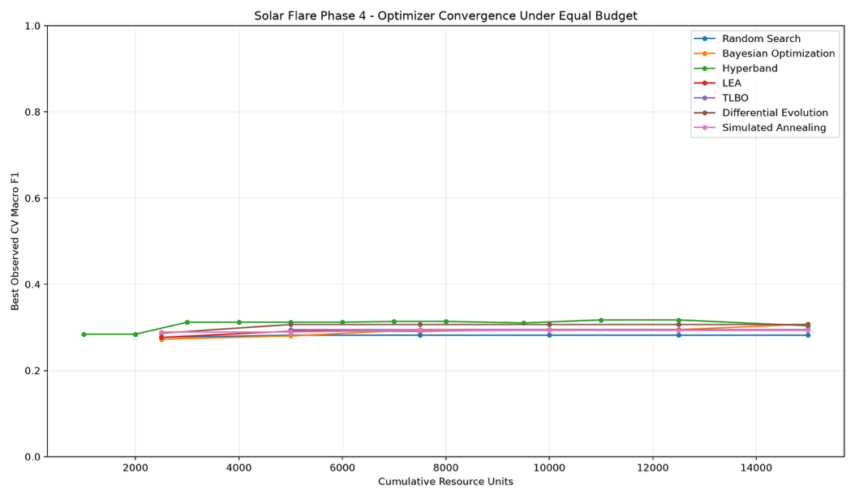
The convergence plot compares the best observed five-fold CV Macro F1 against cumulative computational resources. The curves show that the optimization methods followed different search trajectories despite receiving the same total resource budget. Hyperband increased its observed Macro F1 relatively early through successive halving, while Bayesian Optimization improved progressively and reached 0.3074 by the final evaluation. Differential Evolution also reached approximately 0.3065, whereas Random Search remained comparatively stable at a lower validation Macro F1. The figure therefore illustrates the differences in search behaviour and resource utilization rather than simply comparing the final scores.

Figure 4.2.5.2. Solar Flare Phase 4 – Simulated Annealing Temperature
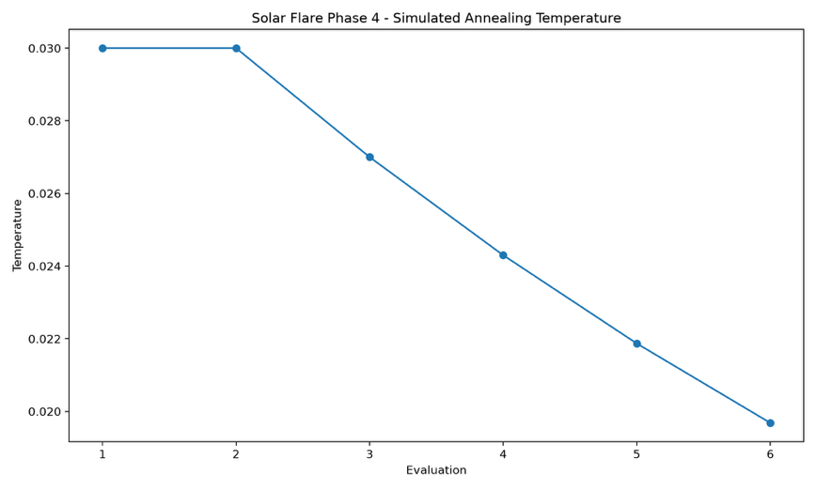
The Simulated Annealing temperature decreased from 0.0300 during the initial evaluations to approximately 0.0197 by the sixth evaluation. This reduction follows the cooling rate of 0.90 specified in the implementation and represents the gradual reduction in the probability of accepting lower-scoring neighbouring configurations as the search progresses.

Overall observation
Phase 4 demonstrates that equal computational resources can lead to substantially different optimization trajectories and final test behaviour. Although Bayesian Optimization achieved the highest optimizer validation Macro F1 of 0.3074 and was consequently selected by the validation procedure, its final test Macro F1 was 0.2192, below the Phase 4 baseline value of 0.2300. This result is important for the Solar Flare dataset because it shows that improvements during cross-validation did not necessarily translate into improved performance on the untouched test set. The strong difference between weighted F1 and Macro F1 also remains consistent with the highly imbalanced four-class target distribution identified in the earlier phases.

3.3 Energy Efficiency Dataset

3.3.1 Dataset and Prediction Objective

The Energy Efficiency dataset was selected as one of the benchmark datasets for evaluating the proposed machine learning optimization framework. The dataset contains 768 observations and 10 variables. Eight variables describe characteristics of the buildings, while two variables, Heating Load (Y1) and Cooling Load (Y2), represent the corresponding energy-load measurements. The building-related variables include Relative Compactness, Surface Area, Wall Area, Roof Area, Overall Height, Orientation, Glazing Area, and Glazing Area Distribution.
The original formulation of the dataset is a regression problem, since both Heating Load and Cooling Load are continuous numerical variables. Therefore, unlike datasets where a categorical target is already available, the Energy Efficiency dataset required an additional target-construction step before it could be used in the classification-based MLP experiments of this study.
The two target variables describe related but distinct aspects of the building's energy requirements. Heating Load represents the heating requirement, while Cooling Load represents the cooling requirement. Consequently, the first stage of Phase 1 focused on understanding the behaviour of these two target variables before deciding how they could be transformed into a classification target.
The dataset was initially loaded from the UCI repository and preserved in its original form as energy_efficiency_original.csv. This ensured that the original continuous target values remained available before any transformation was performed.

3.3.2 Exploratory Analysis of Heating and Cooling Load
Before converting the regression targets into classes, descriptive analysis was performed to understand their range, distribution, and relationship. This step was particularly important because the classification classes were not predefined in the original dataset. The target distributions therefore had to be examined before selecting an appropriate transformation strategy.
Heating Load had a mean value of 22.31 with a standard deviation of approximately 10.09. Its values ranged from 6.01 to 43.10, showing a substantial difference between buildings with relatively low and relatively high heating requirements. Cooling Load had a mean of 24.59 and a standard deviation of approximately 9.51, with values ranging from 10.90 to 48.03.
These ranges show that the observations are spread across considerably different levels of energy demand. Therefore, treating all observations as having essentially the same target level would not represent the structure of the dataset adequately.

3.3.2.1 Heating Load Distribution
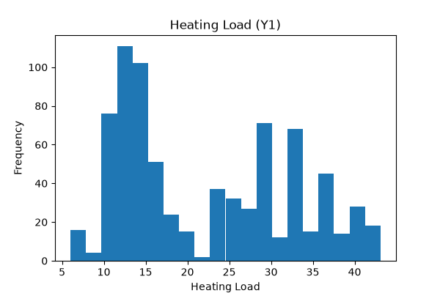
The Heating Load histogram provides a visual overview of how the 768 observations are distributed across the target range. The observations are not uniformly distributed. Instead, several regions contain noticeably larger concentrations of observations, while other parts of the range contain fewer observations.
This distribution is relevant for the later classification transformation because it suggests that the continuous Heating Load variable contains different levels of energy demand rather than forming one homogeneous group. However, the histogram alone does not provide sufficient evidence for defining class boundaries. Therefore, the Cooling Load variable and the joint relationship between both targets were examined as well. The visualization was generated directly in Phase 1 to support this assessment.

3.3.2.2 Cooling Load Distribution
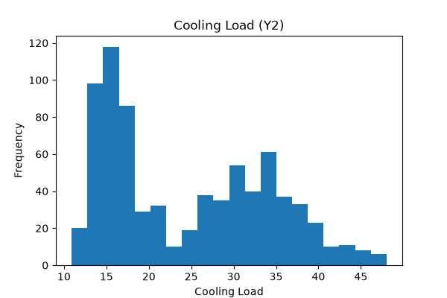
The Cooling Load distribution shows a similar pattern. The values extend from approximately 10.9 to 48.0, with observations concentrated in different parts of the range. This indicates that the buildings also exhibit different levels of cooling requirements.
Considering the two target distributions together is important because the objective is not simply to divide one target into arbitrary intervals. Instead, Phase 1 investigates whether the two energy-load measurements jointly contain a meaningful structure that can be represented by a smaller number of energy-demand categories.

3.3.3 Relationship Between Heating Load and Cooling Load
The relationship between Heating Load and Cooling Load was then examined using correlation analysis and a scatter plot. The calculated correlation coefficient was 0.9759, indicating a very strong positive relationship between the two target variables.
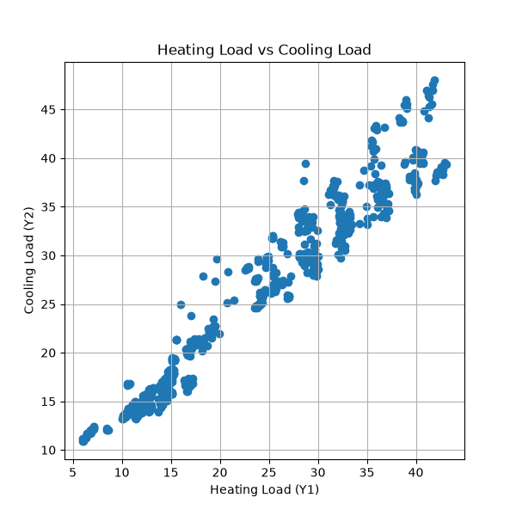
The scatter plot provides a clearer interpretation of this relationship. The observations follow a strong upward pattern: buildings with higher Heating Load generally also have higher Cooling Load. Rather than being randomly distributed across the two-dimensional target space, the observations form a structured progression from lower energy-load values toward higher energy-load values.
This strong relationship was important for the next stage of Phase 1. Since the two targets provide closely related information about energy demand, they were considered jointly when constructing the classification target.
At the same time, correlation alone does not establish that the observations naturally form a particular number of groups. Therefore, the next step was to investigate the structure of the joint target space using clustering. This provided a data-driven approach for converting the continuous targets into discrete energy-demand categories rather than defining arbitrary numerical thresholds.

3.3.4 Preparation of the Target Variables for Clustering
Because K-Means is a distance-based clustering algorithm, Heating Load and Cooling Load were first standardized before clustering. The two target variables were selected together and transformed using StandardScaler.
This step ensured that both target variables contributed comparably to the distance calculations used by K-Means. Without standardization, differences in numerical scale could influence the distances between observations and consequently affect the resulting clusters.
The standardized Heating Load and Cooling Load values were then used to investigate different possible numbers of clusters. Rather than selecting the number of energy classes arbitrarily, Phase 1 evaluated values of k from 2 to 10 using two complementary clustering measures: the Elbow Method and the Silhouette Score.

3.3.5 Determination of the Number of Energy Classes

3.3.5.1 Elbow Method
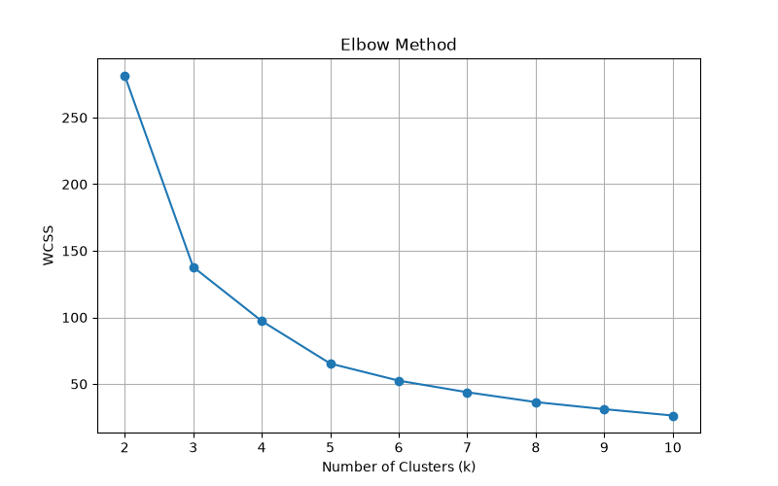
The Elbow Method was used to examine how the Within-Cluster Sum of Squares (WCSS) changed as the number of clusters increased. The WCSS decreased substantially when moving from a small number of clusters to larger values. For example, the WCSS decreased from 281.72 for k = 2 to 137.81 for k = 3 and 97.28 for k = 4. After this point, the reduction became progressively smaller.
The resulting Elbow plot therefore shows a clear reduction in clustering error during the initial increases in k, followed by a more gradual improvement. Around k = 4, the additional reduction in WCSS becomes less substantial compared with the improvements obtained by adding the earlier clusters.
This provided the first indication that four clusters could provide a reasonable representation of the main structure in the energy-load data.

3.3.5.2 Silhouette Analysis
To complement the Elbow Method, the Silhouette Score was calculated for each value of k between 2 and 10. The Silhouette Score evaluates how well observations fit within their assigned clusters relative to neighbouring clusters.
The highest score was obtained for k = 2, with a value of 0.7165. The score for k = 3 was 0.6387, while k = 4 produced a score of 0.5967. Although the two-cluster solution produced the highest numerical Silhouette Score, it would divide the target space into only two broad energy levels.
For this study, the objective was not only to obtain strong mathematical separation, but also to construct a useful multiclass representation of increasing energy demand for the subsequent classification experiments. Therefore, the Silhouette results were considered together with the Elbow behaviour.
Based on this combined assessment, four clusters were selected. This choice provides a more detailed representation of the target space while still maintaining a reasonably strong clustering structure.

3.3.6 Construction of the Energy Classes
After selecting k = 4, K-Means clustering was applied to the standardized Heating Load and Cooling Load variables using random_state = 42 and n_init = 10. Each observation was initially assigned a numerical cluster identifier.
The numerical cluster identifiers were then converted into meaningful ordered energy categories:
- Low
- Medium
- High
- Very High
The mapping was based on the energy-load characteristics of the resulting clusters rather than treating the numerical cluster IDs themselves as meaningful labels. This distinction is important because a K-Means cluster identifier such as 0, 1, 2, or 3 does not inherently indicate whether that cluster represents low or high energy demand.
The resulting classes provide a more interpretable representation of the original continuous targets. Instead of asking the classification model to predict an arbitrary numerical cluster ID, the target now represents an increasing level of energy demand.

3.3.7 Analysis of the Resulting Energy Classes
The final four-class distribution contained 373 Low, 99 Medium, 181 High, and 115 Very High observations.
Energy Class | Number of Observations | Mean Heating Load | Mean Cooling Load
Low | 373 | 13.13 | 15.89
Medium | 99 | 23.21 | 25.89
High | 181 | 30.46 | 32.39
Very High | 115 | 38.46 | 39.40
The class-level averages show a clear and consistent progression. The Low class has the lowest average Heating and Cooling Loads, with values of 13.13 and 15.89, respectively. These values increase for the Medium class to 23.21 and 25.89, followed by 30.46 and 32.39 for the High class. The Very High class has the largest average values, at 38.46 for Heating Load and 39.40 for Cooling Load.
This progression is important because it demonstrates that the generated class labels have a meaningful interpretation. The classes are not simply numerical groups created by the clustering algorithm; they correspond to progressively increasing levels of both heating and cooling demand.
The resulting distribution also shows that the classes are not perfectly balanced. The Low class contains substantially more observations than the Medium class, while the High and Very High classes contain intermediate numbers of observations. This class distribution becomes relevant in the later classification phases because model performance must be evaluated across all four classes rather than relying only on overall accuracy.

3.3.8 Visual Representation of the Energy Classes
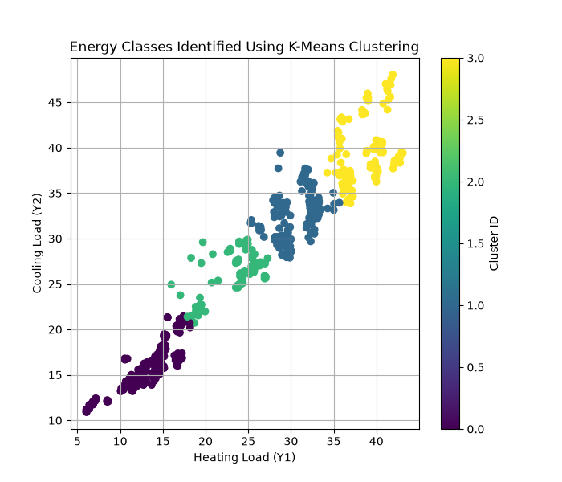
The final clustering visualization provides a direct visual representation of the four energy classes in the Heating Load–Cooling Load space. Each observation is displayed according to its Heating Load and Cooling Load values, with the colour indicating its assigned cluster.
The figure shows a clear progression across the target space. The lower-left region contains observations associated with lower Heating and Cooling Loads and corresponds to the Low-energy group. Moving upward and to the right, the observations transition through the Medium and High groups and eventually reach the Very High group, which contains observations with substantially larger values for both targets.
This visual structure is consistent with the numerical class means presented above. In other words, the clustering does not produce four groups that are difficult to interpret; instead, the groups follow the existing progression in the original target variables.
The figure therefore provides an intuitive representation of how the original continuous target space was transformed into four ordered energy-demand categories.

3.3.9 Final Dataset Preparation
Following the clustering process, the original dataset was augmented with two additional variables: the numerical Cluster identifier and the corresponding Energy_Class label. The processed dataset was then saved as energy_efficiency_clustered.csv.
The resulting dataset retains the original building characteristics and continuous Heating and Cooling Load measurements while providing an additional categorical representation of energy demand. This is useful because the original target information is preserved for analysis, while the newly generated Energy_Class provides the classification target required for the subsequent MLP experiments.
Therefore, Phase 1 does more than simply preprocess the dataset. It establishes the classification formulation that will be used throughout the remaining Energy Efficiency experiments. The analysis begins with the original continuous energy-load measurements, investigates their distributions and relationship, identifies a suitable cluster structure, and finally converts that structure into four interpretable energy-demand classes.

3.3.10 Phase 1 Assessment and Transition to Phase 2
Overall, Phase 1 established that the Energy Efficiency dataset contains substantial variation in both Heating Load and Cooling Load and that the two targets have a very strong positive relationship (r = 0.9759). The visual analysis further showed a structured progression of observations across the two target dimensions rather than a completely random distribution.
The clustering analysis was therefore introduced to construct a classification target from the original regression formulation. Although the Silhouette Score was highest for two clusters, the combined assessment of the Elbow Method, Silhouette analysis, and the requirement for a more informative multiclass representation led to the selection of four energy classes. These classes represent increasing levels of energy demand from Low to Very High.
The resulting dataset contains 373 Low, 99 Medium, 181 High, and 115 Very High observations, with the mean Heating and Cooling Loads increasing consistently across the four groups. This provides a meaningful classification target for the subsequent experiments.
Phase 2 therefore moves from target construction and exploratory clustering to machine learning classification. The building characteristics are used as input variables, while the derived Energy_Class becomes the classification target for the baseline MLP and subsequent optimization experiments.

4.3 Energy Efficiency Prediction – Phase 1 Results

4.3.1 Distribution of the Original Target Variables
The initial analysis of the Energy Efficiency dataset showed substantial variation in both target variables. Heating Load had a mean of 22.31, with values ranging from 6.01 to 43.10, while Cooling Load had a mean of 24.59, ranging from 10.90 to 48.03. The Heating Load distribution demonstrates that the observations are spread across several different energy-demand ranges. A large proportion of observations occur in the lower portion of the range, while additional groups appear at higher heating-load values. This indicates that the dataset contains buildings with noticeably different heating requirements.
The Cooling Load distribution presents a comparable pattern. The observations extend across a relatively wide range, with concentrations occurring at different cooling-load levels. Together, these distributions demonstrate that the target variables contain sufficient variation to support the construction of different energy-demand categories.

4.3.2 Relationship Between the Two Energy Loads
The scatter plot shows a strong and clearly visible positive relationship between Heating Load and Cooling Load. This observation is supported by the calculated correlation coefficient of 0.9759.
The observations generally follow an upward trajectory, meaning that higher Heating Load values are associated with higher Cooling Load values. The relationship is sufficiently strong that the two variables form a clearly structured target space rather than behaving as independent energy measurements.
The scatter plot also provides the first visual indication that the observations can be viewed as different regions of energy demand. This motivated the subsequent use of clustering to investigate whether the continuous target space could be represented using a smaller number of meaningful groups.

4.3.3 Selection of the Number of Clusters
The Elbow Method produced WCSS values of 281.72 for k = 2, 137.81 for k = 3, and 97.28 for k = 4. Although WCSS continued to decrease as additional clusters were introduced, the improvement became progressively smaller after approximately four clusters.
The Silhouette analysis provided an additional perspective. The highest score was observed at k = 2 with 0.7165, while the score for k = 4 was 0.5967.
Although the two-cluster configuration provided the strongest numerical silhouette value, four clusters were selected because they provided a more detailed representation of the progression in energy demand while remaining consistent with the behaviour observed in the Elbow analysis.
Thus, the final classification formulation uses four energy-demand classes rather than reducing the dataset to only two broad categories.

4.3.4 Distribution and Characteristics of the Energy Classes
The final K-Means transformation produced four classes:
Energy Class | Observations | Mean Heating Load | Mean Cooling Load
Low | 373 | 13.13 | 15.89
Medium | 99 | 23.21 | 25.89
High | 181 | 30.46 | 32.39
Very High | 115 | 38.46 | 39.40
The resulting class means show a consistent increase in both Heating Load and Cooling Load from the Low class through to the Very High class. The Low class represents observations with considerably lower energy requirements, whereas the Very High class represents observations with the highest combined heating and cooling loads.
The visualization further demonstrates this progression. The Low observations are concentrated toward the lower-left region of the target space, while the Very High observations are concentrated toward the upper-right region. The Medium and High classes occupy the intermediate regions between these two extremes.
This provides both a numerical and visual confirmation that the four generated classes have an interpretable ordering in terms of energy demand.

4.3.5 Phase 1 Findings
Phase 1 successfully converted the original Energy Efficiency regression targets into a four-class classification formulation. The analysis identified a strong relationship between Heating Load and Cooling Load, with a correlation of 0.9759, and demonstrated a structured progression in the joint target space.
The K-Means analysis resulted in four interpretable energy-demand categories: Low, Medium, High, and Very High. Their respective sample counts were 373, 99, 181, and 115, while their mean heating and cooling loads increased consistently across the classes.
The resulting energy_efficiency_clustered.csv dataset therefore provides the basis for the next experimental stage. Phase 2 uses these derived energy classes as the classification target and moves from exploratory target construction to MLP-based classification and model optimization.

3.3.11 Phase 2 – Hyperparameter Optimization for the Energy Efficiency Dataset
Phase 2 extends the Energy Efficiency experiment by investigating whether optimization of the MLP hyperparameters can improve the classification of buildings into the four energy-load categories created in Phase 1. The eight building characteristics $X_{1}$–$X_{8}$ are used as input variables, while Energy_Class is used as the classification target. The target was created from the Heating Load ($Y_{1}$) and Cooling Load ($Y_{2}$) variables during Phase 1.
The purpose of this phase is therefore to determine whether changing the MLP architecture and training parameters provides a measurable improvement over the baseline configuration.

3.3.11.1 Dataset and Prediction Objective
The Energy Efficiency dataset contains 768 building observations and 10 original variables. Eight variables ($X_{1}$–$X_{8}$) describe building characteristics, while $Y_{1}$represents Heating Load and $Y_{2}$represents Cooling Load.
The eight input variables are:
Variable | Description
$$X_{1}$$ | Relative Compactness
$$X_{2}$$ | Surface Area
$$X_{3}$$ | Wall Area
$$X_{4}$$ | Roof Area
$$X_{5}$$ | Overall Height
$$X_{6}$$ | Orientation
$$X_{7}$$ | Glazing Area
$$X_{8}$$ | Glazing Area Distribution
The original target variables are:
Variable | Description
$$Y_{1}$$ | Heating Load
$$Y_{2}$$ | Cooling Load
The two energy-load variables are strongly related, with a correlation of 0.9759. This indicates that buildings with higher heating loads generally also exhibit higher cooling loads.

3.3.11.2 Dataset-specific representation of the target
Because the experiment focuses on classification, the two continuous energy-load variables were transformed into a four-class Energy_Class target.
For each building $i$, its position in the energy-load space can be represented as:
$$E_{i}=(Y_{1,i},Y_{2,i})$$
where:
- $Y_{1,i}$= Heating Load of building $i$
- $Y_{2,i}$= Cooling Load of building $i$
Before clustering, the two variables were standardized. Using the actual statistics of this dataset:
$$Z_{Y_{1}}=\frac{Y_{1}-22.3072}{10.0902} \\ Z_{Y_{2}}=\frac{Y_{2}-24.5878}{9.5133}$$
Thus, each building is represented in the clustering process by its standardized heating and cooling load:
$$E_{i}=(Z_{Y_{1},i},Z_{Y_{2},i})$$
K-Means clustering was then used to identify groups of buildings with similar energy-load characteristics.

3.3.11.3 Energy classes generated in Phase 1
Energy Class | Samples | Percentage | Mean $Y_{1}$ | Mean $Y_{2}$
Low | 373 | 48.57% | 13.13 | 15.89
Medium | 99 | 12.89% | 23.21 | 25.89
High | 181 | 23.57% | 30.46 | 32.39
Very High | 115 | 14.97% | 38.46 | 39.40
The resulting classes show a clear progression from lower to higher heating and cooling requirements. This provides the basis for treating the Energy Efficiency dataset as a four-class classification problem in Phase 2.
The figure shows that the Low class contains the largest number of buildings, while Medium is the smallest class. Although the classes are not equally distributed, all four classes contain a sufficient number of observations for the classification experiment.

3.3.11.4 Preparation of Input Features
For Phase 2, the generated Energy_Class column is separated from the eight building characteristics. Therefore, the model input can be represented as:
$$X_{i}=(X_{1,i},X_{2,i},X_{3,i},X_{4,i},X_{5,i},X_{6,i},X_{7,i},X_{8,i})$$
and the corresponding target is:
$$y_{i}=Energy_Class_{i}$$
The eight building characteristics are therefore used to predict the energy category derived from the heating and cooling loads.
This separation is important because $Y_{1}$and $Y_{2}$, which were used to construct the energy classes, are not directly supplied to the MLP as predictors. The model instead has to learn the relationship between the physical building characteristics and the resulting energy category.

3.3.11.5 Train-Test Split and Feature Preparation
The dataset was divided into training and testing subsets using an 80:20 stratified split with random_state=42.
This resulted in:
Dataset | Observations
Training set | 614
Test set | 154
Total | 768
Stratification was used so that the four energy classes remained represented in both subsets.
The input features were then standardized before being provided to the MLP. The scaler was fitted using the training data and subsequently applied to the test data.
For this dataset, the transformation can be viewed as converting each building characteristic into a relative scale based on the training-set distribution:
$$X_{j}^{*}=\frac{X_{j}-μ_{X_{j}}}{σ_{X_{j}}}$$
where $X_{j}$represents one of the eight building characteristics.
The purpose of this step is particularly relevant for the Energy Efficiency dataset because the input variables describe different physical properties, such as surface area, wall area, roof area, height and glazing characteristics.

3.3.11.6 Baseline MLP Model
Before applying optimization, a baseline MLP was trained to provide a reference point.
The baseline configuration used:
Hyperparameter | Baseline value
Hidden layers | (64,)
Activation | ReLU
Solver | Adam
Learning rate | 0.001
Alpha | 0.0001
Batch size | 32
Maximum iterations | 500
Random state | 42
The baseline model achieved an accuracy of approximately 96.75%, with precision, recall and F1-score also around 96.7%.

Interpretation
The baseline result is already very high. This indicates that the eight building characteristics contain substantial information for distinguishing the four energy classes.
This is an important observation for the optimization experiments because the subsequent algorithms are not starting from a weak model. Instead, they are attempting to improve a classifier that already provides strong performance on the independent test set.
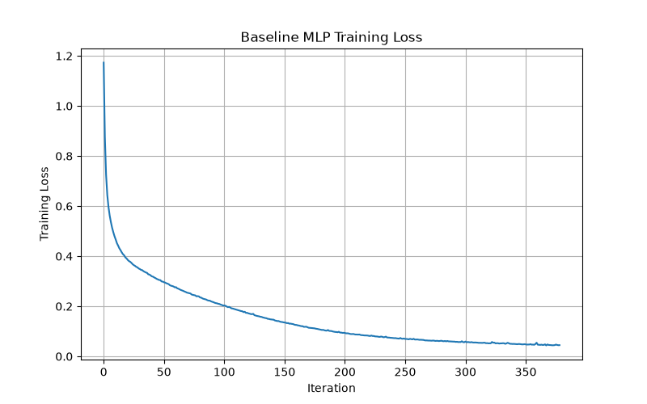
The training-loss curve shows that the model learns the main classification structure relatively quickly and subsequently approaches a stable region. This provides an initial indication that the baseline MLP is able to model the relationship between building characteristics and energy class effectively.

3.3.11.7 Definition of the Hyperparameter Search Space
After establishing the baseline, Phase 2 defines a common search space for the optimization methods.
Hyperparameter | Values considered
Hidden layer architecture | (16,), (32,), (64,), (32,16), (64,32)
Activation | ReLU, tanh
Solver | Adam
Learning rate | 0.0001, 0.001
Alpha | 0.0001, 0.001, 0.01
Batch size | 32, 64, 128
Maximum iterations | 500
The search space represents different levels of MLP complexity. A single hidden layer represents a simpler architecture, whereas (32,16) and (64,32) provide additional modelling capacity.
The total number of discrete combinations is:
$$5×2×2×3×3=180$$
possible configurations.
This means that the optimization problem is not simply about finding a larger network. It also investigates the effect of learning rate, regularization and batch size on the classification of the Energy Efficiency classes.

3.3.11.8 Random Search
Random Search evaluates a selected number of randomly sampled configurations from the defined search space. In this experiment, 20 configurations were evaluated using cross-validation.
The purpose is to determine whether randomly exploring alternative MLP configurations can identify a model that improves upon the baseline.

Result
Metric | Random Search
Accuracy | 96.75%
Precision | approximately 96.7%
Recall | 96.75%
F1-score | approximately 96.7%

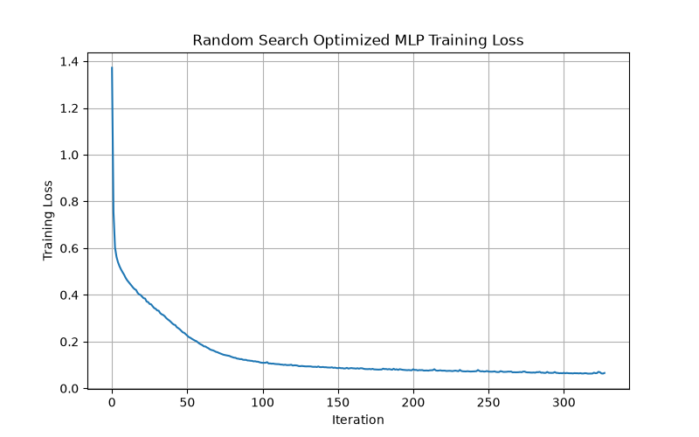

Interpretation
Random Search produced essentially the same test performance as the baseline. This indicates that the baseline configuration was already located in a strong region of the available hyperparameter space.
The result is particularly relevant because random exploration did not discover a configuration that provided a measurable improvement in independent test performance.

What this tells us about the dataset
The building characteristics appear to provide a relatively stable classification structure. Therefore, simply changing the MLP configuration does not automatically improve the separation between the four energy classes.

3.3.11.9 Bayesian Optimization
Bayesian Optimization was introduced to guide the search using information from previously evaluated configurations. Instead of selecting configurations independently, the optimization process uses earlier observations to determine promising areas of the hyperparameter space.
The same MLP search space and classification objective were retained to maintain comparability with Random Search.

Result
Metric | Bayesian Optimization
Accuracy | 96.10%
Precision | approximately 96.1%
Recall | 96.10%
F1-score | approximately 96.0%

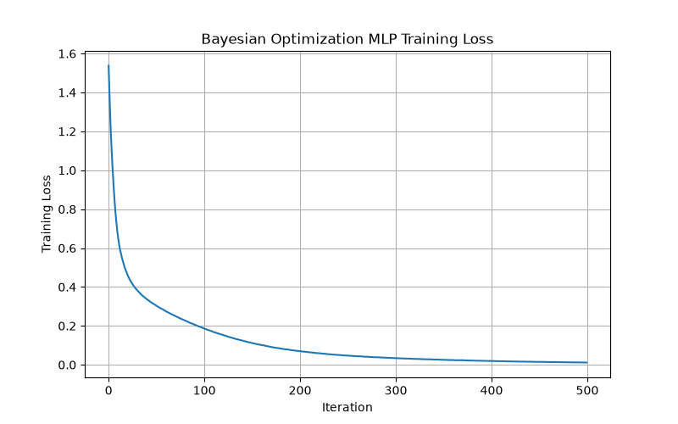

Interpretation
The Bayesian approach produced a high-performing model, but its independent test performance was slightly lower than the baseline.
This shows that a more informed search strategy does not necessarily produce a better final model. The optimization can identify configurations that perform strongly during the search process, while the independent test set may still show slightly lower generalization.

Dataset-level interpretation
The result reinforces the observation that the Energy Efficiency dataset already contains a strong predictive relationship between its eight building characteristics and the derived energy classes. There is therefore limited room for improvement through hyperparameter selection alone.

3.3.11.10 Hyperband
Hyperband was used to introduce a resource-aware optimization strategy. Rather than allocating the same computational effort to every candidate configuration, configurations showing weaker performance can be removed while stronger candidates receive additional training resources.
The same MLP search space was maintained.

Result
Metric | Hyperband
Accuracy | 96.75%
Precision | approximately 96.7%
Recall | 96.75%
F1-score | approximately 96.7%

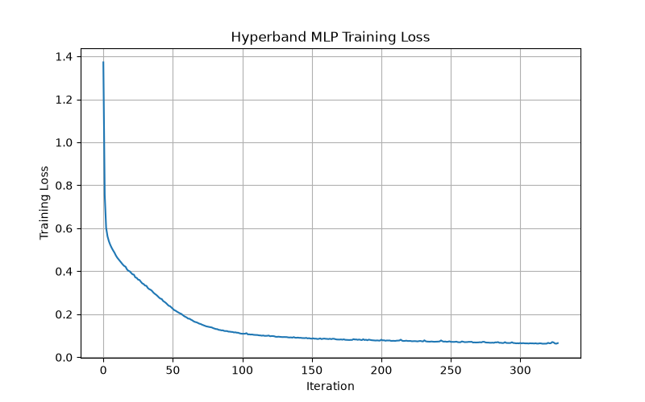

Interpretation
Hyperband reached the same test accuracy as the baseline and Random Search.
This is significant because the optimization strategy changed, but the final predictive performance did not. The result suggests that the limitation is not necessarily the search method itself; rather, the baseline model already captures most of the predictive information available from the eight input variables.

3.3.11.11 Learning Evolutionary Algorithm
The Learning Evolutionary Algorithm (LEA) approaches hyperparameter selection as an evolutionary search problem. Candidate MLP configurations are evaluated and progressively modified toward configurations with better validation performance.
This introduces a substantially different optimization mechanism compared with Random Search, Bayesian Optimization and Hyperband.

Result
Metric | LEA
Accuracy | 95.45%
Precision | approximately 95.5%
Recall | 95.45%
F1-score | 95.45%

Interpretation
LEA produced a lower independent test accuracy than the baseline.
The result does not indicate that the algorithm was unable to find a valid configuration. Instead, it demonstrates the difference between finding a configuration that performs well during optimization and finding one that generalizes better to unseen observations.

What this tells us about the dataset
The Energy Efficiency dataset appears to have relatively stable predictive patterns. More elaborate evolutionary search does not automatically provide additional generalization, particularly when the baseline model is already performing at a high level.

3.3.11.12 Teaching-Learning-Based Optimization
The final optimization method in Phase 2 was Teaching-Learning-Based Optimization (TLBO). TLBO modifies candidate solutions through teacher and learner stages and searches for an improved MLP configuration.
The final TLBO configuration was:
Hyperparameter | Selected value
Hidden layers | (64, 32)
Activation | ReLU
Solver | Adam
Learning rate | 0.001
Alpha | 0.0001
Batch size | 32
The optimization produced a best cross-validation F1-score of 0.9642.

Independent test result
Metric | TLBO
Accuracy | 95.45%
Precision | 95.52%
Recall | 95.45%
F1-score | 95.45%
The class-level results were:
Class | Precision | Recall | F1-score | Support
0 | 1.00 | 1.00 | 1.00 | 75
1 | 0.89 | 0.92 | 0.90 | 36
2 | 0.90 | 0.95 | 0.93 | 20
3 | 0.95 | 0.87 | 0.91 | 23
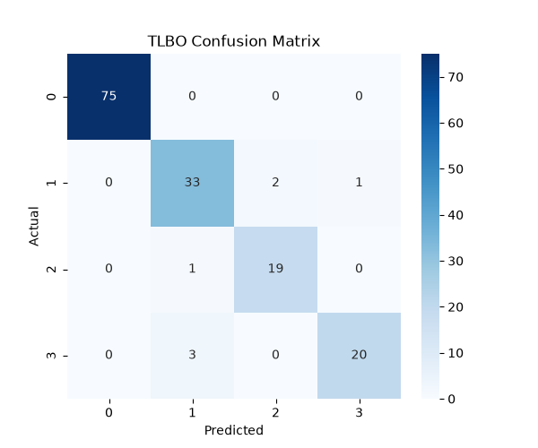
The confusion matrix shows that the first class was classified correctly for all observations, while a small number of observations from the other classes were misclassified.
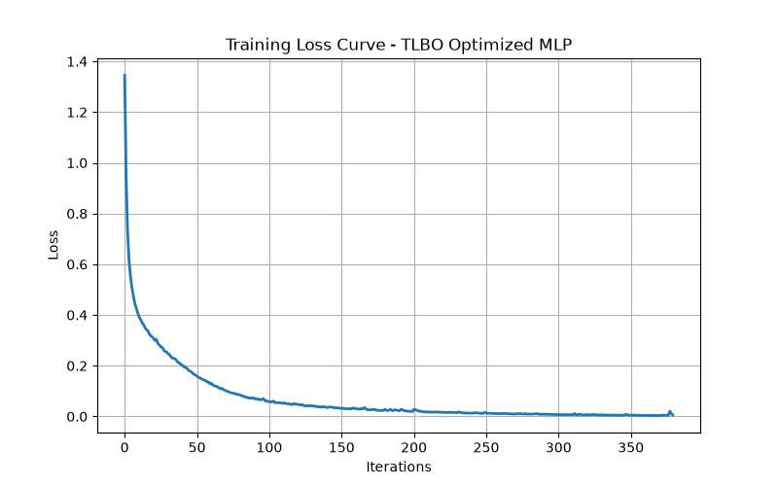

Interpretation
The TLBO result provides an important comparison between cross-validation and independent test performance. Although the best cross-validation F1-score reached 0.9642, the independent test F1-score was 0.9545.
This demonstrates that a high optimization score does not necessarily translate into an improvement on previously unseen observations.
The selected (64,32) architecture is also more complex than the baseline (64,) architecture, but this additional complexity did not improve the independent test result.

3.3.11.13 Phase 2 Comparison
The main results of Phase 2 are summarized below.
Method | Accuracy | F1-score | Observation
Baseline MLP | 96.75% | 96.74% | Strong reference
Random Search | 96.75% | ~96.73% | Similar to baseline
Bayesian Optimization | 96.10% | ~96.04% | Slightly lower
Hyperband | 96.75% | ~96.73% | Similar to baseline
LEA | 95.45% | 95.45% | Lower
TLBO | 95.45% | 95.45% | Lower
The comparison demonstrates that the baseline, Random Search and Hyperband all achieved approximately 96.75% accuracy. Bayesian Optimization was slightly lower, while LEA and TLBO achieved approximately 95.45%.
The important observation is therefore not that one optimization algorithm dramatically outperformed the others. Instead, the results show that the baseline model was already highly effective for this dataset.

3.3.11.14 Interpretation of Phase 2 Findings
The Phase 2 results provide several observations about the Energy Efficiency dataset.
First, the strong baseline performance indicates that the eight building characteristics contain substantial predictive information about the energy classes derived from Heating Load and Cooling Load.
Second, the optimization experiments did not produce a consistent improvement. Random Search and Hyperband reproduced the baseline performance, while Bayesian Optimization, LEA and TLBO resulted in slightly lower independent test performance.
Third, the difference between optimization performance and independent test performance demonstrates the importance of retaining an untouched test set. For example, TLBO achieved a cross-validation F1-score of 0.9642, but its independent test F1-score was 0.9545.
Finally, the computational cost of some optimization methods was considerably larger than the cost of training the final MLP. The TLBO optimization, for example, required approximately 1453.77 seconds, whereas the final TLBO model required only 1.47 seconds to train.
This indicates that additional optimization introduced substantial computational effort without providing a corresponding improvement in predictive performance.

3.3.11.15 Decision on Further Optimization
Based on the Phase 2 results, the Energy Efficiency dataset was not carried forward to the subsequent optimization phases.
The decision was based on the combined experimental evidence rather than accuracy alone. The baseline already achieved approximately 96.75% accuracy and 96.74% F1-score, while the additional optimization methods did not provide a consistent improvement on the independent test set.
Therefore, continuing with increasingly complex optimization procedures would mainly increase computational cost without demonstrating a corresponding improvement in generalization performance.
The Energy Efficiency experiment consequently provides an important result for the overall study: optimization does not necessarily improve every dataset when the baseline model already captures the underlying predictive structure effectively.
This also provides a useful contrast with the other datasets in the study, where later optimization phases can be investigated when the baseline leaves greater scope for improvement.

3.4 Electricity Dataset

3.4.1 Dataset and Prediction Objective
The Electricity dataset, obtained from OpenML (dataset ID 151), contains 45,312 observations representing electricity market conditions in Australia. Each observation corresponds to a half-hour period. The dataset contains eight predictor variables: date, day, period, nswprice, nswdemand, vicprice, vicdemand, and transfer. The variables describe temporal information, electricity prices, regional electricity demand, and electricity transfer between regions.
The prediction target is the electricity price movement in New South Wales, represented by two classes: DOWN and UP. Therefore, the Electricity dataset is treated as a binary classification problem. The original class column was renamed to Target for consistency with the experimental framework.
Table - Electricity Dataset Variables
Variable | Type | Description
date | Numerical | Normalized date of the observation
day | Categorical | Day of the week
period | Numerical | Normalized half-hour period within a day
nswprice | Numerical | New South Wales electricity price
nswdemand | Numerical | New South Wales electricity demand
vicprice | Numerical | Victoria electricity price
vicdemand | Numerical | Victoria electricity demand
transfer | Numerical | Electricity transfer between New South Wales and Victoria
Target | Categorical | Electricity price direction: DOWN or UP
The dataset therefore contains 7 numerical predictors and 1 categorical predictor. Since the target is already defined as a binary class, no target transformation or clustering was required.

3.4.2 Dataset Structure and Data Quality
The dataset structure was examined to determine the number of observations, feature types, unique values, missing values, duplicate observations, and infinite numerical values.
The analysis identified 45,312 observations and 9 columns, consisting of 8 predictors and 1 target. No missing values, duplicate rows, or infinite numerical values were detected. Therefore, no imputation or removal of invalid observations was required during Phase 1.

3.4.3 Target Distribution and Class Balance
The distribution of the two target classes was examined before modelling.
The dataset contains:
$$DOWN=\frac{26,075}{45,312}×100=57.55\%$$
and
$$UP=\frac{19,237}{45,312}×100=42.45\%$$
The majority-class baseline was therefore 57.55%, obtained by always predicting the DOWN class.
Table - Electricity Target Distribution
Target | Samples | Percentage
DOWN | 26,075 | 57.55%
UP | 19,237 | 42.45%
Total | 45,312 | 100%
This baseline was retained as the reference point for evaluating the subsequent MLP models.

3.4.4 Numerical Feature Analysis
Descriptive statistics were calculated for the seven numerical predictors to examine their distributions and identify variables with substantially different behaviour.
Table - Electricity Numerical Feature Statistics
Feature | Mean | Median | Min | Max | Skewness
date | 0.4991 | 0.4563 | 0.0000 | 1.0000 | -0.1658
period | 0.5000 | 0.5000 | 0.0000 | 1.0000 | 0.0000
nswprice | 0.0579 | 0.0487 | 0.0000 | 1.0000 | 9.0733
nswdemand | 0.4254 | 0.4437 | 0.0000 | 1.0000 | -0.0977
vicprice | 0.0035 | 0.0035 | 0.0000 | 1.0000 | 78.6870
vicdemand | 0.4229 | 0.4229 | 0.0000 | 1.0000 | 0.1595
transfer | 0.5005 | 0.4149 | 0.0000 | 1.0000 | 0.6705
The variables are already normalized between 0 and 1. However, the price variables show strong skewness, particularly vicprice with a skewness of 78.6870 and nswprice with 9.0733. This analysis was performed to understand the feature distributions before model development.

3.4.5 Feature–Target Relationship Analysis
The numerical predictors were compared between the DOWN and UP classes, followed by a correlation analysis.
Table - Mean Feature Values by Target
Feature | DOWN | UP
date | 0.5009 | 0.4966
period | 0.4607 | 0.5533
nswprice | 0.0448 | 0.0755
nswdemand | 0.3786 | 0.4889
vicprice | 0.0029 | 0.0042
vicdemand | 0.3986 | 0.4559
transfer | 0.5166 | 0.4787
The largest differences between the two target states were observed for nswdemand, period, and nswprice.
For the correlation analysis, the target was temporarily represented as DOWN = 0 and UP = 1. The strongest feature–target relationships were:
$$r_{nswprice,Target}=0.3793 \\ r_{nswdemand,Target}=0.3339 \\ r_{vicdemand,Target}=0.2342$$
while transfer showed a negative relationship of:
$$r_{transfer,Target}=-0.1223$$
The purpose of this analysis was to identify which electricity and demand variables showed the strongest relationships with the target before model training.

3.4.6 Period and Temporal Analysis
Because the dataset contains 48 half-hour periods per day, the target distribution was analysed across the normalized period variable.
For example, at period 0.127660, the observed distribution was:
$$DOWN=95.02\%,UP=4.98\%$$
whereas at period 0.382979:
$$DOWN=30.72\%,UP=69.28\%$$
This shows that the target distribution changes considerably throughout the daily cycle. Therefore, period was retained as an important temporal feature for the subsequent modelling experiments.

3.4.7 Target Transition Analysis
The target sequence was analysed by sorting observations according to date and period and comparing each target with the preceding observation.
Table - Electricity Target Transition Percentages
Previous Target | Current DOWN | Current UP
DOWN | 86.77% | 13.23%
UP | 17.94% | 82.06%
The results show strong persistence in the target state. A DOWN observation was followed by another DOWN observation in 86.77% of cases, while an UP observation was followed by UP in 82.06% of cases.
This analysis was performed to identify the temporal dependency of the target, which is particularly relevant when interpreting the later classification results.

4.4 Electricity Prediction – Phase 1 Results
For the visualizations, I would keep only the three most relevant figures. The transition plot is useful, but the target distribution, correlation matrix, and period behaviour are the most important for explaining the dataset.

4.4.1 Distribution of the Electricity Target
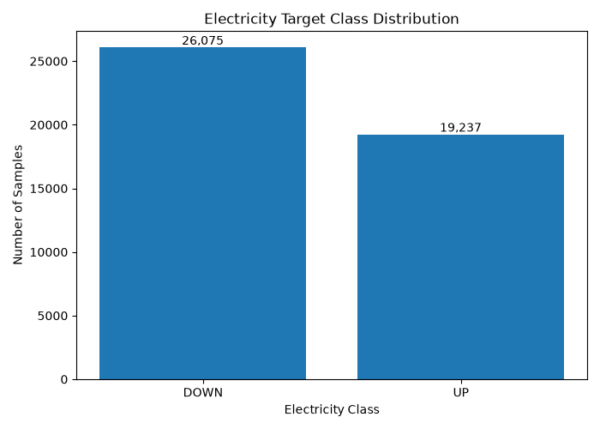
The figure shows that DOWN is the majority class with 26,075 observations (57.55%), while UP contains 19,237 observations (42.45%). The difference is moderate, providing representation for both classes. The majority-class accuracy of 57.55% is used as the baseline for subsequent model evaluation.

4.4.2 Correlation Between Electricity Features and Target
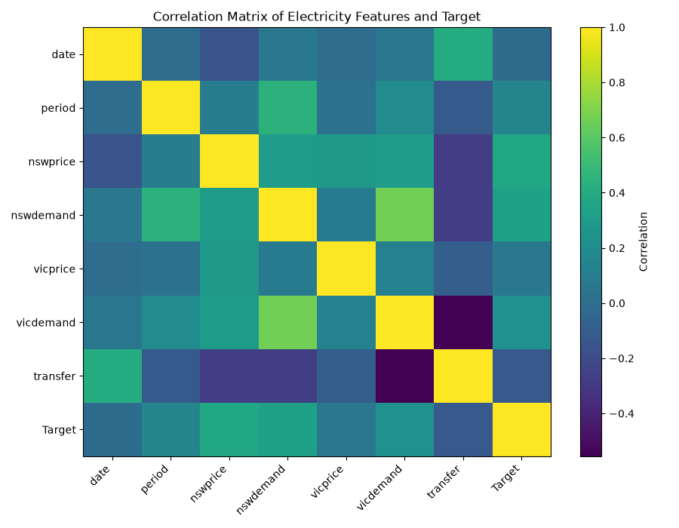
The correlation matrix shows that nswprice has the strongest observed relationship with the target (0.3793), followed by nswdemand (0.3339) and vicdemand (0.2342). The matrix also shows relationships between predictors, such as the 0.6685 correlation between nswdemand and vicdemand. These relationships indicate that the electricity market variables contain dependencies that can potentially be learned by the MLP model.

4.4.3 Electricity Class Distribution Across Periods
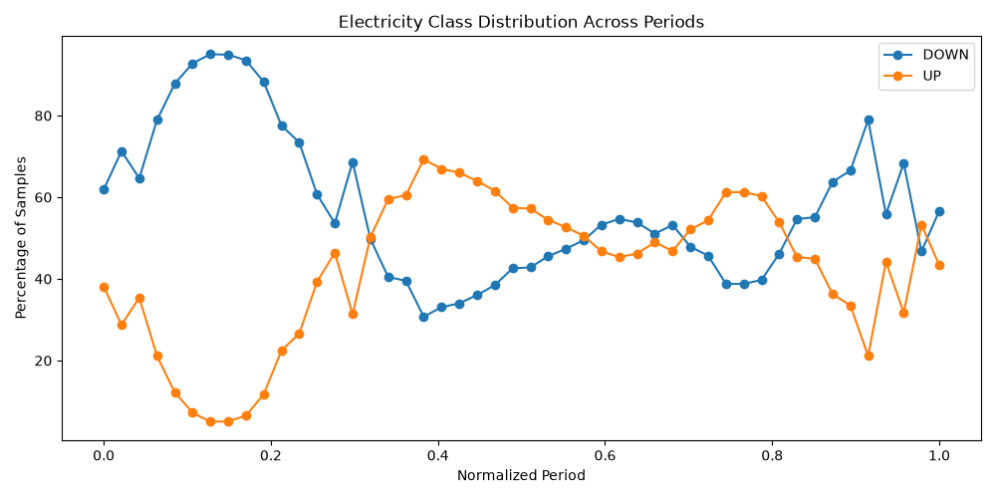
The period-based visualization shows substantial variation in the proportion of DOWN and UP observations throughout the daily cycle. In some periods, DOWN is strongly dominant, while in others UP becomes the more frequent state. This demonstrates that the target distribution is not constant throughout the day and confirms the relevance of the period feature for the subsequent classification experiments.

4.4.4 Target Transition Behaviour
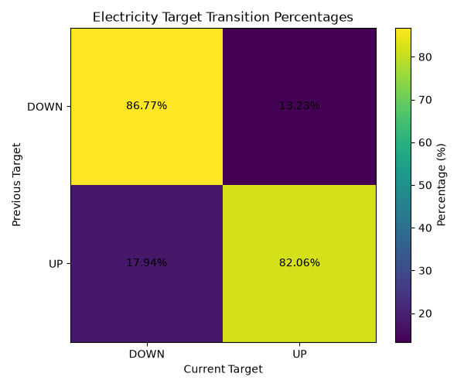
The transition matrix shows that the target tends to remain in the same state between consecutive observations. The DOWN → DOWN transition occurs in 86.77% of cases, while UP → UP occurs in 82.06%. This indicates strong temporal persistence in the target and provides an important characteristic to consider when interpreting the later modelling results.

3.4.8 Phase 2 – MLP Hyperparameter Optimization
Phase 1 established the baseline behaviour of the Electricity dataset. Phase 2 investigated whether the MLP performance could be improved by optimizing its hyperparameters while keeping the same dataset, features and DOWN/UP prediction task.
The Electricity prediction task can be represented as:
$$f(date,day,period,nswprice,nswdemand,vicprice,vicdemand,transfer)→\{DOWN,UP\}$$
Five optimization approaches were investigated:
- Random Search
- Bayesian Optimization
- Hyperband
- Learning Evolutionary Algorithm (LEA)
- Teaching-Learning-Based Optimization (TLBO)
The overall procedure was:
$$\text{Electricity Data}→\text{Train/Test Split}→\text{Standardization}→\text{Baseline MLP}→\text{Hyperparameter Optimization}→\text{Test Evaluation}$$

3.4.8.1 Data Preparation
The dataset contained 45,312 observations and eight predictors. An 80:20 stratified split produced 36,249 training observations and 9,063 test observations.
Dataset | Samples | Features
Training | 36,249 | 8
Testing | 9,063 | 8
Total | 45,312 | 8
The target contained 26,075 DOWN observations (57.55%) and 19,237 UP observations (42.45%).
The class proportion was calculated as:
$$P(Y=c)=\frac{N_{c}}{N}×100$$
The test set was kept independent from hyperparameter selection.

3.4.8.2 Feature Standardization
The numerical Electricity features were standardized before MLP training:
$$z_{ij}=\frac{x_{ij}-μ_{j}}{σ_{j}}$$
where $x_{ij}$is the value of an Electricity feature, and $μ_{j}$and $σ_{j}$are calculated from the training data.
For example:
$$z_{nswprice}=\frac{nswprice-μ_{nswprice}}{σ_{nswprice}}$$
The same transformation was applied to the remaining numerical predictors. The scaler was fitted only on the training data.

3.4.8.3 Baseline MLP
The baseline MLP used the following configuration:
Parameter | Value
Hidden layers | (64,)
Activation | ReLU
Solver | Adam
Learning rate | 0.001
Alpha | 0.0001
Batch size | 32
Maximum iterations | 500
The baseline provided the reference for all subsequent optimization methods.

3.4.8.4 MLP Hyperparameter Search Space
The optimization space consisted of:
Hyperparameter | Values
Hidden layers | (16,), (32,), (64,), (32,16), (64,32)
Activation | ReLU, tanh
Learning rate | 0.0001, 0.001
Alpha | 0.0001, 0.001, 0.01
Batch size | 32, 64, 128
Solver | Adam
Maximum iterations | 500
This produced:
$$5×2×2×3×3=180$$
possible MLP configurations.

3.4.8.5 Optimization Objective
Candidate configurations were evaluated using five-fold cross-validation and weighted F1-score.
For the two Electricity classes:
$$F1_{c}=\frac{2P_{c}R_{c}}{P_{c}+R_{c}}$$
The weighted F1-score was calculated using the number of DOWN and UP observations:
$$F1_{weighted}=\frac{N_{DOWN}F1_{DOWN}+N_{UP}F1_{UP}}{N_{DOWN}+N_{UP}}$$
The five-fold score was:
$$F1_{CV}=\frac{1}{5}\sum_{k=1}^{5}{F}1_{weighted}^{\left(k\right)}$$
This score was used to evaluate candidate MLP configurations.

3.4.8.6 Optimization Methods
Random Search sampled configurations from the defined 180-combination search space and evaluated them using five-fold weighted F1.
Bayesian Optimization used previous evaluations to guide subsequent configurations toward promising areas of the search space.
Hyperband used max_iter as the training resource, with a maximum of 500 iterations and a reduction factor of 3.
LEA treated the MLP configurations as a population of candidate solutions. The population size was 20 and the optimization was performed for five generations.
TLBO also used a population of 20 candidate configurations and five optimization iterations, using teacher and learner phases to update the candidates.
The five optimization iterations/generations refer to the search process, not the 500 training iterations of the MLP.

3.4.8.7 Final Model Evaluation
After optimization, each selected configuration was trained and evaluated on the independent test set.
For the Electricity test data:
$$Accuracy=\frac{N_{DOWN→DOWN}+N_{UP→UP}}{N_{test}}$$
Precision, recall and F1-score were also calculated for the DOWN and UP classes.

4.4.5 Phase 2 – MLP Optimization Results
Phase 2 evaluated the baseline MLP against five hyperparameter optimization methods. The training-loss visualizations were first examined to understand model convergence, followed by comparison of test performance and computational cost.

4.4.5.1 Baseline MLP Training Behaviour
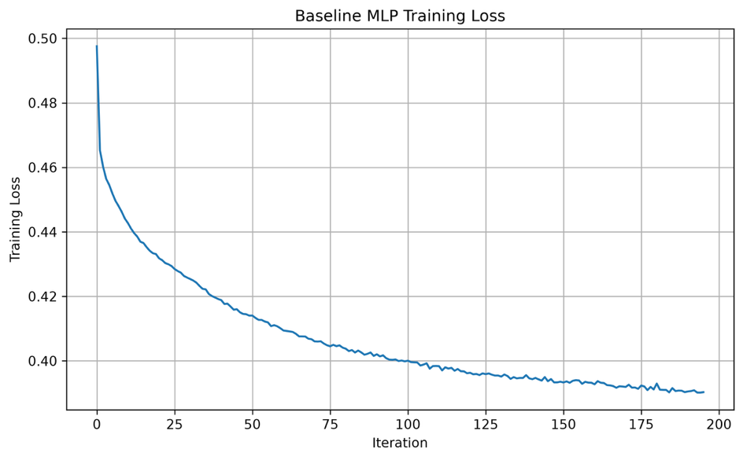
The baseline training loss starts at approximately 0.50 and decreases gradually to approximately 0.39. The largest reduction occurs during the early training iterations, followed by slower improvement toward the end. This provides the reference learning behaviour for the optimized MLP configurations.
The baseline test performance was:
Metric | Baseline
Accuracy | 0.812865
Precision | 0.812473
Recall | 0.812865
F1-score | 0.811514
Training time | 16.22 s

4.4.5.2 Random Search Training Behaviour
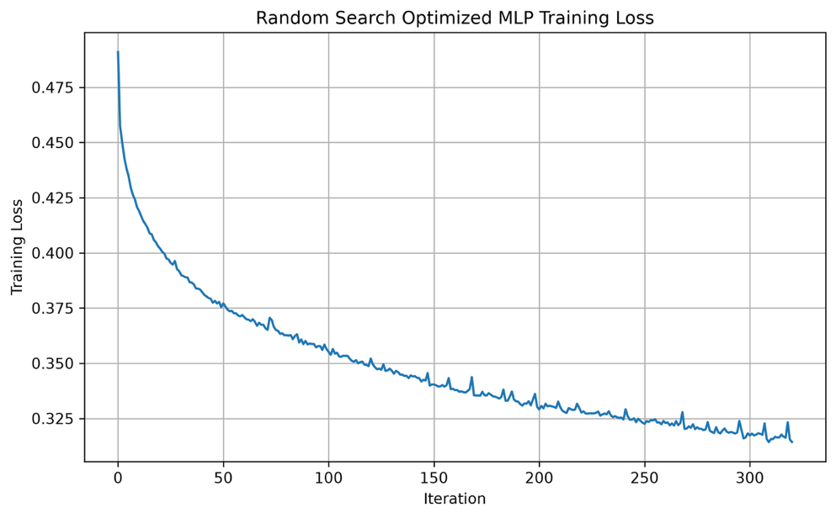
The Random Search model decreases from approximately 0.49 to 0.31. The stronger reduction compared with the baseline indicates that the selected hyperparameters produced a different and more effective training trajectory.
The selected configuration was (64,32) with ReLU, learning rate 0.001, alpha 0.0001 and batch size 64.
Its test F1-score increased to 0.838111, compared with 0.811514 for the baseline.

4.4.5.3 Bayesian Optimization Training Behaviour
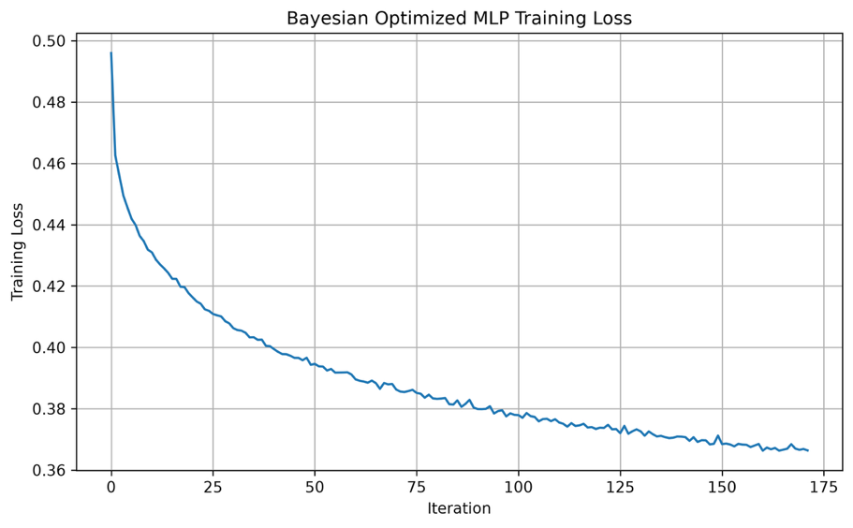
The Bayesian configuration reduces the training loss from approximately 0.50 to 0.37. The curve shows a smooth initial decrease followed by gradual convergence.
The selected model used (64,32) hidden layers, ReLU, learning rate 0.001, alpha 0.01 and batch size 64.
The resulting test F1-score was 0.835026.

4.4.5.4 Hyperband Training Behaviour
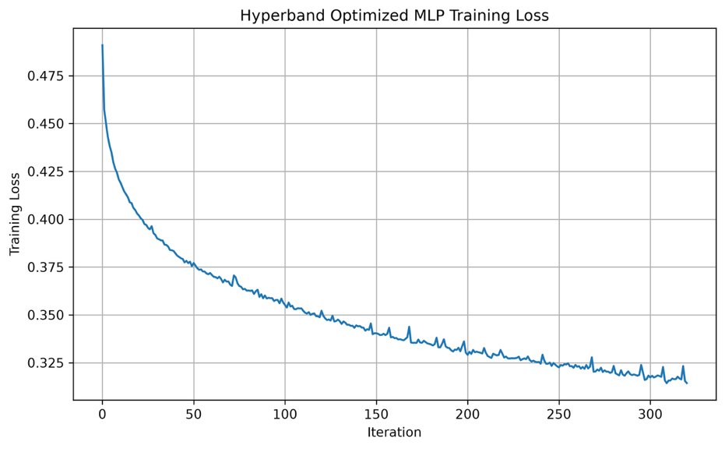
The Hyperband training loss decreases from approximately 0.49 to the lower 0.3 range, with some small fluctuations during later training.
The selected configuration used (64,32) hidden layers, ReLU, learning rate 0.001, alpha 0.0001, batch size 64 and max_iter=81.
The test F1-score was 0.838111.
The selected max_iter of 81 demonstrates the resource-allocation behaviour of Hyperband.

4.4.5.5 LEA Training Behaviour
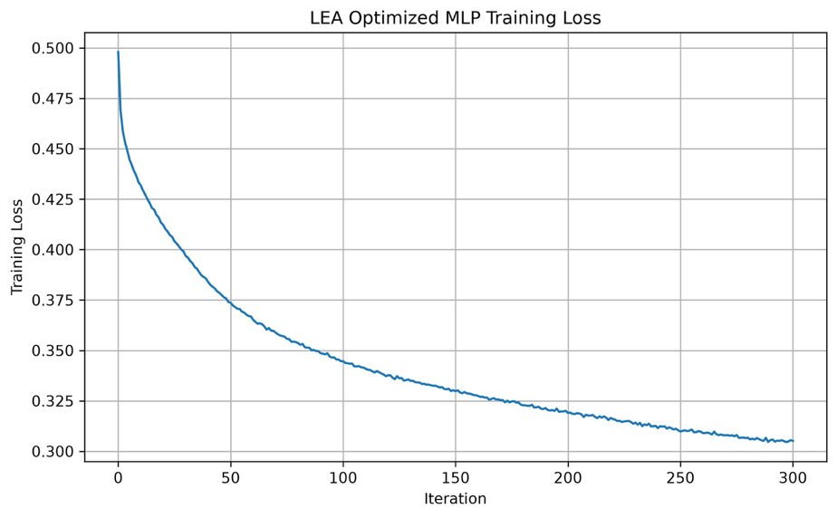
The LEA model decreases from approximately 0.50 to 0.30, showing a sustained reduction throughout training.
The selected configuration used (64,32) hidden layers, tanh activation, learning rate 0.001, alpha 0.001 and batch size 32.
The test F1-score was 0.841142. The optimization required 1,862.80 seconds, considerably more than Random Search, Bayesian Optimization and Hyperband.

4.4.5.6 TLBO Training Behaviour
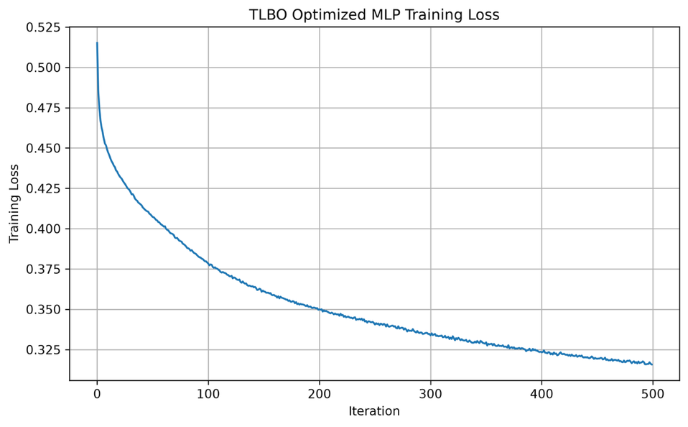
The TLBO model starts at approximately 0.52 and gradually decreases to approximately 0.32. The curve shows a strong initial reduction followed by slower convergence.
The selected configuration used (64,32) hidden layers, tanh activation, learning rate 0.001, alpha 0.01 and batch size 128.
The test F1-score was 0.846204, while the optimization required 7,632.73 seconds.

4.4.5.7 Final Performance Comparison
Table - Electricity Phase 2 MLP Performance
Method | Accuracy | Precision | Recall | F1-score | Optimization Time (s) | Training Time (s)
Baseline MLP | 0.812865 | 0.812473 | 0.812865 | 0.811514 | 0.00 | 16.22
Random Search | 0.838354 | 0.838011 | 0.838354 | 0.838111 | 89.80 | 21.68
Bayesian Optimization | 0.834602 | 0.836061 | 0.834602 | 0.835026 | 65.45 | 11.67
Hyperband | 0.838354 | 0.838011 | 0.838354 | 0.838111 | 74.87 | 21.69
LEA | 0.841554 | 0.841129 | 0.841554 | 0.841142 | 1,862.80 | 35.39
TLBO | 0.846519 | 0.846148 | 0.846519 | 0.846204 | 7,632.73 | 21.51
All five optimization methods produced a higher test F1-score than the baseline. The improvement ranged from 0.023512 for Bayesian Optimization to 0.034690 for TLBO.

4.4.5.8 Selected Hyperparameters
Method | Hidden Layers | Activation | Learning Rate | Alpha | Batch Size | CV F1
Random Search | (64,32) | ReLU | 0.001 | 0.0001 | 64 | 0.8253
Bayesian | (64,32) | ReLU | 0.001 | 0.01 | 64 | 0.8281
Hyperband | (64,32) | ReLU | 0.001 | 0.0001 | 64 | 0.8217
LEA | (64,32) | tanh | 0.001 | 0.001 | 32 | 0.8369
TLBO | (64,32) | tanh | 0.001 | 0.01 | 128 | 0.8413
A common pattern across all optimized configurations was the selection of the (64,32) hidden-layer architecture and a learning rate of 0.001, while activation, regularization and batch size varied between optimization methods.

4.4.5.9 Computational Cost
The optimization methods showed substantial differences in computational requirements.
Method | Optimization Time | Approx. Time
Random Search | 89.80 s | 1.50 min
Bayesian Optimization | 65.45 s | 1.09 min
Hyperband | 74.87 s | 1.25 min
LEA | 1,862.80 s | 31.05 min
TLBO | 7,632.73 s | 127.21 min
The results show that LEA and TLBO required considerably more optimization time than the other methods. Therefore, the Phase 2 experiment demonstrates a clear relationship between predictive improvement and computational cost.

4.4.5.10 Confusion-Matrix Analysis
The baseline confusion matrix was:
$$\left[\begin{matrix}4524 & 691 \\ 774 & 3074\end{matrix}\right]$$
For TLBO, the matrix was:
$$\left[\begin{matrix}4575 & 640 \\ 751 & 3097\end{matrix}\right]$$
Thus, the TLBO model correctly classified 4,575 DOWN and 3,097 UP observations in the test set.
The results indicate that the optimized models changed the distribution of classification errors between the two Electricity classes rather than simply increasing the number of correct predictions uniformly.

4.4.5.11 Phase 2 Interpretation
Phase 2 showed that hyperparameter optimization improved the recorded test performance of the Electricity MLP compared with the baseline.
The baseline F1-score was 0.811514, while the optimized models achieved values between 0.835026 and 0.846204. The training-loss plots also showed that the optimized configurations generally reached lower loss values than the baseline.
However, the optimization methods differed considerably in computational cost. Random Search, Bayesian Optimization and Hyperband completed relatively quickly, whereas LEA and TLBO required substantially longer optimization times.
Therefore, Phase 2 demonstrates that MLP hyperparameter selection affects both model performance and computational requirements for the Electricity prediction task.

4.4.5.12 Phase 2 Summary
Phase 2 investigated five optimization strategies using the same Electricity dataset and MLP framework. The search space contained 180 possible configurations, evaluated using five-fold weighted F1.
The test F1-scores were:
$$0.811514→0.838111→0.835026→0.838111→0.841142→0.846204$$
for the baseline, Random Search, Bayesian Optimization, Hyperband, LEA and TLBO configurations respectively.
The results show improved test performance after hyperparameter optimization, while the training-loss visualizations confirm stable learning across the investigated configurations. At the same time, the substantially higher optimization times of LEA and TLBO demonstrate the computational cost associated with population-based optimization.

3.4.9 Phase 3 – XGBoost Baseline
Phase 3 introduced XGBoost as a tree-based model for the Electricity classification problem. The purpose was to establish a baseline for a nonlinear model before applying hyperparameter optimization in the subsequent phase. The same Electricity dataset and 80:20 stratified split were retained to allow comparison with the previous MLP experiments. The code explicitly does not apply SMOTE/SMOTENC, class weighting, or hyperparameter optimization in this phase.
The prediction task was:
$$f(date,day,period,nswprice,nswdemand,vicprice,vicdemand,transfer)→\{DOWN,UP\}$$
The target was encoded as:
$$DOWN=0,UP=1$$

3.4.9.1 Data Preparation
The Electricity dataset contained 45,312 observations and eight predictors. A stratified 80:20 train-test split produced 36,249 training observations and 9,063 test observations.
Dataset | Samples | Features
Training | 36,249 | 8
Testing | 9,063 | 8
Total | 45,312 | 8
The target distribution was:
Class | Samples | Percentage
DOWN | 26,075 | 57.55%
UP | 19,237 | 42.45%
Stratification was used to preserve the DOWN/UP distribution between the training and testing subsets.

3.4.9.2 Feature Processing
The Electricity data contained eight numerical predictors in the processed dataset. The day feature was therefore retained as a numerical input in this implementation.
Unlike the MLP experiments, feature standardization was not performed because XGBoost uses tree-based threshold splits rather than distance- or gradient-scale-sensitive feature transformations. The code therefore directly supplied the processed feature matrix to XGBoost.
No SMOTE, SMOTENC, or class weighting was applied. This ensured that the experiment represented an unmodified XGBoost baseline.

3.4.9.3 XGBoost Baseline Configuration
The XGBoost classifier was trained using fixed hyperparameters.
Hyperparameter | Value
n_estimators | 100
max_depth | 6
learning_rate | 0.1
subsample | 1.0
colsample_bytree | 1.0
min_child_weight | 1
gamma | 0
reg_alpha | 0
reg_lambda | 1
Objective | Binary logistic
Random state | 42
These parameters were deliberately fixed because the purpose of Phase 3 was to establish a baseline XGBoost model, rather than optimize the model.

3.4.9.4 Baseline Evaluation
The trained XGBoost model was evaluated on the independent test set using accuracy, weighted precision, weighted recall, weighted F1-score and macro F1-score.
For the two Electricity classes, accuracy was calculated from the correctly classified DOWN and UP observations:
$$Accuracy=\frac{N_{DOWN→DOWN}+N_{UP→UP}}{N_{test}}$$
The confusion matrix was also used to examine the distribution of classification errors between the two electricity states.
Feature importance provided an additional analysis of which Electricity predictors contributed most strongly to the trained XGBoost model.

4.4.6 Phase 3 – XGBoost Baseline Results
Phase 3 established the baseline performance of XGBoost on the Electricity dataset. The results were analysed through the target distribution, feature distributions, confusion matrix and XGBoost feature importance.

4.4.6.1 Electricity Target Distribution
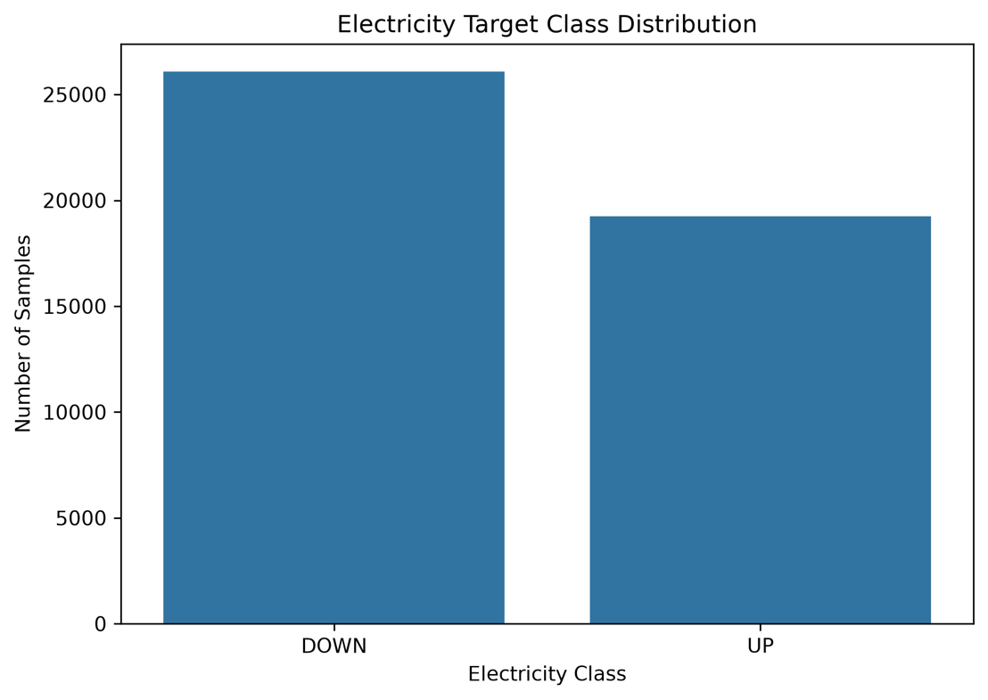
The Electricity dataset contains 26,075 DOWN observations (57.55%) and 19,237 UP observations (42.45%).
The distribution shows a moderate difference between the two classes, with DOWN occurring more frequently than UP. However, both classes contain a substantial number of observations, allowing the XGBoost model to learn from both electricity states.

4.4.6.2 Feature Distributions by Electricity Class
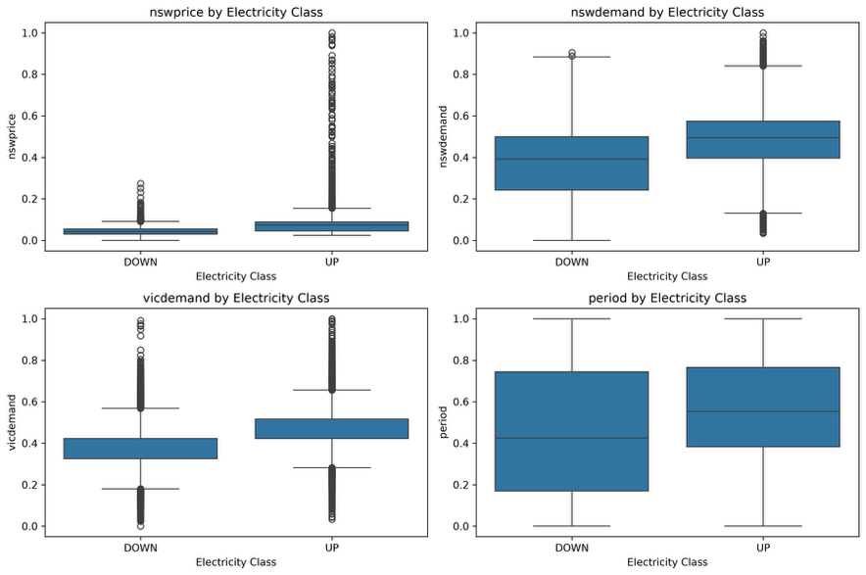
The boxplots show differences between DOWN and UP observations for nswprice, nswdemand, vicdemand and period.
The distributions indicate that the UP class generally has higher central values for nswprice, nswdemand and vicdemand than the DOWN class. The period distributions also show differences between the two classes.
These differences provide a basis for using a nonlinear model such as XGBoost, as the relationship between these Electricity variables and the target may not be adequately represented by a simple linear boundary.

4.4.6.3 XGBoost Baseline Confusion Matrix
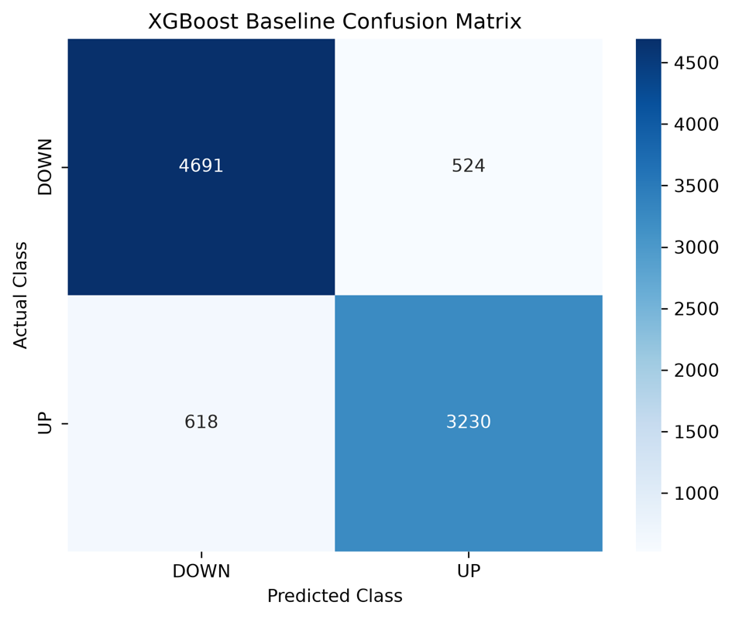
The XGBoost confusion matrix was:
$$\left[\begin{matrix}4691 & 524 \\ 618 & 3230\end{matrix}\right]$$
where the rows represent the actual classes and the columns represent the predicted classes.
Actual / Predicted | DOWN | UP
DOWN | 4,691 | 524
UP | 618 | 3,230
The model correctly classified:
$$4691+3230=7921$$
of the 9,063 test observations.
There were 524 DOWN observations incorrectly classified as UP and 618 UP observations incorrectly classified as DOWN.

4.4.6.4 XGBoost Baseline Performance
The model achieved the following test-set results:
Metric | XGBoost Baseline
Accuracy | 0.8740
Weighted Precision | 0.8738
Weighted Recall | 0.8740
Weighted F1 | 0.8738
Macro F1 | 0.8706
Training Time | 0.15 s
The classification report showed:
Class | Precision | Recall | F1-score | Support
DOWN | 0.88 | 0.90 | 0.89 | 5,215
UP | 0.86 | 0.84 | 0.85 | 3,848
Weighted average | 0.87 | 0.87 | 0.87 | 9,063
The relatively similar performance for DOWN and UP indicates that the model was not relying only on the larger DOWN class.

4.4.6.5 XGBoost Feature Importance
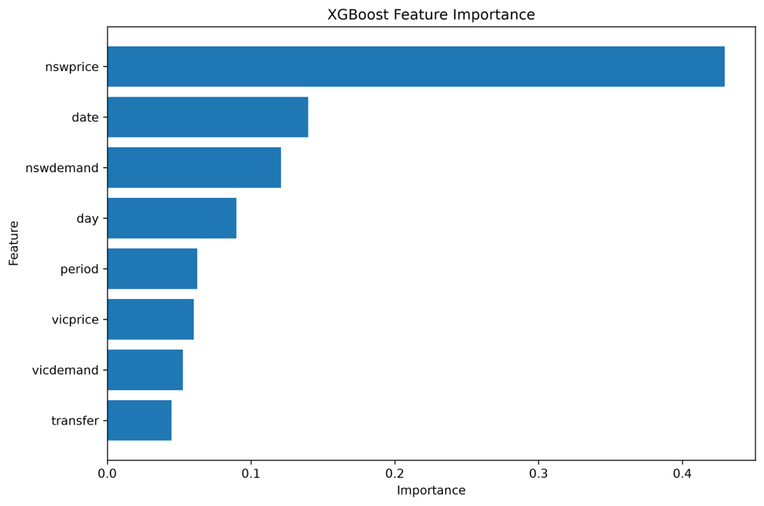
The XGBoost feature-importance values were:
Feature | Importance
nswprice | 0.429356
date | 0.139859
nswdemand | 0.120907
day | 0.089890
period | 0.062473
vicprice | 0.060251
vicdemand | 0.052525
transfer | 0.044738
The results show that nswprice was the dominant feature, with an importance of approximately 0.429, considerably higher than the other predictors.
date and nswdemand followed with importance values of approximately 0.140 and 0.121, respectively.
The importance values indicate which predictors contributed most to the trained XGBoost model's decisions. They should be interpreted as model-specific feature importance, rather than as evidence that a feature independently causes the Electricity target to change.

4.4.6.6 Phase 3 Baseline Summary
The Phase 3 XGBoost baseline achieved an accuracy of 0.8740 and a weighted F1-score of 0.8738, with a training time of only 0.15 seconds.
The main observations from the baseline experiment were:
- The dataset contains a moderate DOWN/UP class imbalance of 57.55% / 42.45%.
- The XGBoost model achieved strong classification performance without SMOTE, class weighting or hyperparameter optimization.
- The confusion matrix shows relatively balanced errors between the two classes.
- nswprice was the most important feature in the trained XGBoost model.
- nswdemand and date were the next most important predictors.
- The feature distributions showed observable differences between DOWN and UP classes.
This baseline provides the reference point for the subsequent XGBoost hyperparameter optimization phase, where the fixed XGBoost parameters will be replaced by systematic optimization strategies.

3.4.9 XGBoost Hyperparameter Optimization
Following the Phase 3 XGBoost baseline, hyperparameter optimization was performed to investigate whether the baseline configuration could be improved through systematic parameter search. Five optimization approaches were evaluated: Random Search, Bayesian Optimization, Hyperband, Learner Evolution Algorithm (LEA), and Teaching-Learning-Based Optimization (TLBO).
The same 80:20 training-test split was retained, with 5-fold cross-validation applied to the training data. The primary optimization objective was Macro F1, allowing the performance of both the DOWN and UP electricity classes to be considered equally.
The optimization procedures were limited to five iterations for Random Search, Bayesian Optimization, LEA, and TLBO. Hyperband used five initial candidates and progressively evaluated the retained configurations using increasing boosting rounds.

3.4.9.1 XGBoost Search Space
The optimization varied the main XGBoost tree and regularization parameters within the following ranges.
Hyperparameter | Search Range
n_estimators | 50–300
max_depth | 2–10
learning_rate | 0.01–0.30
subsample | 0.60–1.00
colsample_bytree | 0.60–1.00
min_child_weight | 1–10
gamma | 0–5
reg_alpha | 0–2
reg_lambda | 0.1–5
These parameters control the number and depth of boosting trees, learning rate, sampling proportions, minimum child weight, and regularization strength. The search therefore allowed the optimization algorithms to modify both model complexity and regularization relative to the Phase 3 baseline.

3.4.9.2 Optimization Objective
For each candidate configuration, the model was evaluated using 5-fold cross-validation. The optimization objective was Macro F1:
$$F1_{macro}=\frac{F1_{DOWN}+F1_{UP}}{2}$$
where $F1_{DOWN}$and $F1_{UP}$represent the F1 scores of the two electricity classes.
This metric was selected because the dataset contains 26,075 DOWN samples and 19,237 UP samples, making it useful to evaluate both classes rather than relying only on overall accuracy.

4.4.6 XGBoost Optimization Performance
The optimization results were evaluated on the previously unseen test set after the best configuration from each optimization method had been selected using cross-validation.
Method | Accuracy | Weighted F1 | Macro F1 | Optimization Time (s)
Phase 3 XGBoost Baseline | 0.8740 | 0.8738 | 0.8706 | 0.00
Random Search | 0.9099 | 0.9098 | 0.9077 | 4.13
Bayesian Optimization | 0.8756 | 0.8755 | 0.8725 | 1.18
Hyperband | 0.9103 | 0.9103 | 0.9081 | 2.45
LEA | 0.9220 | 0.9220 | 0.9201 | 7.29
TLBO | 0.9246 | 0.9246 | 0.9229 | 50.83
The baseline achieved a Macro F1 of 0.8706. The optimized configurations produced Macro F1 values between 0.8725 and 0.9229 on the test set. The corresponding results and optimization times were recorded in the final comparison generated by the experiment.
The optimization results show that the selected configurations substantially changed the XGBoost parameter settings compared with the Phase 3 baseline. For example, the TLBO configuration used 254 estimators, depth 9, learning rate 0.1935, subsample 0.6399, and column sampling 0.6510, together with regularization parameters.

4.4.7 Target Class Distribution
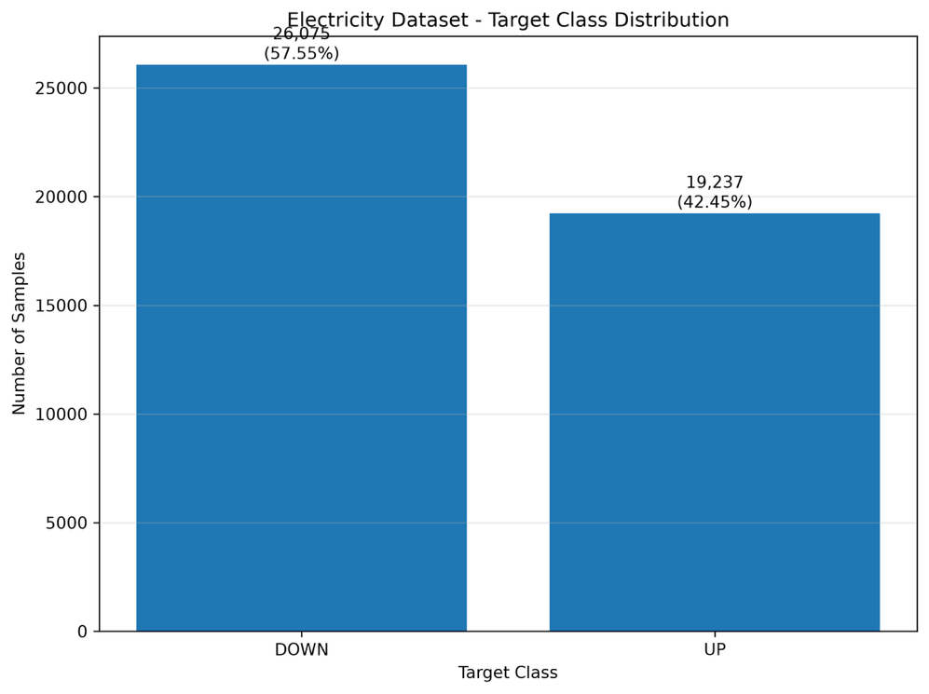
The dataset contains 26,075 DOWN observations (57.55%) and 19,237 UP observations (42.45%). The distribution shows a moderate difference between the two classes rather than an extreme imbalance. This distribution was retained during the stratified train-test split.
The relatively close class proportions provide representation of both electricity movement classes in the training and testing subsets. Therefore, the optimization experiments were evaluated using Macro F1 in addition to accuracy.

4.4.8 Feature–Target Relationships
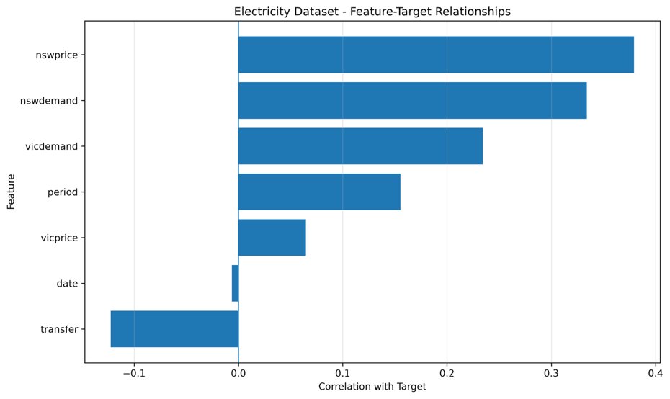
The feature-target correlation analysis shows that nswprice has the strongest positive relationship with the electricity target, followed by nswdemand and vicdemand. The transfer feature shows a negative relationship with the target, while date has a relatively small linear relationship.
The XGBoost baseline feature importance analysis further supports the importance of these variables, with nswprice having the highest model importance (0.4294), followed by date (0.1399) and nswdemand (0.1209). The remaining features have lower importance values. This indicates that the model uses both market price and demand-related variables when distinguishing between DOWN and UP classes.

4.4.9 Feature Correlation Analysis
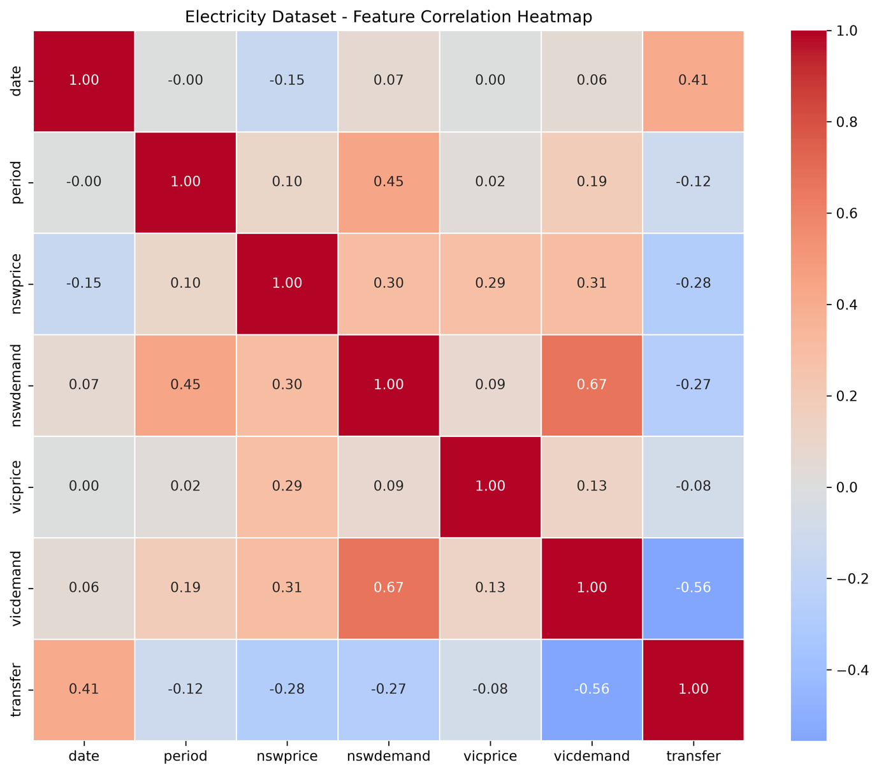
The correlation matrix shows a relatively strong relationship between nswdemand and vicdemand (0.67). A negative relationship is also observed between vicdemand and transfer (-0.56). The correlation between nswprice and the target is approximately 0.38, while nswdemand has a correlation of approximately 0.33.
These relationships indicate that several electricity demand variables contain related information, while transfer provides a different directional relationship. The XGBoost model can capture such nonlinear and interaction effects without requiring feature standardization.

4.4.10 Feature Distributions by Electricity Class
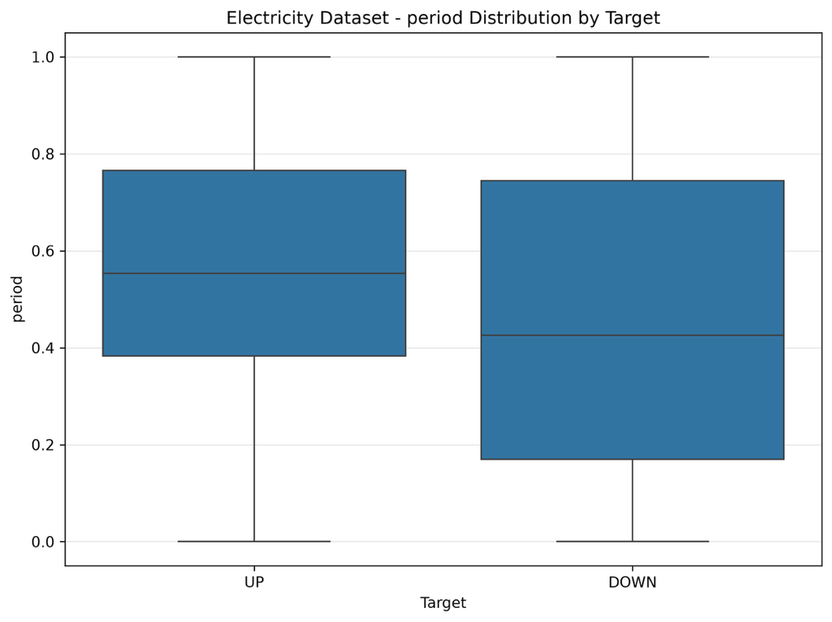
The boxplots show differences in the distributions of nswprice, nswdemand, vicdemand, and period between the DOWN and UP classes. In particular, nswprice and both demand variables show visibly different central distributions between the two classes.
The distributions also contain observations extending across a broad range, especially for nswprice and the demand variables. These differences provide useful predictive information for the XGBoost classifier.

4.4.11 Optimization Performance Comparison
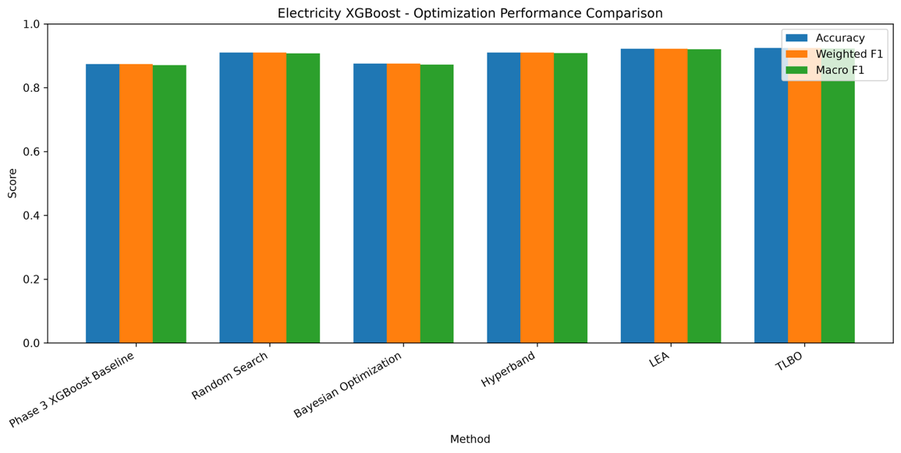
The performance comparison shows that the optimized models generally achieved higher test performance than the Phase 3 baseline. Random Search increased Macro F1 from 0.8706 to 0.9077, while Hyperband achieved 0.9081. LEA achieved 0.9201, and TLBO achieved 0.9229.
The Bayesian configuration produced a smaller improvement, with a Macro F1 of 0.8725.
The final test results therefore demonstrate that the optimized XGBoost configurations were able to improve upon the baseline performance under the experimental settings.

4.4.12 Optimization Time Comparison
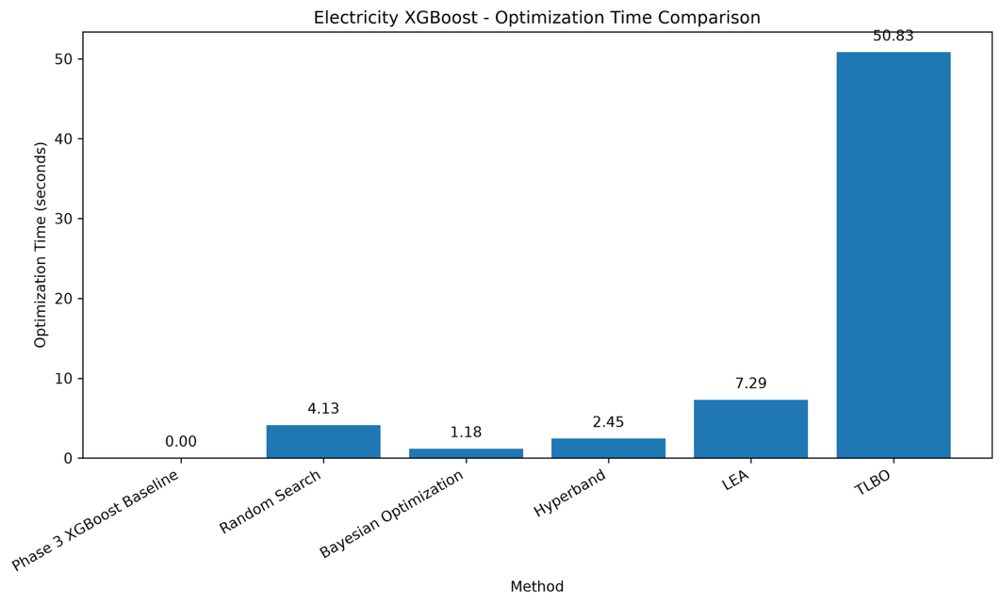
The optimization time varied considerably between the search strategies. Bayesian Optimization required 1.18 seconds, followed by Hyperband at 2.45 seconds and Random Search at 4.13 seconds. LEA required 7.29 seconds, whereas TLBO required substantially more time at 50.83 seconds.
The difference reflects the computational behaviour of the optimization strategies. In particular, TLBO repeatedly evaluates and updates candidate solutions, resulting in substantially higher optimization time in this experiment.

4.4.13 Optimization Convergence
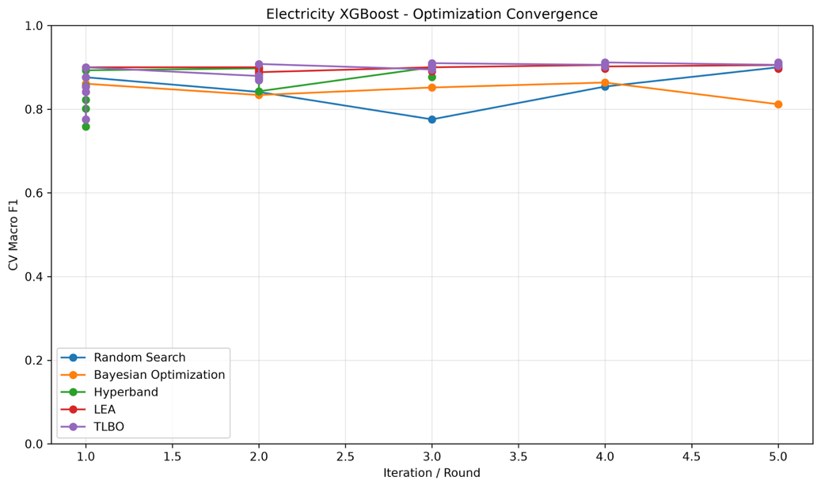
The convergence plot shows the change in cross-validation Macro F1 across the five optimization iterations or Hyperband rounds. Random Search varies considerably between iterations, while Bayesian Optimization also shows fluctuations. Hyperband improves as the boosting-resource level increases.
LEA improves from approximately 0.9002 in the first iteration to 0.9095 by the fifth iteration. TLBO shows a similar progression, increasing from 0.9002 to 0.9119 by its fifth iteration.
The convergence results demonstrate that the evolutionary optimization methods continued to refine the candidate configurations during the limited five-iteration budget.

4.4.14 Final XGBoost Optimization Results
The final optimized models were retrained using their selected configurations and evaluated on the test set. The TLBO model achieved a test accuracy of 0.9246, weighted F1 of 0.9246, and Macro F1 of 0.9229. Its confusion matrix contained 4,877 correctly classified DOWN observations and 3,503 correctly classified UP observations, with 338 DOWN observations classified as UP and 345 UP observations classified as DOWN.
The LEA model produced a Macro F1 of 0.9201, while Hyperband and Random Search achieved 0.9081 and 0.9077, respectively. The Bayesian configuration achieved 0.8725, which was close to the Phase 3 baseline of 0.8706.
Overall, the optimization experiment demonstrates that changing the XGBoost hyperparameters had a measurable effect on prediction performance, while the optimization methods differed substantially in their computational requirements.

3.5 Smart Grid Stability Dataset

3.5.1 Dataset and Prediction Objective
The Smart Grid Stability dataset was selected as one of the benchmark datasets for evaluating the machine learning optimization framework. The dataset represents operating conditions of an electrical power grid and contains observations associated with the stability behaviour of the system.
The dataset contains 10,000 observations and 14 columns. Twelve variables describe the operating characteristics of the grid, while two variables represent stability-related targets. The twelve predictor variables are:
Feature Group | Variables | Description
Time constants | tau1, tau2, tau3, tau4 | Continuous parameters describing the response characteristics of the four grid components
Power-related variables | p1, p2, p3, p4 | Continuous power-related parameters associated with the grid components
Generation-related variables | g1, g2, g3, g4 | Continuous generation-related parameters
The original dataset also contains two target variables: stab, which is a continuous stability measure, and stabf, which represents the binary stability classification.
For the classification experiments in this study, the original stabf variable is renamed to Target. The resulting prediction task is therefore a binary classification problem, where the model predicts whether a grid operating condition belongs to the stable or unstable class.
The continuous stab variable is retained in the processed dataset for completeness and analysis, but it is not used as a model input. The subsequent modelling phases use the twelve grid-related variables as predictors and Target as the classification target. This separation prevents the continuous stability measure from being used as an input to predict the corresponding stability class.

3.5.2 Dataset Structure and Data Quality
The dataset was first loaded from the UCI Machine Learning Repository using UCI dataset ID 471. The original dataset was preserved as smart_grid_stability_original.csv before target preparation.
The dataset contains 10,000 observations and 14 columns. Of these columns, 13 are numerical variables and one is a string-based target variable in the original representation. All twelve predictor variables are continuous numerical measurements.
The data-quality analysis showed that all 10,000 observations contain valid values across the dataset. No missing values were identified, and the Phase 1 analysis reported zero duplicate rows.
Therefore, no missing-value imputation or duplicate-row removal was required during Phase 1. Since all model predictors are numerical, categorical encoding is also not required for the subsequent MLP experiments.
The final Phase 1 dataset therefore retains the original numerical measurements while providing a consistently named binary target variable, Target.

3.5.3 Target Preparation and Class Distribution
The original binary target stabf was renamed to Target to maintain a consistent target naming convention across the benchmark datasets.
The resulting target contains two classes:
- Unstable: 6,380 observations
- Stable: 3,620 observations
The class proportion for a class $c$was calculated as:
$$P(c)=\frac{N_{c}}{N}×100$$
where $N_{c}$represents the number of observations belonging to class $c$, and $N$represents the total number of observations.
For the Smart Grid Stability dataset:
$$P(\text{Unstable})=\frac{6380}{10000}×100=63.80\%$$
and
$$P(\text{Stable})=\frac{3620}{10000}×100=36.20\%$$
Thus, the target is not perfectly balanced, with the unstable class representing the larger proportion of observations.

3.5.4 Exploratory Analysis of Feature Distributions
The twelve predictor variables were examined according to the two stability classes. Boxplots were generated for tau1–tau4, p1–p4, and g1–g4 to compare the distributions of the predictors between stable and unstable grid conditions.
The tau variables show visible differences between the two classes. In particular, the distributions of tau1, tau2, tau3, and tau4 generally show higher central values for the unstable class than for the stable class. This indicates that the time-constant-related variables provide a visible distinction between the two stability conditions.
The generation-related variables g1–g4 also show differences between the classes. The unstable observations generally have higher central values than the stable observations across these variables.
In contrast, the distributions of p1–p4 show considerably more overlap between the two stability classes. The differences between the classes are therefore less visually pronounced for these variables than for the tau and g groups.
These distributions provide an initial indication that the stability classes are associated with differences in several grid operating parameters. However, the degree of separation varies across individual features, which motivates the additional feature–target and feature–feature correlation analyses.

3.5.5 Feature–Target Relationship Analysis
To examine the relationship between the numerical predictors and the binary stability target, the target classes were represented numerically for correlation analysis. The resulting Pearson correlation was calculated between each predictor and the encoded stability target.
For an individual feature $X_{i}$, the feature–target relationship was calculated as:
$$r_{i}=\frac{Cov⁡(X_{i},T)}{σ_{X_{i}}σ_{T}}$$
where $T$represents the numerical representation of the stability class.
The resulting analysis shows that the four tau variables have the strongest positive relationships with the encoded stability target among the predictor variables. tau2 shows the largest correlation, followed closely by tau4, tau3, and tau1.
The g variables also show relatively strong positive relationships with the target. Among them, g3 and g2 show stronger relationships than g4 and g1.
The four p variables show substantially weaker relationships with the stability target. p1 and p2 have only small positive correlations, while p3 is close to zero and p4 has a small negative correlation.
This analysis indicates that the tau and g feature groups have stronger individual linear relationships with the binary stability target than the p variables. However, the analysis does not imply that the weaker features are irrelevant. The MLP model can learn nonlinear relationships and interactions between variables that are not captured by individual Pearson correlations.

3.5.6 Feature–Feature Correlation Analysis
A feature correlation matrix was generated to examine relationships among the twelve predictor variables.
The analysis shows that most of the tau variables have correlations close to zero with one another. Similarly, the g variables demonstrate generally weak pairwise correlations.
A more noticeable relationship occurs among the power-related variables. In particular, p1 has a negative correlation with p2, p3, and p4. The observed correlations are approximately:
- p1–p2: −0.57
- p1–p3: −0.58
- p1–p4: −0.58
The remaining feature pairs are predominantly close to zero.
This indicates that the predictor space contains some structured relationships, particularly within the power-related variables, while many of the other predictor pairs provide relatively independent information.
The correlation analysis therefore supports retaining the complete set of twelve predictors for the baseline modelling stage rather than removing features solely on the basis of pairwise correlation.

3.5.7 Phase 1 Assessment and Transition to Phase 2
Phase 1 established the structure and classification formulation of the Smart Grid Stability dataset. The dataset contains 10,000 observations, 12 continuous predictor variables, and a binary target consisting of stable and unstable grid conditions.
The target distribution contains 6,380 unstable observations (63.80%) and 3,620 stable observations (36.20%). No missing values or duplicate rows were identified, so no data-cleaning procedure was required for these issues.
The exploratory analysis showed visible differences between the stability classes for several predictor groups. The tau and g variables demonstrated relatively strong feature–target relationships, whereas the p variables showed weaker individual relationships. The feature correlation analysis also identified moderate negative relationships between p1 and the other power-related variables.
These findings establish the characteristics of the predictor space before model training. The processed dataset therefore provides a suitable basis for the next experimental stage.
Phase 2 therefore moves from dataset analysis and baseline preparation to MLP-based binary classification and hyperparameter optimization. The twelve grid operating variables are used as model inputs, while Target represents the stability class to be predicted.

4.5 Smart Grid Stability Prediction – Phase 1 Results

4.5.1 Distribution of the Smart Grid Stability Target
The Phase 1 analysis identified two stability classes in the dataset: unstable and stable.
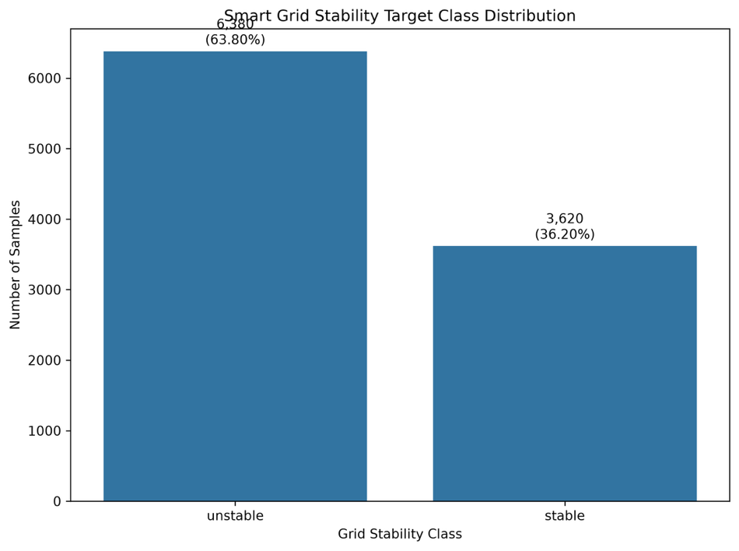.
The target distribution contains 6,380 unstable observations, representing 63.80% of the dataset, and 3,620 stable observations, representing 36.20%.
The unstable class therefore contains 2,760 more observations than the stable class. Although both classes have substantial representation, the distribution is not perfectly balanced. This class distribution is retained for the subsequent modelling experiments rather than applying any balancing procedure during Phase 1.

4.5.2 Feature Distributions Across Stability Classes
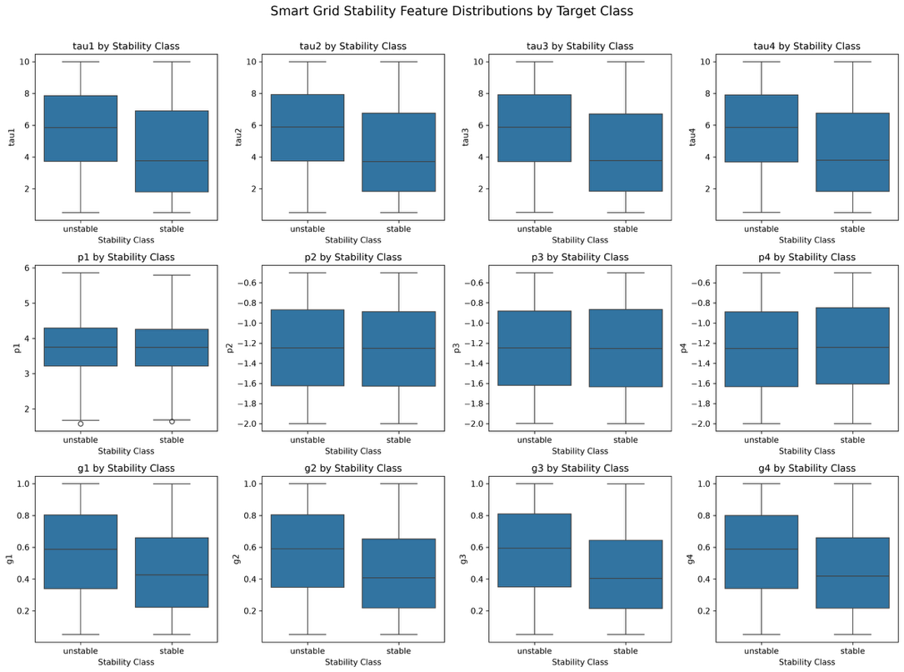
The boxplots show how each of the twelve predictor variables is distributed across the stable and unstable classes.
The clearest differences can be observed in the tau variables. The unstable class generally exhibits higher median values than the stable class across tau1, tau2, tau3, and tau4. This provides a visual indication that the time-constant-related parameters are associated with the stability condition.
A similar pattern can be observed for the generation-related variables g1–g4. The unstable class generally has higher central values than the stable class.
The p variables show considerably greater overlap between the two classes. In particular, the distributions of p2, p3, and p4 are visually similar between stable and unstable observations.
The figure therefore demonstrates that the distinction between stability classes is not equally expressed across all twelve predictors. Some variables show visible differences in their distributions, while others have substantial overlap. This supports the use of a multivariate model capable of combining information across all predictor variables.

4.5.3 Feature–Target Relationships
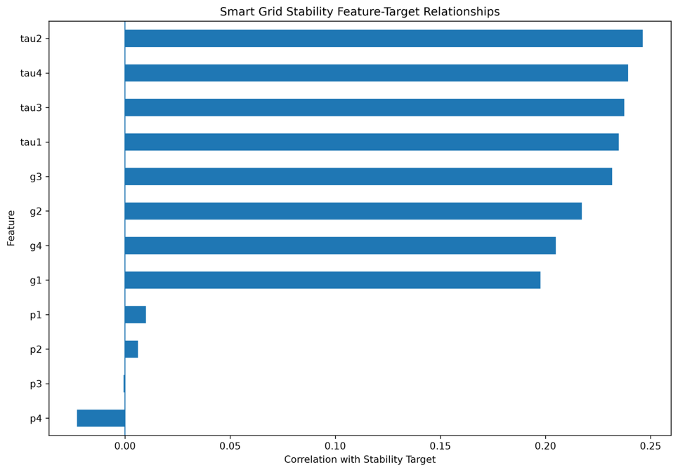.
The feature–target correlation analysis provides a quantitative comparison of the individual relationships between the twelve predictors and the encoded stability target.
The strongest relationships are observed for the tau variables. tau2 has the largest positive correlation in the analysis, followed by tau4, tau3, and tau1. The correlation values for these variables are all substantially larger than those observed for the power-related variables.
The g variables also demonstrate comparatively strong positive relationships. g3 and g2 are particularly prominent, followed by g4 and g1.
The p variables have much smaller absolute correlations. p1 and p2 show small positive relationships, p3 is approximately uncorrelated with the encoded target, and p4 shows a small negative relationship.
The figure therefore indicates that the stability target has stronger individual linear associations with the tau and g groups than with the p group. Nevertheless, these correlations are considered exploratory rather than as a feature-selection criterion. The complete set of twelve predictors is retained for the subsequent MLP experiments.

4.5.4 Correlation Between Predictor Variables
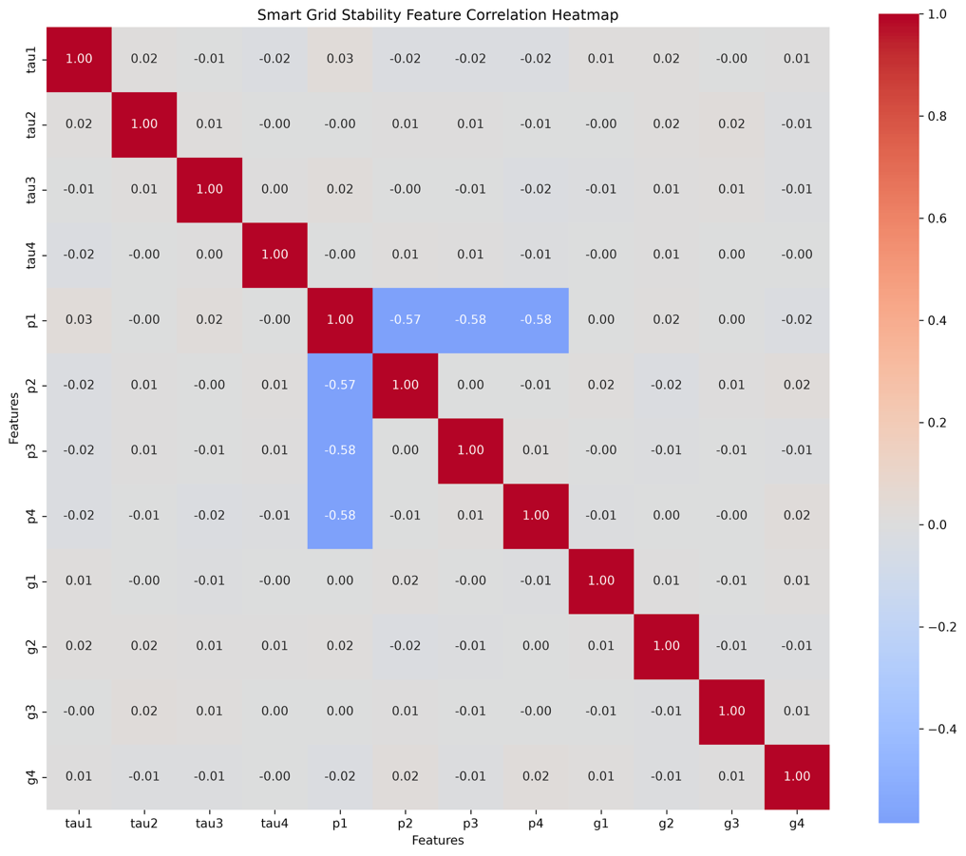.
The feature correlation heatmap shows that most predictor pairs have correlations close to zero, indicating limited linear dependency among many of the grid parameters.
The main exception occurs among the power-related variables. p1 has moderate negative correlations with p2, p3, and p4, with values of approximately −0.57, −0.58, and −0.58, respectively.
In contrast, the tau variables show correlations close to zero with one another. The g variables also show predominantly weak pairwise relationships.
This pattern indicates that the twelve predictors contain both relatively independent variables and a smaller group of correlated power-related variables. The correlation structure does not provide a reason to remove individual predictors at this stage, particularly because the subsequent MLP model can incorporate multiple variables simultaneously.

4.5.5 Phase 1 Findings
The Phase 1 analysis established the main characteristics of the Smart Grid Stability classification problem.
The dataset contains 10,000 observations and 12 model features, with no missing values and no duplicate rows. The target consists of 6,380 unstable observations (63.80%) and 3,620 stable observations (36.20%).
The exploratory visualizations demonstrate that the stability classes differ noticeably across several of the tau and g variables, while the p variables exhibit greater overlap. The feature–target analysis further indicates that the tau variables have the strongest individual relationships with the encoded stability target, followed by the g variables.
The feature correlation analysis identifies moderate negative relationships between p1 and p2, p3, and p4, while most other feature pairs exhibit weak linear correlations.
Overall, Phase 1 provides the structural and exploratory basis for the subsequent modelling experiments. Phase 2 uses the twelve continuous grid parameters as input variables and the stable/unstable Target as the binary classification target for baseline MLP training and hyperparameter optimization.

3.5.8 Smart Grid Stability – Phase 2 MLP Modelling and Optimization
Phase 2 extended the exploratory analysis from Phase 1 by developing a Multilayer Perceptron (MLP) classification model and evaluating several hyperparameter optimization approaches. The objective was to determine whether optimization could improve the classification performance obtained from the baseline MLP.
The dataset contained 10,000 observations and 12 predictor variables. The twelve continuous predictors were used as the input matrix, while the binary Target variable represented the stable and unstable grid conditions. The feature matrix therefore contained 10,000 observations and 12 input variables, while the target contained 10,000 corresponding class labels.

3.5.8.1 Train–Test Data Preparation
The dataset was divided into training and testing subsets before model development. The training set contained 8,000 observations, while the test set contained 2,000 observations. The feature matrix contained all twelve continuous grid variables.
Feature standardization was subsequently applied to transform the predictor variables to a common numerical scale. The standardized training data were used for MLP training and hyperparameter optimization.
The target distribution remained consistent with the Phase 1 analysis, containing 6,380 unstable observations and 3,620 stable observations.

3.5.8.2 Baseline MLP Configuration
A baseline MLP classifier was first trained to establish the reference performance against which the optimization methods could be compared.
The baseline configuration consisted of:
Hyperparameter | Baseline setting
Hidden layers | (64,)
Activation | ReLU
Solver | Adam
Initial learning rate | 0.001
Alpha | 0.0001
Batch size | 32
The baseline model was trained on the standardized training data. The resulting model achieved 97.40% accuracy, 97.40% precision, 97.40% recall, and 97.40% F1 score on the independent test set.
This baseline therefore established a very strong reference point before optimization.

3.5.8.3 Hyperparameter Optimization
Phase 2 evaluated multiple optimization strategies to investigate whether alternative MLP configurations could improve the baseline performance. The parameters considered included the neural-network architecture, activation function, learning rate, regularization parameter, and batch size.
The optimization objective was based on cross-validation F1 score. The optimized configurations were subsequently retrained and evaluated on the independent test set.
The optimization methods considered were:
- Random Search
- Bayesian Optimization
- Hyperband
- Learning Evolutionary Algorithm (LEA)
- Teaching–Learning-Based Optimization (TLBO)
The optimization procedures were performed independently, and the resulting configurations were evaluated using the same test set as the baseline model.

3.5.8.4 Random Search
Random Search explored randomly selected combinations from the defined MLP hyperparameter space.
The best configuration identified by Random Search was:
- Hidden layers: (64, 32)
- Activation: ReLU
- Solver: Adam
- Learning rate: 0.001
- Alpha: 0.0001
- Batch size: 64
The best cross-validation F1 score obtained during optimization was 0.9564. The optimized model was then retrained and evaluated on the test set.

3.5.8.5 Bayesian Optimization
Bayesian Optimization evaluated candidate configurations sequentially and used previous evaluation results to guide subsequent trials.
The run recorded 20 Bayesian trials. The best configuration was:
- Hidden layers: (32, 16)
- Activation: tanh
- Learning rate: 0.001
- Alpha: 0.01
- Batch size: 64
The highest cross-validation F1 score was 0.9583.
The optimized model was then retrained using the selected configuration and evaluated on the independent test set.

3.5.8.6 Hyperband Optimization
Hyperband was used to explore candidate configurations while allocating different training resources to configurations during optimization.
The selected configuration was:
- Hidden layers: (64, 32)
- Activation: ReLU
- Solver: Adam
- Learning rate: 0.001
- Alpha: 0.0001
- Batch size: 64
- Selected max_iter: 3
The best cross-validation F1 score reported by Hyperband was 0.8802. Despite this comparatively lower cross-validation score, the resulting model achieved high test-set performance after retraining.

3.5.8.7 Learning Evolutionary Algorithm
The Learning Evolutionary Algorithm (LEA) used a population-based search procedure. The optimization started with a population of 20 candidate configurations and evolved the candidate population over five generations.
The recorded best F1 score progressed as follows:
Generation | Best F1 Score
Initial population | 0.9598
1 | 0.9598
2 | 0.9598
3 | 0.9617
4 | 0.9632
5 | 0.9632
The final LEA configuration was:
- Hidden layers: (64, 32)
- Activation: tanh
- Solver: Adam
- Learning rate: 0.0001
- Alpha: 0.01
- Batch size: 32
The final cross-validation F1 score was 0.9632.

3.5.8.8 Teaching–Learning-Based Optimization
TLBO also used a population-based optimization strategy with a population size of 20. The optimization was performed for five iterations.
The best F1 score developed during the optimization process from 0.9598 initially to 0.9632, with the improvement occurring primarily during the early iterations. The best score then remained at 0.9632 through the later iterations.
The final TLBO configuration was identical to the configuration identified by LEA:
- Hidden layers: (64, 32)
- Activation: tanh
- Solver: Adam
- Learning rate: 0.0001
- Alpha: 0.01
- Batch size: 32
The resulting cross-validation F1 score was 0.9632.

4.5.6 Smart Grid Stability – Phase 2 Results

4.5.6.1 Overall Model Performance
The test-set performance of the baseline and optimized MLP models is summarized below.
Method | Accuracy | Precision | Recall | F1 Score | Optimization Time (s) | Training Time (s)
Baseline MLP | 0.9740 | 0.9740 | 0.9740 | 0.9740 | 0.00 | 13.82
Random Search | 0.9710 | 0.9710 | 0.9710 | 0.9710 | 31.03 | 5.01
Bayesian Optimization | 0.9660 | 0.9660 | 0.9660 | 0.9659 | 148.49 | 4.50
Hyperband | 0.9710 | 0.9710 | 0.9710 | 0.9710 | 0.50 | 5.03
LEA | 0.9755 | 0.9755 | 0.9755 | 0.9755 | 943.20 | 24.53
TLBO | 0.9755 | 0.9755 | 0.9755 | 0.9755 | 3625.62 | 24.33
The values are taken directly from the Phase 2 comparison output.

4.5.6.2 Optimization Performance Comparison
Figure 4.5.6. Optimization Performance Comparison for Smart Grid Stability
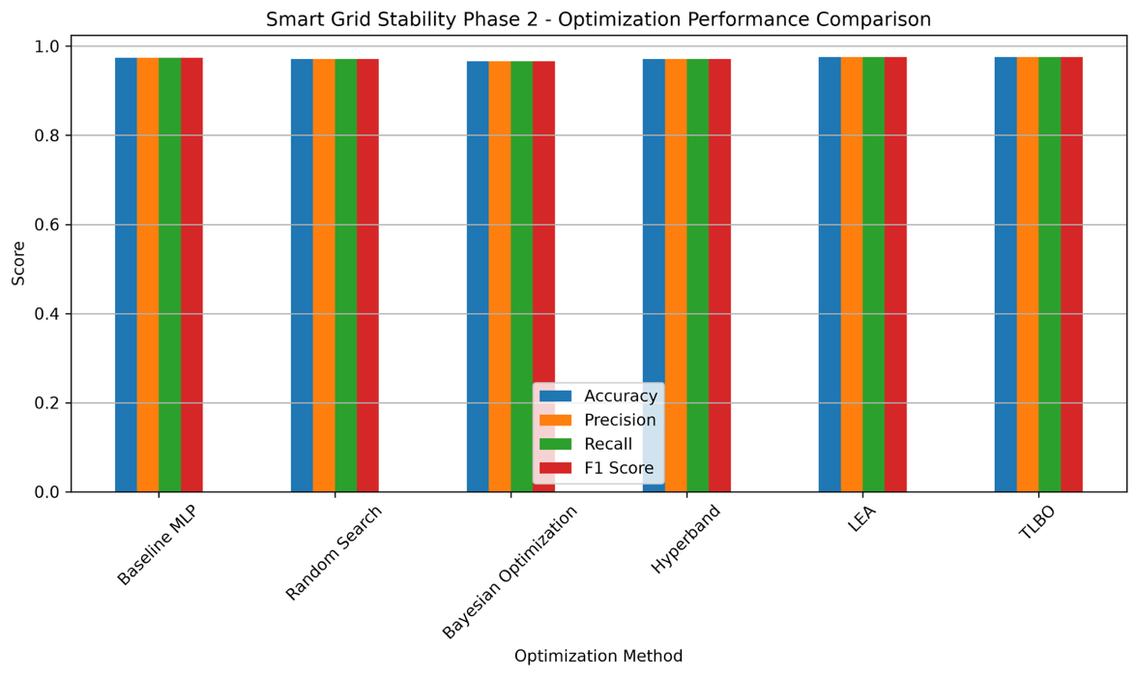.
The performance comparison shows that all six approaches achieved accuracy above 96% on the test set.
The baseline MLP achieved 97.40% accuracy. Random Search and Hyperband achieved 97.10%, while Bayesian Optimization achieved 96.60%. LEA and TLBO achieved the highest recorded test accuracy of 97.55%.
The improvement obtained by LEA and TLBO relative to the baseline was therefore:
$$97.55\%-97.40\%=0.15$$
percentage points.
Thus, although LEA and TLBO produced a marginal increase in test accuracy, the improvement was very small relative to the already strong baseline performance.
The classification reports also show that the models maintained high performance for both stable and unstable classes. For example, the baseline model achieved F1 scores of 0.96 for the stable class and 0.98 for the unstable class.

4.5.6.3 Baseline MLP Training Behaviour
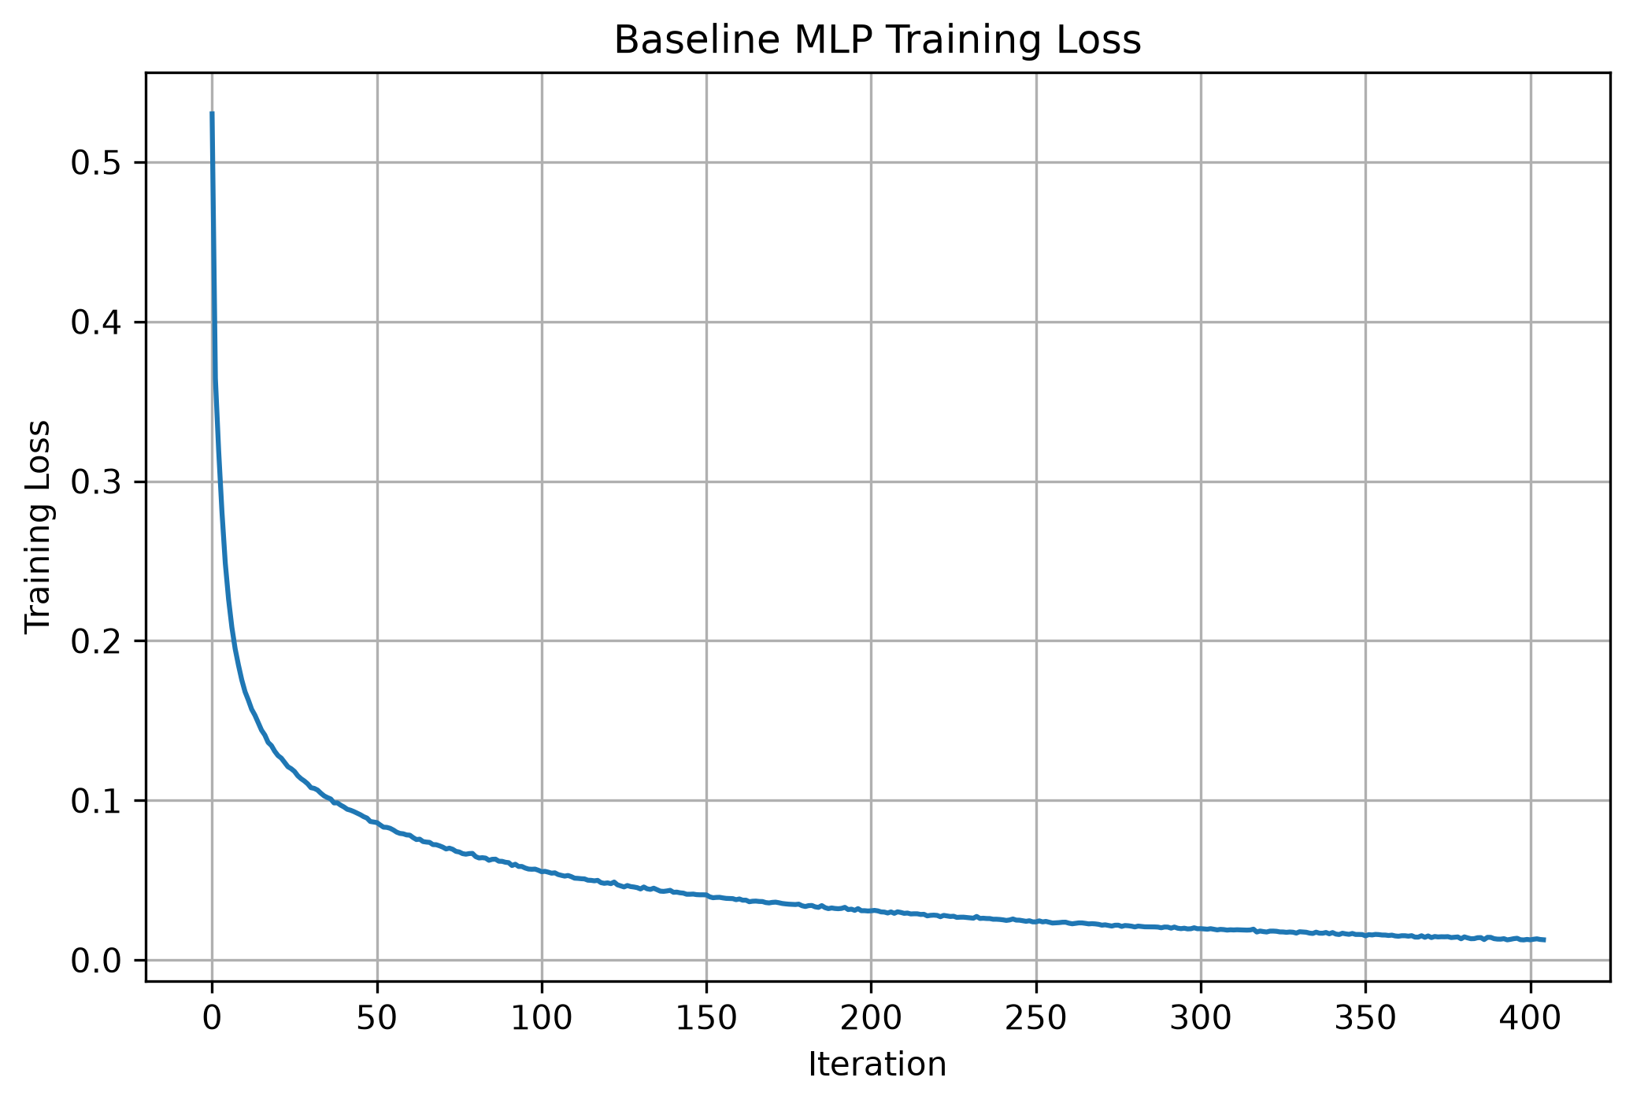
The baseline training-loss curve decreases rapidly during the initial iterations and then gradually approaches a low loss value. The curve shows a smooth convergence pattern, with the largest reduction occurring during the early training stage.
The final baseline model achieved 97.40% test accuracy, demonstrating that the original (64,) ReLU architecture with Adam optimization was already capable of modelling the stability classes effectively.

4.5.6.4 Random Search Training Behaviour
Figure 4.5.8. Random Search Optimized MLP Training Loss
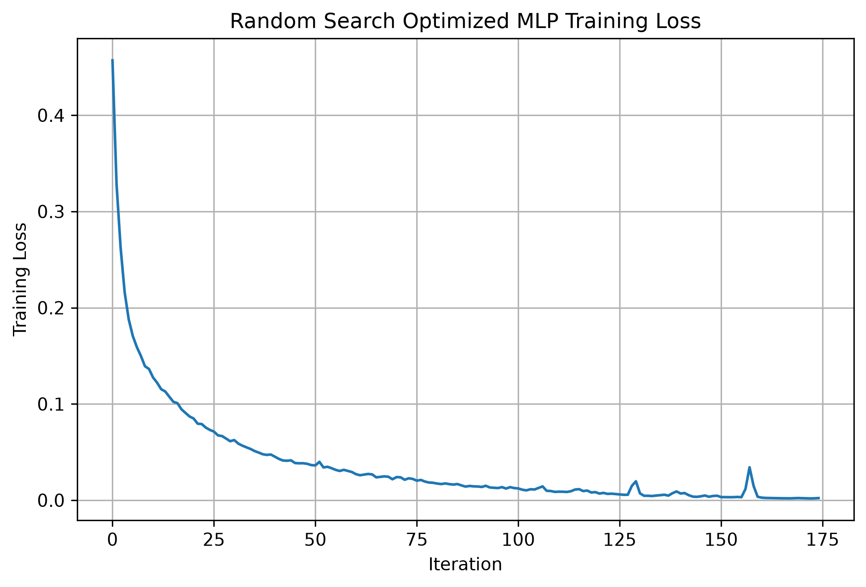
The Random Search optimized model shows a rapid initial decrease in training loss followed by gradual convergence. The optimized (64,32) architecture produced a test accuracy of 97.10%, which was slightly below the baseline accuracy.
Therefore, the randomly selected optimized configuration did not provide an improvement over the baseline despite requiring additional optimization time.

4.5.6.5 Bayesian Optimization Training Behaviour
Figure 4.5.9. Bayesian Optimization MLP Training Loss
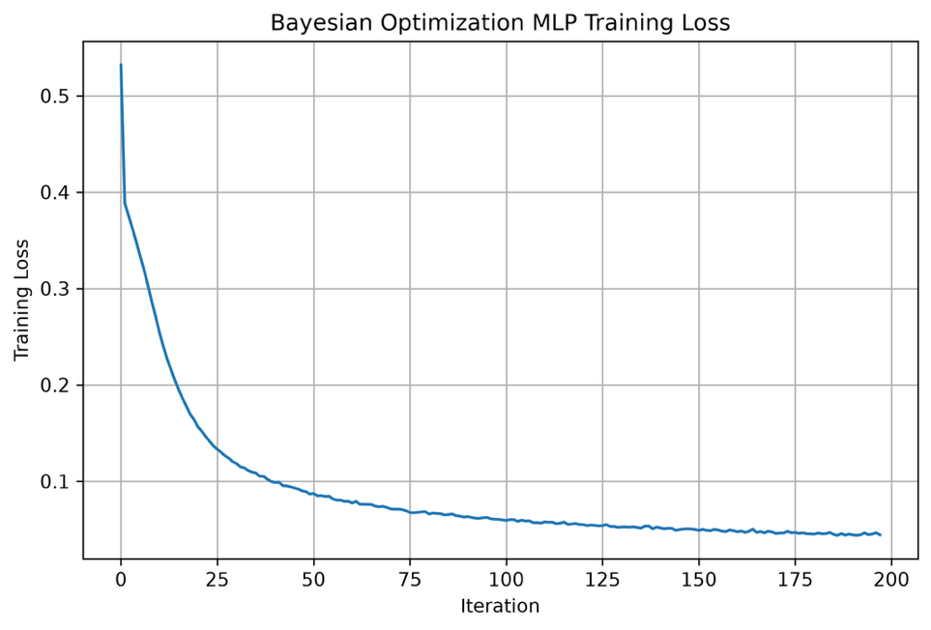.
The Bayesian-optimized model also exhibits a rapid reduction in training loss followed by gradual convergence. Its selected (32,16) tanh architecture produced a test accuracy of 96.60% and an F1 score of 0.9659.
Although Bayesian Optimization achieved a cross-validation F1 score of 0.9583, the independent test performance was slightly lower than the baseline. This demonstrates that a higher cross-validation optimization score does not necessarily translate into a higher test-set accuracy.

4.5.6.6 Hyperband Training Behaviour
Figure 4.5.10. Hyperband MLP Training Loss
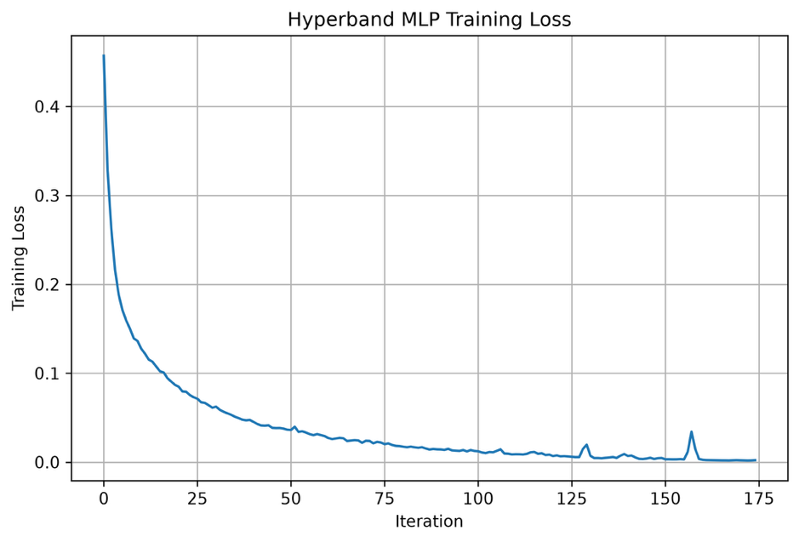.
The Hyperband training curve shows a steep initial reduction in loss followed by a low-loss region. The Hyperband procedure required only 0.50 seconds of optimization time, substantially less than the other optimization methods.
The final Hyperband model achieved 97.10% test accuracy and 0.9710 F1 score.
Thus, the method achieved high predictive performance while requiring very little optimization time in this experiment.

4.5.6.7 LEA Training Behaviour
Figure 4.5.11. LEA MLP Training Loss
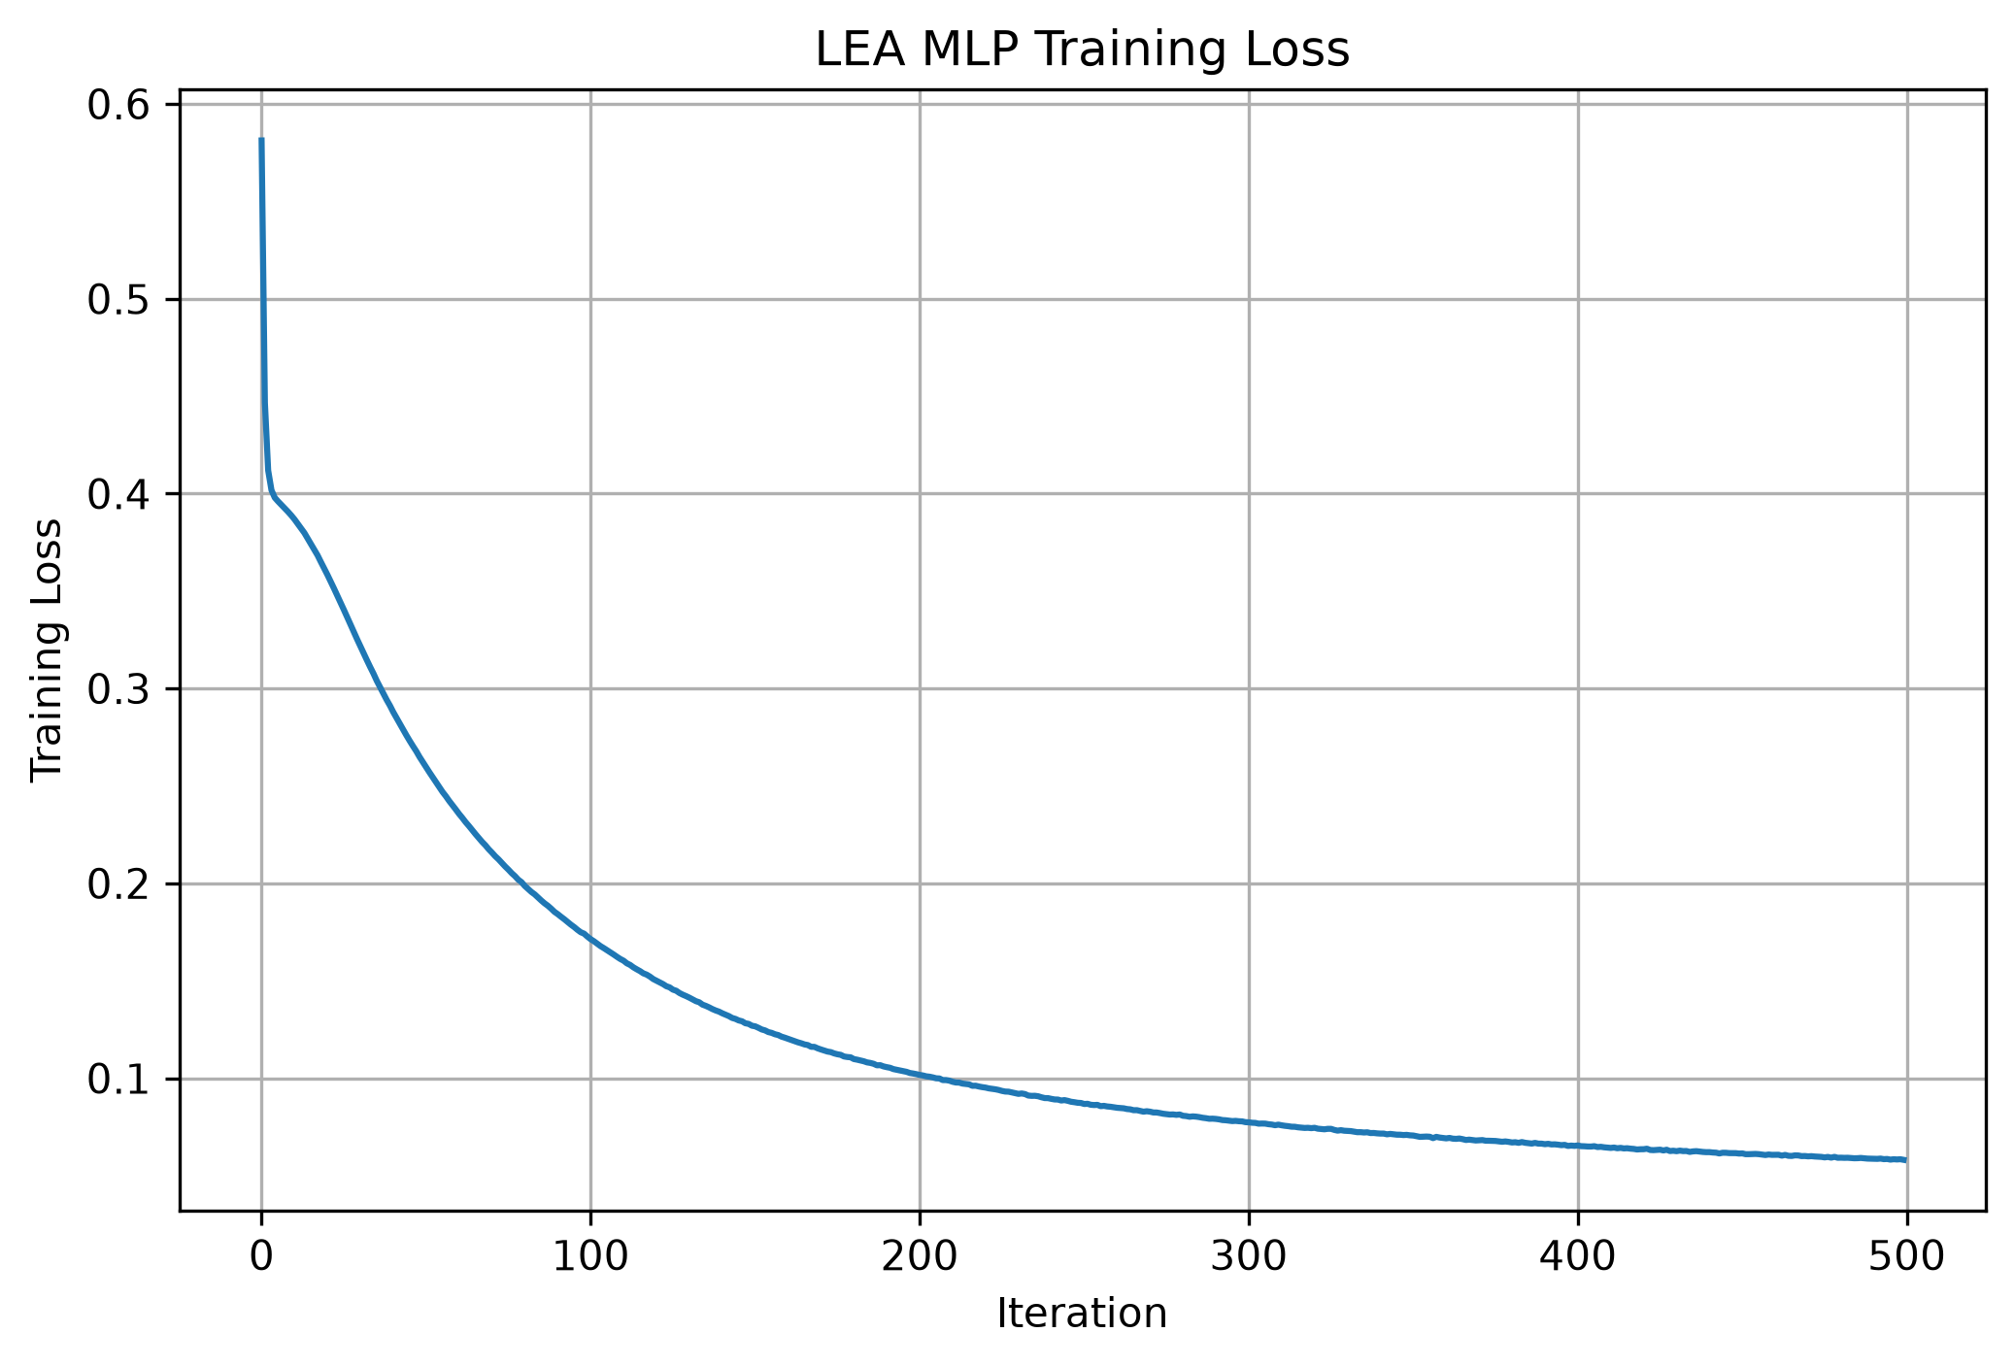.
The LEA training-loss curve demonstrates a smooth decrease from the initial loss toward a substantially lower value. The optimization process improved its cross-validation F1 score from 0.9598 for the initial population to 0.9632 by the fifth generation.
The final LEA model achieved 97.55% accuracy and 0.9755 F1 score on the test set. However, this improvement required 943.20 seconds of optimization time, making the optimization computationally expensive relative to the very small improvement over the baseline.

4.5.6.8 TLBO Training Behaviour
Figure 4.5.12. TLBO MLP Training Loss
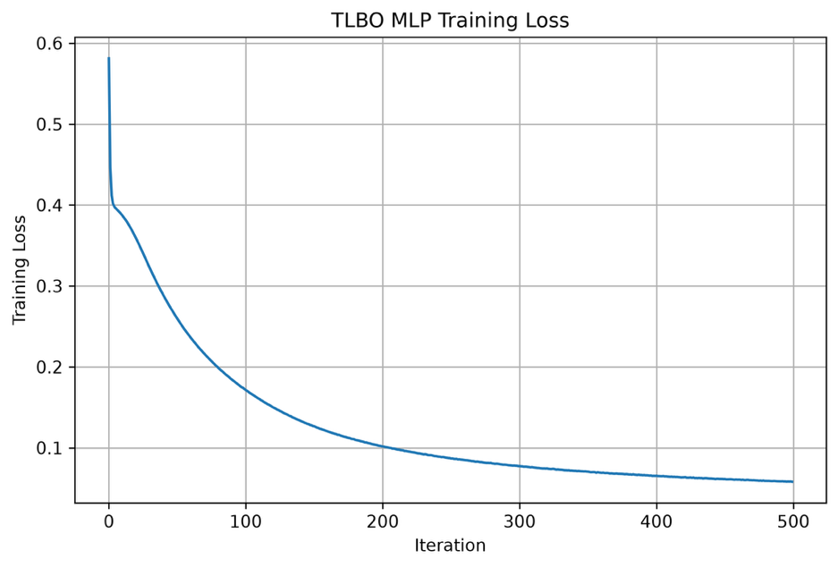.
The TLBO training-loss curve shows a strong decrease during the early iterations followed by gradual convergence. The optimization process reached a best cross-validation F1 score of 0.9632, which was the same value obtained by LEA.
The final TLBO model also achieved 97.55% accuracy and 0.9755 F1 score. However, TLBO required 3,625.62 seconds for optimization, substantially more than all other approaches in this experiment.
Therefore, the additional optimization time did not translate into a substantial predictive improvement over the baseline.

4.5.6.9 Optimization Time Comparison
Figure 4.5.13. Optimization Time Comparison
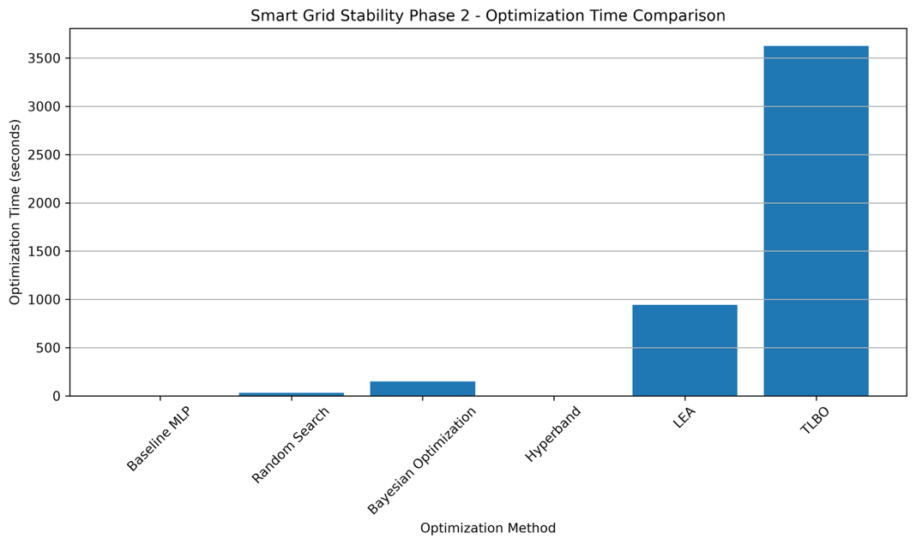.
The optimization-time comparison demonstrates substantial differences in computational cost between the optimization methods.
Hyperband required only 0.50 seconds, followed by Random Search at 31.03 seconds and Bayesian Optimization at 148.49 seconds. LEA required 943.20 seconds, while TLBO required the longest optimization time at 3,625.62 seconds.
The large computational cost of LEA and particularly TLBO is important when interpreting their marginal performance improvement. Although both methods achieved 97.55% test accuracy, the improvement over the 97.40% baseline was only 0.15 percentage points.

4.5.6.10 Phase 2 Overall Findings
The Phase 2 experiment demonstrates that the Smart Grid Stability dataset can already be classified with very high accuracy using a relatively simple MLP configuration.
The baseline model achieved:
- Accuracy: 97.40%
- Precision: 97.40%
- Recall: 97.40%
- F1 score: 97.40%
The optimized methods produced test accuracies between 96.60% and 97.55%. LEA and TLBO achieved the highest observed value of 97.55%, but this represented only a 0.15 percentage-point improvement over the baseline.
An important observation is that optimization did not consistently improve the independent test performance. Random Search, Bayesian Optimization, and Hyperband all produced test accuracy below the baseline. This indicates that the baseline configuration was already well suited to the characteristics of this dataset.
The optimization-time results further reinforce this observation. LEA and TLBO required substantially more computational time than the other methods, despite producing only a marginal improvement in predictive performance.

4.5.6.11 Reason for Not Proceeding to Phase 3
The Smart Grid Stability dataset was not advanced to Phase 3 because the Phase 2 experiments had already demonstrated sufficiently high predictive performance.
Most importantly, the baseline MLP achieved 97.40% accuracy and 97.40% F1 score without any hyperparameter optimization.
The optimization experiments did not reveal a meaningful additional performance gain:
- Random Search: 97.10%
- Bayesian Optimization: 96.60%
- Hyperband: 97.10%
- LEA: 97.55%
- TLBO: 97.55%
The maximum improvement over the baseline was therefore only:
$$97.55-97.40=0.15$$
percentage points.
At the same time, the computational cost of the more complex optimization methods increased considerably. LEA required approximately 15.7 minutes, while TLBO required approximately 60.4 minutes, compared with the very small improvement in predictive performance.
Therefore, continuing to Phase 3 would have resulted in additional optimization experiments on a model that was already achieving more than 95% accuracy, with limited evidence that further optimization would produce a practically meaningful improvement. In this study, the combination of high baseline performance, consistently high optimized performance, and diminishing improvement relative to computational cost provided the basis for stopping the Smart Grid Stability experiments after Phase 2.
This stopping decision also helps maintain the experimental focus of the thesis: subsequent phases are applied where there is sufficient scope for additional optimization to produce measurable differences, rather than applying additional optimization stages uniformly to every dataset regardless of the observed Phase 2 results.

3.6 Appliance Energy Prediction Dataset

3.6.1 Dataset and Prediction Objective
The Appliance Energy Prediction dataset was used as the third benchmark dataset in the experimental study. It was obtained from the UCI Machine Learning Repository using dataset ID 374. The dataset contains 19,735 observations and 29 variables, including indoor environmental measurements, outdoor weather conditions, lighting information, a timestamp, and appliance energy consumption.
The original target variable, Appliances, represents appliance energy consumption in Wh. In Phase 1, this continuous target was transformed into categorical consumption levels using K-Means clustering. This transformation allowed the dataset to be used as a multiclass classification problem in the subsequent MLP experiments.
The main objective of Phase 1 was therefore to investigate the distribution of appliance energy consumption and construct meaningful consumption categories from the original continuous target.

3.6.2 Dataset Structure and Data Quality
The dataset contains 19,735 observations and 29 variables. The variables include:
- date;
- lights;
- indoor temperature measurements (T1–T9);
- indoor relative-humidity measurements (RH_1–RH_9);
- outdoor temperature (T_out);
- atmospheric pressure (Press_mm_hg);
- outdoor relative humidity (RH_out);
- wind speed (Windspeed);
- visibility (Visibility);
- dew point temperature (Tdewpoint);
- two random variables (rv1 and rv2); and
- the target variable Appliances.
The execution output showed that all 19,735 observations were complete, with no missing values reported for any of the 29 variables. The original dataset was saved before the target transformation so that the initial data structure was preserved.

3.6.3 Appliance Energy Consumption Distribution
The Appliances variable was first examined using descriptive statistics and a histogram.
Statistic | Appliance Consumption (Wh)
Minimum | 10
Q1 | 50
Median | 60
Mean | 97.69
Q3 | 100
Maximum | 1080
Standard deviation | 102.52
The difference between the mean and median indicates that the distribution is positively skewed. Most observations have relatively low appliance energy consumption, while a smaller number of observations have substantially higher values.

Figure 3.6.1 – Distribution of Appliance Energy Consumption
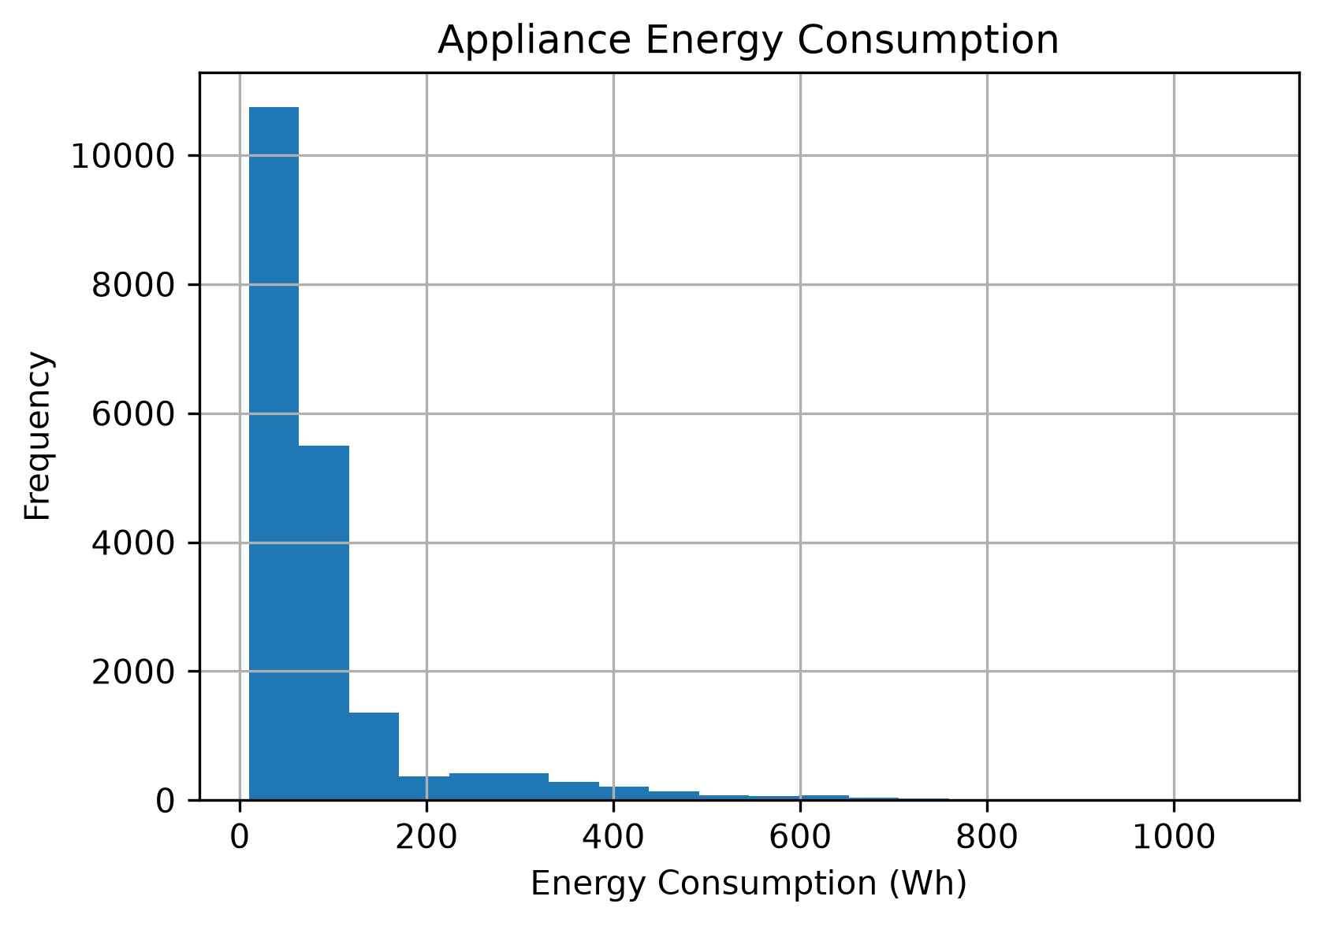
The histogram confirms that most observations are concentrated below approximately 200 Wh. The frequency decreases as consumption increases, while a smaller number of observations extend toward the maximum value of 1,080 Wh. This distribution motivated the use of clustering to identify different consumption levels.

3.6.4 Standardization of the Target Variable
Before applying K-Means, the Appliances variable was standardized using StandardScaler. This was necessary because K-Means determines groups based on distances between observations.
The standardization converts the original consumption values into a normalized representation based on the dataset mean and standard deviation. For this dataset, the mean appliance consumption was 97.69 Wh and the standard deviation was 102.52 Wh.
No additional mathematical transformation was applied to the target before clustering. The standardized target was directly used as the input to the K-Means experiments.

3.6.5 Elbow Analysis for Cluster Selection
The Elbow Method was used to examine different numbers of clusters between 2 and 10. The method evaluates how the within-cluster variation changes as additional clusters are introduced.
The observed WCSS values were:
Number of clusters \(k\) | WCSS
2 | 5033.86
3 | 2673.41
4 | 1580.13
5 | 998.69
6 | 776.39
7 | 603.16
8 | 478.39
9 | 378.74
10 | 308.36
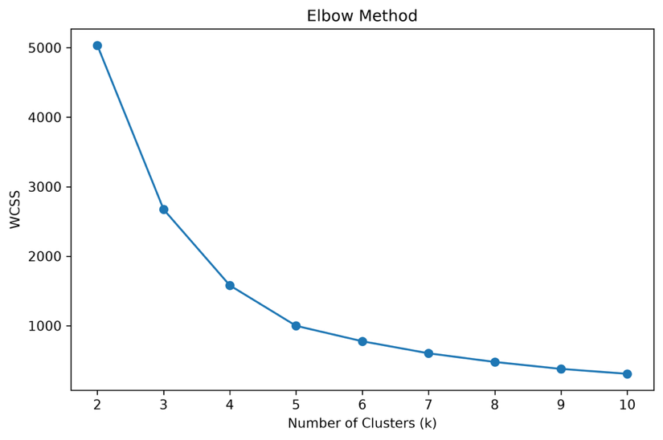
The WCSS decreases substantially between two and five clusters. After five clusters, the reduction becomes progressively smaller. This behaviour indicates that adding more clusters provides smaller improvements in within-cluster compactness.
Therefore, five clusters were considered a suitable configuration for representing different appliance consumption levels.

3.6.6 Silhouette Score Analysis
The Silhouette Score was calculated for each cluster configuration from \(k=2\) to \(k=10\). The results were:
Number of clusters \(k\) | Silhouette Score
2 | 0.8462
3 | 0.8168
4 | 0.6644
5 | 0.6538
6 | 0.6527
7 | 0.6064
8 | 0.6042
9 | 0.5952
10 | 0.5985

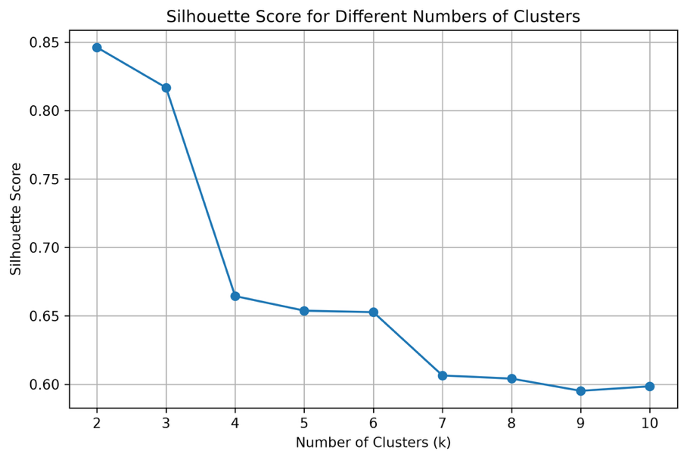
The highest Silhouette Score was obtained at \(k=2\) with a value of 0.8462, followed by \(k=3\) with 0.8168. The score at \(k=5\) was 0.6538.
Although \(k=2\) produced the highest Silhouette Score, it would provide only two broad consumption categories. Five clusters were retained because they provided a more detailed representation of appliance consumption and were consistent with the point where the Elbow curve began to flatten.
Thus, the final selection of \(k=5\) was based on the combined interpretation of the Elbow Method, Silhouette results, and the intended consumption-category structure rather than on the Silhouette Score alone.

3.6.7 K-Means Cluster Formation
The final K-Means model was configured with:
Parameter | Value
Number of clusters | 5
n_init | 10
Random state | 42
Input | Standardized Appliances
The resulting clusters were examined using their sample counts, consumption ranges, and mean consumption values. This allowed the numerical cluster identifiers to be converted into meaningful ordered consumption categories.

3.6.8 K-Means Cluster Results
The final five clusters produced the following results:
Cluster | Samples | Consumption Range (Wh) | Mean (Wh)
0 | 12,304 | 10–70 | 51.52
2 | 5,293 | 80–170 | 103.68
3 | 1,137 | 180–320 | 249.08
1 | 745 | 330–520 | 397.87
4 | 256 | 530–1080 | 647.30
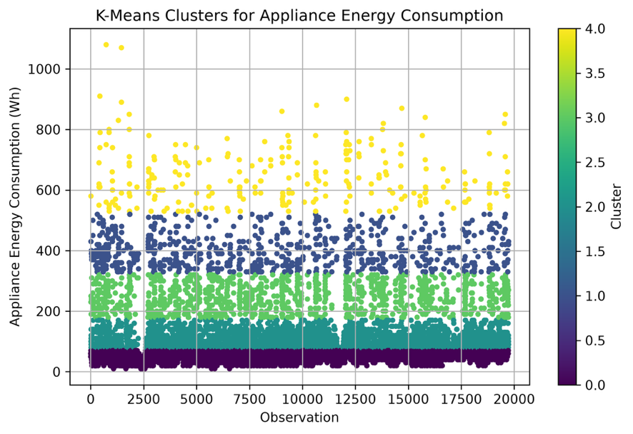
The visualization shows five distinct consumption bands across the observations. The lowest-consumption cluster contains the largest number of observations, while the higher-consumption clusters become progressively smaller.
The highest cluster contains observations between 530 and 1,080 Wh, with an average consumption of 647.30 Wh. This corresponds to the relatively small number of high-consumption observations visible in the original histogram.

3.6.9 Construction of Appliance Consumption Classes
The numerical cluster identifiers were converted into five ordered consumption categories based on their observed consumption levels.
Cluster | Consumption Class | Mean Consumption (Wh)
0 | Very Low | 51.52
2 | Low | 103.68
3 | Medium | 249.08
1 | High | 397.87
4 | Very High | 647.30
The mapping was explicitly defined in the Phase 1 implementation so that the K-Means cluster numbers were converted into meaningful consumption labels.

3.6.10 Final Phase 1 Dataset
The resulting consumption classes were distributed as follows:
Consumption Class | Samples | Percentage | Mean Consumption (Wh)
Very Low | 12,304 | 62.35% | 51.52
Low | 5,293 | 26.83% | 103.68
Medium | 1,137 | 5.76% | 249.08
High | 745 | 3.77% | 397.87
Very High | 256 | 1.30% | 647.30
Total | 19,735 | 100% | —
The resulting target is strongly imbalanced. The Very Low category contains 62.35% of the observations, whereas the Very High category contains only 1.30%. This class structure is relevant to the later MLP experiments because the model must distinguish between a dominant low-consumption class and several considerably smaller classes.

4.6 Appliance Energy Prediction – Phase 1 Results

4.6.1 Appliance Energy Consumption Distribution
The initial target analysis showed that appliance energy consumption ranges from 10 Wh to 1,080 Wh. The mean consumption was 97.69 Wh, while the median was 60 Wh.
The histogram shows a strong concentration of observations at lower consumption levels, particularly below approximately 200 Wh. Only a relatively small number of observations have consumption values above this range. The long upper tail explains the difference between the mean and median and indicates that high-consumption observations are comparatively uncommon.

4.6.2 Elbow Method Results
The WCSS decreased from 5033.86 at \(k=2\) to 998.69 at \(k=5\). Beyond five clusters, the reductions became progressively smaller.
The plotted curve shows the largest reductions in WCSS in the lower range of cluster counts, followed by a flatter region after approximately five clusters. This supports the use of five clusters as a practical representation of the different consumption levels.

4.6.3 Silhouette Score Results
The Silhouette Score was highest for two clusters at 0.8462 and decreased as additional clusters were introduced. At five clusters, the score was 0.6538.
The result shows that fewer clusters provide stronger overall separation according to the Silhouette metric. However, the five-cluster configuration provides greater resolution of the consumption distribution and was therefore retained for the classification experiment.

4.6.4 K-Means Cluster Results
The K-Means visualization shows five distinct horizontal consumption groups. The largest group is concentrated at the lowest consumption levels, while the number of observations decreases as the consumption range increases.
The resulting cluster means increase from 51.52 Wh for Cluster 0 to 647.30 Wh for Cluster 4, providing a clear basis for converting the numerical clusters into ordered consumption categories.

4.6.5 Final Appliance Consumption Classes
The final target transformation produced five consumption classes:
Consumption Class | Samples | Percentage | Mean Consumption (Wh)
Very Low | 12,304 | 62.35% | 51.52
Low | 5,293 | 26.83% | 103.68
Medium | 1,137 | 5.76% | 249.08
High | 745 | 3.77% | 397.87
Very High | 256 | 1.30% | 647.30
The results demonstrate that the continuous appliance energy target can be represented through five clearly ordered consumption levels. However, the resulting classes are highly imbalanced, particularly between the Very Low and Very High categories. This characteristic is carried forward into Phase 2, where MLP hyperparameter optimization is evaluated using classification metrics that account for performance across the different classes.

Phase 1 conclusion
Phase 1 transformed the original continuous appliance energy-consumption target into a five-class categorical target using K-Means clustering. The analysis identified a strongly right-skewed consumption distribution, with most observations concentrated at lower energy levels. The Elbow Method indicated a practical flattening of the clustering improvement around five clusters, while the Silhouette analysis provided an additional assessment of cluster separation.
The final five clusters were mapped to Very Low, Low, Medium, High, and Very High consumption classes and saved in the processed dataset for use in the subsequent MLP classification and optimization experiments.

3.6 Appliance Energy Prediction Dataset – Phase 2

3.6.1 Objective of Phase 2
Phase 2 extended the Appliance Energy Prediction experiment from the energy-consumption clustering performed in Phase 1 to a multiclass classification problem using a Multi-Layer Perceptron (MLP). The objective was to establish a baseline MLP classifier and investigate whether hyperparameter optimization could improve the classification performance.
The Phase 2 dataset contained 19,735 observations and 31 columns. After excluding the target-related variables, the feature matrix contained 28 predictor variables. The target consisted of five energy-consumption clusters generated during Phase 1. The data were divided into 15,788 training observations and 3,947 testing observations. Pasted text Pasted text
Five optimization approaches were evaluated against the baseline MLP: Random Search, Bayesian Optimization, Hyperband, Learning Evolutionary Algorithm (LEA), and Teaching-Learning-Based Optimization (TLBO).

3.6.2 Target Classes and Class Distribution
The classification target consisted of five clusters representing different levels of appliance energy consumption. The complete dataset contained the following distribution:
Cluster | Number of observations
Cluster 0 | 12,304
Cluster 1 | 745
Cluster 2 | 5,293
Cluster 3 | 1,137
Cluster 4 | 256
Total | 19,735
Cluster 0 was the dominant class with 12,304 observations, whereas Cluster 4 contained only 256 observations. The target distribution therefore shows substantial differences in class frequency. Pasted text
The proportion of each cluster can be expressed as:
\[ P_c=\frac{N_c}{N}\times100 \]
where \(N_c\) represents the number of observations in cluster \(c\), and \(N=19,735\) represents the total number of observations.
The class distribution was retained during model evaluation, and class-wise precision, recall and F1-score were examined alongside the overall accuracy.

3.6.3 Data Partitioning and Standardization
The dataset was divided into training and testing subsets. The training feature matrix contained 15,788 observations and 28 features, while the independent test set contained 3,947 observations and 28 features. The corresponding target vectors contained 15,788 and 3,947 observations, respectively. Pasted text
Feature standardization was performed before training the MLP models. The standardized feature representation was then used for the baseline model and the different optimization approaches. The execution output confirms that feature standardization was completed before the baseline model was trained. Pasted text

3.6.4 Baseline MLP Configuration
A Multi-Layer Perceptron classifier was established as the reference model. The baseline configuration consisted of a single hidden layer with 64 neurons, ReLU activation and the Adam solver.
Hyperparameter | Baseline value
Hidden layer architecture | (64,)
Activation | ReLU
Solver | Adam
Learning rate | 0.001
Alpha | 0.0001
Batch size | 32
Maximum iterations | 500
Random state | 42
The baseline model was trained and subsequently evaluated on the independent test set. Accuracy, precision, recall and F1-score were calculated, together with a classification report and confusion matrix. The configuration is explicitly reported in the Phase 2 output. Pasted text

3.6.5 Hyperparameter Search Space
The optimization experiments investigated different combinations of MLP architecture and training parameters. The search space used in Phase 2 consisted of:
Hyperparameter | Search values
Hidden layer architecture | (16,), (32,), (64,), (32,16), (64,32)
Activation | ReLU, tanh
Solver | Adam
Learning rate | 0.0001, 0.001
Alpha | 0.0001, 0.001, 0.01
Batch size | 32, 64, 128
The possible combinations across these parameters form a search space of:
\[ 5\times2\times1\times2\times3\times3=180 \]
configurations.
The optimization methods were therefore used to explore this common MLP parameter space rather than changing the underlying feature representation.

3.6.6 Random Search
Random Search was used to sample candidate configurations from the predefined MLP search space. The selected configurations were evaluated using cross-validation and weighted F1-score as the optimization criterion.
The configuration selected by Random Search was:
- Hidden layers: (32,)
- Activation: tanh
- Solver: Adam
- Learning rate: 0.001
- Alpha: 0.01
- Batch size: 32
The best cross-validation F1-score was 0.9961, with an optimization time of 21.81 seconds. Pasted text

3.6.7 Bayesian Optimization
Bayesian Optimization was implemented to select MLP configurations sequentially based on previously observed cross-validation performance. Five optimization trials were performed in the reported run. The five trials produced weighted F1-scores ranging from approximately 0.9934 to 0.9970. Pasted text
The selected configuration was:
- Hidden layers: (64,32)
- Activation: tanh
- Learning rate: 0.0001
- Alpha: 0.01
- Batch size: 128
The best cross-validation F1-score was 0.9970, and the optimization required 23.69 seconds. Pasted text Pasted text

3.6.8 Hyperband Optimization
Hyperband was included as a resource-aware optimization strategy. It evaluates candidate MLP configurations while allocating different amounts of training resources to the candidates.
The reported Hyperband run completed in 0.61 seconds. The selected configuration was:
- Hidden layers: (64,32)
- Activation: ReLU
- Solver: Adam
- Learning rate: 0.001
- Alpha: 0.0001
- Batch size: 64
- Maximum iterations: 3
The best cross-validation F1-score reported by Hyperband was 0.9420. Pasted text
The final Hyperband model was then trained using the selected configuration before being evaluated on the independent test set.

3.6.9 Learning Evolutionary Algorithm
The Learning Evolutionary Algorithm (LEA) was implemented using a population-based search. The optimization started with a population of 20 candidate configurations and proceeded through five generations. Pasted text
The best cross-validation F1-score was:
- Generation 1: 0.9969
- Generation 2: 0.9969
- Generation 3: 0.9969
- Generation 4: 0.9969
- Generation 5: 0.9973
The final configuration was:
- Hidden layers: (64,32)
- Activation: tanh
- Solver: Adam
- Learning rate: 0.0001
- Alpha: 0.01
- Batch size: 32
The final cross-validation F1-score was 0.9973. The optimization required 600.52 seconds. Pasted text Pasted text

3.6.10 Teaching-Learning-Based Optimization
TLBO was implemented as another population-based optimization method. The optimization used a population of 20 candidate configurations and five generations. Pasted text
The best cross-validation F1-score progressed as follows:
- Generation 1: 0.9968
- Generation 2: 0.9970
- Generation 3: 0.9970
- Generation 4: 0.9970
- Generation 5: 0.9970
The final selected configuration was:
- Hidden layers: (32,16)
- Activation: tanh
- Solver: Adam
- Learning rate: 0.0001
- Alpha: 0.01
- Batch size: 32
The best cross-validation F1-score was 0.9970, and the optimization required 1,327.98 seconds. Pasted text Pasted text

4.6 Appliance Energy Prediction – Phase 2 Results

4.6.1 Baseline MLP Performance
The baseline MLP achieved an accuracy of 0.9959, precision of 0.9960, recall of 0.9959, and F1-score of 0.9959. The training process required approximately 4.21 seconds. Pasted text
The class-wise results show very high performance for the majority classes. Classes 0 and 2 achieved precision, recall and F1-score of 1.00. Class 1 achieved an F1-score of 0.95, Class 3 achieved 0.98, and Class 4 achieved 0.92. Pasted text
The confusion matrix shows that Class 0 was classified completely correctly. Most errors occurred among the lower-frequency classes, particularly between Classes 1, 3 and 4. For example, five observations from Class 4 were classified as Class 1, while three observations from Class 1 were classified as Class 3 and three as Class 4. Pasted text
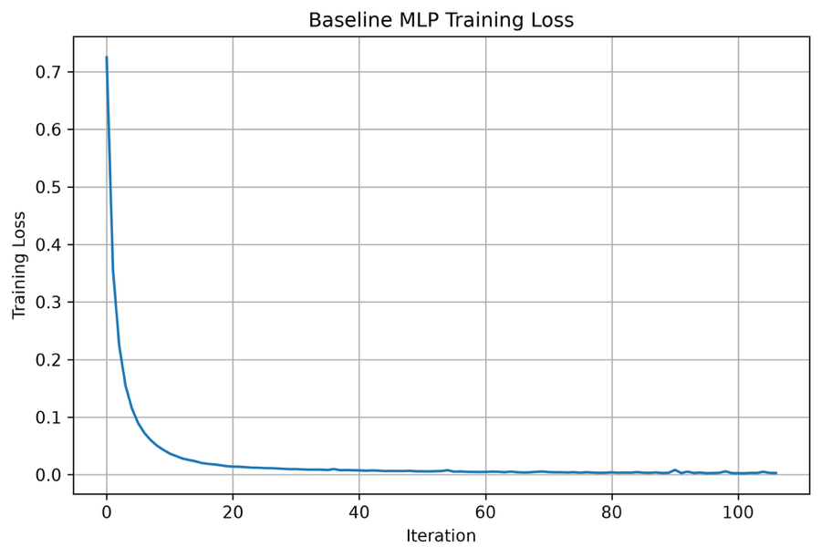
The baseline training-loss curve shows a rapid reduction during the first iterations. The loss decreases from approximately 0.72 to below 0.1 within the early part of training and then gradually approaches a value close to zero. After approximately 40 iterations, only relatively small changes are visible in the curve. This indicates rapid initial learning followed by stable convergence.

4.6.2 Random Search Results
The Random Search optimized MLP achieved an accuracy of 0.9965, precision of 0.9965, recall of 0.9965, and F1-score of 0.9964. The optimized model required 3.41 seconds for training, while the Random Search optimization itself required 21.81 seconds. Pasted text Pasted text
Compared with the baseline, the Random Search configuration produced a small improvement in all four reported overall performance measures. Class 1 recall increased from 0.96 to 0.99, and Class 4 F1-score increased from 0.92 to 0.97. Pasted text
The confusion matrix also shows a reduction in some of the minority-class errors. Class 1 had 148 correctly classified observations compared with 143 for the baseline, while Class 4 had 48 correctly classified observations compared with 46 for the baseline. Pasted text
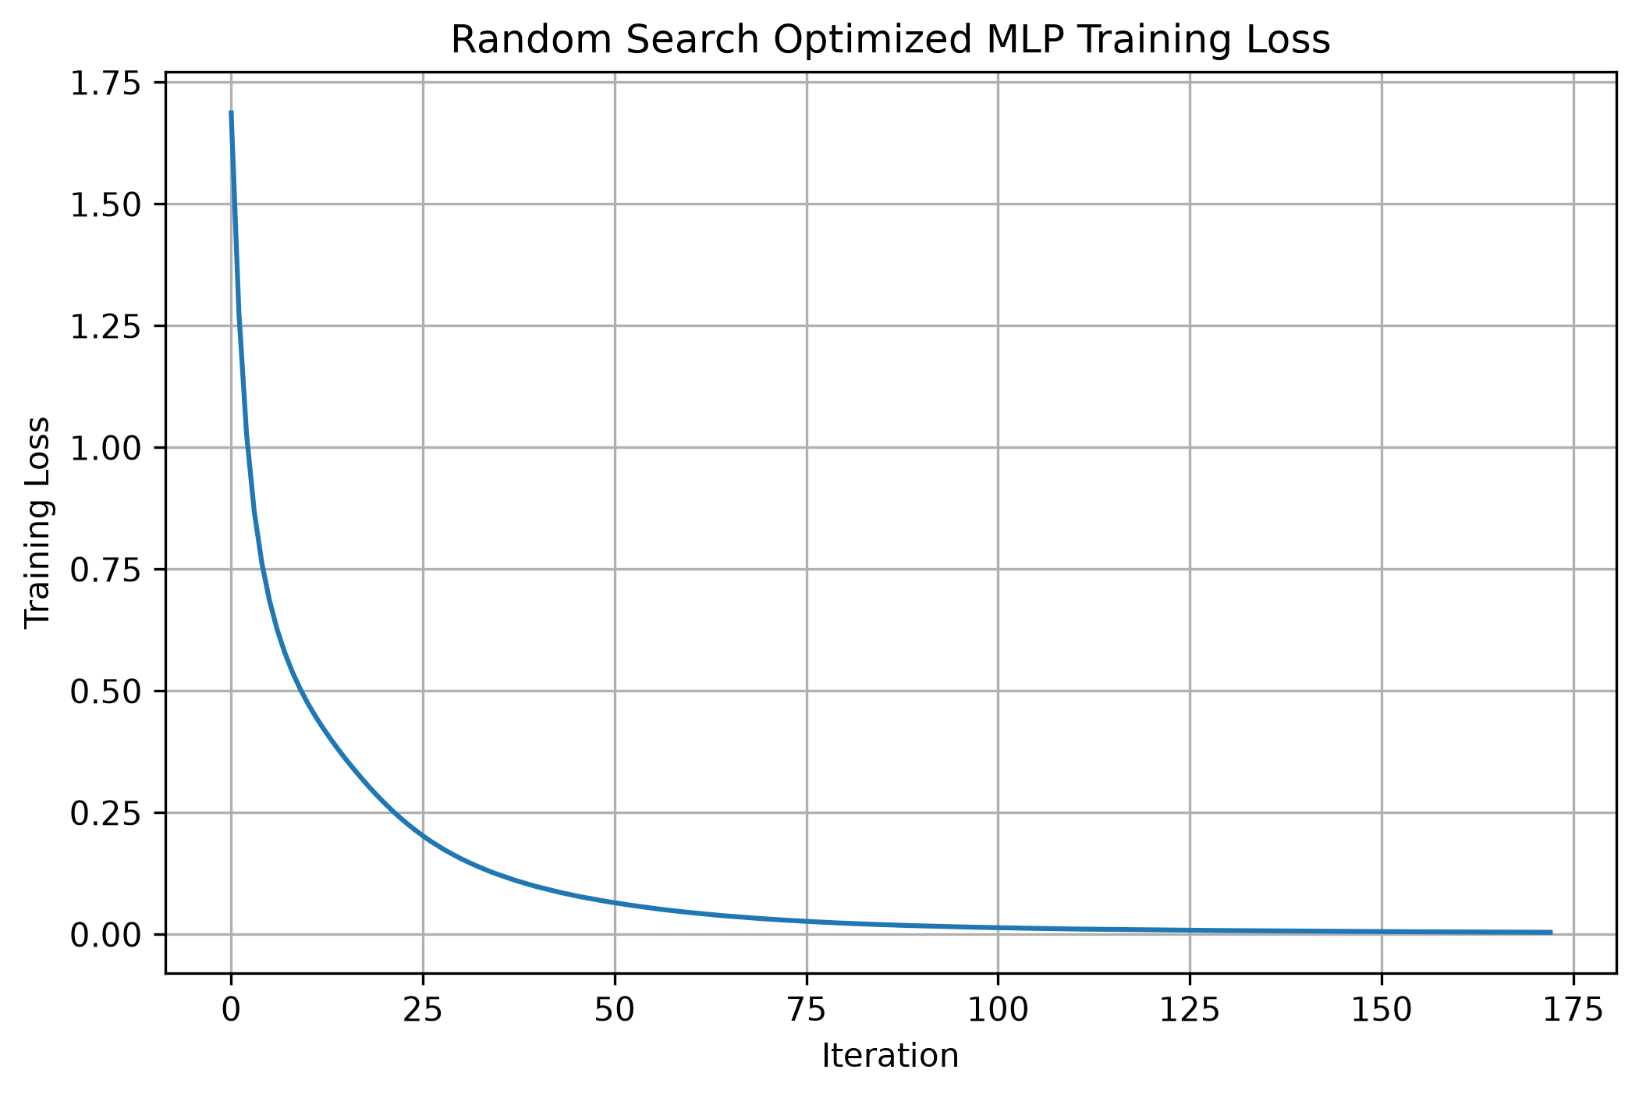
The Random Search training-loss curve begins at approximately 1.7 and decreases sharply during the initial iterations. The decline continues more gradually as training progresses. The loss becomes very small in the later iterations and approaches a stable region toward the end of training, indicating convergence of the selected (32,) tanh configuration.

4.6.3 Bayesian Optimization Results
Bayesian Optimization achieved an accuracy of 0.9975, precision of 0.9975, recall of 0.9975, and F1-score of 0.9975. The optimized model required 3.47 seconds for training, while the Bayesian optimization process required 23.69 seconds. Pasted text Pasted text
The class-wise results demonstrate consistently high performance. Class 0 and Class 2 achieved an F1-score of 1.00. Class 1 achieved 0.97, Class 3 achieved 0.98, and Class 4 achieved 0.97. Pasted text
The confusion matrix shows only a small number of classification errors. Class 3 had 226 correctly classified observations, while Class 4 had 49 correctly classified observations. Pasted text
The Bayesian search evaluated five trials. The best trial achieved a cross-validation F1-score of 0.99703, using the (64,32) architecture with tanh activation, a learning rate of 0.0001, alpha of 0.01 and batch size 128. Pasted text Pasted text
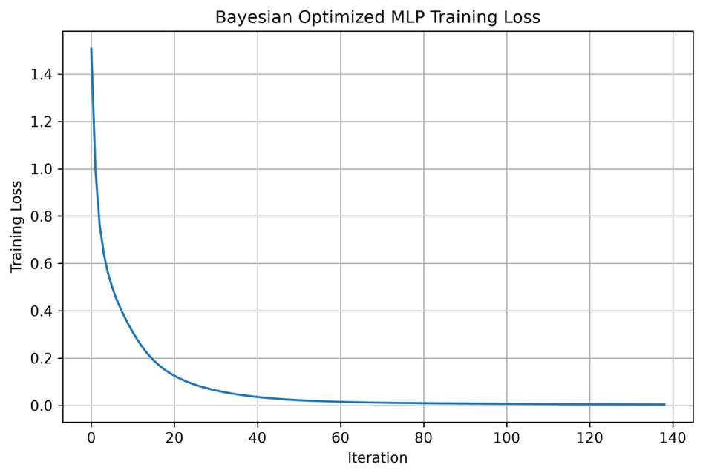
The Bayesian optimized training-loss curve begins at approximately 1.5 and decreases rapidly during the initial iterations. The loss falls below approximately 0.2 during the early training stage and then continues to decrease gradually. After approximately 60 iterations, the loss is very close to zero and remains stable during the later iterations. The curve therefore indicates consistent convergence of the selected two-hidden-layer architecture.

4.6.4 Hyperband Results
The Hyperband optimized MLP achieved an accuracy of 0.9942, precision of 0.9942, recall of 0.9942, and F1-score of 0.9942. The final model required 1.80 seconds for training, while the Hyperband optimization process required only 0.61 seconds. Pasted text
The majority classes remained highly accurate, with Classes 0 and 2 achieving F1-scores of 1.00. However, the minority classes showed somewhat lower performance compared with the other optimization methods. Class 1 achieved an F1-score of 0.94, Class 3 achieved 0.96, and Class 4 achieved 0.95. Pasted text
The confusion matrix shows increased misclassification among the smaller classes compared with the baseline and the other optimized models. In particular, eight Class 1 observations were assigned to Class 3, while five Class 2 observations were assigned to Class 3. Pasted text
The selected Hyperband configuration used a maximum of only three training iterations, with a cross-validation F1-score of 0.9420. Pasted text
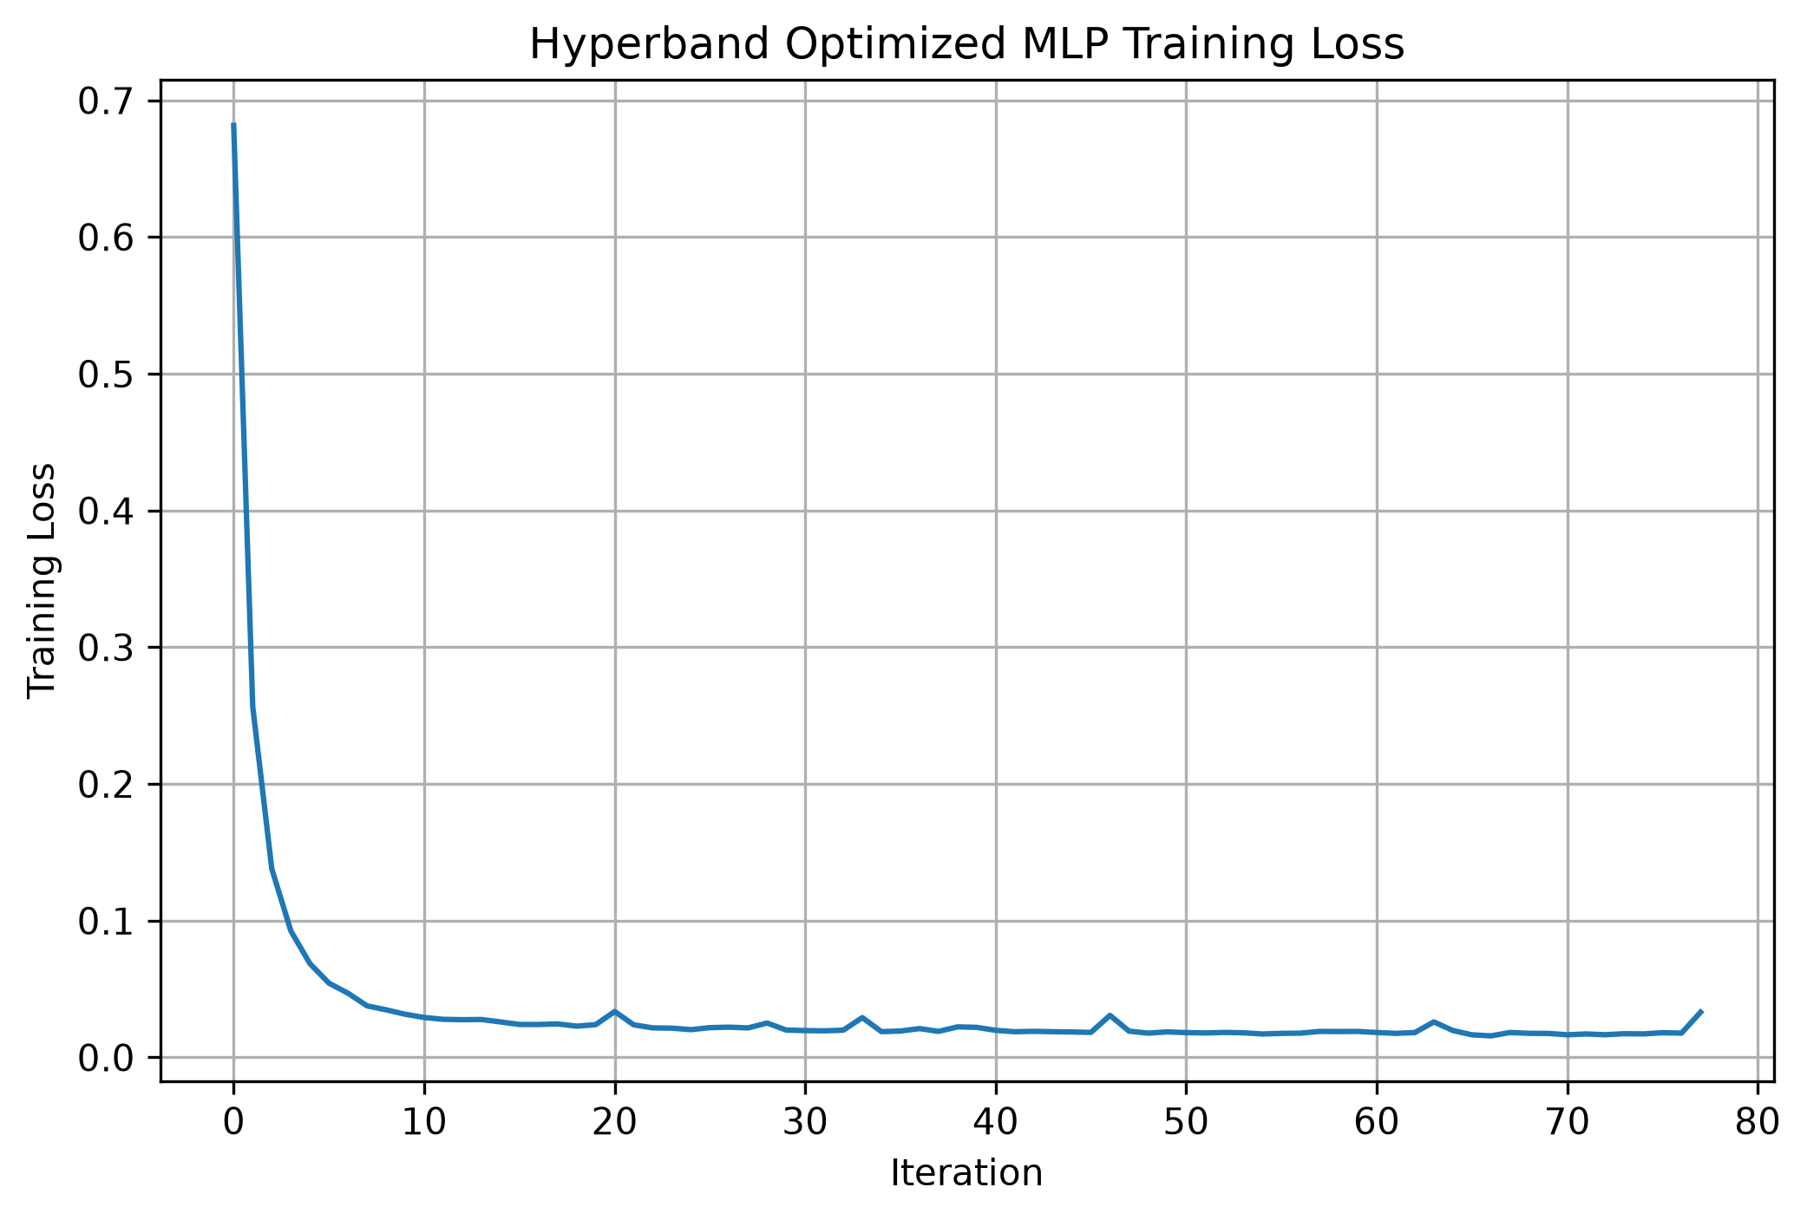
The Hyperband training-loss curve starts at approximately 0.68 and falls very rapidly during the first few iterations. The loss reaches a low region within approximately 10 iterations and remains close to zero afterward, although several small fluctuations are visible. The rapid convergence is consistent with the short training configuration selected by Hyperband.

4.6.5 LEA Results
The LEA optimized MLP achieved an accuracy of 0.9985, precision of 0.9985, recall of 0.9985, and F1-score of 0.9985. The model required 6.04 seconds for final training, while the LEA optimization process required 600.52 seconds. Pasted text Pasted text
The class-wise performance was consistently high. Classes 0 and 2 achieved F1-scores of 1.00. Class 1 achieved 0.98, while Classes 3 and 4 achieved 0.99 and 0.98, respectively. Pasted text
The confusion matrix contains very few classification errors. Class 2 was classified completely correctly, while only one observation from Class 1 was classified as Class 4 and one observation from Class 4 was classified as Class 1. Pasted text
The LEA convergence results show that the best cross-validation F1-score remained at 0.9969 during the first four generations and increased to 0.9973 in Generation 5. Pasted text
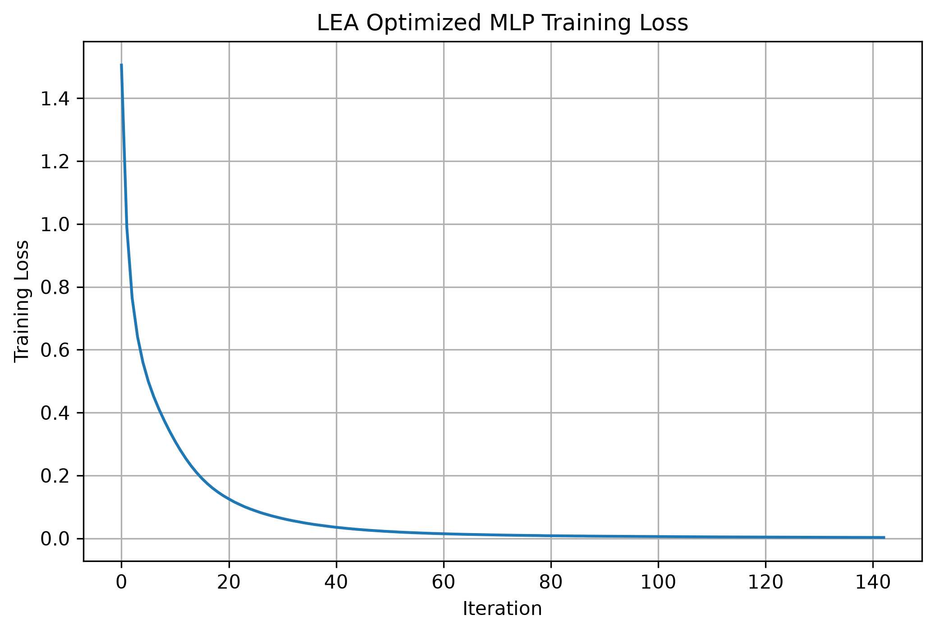
The LEA training-loss curve begins at approximately 1.5 and decreases rapidly during the first several iterations. The loss falls below 0.2 at approximately iteration 15 and continues to decline gradually. After approximately 40 iterations, the loss becomes very small and remains close to zero during the remainder of training. The curve shows a smooth convergence pattern for the optimized two-layer tanh network.

4.6.6 TLBO Results
The TLBO optimized MLP achieved an accuracy of 0.9980, precision of 0.9980, recall of 0.9980, and F1-score of 0.9980. The final model required 5.66 seconds for training, while TLBO required 1,327.98 seconds for optimization. Pasted text Pasted text
The class-wise results remained very high. Classes 0 and 2 achieved F1-scores of 1.00. Class 1 achieved an F1-score of 0.98, Class 3 achieved 0.99, and Class 4 achieved 0.97. Pasted text
The confusion matrix shows that most observations were correctly classified. Class 0 had no misclassifications, while Class 2 had only one observation assigned to Class 3. The remaining errors were concentrated among the lower-frequency Classes 1, 3 and 4. Pasted text
The TLBO optimization progression showed an improvement from 0.9968 in Generation 1 to 0.9970 in Generation 2, after which the best F1-score remained at 0.9970 through Generations 3–5. Pasted text
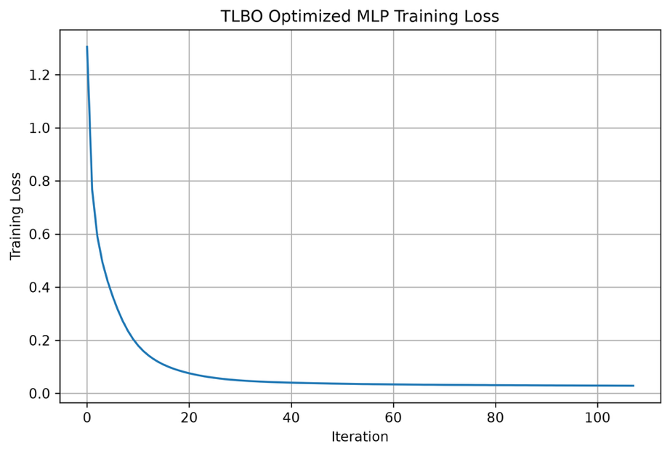
The TLBO training-loss curve begins at approximately 1.3 and decreases sharply during the first few iterations. The loss falls below 0.2 within approximately 10 iterations and then continues to decrease toward a very low value. After approximately 40 iterations, the curve becomes relatively stable, with only small changes during the remaining training iterations. This indicates stable convergence of the selected (32,16) tanh configuration.
The consolidated Phase 2 comparison is shown below. The values are taken directly from the final comparison output generated by the experiment. Pasted text
Method | Accuracy | Precision | Recall | F1 Score | Optimization Time (s) | Training Time (s)
Baseline MLP | 0.9959 | 0.9960 | 0.9959 | 0.9959 | 0.00 | 4.21
Random Search | 0.9965 | 0.9965 | 0.9965 | 0.9964 | 21.81 | 3.41
Bayesian Optimization | 0.9975 | 0.9975 | 0.9975 | 0.9975 | 23.69 | 3.47
Hyperband | 0.9942 | 0.9942 | 0.9942 | 0.9942 | 0.61 | 1.80
LEA | 0.9985 | 0.9985 | 0.9985 | 0.9985 | 600.52 | 6.04
TLBO | 0.9980 | 0.9980 | 0.9980 | 0.9980 | 1327.98 | 5.66
The results show that the baseline MLP already achieved a very high F1-score of 0.9959. Random Search increased the F1-score slightly to 0.9964, while Bayesian Optimization achieved 0.9975. Hyperband produced an F1-score of 0.9942, which was lower than the baseline. The LEA and TLBO approaches achieved F1-scores of 0.9985 and 0.9980, respectively. Pasted text
The optimization times show a substantial difference between the methods. Hyperband required only 0.61 seconds, while Random Search and Bayesian Optimization required 21.81 and 23.69 seconds, respectively. LEA required 600.52 seconds, and TLBO required 1,327.98 seconds. Thus, the population-based methods involved considerably higher optimization costs in this experiment. Pasted text
The training-loss visualizations show that all six MLP configurations converged toward low training loss. The largest reduction generally occurred during the early iterations, followed by a gradual stabilization of the curves. Therefore, the optimization methods mainly affected the selected hyperparameter configuration and final predictive performance rather than changing the overall convergence pattern of the MLP training process.
Overall, the Phase 2 results show that the Appliance Energy Prediction classification task was already highly predictable using the baseline MLP. The optimized models produced relatively small changes in predictive performance, with the reported test F1-score ranging from 0.9942 to 0.9985 across the baseline and optimization methods. At the same time, the computational cost of the optimization procedures varied substantially, particularly for LEA and TLBO. This provides an important basis for comparing predictive improvement against optimization cost in the later cross-dataset analysis.

5. Discussion

5.1 Overall Discussion
The experimental results demonstrate that the effectiveness of hyperparameter optimization depends strongly on the characteristics of the dataset and the underlying prediction task. The study evaluated conventional optimization approaches, including Random Search, Bayesian Optimization and Hyperband, together with metaheuristic approaches such as Learning Evolutionary Algorithm (LEA), Teaching-Learning-Based Optimization (TLBO), Simulated Annealing (SA), and Differential Evolution (DE). The experiments were organized progressively so that baseline performance could first be established before optimization strategies and, where necessary, additional modelling approaches were investigated.
Across the datasets, the baseline models already achieved substantially different levels of performance. In some cases, such as Smart Grid Stability and Appliance Energy Prediction, the baseline MLP achieved very high predictive performance. For Smart Grid Stability, the baseline accuracy was 97.40%, while the highest optimized accuracy was 97.55%. This represented only a 0.15 percentage-point improvement despite substantially higher optimization costs for the population-based methods. Consequently, further optimization was not continued for this dataset because the observed improvement was limited relative to the computational effort.
A similar behaviour was observed for the Appliance Energy Prediction dataset. The baseline MLP achieved an F1-score of 0.9959, while the optimized models produced F1-scores between 0.9942 and 0.9985. Although LEA and TLBO produced small improvements over the baseline, their optimization times were considerably higher. This demonstrates that a higher final predictive score does not necessarily imply a more computationally efficient optimization strategy.
The Water Potability and Solar Flare experiments demonstrated a different issue. In these datasets, aggregate performance measures did not always reflect the behaviour of individual classes. The Water Potability dataset contained an imbalance between Potable and Non-Potable observations, while the Solar Flare dataset exhibited substantially stronger imbalance, particularly for the rare flare categories. The Solar Flare experiments showed that improvements in weighted metrics did not necessarily result in satisfactory recognition of minority classes. This motivated the introduction of SMOTENC and subsequent controlled optimization experiments.
The Energy Efficiency dataset also demonstrated the importance of dataset-specific modelling decisions. The original dataset was a regression problem, requiring the continuous Heating Load and Cooling Load variables to be transformed into meaningful energy-demand categories before classification could be performed. After this transformation, the baseline MLP already achieved approximately 96.75% performance, and subsequent optimization produced little consistent improvement. This indicated that extensive additional optimization was not necessary for that dataset.
The Electricity dataset introduced temporal and sequential characteristics that differed from the other benchmark datasets. Consequently, temporal relationships, target transitions and feature-target relationships were examined during the experimental process before model optimization. This demonstrated that the same optimization procedure cannot necessarily be interpreted independently of the structure of the underlying dataset.

5.2 Comparison of Optimization Strategies
The experiments show that the optimization methods behaved differently in terms of predictive performance, convergence and computational cost. Random Search provides a relatively simple mechanism for exploring the predefined search space, while Bayesian Optimization uses information from previous evaluations to guide subsequent trials. Hyperband additionally incorporates resource allocation by allowing promising configurations to receive greater training resources.
The metaheuristic methods, including LEA, TLBO and SA, introduced population-based or iterative search mechanisms. These methods were capable of identifying strong configurations in several experiments, but their computational requirements were often considerably higher. The results therefore indicate that optimizer comparison should not be based solely on the final predictive metric.
This observation was particularly important in the later controlled-budget experiments. The experimental framework introduced equal computational resource budgets so that optimization methods could be compared under more comparable conditions. This approach reduced the possibility that an optimizer would appear stronger simply because it was allowed to perform substantially more computational work.

5.3 Predictive Performance Versus Computational Cost
One of the main observations from the experiments is the trade-off between predictive improvement and optimization cost.
In several datasets, optimization produced only small improvements because the baseline model was already close to its achievable performance within the selected experimental setting. In these cases, additional optimization required considerably more computational resources without producing a proportionally large predictive gain.
This was particularly evident for Smart Grid Stability and Appliance Energy Prediction. For Smart Grid Stability, LEA and TLBO improved the baseline accuracy from 97.40% to 97.55%, but their optimization times were approximately 943 seconds and 3,626 seconds, respectively. For Appliance Energy Prediction, LEA and TLBO also required substantially more optimization time than Random Search, Bayesian Optimization and Hyperband.
These observations support the use of multiple evaluation dimensions rather than accuracy or F1-score alone. Optimization time and convergence behaviour provide additional information about whether a method reaches a useful configuration efficiently.

5.4 Effect of Class Imbalance
Class imbalance was an important factor in interpreting the results of the Water Potability and Solar Flare datasets.
The Solar Flare experiments particularly demonstrated that weighted metrics can be dominated by the majority class. Although optimization could improve overall or weighted performance, the minority flare classes continued to show weak precision, recall and F1-score. This motivated the introduction of SMOTENC in subsequent experimental phases.
The results therefore demonstrate that model optimization and class-imbalance handling represent different aspects of the modelling problem. Hyperparameter optimization alone does not necessarily solve poor minority-class recognition. Evaluation using Macro F1 and class-specific metrics is therefore necessary when the target distribution is highly uneven.

5.5 Importance of Controlled Experimental Comparison
The results also demonstrate the importance of maintaining a consistent experimental framework. The study used common evaluation principles wherever possible, including fixed train-test partitions, standardized preprocessing, cross-validation during optimization, and independent test evaluation.
The later resource-controlled experiments were particularly important because different optimization algorithms naturally require different numbers of model evaluations. Comparing their final scores without considering computational expenditure could therefore lead to an incomplete interpretation.
The phased structure also allowed the experimental procedure to adapt to the characteristics of individual datasets. Where baseline performance was already high and optimization gains were negligible, further phases were not pursued. Where specific limitations were identified, such as class imbalance or temporal behaviour, additional experiments were introduced.

6. Conclusion and Future Work

6.1 Conclusion
This thesis investigated the behaviour of automated and metaheuristic hyperparameter optimization strategies for machine learning model development across multiple benchmark datasets. The experimental framework was designed as a sequence of phases, beginning with dataset analysis and baseline modelling and progressing toward hyperparameter optimization, extended modelling strategies, and controlled resource-based comparisons.
The experiments demonstrated that optimization can improve predictive performance, but the magnitude of improvement depends strongly on the characteristics of the dataset and the quality of the baseline model. When the baseline model already achieved high predictive performance, additional optimization generally resulted in only incremental improvements.
The experiments also demonstrated that predictive performance alone is insufficient for evaluating optimization algorithms. Optimization time, convergence behaviour and computational resource consumption provide important additional information. Some methods achieved small performance improvements but required substantially more computational effort.
The Solar Flare and Water Potability experiments further showed the importance of class-specific evaluation when datasets are imbalanced. High weighted performance can coexist with weak recognition of minority classes. Therefore, Macro F1, class-specific precision and recall, and confusion matrices were important components of the evaluation.
The controlled-budget experiments provided an additional perspective by comparing optimization methods under comparable computational expenditure. This helped distinguish improvements resulting from the optimization strategy from improvements resulting primarily from greater computational resources.
Overall, the study demonstrates that there is no single optimization strategy that behaves identically across all machine learning problems. The appropriate optimization approach depends on the dataset characteristics, baseline performance, computational resources and evaluation objective. The experimental framework developed in this thesis provides a systematic approach for examining these factors together.

6.2 Future Work
Several directions can be considered for extending the work.
First, repeated experimental runs could be introduced.
The current experiments use controlled random states for reproducibility. Future studies could repeat each experiment using multiple random seeds to quantify variability in optimization performance and convergence.
Second, statistical significance testing could be incorporated.
Future experiments could use repeated cross-validation and statistical tests to determine whether observed differences between optimization strategies are statistically meaningful rather than resulting from experimental variation.
Third, multi-objective optimization could be investigated.
The current experiments primarily consider predictive performance during optimization, while computational cost is evaluated separately. Future work could explicitly optimize multiple objectives simultaneously, such as maximizing F1-score while minimizing optimization time or the number of model evaluations.
Fourth, hybrid optimization strategies could be explored.
The experimental framework could be extended by combining complementary approaches, for example using a population-based method for broad exploration followed by Bayesian Optimization for local refinement.
Fifth, larger and more complex datasets could be evaluated.
The current study focuses on benchmark tabular datasets. Future research could investigate larger datasets and more computationally demanding machine learning problems to determine whether the observed optimization behaviour remains consistent at greater scale.
Finally, explainability and model stability could be incorporated into the evaluation.
Future experiments could investigate whether different optimized configurations produce stable feature importance patterns and whether optimization changes the interpretability of the resulting models.

7. References
7. References
[1] Feurer, M., Klein, A., Eggensperger, K., Springenberg, J., Blum, M., & Hutter, F. (2015). Efficient and Robust Automated Machine Learning. Advances in Neural Information Processing Systems, 28.
[2] Bergstra, J., & Bengio, Y. (2012). Random Search for Hyper-Parameter Optimization. Journal of Machine Learning Research, 13, 281–305.
[3] Snoek, J., Larochelle, H., & Adams, R. P. (2012). Practical Bayesian Optimization of Machine Learning Algorithms. Advances in Neural Information Processing Systems, 25.
[4] Li, L., Jamieson, K., DeSalvo, G., Rostamizadeh, A., & Talwalkar, A. (2017). Hyperband: A Novel Bandit-Based Approach to Hyperparameter Optimization. Journal of Machine Learning Research, 18(185), 1–52.
[5] Storn, R., & Price, K. (1997). Differential Evolution – A Simple and Efficient Heuristic for Global Optimization over Continuous Spaces. Journal of Global Optimization, 11, 341–359.
[6] Kirkpatrick, S., Gelatt, C. D., & Vecchi, M. P. (1983). Optimization by Simulated Annealing. Science, 220(4598), 671–680.
[7] Rao, R. V., & Patel, V. (2012). Multi-Objective Optimization of Heat Exchangers Using a Modified Teaching-Learning-Based Optimization Algorithm. Applied Mathematical Modelling, 36(9), 4124–4135.
[8] Chawla, N. V., Bowyer, K. W., Hall, L. O., & Kegelmeyer, W. P. (2002). SMOTE: Synthetic Minority Over-Sampling Technique. Journal of Artificial Intelligence Research, 16, 321–357.
[9] MacQueen, J. (1967). Some Methods for Classification and Analysis of Multivariate Observations. In Proceedings of the Fifth Berkeley Symposium on Mathematical Statistics and Probability, 281–297.
[10] Kohavi, R. (1995). A Study of Cross-Validation and Bootstrap for Accuracy Estimation and Model Selection. In Proceedings of the 14th International Joint Conference on Artificial Intelligence, 1137–1143.
[11] Pedregosa, F., Varoquaux, G., Gramfort, A., et al. (2011). Scikit-learn: Machine Learning in Python. Journal of Machine Learning Research, 12, 2825–2830.
[12] Akiba, T., Sano, S., Yanase, T., Ohta, T., & Koyama, M. (2019). Optuna: A Next-generation Hyperparameter Optimization Framework. In Proceedings of the 25th ACM SIGKDD International Conference on Knowledge Discovery & Data Mining, 2623–2631.
[13] Tsanas, A., & Xifara, A. (2012). Accurate Quantitative Estimation of Energy Performance of Residential Buildings Using Statistical Machine Learning Tools. Energy and Buildings, 49, 560–567.
[14] Candanedo, L. M., Feldheim, V., & Deramaix, D. (2017). Data Driven Prediction Models of Energy Use of Appliances in a Low-Energy House. Energy and Buildings, 140, 81–97.
[15] UCI Machine Learning Repository. Water Potability Dataset. University of California, Irvine, Machine Learning Repository.
[16] UCI Machine Learning Repository. Solar Flare Dataset. University of California, Irvine, Machine Learning Repository.
[17] UCI Machine Learning Repository. Electrical Grid Stability Simulated Dataset. University of California, Irvine, Machine Learning Repository.

8. Appendices
The appendices should contain material that supports the reproducibility of the experiments but would make the main chapters unnecessarily long.
For your thesis, I would structure them like this:

Appendix A – Dataset Information
Include the detailed dataset information that is too extensive for the main methodology chapter, such as:
- Complete feature descriptions
- Dataset sources
- Dataset dimensions
- Target-class definitions
- Original versus transformed targets

Appendix B – Experimental Configuration
Include the detailed hyperparameter search spaces and configurations used in the experiments.
For example:
Parameter | Values
Hidden layers | (16,), (32,), (64,), (32,16), (64,32)
Activation | ReLU, tanh
Learning rate | 0.0001, 0.001
Alpha | 0.0001, 0.001, 0.01
Batch size | 32, 64, 128

Appendix C – Detailed Experimental Results
Include the complete result tables that are too large for Chapter 4, such as:
- Complete optimizer comparison tables
- Class-wise precision/recall/F1 results
- Confusion matrices
- Optimization times
- Training times
- Cross-validation results
- Convergence values

Appendix D – Additional Visualizations
Include supplementary figures that are not essential to understanding the main results, such as:
- Additional training-loss curves
- Optimization convergence plots
- Additional feature distributions
- Correlation matrices
- PCA visualizations
- Hyperparameter search plot

