The Naylor Model · v14
Base-stealing skill that sprint speed hides — audited, re-specified, and fit era by era
BOTTOM LINE Josh Naylor stole 30 bases at 94% in 2025 while running slower than 98% of the league. That is not luck and it is not speed — it is ground won before the throw. v14 keeps every published number from v11 and adds what a critical audit demanded: the three redundant features are gone, the odds calculator was re-specified by measurement rather than by intuition, every accuracy figure is now printed beside the floor it has to beat, and the model is fit separately on each side of the 2023 rule change instead of averaging across it.

1 · Three numbers, in the order they happen
The single most common confusion with this model is treating ground gained and Burst as the same statistic. They are the same measurement at two different baselines, and the order below is the order the events actually occur on the field.
# | Metric | What it answers | Units / zero point
1 | Ground gained  (the raw measurement) | Feet the runner wins from the pitcher's FIRST MOVE until the pitch reaches the catcher. Measured before any throw and before any outcome. | feet · no zero point;  it is a raw distance
2 | Burst  (the same thing, speed-adjusted) | Ground gained MINUS what a runner of that exact sprint speed typically gains. This is the fair cross-runner comparison — the coachable jump. | feet above/below  the speed-predicted line
3 | Steal+  (the headline) | Net bases (SB − CS) above what an average runner of that sprint speed would produce over the same number of attempts. Volume-aware. | bases above the  same-speed average
Steps 1 and 2 happen on a single pitch. Step 3 is a season total. All three are speed-neutral by construction except step 1, which deliberately is not.
Ground gained is the strongest single lever in the per-attempt model — each extra foot on a given pitch multiplies the odds of being safe by about 1.36×. But it is NOT speed-neutral: it correlates −0.49 with sprint speed, because slower runners take bigger secondary leads and break earlier. Burst removes exactly that, and correlates 0.00 with sprint speed. Section 5 draws the line being subtracted.

2 · Why the distinction matters — a worked contrast
Runner | Sprint speed | Ground gained | Burst | How to read it
Josh Naylor '25 | 24.4 ft/s | 16.7 ft — the most in the pool | +1.6 ft | Wins the most raw ground of anyone. He is also slower than 98% of the league, and slow runners are EXPECTED to gain more.
Corbin Carroll '23 | 30.1 ft/s | 12.8 ft | +2.7 ft | Less raw ground, but at 30.1 ft/s the expectation is far lower. The harder feat, and the better jump.
Rank by raw ground gained and Naylor's jump looks better than Carroll's. Rank by Burst — which accounts for what each runner's speed already buys — and Carroll's is better. Both columns are shown on every leaderboard row so the adjustment is never hidden.
Naylor 2025 for reference: Steal+ +12.0 (99th percentile), ground gained 16.7 ft, Burst +1.6 ft (86th), on 30 SB / 2 CS from 24.4 ft/s.

3 · Steal+ — and why a caught stealing costs about 4×
Steal+ takes a runner's net bases (SB − CS) and subtracts what an average runner of his exact sprint speed would produce over the same number of attempts. Rearranged, the whole metric is one line:
Steal+ = 2 (1 − p) × SB − 2p × CS
where p is the success rate expected from that runner's sprint speed alone. At a typical p ≈ 0.80 that makes each stolen base worth +0.4 bases and each caught stealing −1.6 — a caught stealing erases about four clean steals. Because p is speed-derived, the penalty tightens as a runner gets faster: the league expects more of him, so his mistakes cost more. The identity Net Bases = NetSpeed + Steal+ closes exactly (to under 1e-9) on every subsample tested.

4 · The leaderboard
Top 15 by Steal+, 2023–2026, minimum 15 attempts, out of 452 qualified runner-seasons. Ground gained and Burst are shown adjacent so the speed adjustment is visible on every row.
Player | Yr | Tm | Speed | SB–CS | Net | Steal+ | Ground | Burst
Shohei Ohtani | 2024 | LAD | 28.1 | 59–4 | 55 | +18.2 | 10.4 | -1.4
CJ Abrams | 2023 | WSH | 28.6 | 47–4 | 43 | +12.6 | 10.2 | -1.2
Maikel Garcia | 2024 | KC | 27.9 | 37–2 | 35 | +12.4 | 13.1 | +1.1
Josh Naylor | 2025 | SEA | 24.4 | 30–2 | 28 | +12.0 | 16.7 | +1.6
Corbin Carroll | 2023 | AZ | 30.1 | 54–5 | 49 | +11.8 | 12.8 | +2.7
Juan Soto | 2025 | NYM | 25.8 | 38–4 | 34 | +11.6 | 14.2 | +0.3
Trea Turner | 2023 | PHI | 30.3 | 30–0 | 30 | +11.0 | 13.6 | +3.7
Trevor Story | 2025 | BOS | 28.6 | 31–1 | 30 | +10.9 | 11.4 | -0.0
Brice Turang | 2024 | MIL | 29.3 | 50–6 | 44 | +9.7 | 10.9 | +0.2
Byron Buxton | 2025 | MIN | 30.2 | 24–0 | 24 | +8.8 | 10.0 | +0.0
Freddie Freeman | 2023 | LAD | 26.7 | 23–1 | 22 | +8.7 | 12.1 | -1.0
Josh Lowe | 2024 | TB | 28.4 | 25–1 | 24 | +8.6 | 12.8 | +1.2
Ronald Acuña Jr. | 2023 | ATL | 28.0 | 73–14 | 59 | +8.3 | 12.3 | +0.4
Josh Lowe | 2023 | TB | 28.7 | 32–3 | 29 | +8.1 | 12.2 | +0.9
CJ Abrams | 2025 | WSH | 28.2 | 31–3 | 28 | +8.0 | 11.0 | -0.8
Note how Ground and Burst disagree. Ohtani leads Steal+ outright while sitting BELOW the speed-expected ground line (Burst −1.4) — he is a volume producer, not a technician. Naylor is the reverse read. That disagreement is the point of carrying both.

5 · The two league baselines — how to read the slopes
WHAT IT ACHIEVES This figure was previously three unlabelled lines with axis-name titles, and a reader had no way to answer either question it raises: what is it for, and what does a slope mean. Both are now written onto the figure. It matters because these two lines are the ONLY two things the model subtracts — Burst is the vertical gap from the left line, Steal+ is built on the right one. Neither metric can be checked without seeing them.
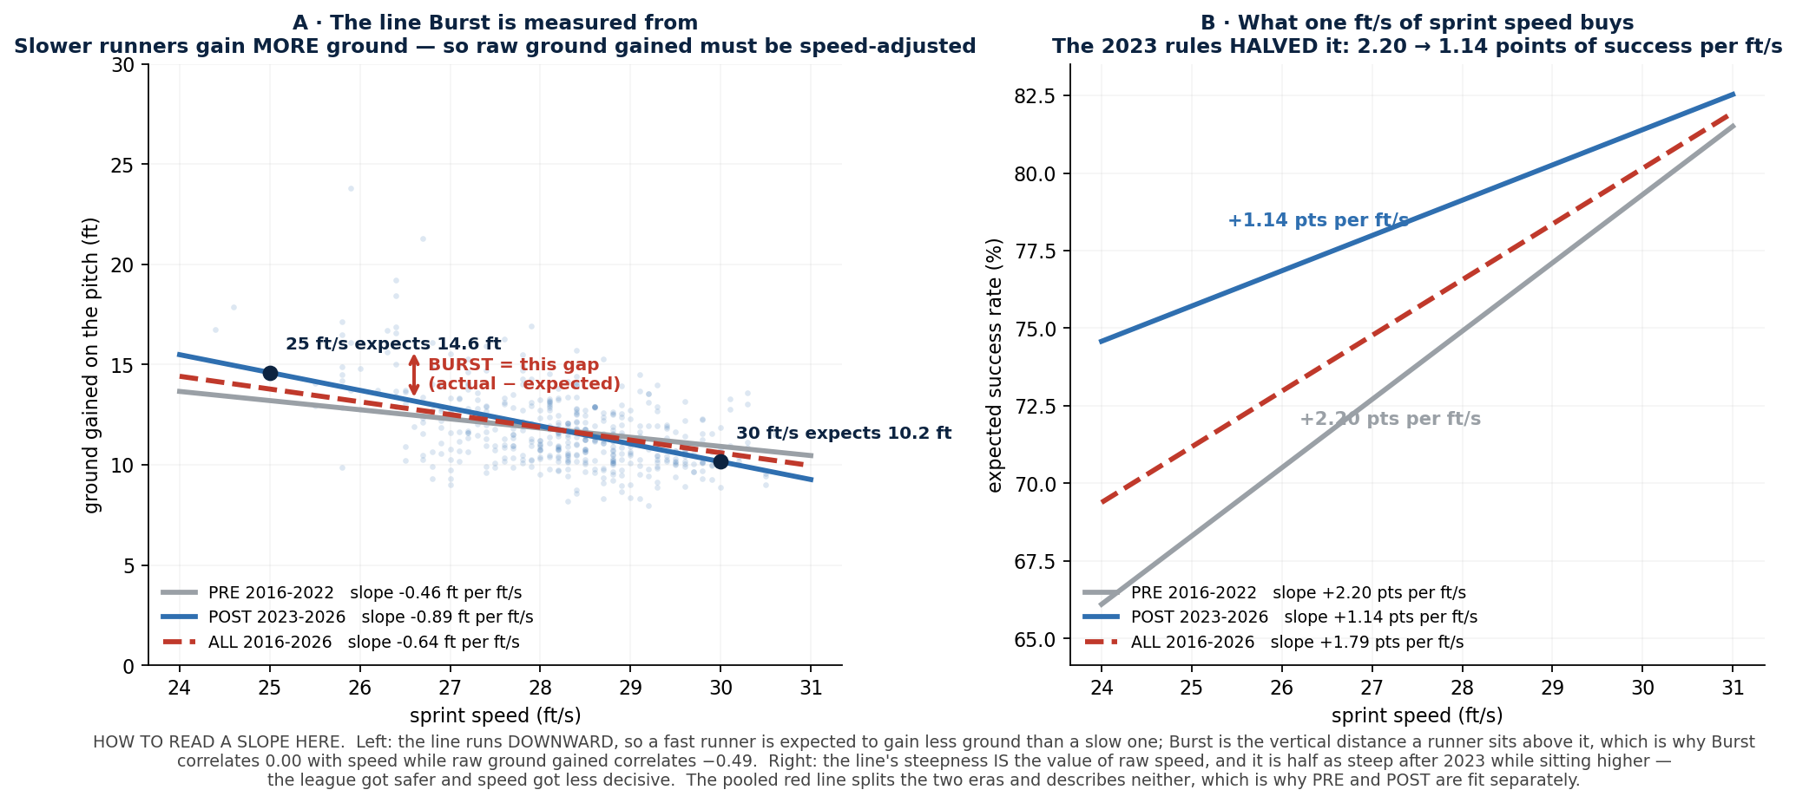
Panel | The slope is | In plain words | Why it is there
A — ground vs speed | b₁ = −0.89 ft per ft/s  (post-2023) | Every extra 1 ft/s of sprint speed comes with 0.89 FEWER feet of ground gained. A 25 ft/s runner is expected to gain 14.6 ft; a 30 ft/s runner only 10.2 ft. | Because the slope is negative, raw ground gained is partly a SLOW-runner statistic. Burst is the distance a runner sits above this line, which is why Burst correlates 0.00 with speed while ground gained correlates −0.49.
B — success vs speed | a₁ = +2.20 → +1.14 pts  per ft/s (PRE → POST) | One extra ft/s bought 2.20 percentage points of success before 2023 and only 1.14 after. The line is also HIGHER post-2023 (league 76.4% → 80.4%). | The steepness IS the price of raw speed, and the 2023 rules roughly halved it while lifting everyone's floor. This is the strongest single argument in the project against pooling the eras.
The pooled (red, dashed) line in both panels splits the two eras and describes neither — it is drawn to make that claim falsifiable rather than asserted. Section 6 prices it.

6 · Three eras, fit separately
The same v11 code is run on three pools under one common qualification gate (≥10 attempts, so the eras are actually comparable). The published leaderboard is the POST column and is unchanged.
Era | Seasons | Runner-seasons | League SB% | Success line  p = a₀ + a₁·speed | Ground line  ground = b₀ + b₁·speed | corr(Burst,  speed)
PRE | 2016-2022 | 690 | 76.4% | 0.133 + 0.02200·s | 24.63 − 0.4569·s | +0.00
POST | 2023-2026 | 452 | 80.4% | 0.473 + 0.01136·s | 36.84 − 0.8893·s | -0.00
ALL | 2016-2026 | 1142 | 78.1% | 0.263 + 0.01794·s | 29.69 − 0.6363·s | -0.00
WHY NOT JUST POOL THEM Pooling the eras is shown and then rejected on a measured cost, not on principle. Scoring the modern pool with the pooled fit barely moves the ranking (Spearman 0.994) — but Burst stops being speed-neutral (correlation with sprint speed 0.00 → −0.159) and modern Steal+ shifts +0.98 bases on average, up to +4.46 for one runner. That happens because 60% of the pooled rows are pre-2023, so a modern runner ends up scored against a league that never existed. PRE and POST are therefore fit separately, and the site's era dropdown switches between them rather than blending them.

7 · The odds calculator, re-specified by measurement
The v11 calculator took sprint speed, Burst and ground gained. v14 replaces Burst with the catcher's pop time, and splits the runner's lead into the two independent quantities that actually exist on the pitch. This was decided by measuring the alternatives, not by argument — and it contradicts the original brief, which proposed keeping Burst.
Specification | n attempts | CV AUROC | Verdict
A — v11: speed + Burst + ground gained | 7,404 | 0.7259 | the shipped v11 calculator
F — speed + Burst + first-move lead + gain + pop | 7,264 | 0.7470 | better, but still gated by Burst
H — speed + first-move lead + gain + pop (no Burst) | 10,844 | 0.7559 | SHIPPED in v14 — wins on both axes
Burst requires a QUALIFIED runner-season (≥10 attempts) to exist at all, so including it discards roughly 3,600 attempts. Removing it gained both sample and accuracy. Adding catcher arm strength on top of pop time added nothing (0.7464 vs 0.7470) and was left out. The measurement says Burst belongs as a SEASON-level metric — speed-neutral, year-to-year 0.48, the most repeatable thing in the model — but not as a per-pitch input once you already know what the runner gained on that pitch.
Input the user sets | Coefficient | Odds effect | What it means
Sprint speed | +0.317 | 1.37× per +1 ft/s | raw wheels, still real but no longer dominant
Lead at first move (ft) | +0.069 | 1.07× per +1 ft | where he already was when the pitcher committed
Ground gained from there (ft) | +0.303 | 1.35× per +1 ft | the coachable part — the strongest per-foot lever
Catcher pop time (s) | +5.858 | 1.80× per +0.10 s | a slower catcher; the largest single swing in the tool
Plain logistic regression, 5-fold CV AUROC 0.7559 on 10,844 attempts. Logistic was kept over XGBoost because it BEAT it on these features (0.7259 vs 0.7215 on the v11 spec) and stays a formula a coach can read. Max VIF across the four inputs: 1.21.

8 · Model scorecard — every number beside the floor it has to beat
WHAT CHANGED Publishing AUPRC without its no-skill floor was a genuine reporting failure in earlier versions. At an 81% base rate an AUPRC of 0.939 reads as excellent and is in fact a modest lift over 0.811. Worse, v13's F1 at the default 0.5 threshold is exactly 0.000 — at a 2.3% base rate no prediction ever crosses 0.5, so that number was vacuous. Both are now printed with context every time.
Model | What it answers | Algo | n | Base rate  (AUPRC floor) | AUROC | AUPRC | Brier | F1 (thr)
v14 calculator | will THIS attempt be safe? | Logistic | 10,844 | 0.809 | 0.7559 | 0.9256 | 0.1359 | 0.894 (.16)
v12 per-attempt | same, with full pitch context | XGBoost | 11,140 | 0.811 | 0.7829 | 0.9387 | 0.1295 | 0.896 (.35)
v12 — forward split | trained past → tested next season | XGBoost | 8,075 | 0.803 | 0.7633 | 0.9296 | 0.1382 | 0.892 (.28)
v13 decision | will he ATTEMPT at all? | XGBoost | 555,092 | 0.023 | 0.7797 | 0.0753 | 0.0218 | 0.136 (.07)
classic (2015–22) | same as v14, pre-rule-change | Logistic | 15,036 | 0.750 | 0.7459 | — | — | —
AUPRC must be read against the base rate in the same row. v13's 0.0753 against a 0.023 floor is a 3.3× lift on a genuinely hard problem; v12's 0.9387 against 0.811 is a much smaller one. F1 is quoted at its tuned threshold, with the threshold shown, never at 0.5 alone.
The forward split is the honest number for anything forward-looking: train on past seasons, test on the next one. v12 loses about 0.020 AUROC that way (0.7829 → 0.7633), which is the cost of not being allowed to see the future. It is reported alongside the headline rather than instead of it.

9 · What the audit found — and fixed
Defect | What was wrong | Fix in v14 | Effect
Exact linear dependency  (v12 leads) | lead_at_release = lead_at_firstmove + gain_to_release to R² = 0.999895 — the residual caps at 0.1 ft, which is just the rounding granularity. VIF 1,588 / 5,836 / 9,532. | Dropped lead_at_release. The two INDEPENDENT quantities are kept: where he already was, and how much he gained from there. | Predictions barely moved (−0.0014 AUROC). But feature importance was being split arbitrarily across perfectly dependent columns, so the importance chart was not quotable. Now it is. Max VIF 1.14.
Dummy-variable trap  (v12 / v13 pitch class) | All three pitch-class dummies were carried, and they sum to 1 on 99.94% of rows. VIF 561 on pc_fastball. | pc_fastball made the reference category and omitted. | Coefficients become interpretable relative to a fastball.
Burst / ground gained  — the FALSE alarm | Suspected collinearity in the calculator. | Measured: VIF 1.08 / 1.19 / 1.24, condition number 1.61. They correlate only 0.371 at the PITCH grain (the 0.87 figure quoted elsewhere is the SEASON grain — a different pair). | No collinearity problem existed here. Burst was still removed from the calculator, but for sample size and accuracy (§7), not for collinearity.
Metric reporting | AUPRC published with no floor; F1 quoted at 0.5 where it is structurally 0.000. | Floors and tuned thresholds printed everywhere, and written into the result CSVs. | §8. No number now reads better than it is.
Every one of these was a presentation or interpretability defect rather than a predictive one — no published Steal+, Burst or leaderboard value changed. That is worth stating plainly: the audit did not overturn the model's findings, it made them defensible.

10 · How any of this is verified
score() is written as a pure function of the frozen league fit. So scoring five random runner-seasons ON THEIR OWN must return byte-identical numbers to scoring those same five inside the full pool. Any statistic computed within-batch — a percentile ranked against whoever happens to be in the dataframe, a mean taken over the scored rows — breaks that equality immediately. Run over 200 random draws per era, it is a standing leak detector.
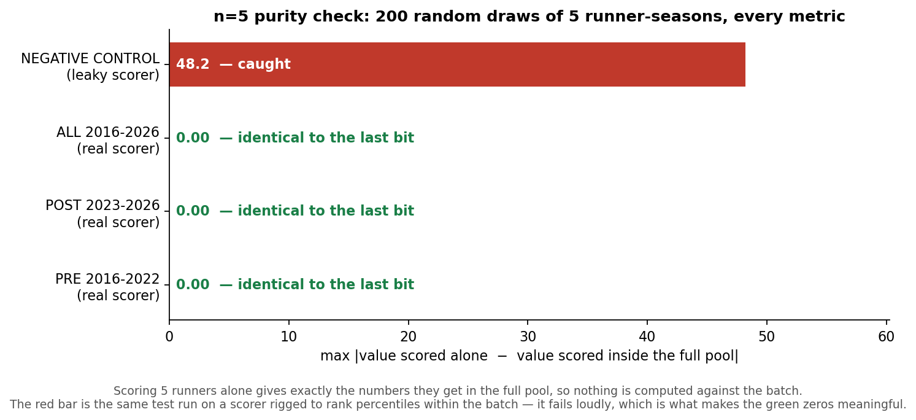
THE NEGATIVE CONTROL A test that always returns zero is worthless unless you can show it would catch the thing it is meant to catch. The red bar is the identical test run against a scorer deliberately rigged to rank percentiles within the batch — it fails at 48.2, which is what makes the green zeros mean anything.
Guard | What it asserts | Current result
n=5 purity | 5 rows scored alone = the same 5 scored in the full pool, over 200 draws × 3 eras | 0.00e+00 — identical to the last bit
Negative control | the purity check must FAIL on a deliberately leaky scorer | caught at 48.2, then clean at 0.0 once restored
Leak audit | no outcome-derived column (11 denied names) ever reaches a feature list | all 11 absent from every pool
Collinearity guard | max VIF < 10 across every shipped feature set — asserted, not printed | 1.14 · 6.63 · 1.21 — all pass
Decomposition invariant | Net Bases = NetSpeed + Steal+ on every subsample | closes to < 1e-9
The collinearity guard is new in v14 and was added because nothing in the pipeline noticed the v12 dependency. On its first run it independently caught two of the three defects in §9.

11 · Validation — including the tests the model loses
BOTTOM LINE Every claim here is tested, including the ones that go against the model. Steal+ and Burst are both speed-neutral by construction; Steal+ describes production, Burst describes repeatable technique; and Net Bases Gained still wins the raw next-year volume question, which is conceded rather than buried.
Question | Net Bases | Steal+ | Burst | Verdict
corr with sprint speed (0 = pure skill, not wheels) | +0.29 | -0.01 | -0.00 | Steal+ and Burst are speed-neutral
describes net steals (SB−CS), same season | — | +0.64 | +0.08 | Steal+ is the production read
describes success rate, same season | — | +0.89 | +0.15 | Steal+ tracks efficiency
predicts NEXT-YEAR net steals | +0.38 | +0.17 | +0.09 | Net Bases wins volume — conceded
predicts NEXT-YEAR success rate | +0.16 | +0.23 | +0.04 | Steal+ wins skill
year-over-year self-stability (repeatable?) | +0.38 | +0.19 | +0.48 | Burst is the most repeatable thing here
n = 224 runner-season pairs for the year T → T+1 rows. Correlations, not R².
Steal+ and Burst are near-orthogonal (r ≈ 0.15), so they are reported separately rather than averaged. A v10 'Steal Grade' did average their percentiles and was dropped: it predicted net steals and success rate no better than Steal+ alone, and it mis-ranked pure producers — Ohtani graded around 109th in the season he led Steal+ outright. Nothing that fails to earn its place is carried forward.

12 · Where this sits
Component | Question it answers | Status in v14
Steal+ / Burst (season) | who steals well, and whose technique repeats | unchanged from v11 — 452 runner-seasons 2023–26, 690 more 2016–22
v14 calculator (per attempt) | will THIS attempt be safe? | RE-SPECIFIED — 4 inputs, +0.030 AUROC, +3,440 attempts of sample
v12 engine (per attempt) | same, with full pitch and battery context | collinearity fixed; importance chart now quotable
v13 (per opportunity) | will he attempt at all? | unchanged; metrics now reported against a 2.3% floor
Era handling | does the 2023 rule change matter? | NEW — fit separately, pooling priced and rejected
Live board, calculator, skill map and era switch: https://shunnchenn.github.io/The-Naylor-Model/
Supporting detail lives in Reports/ — v11 (the original Steal+/Burst write-up), v12 (per-attempt success), v13 (the decision model), and classic (2015–2022). This document supersedes v11 as the primary read.

