The Naylor Model · v12
The per-attempt success engine: what decides a steal, pitch by pitch
BOTTOM LINE v11 answers who steals well over a season (Steal+, Burst). v12 answers a different, sharper question — given how a runner led off on THIS pitch, did the attempt succeed? Adding who was pitching, what was thrown, and the catcher's arm lifts the model from AUROC 0.741 to 0.783, and the gain holds up under an honest train-past / test-future test (0.727 → 0.770). All 2023–2026, the Statcast lead-tracking era.

1 · The question, and the metric that fits it
The per-attempt model predicts a single binary outcome: safe or caught, for one steal attempt. It is descriptive, not a forecast — it explains what drove the attempts that happened, and it is validated out-of-fold so it never grades its own homework.
BOTTOM LINE 81% of tracked attempts succeed, so plain accuracy is useless — a model that guesses “safe” every time is 81% accurate and worthless. AUROC is the right yardstick: it asks whether a random success is ranked above a random caught stealing. Brier is reported alongside because the odds calculator states a probability, not just a ranking, and Brier is what catches over-confidence.

2 · What each added signal is worth
v11's per-attempt engine used the lead distances plus runner skill. v12 layers on three blocks that v11 knew nothing about — who was pitching, what was thrown, and the catcher's physical arm. The ablation is cumulative, top to bottom.
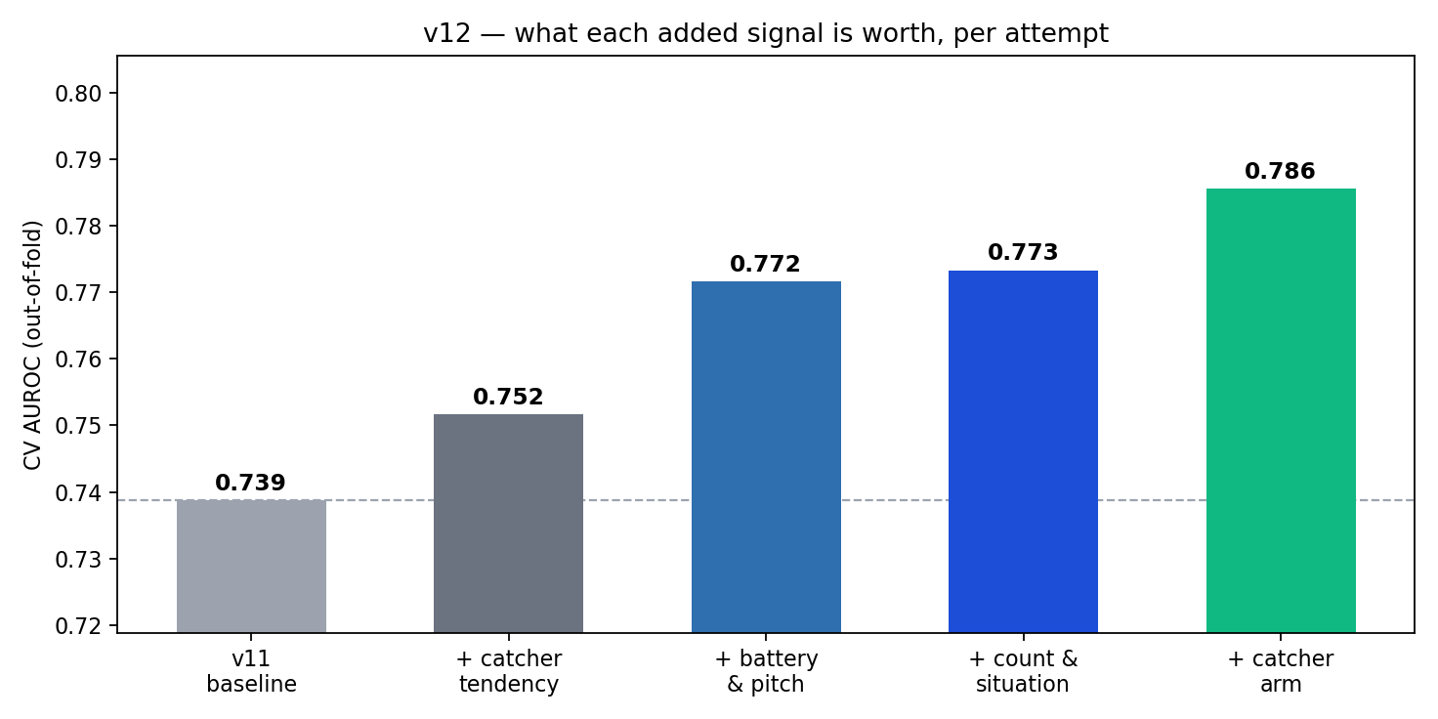
Model (cumulative) | AUROC | AUPRC | Brier
v11 baseline — leads + runner skill | 0.7388 | 0.9252 | 0.1374
v11 + catcher tendency (nested OOF) | 0.7517 | 0.9297 | 0.1356
+ 1. battery & pitch type | 0.7716 | 0.9355 | 0.1318
+ 2. count & situation | 0.7733 | 0.9361 | 0.1315
+ 3. catcher arm (pop time) | 0.7856 | 0.9399 | 0.1292
v12 SHIPPED (post-pitch count dropped) | 0.7832 | 0.9389 | 0.1294
Read alone, on top of the baseline: catcher arm is worth +0.024 AUROC, battery and pitch type +0.021, and count-and-situation essentially nothing (+0.003, and only +0.0002 once battery is already in). The predicted order was wrong — catcher arm, ranked last, is the biggest single lever. The standalone rows are kept in DF_v12_AUC.csv so that claim stays checkable.
Why the catcher and not the pitcher: 147 catchers are each seen a median of 46 times, enough to estimate a real, stable trait (pop time, arm strength); the 1,025 pitchers are seen a median of 6 times, too sparse to estimate a hold tendency — and the runner's own lead already absorbs most of the pitcher's effect, since he only goes when he likes the look.

3 · Honest validation
BOTTOM LINE The published figure came from a random 5-fold split, which is optimistic because a runner's other attempts sit in training. Reported three ways, the number essentially holds — and the forward split, the only one that mirrors real use, is the number to quote.
Validation split | AUROC | AUPRC | Brier | Rows scored
random | 0.7832 | 0.9389 | 0.1294 | 11,140
group | 0.7823 | 0.9382 | 0.1296 | 11,140
forward | 0.7676 | 0.9310 | 0.1375 | 8,075
Random 0.783, GroupKFold by runner 0.783, forward (train past → test next season) 0.770. That the three sit within 0.013 is the reassurance: the model is not leaning on runner identity leaking across the split.

4 · Calibration — and a real signal hiding in it
BOTTOM LINE In-distribution the model is well calibrated (max gap 0.041). The forward split drifts more (max 0.097) — but the cause is external, not over-confidence: the league is getting harder to steal in.
SB success by season runs 0.830 → 0.810 → 0.808 → 0.769 across 2023–2026. A model trained on the past predicts a slightly easier environment than the one it is scored in, which shows up as forward-calibration drift. Because this is a genuine base-rate shift and not model error, no isotonic correction was applied — smoothing it away would have hidden a real trend. Both reliability tables are in DF_v12_Calibration.csv.

5 · What was tried and dropped
The post-pitch count was retired. balls and strikes come from the play-by-play feed AFTER the pitch, so strikes==3 is a strikeout — not the count a coach sees when sending a runner. Dropping it costs 0.0011 AUROC (0.7840 → 0.7829) and is worth it. (v13 later recovers the TRUE pre-pitch count from pitch ordering.)
The pitcher-side running game was investigated and abandoned. Savant's basestealing-run-value leaderboard is runner-only, and its pitch-tempo leaderboard ignores the year parameter — identical data across seasons — so it cannot be used season-correctly. Computing pitcher lead-allowed from our own attempts (leave-one-out, year-correct) was worth +0.0006. Dead end, measured rather than assumed.
More season-aggregate features do nothing: adding all thirteen relevant unused columns from the SSSI table moved AUROC 0.7840 → 0.7840. The model is saturated on runner-season aggregates; the remaining signal is per-pitch.

6 · How v12 relates to v11 and v13
Version | Question | Grain | Headline
v11 | Who steals well? | runner-season | Steal+, Burst (published, unchanged)
v12 | Was this attempt safe? | steal attempt | AUROC 0.770 forward
v13 | Did he go at all? | pitch with runner on 1B | the decision / selection model
v12 changes nothing in v11 — the published Steal+/Burst leaderboard is byte-identical. It only extends the per-attempt skill engine, and only where a forward holdout confirmed the added signal transfers to an unseen season rather than merely fitting the past.

