The Naylor Model · v13
Modelling the decision to steal — not just the outcome
BOTTOM LINE Every previous version answered “was that steal safe?”, which can only be asked once a runner has already gone. v13 adds the half that was missing: of the 517,068 pitches where a runner stood on first with second base open, when did he go at all? The answer reframes the whole project — the fastest runners attempt 7× more often than the slowest, so sprint speed is spent on the decision to run, which is exactly why it looks worthless inside the success model.

1 · The gap this fills
Steal+ and Burst (v11) and the per-attempt success engine (v12) all condition on an attempt having happened. That is a survivorship problem: a runner only goes when he already likes his odds, so the sample of attempts is heavily self-selected. The clearest symptom is that sprint speed on its own predicts the outcome of an attempt at AUROC 0.53 — barely better than a coin flip — which is absurd on its face for a footrace.
The missing piece was the denominator: the pitches where a runner could have gone and did not. It had never been collected. v13 builds it from the MLB play-by-play feed, replaying the base state pitch by pitch.
Dataset | Grain | Rows | What it can answer
Raw_Attempts (v11/v12) | steal attempt | 10,366 | Was this attempt safe?
Raw_Opportunities (v13) | pitch with runner on 1B | 517,068 | Did he go at all?
Because labelling now comes from the play-by-play feed rather than Savant's tracked-attempt drawer, coverage widens from 499 runners to 917, and from 9,412 tracked attempts to 11,917.

2 · The finding: runners self-select, hard
BOTTOM LINE Attempt rate climbs monotonically with sprint speed, from 0.70% in the slowest bin to 4.87% in the fastest — a 7× spread across roughly six feet per second.
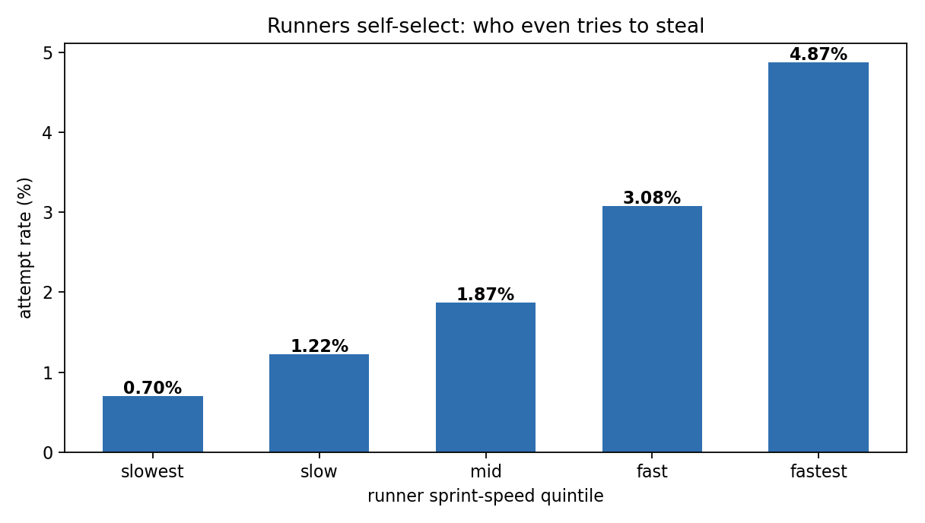
This is the selection effect, measured directly. Fast runners take the marginal chances; slow runners only go when the situation is already favourable. By the time an attempt exists in the data, speed has already done its work — which is why it adds almost nothing to a model of whether that attempt succeeded.

3 · How the speed groups are defined
BOTTOM LINE The five groups are quintiles of the OPPORTUNITY population — every pitch with a runner on first — not MLB-wide percentiles and not equal numbers of runners. Each bin therefore holds about a fifth of the 517,068 pitches, and a runner who reaches base often carries more weight.
Group | Sprint speed (ft/s) | Mean | Runner-seasons | Opportunities | Share of pitches | Attempt rate
SLOWEST | 22.1 – 26.1 | 25.39 | 225 | 102,872 | 19.9% | 0.70%
SLOW | 26.2 – 27.0 | 26.63 | 269 | 113,512 | 22.0% | 1.22%
MID | 27.1 – 27.7 | 27.39 | 277 | 98,405 | 19.0% | 1.87%
FAST | 27.8 – 28.4 | 28.09 | 273 | 100,400 | 19.4% | 3.08%
FASTEST | 28.5 – 30.6 | 29.05 | 228 | 99,055 | 19.2% | 4.87%
Read the boundaries as: slowest ≤ 26.1 ft/s, then 26.2–27.0, 27.1–27.7, 27.8–28.4, and fastest ≥ 28.5 ft/s. Runner-seasons sum to more than 917 because sprint speed is measured per season, so a player can sit in different groups in different years.
Where those speeds fall as percentiles of the same population:
Percentile | p0 | p5 | p10 | p25 | p50 | p75 | p90 | p95 | p100
Sprint speed (ft/s) | 22.1 | 25.0 | 25.6 | 26.4 | 27.3 | 28.2 | 28.9 | 29.3 | 30.6
Two cautions worth stating plainly. First, this is the population of runners who reach first base, weighted by how often they are there — its median is 27.3 ft/s, close to the MLB average, but it is not the league-wide leaderboard. Second, the label “fastest” means the top fifth of this population (≥ 28.5 ft/s), not elite MLB speed; the genuinely elite burners run above 30 ft/s and sit at the far edge of that bin.

4 · The model
A gradient-boosted classifier for P(attempt) on situation (count, outs, inning, score difference, pitcher handedness, batter side, pitch class) and personnel (runner sprint speed, and the runner's own attempt rate from PRIOR seasons only).
BOTTOM LINE Attempts are 2.30% of opportunities — the mirror image of the success model's 81% — so AUPRC against that 0.023 floor is the honest headline, with AUROC secondary. The model lands about 3× the no-skill floor, and the three validation regimes agree.
Validation split | AUPRC | No-skill floor | AUROC | Brier | Rows scored
random | 0.0765 | 0.0230 | 0.7799 | 0.0219 | 517,068
group | 0.0686 | 0.0230 | 0.7704 | 0.0220 | 517,068
forward | 0.0652 | 0.0236 | 0.7620 | 0.0225 | 361,326
“Forward” trains on past seasons and tests on the next one — the only regime that mirrors how the model would actually be used, and the number to quote. That the three sit within 0.011 of each other is the point: an earlier build had them 4× apart (see §5).

5 · What went wrong on the way, and what it still cannot do
A leak, caught by the validation spread. The runner's own attempt rate is the natural “scouting report” prior, but computing it within the season being predicted still reads that season: random AUPRC 0.2534 against 0.0606 grouped by runner, a 4× gap. Rebuilt as an expanding prior-seasons-only rate, the gap closed and forward calibration improved from a maximum 0.171 error to 0.016. This is the third time this same self-contamination pattern has appeared in the project, after the catcher/pitcher encoding in v11 and the Burst check in v12.
Two build errors caught before they shipped. A stolen base is filed as its own event AFTER the pitch it occurred on, so a naive join labelled zero attempts. And the base-state replay initially held runners on base through the third out; fixing that took reconstruction accuracy from 91.2% to 99.25%, verified against MLB's own end-of-inning state across 615,967 plate appearances.
A limitation that cannot be engineered away. The lead distances that carry essentially all of v11 and v12's signal exist only on tracked attempts — Statcast never publishes a lead for a pitch where the runner stayed. Game-theoretically the lead IS the runner's signal of intent, so the decision model is working without the very variable that would explain it best. It sees situation and personnel only. This is a property of the public data, not a modelling choice.
Catcher identity is likewise absent from the opportunity feed. Rather than fill it with a league-season average — a column that would look like a feature while carrying no per-pitch information — no catcher variable is included at all.

6 · How v13 relates to v11 and v12
Version | Question | Status
v11 | Who steals well? (Steal+, Burst) | Published metrics — unchanged
v12 | Was this attempt safe? | Per-attempt engine — unchanged, forward AUROC 0.770
v13 | Did he go at all? | New — additive, changes nothing above it
v12 was re-checked against v11 under the forward holdout before any of this was built, precisely to avoid publishing a regression: v11 baseline 0.7266 → v12 shipped 0.7704, a gain of +0.044 that is larger under the honest split than the optimistic one. Nothing was rolled back.
The natural next step, now unblocked by the denominator: convert P(attempt) and P(success) into run expectancy and ask whether the runner should have gone — the break-even question. That was deliberately deferred until the denominator existed and could be trusted.

