The Naylor Model — v8 Technical Appendix
Full model detail, validation, and the Blueprint Conversion Score. Companion to the applied main report.

A The Three Models (A / B / C) and Validation
What we did. We built three models on the same Statcast runner-season data: a per-attempt predictor (Model A), a season-level predictor (Model B, the headline — now a Bayesian-tuned XGBoost), and an interpretable GLM (Model C) for plain-English weights.
BOTTOM LINE The de-leaked accuracy is honest but modest — which is exactly why the coach-facing report leads with skill rankings and coaching levers, not AUC.
Variables in this view:
- AUC — Area under ROC — predictive accuracy (0.5 = coin flip, 1.0 = perfect).
Model | Unit | AUC | Purpose
Model A — per-attempt XGBoost | Individual attempt | 0.739 | Strongest predictor — does THIS steal succeed
Model B — season XGBoost (tuned) | Runner-season | 0.624 (de-leaked) | Ranks season-long skill
Model C — interpretable GLM | Runner-season | — | Plain-English weight table
AUC caveat (v7/v8 de-leaking). Versions v4–v6 reported AUCs of ~0.66–0.70, but those runs carried duplicate runner-season rows — repeated Statcast split measurements for one player-season — that leaked across cross-validation folds and inflated the score. The pipeline now averages those duplicate splits into one row per runner-season. The resulting AUC is lower but honest; it is intentionally kept out of the main report because predictive AUC is not the deliverable for coaches — the skill rankings and coaching levers are.
v8 model update. Model B was upgraded from a gradient-boosting classifier to a Bayesian-tuned XGBoost (100-trial Optuna search) on the same de-leaked data. De-leaked CV AUC rose from 0.589 to 0.624 overall, and from 0.588 to 0.665 in the post-2023 (bigger-bases) era — a real gain from model choice and tuning, not new signal. The SSSI rankings and the steal-success equation are unchanged.
v9 — the per-attempt model (Model A). Moving from 673 season aggregates to the ~10,400 individual tracked attempts (Statcast leads cache) lifts CV AUC to 0.739. The driver is the per-pitch lead distances — how much ground the runner actually covered on that attempt — which is precisely this report's thesis: ground covered, not raw speed, decides the steal. The model is leakage-checked (no outcome-derived columns; catcher/pitcher tendencies are out-of-fold encoded). Deep learning was considered and rejected: at ~10k rows and a dozen tabular features, gradient boosting is the right tool — neural nets need far more data and overfit here.
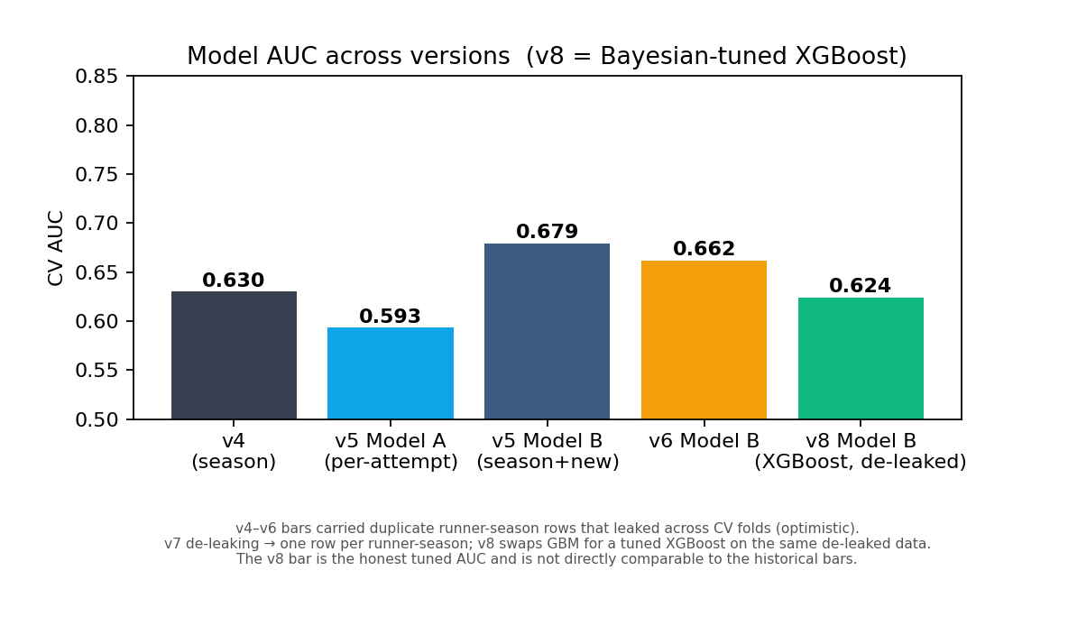
Figure A1 — Model AUC across versions; the latest bar is the de-leaked tuned-XGBoost figure.
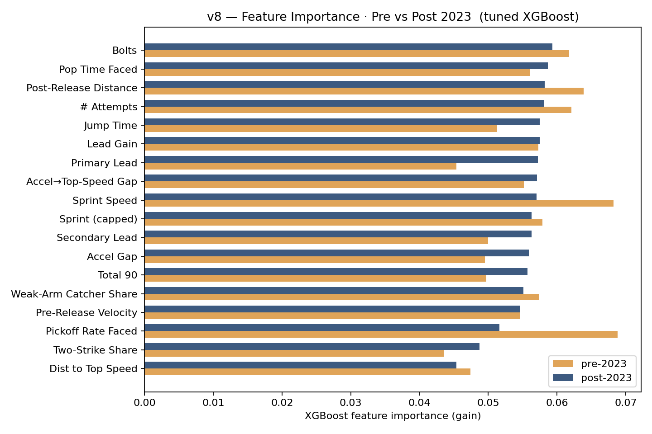
Figure A2 — XGBoost feature-importance shift after the 2023 bigger-bases rule change.

B Model C — The Steal-Success Equation (Full GLM)
What we did. We list every feature in the interpretable GLM, sorted by absolute impact on stolen-base success. The figure restates the model as an equation: standardized coefficients (β) on z-scored inputs, i.e. the effect of a one-SD move in each skill.
BOTTOM LINE The biggest movers are coachable timing skills (ground covered, jump, first-step burst); raw speed and context (catcher/pitcher faced) matter less.
Variables in this view:
- Coachable lever — A trainable skill the model links to stolen-base success.
- League Avg — Typical value across qualified runners.
- One-Step Improvement — A realistic one-standard-deviation gain in that skill.
- Success-Rate Change — Percentage-point change in SB success from that one-step gain.
- Extra steals — Plain translation of the success-rate change into net bags over a typical 20-attempt season.
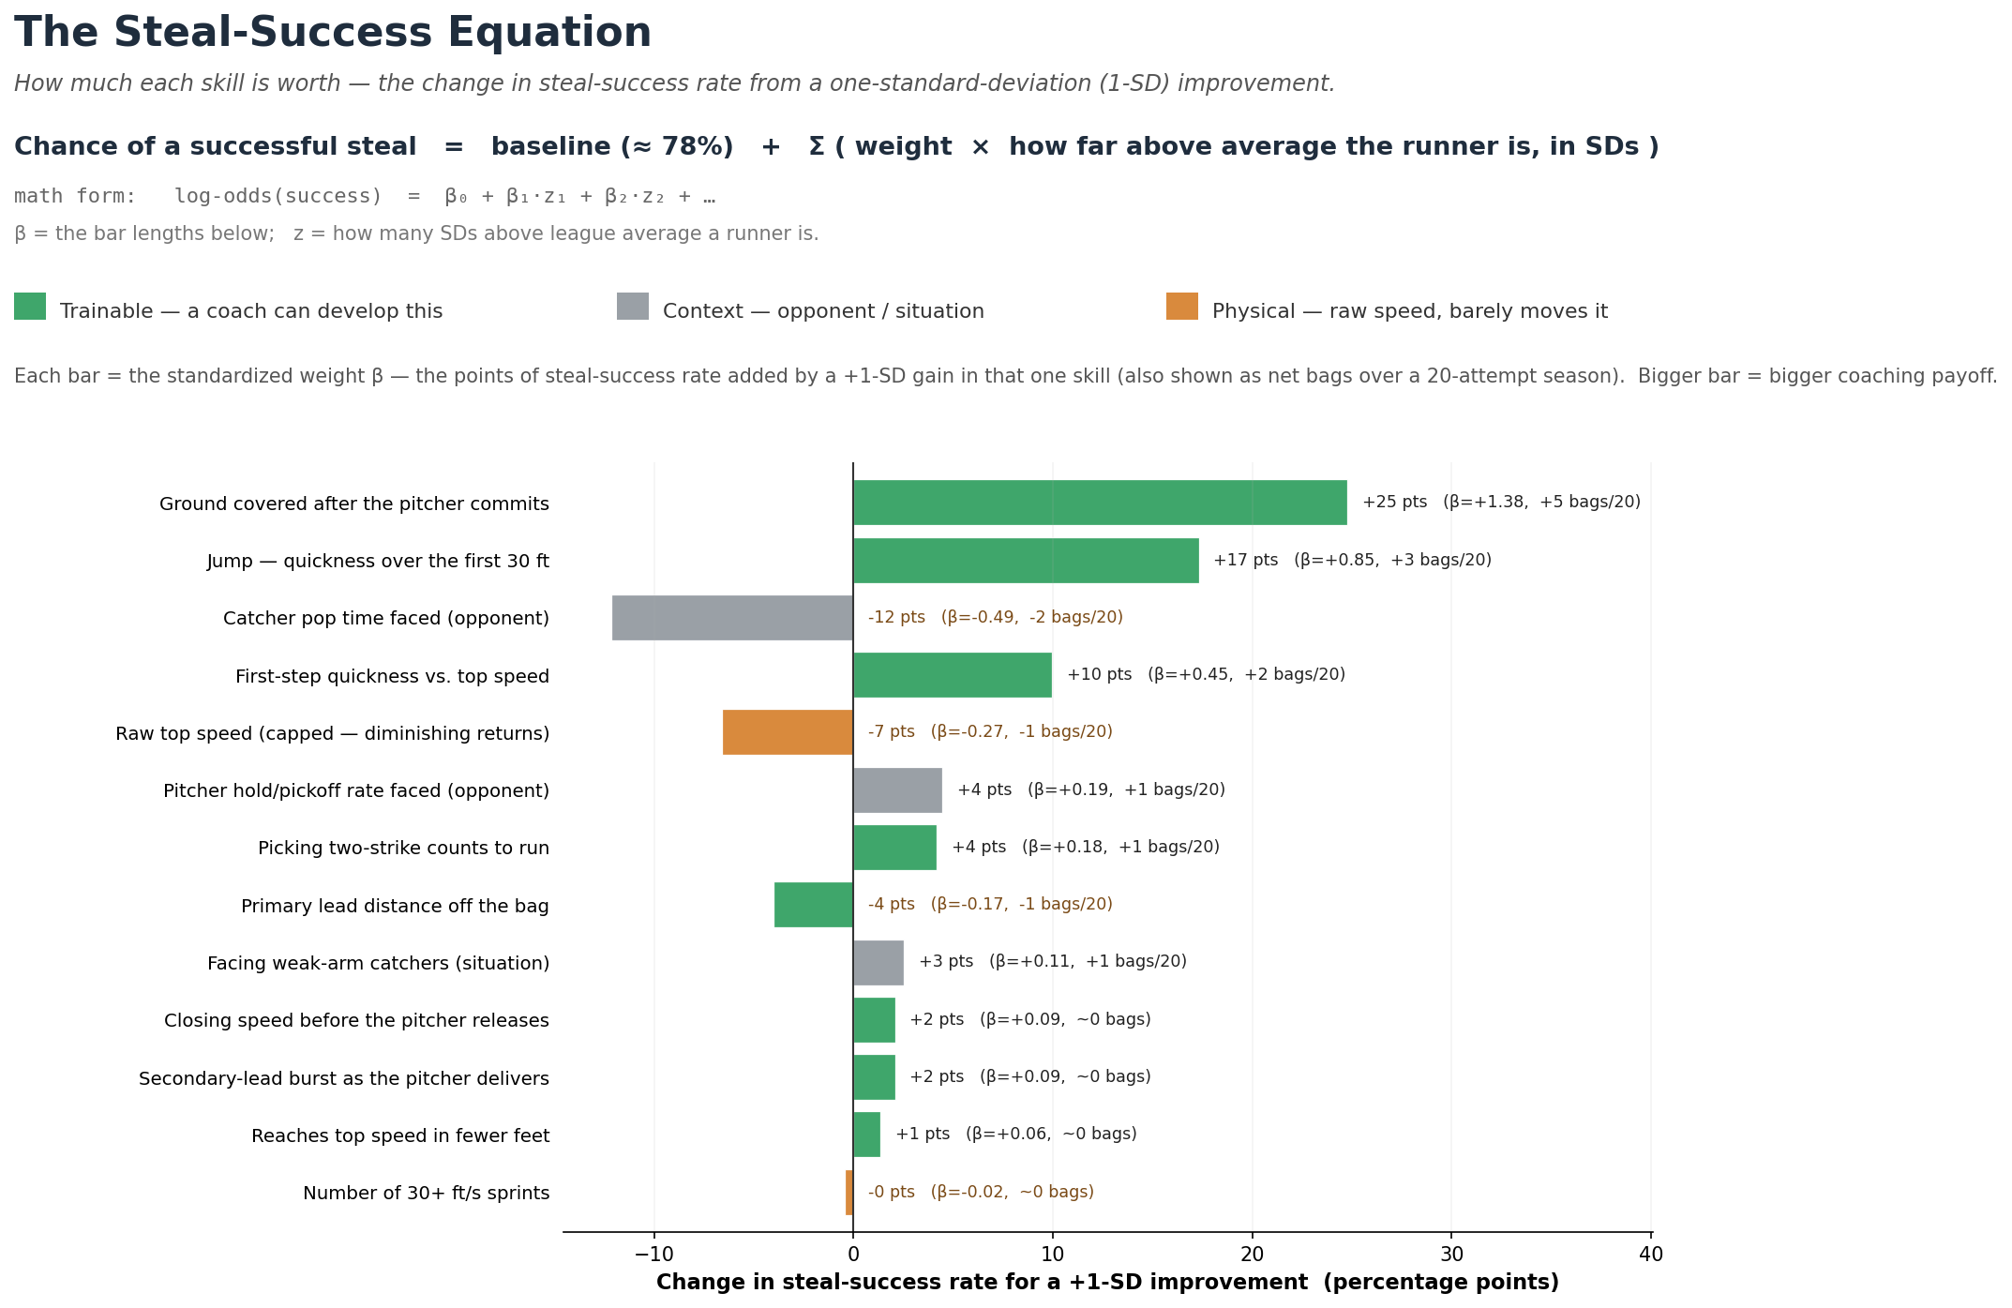
Figure B1 — log-odds(success) = β₀ + Σ βᵢ·zᵢ. Each bar is the per-1-SD coefficient as a percentage-point change in success rate (and net bags / 20 attempts). Green = trainable, grey = context, orange = raw speed.
Reading the weights: 'pp' = percentage points of success rate per one-standard-deviation improvement (one SD = the 'One-Step' column). The odds multiplier is the same effect on the odds scale (exp β). In steals: a +1-SD jump (+17 pp) is ≈ 3 more safe steals over a 20-attempt season; ground-covered (+25 pp) is ≈ 5.
Feature | League  Avg | One-Step  Improvement | Success-Rate  Change (pp) | Odds  Multiplier
Post-Release Distance | 52.205 | 2.916 | +24.76 | 3.994
Jump Time | 1.768 | 0.043 | +17.32 | 2.345
Avg Catcher Pop Faced | 1.962 | 0.036 | -12.13 | 0.610
Accel Gap | -1.405 | 18.951 | +9.94 | 1.570
Sprint Speed (capped at 28) | 27.709 | 0.553 | -6.61 | 0.761
Avg Pitcher Pickoff Rate Faced | 0.011 | 0.010 | +4.46 | 1.214
Two-Strike Count Share | 0.862 | 0.208 | +4.16 | 1.198
Primary Lead | 11.810 | 0.826 | -4.02 | 0.846
Share vs Weak-Arm Catchers | 0.265 | 0.315 | +2.51 | 1.114
Lead Gain (jerk) | 3.730 | 0.791 | +2.08 | 1.093
Pre-Release Velocity | 2.869 | 0.609 | +2.08 | 1.093
Accel→Top-Speed Premium | 0.453 | 11.840 | +1.34 | 1.059
Bolts | 14.355 | 24.845 | -0.46 | 0.981

C Slow-Steal Skill (SSSI) — Full Top 25 with all components
What we did. The full Top 25 by Slow-Steal Skill, with the underlying components exposed.
BOTTOM LINE Skill, not speed, drives the ranking — the leaders cluster in the mid-20s ft/s while grading out elite on jump, burst, and steals-above-expected.
Variables in this view:
- Player — Runner (and season).
- Top Speed — Sprint speed in feet/second — the structural baseline (Statcast).
- Jump (s) — Seconds to cover the first 30 ft. Lower = quicker first step. Coachable.
- Steals Above Speed-Expected — Real success rate minus what sprint speed alone predicts (pct pts).
- First-Step Burst — Reaches top speed in fewer feet than his speed predicts (premium when fast).
- Slow-Steal Skill — Overall technique score — skill beyond raw speed. Higher = better.
# | Player | Yr | Top Speed  (ft/s) | Jump (s)  lower better | Steals Above  Speed-Expected | First-Step  Burst | SB% | Slow-Steal  Skill
1 | Josh Naylor | 2025 | 24.4 | 1.87 | +12.2% | +7.6 | 92% | +1.85
2 | Josh Naylor | 2026 | 24.6 | 1.84 | +4.9% | +8.0 | 84% | +1.68
3 | Freddie Freeman | 2024 | 25.8 | 1.81 | +4.3% | -4.4 | 81% | +1.23
4 | Christian Vázquez | 2021 | 25.2 | 1.93 | -7.3% | +4.4 | 70% | +1.19
5 | Juan Soto | 2025 | 25.8 | 1.85 | +12.9% | +0.6 | 89% | +1.18
6 | Kyle Schwarber | 2025 | 25.9 | 1.79 | +5.6% | +0.8 | 82% | +1.15
7 | Miguel Rojas | 2024 | 25.8 | 1.88 | +3.0% | +10.6 | 79% | +1.12
8 | Kyle Tucker | 2024 | 26.0 | 1.80 | +17.1% | +6.0 | 93% | +1.11
9 | Manny Machado | 2024 | 25.8 | 1.86 | +6.5% | +0.6 | 83% | +1.09
10 | Alec Burleson | 2024 | 25.5 | 1.88 | -5.1% | -5.0 | 72% | +1.08
11 | Ryan McMahon | 2022 | 25.8 | 1.79 | -3.6% | -4.4 | 73% | +1.06
12 | Manny Machado | 2025 | 25.8 | 1.88 | +5.1% | -9.4 | 81% | +1.05
13 | Joc Pederson | 2024 | 25.5 | 1.83 | -8.6% | -5.0 | 68% | +1.04
14 | Josh Naylor | 2023 | 25.8 | 1.83 | +0.9% | -4.4 | 77% | +0.99
15 | TJ Friedl | 2024 | 26.5 | 1.77 | +10.4% | +12.0 | 86% | +0.90
16 | Kyle Schwarber | 2022 | 26.4 | 1.82 | +11.2% | -3.2 | 87% | +0.89
17 | Ryan McMahon | 2023 | 25.8 | 1.80 | -17.0% | -4.4 | 59% | +0.88
18 | Freddie Freeman | 2023 | 26.7 | 1.80 | +17.2% | +7.4 | 93% | +0.87
19 | Adam Frazier | 2023 | 26.5 | 1.79 | -1.1% | +7.0 | 74% | +0.86
20 | Mookie Betts | 2024 | 26.7 | 1.82 | +11.0% | +12.4 | 86% | +0.86
21 | Nolan Schanuel | 2024 | 26.4 | 1.84 | +11.2% | -8.2 | 87% | +0.86
22 | Christian Walker | 2023 | 26.4 | 1.87 | +17.4% | -3.2 | 93% | +0.85
23 | Cal Raleigh | 2025 | 26.0 | 1.85 | +1.8% | +1.0 | 78% | +0.84
24 | Paul Goldschmidt | 2021 | 26.3 | 1.84 | +17.8% | -3.4 | 93% | +0.84
25 | Paul Goldschmidt | 2024 | 26.3 | 1.84 | +17.4% | +1.6 | 93% | +0.83

D Expected SB Outcome (xSB) — Full Leaderboards
What we did. Steal Value (xSB) = z(net steals above average) + z(top speed). It surfaces the runners who are both fast AND productive; the Top 15 are the league's 'Realized Burners'.
BOTTOM LINE The ceiling cases are unsurprising burners (De La Cruz, Carroll); Naylor & Soto reach the same production from the slow side — the opposite, but equally valuable, profile.
Variables in this view:
- Player — Runner (and season).
- Top Speed — Sprint speed in feet/second — the structural baseline (Statcast).
- Net SB — Stolen bases minus times caught.
- Speed (SD) — Top speed expressed in standard deviations vs. the league (positive = faster).
- Steal Value (xSB) — z(net steals above avg) + z(top speed) — fast AND productive.
# | Player | Yr | Top Speed  (ft/s) | SB | CS | Net SB | Speed  (SD) | Steals  (SD) | Steal Value  (xSB)
1 | Billy Hamilton | 2015 | 29.7 | 57 | 8 | 49 | +1.69 | +4.89 | +6.57
2 | Billy Hamilton | 2016 | 30.2 | 58 | 8 | 50 | +2.14 | +4.38 | +6.52
3 | Billy Hamilton | 2017 | 30.1 | 59 | 13 | 46 | +1.82 | +4.37 | +6.18
4 | Elly De La Cruz | 2024 | 30.0 | 67 | 16 | 51 | +1.74 | +4.08 | +5.82
5 | Esteury Ruiz | 2023 | 29.6 | 67 | 13 | 54 | +1.30 | +4.13 | +5.43
6 | Corbin Carroll | 2023 | 30.1 | 54 | 5 | 49 | +1.81 | +3.61 | +5.42
7 | Trea Turner | 2017 | 30.3 | 46 | 8 | 38 | +1.99 | +3.38 | +5.37
8 | Dee Strange-Gordon | 2017 | 29.4 | 60 | 16 | 44 | +1.19 | +4.12 | +5.31
9 | Trea Turner | 2018 | 30.1 | 43 | 9 | 34 | +1.93 | +3.31 | +5.23
10 | Jon Berti | 2022 | 29.5 | 41 | 5 | 36 | +1.14 | +3.94 | +5.08
11 | Adalberto Mondesi | 2019 | 29.9 | 43 | 7 | 36 | +1.63 | +3.34 | +4.97
12 | Starling Marte | 2021 | 28.5 | 47 | 5 | 42 | +0.37 | +4.59 | +4.96
13 | Trea Turner | 2021 | 30.6 | 32 | 5 | 27 | +2.50 | +2.43 | +4.93
14 | Dee Strange-Gordon | 2015 | 29.1 | 58 | 20 | 38 | +1.11 | +3.50 | +4.61
15 | Trea Turner | 2019 | 30.3 | 35 | 5 | 30 | +2.04 | +2.56 | +4.60

D.1 Naylor & Soto — Crafty Technicians (year-by-year)
What we did. Every tracked Naylor and Soto season on the same axes.
BOTTOM LINE Both carry a negative 'Untapped Speed' every year — they out-steal their speed consistently, not in a single lucky season.
Variables in this view:
- Player — Runner (and season).
- Top Speed — Sprint speed in feet/second — the structural baseline (Statcast).
- Speed (SD) — Top speed expressed in standard deviations vs. the league (positive = faster).
- Untapped Speed — Fast but under-stealing: z(top speed) − z(net steals). Higher = bigger coaching upside.
Player | Yr | Top Speed  (ft/s) | SB | CS | Speed  (SD) | Steals  (SD) | Untapped  Speed | Quadrant
Juan Soto | 2025 | 25.8 | 38 | 4 | -2.29 | +2.61 | -4.90 | Crafty Technician
Juan Soto | 2019 | 27.3 | 12 | 1 | -1.04 | +0.08 | -1.12 | Crafty Technician
Josh Naylor | 2025 | 24.4 | 30 | 2 | -3.62 | +1.88 | -5.50 | Crafty Technician
Juan Soto | 2021 | 27.0 | 9 | 7 | -1.15 | -1.16 | +0.01 | Stationary
Juan Soto | 2024 | 26.8 | 7 | 4 | -1.25 | -1.07 | -0.18 | Stationary
Juan Soto | 2023 | 26.8 | 12 | 5 | -1.56 | -0.76 | -0.80 | Stationary
Josh Naylor | 2026 | 24.6 | 12 | 2 | -3.43 | +0.64 | -4.07 | Crafty Technician
Josh Naylor | 2023 | 25.8 | 10 | 3 | -2.59 | -0.76 | -1.83 | Stationary

E Blueprint Conversion Score (BCS)
What we did. BCS combines three speed-adjusted residuals — converts more often than speed predicts (execution), covers more ground first-move→release than speed predicts (timing), and a penalty for fast runners who get caught. The figure below shows the Top 25 each season.
BOTTOM LINE The board is full of slow-but-skilled runners (gold) holding their own against burners — the slow, high-conversion archetype (★ Naylor, Soto) repeats every season.
Variables in this view:
- BCS — Blueprint Conversion Score — speed-adjusted steal-skill composite (higher = better).
- Ground vs Speed-Expected — Extra feet of ground covered (first move → release) beyond speed (ft).
- Top Speed — Sprint speed in feet/second — the structural baseline (Statcast).
- SB / CS — Stolen bases / times caught stealing.
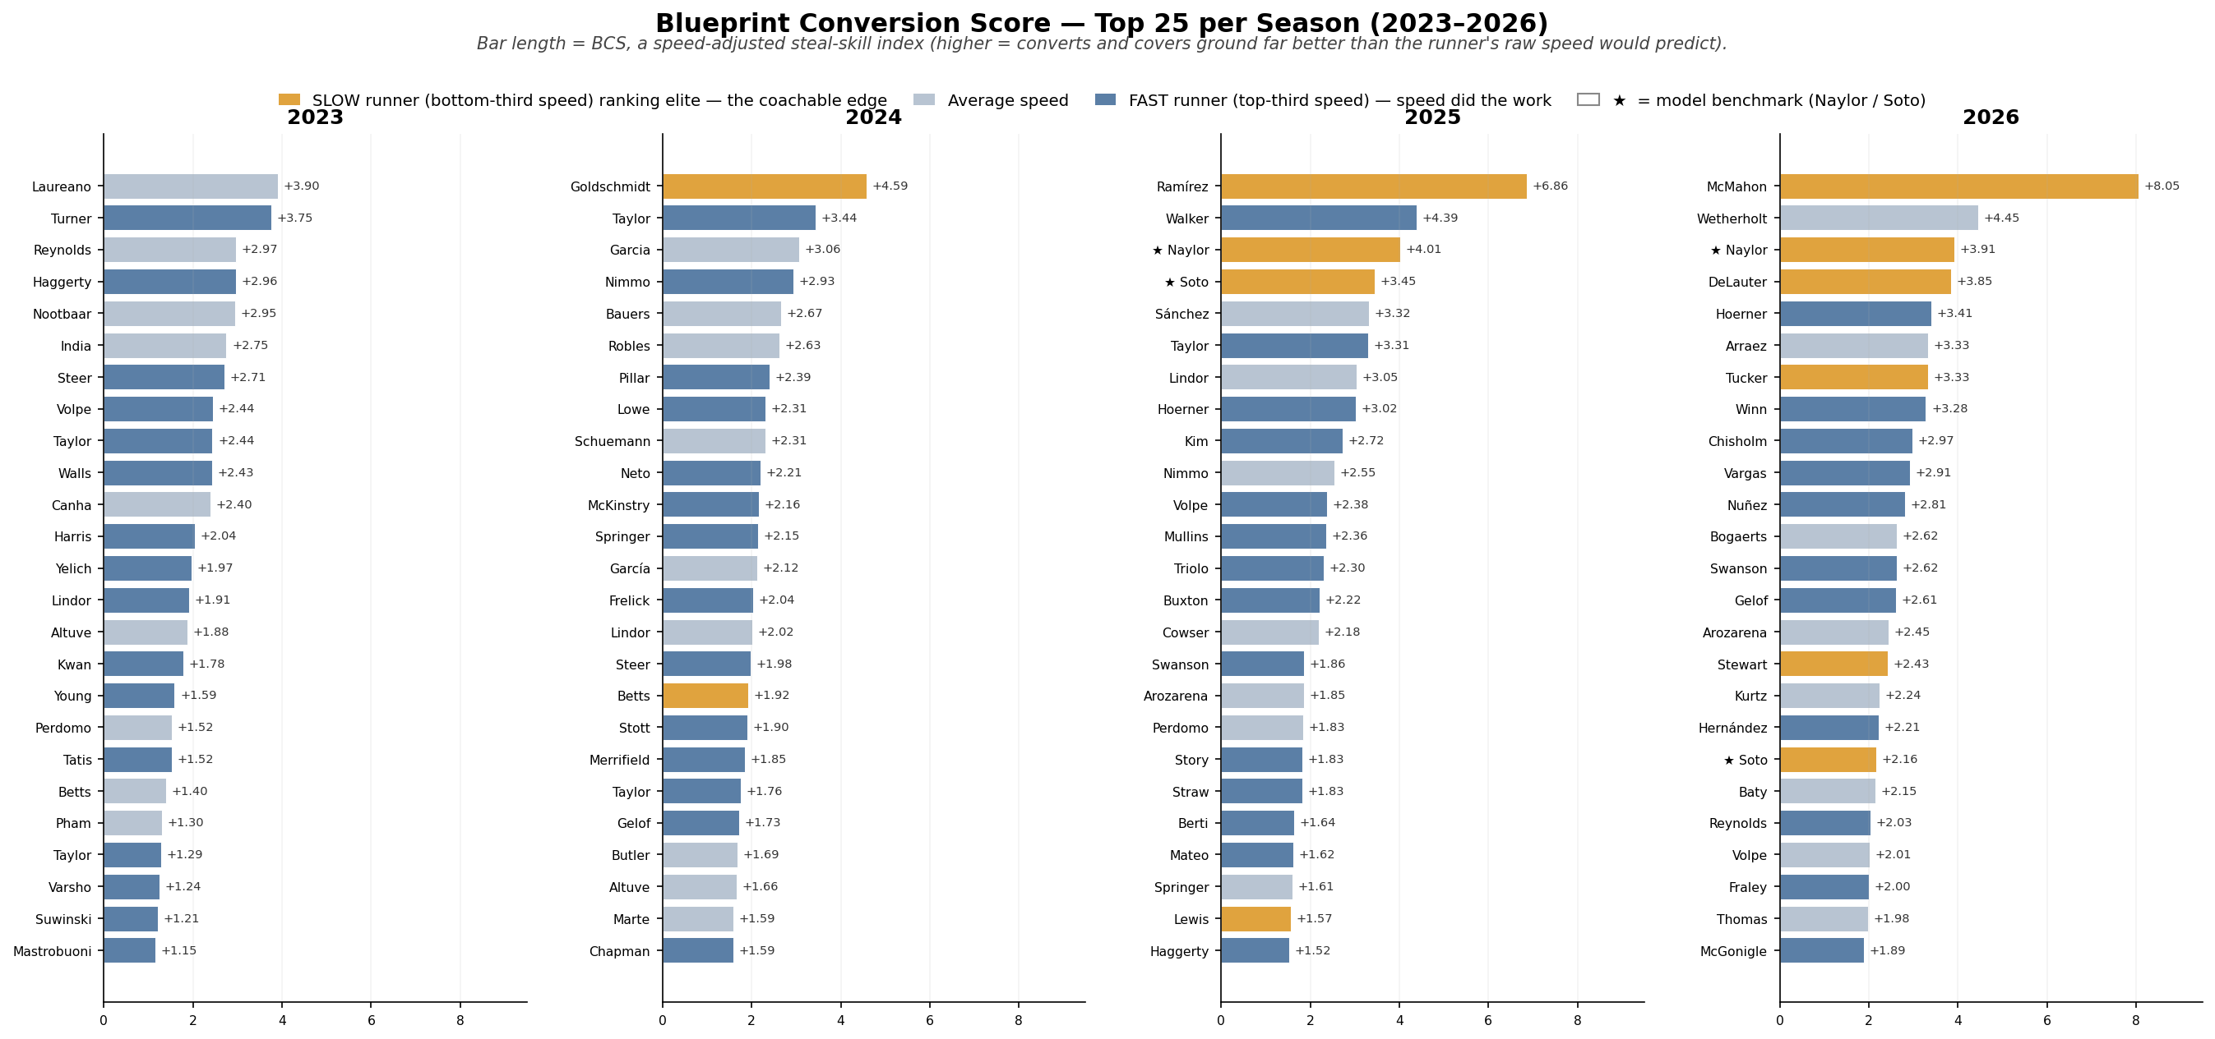
Figure E1 — Top 25 by Blueprint Conversion Score per season. Bar length = BCS (higher = more speed-adjusted steal skill). Color = raw-speed tier only (GOLD = slow / slate = average / blue = fast); ★ marks the benchmark names. No red — every bar is a top-25 result.

E.1 Overall Top 15
# | Player | Team | Yr | Speed  %ile | SB | CS | SB% | Gain  (ft) | Ground vs  Exp (SD) | Convert vs  Exp (SD) | BCS
1 | Ryan McMahon |  | 2026 | 14 | 3 | 0 | 100% | 24.5 | +6.44 | +1.09 | +8.05
2 | Agustín Ramírez |  | 2025 | 30 | 13 | 1 | 93% | 21.3 | +4.90 | +1.44 | +6.86
3 | Paul Goldschmidt |  | 2024 | 22 | 10 | 0 | 100% | 16.7 | +2.27 | +1.79 | +4.59
4 | JJ Wetherholt |  | 2026 | 50 | 5 | 0 | 100% | 16.8 | +2.78 | +1.14 | +4.45
5 | Jordan Walker |  | 2025 | 84 | 10 | 0 | 100% | 15.3 | +2.32 | +1.54 | +4.39
6 | Josh Naylor |  | 2025 | 2 | 22 | 1 | 96% | 16.7 | +1.42 | +2.07 | +4.01
7 | Josh Naylor |  | 2026 | 2 | 9 | 1 | 90% | 17.7 | +2.19 | +1.20 | +3.91
8 | Ramón Laureano |  | 2023 | 63 | 11 | 1 | 92% | 16.9 | +2.66 | +0.72 | +3.90
9 | Chase DeLauter |  | 2026 | 29 | 2 | 1 | 67% | 19.0 | +3.70 | -0.37 | +3.85
10 | Trea Turner |  | 2023 | 100 | 24 | 0 | 100% | 13.6 | +1.74 | +1.49 | +3.75
11 | Juan Soto |  | 2025 | 14 | 30 | 0 | 100% | 14.2 | +0.54 | +2.39 | +3.45
12 | Michael A. Taylor |  | 2024 | 81 | 10 | 0 | 100% | 13.6 | +1.40 | +1.51 | +3.44
13 | Nico Hoerner |  | 2026 | 82 | 10 | 0 | 100% | 13.5 | +1.35 | +1.53 | +3.41
14 | Luis Arraez |  | 2026 | 34 | 4 | 0 | 100% | 15.2 | +1.63 | +1.18 | +3.33
15 | Kyle Tucker |  | 2026 | 25 | 4 | 0 | 100% | 15.4 | +1.62 | +1.18 | +3.33

E.2 Bottom 15 — Squanderers (fast, serial caught-stealings)
# | Player | Team | Yr | Speed  %ile | SB | CS | SB% | Gain  (ft) | Ground vs  Exp (SD) | Convert vs  Exp (SD) | BCS
515 | Chandler Simpson |  | 2025 | 97 | 38 | 8 | 83% | 9.9 | -0.32 | -0.00 | -6.71
514 | Bobby Witt Jr. |  | 2023 | 100 | 40 | 8 | 83% | 9.6 | -0.44 | -0.19 | -6.57
513 | Ji Hwan Bae |  | 2023 | 97 | 19 | 7 | 73% | 11.2 | +0.16 | -1.27 | -5.86
512 | Daylen Lile |  | 2025 | 90 | 8 | 6 | 57% | 8.3 | -1.43 | -2.14 | -5.04
511 | Bobby Witt Jr. |  | 2024 | 100 | 25 | 6 | 81% | 9.4 | -0.13 | -0.22 | -4.87
510 | Ceddanne Rafaela |  | 2024 | 88 | 15 | 8 | 65% | 9.9 | -0.57 | -1.63 | -4.62
509 | Elly De La Cruz |  | 2024 | 99 | 55 | 9 | 86% | 8.9 | -0.63 | +0.49 | -4.60
508 | Bobby Witt Jr. |  | 2025 | 100 | 32 | 7 | 82% | 10.1 | +0.03 | -0.02 | -4.33
507 | Myles Straw |  | 2023 | 94 | 17 | 5 | 77% | 13.5 | +1.27 | -0.74 | -4.20
506 | Luis Rengifo |  | 2025 | 39 | 7 | 7 | 50% | 8.5 | -2.15 | -2.57 | -4.20
505 | Jacob Young |  | 2025 | 94 | 12 | 7 | 63% | 9.8 | -0.49 | -1.76 | -4.11
504 | Jeremy Peña |  | 2023 | 95 | 13 | 7 | 65% | 10.2 | -0.53 | -1.88 | -4.08
503 | Alejandro Osuna |  | 2026 | 82 | 1 | 2 | 33% | 7.4 | -2.04 | -1.98 | -4.04
502 | David Hamilton |  | 2025 | 94 | 15 | 5 | 75% | 10.5 | -0.14 | -0.74 | -3.95
501 | Taylor Ward |  | 2026 | 56 | 1 | 2 | 33% | 7.1 | -2.60 | -1.78 | -3.85

E.3 Ground Covered Beyond Speed-Expected — Top 25 per Season
What we did. The single clearest timing metric: feet of ground gained from the pitcher's first move to release, after removing the runner's sprint speed.
BOTTOM LINE Slow runners (green) routinely top the board — proof that ground covered is a timing/jump skill, not a speed read-out.
Variables in this view:
- Ground vs Speed-Expected — Extra feet of ground covered (first move → release) beyond speed (ft).
- Top Speed — Sprint speed in feet/second — the structural baseline (Statcast).
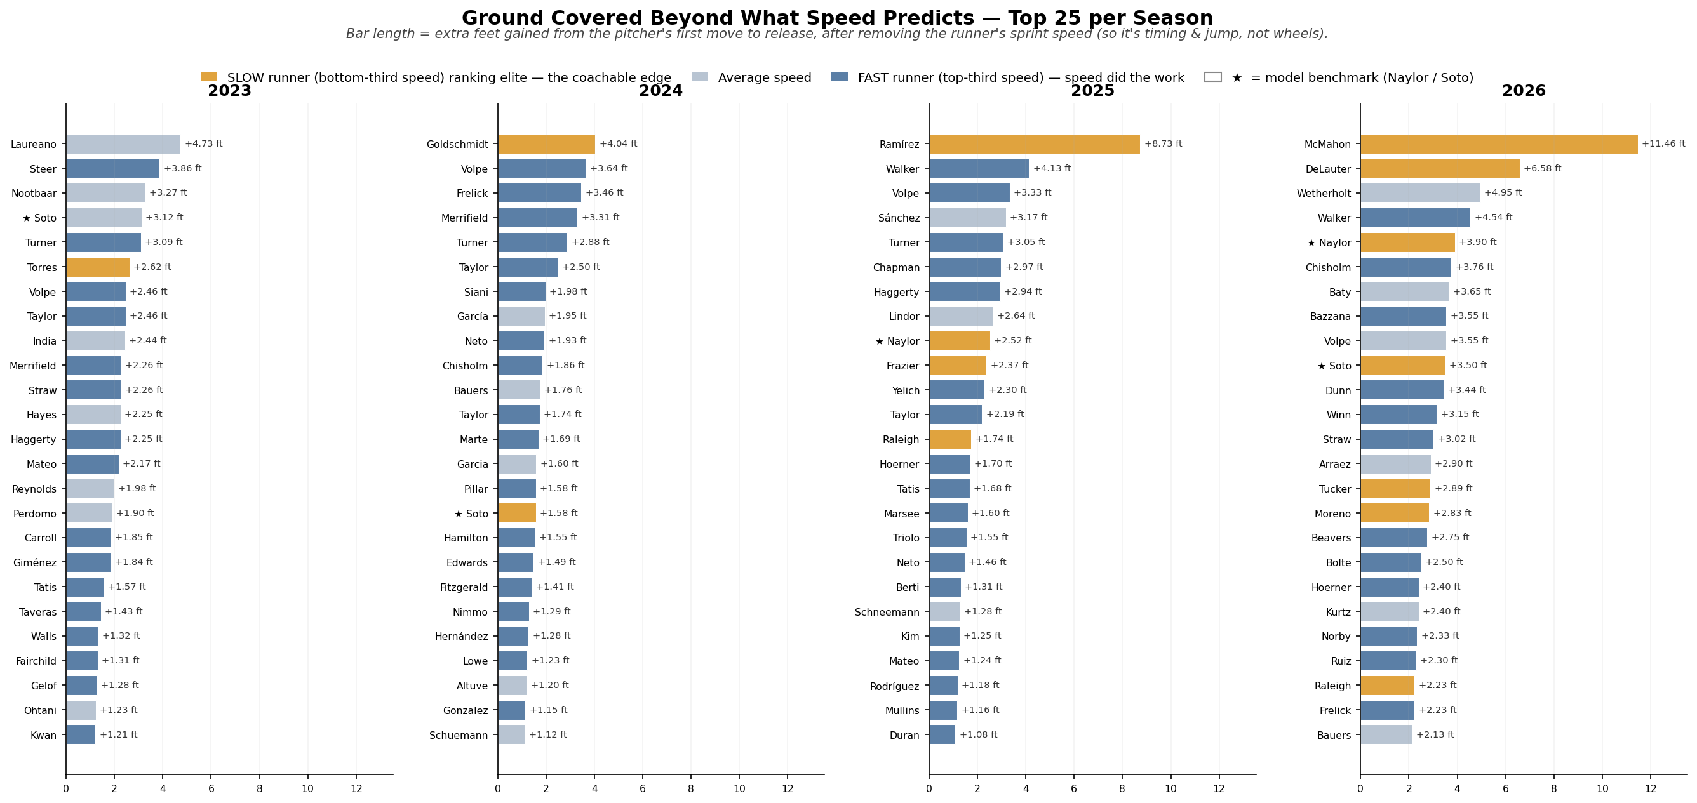
Figure E2 — Bar length = feet of ground covered beyond what sprint speed predicts (e.g. '+3.04 ft' = three feet more than a runner that fast usually gains). Color = raw-speed tier only (GOLD = slow / slate = average / blue = fast); ★ marks the benchmark names. No red — every bar is a top-25 result.

