The Naylor Model
Base-stealing skill that sprint speed hides · for MLB R&D and coaching staffs
BOTTOM LINE Some of the league's best base-stealers are among its slowest. The skill is jump, secondary lead, and reading the pitcher — all coachable, all scattered across the league.
In 2025 Josh Naylor stole 30 bases at 92% while slower than 98% of MLB — the top skill season in 673 tracked. This report prices that skill in steals, names who already has it, and flags the 2025 runners to coach.
HOW TO READ THIS
In steals. Every payoff is extra stolen bases over a 20-attempt season.
Deeper red = higher. On the leaderboards, the headline column is shaded by rank.

THE THREE LEVERS, IN ORDER OF PAYOFF
+5 steals Ground covered after the pitcher commits.
+3 steals Jump — quickness over the first 30 ft.
+2 steals First-step quickness vs. top speed.

1 · What each skill is worth
BOTTOM LINE Three trainable skills move steals. Raw foot speed barely does.
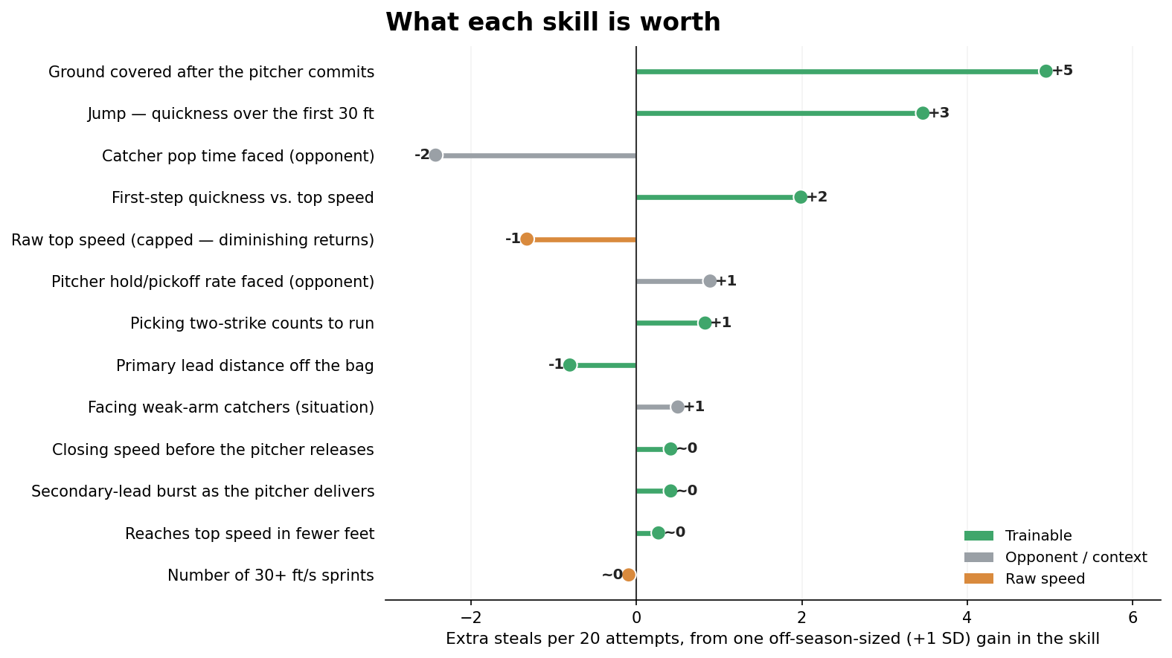
Extra steals over 20 attempts from one off-season-sized (+1 SD) gain. Green = trainable · grey = opponent/context · orange = raw speed.

2 · Who already has the skill
BOTTOM LINE Mid-pack-speed runners fill the leaderboard — the trait is common and findable.
STRIPPING SPEED OUT
Fast runners cover more ground and steal more — of course. Plot a skill against sprint speed, draw the line speed predicts, and keep only how far each runner sits above it. That gap is skill with speed removed.

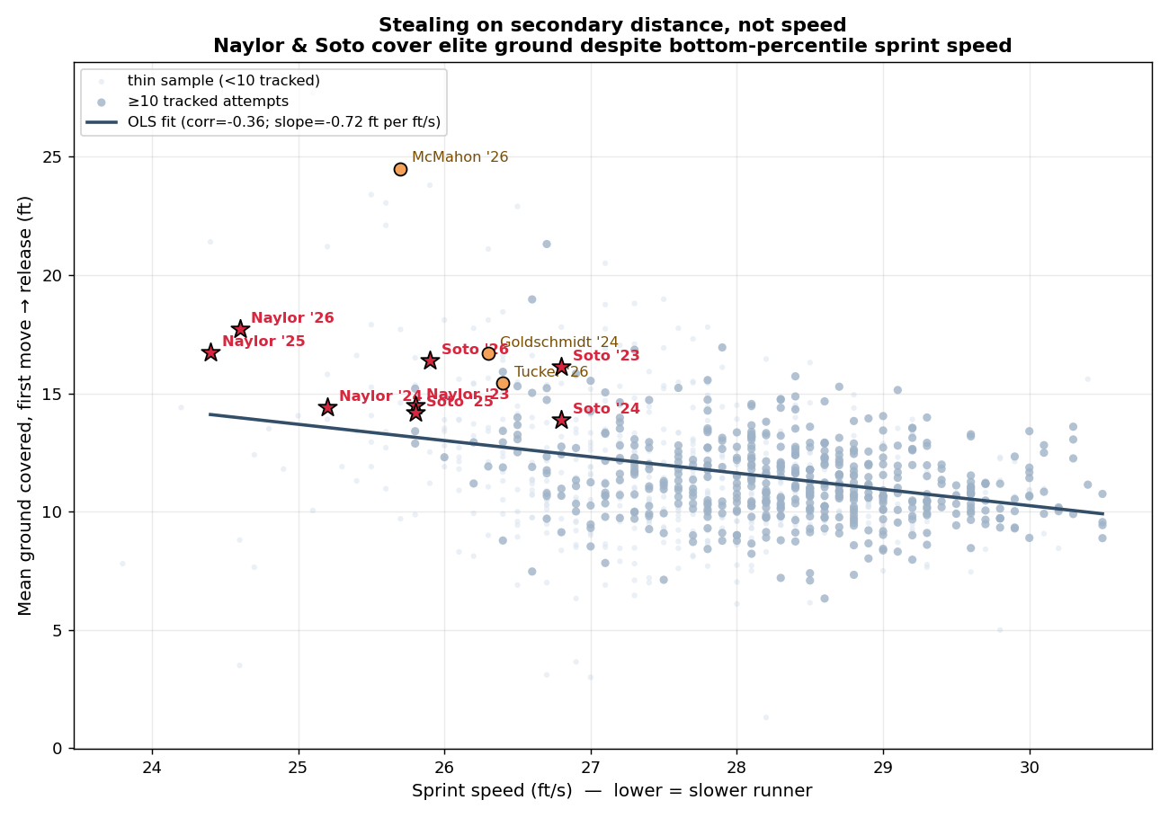
The line is what speed predicts; height above it is skill. Naylor, Soto, and McMahon sit far above it at the slowest speeds.
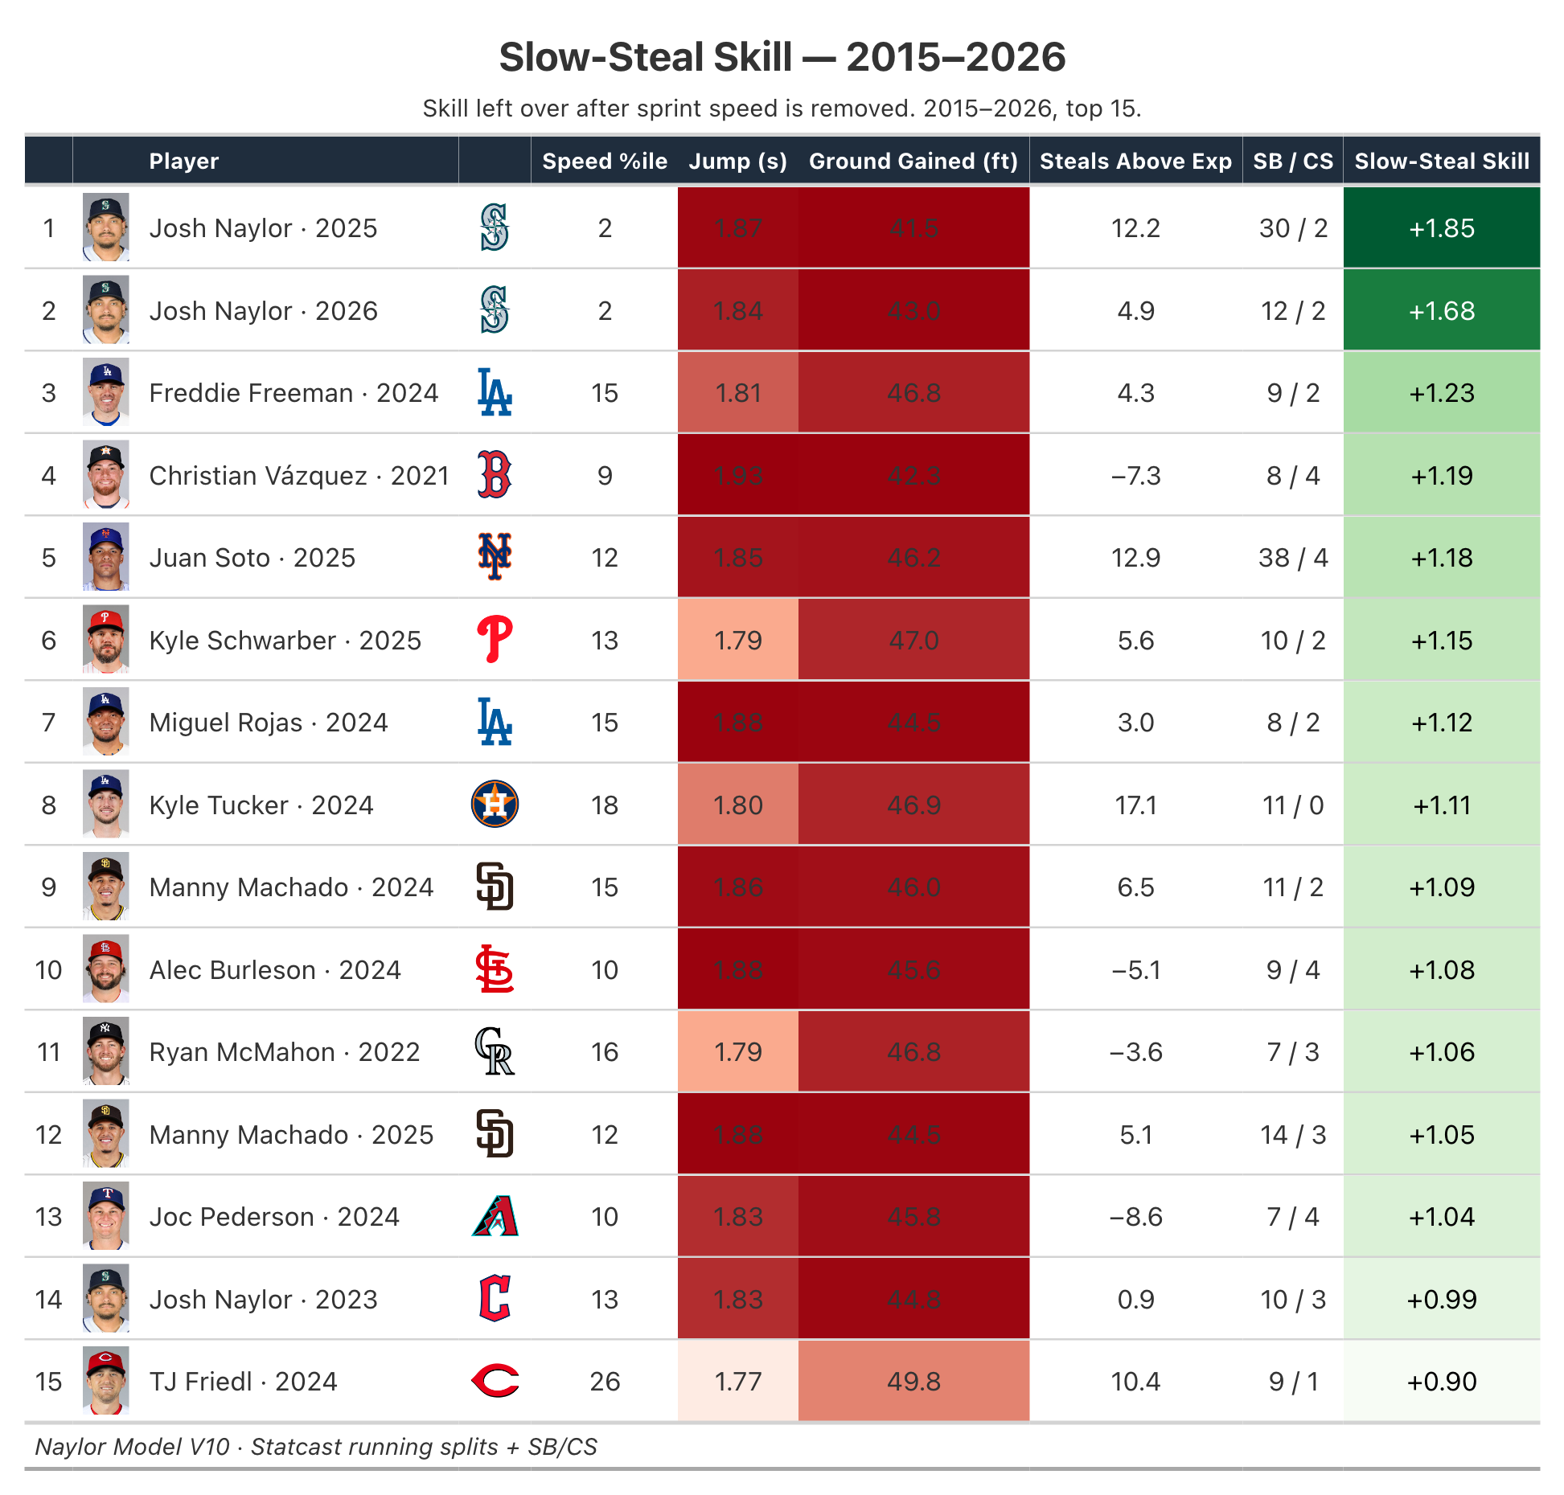

2b · The full skill index, with teams
BOTTOM LINE Ryan McMahon's 2026 is the highest score in the data — a slow corner infielder out-converting the league's burners.
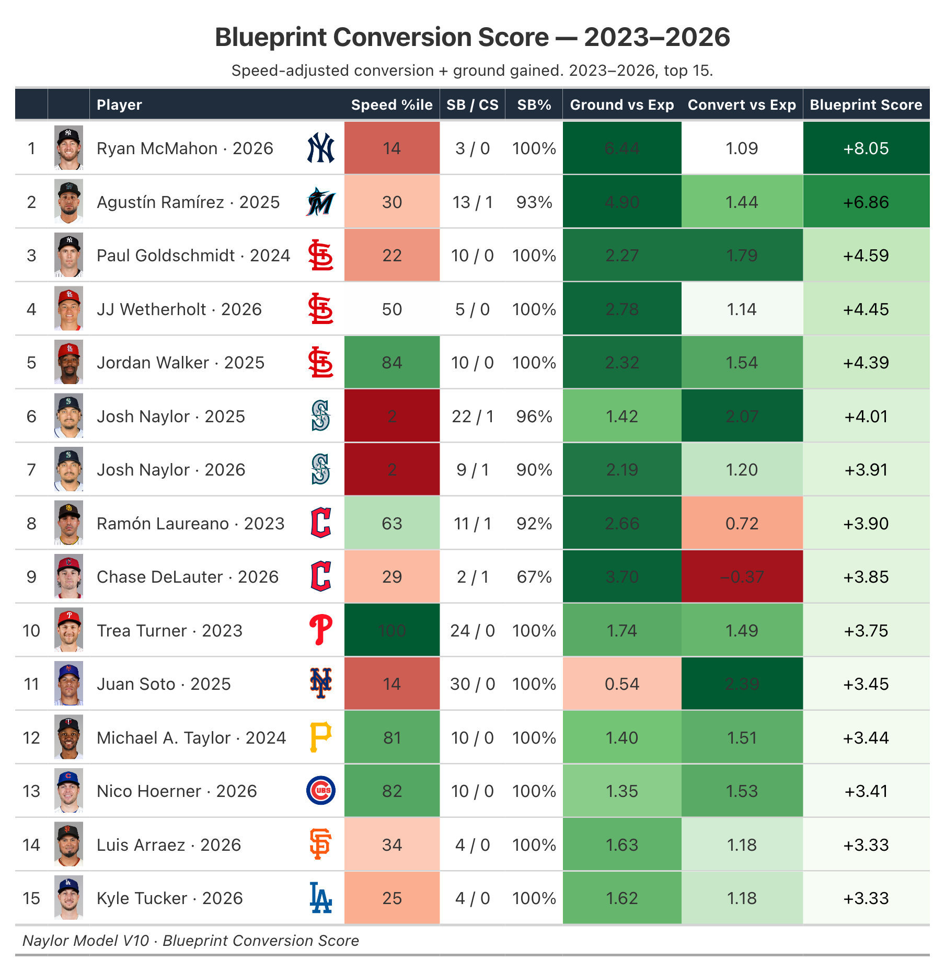

3 · Who to coach in 2025
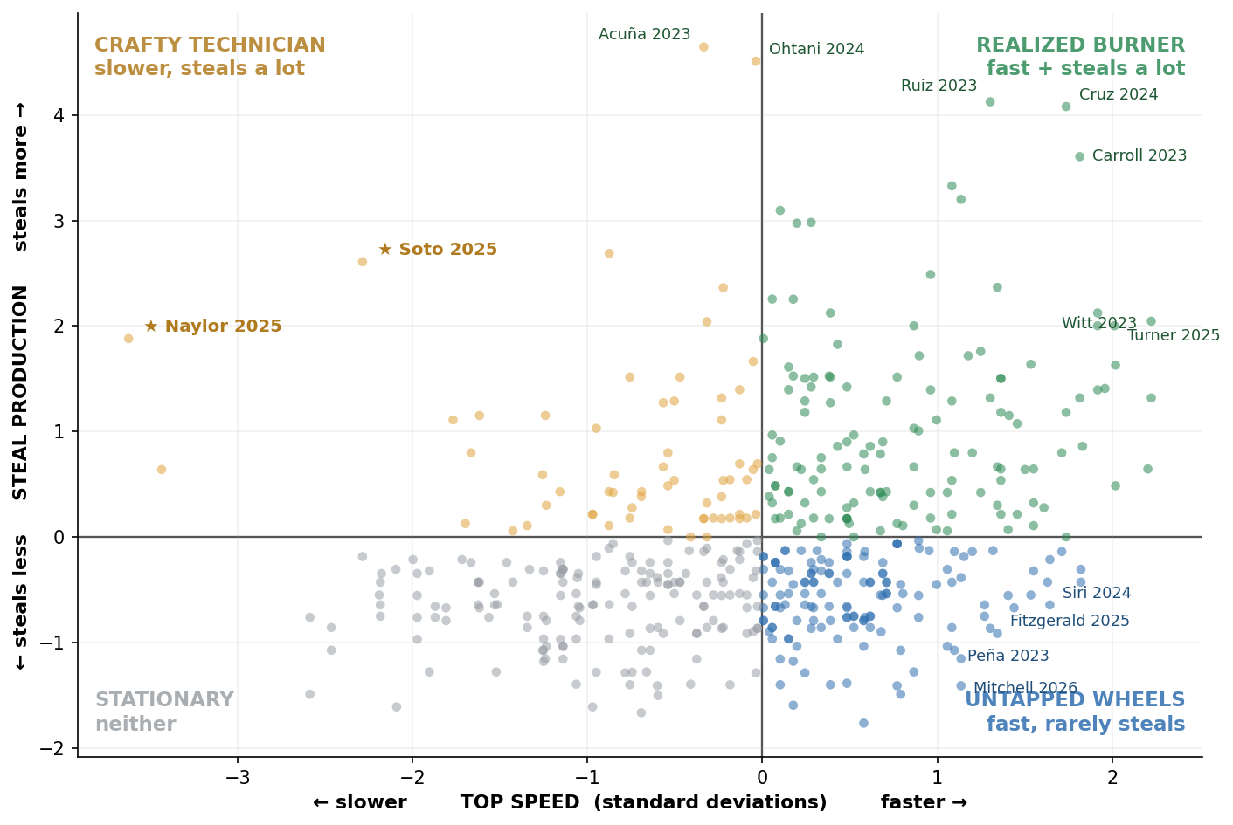
Each dot is a runner-season (2023–2026). Right = faster; up = steals more. Blue lower-right = fast but under-running (green-light); gold = the slow-but-productive archetype (★ Naylor, Soto).

3a · Green-light — fast, efficient, under-running
Top-third speed, 80%+ success, fewer than 20 attempts. Let them run.
# | Player | Top Speed  (ft/s) | SB / CS | Success  rate | Attempts  (2025) | If unleashed  (+ steals)
1 | Nasim Nuñez | 29.8 | 9/1 | 86% | 10 | +7
2 | Eli White | 29.9 | 10/1 | 87% | 11 | +7
3 | Brandon Lockridge | 30.1 | 10/1 | 87% | 11 | +7
4 | Marcus Semien | 28.5 | 11/1 | 88% | 12 | +6
5 | Hyeseong Kim | 28.7 | 13/1 | 89% | 14 | +5
6 | Ezequiel Duran | 28.8 | 11/2 | 83% | 13 | +5
7 | Myles Straw | 29.4 | 12/1 | 88% | 13 | +5
8 | Tyrone Taylor | 29.3 | 12/2 | 84% | 14 | +4
"If unleashed" holds the runner at his own 2025 rate over ~20 attempts — a ranking, not a forecast.

3b · Technique-fix — high volume, caught too often
12+ attempts, under 70% success. Don't run more — run better, on the lever named.
Player | Top Speed  (ft/s) | SB / CS | Success  rate | Attempts  (2025) | Weakest  lever | Fix →  + steals/20
Tyler Freeman | 28.5 | 18/9 | 68% | 27 | Secondary-lead burst | —
Jacob Young | 29.3 | 15/11 | 61% | 26 | First-step burst | +5
James Wood | 27.8 | 15/7 | 70% | 22 | Secondary-lead burst | +1
Andy Pages | 28.1 | 14/7 | 69% | 21 | First-step burst | +3
Harrison Bader | 28.8 | 11/7 | 65% | 18 | Secondary-lead burst | +1
Luis Rengifo | 27.0 | 10/7 | 63% | 17 | Ground covered | +7
"Fix" = steals gained over 20 tries if the weakest skill reaches league average.

4 · What to coach
- Cover more ground once the pitcher commits. (+5 / 20) The biggest lever. Drill the secondary-lead explosion and the read of the pitcher's first move.
- Sharpen the jump. (+3 / 20) Stance, weight shift, first-step direction — pure technique over the first 30 feet.
- Reach top speed sooner. (+2 / 20) Acceleration mechanics, not a higher top speed, are what convert.

Caveats
- Projections rank, they don't forecast. Real results move with health, matchups, and game situation.
- Per-lever gains assume the rest stays fixed. Small compounding gains across two levers beat one full-SD jump.
- Context columns aren't levers. Catcher pop and pitcher hold move the math but can't be coached — shown to separate skill from circumstance.

Metric reference
Slow-Steal Skill (SSSI) | Technique score — skill left after sprint speed is removed. Higher = more.
Top Speed | Sprint speed, feet/second (Statcast). The structural baseline.
Jump | Seconds to cover the first 30 ft. Lower = quicker first step. Coachable.
First-Step Burst | Reaches top speed in fewer feet than his speed predicts.
Steals Above Speed-Expected | Success rate minus the rate his speed alone predicts. Positive = beats his speed peers.
Ground Gained | Feet covered from the pitcher's first move to release — the biggest single driver of a steal.
Steal Value (xSB) | z(net steals above avg) + z(top speed). Surfaces fast, high-volume burners.
Untapped Speed | Fast but under-stealing — z(top speed) minus z(net steals). The clearest coaching targets.

