The Naylor Model — V10 Technical Appendix
Full model detail, validation, and the Blueprint Conversion Score.

A The Three Models (A / B / C) and Validation
What we did. Three models on the same Statcast runner-season data: a per-attempt predictor (Model A), a season-level predictor (Model B, a Bayesian-tuned XGBoost), and an interpretable GLM (Model C) for plain-English weights.
BOTTOM LINE De-leaked accuracy is honest but modest — why the main report leads with skill rankings and coaching levers, not AUC.
Variables in this view:
- AUC — Area under ROC — accuracy (0.5 = coin flip, 1.0 = perfect).
Model | Unit | AUC | Purpose
Model A — per-attempt XGBoost | Individual attempt | 0.739 | Strongest predictor — does THIS steal succeed
Model B — season XGBoost (tuned) | Runner-season | 0.624 (de-leaked) | Ranks season-long skill
Model C — interpretable GLM | Runner-season | — | Plain-English weight table
De-leaking. v4–v6 reported AUCs of ~0.66–0.70, but carried duplicate runner-season rows that leaked across CV folds. The pipeline now averages duplicate splits into one row per runner-season; the resulting AUC is lower but honest.
Model B. Upgraded from a gradient-boosting classifier to a Bayesian-tuned XGBoost (100-trial Optuna). De-leaked CV AUC rose 0.589 → 0.624 overall and 0.588 → 0.665 post-2023 — model choice and tuning, not new signal. SSSI rankings and the equation are unchanged.
Model A. Moving from 673 season aggregates to ~11,000 tracked attempts lifts CV AUC to 0.739. The driver is per-pitch lead distances — ground covered on that attempt — exactly this report's thesis. Leakage-checked. Deep learning was rejected: at ~11k rows and a dozen tabular features, gradient boosting wins.
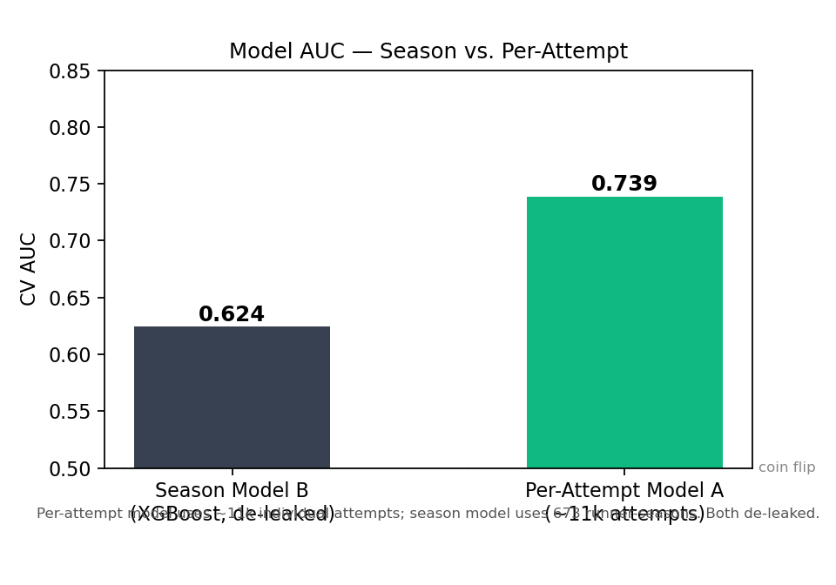
Figure A1 — Season Model B vs. Per-Attempt Model A. Per-attempt model uses ~11k individual steal attempts; season model uses 673 runner-seasons.
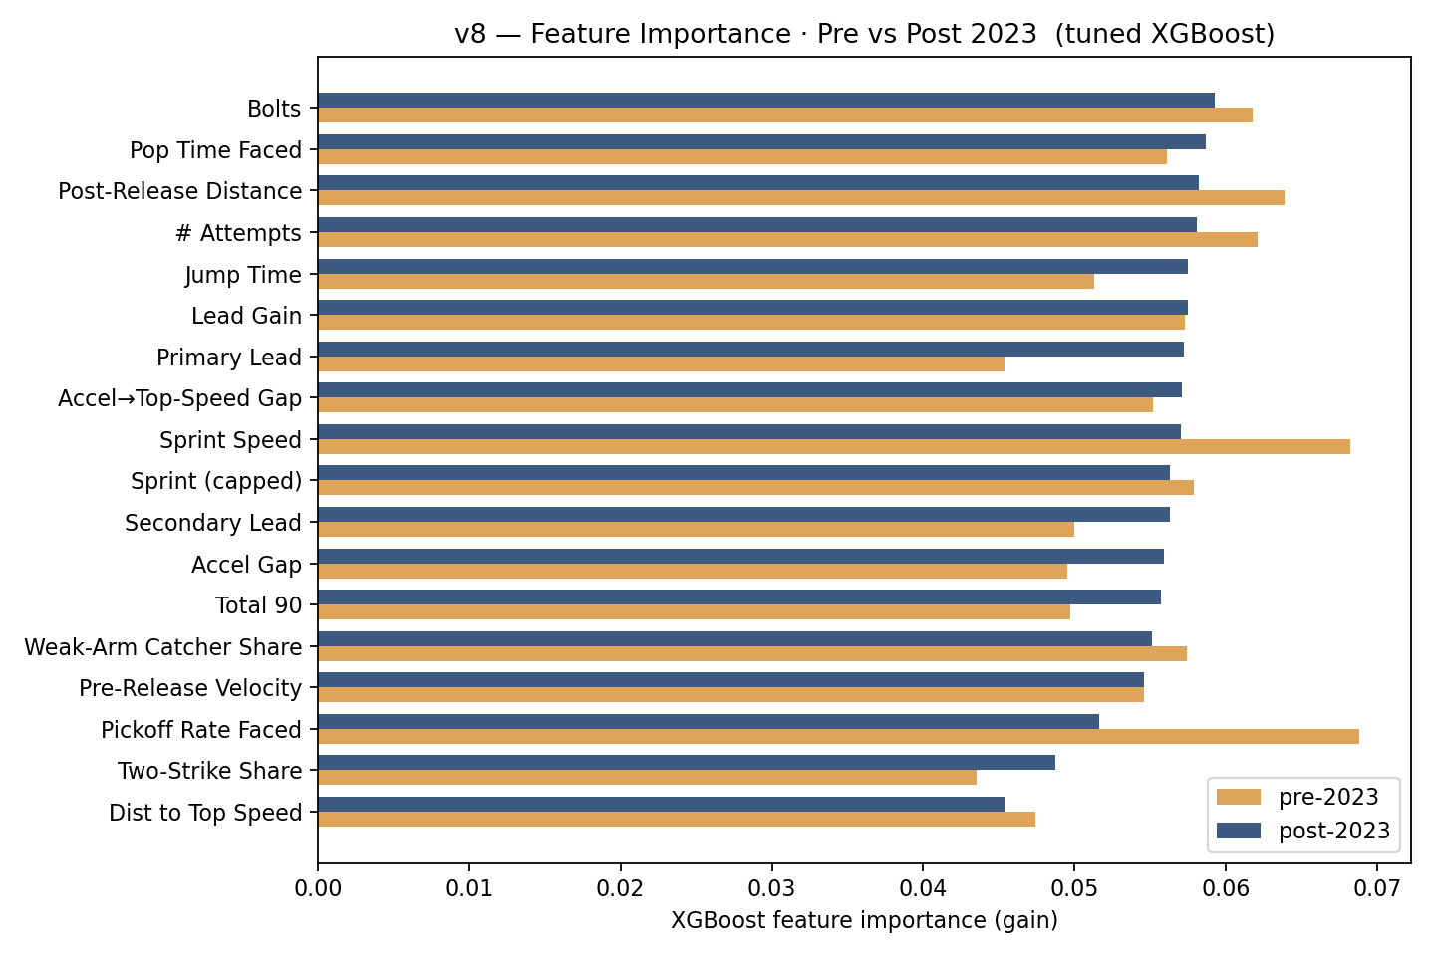
Figure A2 — XGBoost feature-importance shift after the 2023 bigger-bases rule change.

A2 Per-Attempt Model: How AUC 0.739 Was Reached
Grain change. Model B works on 673 runner-seasons — one aggregated row per player-year. Model A drops to the ~11,169 individual tracked attempts in the Statcast leads cache. Each row is one steal attempt: lead at first move, gain to release, lead at release, plus runner skill context (sprint speed, jump time, accel gap). That's the entire feature set.
Why the grain change lifts AUC. One attempt where a runner gains 14 ft before first move is directly informative. The season average of 12.3 ft is diluted by context variance — pitch type, game state, count. At the attempt level the signal is cleaner, and there are 17× more rows.
Leakage discipline. Catcher pop time and pitcher pickoff rate are out-of-fold target-encoded: computed on the training folds only, applied to the held-out fold. Crucially, adding them drops AUC (0.7387 → 0.7231) — the lead distances alone carry the signal; battery tendencies add noise at this sample size.
Model spec. XGBClassifier, 500 trees, max_depth=4, learning_rate=0.03, 5-fold stratified CV. No hyperparameter tuning yet — the default spec already reaches the target range.
Honest ceiling on public data: ~0.74–0.78. To push further: pitch type at first move (fastball vs. off-speed changes runner timing), pitcher handedness (LHP pickoff mechanics differ fundamentally), and Optuna HPO on the per-attempt model. See AUC_Roadmap.md.

B Model C — The Steal-Success Equation (Full GLM)
What we did. Every feature in the GLM, sorted by absolute impact. Coefficients are on z-scored inputs — the effect of a one-SD move in each skill.
BOTTOM LINE The biggest movers are coachable timing skills; raw speed and context matter less.
Variables in this view:
- Coachable lever — A trainable skill the model links to steal success.
- League Avg — Typical value across qualified runners.
- One-Step Improvement — A realistic +1-SD gain in that skill.
- Success-Rate Change — Percentage-point change in SB success from that gain.
- Extra steals — Extra stolen bases over a 20-attempt season.
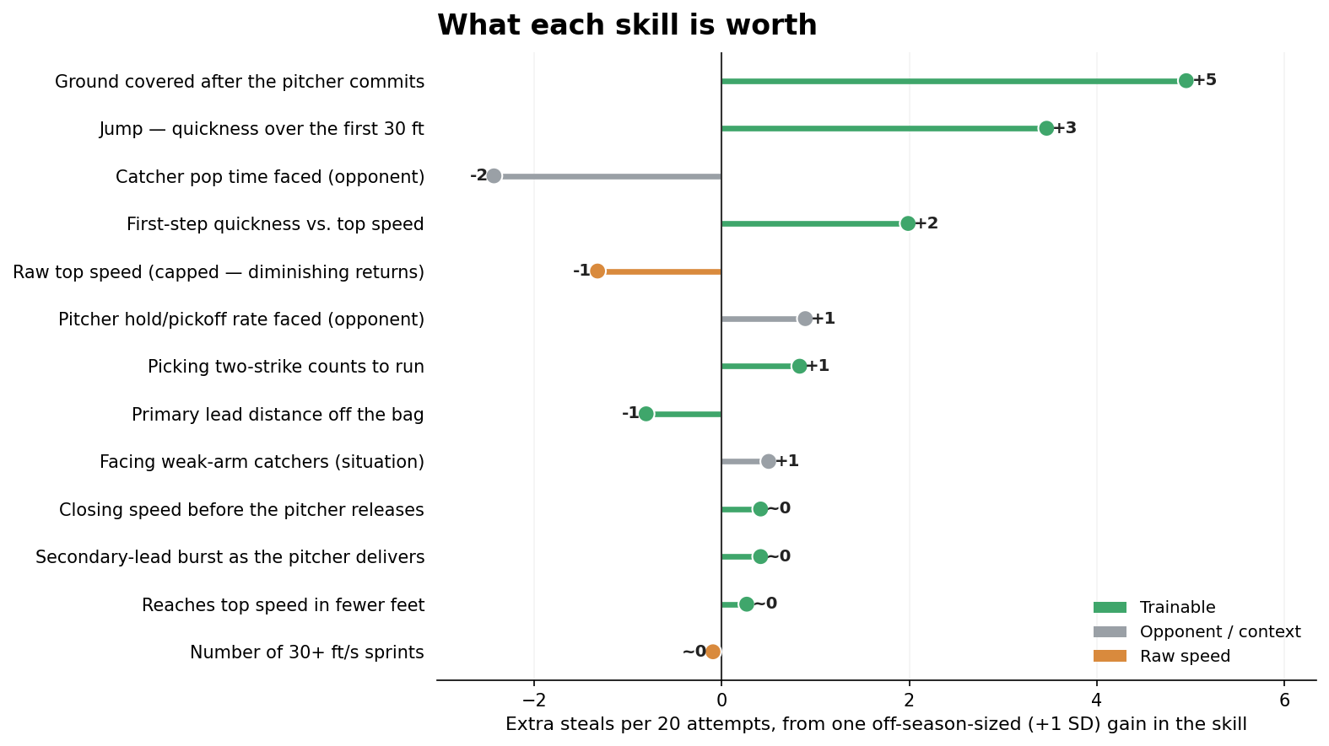
Figure B1 — each skill's worth in extra steals per 20 attempts (one off-season-sized +1-SD gain).
Feature | League  Avg | One-Step  Improvement | Success-Rate  Change (pp) | Odds  Multiplier
Post-Release Distance | 52.205 | 2.916 | +24.76 | 3.994
Jump Time | 1.768 | 0.043 | +17.32 | 2.345
Avg Catcher Pop Faced | 1.962 | 0.036 | -12.13 | 0.610
Accel Gap | -1.405 | 18.951 | +9.94 | 1.570
Sprint Speed (capped at 28) | 27.709 | 0.553 | -6.61 | 0.761
Avg Pitcher Pickoff Rate Faced | 0.011 | 0.010 | +4.46 | 1.214
Two-Strike Count Share | 0.862 | 0.208 | +4.16 | 1.198
Primary Lead | 11.810 | 0.826 | -4.02 | 0.846
Share vs Weak-Arm Catchers | 0.265 | 0.315 | +2.51 | 1.114
Lead Gain (jerk) | 3.730 | 0.791 | +2.08 | 1.093
Pre-Release Velocity | 2.869 | 0.609 | +2.08 | 1.093
Accel→Top-Speed Premium | 0.453 | 11.840 | +1.34 | 1.059
Bolts | 14.355 | 24.845 | -0.46 | 0.981

C Slow-Steal Skill (SSSI) — Full Top 25 with components
What we did. The full Top 25, components exposed.
BOTTOM LINE Skill, not speed, drives the ranking — leaders cluster in the mid-20s ft/s while grading elite on jump, burst, and steals-above-expected.
Variables in this view:
- Player — Runner (and season).
- Top Speed — Sprint speed in feet/second — the structural baseline (Statcast).
- Jump (s) — Seconds to cover the first 30 ft. Lower = quicker first step.
- Steals Above Speed-Expected — Success rate above the rate speed alone predicts.
- First-Step Burst — Reaches top speed in fewer feet than his speed predicts.
- Slow-Steal Skill — Skill beyond raw speed. Higher = better.
# | Player | Yr | Top Speed  (ft/s) | Jump (s)  lower better | Steals Above  Speed-Expected | First-Step  Burst | SB% | Slow-Steal  Skill
1 | Josh Naylor | 2025 | 24.4 | 1.87 | +12.2% | +7.6 | 92% | +1.85
2 | Josh Naylor | 2026 | 24.6 | 1.84 | +4.9% | +8.0 | 84% | +1.68
3 | Freddie Freeman | 2024 | 25.8 | 1.81 | +4.3% | -4.4 | 81% | +1.23
4 | Christian Vázquez | 2021 | 25.2 | 1.93 | -7.3% | +4.4 | 70% | +1.19
5 | Juan Soto | 2025 | 25.8 | 1.85 | +12.9% | +0.6 | 89% | +1.18
6 | Kyle Schwarber | 2025 | 25.9 | 1.79 | +5.6% | +0.8 | 82% | +1.15
7 | Miguel Rojas | 2024 | 25.8 | 1.88 | +3.0% | +10.6 | 79% | +1.12
8 | Kyle Tucker | 2024 | 26.0 | 1.80 | +17.1% | +6.0 | 93% | +1.11
9 | Manny Machado | 2024 | 25.8 | 1.86 | +6.5% | +0.6 | 83% | +1.09
10 | Alec Burleson | 2024 | 25.5 | 1.88 | -5.1% | -5.0 | 72% | +1.08
11 | Ryan McMahon | 2022 | 25.8 | 1.79 | -3.6% | -4.4 | 73% | +1.06
12 | Manny Machado | 2025 | 25.8 | 1.88 | +5.1% | -9.4 | 81% | +1.05
13 | Joc Pederson | 2024 | 25.5 | 1.83 | -8.6% | -5.0 | 68% | +1.04
14 | Josh Naylor | 2023 | 25.8 | 1.83 | +0.9% | -4.4 | 77% | +0.99
15 | TJ Friedl | 2024 | 26.5 | 1.77 | +10.4% | +12.0 | 86% | +0.90
16 | Kyle Schwarber | 2022 | 26.4 | 1.82 | +11.2% | -3.2 | 87% | +0.89
17 | Ryan McMahon | 2023 | 25.8 | 1.80 | -17.0% | -4.4 | 59% | +0.88
18 | Freddie Freeman | 2023 | 26.7 | 1.80 | +17.2% | +7.4 | 93% | +0.87
19 | Adam Frazier | 2023 | 26.5 | 1.79 | -1.1% | +7.0 | 74% | +0.86
20 | Mookie Betts | 2024 | 26.7 | 1.82 | +11.0% | +12.4 | 86% | +0.86
21 | Nolan Schanuel | 2024 | 26.4 | 1.84 | +11.2% | -8.2 | 87% | +0.86
22 | Christian Walker | 2023 | 26.4 | 1.87 | +17.4% | -3.2 | 93% | +0.85
23 | Cal Raleigh | 2025 | 26.0 | 1.85 | +1.8% | +1.0 | 78% | +0.84
24 | Paul Goldschmidt | 2021 | 26.3 | 1.84 | +17.8% | -3.4 | 93% | +0.84
25 | Paul Goldschmidt | 2024 | 26.3 | 1.84 | +17.4% | +1.6 | 93% | +0.83

D Expected SB Outcome (xSB) — Full Leaderboards
What we did. Steal Value (xSB) = z(net steals above average) + z(top speed). Surfaces runners who are both fast AND productive.
BOTTOM LINE Ceiling cases are burners (De La Cruz, Carroll); Naylor & Soto reach the same production from the slow side.
Variables in this view:
- Player — Runner (and season).
- Top Speed — Sprint speed in feet/second — the structural baseline (Statcast).
- Net SB — Stolen bases minus times caught.
- Speed (SD) — Top speed in standard deviations vs. the league.
- Steal Value (xSB) — z(net steals above avg) + z(top speed).
# | Player | Yr | Top Speed  (ft/s) | SB | CS | Net SB | Speed  (SD) | Steals  (SD) | Steal Value  (xSB)
1 | Billy Hamilton | 2015 | 29.7 | 57 | 8 | 49 | +1.69 | +4.89 | +6.57
2 | Billy Hamilton | 2016 | 30.2 | 58 | 8 | 50 | +2.14 | +4.38 | +6.52
3 | Billy Hamilton | 2017 | 30.1 | 59 | 13 | 46 | +1.82 | +4.37 | +6.18
4 | Elly De La Cruz | 2024 | 30.0 | 67 | 16 | 51 | +1.74 | +4.08 | +5.82
5 | Esteury Ruiz | 2023 | 29.6 | 67 | 13 | 54 | +1.30 | +4.13 | +5.43
6 | Corbin Carroll | 2023 | 30.1 | 54 | 5 | 49 | +1.81 | +3.61 | +5.42
7 | Trea Turner | 2017 | 30.3 | 46 | 8 | 38 | +1.99 | +3.38 | +5.37
8 | Dee Strange-Gordon | 2017 | 29.4 | 60 | 16 | 44 | +1.19 | +4.12 | +5.31
9 | Trea Turner | 2018 | 30.1 | 43 | 9 | 34 | +1.93 | +3.31 | +5.23
10 | Jon Berti | 2022 | 29.5 | 41 | 5 | 36 | +1.14 | +3.94 | +5.08
11 | Adalberto Mondesi | 2019 | 29.9 | 43 | 7 | 36 | +1.63 | +3.34 | +4.97
12 | Starling Marte | 2021 | 28.5 | 47 | 5 | 42 | +0.37 | +4.59 | +4.96
13 | Trea Turner | 2021 | 30.6 | 32 | 5 | 27 | +2.50 | +2.43 | +4.93
14 | Dee Strange-Gordon | 2015 | 29.1 | 58 | 20 | 38 | +1.11 | +3.50 | +4.61
15 | Trea Turner | 2019 | 30.3 | 35 | 5 | 30 | +2.04 | +2.56 | +4.60

D.1 Naylor & Soto — Crafty Technicians (year-by-year)
Both carry a negative Untapped Speed every year — they out-steal their speed consistently.
Player | Yr | Top Speed  (ft/s) | SB | CS | Speed  (SD) | Steals  (SD) | Untapped  Speed | Quadrant
Juan Soto | 2025 | 25.8 | 38 | 4 | -2.29 | +2.61 | -4.90 | Crafty Technician
Juan Soto | 2019 | 27.3 | 12 | 1 | -1.04 | +0.08 | -1.12 | Crafty Technician
Josh Naylor | 2025 | 24.4 | 30 | 2 | -3.62 | +1.88 | -5.50 | Crafty Technician
Juan Soto | 2021 | 27.0 | 9 | 7 | -1.15 | -1.16 | +0.01 | Stationary
Juan Soto | 2024 | 26.8 | 7 | 4 | -1.25 | -1.07 | -0.18 | Stationary
Juan Soto | 2023 | 26.8 | 12 | 5 | -1.56 | -0.76 | -0.80 | Stationary
Josh Naylor | 2026 | 24.6 | 12 | 2 | -3.43 | +0.64 | -4.07 | Crafty Technician
Josh Naylor | 2023 | 25.8 | 10 | 3 | -2.59 | -0.76 | -1.83 | Stationary

E Blueprint Conversion Score (BCS)
What we did. BCS combines three speed-adjusted residuals — converts more than speed predicts, covers more ground than speed predicts, less a caught-stealing penalty.
BOTTOM LINE Full of slow-but-skilled runners (★ Naylor, Soto) holding their own against burners.
Variables in this view:
- BCS — Blueprint Conversion Score — speed-adjusted steal-skill composite.
- Ground vs Speed-Expected — Feet of ground covered beyond what speed predicts.
- Top Speed — Sprint speed in feet/second — the structural baseline (Statcast).
- SB / CS — Stolen bases / times caught stealing.
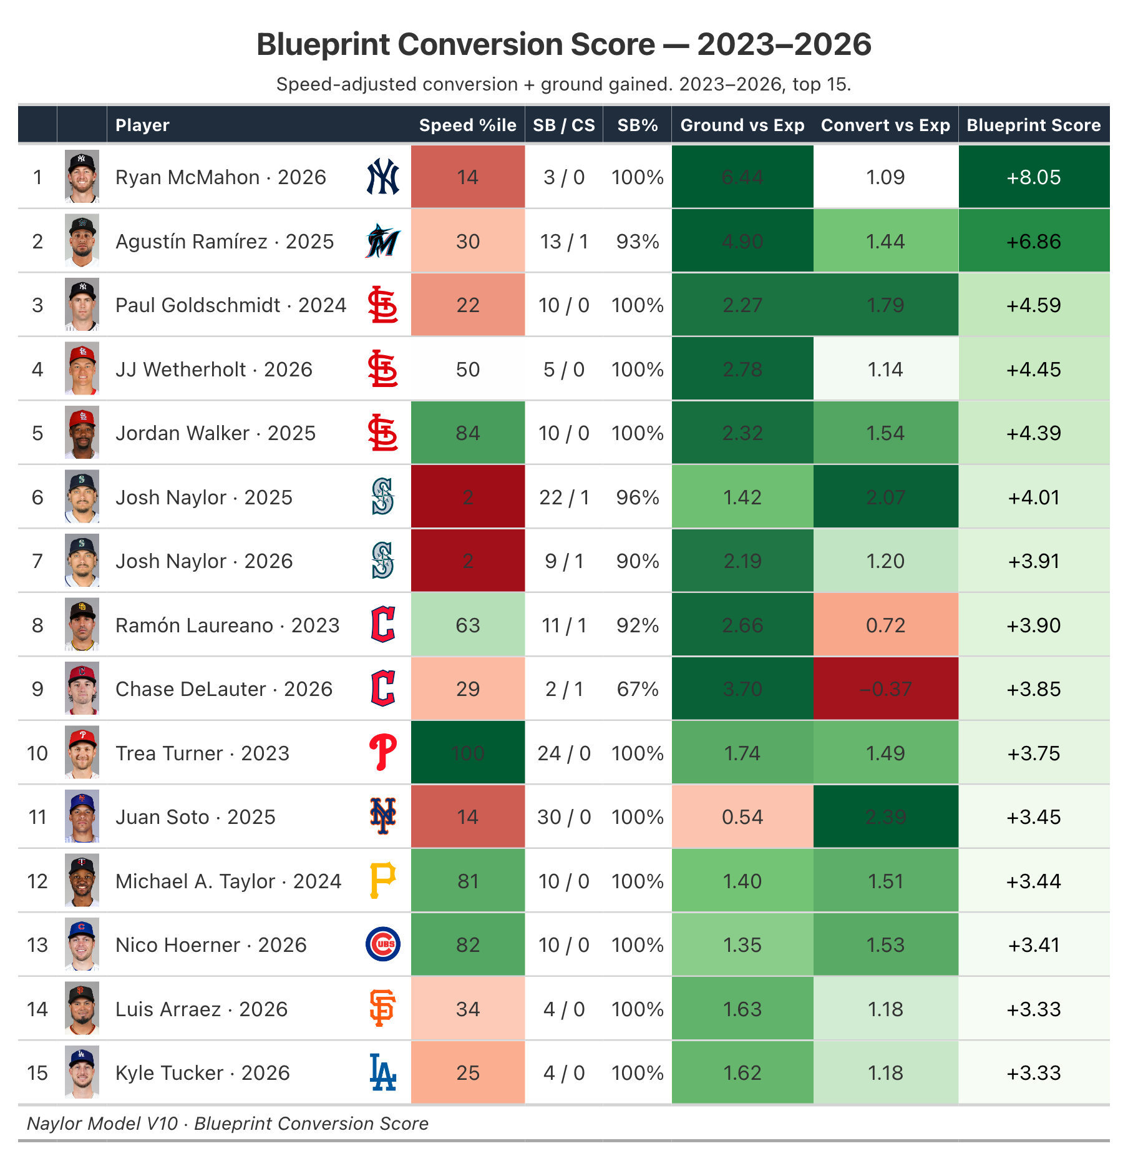
Figure E1 — Top 15 by Blueprint Conversion Score.

E.1 Overall Top 15
# | Player | Team | Yr | Speed  %ile | SB | CS | SB% | Gain  (ft) | Ground vs  Exp (SD) | Convert vs  Exp (SD) | BCS
1 | Ryan McMahon |  | 2026 | 14 | 3 | 0 | 100% | 24.5 | +6.44 | +1.09 | +8.05
2 | Agustín Ramírez |  | 2025 | 30 | 13 | 1 | 93% | 21.3 | +4.90 | +1.44 | +6.86
3 | Paul Goldschmidt |  | 2024 | 22 | 10 | 0 | 100% | 16.7 | +2.27 | +1.79 | +4.59
4 | JJ Wetherholt |  | 2026 | 50 | 5 | 0 | 100% | 16.8 | +2.78 | +1.14 | +4.45
5 | Jordan Walker |  | 2025 | 84 | 10 | 0 | 100% | 15.3 | +2.32 | +1.54 | +4.39
6 | Josh Naylor |  | 2025 | 2 | 22 | 1 | 96% | 16.7 | +1.42 | +2.07 | +4.01
7 | Josh Naylor |  | 2026 | 2 | 9 | 1 | 90% | 17.7 | +2.19 | +1.20 | +3.91
8 | Ramón Laureano |  | 2023 | 63 | 11 | 1 | 92% | 16.9 | +2.66 | +0.72 | +3.90
9 | Chase DeLauter |  | 2026 | 29 | 2 | 1 | 67% | 19.0 | +3.70 | -0.37 | +3.85
10 | Trea Turner |  | 2023 | 100 | 24 | 0 | 100% | 13.6 | +1.74 | +1.49 | +3.75
11 | Juan Soto |  | 2025 | 14 | 30 | 0 | 100% | 14.2 | +0.54 | +2.39 | +3.45
12 | Michael A. Taylor |  | 2024 | 81 | 10 | 0 | 100% | 13.6 | +1.40 | +1.51 | +3.44
13 | Nico Hoerner |  | 2026 | 82 | 10 | 0 | 100% | 13.5 | +1.35 | +1.53 | +3.41
14 | Luis Arraez |  | 2026 | 34 | 4 | 0 | 100% | 15.2 | +1.63 | +1.18 | +3.33
15 | Kyle Tucker |  | 2026 | 25 | 4 | 0 | 100% | 15.4 | +1.62 | +1.18 | +3.33

E.2 Bottom 15 — Squanderers (fast, serial caught-stealings)
# | Player | Team | Yr | Speed  %ile | SB | CS | SB% | Gain  (ft) | Ground vs  Exp (SD) | Convert vs  Exp (SD) | BCS
515 | Chandler Simpson |  | 2025 | 97 | 38 | 8 | 83% | 9.9 | -0.32 | -0.00 | -6.71
514 | Bobby Witt Jr. |  | 2023 | 100 | 40 | 8 | 83% | 9.6 | -0.44 | -0.19 | -6.57
513 | Ji Hwan Bae |  | 2023 | 97 | 19 | 7 | 73% | 11.2 | +0.16 | -1.27 | -5.86
512 | Daylen Lile |  | 2025 | 90 | 8 | 6 | 57% | 8.3 | -1.43 | -2.14 | -5.04
511 | Bobby Witt Jr. |  | 2024 | 100 | 25 | 6 | 81% | 9.4 | -0.13 | -0.22 | -4.87
510 | Ceddanne Rafaela |  | 2024 | 88 | 15 | 8 | 65% | 9.9 | -0.57 | -1.63 | -4.62
509 | Elly De La Cruz |  | 2024 | 99 | 55 | 9 | 86% | 8.9 | -0.63 | +0.49 | -4.60
508 | Bobby Witt Jr. |  | 2025 | 100 | 32 | 7 | 82% | 10.1 | +0.03 | -0.02 | -4.33
507 | Myles Straw |  | 2023 | 94 | 17 | 5 | 77% | 13.5 | +1.27 | -0.74 | -4.20
506 | Luis Rengifo |  | 2025 | 39 | 7 | 7 | 50% | 8.5 | -2.15 | -2.57 | -4.20
505 | Jacob Young |  | 2025 | 94 | 12 | 7 | 63% | 9.8 | -0.49 | -1.76 | -4.11
504 | Jeremy Peña |  | 2023 | 95 | 13 | 7 | 65% | 10.2 | -0.53 | -1.88 | -4.08
503 | Alejandro Osuna |  | 2026 | 82 | 1 | 2 | 33% | 7.4 | -2.04 | -1.98 | -4.04
502 | David Hamilton |  | 2025 | 94 | 15 | 5 | 75% | 10.5 | -0.14 | -0.74 | -3.95
501 | Taylor Ward |  | 2026 | 56 | 1 | 2 | 33% | 7.1 | -2.60 | -1.78 | -3.85

E.3 Ground Covered Beyond Speed-Expected — Top 15
Feet gained first-move→release, after removing sprint speed. Slow runners top it.
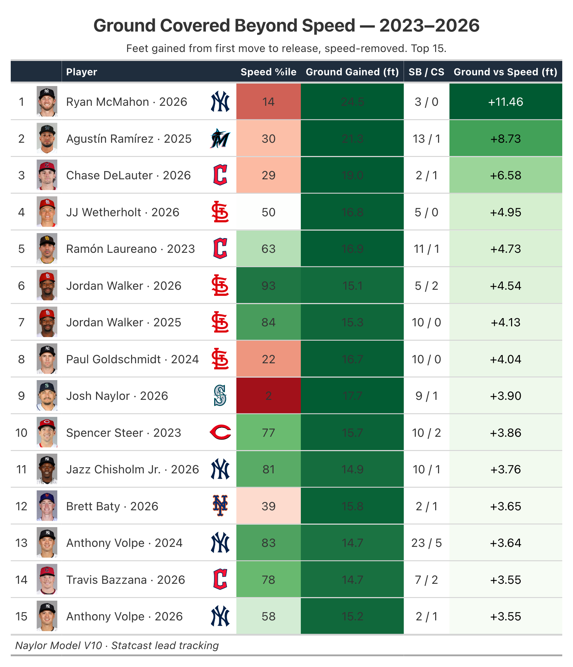
Figure E2 — Top 15 by ground covered beyond what speed predicts.

