The Naylor Model · v15
Predicting stolen-base success from the runner's lead: model specification, results, and a row-level audit
Supersedes v11–v14 and the separate Results & Discussion. This is the single report for the project.
ABSTRACT A four-feature logistic regression predicts whether an individual stolen-base attempt succeeds, from 10,844 tracked attempts (2023–2026). Out-of-fold AUROC = 0.7559 (bootstrap 95% CI 0.7416–0.7703) against a permutation null of 0.4985. The dominant predictor is the ground the runner gains between the pitcher's first move and release: a one-standard-deviation increase multiplies the odds of being safe by 3.19×, against 1.40× for sprint speed. Every coefficient is sign-stable across 1,000 bootstrap resamples, the learning curve is flat past ~85% of the sample, and a hand-computed reconstruction of the linear predictor matches sklearn to 1.7e-15. The model is well discriminating but imperfectly calibrated (ECE = 0.0208), which §6.2 quantifies rather than corrects.

1 · Task definition
The project asks four distinct questions at three different grains. Confusing them is the single easiest way to misread what follows, so they are separated up front. This report is primarily about the first row — the model that is deployed in the browser calculator — with the season-level constructions covered in §7.
Question | Grain | Model | n | Target
Given he went, is he safe? | one attempt | Logistic regression (4 features) | 10,844 | SB = 1, CS = 0
Same, with full pitch context | one attempt | XGBoost (19 features) | 11,140 | SB = 1, CS = 0
Will he attempt at all? | one opportunity | XGBoost | 555,092 | attempt = 1
How well does he steal, for his speed? | runner-season | Steal+ (closed form) | 452 | — (constructed)
Only the first three are fitted predictive models with an AUC. Steal+ and Burst are constructions with an explicit baseline, not estimators — §7.

2 · Data

2.1 · Sample construction
The modelling frame is built by an explicit, auditable funnel. Merge order and the terminal dropna are reproduced exactly from the shipped pipeline rather than re-derived, because StratifiedKFold assigns folds by position — any reordering silently changes the out-of-fold AUROC.
Stage | n | Retained
Raw_Attempts.csv rows | 12,021 | 100.0%
decided (SB/CS only) | 11,140 | 92.7%
+ sprint speed, pop time | 11,140 | 92.7%
complete on all 4 features | 10,844 | 90.2%
dropped: any feature missing | 296 | —
Attrition is 296 rows (2.7% of decided attempts), driven almost entirely by missing catcher pop time. Pickoffs and other undecided outcomes are excluded by construction: the target is defined only on attempts that resolved as SB or CS.

2.2 · Class balance and temporal drift
Season | n | Safe | Base rate
2023 | 2,989 | 2,475 | 0.8280
2024 | 3,052 | 2,467 | 0.8083
2025 | 2,923 | 2,356 | 0.8060
2026 | 1,880 | 1,472 | 0.7830
ALL | 10,844 | 8,770 | 0.8087
TWO CONSEQUENCES The target is heavily imbalanced toward success (80.9%) and the base rate is falling monotonically — 0.828 in 2023 to 0.783 in 2026. Two consequences carried through the whole report: AUPRC must be quoted against this base rate as its no-skill floor, and any forward-in-time validation is scored in a harder environment than it was trained on (§6.5).

2.3 · Missingness, distributions, edge cases
Feature | Missing (pre-drop) | % missing | Missing (post-drop)
sprint_speed | 33 | 0.30% | 0
lead_at_firstmove_ft | 56 | 0.50% | 0
gain_to_release_ft | 56 | 0.50% | 0
pop_faced | 209 | 1.88% | 0
lead_at_release_ft | 56 | 0.50% | 0
Feature | Unit | Mean | SD | Min | Median | Max | Skew | Distinct
sprint_speed | ft/s | 28.310 | 1.056 | 23.80 | 27.7 | 30.60 | -0.384 | 64
lead_at_firstmove_ft | ft | 12.355 | 2.001 | 4.80 | 11.1 | 22.50 | 1.356 | 159
gain_to_release_ft | ft | 11.613 | 3.834 | -0.70 | 9.1 | 39.60 | 1.266 | 279
pop_faced | s | 1.957 | 0.051 | 1.83 | 1.93 | 2.11 | 0.022 | 27
Median column is the 50th percentile. All four features are used on their raw scale — the model is a plain logistic regression with no transformation, so coefficients read directly in ft/s, feet and seconds.
Assumption check | Violations
duplicate play_id | 0
gain_to_release_ft <= 0 | 1
lead_at_firstmove_ft <= 0 | 0
violations of firstmove + gain == lead_at_release (> 0.1 ft) | 0
The last row is the important one. lead_at_release is the exact sum of the two lead features, and zero rows violate it beyond the 0.1 ft rounding granularity — which is precisely why that column is excluded from the model (§3). The single non-positive ground-gained value is a runner who lost ground before release (a dive back), physically real and left in.

3 · Feature set and collinearity
Four features, chosen by measurement against alternatives rather than by intuition. The specification search is reported in §3.2.
Feature | R² on the others | VIF (shipped) | R² with lead_at_release | VIF (with it)
sprint_speed | 0.0555 | 1.0587 | 0.055472 | 1.1
lead_at_firstmove_ft | 0.1303 | 1.1498 | 0.999372 | 1,591.7
gain_to_release_ft | 0.1703 | 1.2053 | 0.999829 | 5,844.4
pop_faced | 0.0044 | 1.0044 | 0.004561 | 1.0
lead_at_release_ft (excluded) | — | — | 0.999895 | 9,546.4
WHY IT MATTERS The right-hand columns show what excluding lead_at_release buys. Carried alongside its two components it is predicted by them at R² = 0.999895, driving VIFs to 1,592 / 5,844 / 9,546. Dropped, the shipped design has a maximum VIF of 1.21 — no meaningful collinearity at all. This is not a predictive question (the redundant column changes AUROC by ~0.001); it is an interpretability one. With it in, coefficients and feature importances are split arbitrarily across perfectly dependent columns and cannot be quoted.

3.2 · Specification search
Specification | n | CV AUROC | Outcome
A — speed + Burst + ground gained | 7,404 | 0.7259 | the v11 calculator
F — speed + Burst + first-move lead + gain + pop | 7,264 | 0.7470 | better, still gated by Burst
H — speed + first-move lead + gain + pop | 10,844 | 0.7559 | SHIPPED
H + catcher arm strength | 10,844 | 0.7464 | no gain; arm adds nothing over pop
Burst is a season-level residual, so it only exists for a runner with ≥10 qualified attempts; requiring it discarded ~3,600 attempts. Removing it gained both sample and accuracy. This contradicted the original design intent, and the measurement was followed rather than the intent. Burst remains the season-level technique metric (§7) — it is simply not a per-pitch input once the model already knows what the runner gained on that pitch.

4 · Model specification and training protocol
Component | Choice | Rationale
Estimator | Logistic regression | Beat XGBoost on the same features (0.7259 vs 0.7215) and stays a readable formula a coach can reason about.
Regularisation | l2, C=1.0, solver=lbfgs | sklearn default. Named explicitly so the shrinkage is never invisible; the Wald SEs in §5.1 do not account for it, which is why the bootstrap is the primary uncertainty statement.
Preprocessing | None (raw units) | Coefficients read directly per ft/s, per foot, per second. The imputer in the pipeline is a verified no-op — 0 cells imputed.
Validation | 5-fold stratified, out-of-fold | Every reported metric is computed on held-out predictions, pooled across folds.
Seed | 42 (committed) | Changing it changes the shipped fit. §6.3 measures how much of the headline AUROC is seed-dependent.
The linear predictor is reported in full for every attempt, not just as a fitted probability:
logit(pᵢ) = β₀ + Σ βf · xᵢf pᵢ = 1 / (1 + e^−logit)

5 · Results

5.1 · Coefficients and effect sizes
Term | Unit | β | Wald SE | z | Odds ratio / unit | Odds ratio / SD
gain_to_release_ft | ft | +0.3028 | 0.0108 | 28.15 | 1.35× | 3.19×
sprint_speed | ft/s | +0.3168 | 0.0260 | 12.19 | 1.37× | 1.40×
pop_faced | s | +5.8579 | 0.5205 | 11.25 | 350× | 1.35×
lead_at_firstmove_ft | ft | +0.0687 | 0.0170 | 4.04 | 1.07× | 1.15×
intercept | logit | -23.0108 | 1.3343 | -17.25 | — | —
THE HEADLINE RESULT Read the last column, not the second-to-last. Per-unit odds ratios are not comparable across features measured in different units — pop time's 350× per second looks enormous only because a whole second of pop time is roughly 20 standard deviations. Standardised, the ordering is unambiguous: ground gained (3.19× per SD) is worth more than sprint speed (1.40×), catcher pop time (1.35×) and the first-move lead (1.15×) combined. That is the project's central empirical claim, and it is what makes base-stealing look coachable rather than structural.
The z-statistics tell the same story about evidential strength: ground gained z = 28.1, sprint speed z = 12.2, pop time z = 11.3, first-move lead z = 4.0. The first-move lead is the weakest of the four by a wide margin — runners converge on a similar primary lead, so it separates them poorly — but it is retained because it is free, sign-stable, and completes the physical decomposition of the runner's position.

5.2 · Discrimination
Metric | Value | Reference | Reading
AUROC | 0.7559 | 0.5000 = chance | ranks a random safe attempt above a random caught one 76% of the time
AUPRC | 0.9256 | 0.8087 = base rate | a modest lift over the floor, not the near-perfect score it resembles
Brier | 0.1359 | lower is better | mean squared error of the probability itself
F1 | 0.8944 | at threshold 0.16 | quoted at its tuned threshold; F1 at 0.5 is not meaningful at this base rate
Fold | n | Base rate | AUROC
0 | 2,169 | 0.8087 | 0.7749
1 | 2,169 | 0.8087 | 0.7608
2 | 2,169 | 0.8087 | 0.7412
3 | 2,169 | 0.8087 | 0.7461
4 | 2,168 | 0.8090 | 0.7579
spread | — | — | 0.0337
Per-fold AUROC ranges 0.7412–0.7749. The fold-to-fold spread (0.034) is about four times the bootstrap SD, so single-fold numbers should never be quoted alone.
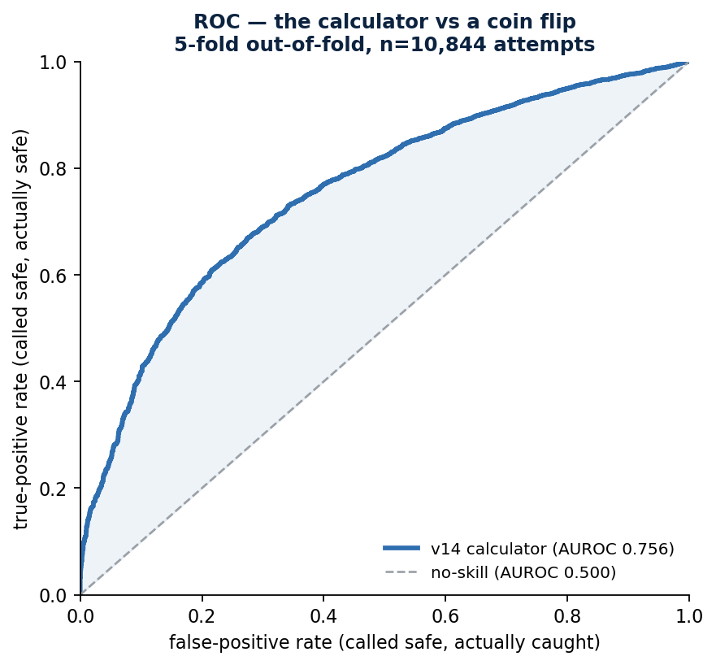
The ROC curve behind the headline number. The curve is smooth and well above the diagonal across the whole range — there is no narrow operating region carrying the performance.

5.3 · Calibration
Decile | n | Predicted | Observed | Gap | Gap in binomial SE
1 | 1,085 | 0.5310 | 0.5290 | -0.0020 | -0.13
2 | 1,084 | 0.6731 | 0.6310 | -0.0421 | -2.87
3 | 1,084 | 0.7320 | 0.6974 | -0.0346 | -2.48
4 | 1,085 | 0.7762 | 0.7696 | -0.0066 | -0.52
5 | 1,084 | 0.8124 | 0.8229 | +0.0105 | +0.91
6 | 1,084 | 0.8445 | 0.8736 | +0.0291 | +2.88
7 | 1,085 | 0.8760 | 0.9189 | +0.0429 | +5.18
8 | 1,084 | 0.9096 | 0.9308 | +0.0213 | +2.76
9 | 1,084 | 0.9487 | 0.9336 | -0.0151 | -1.99
10 | 1,085 | 0.9841 | 0.9806 | -0.0034 | -0.82
AN HONEST WEAKNESS This is the model's weakest result and it is reported as such. Expected calibration error is 0.0208, but 5 of 10 deciles sit more than two binomial standard errors from their predicted rate — the worst is decile 7, which predicts 0.876 and observes 0.919. The pattern is systematic rather than noisy: the model is under-confident in the middle of the range and slightly over-confident at the top. A stated probability from this model should be read as a good ranking and an approximate rate, with roughly ±4 points of slack in the middle deciles. No post-hoc correction is applied, because the drift has an identifiable cause (§2.2, the falling league base rate) that isotonic rescaling on pooled data would hide rather than fix.

5.4 · Numerical reproducibility
Identity asserted | Max residual | Tolerance
intercept + Σ βf·xf = logit (raw contributions) | 0.00e+00 | < 1e-9
logit at mean + Σ βf·(xf − mean) = logit (centered) | 7.11e-15 | < 1e-9
hand-computed probability = sklearn predict_proba | 1.67e-15 | < 1e-12
hand-computed class = sklearn predict | 0 mismatches | = 0
imputer is a no-op (pipeline parity) | 0 cells imputed | = 0
Every one of the 10,844 attempts is reconstructed by hand from the coefficients and compared against the fitted estimator. This is what licenses the per-attempt explanations the browser calculator shows: the decomposition is of the shipped model, not of a look-alike refit. The reference-fit check additionally asserts that this run lands on the committed coefficients — all seven quantities match to within 5e-5.
Attempt | Yr | Base | Result | Speed | Lead | Gain | Pop | logit | P(safe) | Top driver
3975 | 2025 | 3B | CS | 27.3 | 13.3 | -0.7 | 1.94 | -2.29 | 0.092 | gain to release
2832 | 2026 | 3B | CS | 25.8 | 11.8 | 0.8 | 1.97 | -2.24 | 0.096 | gain to release
10149 | 2025 | 2B | SB | 28.9 | 12.9 | 8.7 | 1.95 | +1.09 | 0.748 | gain to release
1709 | 2026 | 2B | SB | 30.3 | 11.4 | 12.5 | 1.99 | +2.82 | 0.943 | sprint speed
2703 | 2023 | 2B | SB | 28.5 | 9.7 | 15.2 | 2.05 | +3.30 | 0.964 | gain to release
2800 | 2025 | 2B | SB | 28.4 | 14.7 | 26.1 | 1.89 | +5.97 | 0.997 | gain to release
8088 | 2023 | 2B | SB | 28.1 | 12.3 | 35.1 | 1.93 | +8.67 | 1.000 | gain to release
5292 | 2025 | 2B | SB | 27.7 | 16.0 | 39.6 | 2.00 | +10.57 | 1.000 | gain to release
Eight attempts spanning the probability range. 'Top driver' is the largest mean-centered contribution — the term that most moved this attempt away from an average one. It is gain_to_release on seven of the eight.

6 · Robustness and uncertainty

6.1 · Bootstrap
Term | Mean | SD | 95% CI low | 95% CI high | Sign stable | CV(|β|)
intercept | -23.0425 | 1.1677 | -25.2215 | -20.7571 | yes | 0.0507
sprint_speed | +0.3173 | 0.0253 | +0.2685 | +0.3661 | yes | 0.0799
lead_at_firstmove_ft | +0.0698 | 0.0186 | +0.0340 | +0.1057 | yes | 0.2658
gain_to_release_ft | +0.3029 | 0.0108 | +0.2816 | +0.3229 | yes | 0.0357
pop_faced | +5.8614 | 0.4095 | +5.0669 | +6.6942 | yes | 0.0699
1,000 resamples. Every coefficient keeps its sign in 95% of draws, so no effect direction is in doubt. Relative stability follows the z-statistics exactly: ground gained is the tightest (CV 0.036) and the first-move lead the loosest (0.266). AUROC scored on the out-of-bag rows of each draw is 0.7559 (SD 0.0075), 95% CI 0.7416–0.7703 — the interval to quote.

6.2 · Seed sensitivity and the permutation null
Test | Result | What it rules out
Repeated 5-fold CV (10 partitions) | AUROC 0.7557 (SD 0.0003, range 0.7552–0.7562) | that the headline number is an artefact of one lucky fold assignment — it is not; the seed moves it by <0.001
Label permutation (200 shuffles) | null 0.4985 (SD 0.0107, p95 0.5142) vs observed 0.7559; p = 0.004975 | that 0.756 could arise from noise at this sample size — 0 of 200 nulls reached it, and the p-value is at its resolution floor

6.3 · Learning curve — is more data the answer?
Fraction of sample | n | AUROC (mean) | SD across draws
10% | 1,084 | 0.7351 | 0.0089
20% | 2,169 | 0.7497 | 0.0077
30% | 3,253 | 0.7586 | 0.0086
50% | 5,422 | 0.7536 | 0.0032
70% | 7,591 | 0.7552 | 0.0039
85% | 9,217 | 0.7558 | 0.0013
100% | 10,844 | 0.7559 | 0.0000
THE PRACTICAL READ The curve is flat from roughly 30% of the sample onward: 3,253 attempts already reach 0.7586, and the last 15% of the data is worth +0.0000. More attempts of the same kind will not improve this model. The ceiling is the feature set, not the sample size — which is what makes the missing pitcher-side information (§8) the most valuable thing the project does not currently have.

6.4 · The XGBoost engine and forward validation
A gradient-boosted model with the full pitch, battery and catcher context is fit separately as a research ceiling. It is more accurate and less interpretable; the shipped calculator trades roughly 0.027 AUROC for a formula that can be read.
Validation regime | What it tests | AUROC | AUPRC | Brier
random | shuffled folds — the optimistic number | 0.7829 | 0.9387 | 0.1295
group | held-out runners — none appear on both sides | 0.7783 | 0.9368 | 0.1303
forward | trained on past seasons, tested on the next | 0.7633 | 0.9296 | 0.1382
Grouping by runner costs only 0.005 AUROC, so the model is not memorising individual runners. Testing forward in time costs 0.020 and is the number any forward-looking claim should use — it is lower largely because the league base rate is falling (§2.2), so a model trained on the past predicts an easier environment than the one it is scored in.
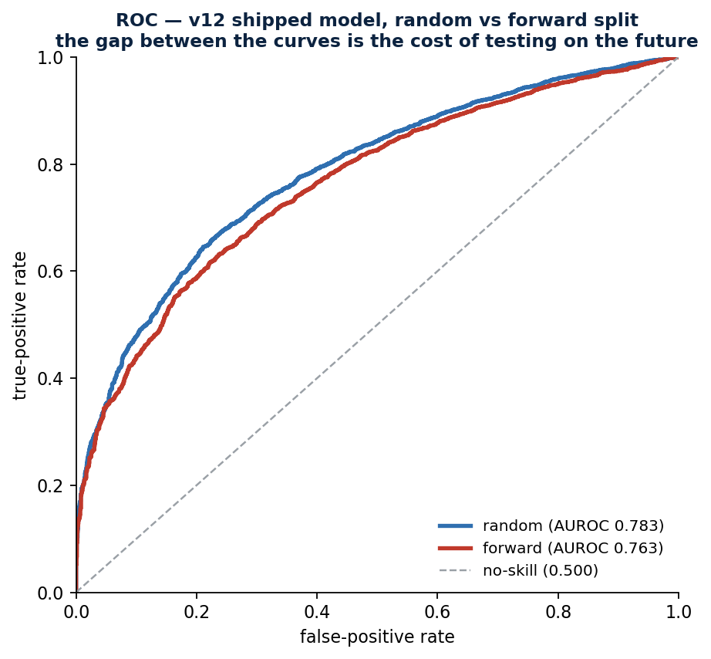
Random vs forward split. The gap between the curves is the cost of not being allowed to see the future.

7 · The season-level constructions
Steal+ and Burst are not estimators — they are 'actual minus expected' constructions with an explicit, published baseline. They are included here because the report is the single document for the project, and because §7.3 is a genuine ML result about them.
Quantity | Definition | Speed-neutral?
NetSpeed | attempts × (2·p_speed − 1), where p_speed = a₀ + a₁·sprint_speed | no — it IS the speed term
Steal+ | Net bases (SB − CS) − NetSpeed = 2(1−p)·SB − 2p·CS | yes — r = -0.01 with sprint speed
Ground gained | feet won between the pitcher's first move and his release | no — r = -0.48, deliberately
Burst | ground gained − (b₀ + b₁·sprint_speed) | yes — r = -0.00 by construction
The decomposition Net Bases = NetSpeed + Steal+ is an identity and closes to 3.6e-15 across all 452 runner-seasons; recomputing both terms from the published league constants rather than trusting the leaderboard columns agrees to 3.6e-15.

7.1 · Era separation
Era | Seasons | n | League SB% | p = a₀ + a₁·speed | ground = b₀ + b₁·speed
PRE | 2016-2022 | 690 | 76.4% | 0.1330 + 0.02200·s | 23.177 − 0.4033·s
POST | 2023-2026 | 452 | 80.4% | 0.4730 + 0.01136·s | 32.186 − 0.7206·s
ALL | 2016-2026 | 1142 | 78.1% | 0.2632 + 0.01794·s | 26.898 − 0.5345·s
The 2023 rule package roughly halved the return on raw sprint speed (2.20 → 1.14 percentage points per ft/s) while lifting the league floor. Pooling the eras barely disturbs the ranking (Spearman 0.994) but destroys the property the metric exists for: Burst's correlation with sprint speed moves from -0.000 to -0.139. The eras are therefore fit separately.
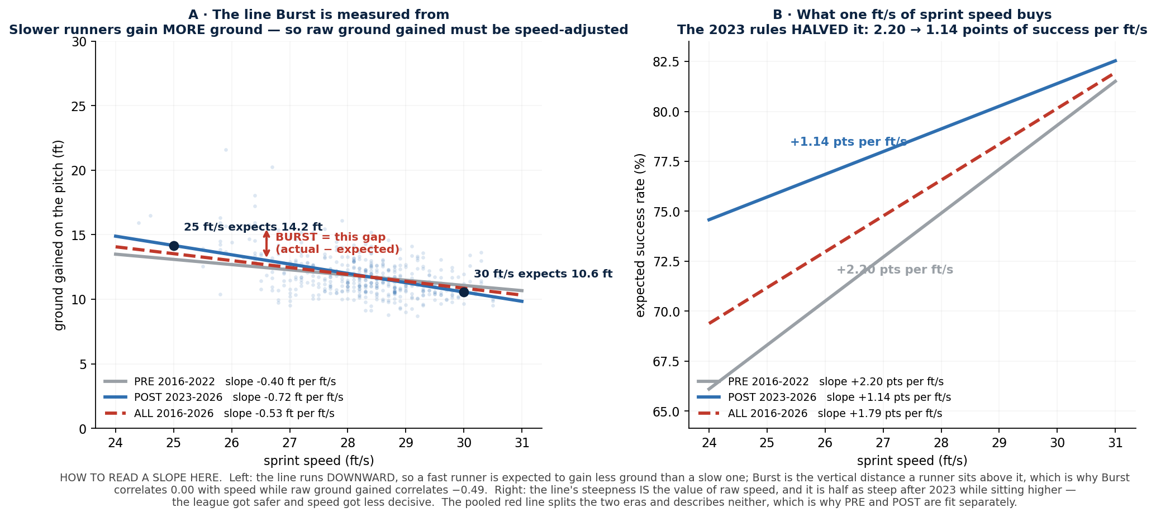
The two baselines the season metrics subtract from, drawn per era with the slopes annotated.

7.2 · Reliability of a single season's Steal+
Steal+ repeats year to year at only 0.19, which invites the conclusion that it is not measuring skill. It is answerable in closed form, and the answer substantially rehabilitates the metric.
Quantity | Value | Interpretation
Observed SD of Steal+ | 4.17 bases | spread actually seen across 452 runner-seasons
SD from chance alone | 3.73 bases | SB ~ Binomial(attempts, p_speed) under the null of exactly average skill
Implied true skill SD | 1.87 bases | what survives
Reliability of one season | 0.201 | signal share of variance — 80% is sampling noise
Observed year-over-year r | 0.192 | INDEPENDENT CHECK — the noise model predicted 0.20
Two calculations sharing no code agree to within 0.01. The weak year-to-year figure is therefore not a defect in Steal+ but the arithmetic of grading a season on a median of 17 binary outcomes. The practical consequence is an error bar: at median volume the chance SD is 3.36 bases, and only 7.1% of runner-seasons separate from average by more than two of them. Burst, averaged over hundreds of tracked pitches instead of 17 outcomes, repeats at +0.46.
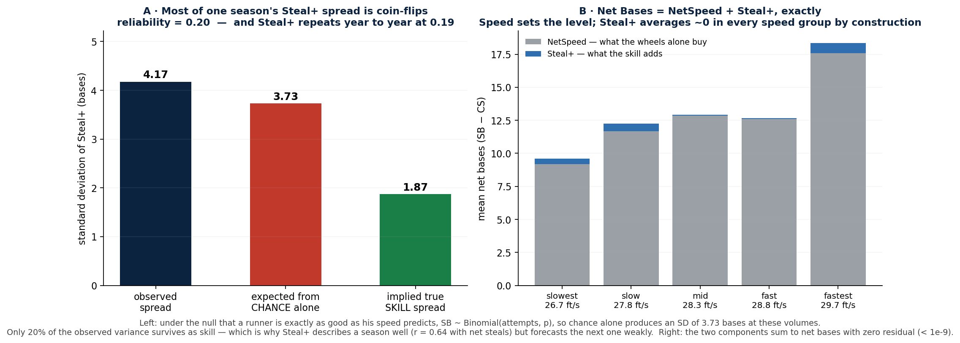

8 · The decision model, and what it implies about everything above
Model | Split | AUROC | AUPRC | Floor | Lift | Brier
situation only | random | 0.6703 | 0.0418 | 0.0230 | 1.8× | 0.0222
personnel only | random | 0.7149 | 0.0568 | 0.0230 | 2.5× | 0.0221
v13 FULL (situation + personnel) | random | 0.7797 | 0.0753 | 0.0230 | 3.3× | 0.0218
v13 FULL | group | 0.7690 | 0.0683 | 0.0230 | 3.0× | 0.0219
v13 FULL | forward | 0.7632 | 0.0655 | 0.0234 | 2.8× | 0.0224
Speed group | Range (ft/s) | Runner-seasons | Opportunities | Attempts | Attempt rate
slowest | 22.1–26.1 | 229 | 111,958 | 764 | 0.68%
slow | 26.2–27.0 | 276 | 121,320 | 1,482 | 1.22%
mid | 27.1–27.7 | 280 | 104,050 | 1,954 | 1.88%
fast | 27.8–28.4 | 277 | 107,506 | 3,309 | 3.08%
fastest | 28.5–30.6 | 236 | 106,989 | 5,170 | 4.83%
SELECTION EFFECT This table is the most important caveat in the report. The fastest quintile attempts at 4.83% and the slowest at 0.68% — a 7.1× gradient — on near-identical shares of total opportunity. Attempts are selected, heavily and on speed. Everything in §5 is therefore fit on attempts someone chose to make, and the 80.9% base rate is a property of that filtered sample. An AUROC of 0.756 does not license the claim that the model would rank hypothetical, never-attempted steals equally well.

9 · Verification harness
Guard | What it asserts | Current result
n = 5 purity | 5 runner-seasons scored alone equal the same 5 scored inside the full pool, over 200 random draws per era | 0.00e+00 — identical to the last bit
Negative control | the purity check must FAIL against a scorer rigged to rank percentiles within the batch | caught at 48.2, clean at 0.0 once restored
Leak audit | none of 11 outcome-derived column names reaches any feature list | all 11 absent
Collinearity guard | max VIF < 10 across every shipped feature set | v12 leads 1.14 · v12 shipped 6.63 · v11 calculator 1.21
Decomposition invariant | Net Bases = NetSpeed + Steal+ on every subsample | closes to 3.6e-15
Reference-fit check | decompose.py must land on the committed coefficients | all 7 quantities match within 5e-5
These assert rather than print, so a regression fails the run. The negative control is what makes the zeros meaningful — a test that always returns zero proves nothing until it is shown to fail on the defect it was built to catch.

10 · Limitations
- Attempts are a selected sample (§8). Per-attempt coefficients describe variation among attempts that survived a 7.1× speed-dependent selection filter and cannot be read as counterfactually valid for attempts never made.
- Calibration is imperfect (5/10 deciles beyond 2 binomial SE). The model ranks better than it states rates; treat a quoted probability as ±4 points in the middle of the range.
- More data will not help (§6.3). The learning curve is flat past ~30% of the sample; the binding constraint is the feature set.
- No pitcher-side features. Delivery time to the plate, pickoff frequency and hold ability are the largest missing block of information. Attempted and abandoned: the public basestealing run-value leaderboard is runner-only, and the pitch-tempo endpoint ignores its year parameter.
- Single-season Steal+ is ~20% signal (§7.2). It should never be quoted without its chance-SD, and small differences between runners are not real differences.
- No run-expectancy layer. The model estimates P(safe), not whether an attempt is worth making, which additionally requires the value of the base against the cost of the out.
- 'Coachable' is an interpretation of stability and speed-independence, not a demonstrated causal property. Nothing here observes a runner being coached.
- 2026 is a partial season (through 2026-07-17), so its rows carry lower volume and wider chance bands.

11 · Conclusions
A four-feature logistic regression on 10,844 tracked attempts reaches an out-of-fold AUROC of 0.7559 (95% CI 0.7416–0.7703), against a permutation null of 0.4985 with p at its resolution floor. The result is stable to fold assignment (SD 0.0003 across 10 partitions), sign-stable across 1,000 bootstrap resamples, and reproducible by hand to 2e-15.
The substantive finding is the standardised effect ordering. Ground gained between the pitcher's first move and his release is worth 3.19× the odds of being safe per standard deviation — more than sprint speed, catcher pop time and the primary lead combined. Speed matters and is not dismissed (1.40× per SD, z = 12.2), but it is not the largest term, and the largest term is the one a runner has most scope to change.
Two results temper this. The model is imperfectly calibrated in the middle of its range, and its training sample is filtered by a 7.1× speed-dependent selection effect. Both are measured and reported rather than corrected away. At the season grain, the same honesty applies: a single year of Steal+ is roughly 20% signal, which a binomial noise model predicts and an independent year-over-year correlation confirms — so it is a description with an error bar, not a projection.
Reproduce with: python3 model/metrics.py · model/metrics.py eras · model/engines.py success · model/engines.py decision · model/decompose.py — the era run and the audit assert their guards rather than printing them, so a regression fails the run.

