The Naylor Model
BOTTOM LINE Some of the best base-stealers in baseball are among its slowest runners. This report measures the skill speed hides, gives you the equation for what that skill is worth, and hands you a 2025 list of exactly who to coach and the steals it adds.
The model is named for the clearest living example of one quality — a runner who steals better than ~99% of the league despite bottom-of-the-league speed. In 2025 Josh Naylor stole 30 bases at 92% while running slower than 98% of MLB: the #1 steal-skill season in our data of 673. But this is not a report about one player. It is about the quality he exemplifies — a quick jump, an explosive secondary lead, and reading the pitcher early — which shows up all over the league and, unlike foot speed, is coachable. The next four pages give you (1) the equation for what each skill is worth, (2) the runners who already have it, (3) a 2025 target board of who to develop and the projected prize, and (4) the three drills that move the needle most.

What the metrics mean (everything you need — no other pages required)
Slow-Steal Skill (SSSI) | Overall technique score — how good a runner is beyond what raw speed explains. Higher = more skill.
Top Speed | Sprint speed in feet/second (Statcast). The structural baseline a runner is born with.
Jump | Seconds to cover the first 30 ft. Lower = quicker first step. Coachable.
First-Step Burst | Reaches top speed in fewer feet than his speed predicts. A premium when paired with high speed.
Steals Above Speed-Expected | Real success rate minus the rate his sprint speed alone would predict. Positive = beats his speed peers.
Steal Value (xSB) | Speed AND production combined: z(net steals above avg) + z(top speed). Surfaces fast, high-volume burners.
Untapped Speed | Fast but under-stealing — z(top speed) minus z(net steals). The clearest coaching targets.

How to read this report
■ better than peers ■ league-average ■ worse than peers (shading = standard deviations above/below the players shown)
Colors are a within-table ranking, not a league verdict. Green = a strength, red = a weakness, white = middle — but only versus the other players in that same table. A red cell can still be an above-average MLB number; it just trails the others shown. On the leaderboard figures there is deliberately no red at all: bars are gold for slow runners and blue for fast, because every runner shown is already elite.
"Percentage points" are always translated into steals. A percentage point (pp) is a raw change in success rate — going from 78% to 80% is +2 pp. So you never have to do the math, every pp is also shown as bags: for a runner who tries ~20 steals a season, +5 pp ≈ one extra stolen base and one fewer caught-stealing.
What this model is good at. It is strong at ranking steal skill and telling you which techniques pay off — that is what the equation and the rankings deliver. It is deliberately not a single-pitch oracle: stealing is high-variance, so no model calls individual attempts well (the honest, de-leaked predictive accuracy is in the Technical Appendix). Use it to decide who to develop and what to drill.

1 What Each Skill Is Worth — The Steal-Success Equation
What we did. We fit an interpretable model (a logistic GLM) on Statcast runner-seasons that isolates how each skill changes the chance of a successful steal, then converted every weight into plain points of success rate for one realistic one-standard-deviation (1-SD) improvement — and into concrete steals.
BOTTOM LINE Three trainable levers dominate — covering ground after the pitcher commits, a quicker jump, and reaching top speed sooner. Raw foot speed barely moves the needle.
Variables in this view:
- Coachable lever — A trainable skill the model links to stolen-base success.
- League Avg — Typical value across qualified runners.
- One-Step Improvement — A realistic one-standard-deviation gain in that skill.
- Success-Rate Change — Percentage-point change in SB success from that one-step gain.
- Extra steals — Plain translation of the success-rate change into net bags over a typical 20-attempt season.
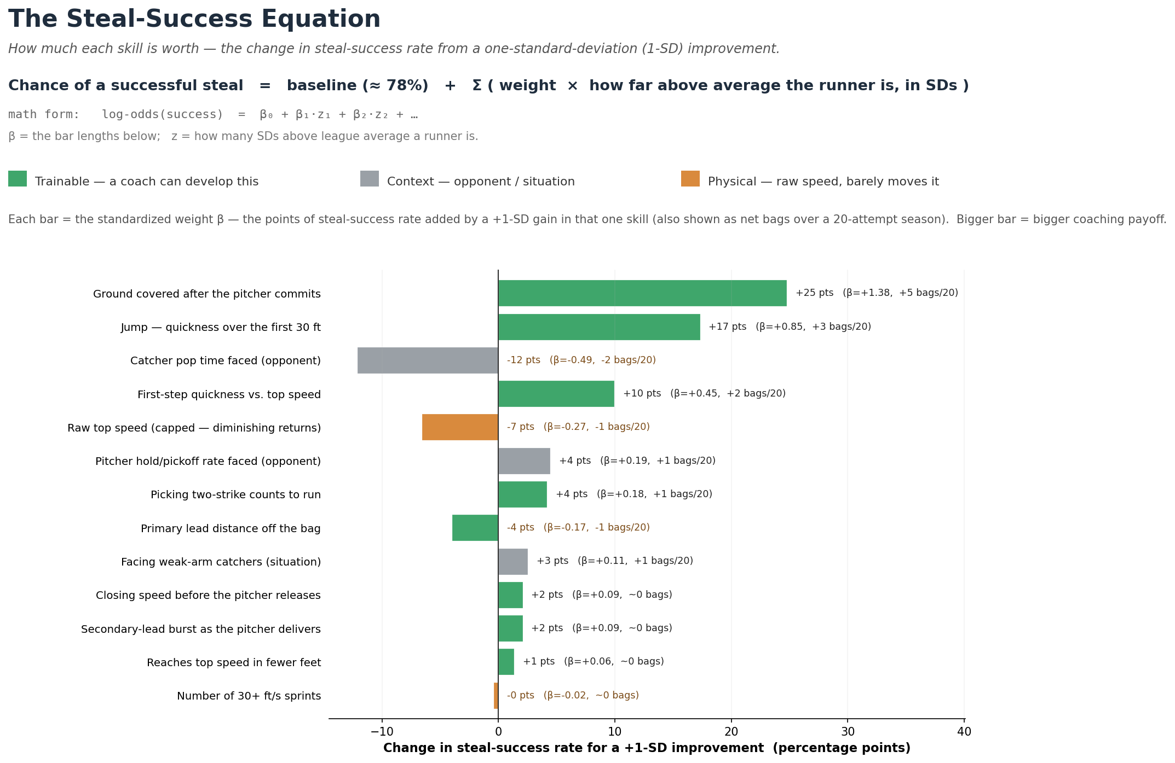
Figure 1 — Each bar is the standardized weight β: the change in steal-success rate from a +1-SD improvement in that one skill (also shown as net bags / 20 attempts). Green = trainable, grey = opponent/situation context, orange = raw speed. The equation at top: success odds = baseline + Σ (weight × how many SDs above average the runner is).

Coachable lever | League  Avg | One-Step  (+1 SD) | Success Rate  Change (pts) | ≈ Extra steals  (per 20 tries) | Effect
Ground covered after the pitcher commits | 52.20 | 2.92 | +25 pts | +5 bags/20 | ↑ raises
Jump — quickness over the first 30 ft | 1.77 | 0.04 | +17 pts | +3 bags/20 | ↑ raises
Catcher pop time faced (opponent) | 1.96 | 0.04 | -12 pts | -2 bags/20 | ↓ lowers
First-step quickness vs. top speed | -1.41 | 18.95 | +10 pts | +2 bags/20 | ↑ raises
Raw top speed (capped — diminishing returns) | 27.71 | 0.55 | -7 pts | -1 bags/20 | ↓ lowers
Pitcher hold/pickoff rate faced (opponent) | 0.01 | 0.01 | +4 pts | +1 bags/20 | ↑ raises
Picking two-strike counts to run | 0.86 | 0.21 | +4 pts | +1 bags/20 | ↑ raises
Primary lead distance off the bag | 11.81 | 0.83 | -4 pts | -1 bags/20 | ↓ lowers
Facing weak-arm catchers (situation) | 0.27 | 0.32 | +3 pts | +1 bags/20 | ↑ raises
Table 1 — The nine biggest levers. "+17 pts" means a one-step (1-SD) improvement raises the success rate by 17 percentage points — about 3 extra safe steals over a 20-attempt season. Read with Figure 1.

2 The Runners Who Already Have the Skill (Slow-Steal Skill)
What we did. We combined the skills above — jump, first-step burst, and steals-above-what-speed-predicts — into one 'Slow-Steal Skill' score, tuned on 80% of the league with the benchmark names (Naylor, Soto) held out, then ranked every runner-season.
BOTTOM LINE The leaderboard is full of mid-pack-speed runners grading out elite on skill — proof the trait is widespread and findable, not a one-player quirk.
Variables in this view:
- Player — Runner (and season).
- Top Speed — Sprint speed in feet/second — the structural baseline (Statcast).
- Jump (s) — Seconds to cover the first 30 ft. Lower = quicker first step. Coachable.
- First-Step Burst — Reaches top speed in fewer feet than his speed predicts (premium when fast).
- Steals Above Speed-Expected — Real success rate minus what sprint speed alone predicts (pct pts).
- SB / CS — Stolen bases / times caught stealing.
- Slow-Steal Skill — Overall technique score — skill beyond raw speed. Higher = better.
■ better than peers ■ league-average ■ worse than peers (shading = standard deviations above/below the players shown)
# | Player | Year | Top Speed  (ft/s) | Jump (s)  lower better | First-Step  Burst | Steals Above  Speed-Expected | SB / CS | Slow-Steal  Skill
1 | Josh Naylor | 2025 | 24.4 | 1.87 | +7.6 | +12.2% | 30/2 | +1.85
2 | Josh Naylor | 2026 | 24.6 | 1.84 | +8.0 | +4.9% | 12/2 | +1.68
3 | Freddie Freeman | 2024 | 25.8 | 1.81 | -4.4 | +4.3% | 9/2 | +1.23
4 | Christian Vázquez | 2021 | 25.2 | 1.93 | +4.4 | -7.3% | 8/4 | +1.19
5 | Juan Soto | 2025 | 25.8 | 1.85 | +0.6 | +12.9% | 38/4 | +1.18
6 | Kyle Schwarber | 2025 | 25.9 | 1.79 | +0.8 | +5.6% | 10/2 | +1.15
7 | Miguel Rojas | 2024 | 25.8 | 1.88 | +10.6 | +3.0% | 8/2 | +1.12
8 | Kyle Tucker | 2024 | 26.0 | 1.80 | +6.0 | +17.1% | 11/0 | +1.11
9 | Manny Machado | 2024 | 25.8 | 1.86 | +0.6 | +6.5% | 11/2 | +1.09
10 | Alec Burleson | 2024 | 25.5 | 1.88 | -5.0 | -5.1% | 9/4 | +1.08
11 | Ryan McMahon | 2022 | 25.8 | 1.79 | -4.4 | -3.6% | 7/3 | +1.06
12 | Manny Machado | 2025 | 25.8 | 1.88 | -9.4 | +5.1% | 14/3 | +1.05
13 | Joc Pederson | 2024 | 25.5 | 1.83 | -5.0 | -8.6% | 7/4 | +1.04
14 | Josh Naylor | 2023 | 25.8 | 1.83 | -4.4 | +0.9% | 10/3 | +0.99
15 | TJ Friedl | 2024 | 26.5 | 1.77 | +12.0 | +10.4% | 9/1 | +0.90
Table 2 — Top 15 by Slow-Steal Skill (2015–2026). The Top Speed column is deliberately uncolored: speed is NOT what earns a spot here. Amber rows flag the benchmark names (Naylor, Soto) — the clearest examples of the trait, not the basis of the score (they were held out while the score was tuned).

3 Who To Coach In 2025 — Targets and the Projected Prize
What we did. We plotted every qualified runner-season since 2023 by top speed (left→right) against steal production (down→up), then pulled the 2025 names into a target board with a projected payoff for each.
BOTTOM LINE Two clean opportunities fall out: fast, efficient runners who simply don't run enough (green-light them) and high-volume runners who get caught too often (fix the technique).

Variables in this view:
- Speed (SD) — Top speed expressed in standard deviations vs. the league (positive = faster).
- Steal Value (xSB) — z(net steals above avg) + z(top speed) — fast AND productive.
- Untapped Speed — Fast but under-stealing: z(top speed) − z(net steals). Higher = bigger coaching upside.
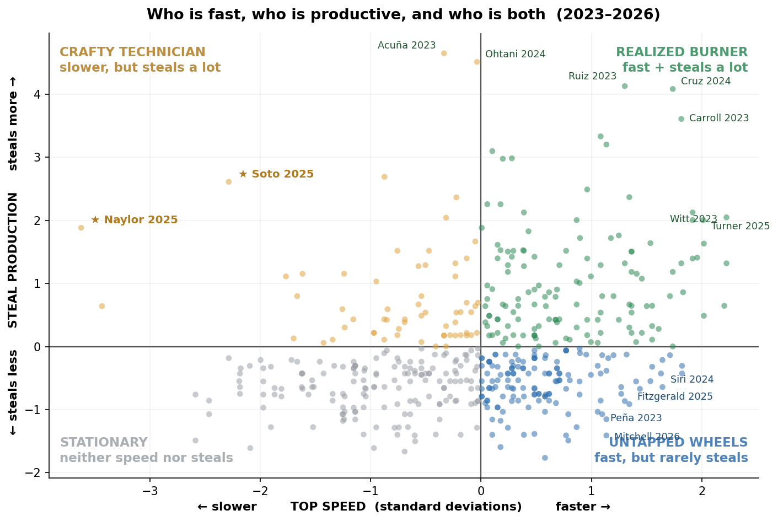
Figure 2 — Each dot is a runner-season (2023–2026). X-axis = top speed in standard deviations (right = faster); Y-axis = steal production (up = more). Green = fast & productive; blue (lower-right) = fast but under-stealing (the green-light targets); gold = the slow-but-productive archetype (★ Naylor, Soto); grey = neither. No red — no quadrant here is 'bad'.

3a Green-light targets — fast, efficient, under-running (just let them run)
What we did. We isolated the 2025 runners with top-third speed who already succeed at 80%+ but attempt fewer than ~20 steals, and projected the bags they'd add at a modest, speed-appropriate volume — kept at their own proven success rate.
BOTTOM LINE These are low-risk green-light decisions, not mechanics rebuilds: each already converts; they simply aren't running.

Variables in this view:
- Player — Runner (and season).
- Top Speed — Sprint speed in feet/second — the structural baseline (Statcast).
- SB / CS — Stolen bases / times caught stealing.
- Success rate — Share of steal attempts that succeed (SB ÷ attempts).
- Attempts — Stolen-base attempts this season (SB + CS).
- If unleashed — Projected extra net steals at a modest, speed-appropriate ~20-attempt volume, kept at the runner's own demonstrated success rate.
■ better than peers ■ league-average ■ worse than peers (shading = standard deviations above/below the players shown)
# | Player | Top Speed  (ft/s) | SB / CS | Success  rate | Attempts  (2025) | If unleashed  (+ bags)
1 | Nasim Nuñez | 29.8 | 9/1 | 86% | 10 | +7
2 | Eli White | 29.9 | 10/1 | 87% | 11 | +7
3 | Brandon Lockridge | 30.1 | 10/1 | 87% | 11 | +7
4 | Marcus Semien | 28.5 | 11/1 | 88% | 12 | +6
5 | Hyeseong Kim | 28.7 | 13/1 | 89% | 14 | +5
6 | Ezequiel Duran | 28.8 | 11/2 | 83% | 13 | +5
7 | Myles Straw | 29.4 | 12/1 | 88% | 13 | +5
8 | Tyrone Taylor | 29.3 | 12/2 | 84% | 14 | +4
Table 3 — 2025 green-light board. "If unleashed" = projected extra net steals at ~20 attempts, at the runner's own 2025 success rate (illustrative, not a forecast of behavior).

3b Technique-fix targets — high volume, caught too often (drill the weakest lever)
What we did. The opposite group: 2025 runners attempting a lot (12+) but converting below 70%. For each we name the trainable skill where they are furthest below average and the success-rate gain from lifting it to league average.
BOTTOM LINE These should not run more — they should run better. The fix is mechanics, and the model says which one.
Variables in this view:
- Player — Runner (and season).
- Top Speed — Sprint speed in feet/second — the structural baseline (Statcast).
- SB / CS — Stolen bases / times caught stealing.
- Success rate — Share of steal attempts that succeed (SB ÷ attempts).
- Weakest lever — The trainable skill where this runner is furthest below league average.
- Projected fix — Success-rate gain if that weakest lever is lifted to the league average.
Player | Top Speed  (ft/s) | SB / CS | Success  rate | Attempts  (2025) | Weakest  lever | Fix → success  gain
Tyler Freeman | 28.5 | 18/9 | 68% | 27 | Secondary-lead burst | +1 pts
Jacob Young | 29.3 | 15/11 | 61% | 26 | First-step burst | +23 pts
James Wood | 27.8 | 15/7 | 70% | 22 | Secondary-lead burst | +3 pts
Andy Pages | 28.1 | 14/7 | 69% | 21 | First-step burst | +16 pts
Harrison Bader | 28.8 | 11/7 | 65% | 18 | Secondary-lead burst | +4 pts
Luis Rengifo | 27.0 | 10/7 | 63% | 17 | Ground covered | +33 pts
Table 4 — 2025 technique-fix board. "Fix → success gain" = projected percentage-point gain if the weakest lever is raised to league average (via the Table-1 weights); higher success rate = redder here is worse, greener is better.

4 What To Coach — Three Priorities, and the Caveats
The equation in Section 1 points to three trainable levers. Each is technique, not body type — which is why a slow runner can lead the league in steal skill. The payoff below is straight off Table 1.
- Cover more ground once the pitcher commits. (+25 pts ≈ +5 bags / 20 tries) The single biggest lever. Train the secondary-lead explosion and the read of the pitcher's first move — distance gained before the throw is worth more than raw foot speed.
- Sharpen the jump. (+17 pts ≈ +3 bags / 20 tries) Cutting the time to the first 30 feet is pure technique — stance, weight shift, and first-step direction, not body type.
- Reach top speed sooner — first-step burst. (+10 pts ≈ +2 bags / 20 tries) Runners who hit top gear in fewer feet steal above their speed peers. Acceleration mechanics, not a higher top speed, are what convert.
Net play: green-light the Table-3 names, drill the Table-4 names on the lever listed, and you convert latent speed and wasted attempts into runs — without touching anyone's physical ceiling.

Read the projections honestly
- The target boards are estimates, not forecasts. "If unleashed" holds a runner at his own 2025 success rate and a modest ~20-attempt volume; real results depend on health, matchups, and game situation. Treat the bag counts as a priority ranking, not a guarantee.
- Per-lever gains assume the rest stays equal. A +1-SD improvement is real but ambitious, and the model holds the other skills fixed. Small, compounding gains across two levers are more realistic than a single full-SD jump.
- Context columns are not coaching levers. Catcher pop time and pitcher hold rate move success in the math, but you don't coach them — they're shown so you can separate skill from circumstance.

