The Naylor Model — v7
Speed-adjusted base-stealing skill · SSSI · Expected SB Outcome · Blueprint Conversion Score

José Caballero led MLB in net stolen bases in 2025 running a quarter-second slower than Chandler Simpson. Josh Naylor stole 20 bases above average at 93.8% while running slower than 97% of the league. Sprint speed is the most intuitive base-stealing metric — it is not the most essential one. What separates these runners is technique: lead distance, secondary-lead timing, and first-step burst. v7 measures that skill three ways — the SSSI (slow-but-skilled), the Expected SB Outcome quadrant (fast and productive), and the Blueprint Conversion Score (timing the pitcher).

1 The Models (A / B / C)
Model | Unit | AUC | Purpose
Model A — per-attempt GBM | Individual attempt | ~0.59 | Strict noise-floor test
Model B — season GBM | Runner-season | 0.576 (de-leaked) | Headline predictor
Model C — interpretable GLM | Runner-season | — | Plain-English weight table
AUC caveat (v7 de-leaking). Versions v4–v6 reported AUCs of ~0.66–0.70, but those runs carried duplicate runner-season rows — repeated Statcast split measurements for one player-season — that leaked across cross-validation folds and inflated the score. v7 averages those duplicate splits into one row per runner-season. The v7 AUC is lower but honest, not a regression. The historical bars below are kept for context only.
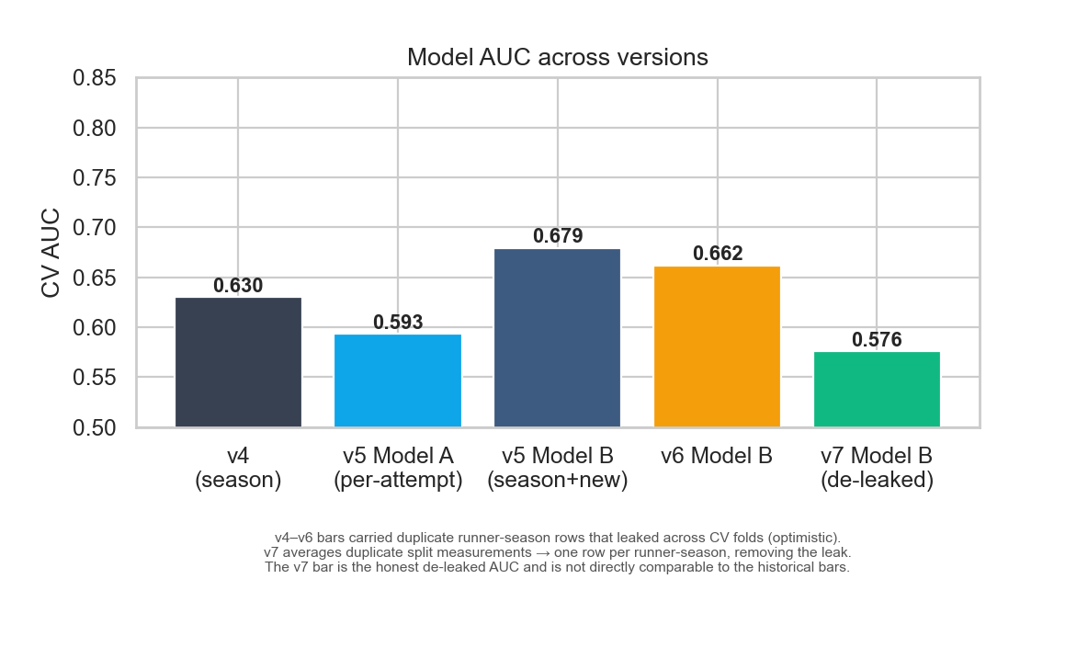
Figure 1 — Model AUC across versions. The v7 bar is the de-leaked figure; v4–v6 are optimistic.

2 Model C — What Actually Moves the Needle
Each bar is the predicted percentage-point change in SB success when a runner improves on that feature by one tier (1 SD). Green helps; red hurts.
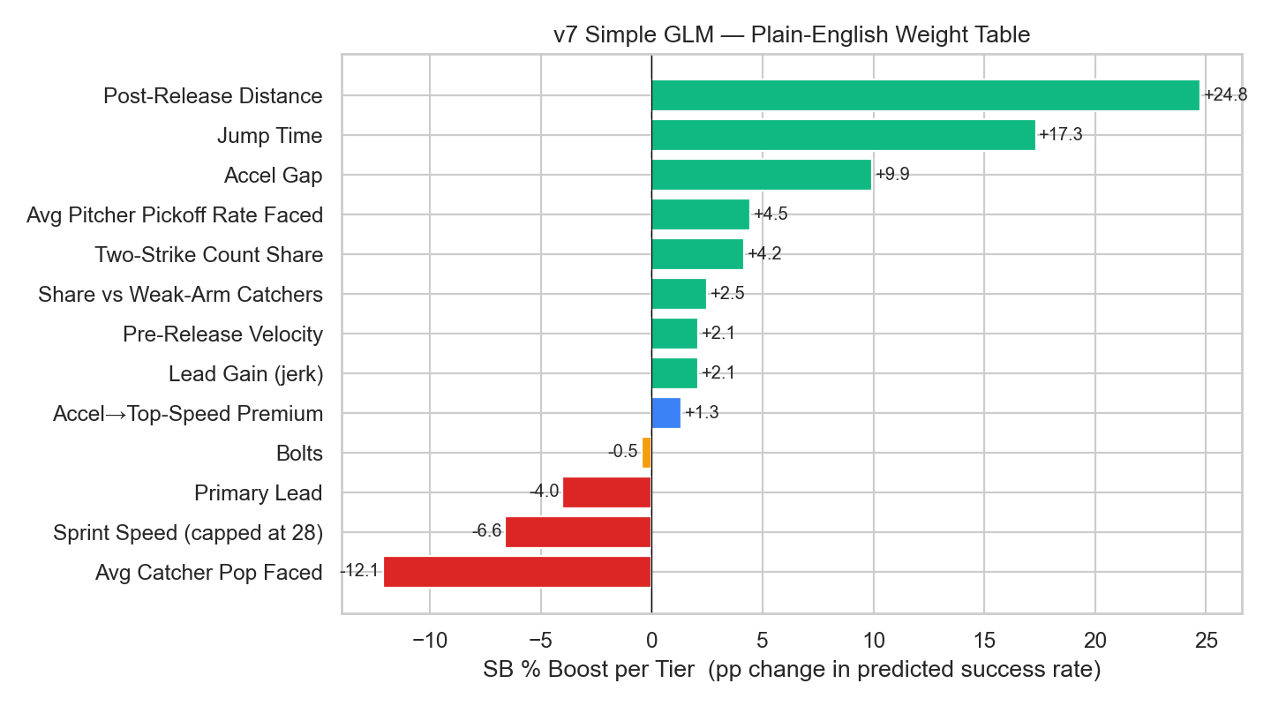
Figure 2 — GLM plain-English weight table.

3 Feature Importance — Pre vs Post 2023
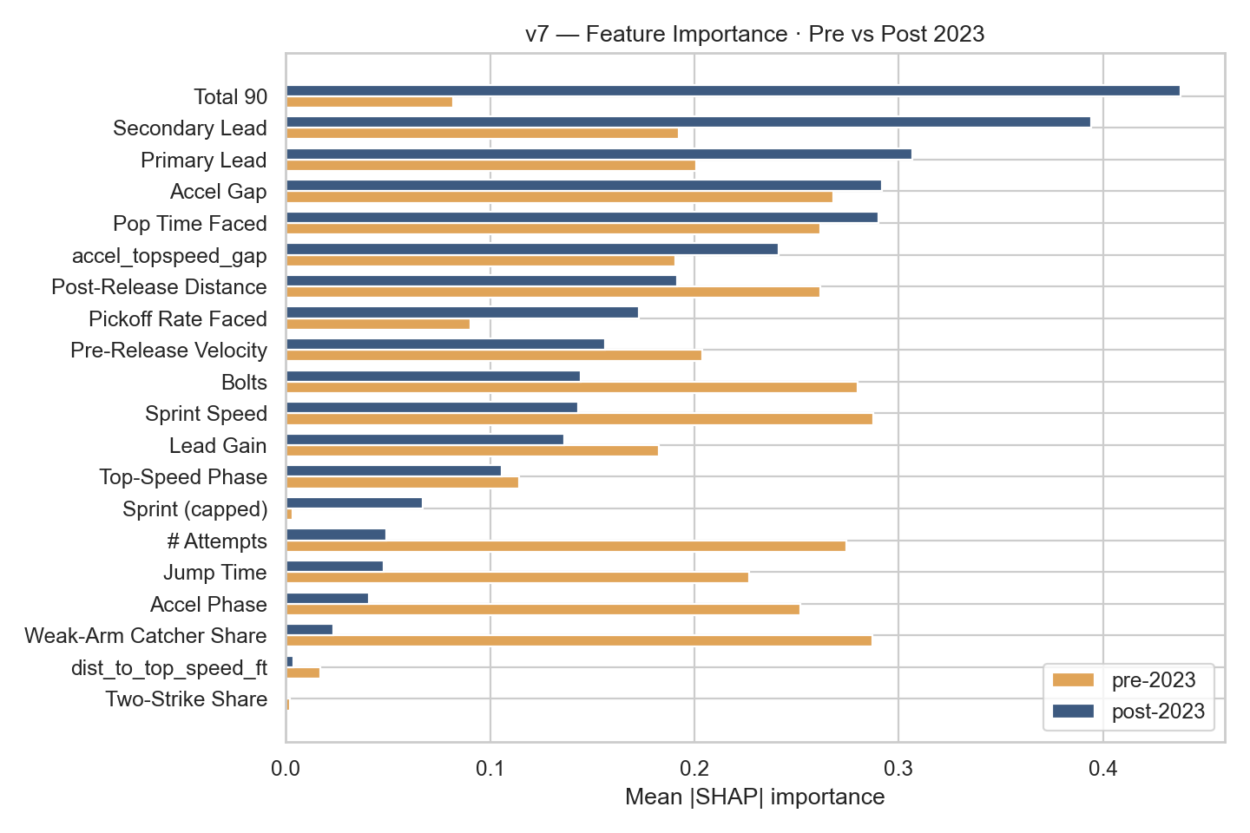
Figure 3 — How feature importance shifted after the 2023 bigger-bases rule change.

4 SSSI — Slow-Steal Skill Index
A weighted composite of nine z-scored features, optimised on 80% of runners with Naylor and Soto held out entirely — so their ranking is genuinely out-of-sample. The index surfaces elite-performing slow runners. Naylor holds the top two seasons; Soto is top five.
# | Player | Yr | Sprint | Jump | SB resid | Accel prem | SB% | SSSI
1 | Josh Naylor | 2025 | 24.4 | 1.87 | +0.122 | +7.6 | 92% | +1.85
2 | Josh Naylor | 2026 | 24.6 | 1.84 | +0.049 | +8.0 | 84% | +1.68
3 | Freddie Freeman | 2024 | 25.8 | 1.81 | +0.043 | -4.4 | 81% | +1.23
4 | Christian Vázquez | 2021 | 25.2 | 1.93 | -0.073 | +4.4 | 70% | +1.19
5 | Juan Soto | 2025 | 25.8 | 1.85 | +0.129 | +0.6 | 89% | +1.18
6 | Kyle Schwarber | 2025 | 25.9 | 1.79 | +0.056 | +0.8 | 82% | +1.15
7 | Miguel Rojas | 2024 | 25.8 | 1.88 | +0.030 | +10.6 | 79% | +1.12
8 | Kyle Tucker | 2024 | 26.0 | 1.80 | +0.171 | +6.0 | 93% | +1.11
9 | Manny Machado | 2024 | 25.8 | 1.86 | +0.065 | +0.6 | 83% | +1.09
10 | Alec Burleson | 2024 | 25.5 | 1.88 | -0.051 | -5.0 | 72% | +1.08
11 | Ryan McMahon | 2022 | 25.8 | 1.79 | -0.036 | -4.4 | 73% | +1.06
12 | Manny Machado | 2025 | 25.8 | 1.88 | +0.051 | -9.4 | 81% | +1.05
13 | Joc Pederson | 2024 | 25.5 | 1.83 | -0.086 | -5.0 | 68% | +1.04
14 | Josh Naylor | 2023 | 25.8 | 1.83 | +0.009 | -4.4 | 77% | +0.99
15 | TJ Friedl | 2024 | 26.5 | 1.77 | +0.104 | +12.0 | 86% | +0.90
16 | Kyle Schwarber | 2022 | 26.4 | 1.82 | +0.112 | -3.2 | 87% | +0.89
17 | Ryan McMahon | 2023 | 25.8 | 1.80 | -0.170 | -4.4 | 59% | +0.88
18 | Freddie Freeman | 2023 | 26.7 | 1.80 | +0.172 | +7.4 | 93% | +0.87
19 | Adam Frazier | 2023 | 26.5 | 1.79 | -0.011 | +7.0 | 74% | +0.86
20 | Mookie Betts | 2024 | 26.7 | 1.82 | +0.110 | +12.4 | 86% | +0.86
21 | Nolan Schanuel | 2024 | 26.4 | 1.84 | +0.112 | -8.2 | 87% | +0.86
22 | Christian Walker | 2023 | 26.4 | 1.87 | +0.174 | -3.2 | 93% | +0.85
23 | Cal Raleigh | 2025 | 26.0 | 1.85 | +0.018 | +1.0 | 78% | +0.84
24 | Paul Goldschmidt | 2021 | 26.3 | 1.84 | +0.178 | -3.4 | 93% | +0.84
25 | Paul Goldschmidt | 2024 | 26.3 | 1.84 | +0.174 | +1.6 | 93% | +0.83
Table 1 — SSSI v7 Top 25 (green = better on that metric, red = worse). Amber rows = Naylor / Soto.
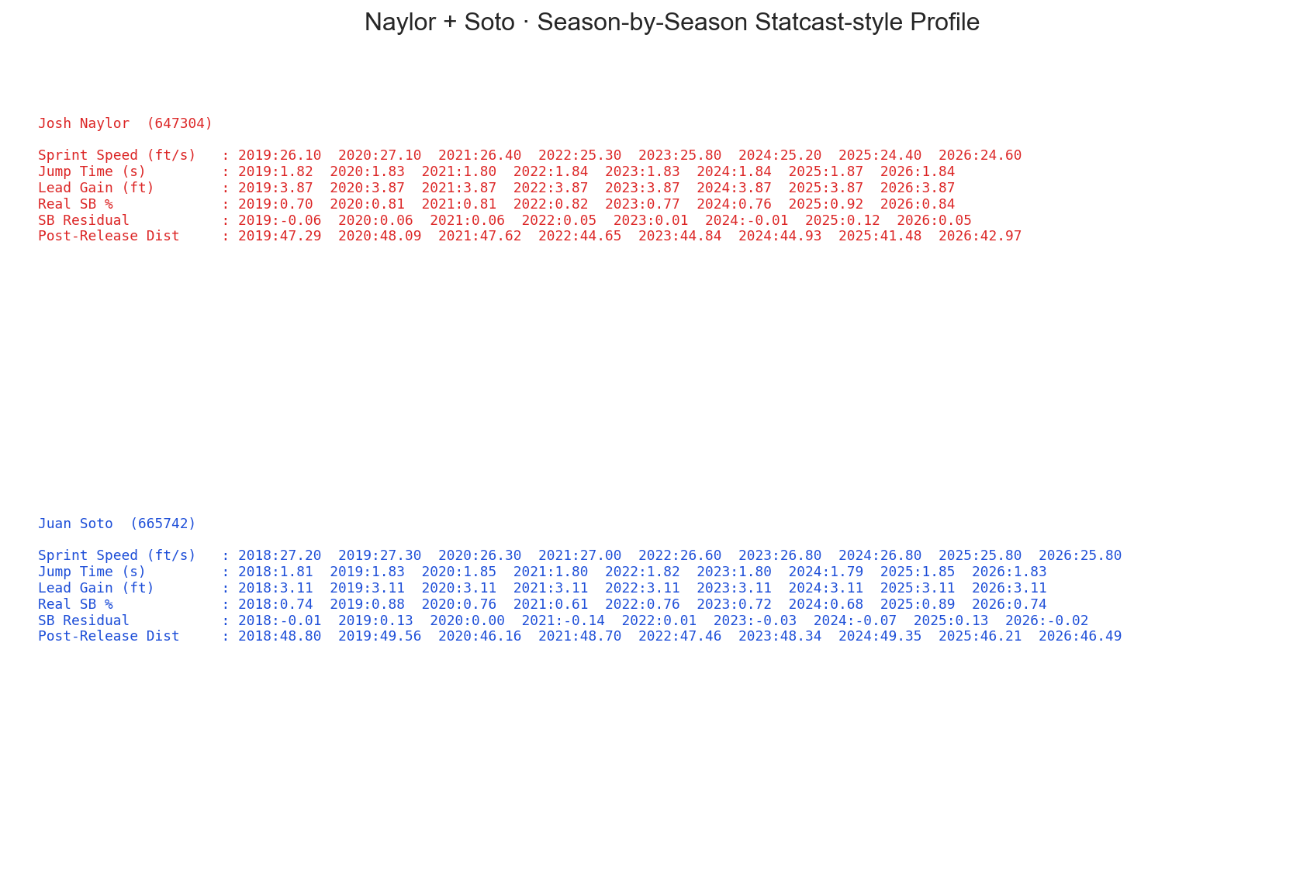
Figure 4 — Naylor & Soto skill profile vs league.

5 Expected SB Outcome (xSB)
xSB = z(net SB above average) + z(sprint speed). A complementary lens to the SSSI: where the SSSI surfaces slow-but-skilled stealers, xSB surfaces the runners who are both fast AND productive. The companion sb_potential_gap = z(sprint) − z(net SB) splits the league into four quadrants. Positive gap = fast but under-stealing — the clearest coaching targets.
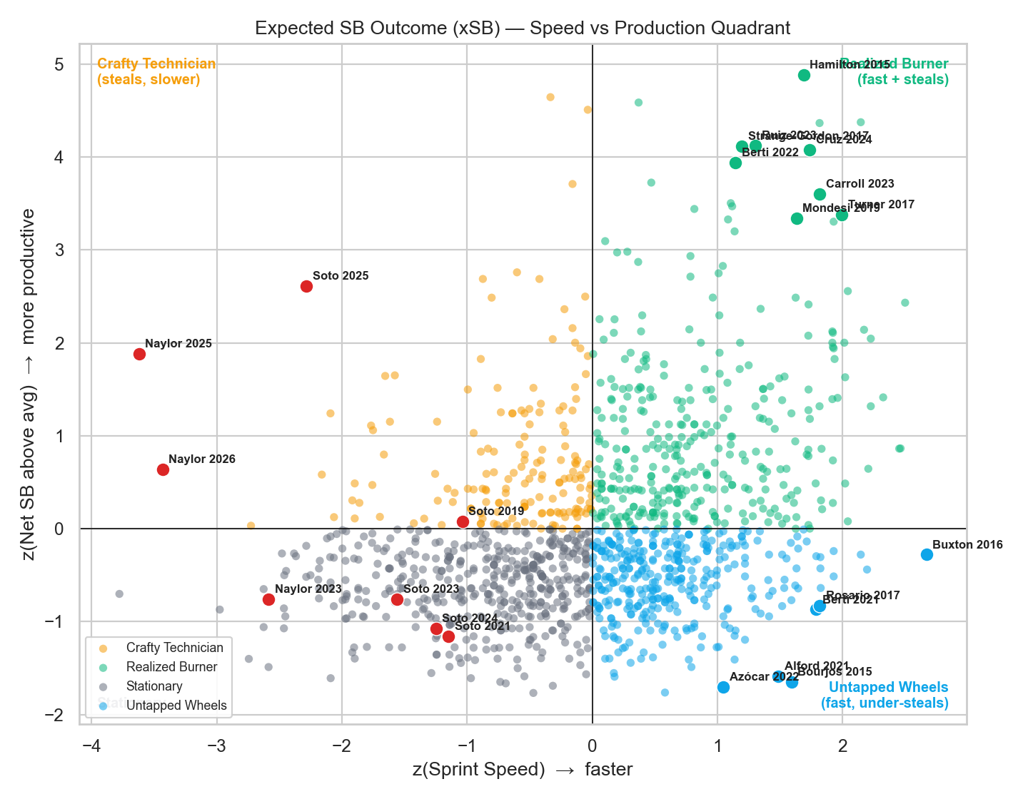
Figure 5 — Speed-vs-production quadrant. Green = Realized Burners, blue = Untapped Wheels, red = Naylor/Soto (Crafty Technicians).

5.1 Top 15 by xSB — Realized Burners (fast + productive)
# | Player | Yr | Sprint | SB | CS | Net SB | z spd | z stl | xSB
1 | Billy Hamilton | 2015 | 29.7 | 57 | 8 | 49 | +1.69 | +4.89 | +6.57
2 | Billy Hamilton | 2016 | 30.2 | 58 | 8 | 50 | +2.14 | +4.38 | +6.52
3 | Billy Hamilton | 2017 | 30.1 | 59 | 13 | 46 | +1.82 | +4.37 | +6.18
4 | Elly De La Cruz | 2024 | 30.0 | 67 | 16 | 51 | +1.74 | +4.08 | +5.82
5 | Esteury Ruiz | 2023 | 29.6 | 67 | 13 | 54 | +1.30 | +4.13 | +5.43
6 | Corbin Carroll | 2023 | 30.1 | 54 | 5 | 49 | +1.81 | +3.61 | +5.42
7 | Trea Turner | 2017 | 30.3 | 46 | 8 | 38 | +1.99 | +3.38 | +5.37
8 | Dee Strange-Gordon | 2017 | 29.4 | 60 | 16 | 44 | +1.19 | +4.12 | +5.31
9 | Trea Turner | 2018 | 30.1 | 43 | 9 | 34 | +1.93 | +3.31 | +5.23
10 | Jon Berti | 2022 | 29.5 | 41 | 5 | 36 | +1.14 | +3.94 | +5.08
11 | Adalberto Mondesi | 2019 | 29.9 | 43 | 7 | 36 | +1.63 | +3.34 | +4.97
12 | Starling Marte | 2021 | 28.5 | 47 | 5 | 42 | +0.37 | +4.59 | +4.96
13 | Trea Turner | 2021 | 30.6 | 32 | 5 | 27 | +2.50 | +2.43 | +4.93
14 | Dee Strange-Gordon | 2015 | 29.1 | 58 | 20 | 38 | +1.11 | +3.50 | +4.61
15 | Trea Turner | 2019 | 30.3 | 35 | 5 | 30 | +2.04 | +2.56 | +4.60
Table 2 — the recognizable burners: fast and converting in volume.

5.2 Untapped Wheels — fast but under-stealing (coach them up)
# | Player | Yr | Sprint | SB | CS | z spd | Potential gap
1 | Peter Bourjos | 2015 | 29.6 | 5 | 8 | +1.59 | +3.24
2 | Anthony Alford | 2021 | 29.6 | 5 | 6 | +1.48 | +3.07
3 | Byron Buxton | 2016 | 30.7 | 10 | 2 | +2.67 | +2.95
4 | José Azócar | 2022 | 29.4 | 5 | 6 | +1.05 | +2.75
5 | Jon Berti | 2021 | 29.9 | 8 | 4 | +1.79 | +2.66
6 | Amed Rosario | 2017 | 30.1 | 7 | 3 | +1.82 | +2.64
7 | Jorge Mateo | 2021 | 30.3 | 10 | 3 | +2.19 | +2.63
8 | Garrett Mitchell | 2026 | 29.6 | 6 | 4 | +1.14 | +2.54
9 | Tim Locastro | 2022 | 30.2 | 8 | 2 | +1.82 | +2.46
10 | Roman Quinn | 2018 | 30.1 | 10 | 4 | +1.93 | +2.44
11 | Adalberto Mondesi | 2016 | 30.2 | 9 | 1 | +2.14 | +2.42
12 | Manuel Margot | 2018 | 29.4 | 11 | 10 | +1.22 | +2.41
Table 3 — biggest gaps between speed and steal production. These are the unrealized high-ceiling runners.

5.3 Naylor & Soto — Crafty Technicians
Player | Yr | Sprint | SB | CS | z spd | z stl | Potential gap | Quadrant
Juan Soto | 2025 | 25.8 | 38 | 4 | -2.29 | +2.61 | -4.90 | Crafty Technician
Juan Soto | 2019 | 27.3 | 12 | 1 | -1.04 | +0.08 | -1.12 | Crafty Technician
Josh Naylor | 2025 | 24.4 | 30 | 2 | -3.62 | +1.88 | -5.50 | Crafty Technician
Juan Soto | 2021 | 27.0 | 9 | 7 | -1.15 | -1.16 | +0.01 | Stationary
Juan Soto | 2024 | 26.8 | 7 | 4 | -1.25 | -1.07 | -0.18 | Stationary
Juan Soto | 2023 | 26.8 | 12 | 5 | -1.56 | -0.76 | -0.80 | Stationary
Josh Naylor | 2026 | 24.6 | 12 | 2 | -3.43 | +0.64 | -4.07 | Crafty Technician
Josh Naylor | 2023 | 25.8 | 10 | 3 | -2.59 | -0.76 | -1.83 | Stationary
Table 4 — negative potential gap = they out-steal their speed. The archetype this whole model is built around.

6 Blueprint Conversion Score (BCS)
BCS combines three speed-adjusted residuals: success_resid_z (converts more often than sprint speed predicts — execution), gain_resid_z (covers more ground first-move→release than speed predicts — timing), and squander_z (penalty for fast runners who get caught). It scores the Naylor archetype directly: slow sprint, big jump, elite conversion.

6.1 Overall Top 15 — The Blueprint
# | Player | Team | Yr | Spd %ile | SB | CS | SB% | Gain ft | Gn z | Su z | BCS
1 | Ryan McMahon |  | 2026 | 14 | 3 | 0 | 100% | 24.5 | +6.44 | +1.09 | +8.05
2 | Agustín Ramírez |  | 2025 | 30 | 13 | 1 | 93% | 21.3 | +4.90 | +1.44 | +6.86
3 | Paul Goldschmidt |  | 2024 | 22 | 10 | 0 | 100% | 16.7 | +2.27 | +1.79 | +4.59
4 | JJ Wetherholt |  | 2026 | 50 | 5 | 0 | 100% | 16.8 | +2.78 | +1.14 | +4.45
5 | Jordan Walker |  | 2025 | 84 | 10 | 0 | 100% | 15.3 | +2.32 | +1.54 | +4.39
6 | Josh Naylor |  | 2025 | 2 | 22 | 1 | 96% | 16.7 | +1.42 | +2.07 | +4.01
7 | Josh Naylor |  | 2026 | 2 | 9 | 1 | 90% | 17.7 | +2.19 | +1.20 | +3.91
8 | Ramón Laureano |  | 2023 | 63 | 11 | 1 | 92% | 16.9 | +2.66 | +0.72 | +3.90
9 | Chase DeLauter |  | 2026 | 29 | 2 | 1 | 67% | 19.0 | +3.70 | -0.37 | +3.85
10 | Trea Turner |  | 2023 | 100 | 24 | 0 | 100% | 13.6 | +1.74 | +1.49 | +3.75
11 | Juan Soto |  | 2025 | 14 | 30 | 0 | 100% | 14.2 | +0.54 | +2.39 | +3.45
12 | Michael A. Taylor |  | 2024 | 81 | 10 | 0 | 100% | 13.6 | +1.40 | +1.51 | +3.44
13 | Nico Hoerner |  | 2026 | 82 | 10 | 0 | 100% | 13.5 | +1.35 | +1.53 | +3.41
14 | Luis Arraez |  | 2026 | 34 | 4 | 0 | 100% | 15.2 | +1.63 | +1.18 | +3.33
15 | Kyle Tucker |  | 2026 | 25 | 4 | 0 | 100% | 15.4 | +1.62 | +1.18 | +3.33
Table 5 — Overall Top 15 BCS (2023–2026). Logos mark each runner's team.
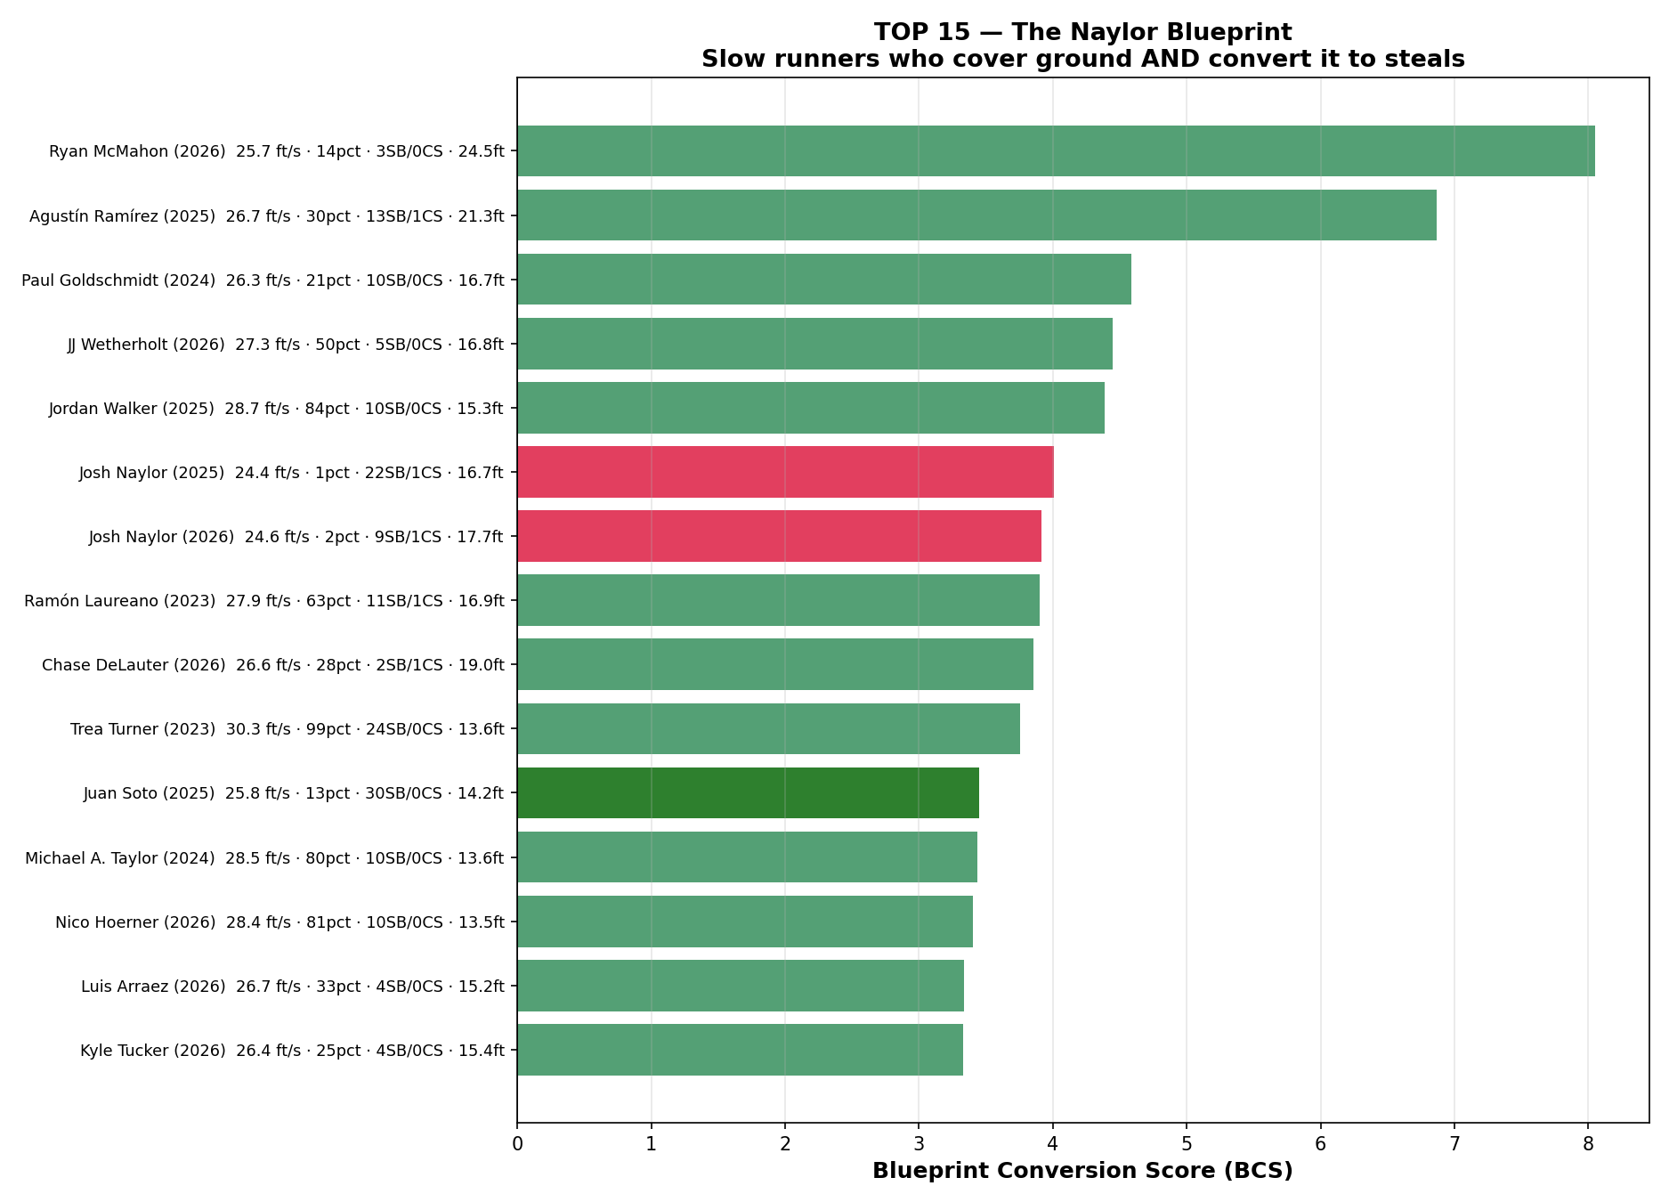
Figure 6 — Top BCS runner-seasons. Red = Naylor, green = Soto.

6.2 Naylor & Soto — The Archetype Profile (year-by-year)
# | Player | Team | Yr | Spd %ile | SB | CS | SB% | Gain ft | Gn z | Su z | BCS
6 | Josh Naylor |  | 2025 | 2 | 22 | 1 | 96% | 16.7 | +1.42 | +2.07 | +4.01
7 | Josh Naylor |  | 2026 | 2 | 9 | 1 | 90% | 17.7 | +2.19 | +1.20 | +3.91
209 | Juan Soto |  | 2023 | 34 | 6 | 4 | 60% | 16.1 | +1.75 | -1.75 | +0.53
284 | Juan Soto |  | 2024 | 32 | 6 | 4 | 60% | 13.9 | +0.89 | -1.47 | -0.06
11 | Juan Soto |  | 2025 | 14 | 30 | 0 | 100% | 14.2 | +0.54 | +2.39 | +3.45
55 | Juan Soto |  | 2026 | 19 | 2 | 1 | 67% | 16.4 | +1.97 | -0.33 | +2.16
Table 6 — Naylor & Soto, all tracked seasons.
- Naylor 2025: 24.4 ft/s (2th pct), 16.7 ft gain, 22/23 = 96% SB, BCS +4.01.
- Naylor 2026: 24.6 ft/s (2th pct), 17.7 ft gain, 9/10 = 90% SB, BCS +3.91.
- Soto 2023: 26.8 ft/s (34th pct), 16.1 ft gain, 6/10 = 60% SB, BCS +0.53.
- Soto 2024: 26.8 ft/s (32th pct), 13.9 ft gain, 6/10 = 60% SB, BCS -0.06.
- Soto 2025: 25.8 ft/s (14th pct), 14.2 ft gain, 30/30 = 100% SB, BCS +3.45.
- Soto 2026: 25.9 ft/s (19th pct), 16.4 ft gain, 2/3 = 67% SB, BCS +2.16.
The Naylor archetype — slow sprint, big jump, high conversion — appears in every season and is not a single-year outlier. Naylor 2026 is already tracking above his 2025 pace.
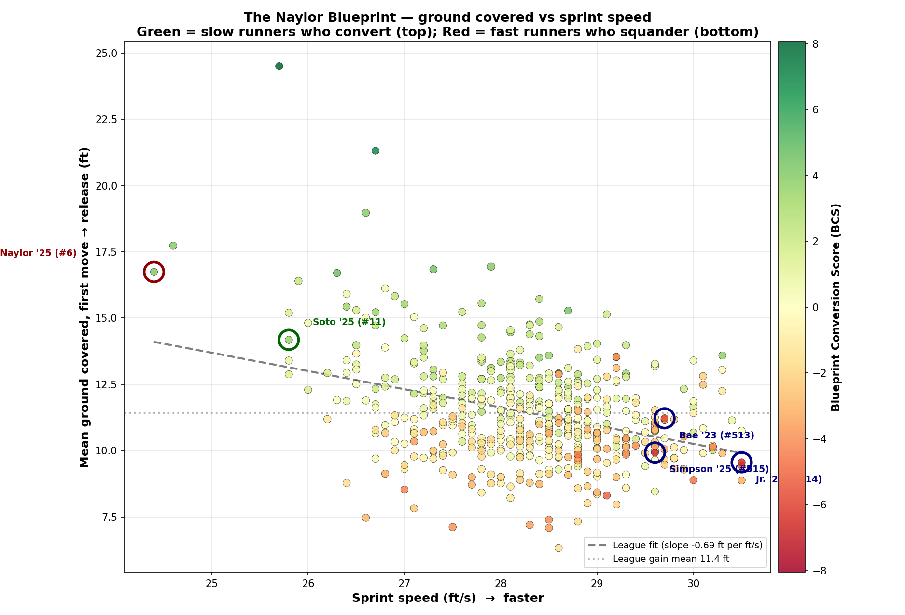
Figure 7 — BCS scatter: sprint speed vs mean gain, coloured by score. Naylor/Soto annotated.

6.3 Top 25 Per Season — Ground Covered
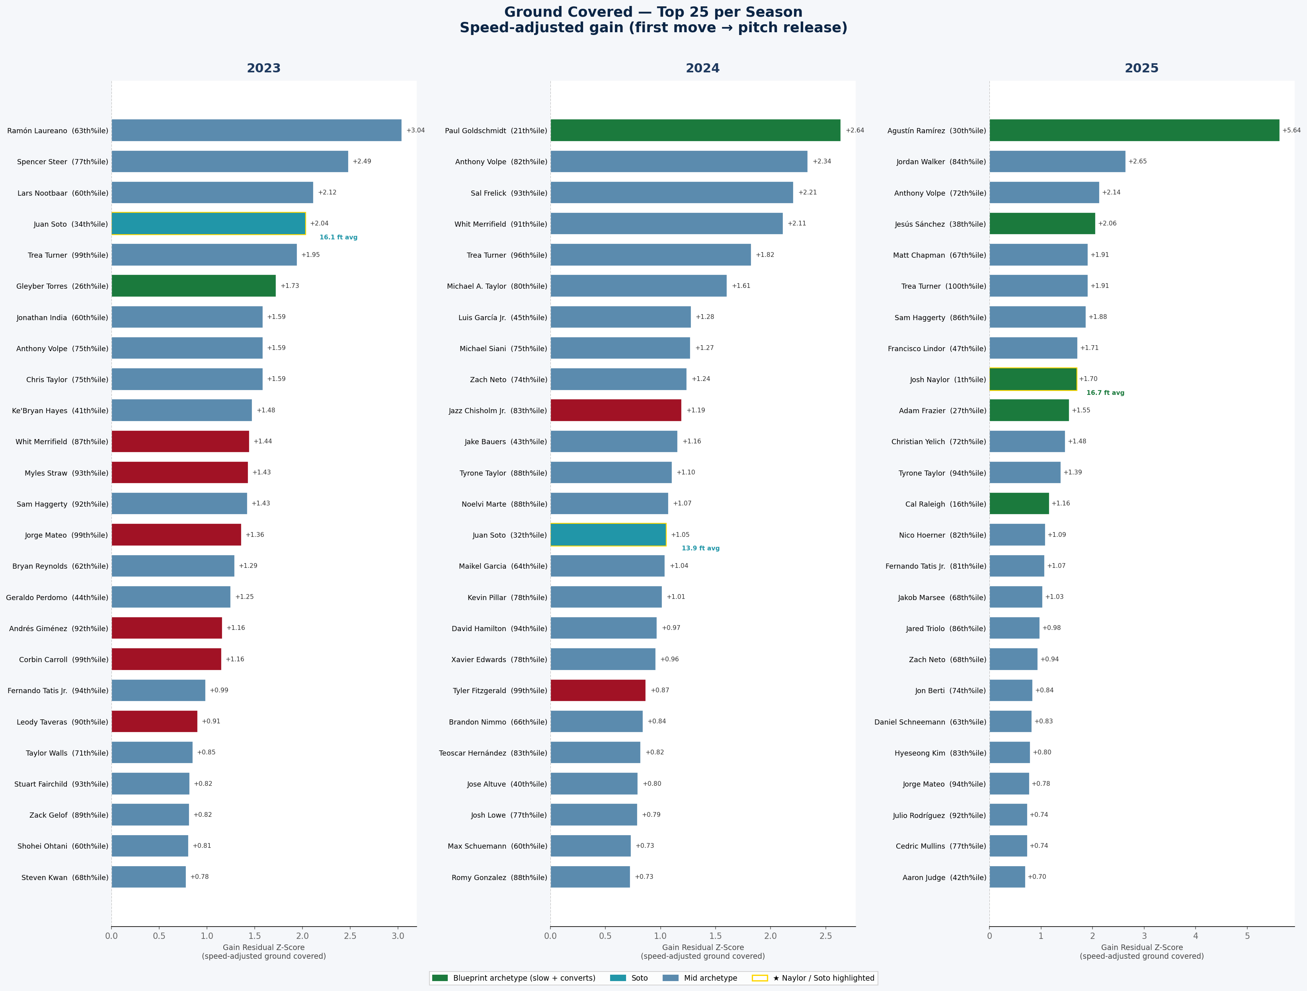
Figure 8 — Top 25 per season by speed-adjusted ground covered, with team logos.

6.4 Bottom 15 — The Anti-Naylor (Squanderers)
# | Player | Team | Yr | Spd %ile | SB | CS | SB% | Gain ft | Gn z | Su z | BCS
515 | Chandler Simpson |  | 2025 | 97 | 38 | 8 | 83% | 9.9 | -0.32 | -0.00 | -6.71
514 | Bobby Witt Jr. |  | 2023 | 100 | 40 | 8 | 83% | 9.6 | -0.44 | -0.19 | -6.57
513 | Ji Hwan Bae |  | 2023 | 97 | 19 | 7 | 73% | 11.2 | +0.16 | -1.27 | -5.86
512 | Daylen Lile |  | 2025 | 90 | 8 | 6 | 57% | 8.3 | -1.43 | -2.14 | -5.04
511 | Bobby Witt Jr. |  | 2024 | 100 | 25 | 6 | 81% | 9.4 | -0.13 | -0.22 | -4.87
510 | Ceddanne Rafaela |  | 2024 | 88 | 15 | 8 | 65% | 9.9 | -0.57 | -1.63 | -4.62
509 | Elly De La Cruz |  | 2024 | 99 | 55 | 9 | 86% | 8.9 | -0.63 | +0.49 | -4.60
508 | Bobby Witt Jr. |  | 2025 | 100 | 32 | 7 | 82% | 10.1 | +0.03 | -0.02 | -4.33
507 | Myles Straw |  | 2023 | 94 | 17 | 5 | 77% | 13.5 | +1.27 | -0.74 | -4.20
506 | Luis Rengifo |  | 2025 | 39 | 7 | 7 | 50% | 8.5 | -2.15 | -2.57 | -4.20
505 | Jacob Young |  | 2025 | 94 | 12 | 7 | 63% | 9.8 | -0.49 | -1.76 | -4.11
504 | Jeremy Peña |  | 2023 | 95 | 13 | 7 | 65% | 10.2 | -0.53 | -1.88 | -4.08
503 | Alejandro Osuna |  | 2026 | 82 | 1 | 2 | 33% | 7.4 | -2.04 | -1.98 | -4.04
502 | David Hamilton |  | 2025 | 94 | 15 | 5 | 75% | 10.5 | -0.14 | -0.74 | -3.95
501 | Taylor Ward |  | 2026 | 56 | 1 | 2 | 33% | 7.1 | -2.60 | -1.78 | -3.85
Table 7 — fast runners who get caught repeatedly. Bobby Witt Jr. is bottom-five every season in the dataset.
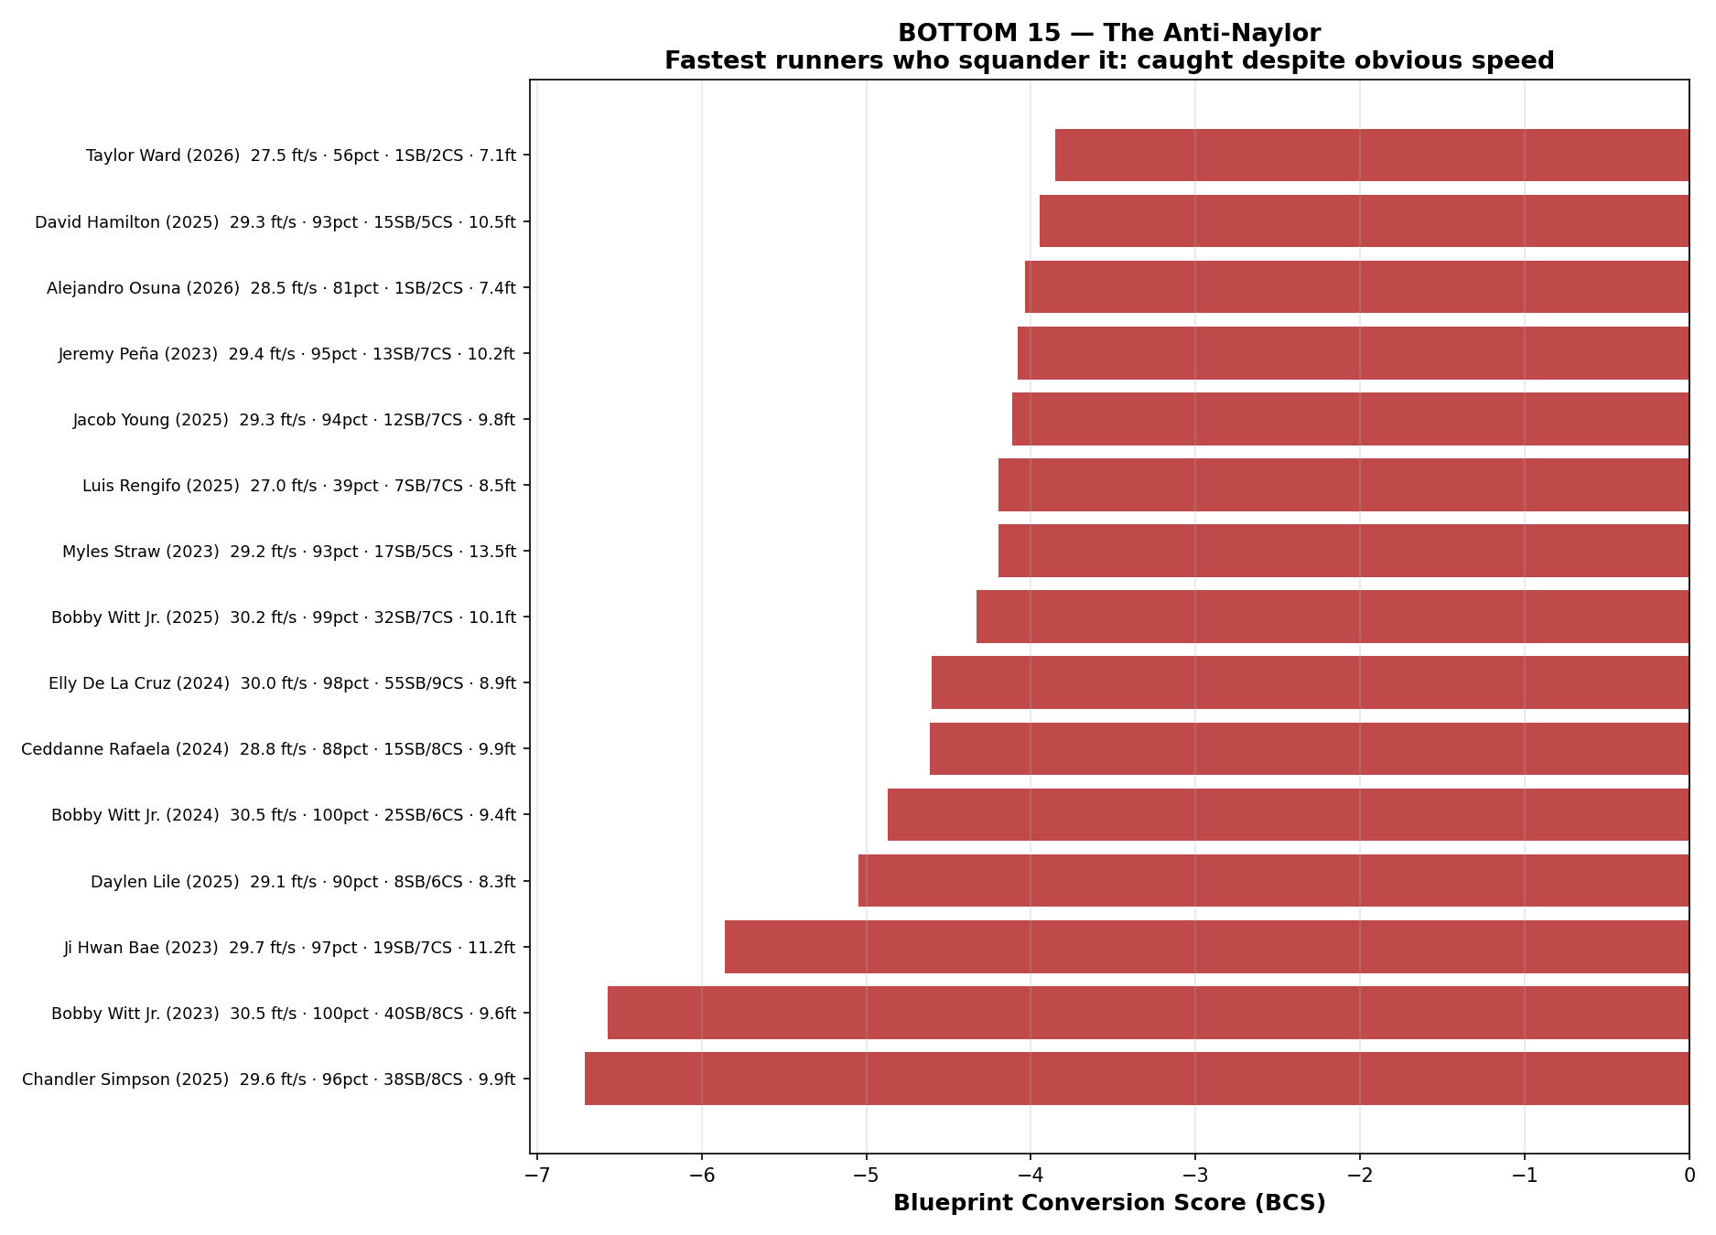
Figure 9 — Bottom BCS runner-seasons: elite speed, serial caught-stealings.

6.5 Per-Season BCS Top 25 — with Team Logos
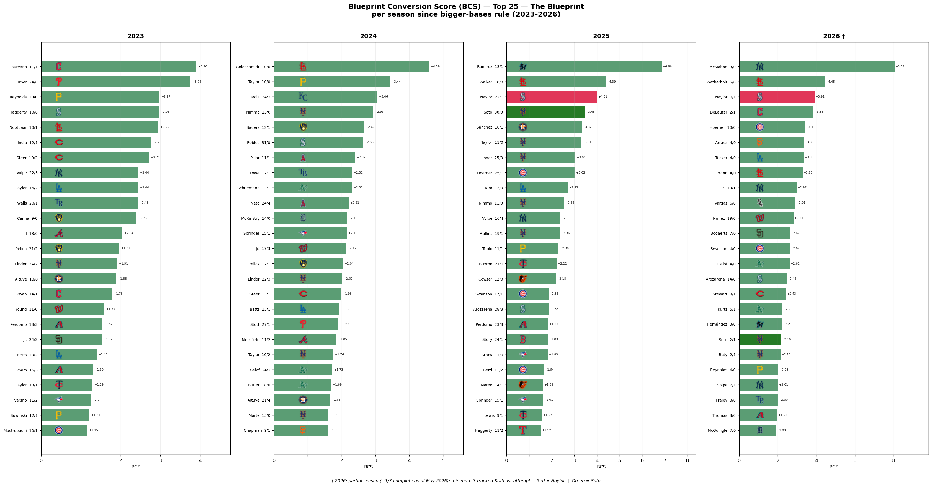
Figure 10 — Top 25 BCS per season (2023–2026) with team logos. Red = Naylor, green = Soto.

7 Conclusions
- Ground covered (first move → release) is near speed-independent — sprint speed explains only a small fraction of the variance (r = −0.36).
- The gain metric meaningfully predicts steal success (r ≈ +0.25–0.29 with SB%). The signal is real.
- The Naylor archetype — slow sprint, big jump, high conversion — is stable across every season.
- The squander archetype — fast sprint, serial caught-stealings — is equally stable.
- Practical implication: timing and jump training can shift scores at both ends of the speed spectrum. Sprint speed is structural; the jump window is behavioral.

