The Naylor Model · v11
Base-stealing skill that sprint speed hides — for MLB R&D and coaching staffs
BOTTOM LINE The league's best base-stealers, 2023-2026: Shohei Ohtani '24 leads on Steal+ — skill above his own sprint speed — while Ronald Acuña Jr. '23 banks the most raw bases (Net Bases). Steal+ is the headline; Burst (the coachable jump/lead) is a separate lens. Both are defined first so the leaderboard reads clearly.

How Steal+ is calculated — and why a caught stealing hurts 4×
BOTTOM LINE Steal+ = your net steals (SB − CS) minus what an average runner of your sprint speed would net over the same attempts. Because speed already buys ~80% success, each caught stealing is weighted about 4× a stolen base.
Steal+ = ( SB − CS ) − ( what your sprint speed alone would net over the same attempts )
0 = exactly what your speed predicts · + = your skill adds bases · − = you cost bases.
Rearrange it and every attempt is scored against your speed's expected success rate p (≈ 0.80 league-wide) — which is where the penalty appears:
Steal+ = 2 (1 − p) × SB − 2p × CS
EACH STOLEN BASE | EACH CAUGHT STEALING
+0.4 bases (2 × [1 − 0.80]) | −1.6 bases (2 × 0.80)
→ one caught stealing erases about FOUR clean steals.
One more step, so the per-steal weights aren't a mystery: p is not a fixed 0.80 — it is each runner's own speed-expected success rate, p = 0.50 + 0.011 × sprint speed. A slower runner has a lower p, so each of his steals counts more (+) and each caught stealing less (−):
Runner | Sprint speed | p = 0.50 + 0.011·speed | Each SB = 2(1−p) | Each CS = 2p
Josh Naylor · 2025 | 24.4 ft/s | 0.75 | +0.49 | −1.51
Elly De La Cruz · 2024 | 30.0 ft/s | 0.81 | +0.37 | −1.63
The same math in two real seasons — fast-and-prolific is not enough:
Player-season | SB | CS | Calculation | Steal+ | %ile
Josh Naylor · 2025 (24.4 ft/s) | 30 | 2 | 30 × (+0.49) − 2 × (1.51) | +11.7 | 99th
Elly De La Cruz · 2024 (30.0 ft/s) | 67 | 16 | 67 × (+0.37) − 16 × (1.63) | -1.0 | 36th
Elly's 16 caught stealings drag a huge steal total below average (−1.0, 36th %ile); Naylor's near-flawless conversion clears his slow-speed baseline by a mile (+11.7, 99th %ile).

The baseline: expected steals by sprint speed
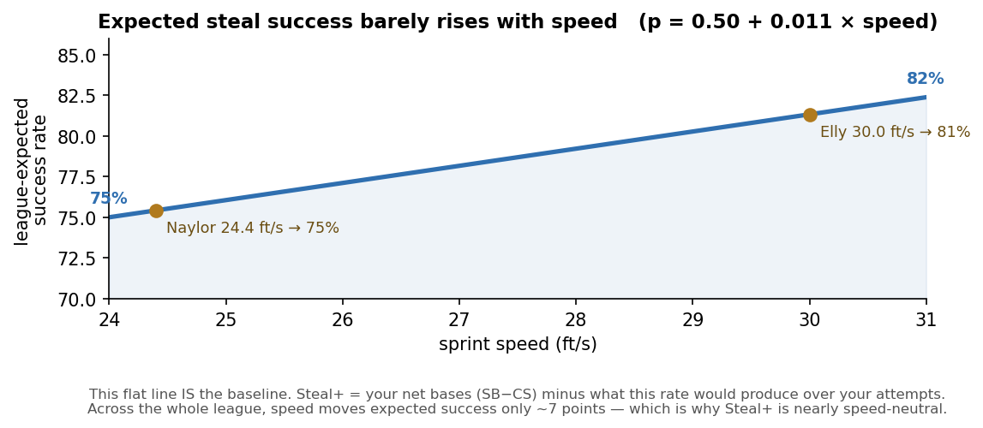
Speed is continuous here — 30.0 and 30.1 ft/s get slightly different expectations (no bins). The line is nearly flat, so beating it is skill, not wheels.

1 · How Burst is calculated — the coachable half
BOTTOM LINE Burst = the feet of ground you gain off the base (pitcher's first move → the pitch reaching the catcher) ABOVE what your sprint speed alone predicts. It's the jump and lead — coachable, and a different signal from Steal+.
Burst = ( your ground gained ) − ( ground an average runner of your speed gains )
Ground gained = your secondary lead − primary lead: how far you shuffle off the base while the pitch is in flight. We fit the league's ground gained on sprint speed (ground = 36.8 − 0.89 × speed — slower runners actually shuffle a bit more), and Burst is how far above that line you land. 0 = exactly speed-predicted; + = a better jump than your wheels explain.
It is measured before any SB or CS exists — process, not outcome — and it barely tracks Steal+ (r ≈ 0.16). That independence is the point: a slow runner with high Burst is a development target.

2 · The leaderboard — top base-stealers by Steal+
Ranked by Steal+ (net bases above a same-speed average). Speed in ft/s (MLB avg ≈ 27.0); Steal+ and Burst both in units above speed-expected (0 = average). Burst is shown alongside as the separate coachable-process read. Min 15 att; Naylor & Soto in bold.
Steal+ and Burst are independent (r ≈ 0.16), so the two columns disagree — by design. Ohtani '24 leads Steal+ (+18.1, elite production) with a below-average Burst (−1.4 ft): his value is volume and pitch selection, not first-move technique. Naylor pairs a top-5 Steal+ with a positive Burst — he clears his slow-speed baseline on both.
# | Player | Yr | Speed  (ft/s) | Net  Bases | Steal+  (+bases) | Burst  (+ft)
1 | Shohei Ohtani | 2024 | 28.1 | +55 | +18.1 | -1.4
2 | CJ Abrams | 2023 | 28.6 | +43 | +12.6 | -1.2
3 | Maikel Garcia | 2024 | 27.9 | +35 | +12.3 | +1.1
4 | Corbin Carroll | 2023 | 30.1 | +49 | +11.9 | +2.7
5 | Josh Naylor | 2025 | 24.4 | +28 | +11.7 | +1.6
6 | Juan Soto | 2025 | 25.8 | +34 | +11.4 | +0.3
7 | Trea Turner | 2023 | 30.3 | +30 | +11.0 | +3.7
8 | Trevor Story | 2025 | 28.6 | +30 | +10.9 | +0.0
9 | Brice Turang | 2024 | 29.3 | +44 | +9.7 | +0.2
10 | Byron Buxton | 2025 | 30.2 | +24 | +8.9 | +0.1
11 | Freddie Freeman | 2023 | 26.7 | +22 | +8.6 | -1.0
12 | Josh Lowe | 2024 | 28.4 | +24 | +8.6 | +1.2
13 | Ronald Acuña Jr. | 2023 | 28.0 | +59 | +8.2 | +0.4
14 | Josh Lowe | 2023 | 28.7 | +29 | +8.0 | +0.9
15 | CJ Abrams | 2025 | 28.2 | +28 | +8.0 | -0.8
16 | Bryson Stott | 2024 | 29.1 | +29 | +7.7 | +0.1
17 | Lawrence Butler | 2024 | 27.6 | +18 | +7.6 | -1.9
18 | Bryson Stott | 2023 | 28.8 | +28 | +7.6 | -0.5
19 | Taylor Walls | 2023 | 28.2 | +21 | +7.5 | +1.6
20 | Oneil Cruz | 2024 | 28.8 | +21 | +7.2 | -0.7

3 · Leaders by each lens — production, skill, process
The same league ranked three ways — raw production, skill above speed, and coachable process. The names change across lenses; that is the point. All min 15 att.
Most raw production — Net Bases (SB − CS)
# | Player | Yr | Speed  (ft/s) | SB | CS | Net Bases  (SB−CS) | Steal+  (+bases)
1 | Ronald Acuña Jr. | 2023 | 28.0 | 73 | 14 | +59 | +8.2
2 | Shohei Ohtani | 2024 | 28.1 | 59 | 4 | +55 | +18.1
3 | Esteury Ruiz | 2023 | 29.6 | 67 | 13 | +54 | +4.6
4 | Elly De La Cruz | 2024 | 30.0 | 67 | 16 | +51 | -1.0
5 | Corbin Carroll | 2023 | 30.1 | 54 | 5 | +49 | +11.9
6 | Brice Turang | 2024 | 29.3 | 50 | 6 | +44 | +9.7
7 | CJ Abrams | 2023 | 28.6 | 47 | 4 | +43 | +12.6
8 | José Caballero | 2025 | 28.3 | 49 | 11 | +38 | +2.6
9 | José Ramírez | 2025 | 28.4 | 44 | 7 | +37 | +6.8
10 | Nico Hoerner | 2023 | 28.5 | 43 | 7 | +36 | +6.3

Most skill above speed — Steal+ (net bases above what his speed produces)
Baseline = 0 bases above speed-expected (what an average runner of this player's exact sprint speed would produce over the same attempts). Positive = outperforming speed; negative = underperforming it.
# | Player | Yr | Speed  (ft/s) | SB  (actual) | CS | Net  Bases | Steal+  (+bases)
1 | Shohei Ohtani | 2024 | 28.1 | 59 | 4 | +55 | +18.1
2 | CJ Abrams | 2023 | 28.6 | 47 | 4 | +43 | +12.6
3 | Maikel Garcia | 2024 | 27.9 | 37 | 2 | +35 | +12.3
4 | Corbin Carroll | 2023 | 30.1 | 54 | 5 | +49 | +11.9
5 | Josh Naylor | 2025 | 24.4 | 30 | 2 | +28 | +11.7
6 | Juan Soto | 2025 | 25.8 | 38 | 4 | +34 | +11.4
7 | Trea Turner | 2023 | 30.3 | 30 | 0 | +30 | +11.0
8 | Trevor Story | 2025 | 28.6 | 31 | 1 | +30 | +10.9
9 | Brice Turang | 2024 | 29.3 | 50 | 6 | +44 | +9.7
10 | Byron Buxton | 2025 | 30.2 | 24 | 0 | +24 | +8.9

Best coachable process — Burst (ft of ground covered above speed-expected)
Ground (ft/att) = average feet the runner gains off the base from first move to the pitch reaching the catcher (secondary lead) per attempt (league avg ≈ 11.7 ft). Burst = ft above what this runner's sprint speed predicts (0 = exactly speed-predicted; positive = covers more ground than speed alone explains).
# | Player | Yr | Speed  (ft/s) | Ground  (ft/att) | Burst  (+ft vs avg) | Steal+  (+bases)
1 | Agustín Ramírez | 2025 | 26.7 | 21.3 | +8.2 | +2.4
2 | Spencer Steer | 2023 | 28.4 | 15.7 | +4.2 | +1.3
3 | Trea Turner | 2023 | 30.3 | 13.6 | +3.7 | +11.0
4 | Gleyber Torres | 2023 | 26.4 | 16.9 | +3.5 | -3.5
5 | Jorge Mateo | 2023 | 30.1 | 13.3 | +3.2 | +3.7
6 | Jazz Chisholm Jr. | 2026 | 28.3 | 14.9 | +3.2 | +0.5
7 | Sal Frelick | 2024 | 29.3 | 14.0 | +3.2 | +2.2
8 | Trea Turner | 2025 | 30.3 | 13.0 | +3.2 | +1.8
9 | Juan Soto | 2023 | 26.8 | 16.1 | +3.1 | -2.5
10 | Ernie Clement | 2024 | 28.4 | 14.4 | +2.9 | +0.1

4 · Are these more useful than Net Bases Gained?
Net Bases Gained is an outcome that bundles five things: sprint speed, volume, opponent difficulty, execution, and luck. Statcast's SB Run Value doesn't separate them either — empirically it is a fixed credit per steal minus a larger debit per caught, correlated +0.85 with Net Bases and +0.23 with sprint speed; it adjusts for neither speed nor opponent. v11 strips one confound per metric.
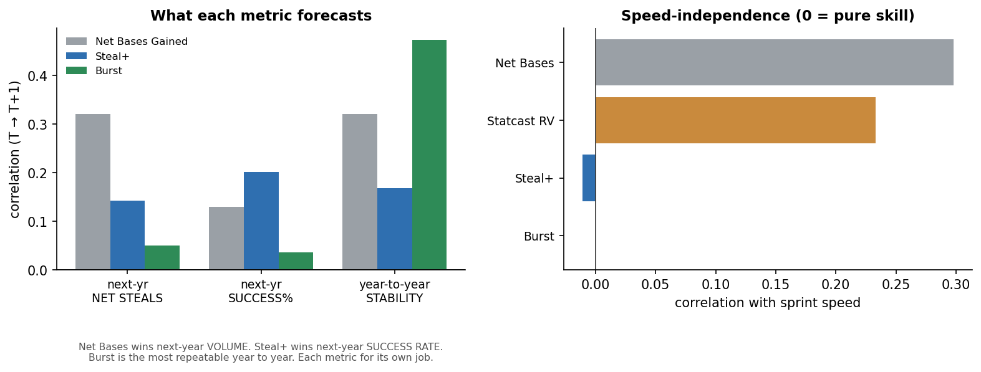
Left: what each metric forecasts (T→T+1). Net Bases wins next-year volume; Steal+ next-year success rate; Burst is the most repeatable. Right: only the v11 metrics are speed-independent.
Question (year T → T+1) | Net Bases | Steal+ | Burst | Best metric
Predict next-yr net steals (volume) | +0.32 | +0.14 | +0.05 | Net Bases Gained
Predict next-yr success rate | +0.13 | +0.20 | +0.04 | Steal+
Year-to-year stability (repeatable) | +0.32 | +0.17 | +0.47 | Burst
Net Bases is the better predictor of next-year totals — we concede that; on every other axis a coach cares about (skill, efficiency, repeatable technique), v11 wins. Net Bases is the outcome; v11 isolates the coachable cause.

5 · The decomposition — where production comes from
BOTTOM LINE Net Bases = NetSpeed + Steal+, exactly. NetSpeed is what the wheels buy; Steal+ is the skill.
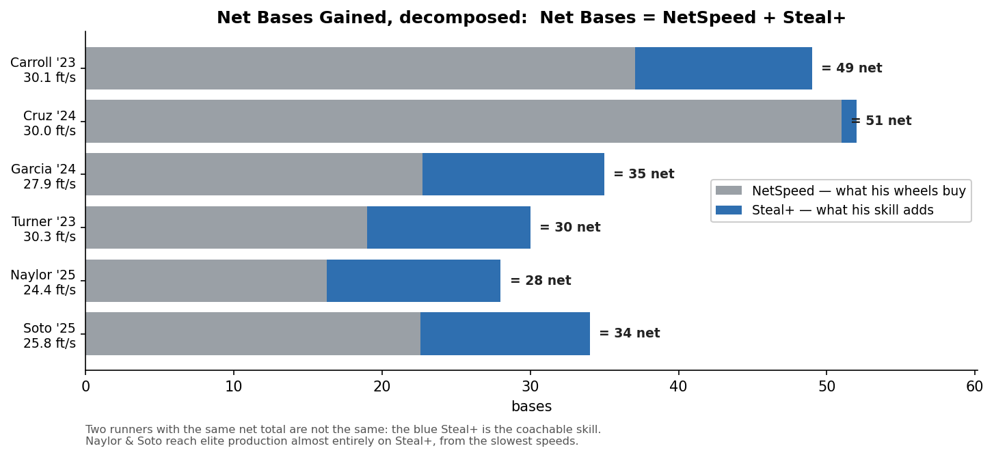
Two runners with identical net totals are not the same runner: the blue Steal+ is the coachable part. Naylor & Soto reach elite production almost entirely on Steal+, from the slowest speeds.

Metric reference
Net Bases Gained | SB − CS. The baseline; bundles speed, volume, difficulty, execution, luck.
Steal+ | HEADLINE. Net bases (SB − CS) above what an average runner of his sprint speed produces over the same attempts. = 2(1−p)·SB − 2p·CS, p = speed-expected success. Volume-aware, speed-neutral.
Burst | Ground gained off the base (first move → pitch reaching the catcher) above what speed predicts, in feet. The separate coachable process; replaces v10's SB Run Value.
NetSpeed | Net bases a runner's raw speed alone buys — the structural floor in the decomposition (Net Bases = NetSpeed + Steal+).

