CentOS 7安装Apache

1、GitHub开源笔记进行换源
https://github.com/kybll/Centos7-to-set-up
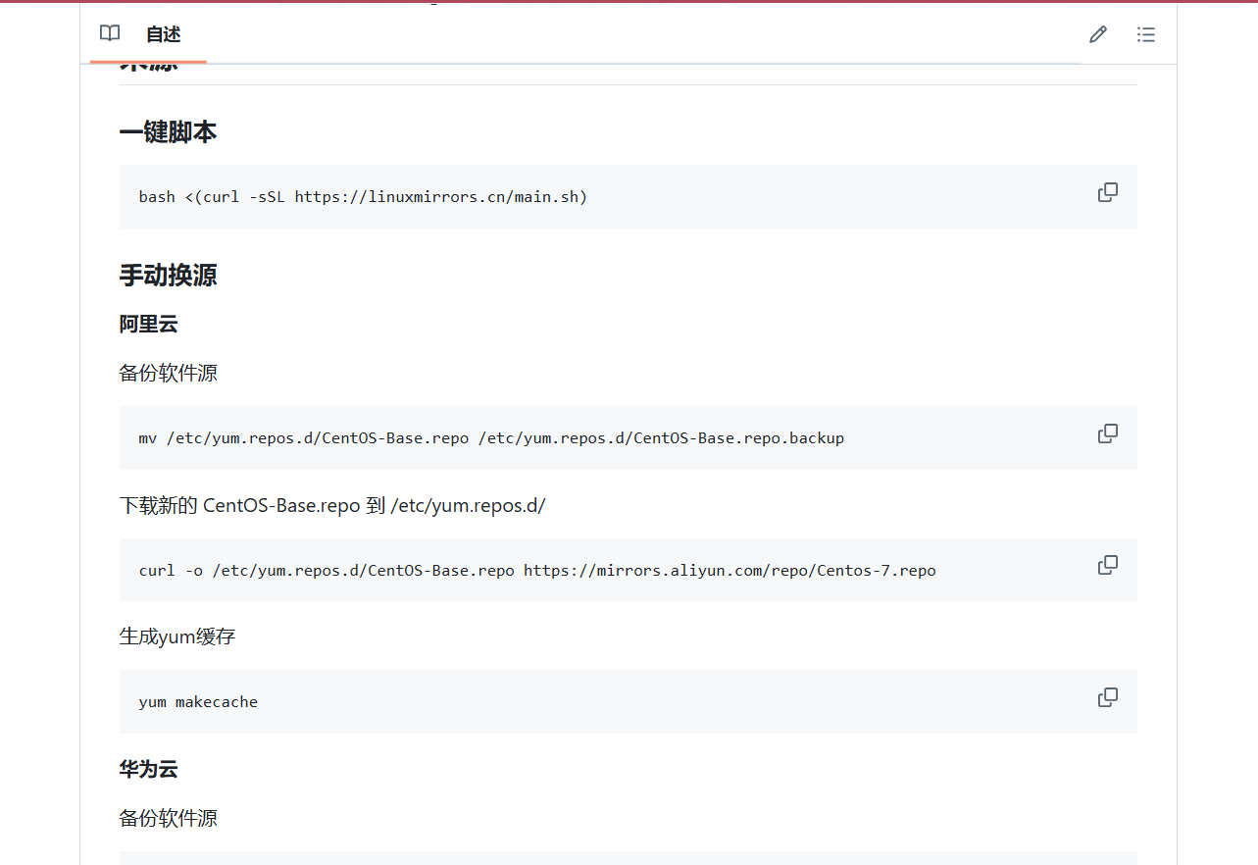
2、更新更新软件包
Sudo yum update -y
3、安装apache HTTP Server
Sduo yum install httpd -y
- 启用Apache服务并设置开机启动
sudo systemctl start httpd
sudo systemctl enable httpd
- 检查Apaceh服务状态
sudo systemctl status httpd
- 配置防火墙
sudo firewall-cmd --permanent --add-service=http
sudo firewall-cmd --permanent --add-service=https
sudo firewall-cmd --reload
- 测试Apache安装
查看CentOS IP地址，在浏览器输入IP地址
