International GDP Population Historical

R Analysis

By: Stephanie Hunter

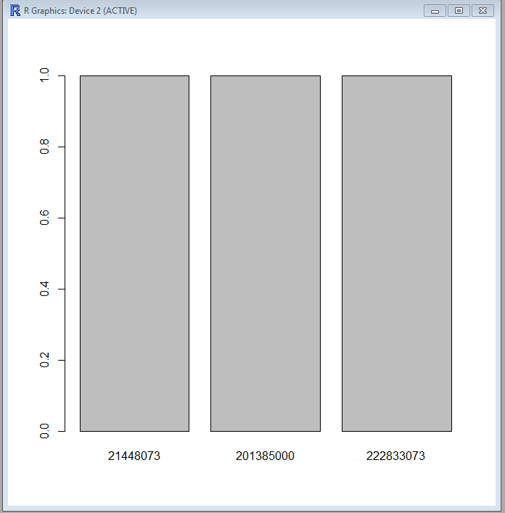

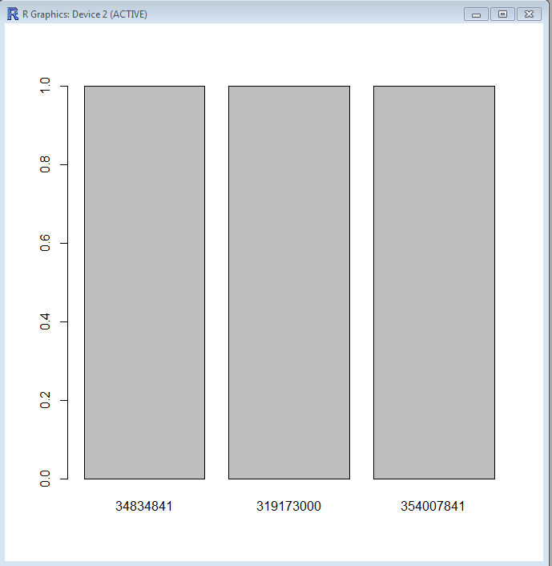1969 Bar plot

2014 Bar plot

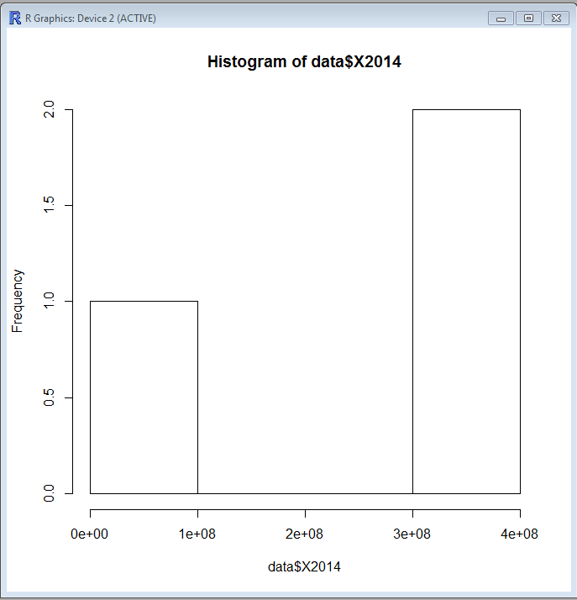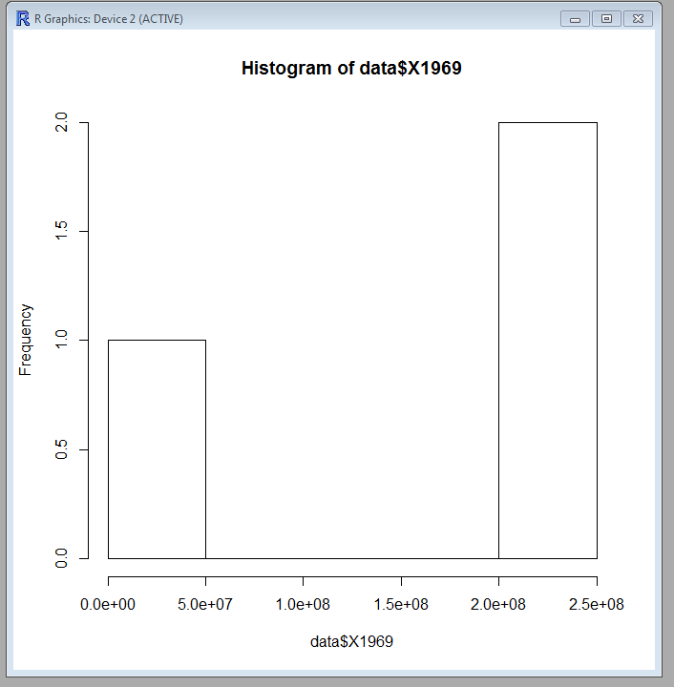

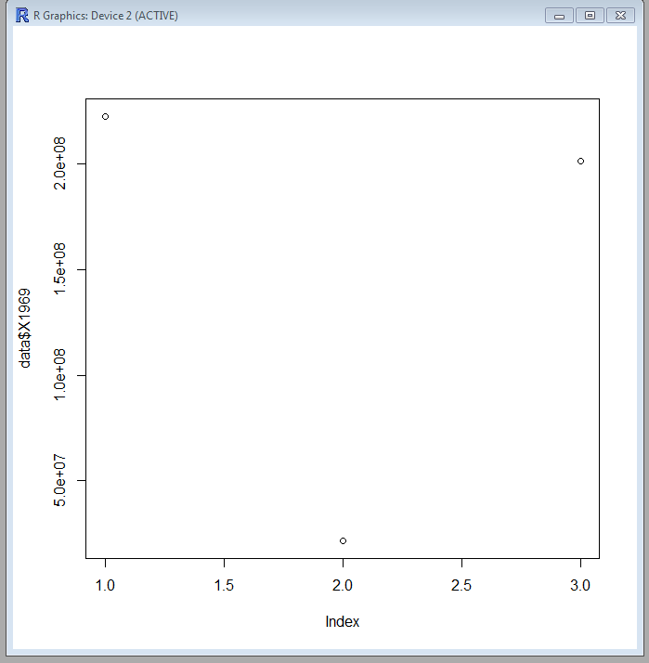

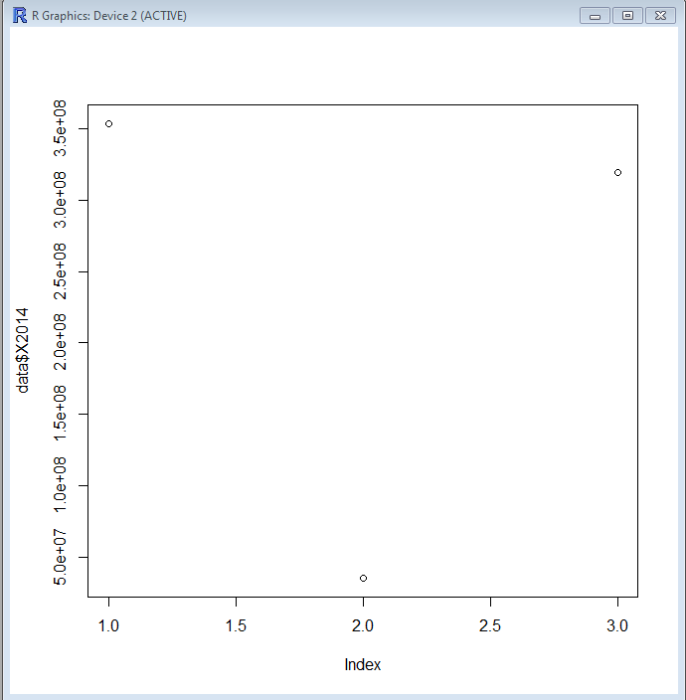

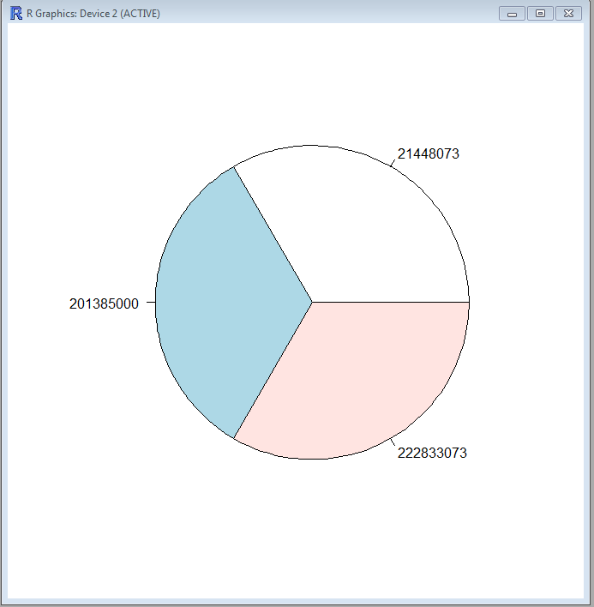

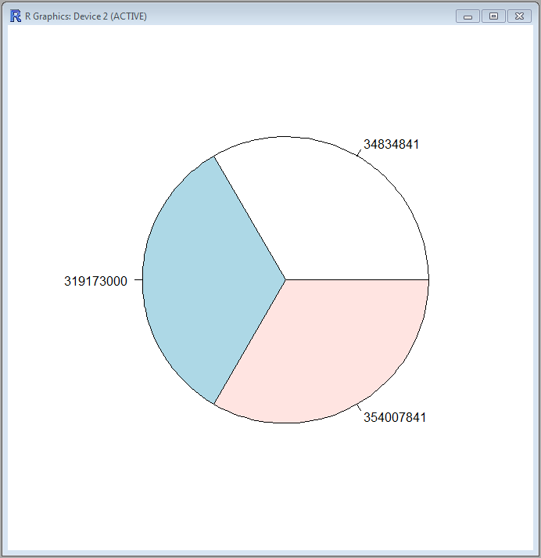 Pie Chart (1969)

Pie Chart (2014)

My analysis is comparing two different years of the GDP. They are being compared with 1696 and 2014. North America, United States and Canada are the location that are my main focusing on. I put together four different plots or charts in R to see the number a little better. The GDP provides 189 countries but I wanted to lessen the scope to see the county in which I live in. The countries do account for 99 percent of the world’s economy. The basic analysis that I did gives basic facts of minimum, maximum, quartiles, and other statistics. The main reason for this project was to see if I could run the data in R and be able to understand it. The numbers give me an understanding of how the population grow from year to year. The population in the 1969 was roughly 20138500 in the United States. With years it has grown with about 10000000 more people in 2014. Since its 2016 I would only imagine that the updated total is about 300000 people. By looking at the numbers it looks like a peck of 300000 thousand people every day is being calculated. The database that I choice to do my project on the United States Department of Agriculture website also gave baseline estimation. I felt like the historical would be a better way to look at some of the previous information.

Update in population numbers

Nonmetro areas in some parts of the country have experienced population loss for decades. However, the 2010-14 period marks the first time with an estimated population loss for nonmetro America as a whole.

* Population loss of just over 115,000 people since 2010 represents a quite small -0.25 percentage loss for nonmetro areas as a whole over the 2010-14 period.
* The number of nonmetro counties losing population during 2010-14 reached an historic high of 1,310. Taken together, these counties declined in population by 523,000 people, while the 666 nonmetro counties that gained population added 408,000 people.

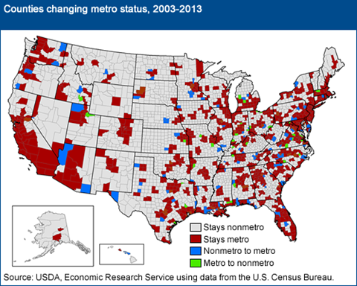Nonmetro America does "lose" population every 10 years when nonmetro counties that have been growing rapidly enough become reclassified as metro. In the latest update announced by the U.S. Office of Management and Budget in March 2013, 113 nonmetro counties (with 5.9 million people) switched to metro status while 36 counties (with 1 million people) no longer qualified as metro, resulting in a net nonmetro population "loss" of 4.9 million from reclassification. The recent nonmetro population trends described here are independent of reclassification, having occurred in a constant set of nonmetro counties. In the long run, removal of fast-growing counties makes it harder for nonmetro America to sustain overall population growth.

|  |
| --- |
|  |
|  |

County population change includes two major components: natural change (births minus deaths) and net migration (in-migrants minus out-migrants).

* Since 2010, the increase in nonmetro population from natural change (230,000 more births than deaths) has not matched the decrease in population from net migration (346,000 more people moved out than moved in).
* While natural change has gradually trended downward over time, net migration rates tend to fluctuate in response to economic conditions.
* 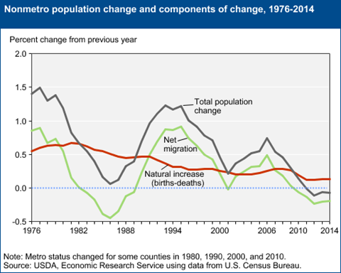Net out-migration rates were sometimes much greater in the past (such as in the 1980s), but were always offset by higher rates of natural increase.

|  |
| --- |
|  |

Historically, nonmetro population grew because high rates of natural increase always offset any net migration loss in nonmetro areas.

* Rural out-migration peaked in the 1950s and 1960s (not shown on graph), but was offset by high "baby boom" birth rates.
* Net out-migration from nonmetro areas was more severe during the 1980s than during 2010-14, but overall population change remained positive during the 1980s because natural increase contributed roughly 0.5 percent growth (compared with 0.1 percent recently).
* Falling birth rates and an aging nonmetro population have steadily dampened the contribution of natural change to nonmetro population growth.
* Nonmetro net migration rates peaked during the "rural rebound" in the mid-1990s and again in 2004-06, just prior to the recent housing mortgage crisis and economic recession. Net migration remained positive for much of the past two decades, increasing nonmetro population every year but one from 1990 to 2009, but has since contributed to population loss.

Lowering rates of natural change contributed to expanded population decline in nonmetro areas and resulted in 276 counties experiencing natural decrease for the first time during 2010-14. The map shows natural change for all counties, metro and nonmetro. Urbanized areas (shown in dark gray) are at the center of metro areas, and nonmetro counties are those that are some distance removed, depending on the size of the metro area.

|  |
| --- |
|  |
| [\](http://www.ers.usda.gov/media/1100076/natmap.png) |

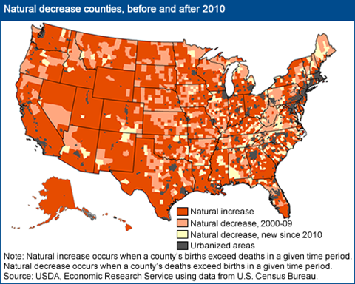

Areas that recently began experiencing natural decrease are found in the Northeast, South, and especially around the margins of Appalachia, expanding a large region of natural decrease extending from Pennsylvania through northern Alabama.

* Counties end up as natural decrease counties as a result of two separate demographic processes operating over several decades: retiree attraction and long-term out-migration of young adults (who take their future children with them, so to speak).
* Typically, these trends occur in different regions of the country: retiree attraction in Florida, Arizona, and other Sunbelt locations; and out-migration of young adults in persistent out-migration areas such as in the Great Plains and Corn Belt. However, both trends are contributing to the emergence of natural decrease counties in many nonmetro regions, such as in Virginia, Kentucky, North Carolina, and Tennessee.

This period of nonmetro population loss may be short-lived depending on the course of the Nation's economic recovery. Even if temporary, this small but historic shift to overall population loss highlights a growing demographic challenge facing many regions across rural and small-town America, as population growth from natural increase is no longer large enough to counter cyclical net migration losses.

<http://www.ers.usda.gov/topics/rural-economy-population/population-migration/recent-population-change.aspx>. March 1, 2016